q

Operating systems 4 project documentation

**Project description:**

The N-Queens problem is a classic chessboard puzzle that involves placing N chess queens on an N×N chessboard in such a way that no two queens threaten each other. In other words, no two queens should share the same row, column, or diagonal. The challenge is to find all possible arrangements of queens on the chessboard that satisfy this constraint.

The inputs are given as:

**Chessboard Size (N):** An integer representing the dimensions of the chessboard.

**Initial State (optional):** For certain algorithms, an initial state may be provided as a starting point for the solution search.

**Concurrency Level (for multi-threading):** information about the number of threads or processors available for parallel

**Solution of the problem:**

Solving the N-Queens problem using multi-threading involves parallelizing the search for a solution by dividing the problem into smaller sub problems that can be solved concurrently by multiple threads.

**Here's a brief summary of the approach**:

**Task Decomposition:** Break down the N-Queens problem into smaller independent tasks. Each task represents a portion of the search space, where queens are placed on a subset of rows.

**Thread Creation:** Create multiple threads, each responsible for solving a specific sub problem independently. The threads work concurrently to explore different regions of the solution space.

**Concurrency:** Utilize multi-threading to explore potential solutions simultaneously. Each thread independently searches for valid queen placements in its assigned portion of the chessboard.

**Combine Solutions:** Once individual threads find solutions for their respective sub problems, combine the results to form a complete solution to the N-Queens problem.

**What we have actually did:**

Using the solutions that were presented, we found a way of cooperating with one another as a team and we have done the project exactly as it was described

**Team members:**

Board: Ziad Ammen,Rashad Samir,Ziad Mohamed mosaad.

Pieces: Rashad samir, Ziad Mohamed mosaad.

Testing the code: omar moheb,Ziad Mohamed mohamed.

Documentation: omar moheb

Gui: Islam adel ,Mahmoud mohy.

**Code documentation:**

1-Gui component:

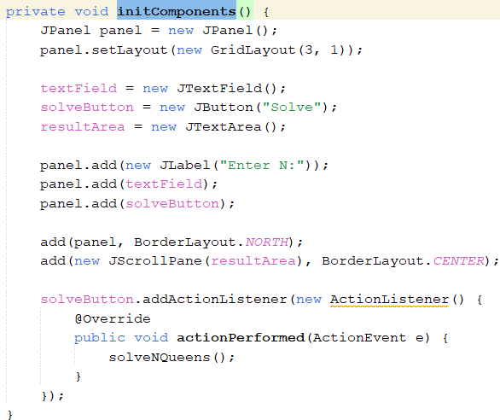

Gui solve queen

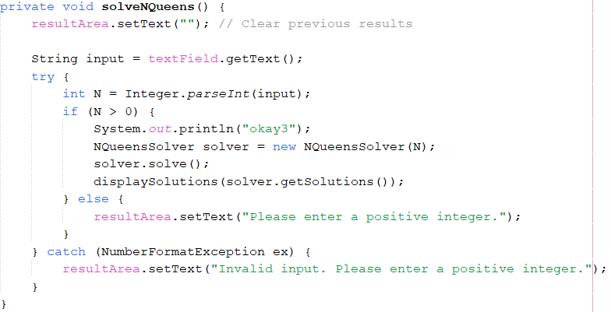

DisplaySolutions :

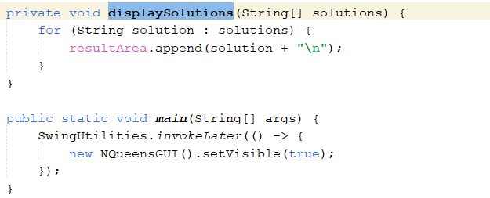

SOLVE FUNCTION:

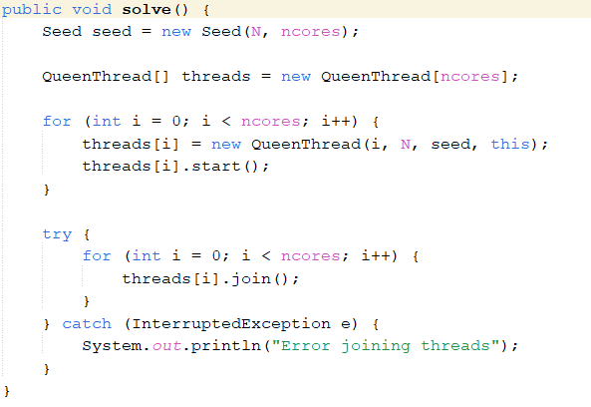

INCREMENT SOLUTION:

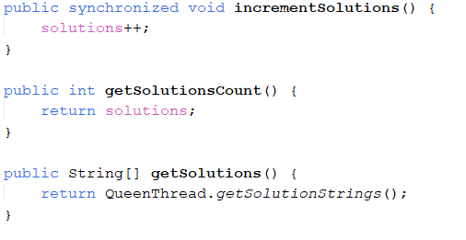

SEED FUNCTION:

