Tableau Public Link: https://public.tableau.com/app/profile/harsh.gupta5674/viz/NHS_Services4/NewsAccessStory

Executive summary
This report interprets NHS e-Referral Service (e-RS) appointment-slot issues (ASIs) as an operational indicator of hidden access pressure in elective outpatient pathways. An ASI occurs when a referral reaches the booking stage, but no appointment slot is available at the time of search, causing the referral to enter the ‘defer to provider’ process (NHS England, 2025a). This is not a patient-level outcome measure, but it can signal booking friction and potential demand-capacity mismatch when interpreted with appropriate caution.
The visual design is deliberately split into two audience-specific outputs: a public/news-facing story and internal NHS dashboards. This separation follows dashboard-design literature, which argues that public health dashboards should be clear, interpretable and aligned with user literacy, while operational dashboards need actionability, trusted metrics and workflow integration (Schulze et al., 2023; Rabiei et al., 2024; Randell et al., 2022; Vornhagen et al., 2026). The results show 80,455,957 referrals, 30,327,787 bookings and 21,871,565 ASI actions, producing a national ASI-to-referral ratio of 27.2%. This is not a patient conversion funnel because referrals, bookings and ASIs are separate event types. However, it is a useful measure of booking-process friction between referral demand and bookable outpatient capacity.
The main finding is that ASI pressure is substantial, persistent and geographically uneven. North West has the highest ASI burden when standardised per 10,000 GP-registered patients, while London has the highest ASI-to-referral ratio. Specialty-level views show that ASIs are concentrated in a smaller group of services, while ICB heatmaps reveal that local hotspots are more specific than regional averages suggest.

1. Introduction and policy context
The NHS e-RS is a national digital referral and booking infrastructure through which referrers, providers and patients manage first outpatient appointments, triage and related advice processes. NHS guidance positions e-RS as a mechanism for standardising referral and booking communication between referrers and providers, while the wider elective-care context is shaped by persistent referral-to-treatment pressure and outpatient transformation (NHS England, 2025c; NHS England, 2025e). Public Accounts Committee (2025) evidence indicates that the 18-week referral-to-treatment standard has not been met since 2015, making the referral-booking interface a relevant site for visual analysis.
Within this context, ASIs matter because they expose a stage of access pressure that may be hidden behind headline waiting-list measures. A referral may have entered the system, but if no slot is available, the patient cannot be booked into an appointment at that point. ASIs therefore represent booking friction at the boundary between primary-care referral demand and secondary-care outpatient capacity. They do not directly measure patient harm, waiting duration or referral-to-treatment breach; in this report, they are treated as an operational indicator that may signal booking friction and potential demand-capacity mismatch when interpreted with appropriate caution.
The report addresses the requirement for two different visual representations. The first is suitable for a public or international news audience and prioritises clarity, geographical storytelling and careful explanation. The second is designed for NHS country directors and internal decision-makers, using KPI cards, regional comparison, priority mix, box plots, a priority matrix and ICB-specialty hotspots to support operational diagnosis. The distinction is important: public communication should avoid overwhelming detail, whereas internal dashboards must help managers decide where to investigate first.

2. Data sources, preparation and analytical method
The primary source is the NHS e-RS open data publication, using weekly event records for referrals, bookings and ASIs across 2020-2024. The source files were unioned by year in Tableau to create a five-year analytical extract. The 2020-2024 window was selected because it provides complete calendar years and avoids partial baseline weeks from late 2019 and incomplete 2025 data. Records were linked to NHS geography using Sub-ICB to ICB and NHS England region lookup data. Null or non-mappable geographies were checked and excluded from regional analysis where they would distort dashboard interpretation.
A second dataset, NHS patients registered at a GP practice, was joined to enrich the e-RS activity data with a service-population denominator (NHS England, 2025d). This was essential because raw ASI volume alone can reflect population size as much as access pressure. The report, therefore, compares absolute ASI counts with an ASI burden per 10,000 GP-registered patients. This measure is not the official NHS dashboard ASI rate; it is an additional population-standardised indicator used to compare appointment-slot pressure against the registered service population. ONS health geography population estimates were reviewed as an alternative denominator, but GP-registration counts were preferred because they better align with NHS service-registration populations (Office for National Statistics, 2025).
Four core measures were created. First, adjusted ASI volume uses the official events-adjusted field, which accounts for bank-holiday effects in the source data. Second, the ASI-to-referral ratio is calculated as total adjusted ASIs divided by total adjusted referrals, expressed as a percentage. Third, the ASI burden per 10,000 GP-registered patients is calculated as total adjusted ASIs divided by GP-registered patients and multiplied by 10,000. Fourth, specialty concentration is assessed using a Pareto chart, where descending bars show specialty ASI volume and the cumulative line identifies how quickly the largest specialties account for overall pressure.
A key cleaning decision was to exclude 2WW from the specialty Pareto analysis. The two-week-wait pathway is a referral priority pathway rather than a conventional clinical specialty. Including it in a specialty ranking would conflate urgency with service-line capacity and could mislead managers who are trying to identify which clinical departments, such as orthopaedics or dermatology, require review. 2WW remains relevant in the priority-mix visualisation, where it is more appropriately interpreted.
As a sensitivity decision, the Pareto chart should be read as a specialty-focused view rather than a complete pathway ranking. A version including 2WW would answer a different question about pathways and priorities; excluding it improves the interpretation of conventional service-line pressure, but it means the Pareto results should not be presented as a full ranking of every e-RS clinic type.
The analysis is descriptive visual analytics rather than causal modelling. It identifies where pressure appears concentrated and how it differs by region, priority, ICB and specialty. It cannot prove whether a hotspot is caused by insufficient slots, coding differences, referral behaviour, case-mix, local pathway design or provider-level capacity constraints. Therefore, terms such as ‘hidden access pressure’ are used as interpretive framing rather than as validated clinical outcome measures.

2.1 Reproducibility and calculation note
To improve reproducibility, the headline figures should be read as calculations from the unioned NHS e-RS open data files for the complete calendar years 2020-2024. Partial 2019 and 2025 records were excluded. The Tableau workbook used the Sub-ICB to ICB and NHS England region lookup to map geography, and regional and ICB-level visuals excluded null or unmatched geography values. The GP registered-patient denominator was derived from the GP practice all-persons file with extract date 1 December 2024, aggregated to Sub-ICB/ICB geography using the available ONS/NHS location codes. This denominator is cross-sectional and service-population based, so it should be interpreted as a comparative burden denominator rather than a historic annual population series.
Total referrals, total bookings and total ASIs were calculated by summing Events Adj after filtering Event type to Referrals, Bookings or ASIs, respectively. The ASI-to-referral ratio was calculated as: SUM(Events Adj where Event type = ASIs) / SUM(Events Adj where Event type = Referrals) x 100. The ASI burden per 10,000 GP-registered patients was calculated as: SUM(Events Adj where Event type = ASIs) / Number of GP-registered patients x 10,000. This measure is not the official NHS dashboard ASI rate, which uses ASIs per 10,000 referrals (NHS England, 2025b).
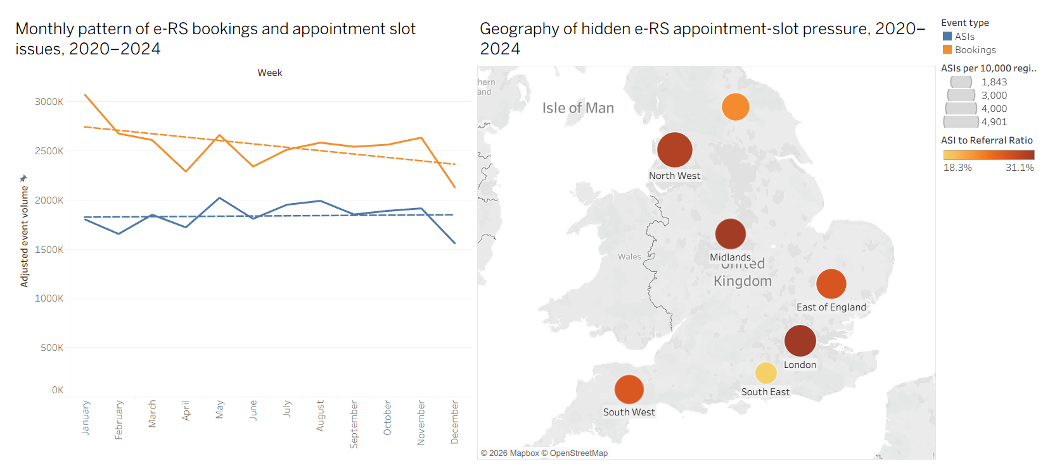
Figure 1: Public-facing view of monthly e-RS bookings and ASIs alongside the geography of hidden appointment-slot pressure across NHS England regions, 2020-2024.

3. Visualisation design and audience justification
The public-facing visualisation uses a monthly line chart and a regional map. This design makes the issue intelligible before introducing diagnostic complexity. The line chart shows the monthly pattern of bookings and ASIs, while the map communicates that ASI pressure is not evenly distributed across NHS England regions. The map uses dual encoding: bubble size represents ASI burden per 10,000 GP-registered patients, and colour represents ASI-to-referral ratio. This separates population-adjusted burden from referral-relative friction, but it also creates a risk of cognitive overload for lay users. For that reason, the story explains the key message directly, and detailed ICB and specialty information is reserved for the internal NHS product.
This design choice is supported by public health dashboard literature. Schulze et al. (2023) find that dashboards commonly use maps, charts and tables, but warn that public dashboards often under-address health literacy and heterogeneous user needs. Rabiei et al. (2024) similarly argue that dashboard design should begin with user role, aim, content and presentation format. The public dashboard, therefore, prioritises a simple narrative: referrals may enter the system, yet a bookable slot may not be available.
The internal dashboards are more diagnostic. The executive overview begins with four KPI cards, then compares priority mix, ASI-to-referral ratio, ASI burden per 10,000 GP-registered patients and adjusted ASI volume. This supports senior managers who need rapid comparison across regions. The operational dashboard then uses box plots, a priority matrix and ICB-specialty heatmaps to move from high-level comparison to targeted service-line diagnosis. Khanbhai et al. (2022) and Randell et al. (2022) support this dashboard logic: interactivity, drill-down and user-aligned summaries are most useful when they connect to improvement questions rather than simply displaying more data.
Tableau Public enabled unioning, filters, maps, tooltips, Pareto views and interactivity, but its strengths also create risks. Dense dashboards can increase cognitive load, tooltip text can encourage over-interpretation, and interactive filters can hide context if users do not notice that a view is filtered. Zhuang, Concannon and Manley (2022) argue that healthcare dashboards should be evaluated not only by visual appeal but by whether users can correctly interpret and act on them. This is why the final design separates public communication, executive comparison and operational diagnosis rather than placing every visual on one page.
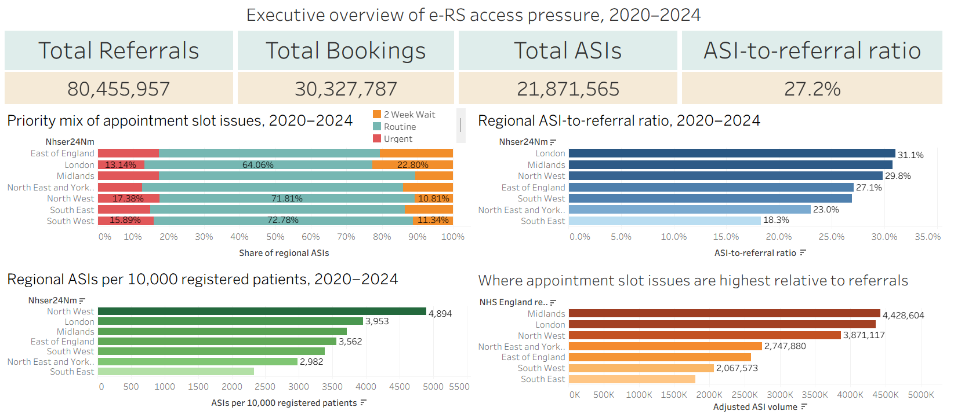
Figure 2: Internal executive overview combining KPI cards with regional priority mix, ASI-to-referral ratio, ASI burden per 10,000 GP-registered patients and adjusted ASI volume.

4. Findings: public story and executive regional pressure
The public story shows that ASIs are persistent across calendar months. Bookings remain above ASIs, but ASIs do not disappear, indicating a continuing layer of booking friction. The December reduction in both series may reflect seasonal or bank-holiday effects, although a year-by-year decomposition would be needed to confirm this. For a public audience, the main point is not precise monthly variation, but the continuing gap between booking activity and available appointment slots.
The regional map communicates a key public-facing message: e-RS appointment-slot pressure is geographically uneven. North West shows the highest ASI burden when standardised per 10,000 GP-registered patients, whereas London shows the highest ASI-to-referral ratio. This difference demonstrates why raw volume alone is inadequate. A region can have a high absolute number of ASIs because it has a large activity base, but ratio and denominator-adjusted views help distinguish scale from relative pressure.
The executive overview quantifies the national scale: 80,455,957 referrals, 30,327,787 bookings and 21,871,565 ASI actions, with an ASI-to-referral ratio of 27.2%. These figures are the calculations from the processed 2020-2024 extract and should be interpreted with the reproducibility assumptions stated above. The ratio does not mean 27.2% of individual patients failed to secure appointments; it means that adjusted ASI actions are equivalent to 27.2% of adjusted referral event volume in the analysed data. This distinction matters because NHS e-RS open data is event-level, not patient-level, and because referrals, bookings and ASIs are not a single linear conversion funnel.
Priority mix is also important. Routine pathways account for the largest share of ASIs in every region, usually around two-thirds or more. This undermines any simplistic explanation that ASIs are mainly an urgent or cancer-pathway issue. At the same time, London and the East of England show relatively larger 2WW shares than some other regions, which suggests that urgent pathways may still require local review. The practical implication is that improvement programmes focused only on urgent pathways would miss much of the overall ASI burden.
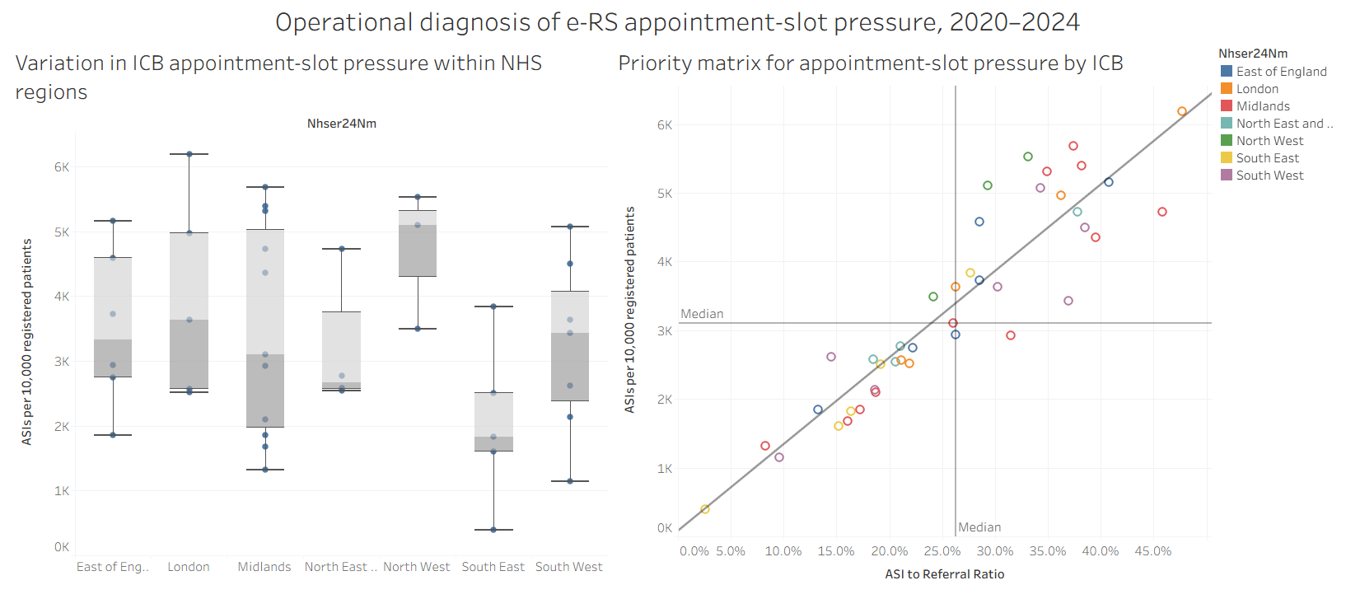
Figure 3: Operational diagnosis of appointment-slot pressure using a regional box plot and ICB priority matrix.

5. Findings: specialty drivers and operational diagnosis
The Pareto chart shows that ASI pressure is concentrated in a relatively small number of specialties once 2WW is removed. Children’s services, orthopaedics, ENT, gynaecology, GI and liver, ophthalmology, dermatology, cardiology and urology appear among the main pressure-driving areas. This is operationally useful because it converts a broad access problem into a targeted review problem. Instead of asking every service to respond equally, managers can begin with the specialties that account for the greatest cumulative share of ASIs.
However, the Pareto view should not be interpreted in isolation. When the dashboard is filtered by region, the specialty mix changes. London appears especially affected by children’s services, dermatology, ophthalmology and gynaecology, while the North East and Yorkshire show stronger GI and liver pressure. This means that national rankings should guide attention but not determine action without local review. Service-line decisions should be made at ICB-specialty level.
The box plot confirms that regional averages conceal local variation. London and the Midlands show wide ICB distributions, indicating that some local systems experience much higher pressure than others inside the same region. North West appears consistently high, whereas South East is lower overall but not free of local pressure. The priority matrix is therefore one of the most useful internal prioritisation views. ICBs in the upper-right quadrant combine a high ASI-to-referral ratio with high ASI burden per 10,000 GP-registered patients and should be reviewed first. This logic aligns with demand-capacity theory, which treats waiting and access problems as the interaction of demand, available capacity, flow constraints and organisational response (Jack and Powers, 2009; Myrberg et al., 2024).
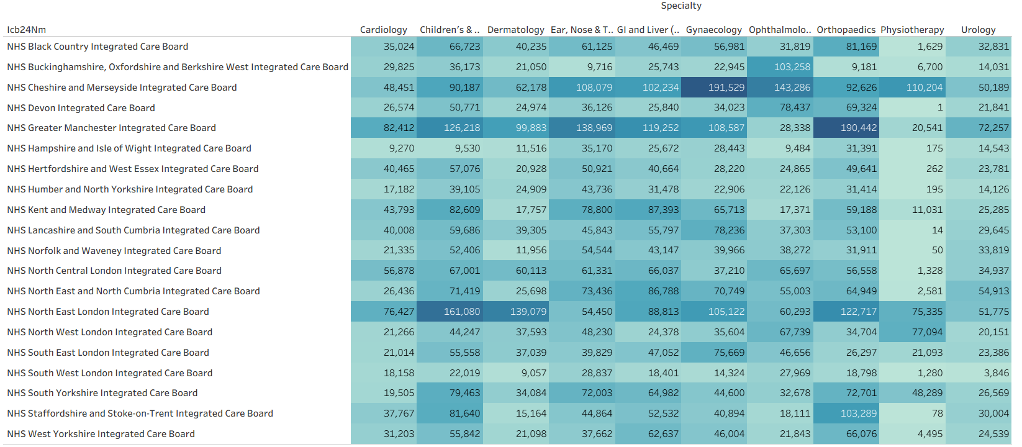
Figure 4: ICB-specialty heatmap of adjusted ASI volume, identifying local service-line hotspots for targeted operational review.
The heatmap converts regional diagnosis into operational hypotheses. Hotspot cells include examples such as Cheshire and Merseyside in gynaecology, Greater Manchester in orthopaedics, North East London in children’s services and dermatology, and Cheshire and Merseyside in ophthalmology. These should be treated as starting points for investigation rather than as direct performance judgements. They show where ASI activity is concentrated, but not why it occurs.

6. Critical discussion, limitations and recommendations
The findings are consistent with wider literature on e-referral systems and demand-capacity management. Naseriasl, Adham and Janati (2015) argue that e-referral systems can improve access, communication and referral tracking, but that success depends on implementation context. Azamar-Alonso et al. (2019) similarly conclude that e-referral evidence is promising but mixed and often localised. Therefore, e-RS should not be treated as either the cause of ASIs or the full solution to them. It is a digital infrastructure that makes capacity friction more visible.
Demand-capacity literature provides a stronger explanation. Jack and Powers (2009) frame healthcare performance as a problem of matching fluctuating demand with available capacity, while Myrberg et al. (2024) argue that demand-capacity management must operate across units, processes and governance levels. This supports the report’s use of multiple pressure indicators rather than a single KPI. However, ASIs should be described as an operational indicator that may signal booking friction and potential demand-capacity mismatch, not as a validated causal proxy for waiting-list backlog or clinical harm.
The analysis also has an equity dimension. Digital appointment systems can reproduce unequal access if they assume equal digital literacy, confidence or connectivity. Atherton et al. (2024) show that patient use and experience of online appointment booking vary across primary-care contexts, while Sung et al. (2024) identify barriers to outpatient attendance among groups at risk of inequity. Although these studies do not measure ASIs directly, they caution against treating digital referral systems as neutral infrastructure. High ASI regions may therefore require qualitative investigation of local booking practices, communication, patient support and pathway design alongside quantitative monitoring.
There are five main limitations. First, ASIs are event counts, not unique patients, so the dashboard cannot estimate the number of affected people or the length of delay. Second, the analysis is descriptive and cannot determine causality. Third, the GP-registered-patient denominator is useful for population-adjusted burden comparison. Still, it is not the official NHS ASI rate and may not reflect specialty-specific demand. Fourth, aggregating to the region and ICB can hide provider-level variation. Fifth, reproducibility depends on the exact e-RS files, the geography lookup, the denominator date, and the Tableau filters used; therefore, the interactive Tableau Public links and the calculation note should accompany the report.
The recommendations follow directly from these limitations. NHS managers should monitor ASIs through a bundle of indicators: adjusted ASI volume, ASI-to-referral ratio, ASI burden per 10,000 GP-registered patients, priority mix and ICB-specialty hotspots. ICBs should not respond only to the highest regional totals. Instead, they should investigate high-ratio and high-burden combinations, especially where the heatmap identifies repeated specialty hotspots. Operational review should begin with whether referral templates, clinic-slot release, triage rules, booking governance and advice-and-guidance pathways are aligned with observed demand. Finally, dashboards should be embedded into governance routines rather than treated as standalone products; otherwise, they risk becoming descriptive outputs that are not used in operational decision-making.

7. Conclusion
The visual evidence shows that e-RS appointment-slot issues are a substantial and uneven form of hidden access pressure. The strongest interpretation is not that ASIs directly equal waiting-list backlog, but that they expose friction between referral demand and visible bookable capacity. This finding is operationally important because it identifies a pressure point that can be overlooked when attention is focused only on aggregate waiting lists or raw referral volumes.
The analysis also shows why a single measure is insufficient. Raw ASI volume indicates scale, the ASI-to-referral ratio shows referral-relative pressure, and ASIs per 10,000 GP-registered patients provide a population-adjusted view of regional burden. When these measures are combined with priority mix, Pareto analysis, box plots and ICB-specialty heatmaps, the pattern becomes more actionable. The findings suggest that pressure is not only regional but also local and service-specific. Therefore, any operational response should avoid broad assumptions and instead begin with targeted review of the ICBs and specialties where multiple indicators point to concentrated pressure.
The key contribution is not the production of attractive dashboards but the design of an evidence-based analytical pathway. The report moves from public communication to executive comparison and then to operational diagnosis. Used carefully, this approach can help NHS managers prioritise where to investigate, where to target service-line review and where future equity and outcome analysis is needed.

References
Atherton, H., Eccles, A., Poltawski, L., Dale, J., Campbell, J. and Abel, G. (2024) 'Investigating patient use and experience of online appointment booking in primary care: mixed methods study', Journal of Medical Internet Research, 26, e51931. doi:10.2196/51931.
Azamar-Alonso, A., Costa, A.P., Huebner, L.-A. and Tarride, J.-E. (2019) 'Electronic referral systems in health care: a scoping review', ClinicoEconomics and Outcomes Research, 11, pp. 325-333. doi:10.2147/CEOR.S195597.
Jack, E.P. and Powers, T.L. (2009) 'A review and synthesis of demand management, capacity management and performance in health-care services', International Journal of Management Reviews, 11(2), pp. 149-174. doi:10.1111/j.1468-2370.2008.00235.x.
Khanbhai, M., Symons, J., Flott, K., Harrison-White, S., Spofforth, J., Klaber, R., Manton, D., Darzi, A. and Mayer, E. (2022) 'Enriching the value of patient experience feedback: web-based dashboard development using co-design and heuristic evaluation', JMIR Human Factors, 9(1), e27887. doi:10.2196/27887.
Myrberg, K., Wiger, M. and Björkman, A. (2024) 'Development of a maturity model for demand and capacity management in healthcare', BMC Health Services Research, 24, 1109. doi:10.1186/s12913-024-11456-4.
Naseriasl, M., Adham, D. and Janati, A. (2015) 'E-referral solutions: successful experiences, key features and challenges - a systematic review', Materia Socio-Medica, 27(3), pp. 195-199. doi:10.5455/msm.2015.27.195-199.
NHS England (2025a) NHS e-Referral Service Open Data. Available at: https://digital.nhs.uk/data-and-information/publications/statistical/mi-nhs-e-referral-service-open-data/current (Accessed: 25 May 2026).
NHS England (2025b) NHS e-Referral Service Open Data Dashboard. Available at: https://digital.nhs.uk/dashboards/ers-open-data (Accessed: 25 May 2026).
NHS England (2025c) Joint guidance on the use of the NHS e-Referral Service. Available at: https://digital.nhs.uk/services/e-referral-service/joint-guidance-on-the-use-of-the-nhs-e-referral-service (Accessed: 25 May 2026).
NHS England (2025d) Patients Registered at a GP Practice. Available at: https://digital.nhs.uk/data-and-information/publications/statistical/patients-registered-at-a-gp-practice (Accessed: 25 May 2026).
NHS England (2025e) Reforming elective care for patients. Available at: https://www.england.nhs.uk/publication/reforming-elective-care-for-patients/ (Accessed: 25 May 2026).
Office for National Statistics (2025) Health geographies population estimates. Available at: https://www.ons.gov.uk/peoplepopulationandcommunity/populationandmigration/populationestimates/datasets/clinicalcommissioninggroupmidyearpopulationestimates (Accessed: 25 May 2026).
Public Accounts Committee (2025) Reducing NHS waiting times for elective care: Fifty-fifth Report of Session 2024-26, HC 820. London: House of Commons.
Rabiei, R., Bastani, P., Ahmadi, H., Dehghan, S. and Almasi, S. (2024) 'Developing public health surveillance dashboards: a scoping review on the design principles', BMC Public Health, 24, 392. doi:10.1186/s12889-024-17841-2.
Randell, R., Alvarado, N., Elshehaly, M., McVey, L., West, R.M., Doherty, P., Dowding, D., Farrin, A.J., Feltbower, R.G., Gale, C.P. and Greenhalgh, J. (2022) 'Design and evaluation of an interactive quality dashboard for national clinical audit data: a realist evaluation', Health and Social Care Delivery Research, 10(12). doi:10.3310/WBKW4927.
Schulze, A., Brand, F., Geppert, J. and Bol, G.-F. (2023) 'Digital dashboards visualizing public health data: a systematic review', Frontiers in Public Health, 11, 999958. doi:10.3389/fpubh.2023.999958.
Sung, C., Langley, T., O'Neill, S., et al. (2024) 'Identifying barriers to outpatient appointment attendance in patient groups at risk of inequity: a mixed methods study in a London NHS trust', BMC Health Services Research, 24, 554. doi:10.1186/s12913-024-10947-8.
Vornhagen, H., Barrett, S., Carroll, C., Iladiva, L.K., Martin, G., McKeown, D. and Martin, J. (2026) 'Design practices for data dashboards in health care: scoping review', Journal of Medical Internet Research, 28, e77361. doi:10.2196/77361.
Zhuang, M., Concannon, D. and Manley, E. (2022) 'A framework for evaluating dashboards in healthcare', IEEE Transactions on Visualization and Computer Graphics, 28(4), pp. 1715-1731. doi:10.1109/TVCG.2022.3147154.

