Section 1: Introduction
BrewFast Coffee’s growth depends on aligning bean supply, blend production, machine inventory and technician capacity with a retail partner network whose demand is both seasonal and uncertain. This management-oriented technical report applies Excel-based operations analytics to support decisions across forecasting, inventory control, capacity and supply-chain planning. It is written for BrewFast management rather than as a purely technical spreadsheet appendix, so the emphasis is on interpreting the results and converting them into actionable operational recommendations.
The report first decomposes monthly coffee-bean demand from January 2022 to December 2024 to identify trend and seasonality. It then evaluates seasonal naive, seasonal average and seasonal exponential smoothing forecasts against the 2025 holdout year. The product-development decision is formulated as a linear programme for Regular and Special blends, while two simulation models assess the express-machine inventory policy and the Sunday two-technician servicing operation.
Overall, the evidence supports adopting seasonal exponential smoothing for bean planning, producing 35,000 kg of Regular and 65,000 kg of Special blend, increasing the machine inventory reorder point and order quantity, and improving servicing through workload-aware scheduling. These recommendations reflect the wider supply-chain principle that analytical coordination improves cost, service and resource utilisation (Power, 2005; Irjayanti et al., 2025).

Section 2: Investigating Coffee Bean Demand
Forecasting should begin with the demand structure rather than model fitting alone, because poorly understood demand can create inventory distortion and bullwhip effects across the supply chain (Power, 2005). BrewFast’s first three years of monthly bean-demand data were therefore analysed using time-series decomposition. This is important because the company must distinguish underlying growth from recurring seasonal movement before using any forecast to inform procurement or production decisions.
A 12-month centred moving average (CMA-12) was selected because the observations are monthly and the seasonal cycle is annual. Averaging over twelve months suppresses within-year seasonal fluctuation and leaves the trend-cycle component; because the window is even, adjacent 12-month averages were averaged again to centre the value on a specific month. For example, the July 2022 CMA equals one-half of the January-December 2022 average plus the February 2022-January 2023 average, giving 12,825.54 kg. This CMA value is then used as the local trend estimate for detrending.
The trend rises from approximately 12,826 kg in July 2022 to 13,777 kg in June 2024, representing growth of about 7.4% over the comparable CMA window. This indicates a structurally higher demand base by 2024, although it should not be interpreted as smooth linear growth in every month. An additive model, Y = T + S + N, is more appropriate than a multiplicative model because the seasonal movement remains broadly constant in absolute kilograms rather than expanding proportionally with the trend (Mbuli et al., 2020). A multiplicative model would risk overstating seasonal peaks as the demand base rises.
The detrended matrix and adjusted seasonal profile show a clear winter peak and summer trough. January is strongest at approximately +1,016 kg above trend, followed by December and November, while August is weakest at approximately -1,089 kg. The January-to-August seasonal range exceeds 2,100 kg, a material proportion of monthly demand. The use of the median seasonal index is defensible because it reduces the influence of unusual monthly observations while preserving the repeated seasonal pattern.
Managerially, BrewFast should not interpret low summer demand as permanent market weakness or winter demand as a new steady state. Procurement and production planning should combine the upward trend with seasonal buffers. This is especially important in coffee supply chains, where poor planning can simultaneously create excess inventory in trough months and weak service in peak months, reducing operational efficiency and customer responsiveness (Irjayanti et al., 2025).

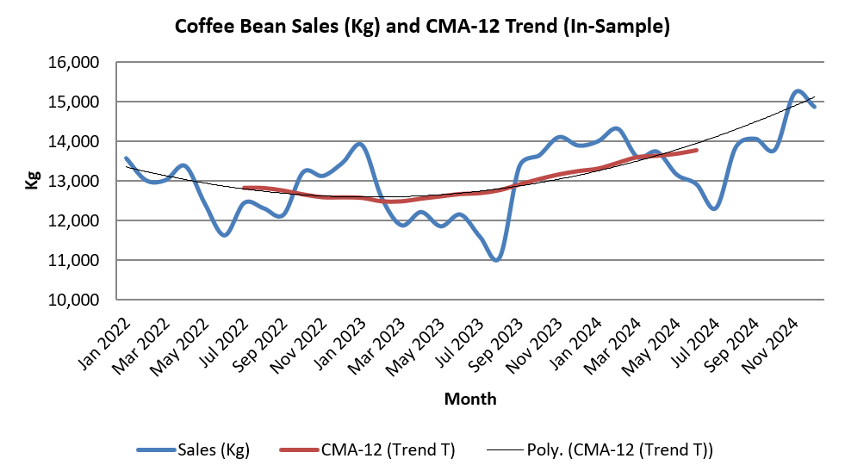
Figure 2.1 Original monthly bean demand with CMA-12 trend from Excel.
Table 2.1 Detrended seasonal matrix and adjusted monthly seasonal indices (kg).
Month | 2022 Detrended | 2023 Detrended | 2024 Detrended | Adjusted Seasonal Index
Jan | — | 1326 | 685 | 1016
Feb | — | 86 | 854 | 481
Mar | — | -600 | -7 | -293
Apr | — | -335 | 96 | -109
May | — | -753 | -533 | -632
Jun | — | -515 | -860 | -677
Jul | -379 | -1104 | — | -731
Aug | -511 | -1688 | — | -1089
Sep | -606 | 461 | — | -62
Oct | 561 | 591 | — | 586
Nov | 537 | 937 | — | 747
Dec | 869 | 638 | — | 764

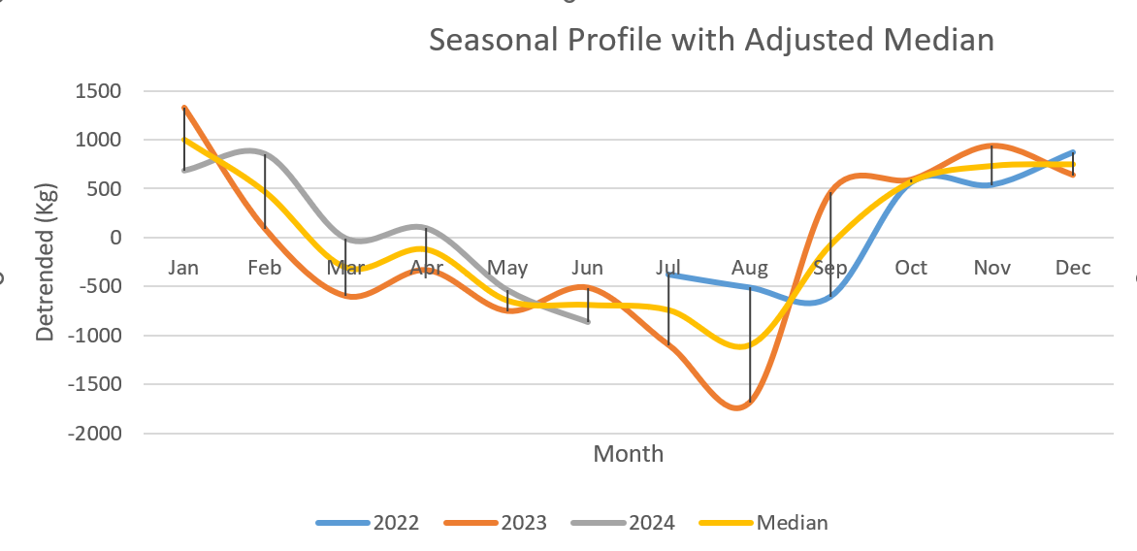

Figure 2.2 Monthly seasonal profile and adjusted median seasonal index.

Section 3: Forecasting Coffee Demand
Three models were built using January 2022-December 2024 as the in-sample period and January-December 2025 as the holdout year. This distinction is important because forecasting methods should be judged on their ability to support future operational decisions, not only on in-sample fit (Pacella and Papadia, 2021). A model that fits historical demand but performs weakly on the holdout year would be unsuitable for BrewFast’s procurement and production planning.
The seasonal naive method uses the same calendar month from the previous year and provides a transparent benchmark; more complex methods should improve on this seasonal reference (Svetunkov, Chen and Boylan, 2023). The seasonal average uses the historical mean for each month, reducing random noise but responding weakly to growth. Seasonal exponential smoothing used alpha = 0.3 and gamma = 0.35, allowing forecasts to update recursively as new information arrives while avoiding excessive reactivity (Svetunkov, Kourentzes and Ord, 2022).
Out-of-sample results identify seasonal exponential smoothing as the preferred model. Its ME is -31.57 kg, indicating almost no bias, compared with 591.58 kg for seasonal naive and 1,303.11 kg for seasonal average. It also records the lowest MAE (662.91 kg) and RMSE (884.79 kg). MAE is management-friendly because it reports average error in kilograms, while RMSE is useful because it penalises large misses that could cause stockouts or excess procurement.
The seasonal average performs worst because it anchors 2025 forecasts to lower historical demand levels and cannot adapt to the rising demand base. Seasonal naive performs better but still lags because 2025 demand is generally above 2024. Seasonal exponential smoothing is therefore the most operationally defensible choice for monthly production and bean procurement planning because it captures recurring seasonality while partially adapting to demand growth.
Table 3.1 Forecast accuracy comparison, in-sample and out-of-sample.
Method | ME (in) | MAE (in) | RMSE (in) | ME (out) | MAE (out) | RMSE (out)
Seasonal naïve | 502.63 | 952.21 | 1118.07 | 591.58 | 782.25 | 966.29
Seasonal average | 471.60 | 921.19 | 1035.96 | 1303.11 | 1303.11 | 1449.27
Seasonal exponential smoothing | 112.37 | 879.59 | 1008.77 | -31.57 | 662.91 | 884.79
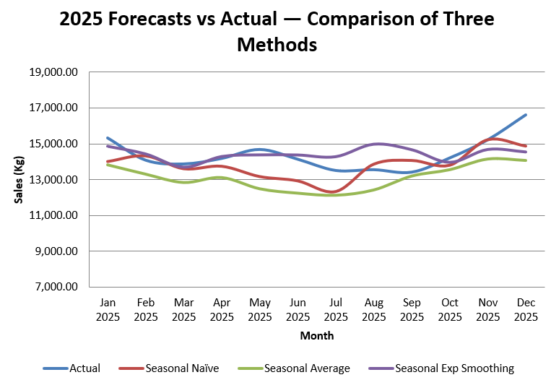
Figure 3.1 2025 actual demand versus candidate forecasts.

Section 4: Product Development: Creating 'Special' and 'Regular' Blends
The product-development problem is a constrained resource-allocation decision. Linear programming is appropriate because BrewFast must maximise profit from limited El Salvador, Panama and Brazil bean supplies while meeting recipe, demand and contractual requirements. This reflects the purpose of OR models: selecting the best feasible decision under explicit constraints (Tripathi and Kumar, 2024). It also reflects supply-chain planning work showing that procurement, product mix and downstream demand must be coordinated rather than optimised in isolation (D’Amours, Rönnqvist and Weintraub, 2008). In practical terms, the model prevents BrewFast from making a commercially attractive but operationally infeasible launch decision.
Six decision variables were defined: E_R, P_R and B_R denote kilograms of El Salvador, Panama and Brazil beans used in Regular; E_S, P_S and B_S denote the corresponding beans used in Special. Total blend production is R = E_R + P_R + B_R and S = E_S + P_S + B_S. The objective is to maximise contribution, calculated as selling price less bean cost:
Max Z = 9E_R + 6P_R + 0B_R + 18E_S + 15P_S + 9B_S.
The objective coefficients show that each bean earns a higher contribution in Special than in Regular, which explains why the model should favour Special whenever feasible. However, Brazil still appears in Regular because the recipe requires at least 30% Brazil and the minimum Regular contract must be honoured. The optimisation is therefore not a simple ‘produce the highest-margin product’ decision; it must balance contribution, recipe feasibility, demand ceilings and contractual obligations.
The supply constraints are E_R + E_S <= 28,000; P_R + P_S <= 32,000; and B_R + B_S <= 40,000. Production constraints are 35,000 <= R <= 45,000 and 35,000 <= S <= 72,000. Recipe constraints are E_R >= 0.3R, P_R <= 0.5R, B_R >= 0.3R, E_S <= 0.4S, P_S >= 0.35S and B_S <= 0.4S, with all variables non-negative. These percentage rules remain linear once rearranged, so the Simplex LP method is appropriate. Expressing the constraints algebraically also makes the trade-offs auditable in Excel rather than hidden inside Solver output. This is important for management because the optimum is only useful if the limits driving it can be explained and challenged.
Excel Solver gives an optimal plan of 35,000 kg Regular and 65,000 kg Special. Regular uses 11,750 kg El Salvador, 9,250 kg Panama and 14,000 kg Brazil. Special uses 16,250 kg El Salvador, 22,750 kg Panama and 26,000 kg Brazil. All three bean supplies are fully consumed, showing that bean availability is the binding system constraint. Regular remains at its contractual minimum because additional Regular would divert beans from the more profitable Special blend, reducing total contribution. The Special demand ceiling is not reached, so the limiting factor is supply capability rather than market potential.
Total revenue is £2,185,000 and bean procurement cost is £1,156,000, producing total profit of £1,029,000. BrewFast should therefore adopt the 35,000/65,000 plan and prioritise supplier development, because additional feasible bean supply could enable further Special production. The result converts a marketing opportunity into an operationally feasible production plan rather than a generic growth target, which is precisely the managerial value of the LP model.
Table 4.1 Solver optimal blending plan and financial outcome.
Blend | El Salvador (kg) | Panama (kg) | Brazil (kg) | Total output (kg) | Revenue | Bean cost | Profit
Regular | 11,750 | 9,250 | 14,000 | 35,000 | £560,000 | £398,750 | £161,250
Special | 16,250 | 22,750 | 26,000 | 65,000 | £1,625,000 | £757,250 | £867,750
Total / available | 28,000 | 32,000 | 40,000 | 100,000 | £2,185,000 | £1,156,000 | £1,029,000

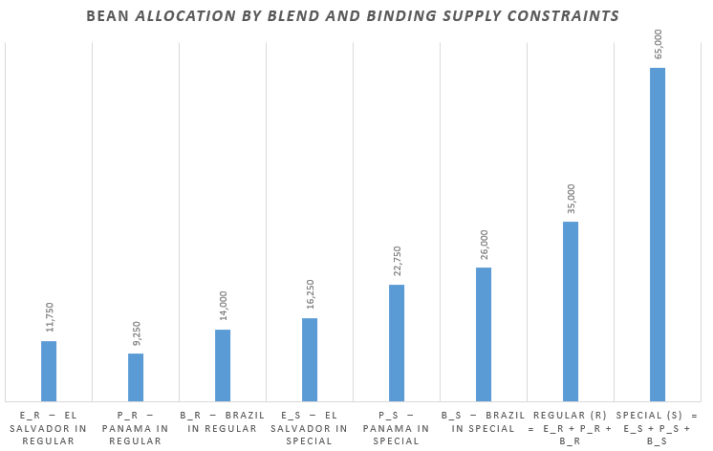
Figure 4.1 Bean allocation by blend and binding supply constraints.

Section 5: New Express Machine Installation: Inventory Simulation
The express-machine inventory system is a periodic implementation of a fixed-order-quantity reorder policy with an (s, Q)-style trigger. Inventory is reviewed monthly and, when ending stock is at or below the reorder point of s = 2, BrewFast places an order for Q = 5 machines for receipt at the start of the following month. The key parameters are an initial stock of 10 machines, a one-month lead time, a monthly holding cost of £100 per machine, an ordering cost of £1,000 per order and a backorder penalty of £600 per machine per month. The simulation evaluates whether this policy balances service responsiveness against inventory cost.
This policy is administratively simple because both the order quantity and reorder rule are fixed. However, it is vulnerable when demand is variable. Stevenson (2020) explains that inventory decisions involve a trade-off between holding, ordering and shortage costs. BrewFast’s current policy attempts to limit holding cost, but the simulation shows that low buffers can expose the business to installation delays. This is a significant service issue because express machines are revenue-enabling assets for new and expanding retail partners, not routine consumables.
The Excel model used random seed 3038 and inverse-transform logic to convert RAND() values into monthly partner requests and machine demand per partner. Each month begins with any stock carried forward plus any receipt from a previous order. Crucially, the corrected model first uses receipts to clear outstanding backorders before satisfying the current month’s new demand, reflecting the case requirement. Any demand that cannot be met becomes a new backorder and incurs the £600 monthly penalty. Holding cost is charged on ending inventory, and an order is triggered when ending stock is less than or equal to two machines.
Across the ten-month simulation, BrewFast places five orders, generating £5,000 in ordering cost. Holding cost totals £2,800, while backorder cost totals £1,800. Total inventory cost is therefore £9,600, giving an average monthly cost of £960. The main service failure occurs in Month 4, when six machines are demanded but only three are available, creating a backorder of three machines and a penalty of £1,800. Month 4 is therefore the most expensive period, with total cost of £2,800 once ordering cost is also included.
The cost profile in Figure 5.1 shows that ordering cost is the largest component of total cost, accounting for just over half of the ten-month total. This indicates that Q = 5 may be too small relative to the fixed ordering cost and demand variability. At the same time, the Month 4 backorder demonstrates that a reorder point of two machines provides insufficient protection during the one-month replenishment lead time. BrewFast should therefore test revised policies, particularly s = 4 with Q = 7 or Q = 8. A higher reorder point would create more safety stock against demand spikes, while a larger order quantity could reduce repeated ordering. The policy should be evaluated over multiple simulation replications because one seeded run is a useful scenario, not a long-run expected-cost estimate.

Table 5.1 Ten-month machine inventory simulation: demand and stock movement.
Month | Partner requests | Demand | Opening stock | Satisfied demand | Backorder ending | Ending stock | Order placed
1 | 1 | 3 | 10 | 3 | 0 | 7 | 0
2 | 0 | 0 | 7 | 0 | 0 | 7 | 0
3 | 2 | 4 | 7 | 4 | 0 | 3 | 0
4 | 2 | 6 | 3 | 3 | 3 | 0 | 5
5 | 1 | 1 | 2 | 1 | 0 | 1 | 5
6 | 2 | 4 | 6 | 4 | 0 | 2 | 5
7 | 2 | 6 | 7 | 6 | 0 | 1 | 5
8 | 1 | 3 | 6 | 3 | 0 | 3 | 0
9 | 1 | 2 | 3 | 2 | 0 | 1 | 5
10 | 1 | 3 | 6 | 3 | 0 | 3 | 0
Table 5.2 Ten-month machine inventory simulation: monthly cost components (£).
Month | Ordering cost | Holding cost | Backorder cost | Total cost
1 | £0 | £700 | £0 | £700
2 | £0 | £700 | £0 | £700
3 | £0 | £300 | £0 | £300
4 | £1,000 | £0 | £1,800 | £2,800
5 | £1,000 | £100 | £0 | £1,100
6 | £1,000 | £200 | £0 | £1,200
7 | £1,000 | £100 | £0 | £1,100
8 | £0 | £300 | £0 | £300
9 | £1,000 | £100 | £0 | £1,100
10 | £0 | £300 | £0 | £300
Total | £5,000 | £2,800 | £1,800 | £9,600
Average/month | £500 | £280 | £180 | £960

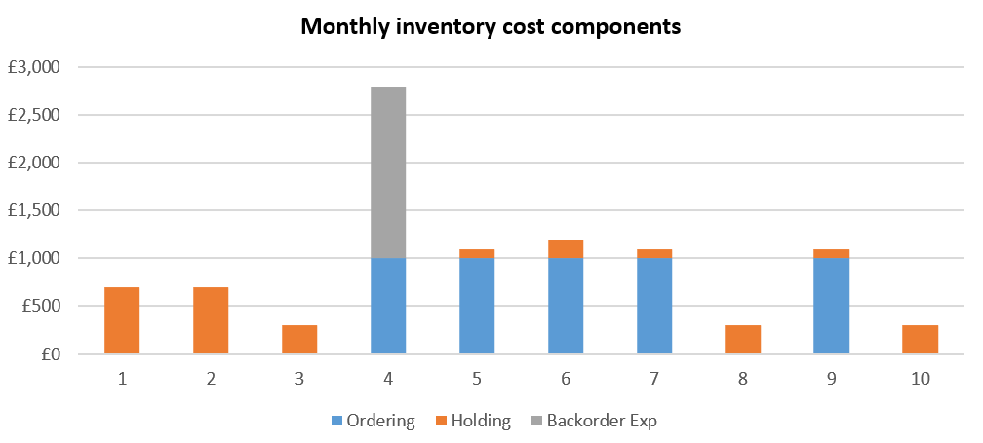
Figure 5.1 Monthly inventory cost components.

Section 6: Express Machine Servicing and Maintenance
BrewFast’s Sunday maintenance operation was modelled as a two-server stochastic service system. Requests arrive at an average of two per hour, giving a mean inter-arrival time of 30 minutes, while service times are exponentially distributed with a mean of 60 minutes. With two technicians, traffic intensity is lambda/(c mu) = 2/(2 x 1) = 1, placing the system at its capacity boundary. At this level, queues can form even when average capacity appears sufficient because random arrivals and long jobs create temporary congestion (Field et al., 2018). This makes simulation useful because it captures the time path of arrivals and service completions rather than relying only on average capacity.
The Excel simulation used seed 3038. Inter-arrival and service times were generated using the inverse-exponential formula: -mean x LN(1-U), where U is an Excel random number. This follows standard discrete-event simulation logic in which work items arrive, wait if necessary, use a resource and then leave the system. Each machine was allocated to one technician only; if both were free, Technician 1 was used as the tie-breaker. Otherwise, the machine was assigned to the technician with the earlier completion time. Start, wait, completion and idle times were then calculated from this allocation logic, allowing both customer delay and technician utilisation to be assessed.
The single-run results show substantial delay. Total wait time across the 12 machines was 457.42 minutes, with an average wait of 38.12 minutes and a maximum wait of 165.35 minutes. Technician 1 served eight machines and Technician 2 served four. Their idle times were 49.90 minutes (10.89%) and 44.12 minutes (8.15%), respectively, indicating heavy utilisation rather than excess spare capacity. The result therefore points to variability management, not simply underuse of labour, as the central issue.
The main bottleneck is caused by long service durations interacting with clustered arrivals. Machine 2 required 190.21 minutes of Technician 2 time, while Machine 12 waited 165.35 minutes because both technicians were committed to earlier jobs. This pattern is typical of exponential service systems, where long-tail jobs dominate queue performance. Irjayanti et al. (2025) argue that bottleneck reduction requires attention to workstation capacity and workload allocation; the same logic applies to technician capacity. Averages alone therefore understate the operational risk, because a small number of unusually long jobs can drive most of the customer waiting time.
BrewFast should not make permanent staffing decisions from one simulation run alone. However, the result justifies improvement: collect fault-type information before Sunday, reserve early slots for expected long-duration services, test appointment-based scheduling to spread arrivals, and consider a floating technician or overflow slot when demand regularly approaches 12 services. Multiple replications should also be run to produce confidence intervals for average and maximum wait time. This would make any staffing or scheduling change statistically defensible rather than dependent on one random sample path, while still addressing the clear evidence of delay.
Table 6.1 Summary of queuing simulation performance.
Metric | Value
Total wait time | 457.42 min
Average wait time | 38.12 min
Maximum wait time | 165.35 min
Technician 1 machines serviced | 8
Technician 1 idle time | 49.90 min (10.89%)
Technician 2 machines serviced | 4
Technician 2 idle time | 44.12 min (8.15%)
Table 6.2 Per-machine queuing simulation results (minutes).
Machine | Inter-arrival | Arrival | Tech. | Start | Service | Completion | Wait
1 | 35.73 | 35.73 | 1 | 35.73 | 17.57 | 53.30 | 0.00
2 | 3.89 | 39.62 | 2 | 39.62 | 190.21 | 229.83 | 0.00
3 | 17.43 | 57.05 | 1 | 57.05 | 52.54 | 109.59 | 0.00
4 | 6.03 | 63.08 | 1 | 109.59 | 31.60 | 141.19 | 46.52
5 | 57.29 | 120.37 | 1 | 141.19 | 4.22 | 145.41 | 20.82
6 | 22.92 | 143.29 | 1 | 145.41 | 3.63 | 149.04 | 2.13
7 | 16.17 | 159.46 | 1 | 159.46 | 170.63 | 330.09 | 0.00
8 | 64.77 | 224.23 | 2 | 229.83 | 3.59 | 233.42 | 5.60
9 | 13.69 | 237.92 | 2 | 237.92 | 181.05 | 418.97 | 0.00
10 | 5.88 | 243.80 | 1 | 330.09 | 44.45 | 374.55 | 86.29
11 | 0.03 | 243.83 | 1 | 374.55 | 83.62 | 458.16 | 130.71
12 | 9.79 | 253.62 | 2 | 418.97 | 122.07 | 541.04 | 165.35

Section 7: Conclusion and Recommendations
BrewFast’s operational challenge is not isolated to one function; forecasting, blending, inventory and servicing decisions are linked through capacity, service and cost trade-offs. Demand decomposition identified a rising trend and a stable additive seasonal profile, with January materially above trend and August materially below it. Seasonal exponential smoothing is recommended because it produced the lowest out-of-sample MAE and RMSE and near-zero bias, making it the strongest model for bean planning.
For product development, BrewFast should implement the Solver plan of 35,000 kg Regular and 65,000 kg Special, generating £1,029,000 profit. Because all bean supplies are binding, supplier capacity expansion should be prioritised before pursuing additional Special demand. This links the commercial opportunity directly to procurement capability.
For machine inventory management, the current s = 2, Q = 5 policy should be recalibrated. The corrected simulation produced £9,600 total cost and £960 average monthly cost, with the principal backorder exposure occurring in Month 4. BrewFast should test higher safety stock through s = 4 and larger replenishment quantities of Q = 7-8 before implementation.
For machine servicing, the M/M/2 simulation shows an average wait of 38.12 minutes and a maximum wait of 165.35 minutes. BrewFast should use pre-booking, workload-aware scheduling and multiple simulation replications to reduce queue risk before adding permanent capacity. This preserves managerial caution while still addressing the clear evidence of delay.

References
D’Amours, S., Rönnqvist, M. and Weintraub, A. (2008) ‘Using operational research for Supply Chain Planning in the Forest Products Industry’, INFOR: Information Systems and Operational Research, 46(4), pp. 265–281. doi:10.3138/infor.46.4.265.
Field, J.M., Victorino, L., Buell, R.W., Dixon, M.J., Meyer Goldstein, S., Menor, L.J., Pullman, M.E., Roth, A.V., Secchi, E. and Zhang, J.J. (2018) ‘Service operations: what’s next?’, Journal of Service Management, 29(1), pp. 55–97. doi:10.1108/JOSM-08-2017-0191.
Irjayanti, M., Azis, A.M., Susilawati and Sobari, A.R. (2025) ‘Transformative innovations igniting coffee supply chain process efficiency’, Journal of Innovation and Entrepreneurship, 14(44), pp. 1–15. doi:10.1186/s13731-025-00486-9.
Mbuli, N., Mathonsi, M., Seitshiro, M. and Pretorius, J.-H. (2020). Decomposition forecasting methods: A review of applications in power systems. Energy Reports. 6, 298- 306. doi: 10.1016/j.egyr.2020.11.238.
Pacella, M. and Papadia, G. (2021) ‘Evaluation of deep learning with long short-term memory networks for time series forecasting in Supply Chain Management’, Procedia CIRP, 99, pp. 604–609. doi:10.1016/j.procir.2021.03.081.
Power, D. (2005) ‘Supply chain management integration and implementation: a literature review’, Supply Chain Management: An International Journal, 10(4), pp. 252–263. doi:10.1108/13598540510612721.
Stevenson, W.J. (2020) Operations Management. 14th edn. New York: McGraw-Hill Education.
Svetunkov, I., Chen, H. and Boylan, J.E. (2023) ‘A new taxonomy for vector exponential smoothing and its application to seasonal time series’, European Journal of Operational Research, 304(3), pp. 964–980. doi: 10.1016/j.ejor.2022.04.040.
Svetunkov, I., Kourentzes, N. and Ord, J.K. (2022). Complex exponential smoothing. Naval Research Logistics, 69(8), 1108–1123. doi:10.1002/nav.22074
Tripathi, S.K. and Kumar, R. (2024) ‘Recent Trends and Applications of Linear Programming in Network Flow: A Comprehensive Survey’, Optimality, 1(1), pp. 140–146. doi:10.22105/opt.v1i1.51.

