Executive Summary
This report examines online employee reviewing behaviour using 67,529 Glassdoor reviews. Combining lexicon-based sentiment analysis, a TF-IDF ridge classifier (test AUC 0.777), Latent Dirichlet Allocation (LDA) and a Structural Topic Model (STM), the study links linguistic patterns to numerical satisfaction ratings. Findings reveal that culture and senior management dominate overcompensation as drivers of overall ratings, that negative reviews are systematically longer and concentrate around management dysfunction, and that topic content shifts qualitatively across the rating scale. Implications for employer-branding clients include prioritising cultural diagnostics over pay benchmarking and treating low-rated reviews as targeted operational signals rather than noise.

1. Introduction and Research Question
Glassdoor and comparable third-party employee-review platforms now receive between 60 and 250 million monthly visits, and an estimated 70% of job applicants consult employee reviews before applying for a role (Morgan and Chapman, 2024). For corporate clients pursuing employer-branding strategies, this voluntary, public and largely uncontrolled stream of feedback constitutes both a reputational risk and a behavioural data asset. Conventional satisfaction surveys are constrained by social desirability bias, sample limitations, and limited candour, particularly when administered within an organisation's formal communication channels (Das Swain et al., 2020). Voluntary online reviews, by contrast, surface candid evaluations of organisational culture, leadership quality and reward systems that traditional instruments cannot easily reach. Crucially, this information is not merely reputational: Chemmanur, Rajaiya and Sheng (2019), using a sample of 1.1 million Glassdoor reviews across 2,842 public firms, demonstrate that variations in employee ratings causally affect equity-issue announcement returns, debt-versus-equity financing choices and subsequent investment levels, establishing the financial-market materiality of online employee voice.
Despite this growing literature, two analytical questions remain underexplored in ways that matter directly for client decisions. First, which dimensions of employee experience most strongly drive overall satisfaction ratings, and is the conventional managerial assumption that compensation dominates supported by linguistic evidence? Second, do reviews at different rating levels differ qualitatively in content — that is, do low-rated reviews discuss substantively different themes than high-rated ones, beyond mere sentiment intensity? Answering these questions has direct managerial value: if culture rather than pay drives satisfaction, employer-branding investment should be reallocated accordingly; if low-rated reviews concentrate around specific themes, they constitute targeted operational intelligence rather than diffuse reputational complaint.
This report, therefore, addresses the following research question: What linguistic, thematic and rating-related patterns characterise online reviewing behaviour on Glassdoor, and which dimensions of employee experience most strongly drive overall satisfaction ratings?
The investigation is operationalised through four complementary analytical methods — lexicon-based sentiment analysis, TF-IDF ridge logistic classification, Latent Dirichlet Allocation (LDA) topic modelling, and Structural Topic Modelling (STM) — selected to triangulate between linguistic, thematic and numerical signals. Each method addresses a different facet of the research question and surfaces different methodological limitations, supporting the critical evaluation that analysis demands. The remainder of the report describes the data preparation and methodological choices (Section 2), reports converging results across the four analyses (Section 3), discusses behavioural interpretation, managerial implications and limitations (Section 4), and concludes with directions for further work (Section 5).

2. Data Preparation and Methodology

2.1 Dataset and Sampling
The dataset comprises 67,529 Glassdoor employee reviews containing free-text 'pros' and 'cons' fields alongside six numerical ratings: an overall score and five sub-dimensions (work–life balance, culture and values, career opportunities, compensation and benefits, and senior management), each on a five-point scale. All 67,529 records were retained for analysis; applying topic modelling to this complete corpus allows for the systematic analysis of a dataset that is far too large for manual reading and coding (Murakami et al., 2017). Table 1 reports descriptive statistics. The overall rating distribution is negatively skewed (mean 3.83, SD 1.15, median 4), with five-star reviews appearing approximately six times more frequently than one-star reviews, indicating a pronounced positivity bias and self-selection pattern within this specific sample.
Table 1. Descriptive statistics of review rating dimensions.
Variable | n | Mean | SD | Min | Q1 | Median | Q3 | Max
overall | 67,529 | 3.83 | 1.16 | 1 | 3 | 4 | 5 | 5
work_balance | 60,369 | 3.37 | 1.30 | 1 | 2 | 3.5 | 4 | 5
culture_values | 53,983 | 3.78 | 1.30 | 1 | 3 | 4 | 5 | 5
career_opps | 60,421 | 3.63 | 1.23 | 1 | 3 | 4 | 5 | 5
comp_benefit | 60,368 | 3.94 | 1.04 | 1 | 3 | 4 | 5 | 5
senior_management | 59,754 | 3.32 | 1.31 | 1 | 2 | 3 | 4 | 5

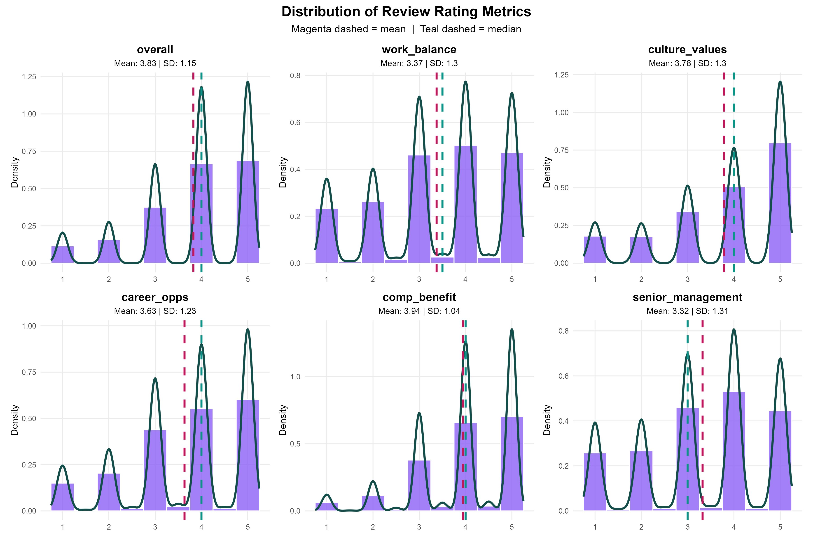
Figure 1. Distribution of review rating metrics across the six numerical dimensions.

2.2 Text Preprocessing
Text preprocessing followed standard textual analytics conventions documented in Pejić Bach et al. (2019). The pros and cons fields were concatenated, lower-cased, stripped of punctuation, numerals and URLs, and tokenised. Lemmatisation was applied to collapse inflected forms (e.g., managing, managed → manage), reducing vocabulary sparsity. Stopwords were removed using the standard English list, and domain-specific filtering eliminated review-platform artefacts (e.g., pros, cons, review) that would otherwise dominate topic models. To further limit noise and computational burden, tokens with fewer than three characters or appearing in fewer than ten documents were filtered—a common preprocessing step for large corpora (Murakami et al., 2017). The resulting clean vocabulary is summarised in the token-frequency profile, with benefit, management, manager, team and pay as the most frequent terms—a distribution that clearly foreshadows the report's central findings by highlighting a dual focus on both structural compensation and interpersonal management dynamics.

2.3 Feature Engineering and Analytical Methods
Four complementary representations and analyses were constructed; each was deliberately chosen to address a different aspect of the research question and to expose different methodological assumptions.
Sentiment scoring used both the Bing binary lexicon and the AFINN valence-rated lexicon Wankhade et al., (2022), normalised per 100 words to control for review-length confounding. The dual-lexicon strategy guards against single-dictionary bias and allows cross-validation of the sentiment–rating relationship. Lexicon-based sentiment was chosen over supervised sentiment classifiers because no gold-standard sentiment labels exist for the corpus; the rating itself can serve as a proxy but should not double as both label and validation, which is a circularity Wankhade et al. (2022) explicitly warn against.
TF-IDF ridge logistic classification transformed the corpus into a term–frequency–inverse-document-frequency matrix (Zhang, Yoshida and Tang, 2011), with the IDF weighting suppressing high-frequency function words while elevating discriminating terms. A binary positive/negative label was constructed (≥4 stars vs ≤2 stars; 3-star reviews omitted as ambiguous) and modelled with ridge-penalised logistic regression to control for the high dimensionality of the TF-IDF space. An 80/20 stratified train–test split preserved class proportions, and all performance metrics were calculated on the held-out 20% to avoid optimistic bias — a procedural safeguard Janssens and Martens (2020) identify as essential for credible AUC reporting.
LDA topic modelling with K = 10 topics was fitted to the document–term matrix. K was selected via perplexity diagnostics across K ∈ {5, 8, 10, 12}; because perplexity rose monotonically with K — a known LDA pathology when topics are not clearly separable on short documents (Zhao et al., 2021) — selection was complemented by interpretability assessment, following the corpus-linguistic guidance in Murakami et al. (2017) that K should balance statistical fit against analyst interpretability rather than minimise perplexity alone.
Structural Topic Modelling (STM) with K = 10 was fitted, using the overall rating as a prevalence covariate. This permits direct estimation of how topic prevalence varies with rating — the central object of the second research question. STM was retained alongside LDA precisely because LDA's blurred topic boundaries (reported in Section 3.3) motivated a more discriminating model. Reporting both methods allows the reader to assess the value added by covariate-informed priors and is a deliberate critical choice rather than analytical redundancy.
Finally, Spearman's rank correlation (chosen over Pearson because rating data are ordinal) and OLS regression of overall rating on the five sub-dimensions quantified which experience domains most strongly predicted satisfaction. Variance inflation factors were examined to assess the absence of harmful multicollinearity, and the findings were interpreted as conditional associations rather than causal effects, given the cross-sectional observational design.

3. Results and Interpretation

3.1 Sentiment is Strongly but Imperfectly Aligned with Ratings
Table 2 and Figure 2 confirm a monotonic relationship between sentiment and rating. Bing-derived net sentiment per 100 words rises from −1.18 at one star to +4.37 at five stars, and AFINN-derived means follow the same gradient, increasing from −2.04 to +10.74 across the rating scale. The convergence between the two independent lexicons strengthens confidence that the pattern reflects a genuine linguistic signal rather than a single-dictionary artefact. However, the within-rating standard deviations (9.75 to 12.83 in the AFINN distribution) substantially exceed the between-rating differences in means, indicating that individual sentiment scores cannot reliably classify rating level — a high-rated review can plausibly carry mildly negative net sentiment if it concludes with criticisms of compensation, and vice versa. Importantly, low-rated reviews are systematically longer in cons words (Spearman ρ = −0.28 between cons-word count and overall rating), consistent with the negativity asymmetry documented in consumer-review literature: dissatisfied reviewers expend more lexical effort to articulate grievances, while satisfied reviewers favour shorter, more conventional affirmations. Length-normalisation is therefore not a methodological nicety but a substantive correction without which sentiment estimates would be confounded with verbosity, biasing low-rated reviews toward apparently more extreme negativity simply because they contain more text.

Table 2. Bing sentiment decomposition by overall rating.
Rating | N reviews | Mean pos/100w | Mean neg/100w | Net sent/100w | Total negative
1 | 3,906 | 3.36 | 4.54 | −1.18 | 19,766
2 | 5,282 | 4.22 | 3.85 | +0.37 | 20,789
3 | 12,653 | 5.15 | 3.24 | +1.91 | 28,169
4 | 22,498 | 5.77 | 2.54 | +3.23 | 33,373
5 | 23,190 | 6.41 | 2.03 | +4.37 | 24,049

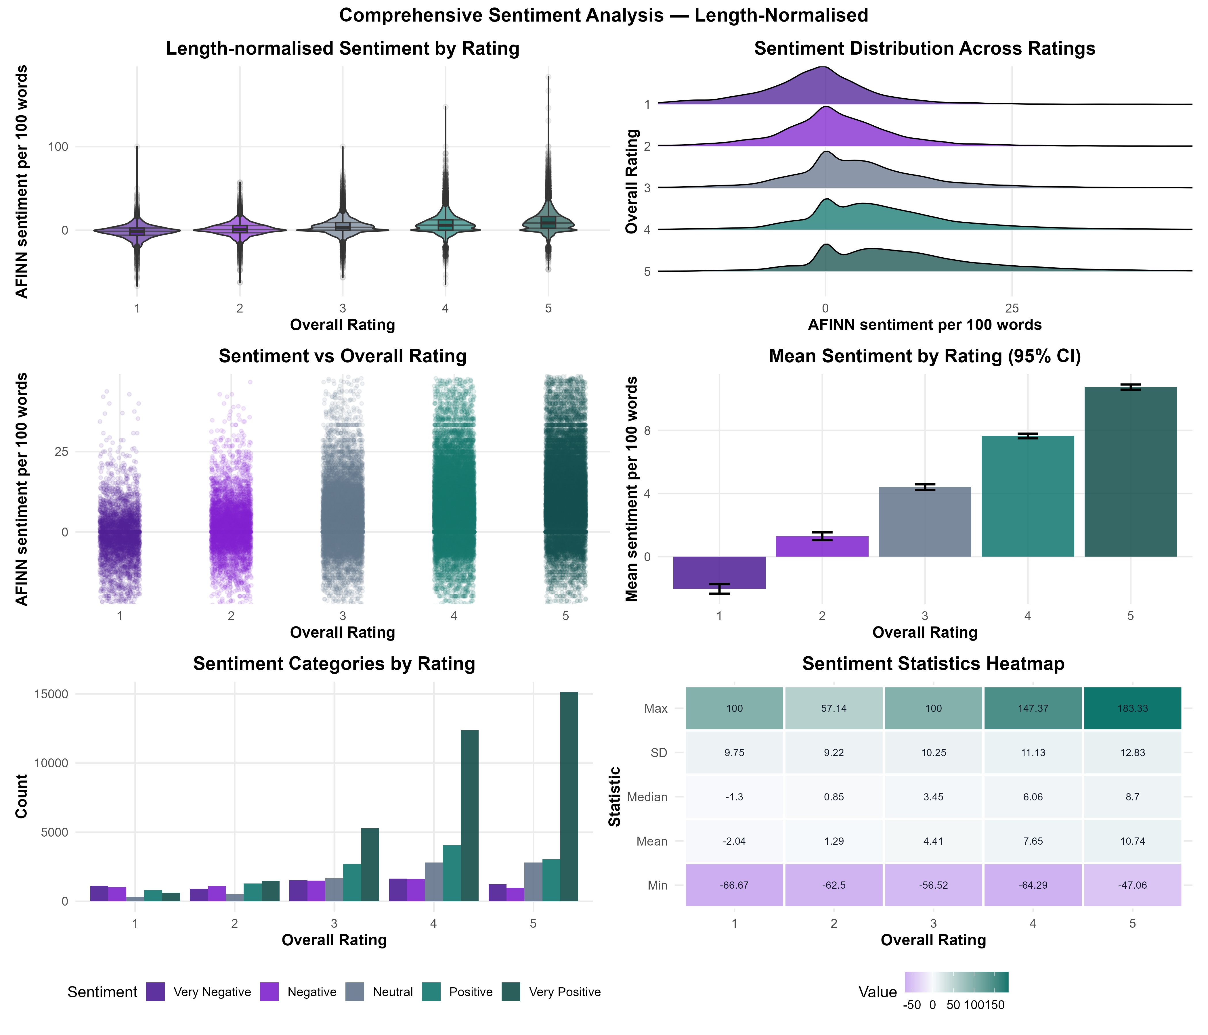
Figure 2. Length-normalised AFINN sentiment by rating, with distribution shapes, mean confidence intervals, and summary statistics heatmap.

3.2 The Classifier Reveals Class-Imbalanced but Substantively Meaningful Signals
The TF-IDF ridge classifier achieved a held-out test AUC of 0.777 (Figure 3, Table 3) — moderate discrimination by the conventional Hosmer–Lemeshow benchmark and broadly comparable to text classifiers reported in Wankhade et al. (2022). Critically, however, sensitivity (0.93) far exceeds specificity (0.32), indicating that the model recognises positive reviews well but misclassifies many negative ones as positive. This is the predictable signature of class imbalance combined with the linguistic diversity of dissatisfaction: positive reviews use a relatively narrow vocabulary (excellent, awesome, supportive), whereas negative reviews are lexically heterogeneous, ranging from procedural complaints to interpersonal grievances. Janssens and Martens (2020) caution that AUC alone obscures such imbalances and that calibration-aware metrics are required for managerial decisions — a critique directly applicable here.

The ridge coefficients in Figure 4 are nonetheless substantively interpretable. The strongest negative predictors — poor, turnover, horrible, terrible, fire, management, favoritism, leave, lack, treat, hire — map onto a coherent latent construct of management dysfunction and attrition. The strongest positive predictors — amaze, supportive, excellent, awesome, challenge, love — capture affirmative cultural and developmental experience. The asymmetry of these vocabularies explains the specificity gap and itself constitutes a finding: dissatisfaction is linguistically broader than satisfaction.
Table 3. Held-out classifier performance.
Metric | Value
Test AUC | 0.777
Accuracy | 0.729
Sensitivity | 0.930
Specificity | 0.322
Balanced accuracy | 0.626

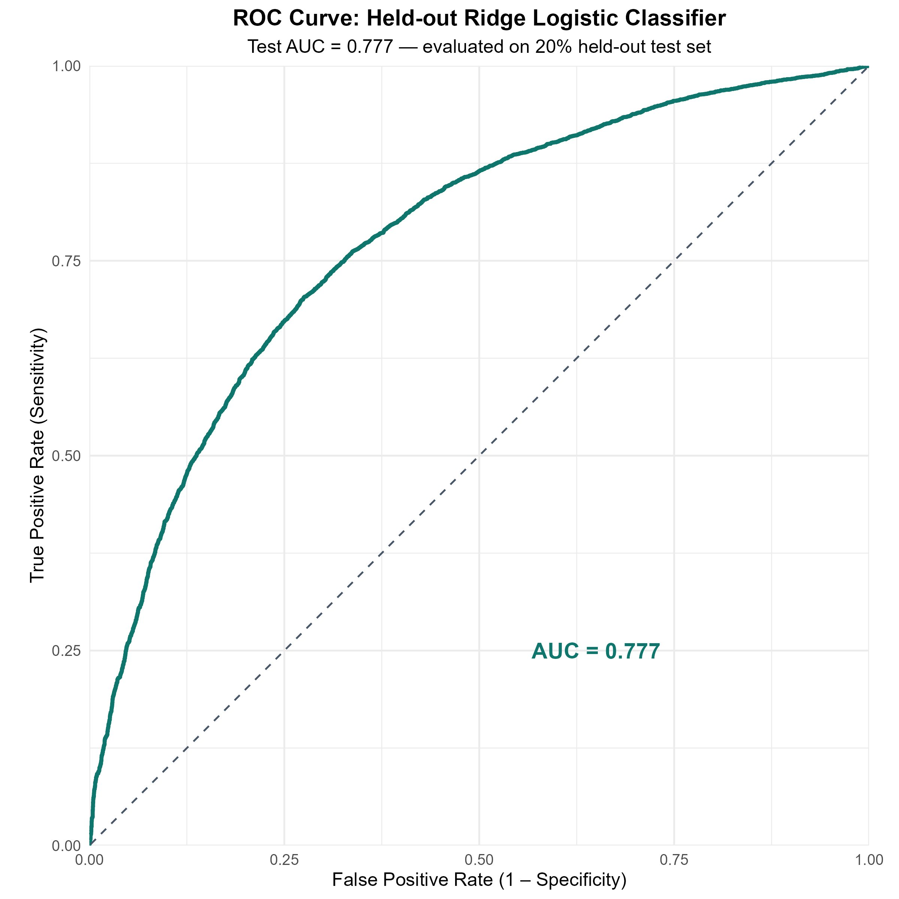
Figure 3. ROC curve for held-out ridge logistic classifier (test AUC = 0.777).
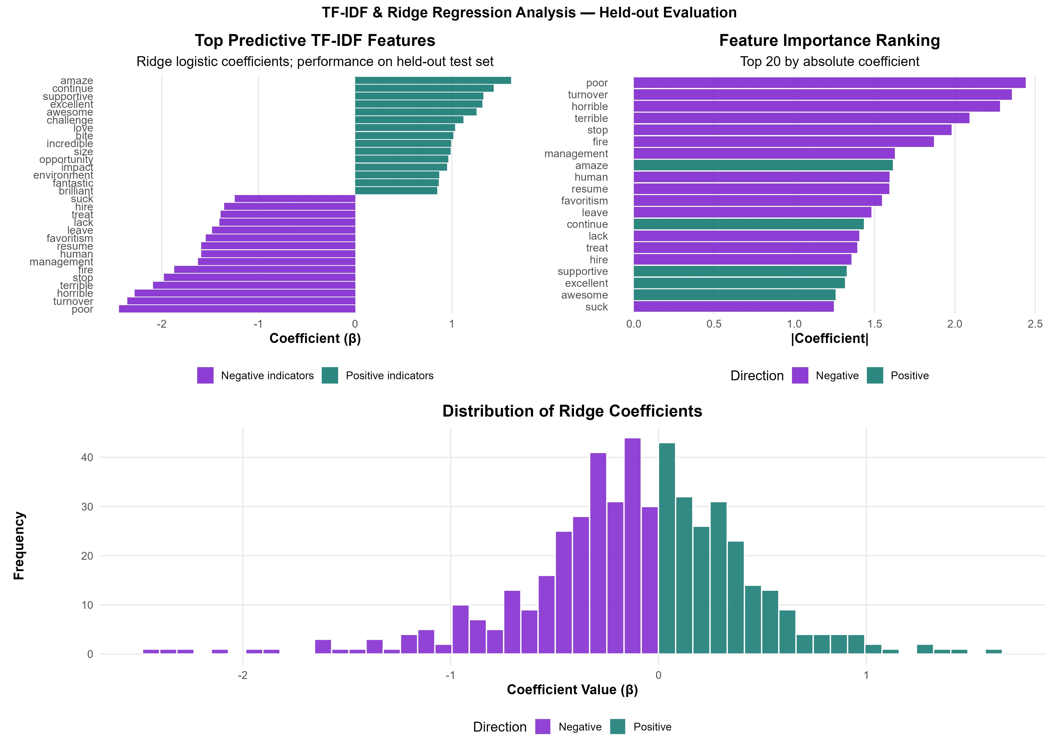
Figure 4. Top predictive TF-IDF features and ridge coefficient distribution.

3.3 LDA Topics Are Blurred; STM Resolves Them
LDA with K = 10 produced topics with high pairwise cosine similarity (0.51 to 0.80), visible in the similarity matrix shown in Figure 5. Top-term lists across topics share manager, management, benefit and team repeatedly, indicating that LDA recovered topic fragments rather than discriminating themes—a known limitation of vanilla LDA on short, semantically overlapping documents (Zhao et al., 2021). This is an honest weakness of the chosen K = 10 specification and motivates the additional STM analysis rather than reporting LDA in isolation.
Conditioning on the overall rating, STM produced more interpretable, discriminating topics (Figure 6). The most prevalent topic, Topic 2, combines FREX terms great, fantastic, supportive, atmosphere, opportunities, career—an unambiguous positive culture topic. Topic 5 (store, overtime, warehouse, stores, season, breaks, holidays) captures retail operational strain. Topic 6 (managers, management, politics, stack, ranking, middle, dev, evaluation) captures management dysfunction. Topic 4 (told, fired, white, answer, telling, mistake, email, lie) captures toxic incidents. Topic 7 (size, satya, businesses, impact, enterprise, mission, strategy) captures corporate strategy, and Topic 8 (free, gym, snacks, food, valley, bay) captures perks and signalling. These topics align meaningfully with the dimensions identified in Das Swain et al.'s (2020) Glassdoor-based organisational-culture construct.
Figure 7—STM topic prevalence by rating—provides the report's most managerially actionable result. As ratings move from one to five stars, Topic 2 (positive culture) rises from approximately zero to over 18% of topic mass, while Topic 5 (retail strain), Topic 6 (management dysfunction) and Topic 4 (toxic incidents) decline sharply. This demonstrates that rating differences encode substantive content shifts, not merely sentiment intensity: a one-star review is not simply a ‘negatively toned’ five-star review but a qualitatively different conversation about different aspects of work.
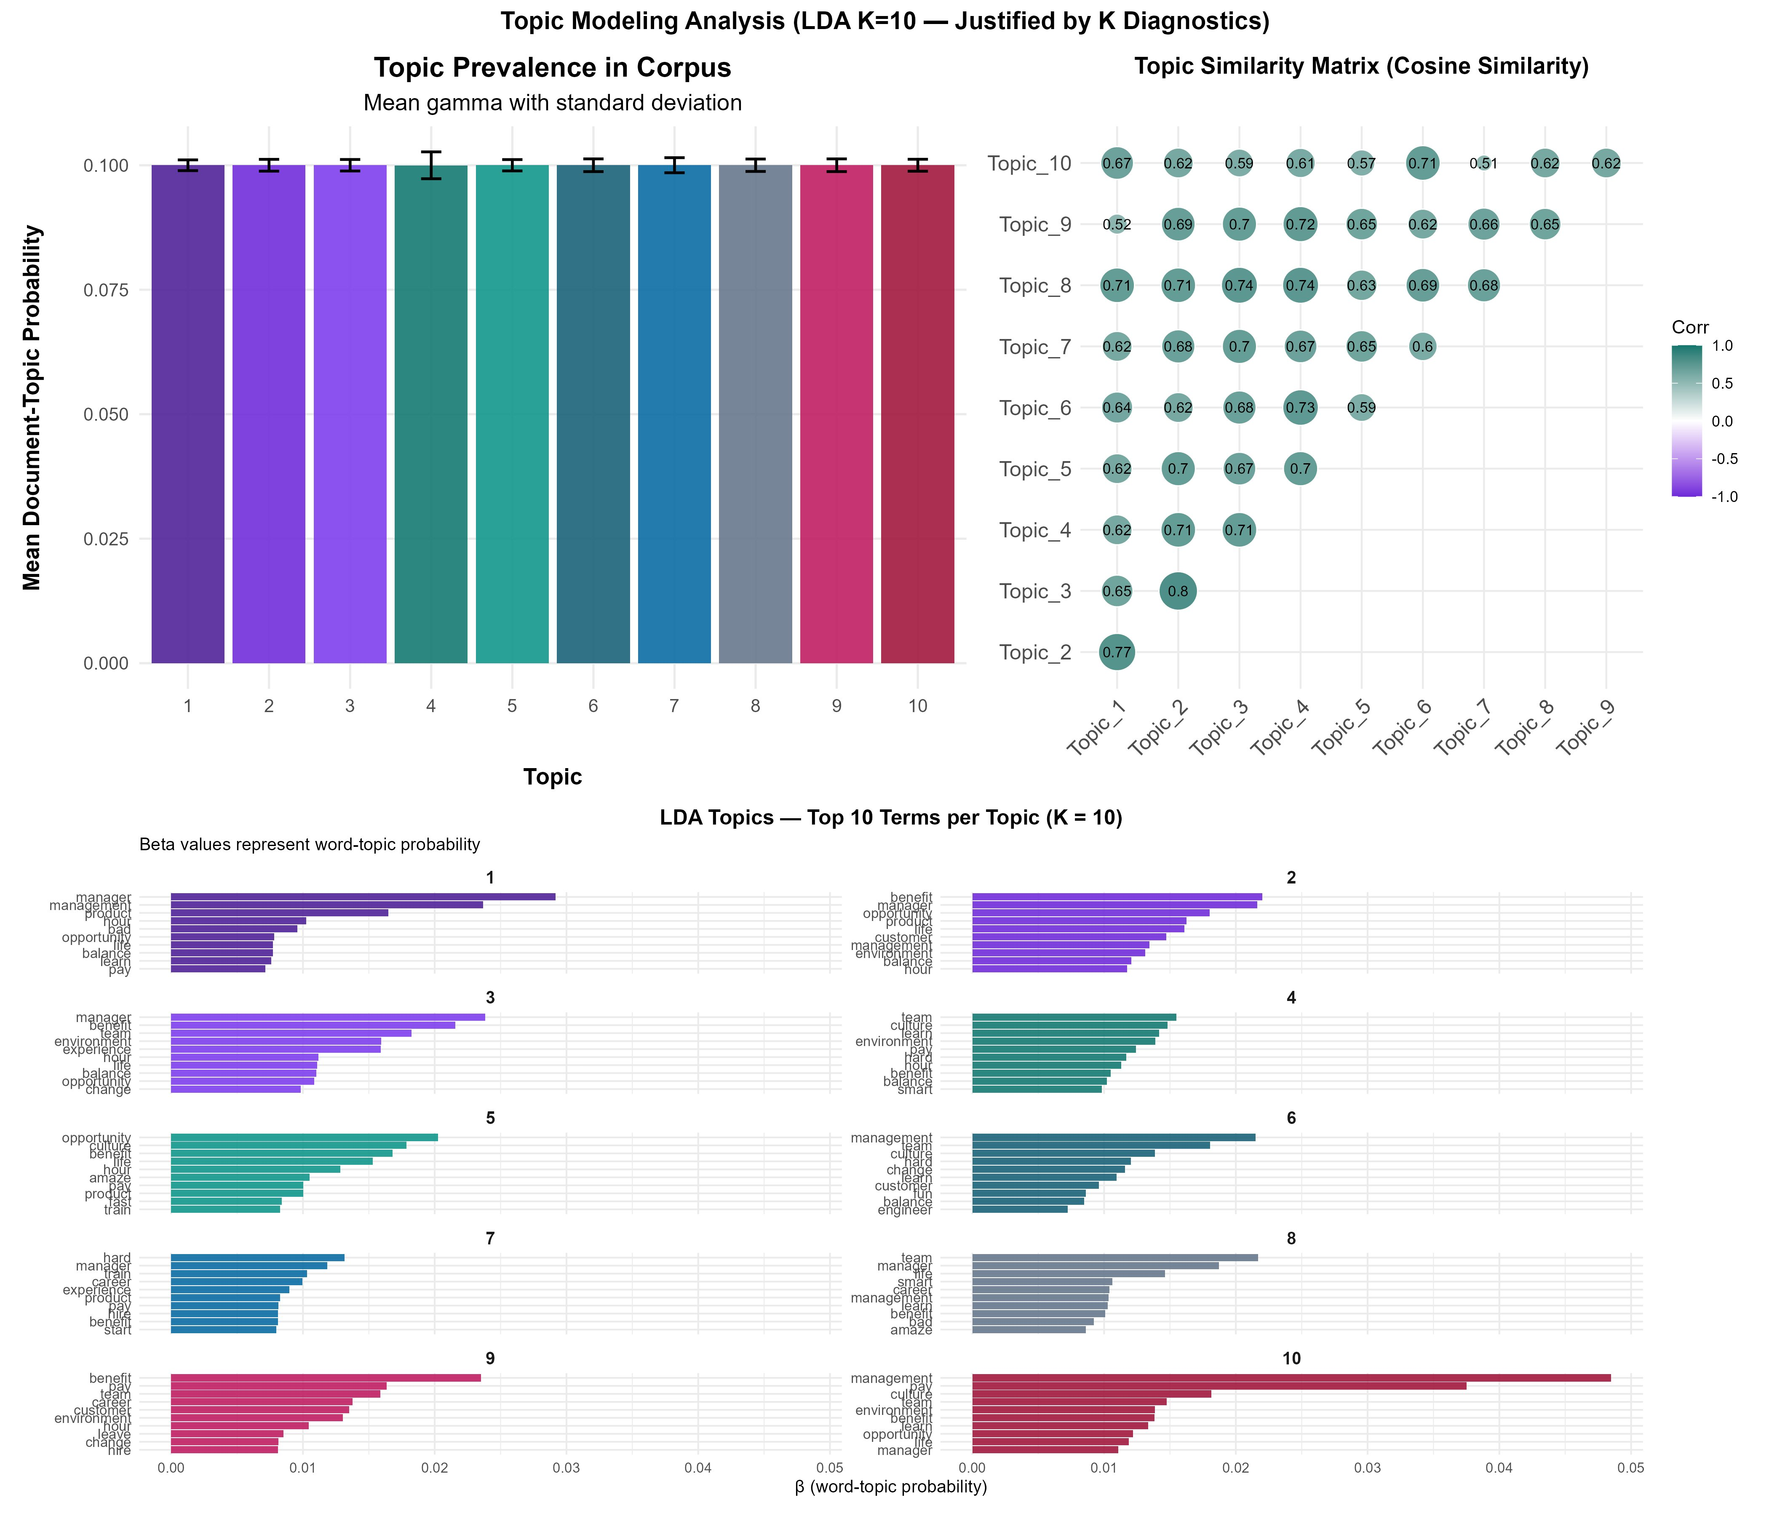
Figure 5. LDA topic modelling — topic prevalence, similarity matrix, and top terms per topic.
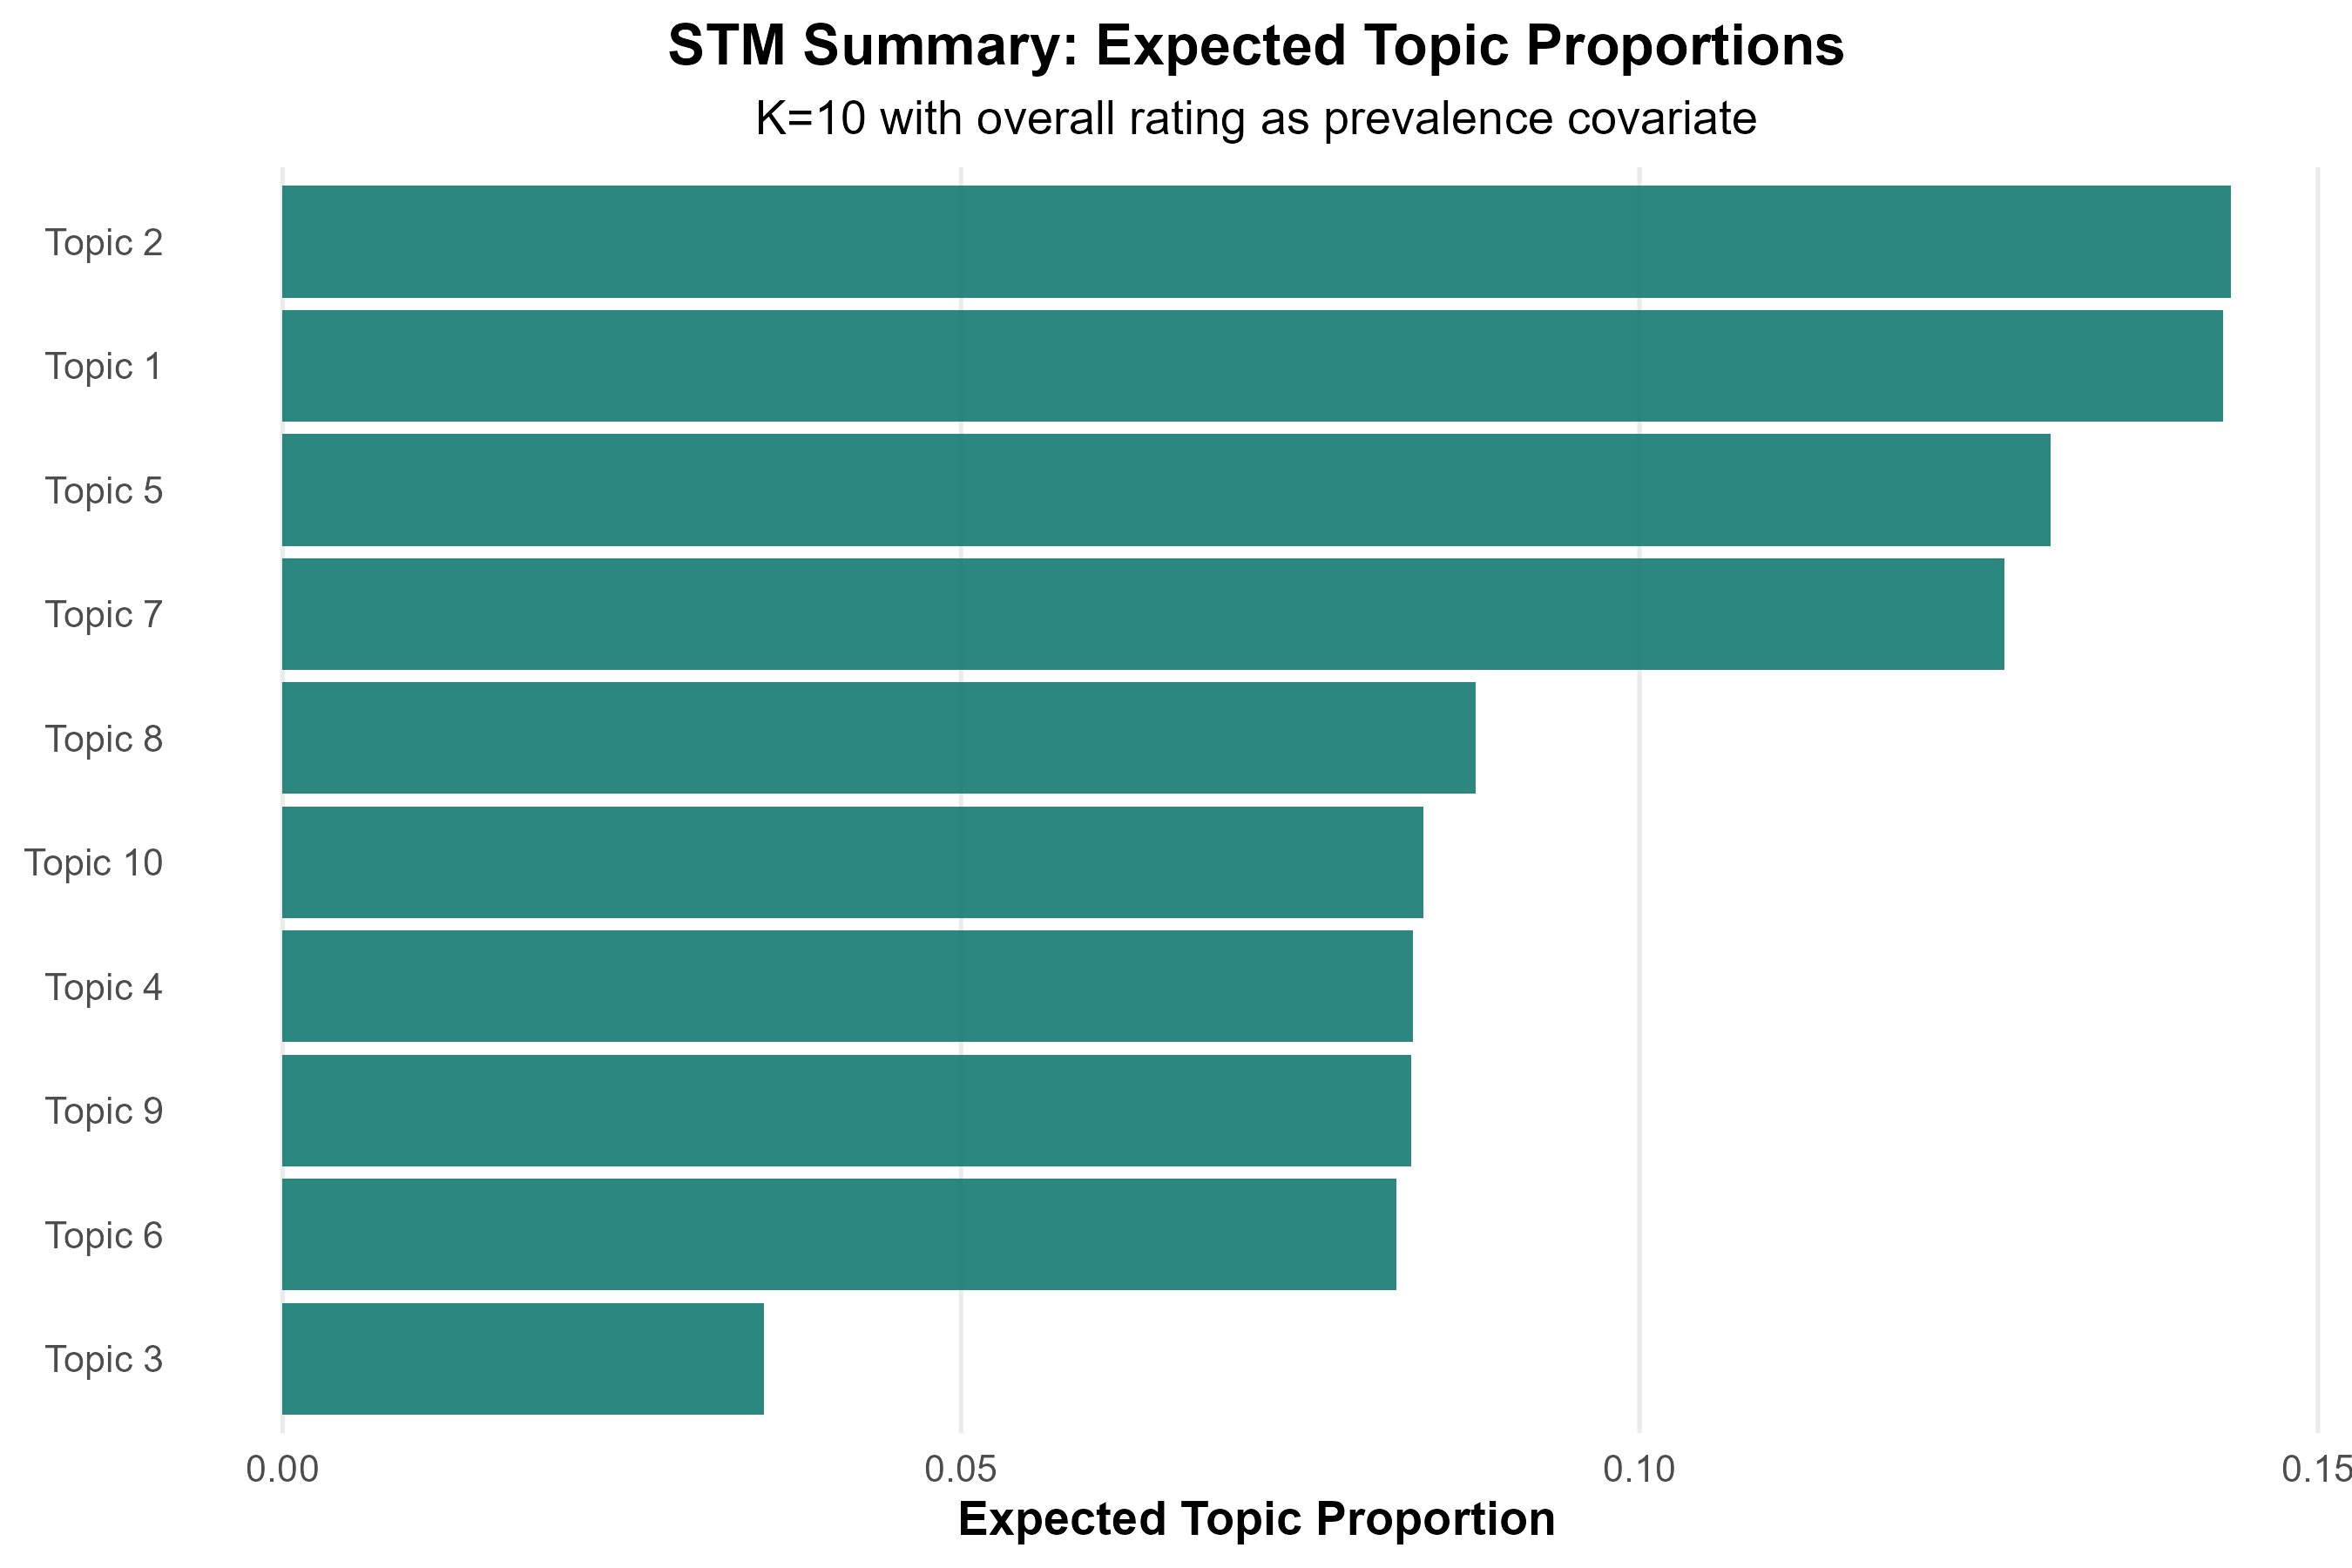
Figure 6. STM expected topic proportions (K = 10) with overall rating as prevalence covariate.
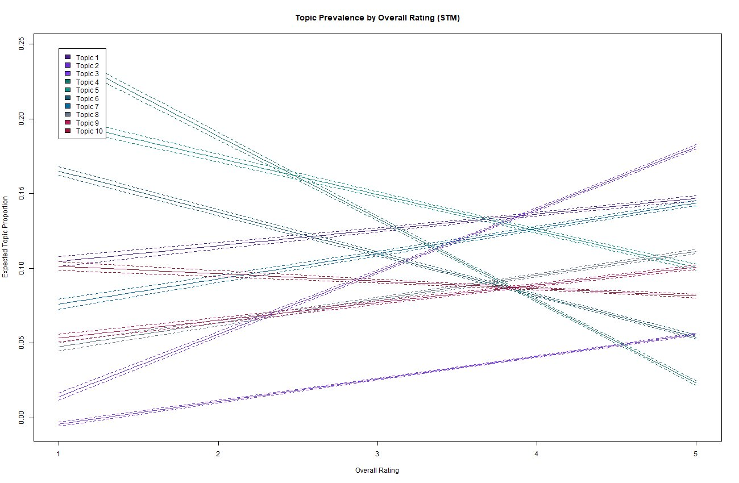
Figure 7. STM topic prevalence by overall rating — topics shift in content, not only in tone.

3.4 Culture, Not Compensation, Drives Satisfaction
Spearman correlations (Figure 8) rank the five sub-dimensions against overall rating: culture and values (ρ = 0.72), senior management (0.71), career opportunities (0.66), work–life balance (0.59), and compensation and benefits (0.52). The OLS regression in Table 4 (Figure 9) confirms this ordering as a set of conditional partial associations: culture and values have the largest coefficient (β = 0.32), career opportunities follow (β = 0.23), then senior management (β = 0.17), work–life balance (β = 0.13), and compensation last (β = 0.11). All coefficients are statistically significant at p < 0.001, and all variance inflation factors lie below 2.6, well within the conventional threshold of five, indicating no problematic collinearity. Compensation, despite being the most commonly cited employer-branding lever, is the weakest predictor of overall satisfaction in this corpus. This finding directly contradicts a common managerial intuition and is the report's central evidentiary contribution. It is also coherent with Das Swain et al.'s (2020) word-embedding analysis of Glassdoor data, which showed that organisational-culture constructs explain employee outcomes over and above intrinsic traits. The convergence of the OLS finding with the STM topic-prevalence results (Section 3.3) — where culture-laden topics dominate at high ratings and management-dysfunction topics dominate at low ratings — provides triangulated evidence that this is not a regression artefact but a genuine signal in the textual content itself.

Table 4. OLS regression of overall rating on five sub-dimensions (n = 53,820 complete cases; all p < 0.001; all VIF < 2.6).
Predictor | β | SE | p
culture_values | 0.316 | 0.003 | < 0.001
career_opps | 0.228 | 0.003 | < 0.001
senior_management | 0.166 | 0.003 | < 0.001
work_balance | 0.130 | 0.003 | < 0.001
comp_benefit | 0.111 | 0.003 | < 0.001
(Intercept) | 0.386 | 0.011 | < 0.001

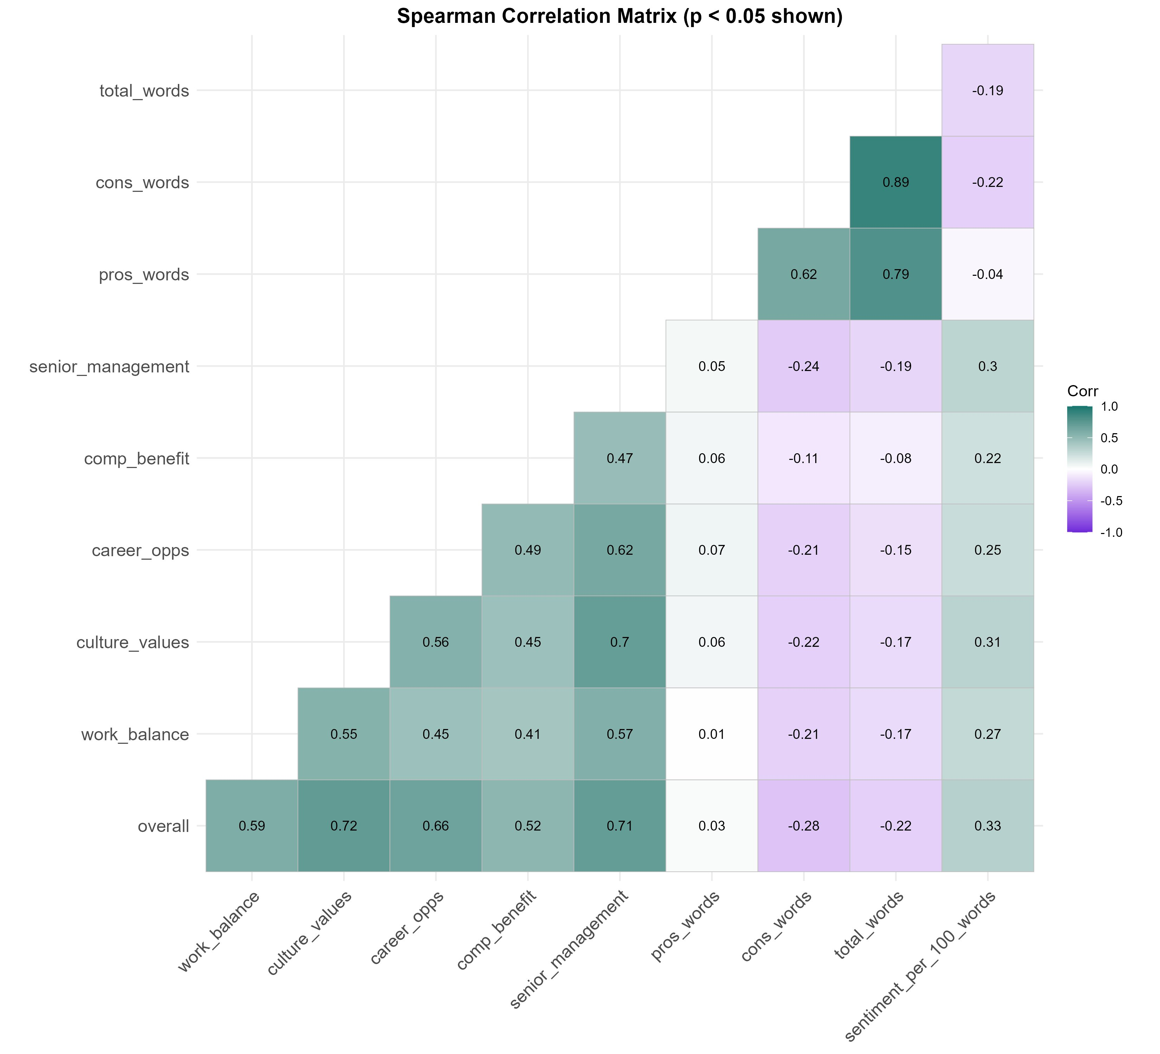
Figure 8. Spearman correlation matrix of rating dimensions, sentiment and review-length features.
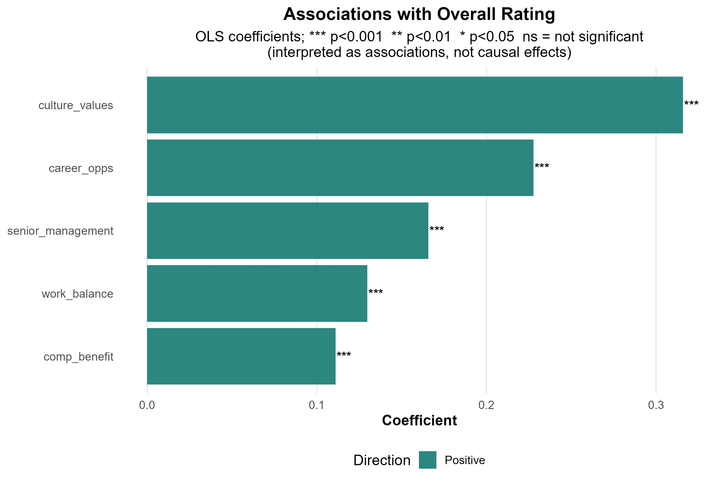
Figure 9. OLS coefficient estimates for the satisfaction regression (all p < 0.001).

4. Discussion and Managerial Implications

4.1 Behavioural Interpretation of the Findings
The convergence of three independent analytical signals — OLS regression coefficients, STM topic-prevalence shifts, and ridge-classifier coefficients — produces a triangulated picture of online reviewing behaviour. Reviewers respond more strongly to relational and cultural features of the organisation than to transactional features such as pay. This is consistent with established organisational-behaviour theory (Das Swain et al., 2020) but acquires particular force here because it emerges from voluntarily disclosed text rather than from survey instruments subject to social-desirability bias. The asymmetry between positive and negative review vocabularies — narrow and ritualised on the positive side (excellent, awesome, supportive), broad and idiosyncratic on the negative side (poor, turnover, favoritism, fire, lack, treat) — further suggests that satisfaction is articulated in conventional language, whereas dissatisfaction prompts more elaborate, individuated expression. Morgan and Chapman (2024) link this asymmetry directly to higher helpfulness ratings awarded to negative reviews on Glassdoor, indicating that prospective applicants attend more closely to negative content. The behavioural reading is therefore that negative reviewing is both informationally richer and influentially more weighted than positive reviewing, with direct consequences for how clients should interpret their review portfolios.

4.2 Implications for Employer-Branding Clients
Three managerial implications follow directly from the evidence. First, diagnostic priority should shift from compensation benchmarking toward cultural and managerial diagnostics. The OLS coefficient on compensation (β = 0.11) is less than one-third the coefficient on culture (β = 0.32); reallocating employer-branding investment accordingly is supported by the data. In practice, this means routine cultural pulse audits, leadership-quality reviews and explicit cultural-value articulation should take precedence over salary-positioning exercises in the diagnostic toolkit. Second, low-rated reviews should be treated as targeted operational signals, not noise. Because Topics 4 and 6 (toxic incidents and management dysfunction) concentrate disproportionately at low ratings, organisations can route low-rated reviews through topic-classification pipelines to identify specific operational hotspots — for example, distinguishing retail-shift complaints (Topic 5) from middle-management evaluation grievances (Topic 6). This converts what is often dismissed as an anecdotal complaint into structured early-warning intelligence. Third, monitoring should track topic prevalence, not only sentiment polarity. A firm whose mean review sentiment is stable, but whose Topic 6 (management dysfunction) prevalence is rising, is exhibiting an early-warning signal that aggregate sentiment metrics will entirely miss. Taken together with evidence from Chemmanur, Rajaiya, and Sheng (2019) that Glassdoor ratings causally influence financial-market outcomes, this implies that topic monitoring is not merely an HR concern but a corporate-disclosure-adjacent activity warranting investment.

4.3 Methodological Critique and Limitations
Four limitations bound these findings. First, as established in our descriptive statistics, the sample exhibits a pronounced self-selection and positivity bias; consequently, the modal voice of the moderately satisfied employee is under-represented. Second, lexicon-based sentiment analysis cannot reliably handle negation, sarcasm or domain-specific connotation (Wankhade et al., 2022); for example, the term ‘challenging’ is loaded positively in the ridge model but may carry the opposite valence in some industries. Third, the classifier's specificity (0.32) means many negative reviews are misclassified, and managerial deployment would require either threshold recalibration or class-rebalanced training. Fourth, LDA's blurred topic structure demonstrates the well-documented limits of bag-of-words probabilistic topic models on short, lexically overlapping text (Zhao et al., 2021); the STM specification mitigates this through a covariate-informed prior but does not eliminate it. Future work should apply embedding-based models (e.g., neural topic models or BERTopic) and validate findings against external datasets such as Indeed.

5. Conclusion
This report has used sentiment analysis, ridge classification, LDA and STM in combination to characterise online reviewing behaviour in 67,529 Glassdoor reviews. Three findings stand out. First, sentiment scales monotonically with rating but with substantial within-rating variance, making sentiment a useful but imprecise rating proxy. Second, low-rated and high-rated reviews differ in topic content and not merely in tone — STM topic prevalence shifts substantially across the rating scale, with management dysfunction and toxic incidents concentrating at low ratings and positive culture at high ratings. Third, regression analysis confirms that culture and values, career opportunities and senior management quality predict overall satisfaction far more strongly than compensation. The methodological contrast between LDA and STM additionally illustrates the value of incorporating known covariates into topic-model priors when documents are short and lexically overlapping. For employer-branding clients, the implication is that pay alone is insufficient as a satisfaction lever and that low-rated reviews should be treated as actionable operational signals rather than reputational noise. Future analysis should extend these methods with embedding-based models, integrate cross-platform validation, and incorporate calibration-aware classifier evaluation to support managerial deployment.

References
Chemmanur, T.J., Rajaiya, H. and Sheng, J., 2019. How does online employee ratings affect external firm financing? Evidence from Glassdoor. Evidence from Glassdoor (December 16, 2019).
Das Swain, V., Saha, K., Reddy, M.D., Rajvanshy, H., Abowd, G.D. and De Choudhury, M., 2020, April. Modeling organizational culture with workplace experiences shared on glassdoor. In Proceedings of the 2020 CHI conference on human factors in computing systems (pp. 1-15).
Janssens, A.C.J. and Martens, F.K., 2020. Reflection on modern methods: Revisiting the area under the ROC Curve. International journal of epidemiology, 49(4), pp.1397-1403.
Morgan, J.A. and Chapman, D.S., 2024. Examining the characteristics and effectiveness of online employee reviews. Computers in Human Behavior Reports, 16, p.100471.
Murakami, A., Thompson, P., Hunston, S. and Vajn, D., 2017. ‘What is this corpus about?’: using topic modelling to explore a specialised corpus. Corpora, 12(2), pp.243-277.
Pejić Bach, M., Krstić, Ž., Seljan, S. and Turulja, L., 2019. Text mining for big data analysis in financial sector: A literature review. Sustainability, 11(5), p.1277.
Wankhade, M., Rao, A.C.S. and Kulkarni, C., 2022. A survey on sentiment analysis methods, applications, and challenges. Artificial intelligence review, 55(7), pp.5731-5780.
Zhang, W., Yoshida, T. and Tang, X., 2011. A comparative study of TF* IDF, LSI and multi-words for text classification. Expert systems with applications, 38(3), pp.2758-2765..
Zhao, H., Phung, D., Huynh, V., Jin, Y., Du, L. and Buntine, W., 2021. Topic modelling meets deep neural networks: A survey. arXiv preprint arXiv:2103.00498.

Appendices:

Appendix A: R Code

# ==============================================================================
# 0. PACKAGE SETUP
# ==============================================================================

required_packages <- c(
"tidyverse", "tidytext", "textstem", "quanteda", "topicmodels", "stm",
"glmnet", "caret", "pROC", "ggcorrplot", "lubridate", "janitor",
"patchwork", "ggridges", "gt", "Matrix", "scales", "broom", "Hmisc", "purrr"
)

missing_pkgs <- required_packages[!vapply(required_packages, requireNamespace,
logical(1), quietly = TRUE)]
if (length(missing_pkgs) > 0) {
install.packages(missing_pkgs, repos = "https://cloud.r-project.org")
}

invisible(lapply(required_packages, library, character.only = TRUE))

set.seed(2435)
options(stringsAsFactors = FALSE)

# ==============================================================================
# 1. GLOBAL CONFIGURATION
# ==============================================================================

DATA_FILE <- "glassdoor.csv"
if (!file.exists(DATA_FILE) && file.exists("/mnt/data/glassdoor.csv")) {
DATA_FILE <- "/mnt/data/glassdoor.csv"
}

OUTPUT_DIR <- "glassdoor_outputs_DEFINITIVE"
dir.create(OUTPUT_DIR, showWarnings = FALSE, recursive = TRUE)

RUN_STM <- TRUE
RUN_LDA_K_DIAGNOSTICS <- TRUE
LDA_K_FINAL <- 10
LDA_K_CANDIDATES <- c(5, 8, 10, 12)
MIN_TERM_FREQUENCY_FOR_TOPICS <- 25
TFIDF_TOP_N_TERMS <- 500
TRAIN_SPLIT <- 0.80

# Colour palette
COL_RATING <- c("1" = "#4C1D95", "2" = "#7E22CE", "3" = "#64748B",
"4" = "#0F766E", "5" = "#134E4A")
COL_POS <- "#0F766E"
COL_NEG <- "#7E22CE"
COL_NEUTRAL <- "#64748B"
COL_ACCENT <- "#BE185D"
COL_MEDIAN <- "#0D9488"
COL_TOPIC <- c("#4C1D95","#6D28D9","#7C3AED","#0F766E","#0D9488",
"#155E75","#0369A1","#64748B","#BE185D","#9F1239")

main_theme <- theme_minimal(base_size = 13) +
theme(
plot.title = element_text(face = "bold", hjust = 0.5),
plot.subtitle = element_text(hjust = 0.5),
axis.title = element_text(face = "bold"),
panel.grid.minor = element_blank(),
legend.position = "bottom"
)
theme_set(main_theme)

save_plot <- function(filename, plot, width, height, dpi = 300) {
ggsave(file.path(OUTPUT_DIR, filename), plot,
width = width, height = height, dpi = dpi)
}

count_words <- function(x) {
x <- replace_na(as.character(x), "")
x <- stringr::str_squish(x)
ifelse(x == "", 0L, stringr::str_count(x, "\\S+"))
}

cat("\n============================================================\n")
cat("GLASSDOOR DEFINITIVE FINAL ANALYSIS SCRIPT\n")
cat("Data file :", DATA_FILE, "\n")
cat("Output dir:", OUTPUT_DIR, "\n")
cat("============================================================\n\n")

# ==============================================================================
# 2. DATA IMPORT & PREPARATION
# ==============================================================================

reviews_raw <- readr::read_csv(DATA_FILE, show_col_types = FALSE) %>%
janitor::clean_names()

raw_n <- nrow(reviews_raw)

text_cols <- intersect(c("pros","cons","advice_to_mgmt","summary"), names(reviews_raw))
rating_cols <- intersect(
c("overall","work_balance","culture_values","career_opps","comp_benefit","senior_management"),
names(reviews_raw)
)

reviews <- reviews_raw %>%
select(-any_of(c("x","unnamed_0"))) %>%
mutate(across(all_of(text_cols), ~ replace_na(as.character(.x), ""))) %>%
mutate(across(all_of(rating_cols), ~ readr::parse_number(as.character(.x)))) %>%
mutate(
date = if ("date" %in% names(.))
lubridate::parse_date_time(as.character(date),
orders = c("mdy","dmy","ymd","Ymd"))
else as.POSIXct(NA),
year = lubridate::year(date),
review_id = row_number(),
text = stringr::str_squish(paste(pros, cons,
if ("advice_to_mgmt" %in% names(.)) advice_to_mgmt else "",
if ("summary" %in% names(.)) summary else "")),
pros_words = count_words(pros),
cons_words = count_words(cons),
advice_words = if ("advice_to_mgmt" %in% names(.)) count_words(advice_to_mgmt) else 0L,
summary_words = if ("summary" %in% names(.)) count_words(summary) else 0L,
total_words = pros_words + cons_words + advice_words + summary_words,
sentiment_label = case_when(
overall >= 4 ~ "Positive",
overall <= 2 ~ "Negative",
TRUE ~ "Neutral"
),
high_rating = as.integer(overall >= 4)
)

text_reviews <- reviews %>%
filter(total_words > 0, stringr::str_squish(text) != "")

cat("Raw rows :", raw_n, "\n")
cat("Main dataset rows :", nrow(reviews), "\n")
cat("Text-bearing rows :", nrow(text_reviews), "\n")
cat("Rating columns used :", paste(rating_cols, collapse = ", "), "\n\n")

readr::write_csv(reviews, file.path(OUTPUT_DIR, "cleaned_review_level_data.csv"))

# ==============================================================================
# 3. EXPLORATORY DATA ANALYSIS
# ==============================================================================

numeric_cols <- intersect(
c("overall","work_balance","culture_values","career_opps","comp_benefit","senior_management"),
names(reviews)
)

# ---------- 3.1 Distribution plots ----------
plot_list <- list()

for (col in numeric_cols) {
mean_val <- mean(reviews[[col]], na.rm = TRUE)
median_val <- median(reviews[[col]], na.rm = TRUE)
sd_val <- sd(reviews[[col]], na.rm = TRUE)

p <- ggplot(reviews, aes(x = .data[[col]])) +
geom_histogram(aes(y = after_stat(density)),
binwidth = 0.5, fill = "#8B5CF6", color = "white", alpha = 0.78) +
geom_density(color = "#134E4A", linewidth = 1.05, alpha = 0.8, na.rm = TRUE) +
geom_vline(xintercept = mean_val, color = COL_ACCENT, linetype = "dashed", linewidth = 1) +
geom_vline(xintercept = median_val, color = COL_MEDIAN, linetype = "dashed", linewidth = 1) +
scale_x_continuous(breaks = 1:5, limits = c(0.75, 5.25)) +
labs(
title = col,
subtitle = paste0("Mean: ", round(mean_val, 2), " | SD: ", round(sd_val, 2)),
x = NULL, y = "Density"
) +
theme_minimal(base_size = 10) +
theme(plot.title = element_text(face = "bold", hjust = 0.5),
plot.subtitle = element_text(size = 9, hjust = 0.5),
panel.grid.minor = element_blank())

plot_list[[col]] <- p
}

combined_plot <- patchwork::wrap_plots(plot_list, ncol = 3, nrow = 2) +
patchwork::plot_annotation(
title = "Distribution of Review Rating Metrics",
subtitle = "Magenta dashed = mean | Teal dashed = median",
theme = theme(plot.title = element_text(face = "bold", size = 15, hjust = 0.5),
plot.subtitle = element_text(size = 11, hjust = 0.5))
)

print(combined_plot)
save_plot("01_descriptive_rating_distributions.png", combined_plot, width = 12, height = 8)

# ---------- 3.2 Table 1: Descriptive statistics ----------

desc_stats_table <- reviews %>%
select(all_of(numeric_cols)) %>%
summarise(across(everything(), list(
n = ~ sum(!is.na(.)),
mean = ~ mean(., na.rm = TRUE),
sd = ~ sd(., na.rm = TRUE),
min = ~ min(., na.rm = TRUE),
q1 = ~ as.numeric(quantile(., 0.25, na.rm = TRUE)),
median = ~ median(., na.rm = TRUE),
q3 = ~ as.numeric(quantile(., 0.75, na.rm = TRUE)),
max = ~ max(., na.rm = TRUE)
))) %>%
underscore+stat
pivot_longer(
everything(),
names_to = c("Variable", ".value"),
names_pattern = "(.+)_(n|mean|sd|min|q1|median|q3|max)$"
) %>%
mutate(across(where(is.numeric), ~ round(.x, 3)))

readr::write_csv(desc_stats_table,
file.path(OUTPUT_DIR, "Table_1_Descriptive_Statistics.csv"))

desc_table_gt <- gt::gt(desc_stats_table) %>%
gt::tab_header(title = "Table 1: Descriptive Statistics of Review Metrics") %>%
gt::cols_label(Variable = "Variable", n = "n", mean = "Mean", sd = "SD",
min = "Min", q1 = "Q1", median = "Median", q3 = "Q3", max = "Max") %>%
gt::fmt_number(columns = where(is.numeric), decimals = 3)

gt::gtsave(desc_table_gt, file.path(OUTPUT_DIR, "Table_1_Descriptive_Statistics.html"))

cat("\n=== TABLE 1: DESCRIPTIVE STATISTICS ===\n")
print(desc_stats_table)

# ==============================================================================
# 4. TEXT PREPROCESSING
# ==============================================================================

# Dynamic company name extraction (if column exists)
company_stop <- character(0)
if ("company" %in% names(reviews)) {
company_stop <- reviews %>%
distinct(company) %>%
mutate(company = str_to_lower(as.character(company))) %>%
pull(company) %>%
str_split("\\s+|&|,|\\.|-") %>%
unlist() %>%
str_replace_all("[^a-z]", "") %>%
purrr::discard(~ nchar(.x) <= 2) %>%
unique()
}

custom_stop <- tibble::tibble(
word = unique(c(
"company","companies","employee","employees","employer","work","working",
"job","jobs","people","person","year","years","month","months",
"day","days","week","weeks","time","times","pros","cons",
"review","reviews","rating","star","stars","thing","things","lot",
"really","just","get","got","make","made","go","going","like",
"feel","ve","ll","re","don","glassdoor",
company_stop
)),
lexicon = "custom"
)

all_stop <- bind_rows(tidytext::stop_words, custom_stop) %>%
distinct(word, .keep_all = TRUE)

tidy_reviews <- text_reviews %>%
select(review_id, overall, high_rating, text) %>%
tidytext::unnest_tokens(word, text) %>%
mutate(word = str_replace_all(word, "[^a-z']", ""),
word = textstem::lemmatize_words(word)) %>%
filter(nchar(word) > 2, !str_detect(word, "^[0-9]+$")) %>%
anti_join(all_stop, by = "word") %>%
filter(nchar(word) > 2)

# Preprocessing audit export
readr::write_csv(
tidy_reviews %>% count(word, sort = TRUE),
file.path(OUTPUT_DIR, "token_frequency_after_cleaning.csv")
)

cat("\nTokenised rows after preprocessing:", nrow(tidy_reviews), "\n")
cat("Unique terms after preprocessing :", n_distinct(tidy_reviews$word), "\n")

# ==============================================================================
# 5. SENTIMENT ANALYSIS — AFINN AND BING
# ==============================================================================

# ---------- 5.1 AFINN: length-normalised sentiment ----------
afinn <- tidytext::get_sentiments("afinn")

sentiment_scores <- tidy_reviews %>%
inner_join(afinn, by = "word") %>%
group_by(review_id) %>%
summarise(score_raw = sum(value), afinn_word_count = n(), .groups = "drop")

reviews_sent <- reviews %>%
left_join(sentiment_scores, by = "review_id") %>%
mutate(
score_raw = replace_na(score_raw, 0),
afinn_word_count = replace_na(afinn_word_count, 0),

sentiment_per_100_words = if_else(total_words > 0,
(score_raw / total_words) * 100, 0),
sentiment_category = case_when(
sentiment_per_100_words > 5 ~ "Very Positive",
sentiment_per_100_words > 0 ~ "Positive",
sentiment_per_100_words == 0 ~ "Neutral",
sentiment_per_100_words > -5 ~ "Negative",
TRUE ~ "Very Negative"
)
)

# ANOVA: does normalised sentiment differ significantly across rating groups?
anova_result <- aov(sentiment_per_100_words ~ factor(overall), data = reviews_sent)
anova_summary <- summary(anova_result)

cat("\n=== ANOVA: NORMALISED AFINN SENTIMENT BY OVERALL RATING ===\n")
print(anova_summary)

f_stat <- anova_summary[[1]]$`F value`[1]
p_val <- anova_summary[[1]]$`Pr(>F)`[1]
cat("Key result: F =", round(f_stat, 2), ", p =", format(p_val, scientific = TRUE), "\n")

# ---------- 5.2 Bing: normalised positive / negative word counts ----------
bing <- tidytext::get_sentiments("bing")

bing_sent <- tidy_reviews %>%
inner_join(bing, by = "word") %>%
group_by(review_id, sentiment) %>%
summarise(n_words = n(), .groups = "drop") %>%
pivot_wider(names_from = sentiment, values_from = n_words, values_fill = 0) %>%
rename(negative_words = negative, positive_words = positive)

reviews_sent <- reviews_sent %>%
left_join(bing_sent, by = "review_id") %>%
mutate(
positive_words = replace_na(positive_words, 0),
negative_words = replace_na(negative_words, 0),
net_bing_words = positive_words - negative_words,
positive_words_per_100 = if_else(total_words > 0, positive_words / total_words * 100, 0),
negative_words_per_100 = if_else(total_words > 0, negative_words / total_words * 100, 0),
net_bing_per_100 = if_else(total_words > 0, net_bing_words / total_words * 100, 0)
)

# ---------- Table 2: Bing decomposition ----------
bing_table <- reviews_sent %>%
group_by(overall) %>%
summarise(
n_reviews = n(),
mean_pos_words = mean(positive_words, na.rm = TRUE),
mean_neg_words = mean(negative_words, na.rm = TRUE),
mean_pos_per_100 = mean(positive_words_per_100, na.rm = TRUE),
mean_neg_per_100 = mean(negative_words_per_100, na.rm = TRUE),
mean_net_per_100 = mean(net_bing_per_100, na.rm = TRUE),
total_pos_words = sum(positive_words, na.rm = TRUE),
total_neg_words = sum(negative_words, na.rm = TRUE),
.groups = "drop"
) %>%
mutate(across(where(is.numeric), ~ round(.x, 2)))

readr::write_csv(bing_table, file.path(OUTPUT_DIR, "Table_2_Bing_Sentiment.csv"))

bing_table_gt <- gt::gt(bing_table) %>%
gt::tab_header(title = "Table 2: Bing Sentiment Word Decomposition by Rating") %>%
gt::cols_label(
overall = "Rating", n_reviews = "N Reviews",
mean_pos_words = "Mean Positive Words", mean_neg_words = "Mean Negative Words",
mean_pos_per_100 = "Mean Positive per 100 Words",
mean_neg_per_100 = "Mean Negative per 100 Words",
mean_net_per_100 = "Net Sentiment per 100 Words",
total_pos_words = "Total Positive", total_neg_words = "Total Negative"
)

gt::gtsave(bing_table_gt, file.path(OUTPUT_DIR, "Table_2_Bing_Sentiment.html"))

cat("\n=== TABLE 2: BING SENTIMENT ===\n")
print(bing_table)

# ---------- 5.3 Sentiment visualisations (true 95% CI) ----------
sentiment_summary <- reviews_sent %>%
group_by(overall) %>%
summarise(
mean_score = mean(sentiment_per_100_words, na.rm = TRUE),
sd_score = sd(sentiment_per_100_words, na.rm = TRUE),
n = sum(!is.na(sentiment_per_100_words)),
se_score = sd_score / sqrt(n),
# t-based CI (more accurate than 1.96 * SE for smaller groups)
ci_low = mean_score - qt(0.975, df = pmax(n - 1, 1)) * se_score,
ci_high = mean_score + qt(0.975, df = pmax(n - 1, 1)) * se_score,
.groups = "drop"
)

p1 <- ggplot(reviews_sent,
aes(x = factor(overall), y = sentiment_per_100_words, fill = factor(overall))) +
geom_violin(alpha = 0.65, draw_quantiles = c(0.25, 0.5, 0.75), na.rm = TRUE) +
geom_boxplot(width = 0.14, alpha = 0.75, outlier.alpha = 0.08, na.rm = TRUE) +
scale_fill_manual(values = COL_RATING) +
labs(title = "Length-normalised Sentiment by Rating",
x = "Overall Rating", y = "AFINN sentiment per 100 words") +
theme(legend.position = "none")

p2 <- ggplot(reviews_sent,
aes(x = sentiment_per_100_words,
y = factor(overall, levels = 5:1), fill = factor(overall))) +
geom_density_ridges(alpha = 0.75, scale = 0.95, na.rm = TRUE) +
scale_fill_manual(values = COL_RATING) +
coord_cartesian(xlim = quantile(reviews_sent$sentiment_per_100_words,
c(0.01, 0.99), na.rm = TRUE)) +
labs(title = "Sentiment Distribution Across Ratings",
x = "AFINN sentiment per 100 words", y = "Overall Rating") +
theme(legend.position = "none")

p3 <- ggplot(reviews_sent, aes(x = overall, y = sentiment_per_100_words,
color = factor(overall))) +
geom_jitter(alpha = 0.10, width = 0.18, size = 1.1, na.rm = TRUE) +
geom_smooth(method = "loess", color = "#111827", se = TRUE,
linewidth = 0.9, na.rm = TRUE) +
scale_color_manual(values = COL_RATING) +
coord_cartesian(ylim = quantile(reviews_sent$sentiment_per_100_words,
c(0.01, 0.99), na.rm = TRUE)) +
labs(title = "Sentiment vs Overall Rating",
x = "Overall Rating", y = "AFINN sentiment per 100 words") +
theme(legend.position = "none")

p4 <- ggplot(sentiment_summary,
aes(x = factor(overall), y = mean_score, fill = factor(overall))) +
geom_col(alpha = 0.85) +
geom_errorbar(aes(ymin = ci_low, ymax = ci_high), width = 0.20, linewidth = 0.9) +
scale_fill_manual(values = COL_RATING) +
labs(title = "Mean Sentiment by Rating (95% CI)",
x = "Overall Rating", y = "Mean sentiment per 100 words") +
theme(legend.position = "none")

sentiment_label_data <- reviews_sent %>%
group_by(overall, sentiment_category) %>%
summarise(count = n(), .groups = "drop") %>%
mutate(sentiment_category = factor(sentiment_category,
levels = c("Very Negative","Negative",
"Neutral","Positive","Very Positive")))

p5 <- ggplot(sentiment_label_data,
aes(x = factor(overall), y = count, fill = sentiment_category)) +
geom_col(position = "dodge", alpha = 0.9) +
scale_fill_manual(values = c("Very Negative" = "#4C1D95","Negative" = "#7E22CE",
"Neutral" = "#64748B","Positive" = "#0F766E",
"Very Positive" = "#134E4A")) +
labs(title = "Sentiment Categories by Rating",
x = "Overall Rating", y = "Count", fill = "Sentiment")

sentiment_heatmap_data <- reviews_sent %>%
group_by(overall) %>%
summarise(
Mean = mean(sentiment_per_100_words, na.rm = TRUE),
Median = median(sentiment_per_100_words, na.rm = TRUE),
SD = sd(sentiment_per_100_words, na.rm = TRUE),
Min = min(sentiment_per_100_words, na.rm = TRUE),
Max = max(sentiment_per_100_words, na.rm = TRUE),
.groups = "drop"
) %>%
pivot_longer(-overall, names_to = "Statistic", values_to = "Value") %>%
mutate(Statistic = factor(Statistic, levels = c("Min","Mean","Median","SD","Max")))

p6 <- ggplot(sentiment_heatmap_data,
aes(x = factor(overall), y = Statistic, fill = Value)) +
geom_tile(color = "white", linewidth = 0.9) +
geom_text(aes(label = round(Value, 2)), color = "#111827", size = 3) +
scale_fill_gradient2(low = "#6D28D9", mid = "#F8FAFC", high = "#0F766E") +
labs(title = "Sentiment Statistics Heatmap",
x = "Overall Rating", y = "Statistic", fill = "Value")

combined_sentiment <- (p1 + p2) / (p3 + p4) / (p5 + p6) +
patchwork::plot_annotation(
title = "Comprehensive Sentiment Analysis — Length-Normalised",
theme = theme(plot.title = element_text(face = "bold", size = 16, hjust = 0.5))
)

print(combined_sentiment)
save_plot("02_sentiment_analysis_corrected.png", combined_sentiment, width = 14, height = 12)

# ==============================================================================
# 6. TF-IDF FEATURE EXTRACTION + HELD-OUT RIDGE LOGISTIC CLASSIFIER
# ==============================================================================

# Select terms by TF-IDF importance, filtering rare terms
tfidf_terms <- tidy_reviews %>%
count(review_id, word) %>%
bind_tf_idf(word, review_id, n) %>%
group_by(word) %>%
summarise(total_tf_idf = sum(tf_idf),
doc_freq = n_distinct(review_id), .groups = "drop") %>%
filter(doc_freq >= 10) %>%
slice_max(total_tf_idf, n = TFIDF_TOP_N_TERMS) %>%
pull(word) %>%
unique()

tfidf_sparse <- tidy_reviews %>%
count(review_id, word) %>%
filter(word %in% tfidf_terms) %>%
bind_tf_idf(word, review_id, n) %>%
tidytext::cast_sparse(review_id, word, tf_idf)

review_ids <- as.integer(rownames(tfidf_sparse))
y <- reviews_sent$high_rating[match(review_ids, reviews_sent$review_id)]
valid_idx <- !is.na(y)

tfidf_sparse <- tfidf_sparse[valid_idx, ]
y <- y[valid_idx]
review_ids <- review_ids[valid_idx]

cat("\nTF-IDF sparse matrix:", nrow(tfidf_sparse), "reviews x",
ncol(tfidf_sparse), "terms\n")
cat("High-rating prevalence:", round(mean(y), 3), "\n")

# 80 / 20 stratified split — avoids data leakage / inflated AUC
train_idx <- caret::createDataPartition(y, p = TRAIN_SPLIT, list = FALSE)
x_train <- tfidf_sparse[train_idx, ]
y_train <- y[train_idx]
x_test <- tfidf_sparse[-train_idx, ]
y_test <- y[-train_idx]

# Cross-validated Ridge (alpha = 0, L2 penalty) on training data
glmnet_cv <- glmnet::cv.glmnet(
x = x_train, y = y_train,
family = "binomial",
alpha = 0,
standardize = TRUE,
nfolds = 5,
type.measure = "auc"
)

lambda_opt <- glmnet_cv$lambda.1se
cat("Optimal lambda.1se:", lambda_opt, "\n")

# Evaluate on HELD-OUT TEST DATA
pred_test <- as.numeric(predict(glmnet_cv, newx = x_test,
s = lambda_opt, type = "response"))
roc_obj <- pROC::roc(response = y_test, predictor = pred_test, quiet = TRUE)
auc_value <- as.numeric(pROC::auc(roc_obj))

class_pred <- ifelse(pred_test >= 0.5, 1, 0)
conf_mat <- caret::confusionMatrix(
factor(class_pred, levels = c(0,1)),
factor(y_test, levels = c(0,1)),
positive = "1"
)

cat("\n=== HELD-OUT MODEL PERFORMANCE ===\n")
cat("Test AUC:", round(auc_value, 4), "\n")
print(conf_mat)

performance_table <- tibble::tibble(
metric = c("test_auc","accuracy","sensitivity","specificity","balanced_accuracy"),
value = c(
auc_value,
unname(conf_mat$overall["Accuracy"]),
unname(conf_mat$byClass["Sensitivity"]),
unname(conf_mat$byClass["Specificity"]),
unname(conf_mat$byClass["Balanced Accuracy"])
)
) %>% mutate(value = round(value, 4))

readr::write_csv(performance_table,
file.path(OUTPUT_DIR, "Table_3_Held_Out_Classifier_Performance.csv"))

# ROC curve with conventional FPR (x) vs TPR (y) axes
p_roc <- pROC::ggroc(roc_obj, legacy.axes = TRUE,
colour = COL_POS, linewidth = 1.2) +
geom_abline(intercept = 0, slope = 1,
linetype = "dashed", color = "#475569") +
coord_equal(xlim = c(0,1), ylim = c(0,1), expand = FALSE) +
annotate("text", x = 0.65, y = 0.25,
label = paste("AUC =", round(auc_value, 4)),
size = 5, fontface = "bold", color = COL_POS) +
labs(title = "ROC Curve: Held-out Ridge Logistic Classifier",
subtitle = paste("Test AUC =", round(auc_value, 4),
"— evaluated on 20% held-out test set"),
x = "False Positive Rate (1 – Specificity)",
y = "True Positive Rate (Sensitivity)") +
theme_minimal(base_size = 12) +
theme(plot.title = element_text(face = "bold", hjust = 0.5),
plot.subtitle = element_text(hjust = 0.5))

print(p_roc)
save_plot("03_roc_curve_held_out_corrected.png", p_roc, width = 8, height = 8)

# Feature coefficients
coef_mat <- as.matrix(coef(glmnet_cv, s = lambda_opt))
coef_df <- tibble::tibble(
feature = rownames(coef_mat)[-1],
beta = as.numeric(coef_mat[-1, 1])
) %>%
filter(is.finite(beta), beta != 0) %>%
arrange(desc(abs(beta)))

cat("Non-zero features selected:", nrow(coef_df), "\n")

top_bottom <- bind_rows(
coef_df %>% slice_max(beta, n = 15) %>% mutate(direction = "Positive indicators"),
coef_df %>% slice_min(beta, n = 15) %>% mutate(direction = "Negative indicators")
)

p_tfidf1 <- ggplot(top_bottom, aes(x = reorder(feature, beta),
y = beta, fill = direction)) +
geom_col(alpha = 0.88) +
scale_fill_manual(values = c("Positive indicators" = COL_POS,
"Negative indicators" = COL_NEG)) +
coord_flip() +
labs(title = "Top Predictive TF-IDF Features",
subtitle = "Ridge logistic coefficients; performance on held-out test set",
x = NULL, y = "Coefficient (β)", fill = NULL) +
theme(panel.grid.major.y = element_blank())

top_features <- coef_df %>%
slice_max(abs(beta), n = 20) %>%
mutate(direction = ifelse(beta > 0, "Positive", "Negative"))

p_tfidf2 <- ggplot(top_features,
aes(x = reorder(feature, abs(beta)), y = abs(beta), fill = direction)) +
geom_col(alpha = 0.88) +
scale_fill_manual(values = c("Positive" = COL_POS, "Negative" = COL_NEG)) +
coord_flip() +
labs(title = "Feature Importance Ranking",
subtitle = "Top 20 by absolute coefficient",
x = NULL, y = "|Coefficient|", fill = "Direction") +
theme(panel.grid.major.y = element_blank())

p_tfidf3 <- ggplot(coef_df, aes(x = beta,
fill = ifelse(beta > 0, "Positive", "Negative"))) +
geom_histogram(bins = 50, alpha = 0.85, color = "white") +
scale_fill_manual(values = c("Positive" = COL_POS, "Negative" = COL_NEG)) +
labs(title = "Distribution of Ridge Coefficients",
x = "Coefficient Value (β)", y = "Frequency", fill = "Direction")

tfidf_combined <- (p_tfidf1 + p_tfidf2) / p_tfidf3 +
patchwork::plot_annotation(
title = "TF-IDF & Ridge Regression Analysis — Held-out Evaluation",
theme = theme(plot.title = element_text(face = "bold", size = 14, hjust = 0.5))
)

print(tfidf_combined)
save_plot("04_tfidf_ridge_analysis_corrected.png", tfidf_combined, width = 14, height = 10)

tfidf_table <- coef_df %>%
mutate(direction = ifelse(beta > 0, "Positive", "Negative"),
beta = round(beta, 4),
abs_beta = round(abs(beta), 4)) %>%
arrange(desc(abs_beta)) %>%
head(30) %>%
select(feature, beta, direction, abs_beta) %>%
rename(Feature = feature, Coefficient = beta,
Direction = direction, Importance = abs_beta)

readr::write_csv(tfidf_table,
file.path(OUTPUT_DIR, "Table_4_TFIDF_Ridge_Top_Features.csv"))

# ==============================================================================
# 7. TOPIC MODELLING — LDA WITH K DIAGNOSTICS
# ==============================================================================

# Filter terms by minimum document frequency to reduce noise
lda_terms <- tidy_reviews %>%
count(word, sort = TRUE) %>%
filter(n >= MIN_TERM_FREQUENCY_FOR_TOPICS) %>%
pull(word)

dtm_lda <- tidy_reviews %>%
filter(word %in% lda_terms) %>%
count(review_id, word) %>%
tidytext::cast_dtm(review_id, word, n)

cat("\nLDA DTM:", dim(dtm_lda)[1], "documents x", dim(dtm_lda)[2], "terms\n")

# K diagnostics — perplexity over candidate K values
if (RUN_LDA_K_DIAGNOSTICS) {
cat("\n=== LDA K DIAGNOSTICS ===\n")

lda_k_results <- purrr::map_dfr(LDA_K_CANDIDATES, function(k) {
cat("Fitting LDA K =", k, "\n")
fit <- topicmodels::LDA(dtm_lda, k = k, control = list(seed = 1234))
tibble::tibble(
K = k,
logLik = as.numeric(logLik(fit)),
perplexity = topicmodels::perplexity(fit)
)
})

readr::write_csv(lda_k_results,
file.path(OUTPUT_DIR, "Table_5_LDA_K_Diagnostics.csv"))
print(lda_k_results)

p_k <- ggplot(lda_k_results, aes(x = K, y = perplexity)) +
geom_line(color = COL_POS, linewidth = 1.2) +
geom_point(color = COL_ACCENT, size = 3.5) +
geom_vline(xintercept = LDA_K_FINAL, linetype = "dashed",
color = COL_ACCENT, linewidth = 0.8) +
annotate("text", x = LDA_K_FINAL, y = max(lda_k_results$perplexity),
label = paste0("K=", LDA_K_FINAL, " chosen"),
hjust = -0.1, size = 3.5, color = COL_ACCENT) +
scale_x_continuous(breaks = LDA_K_CANDIDATES) +
labs(title = "LDA K Diagnostics: Perplexity by Number of Topics",
subtitle = "Lower perplexity = better statistical fit; K=10 balances fit and interpretability",
x = "Number of Topics (K)", y = "Perplexity")

print(p_k)
save_plot("05_LDA_K_diagnostics.png", p_k, width = 7, height = 5)
}

# Fit final LDA model
lda_model <- topicmodels::LDA(dtm_lda, k = LDA_K_FINAL,
control = list(seed = 1234))

topics <- tidytext::tidy(lda_model, matrix = "beta") %>%
group_by(topic) %>%
slice_max(beta, n = 10) %>%
ungroup() %>%
mutate(term = tidytext::reorder_within(term, beta, topic))

p_topics1 <- ggplot(topics, aes(x = beta, y = term, fill = factor(topic))) +
geom_col(show.legend = FALSE, alpha = 0.88) +
tidytext::scale_y_reordered() +
facet_wrap(~ topic, scales = "free_y", ncol = 2) +
scale_fill_manual(values = COL_TOPIC) +
labs(title = paste0("LDA Topics — Top 10 Terms per Topic (K = ", LDA_K_FINAL, ")"),
subtitle = "Beta values represent word-topic probability",
x = "β (word-topic probability)", y = NULL) +
theme_minimal(base_size = 10) +
theme(strip.text = element_text(size = 10, face = "bold"),
axis.text.y = element_text(size = 8),
plot.title = element_text(face = "bold", hjust = 0.5))

lda_gamma <- tidytext::tidy(lda_model, matrix = "gamma") %>%
mutate(review_id = as.integer(as.character(document)),
topic = as.integer(topic))

gamma_summary <- lda_gamma %>%
group_by(topic) %>%
summarise(mean_gamma = mean(gamma), sd_gamma = sd(gamma), .groups = "drop")

p_topics2 <- ggplot(gamma_summary,
aes(x = factor(topic), y = mean_gamma, fill = factor(topic))) +
geom_col(alpha = 0.88, show.legend = FALSE) +
geom_errorbar(aes(ymin = mean_gamma - sd_gamma,
ymax = mean_gamma + sd_gamma),
width = 0.25, linewidth = 0.75) +
scale_fill_manual(values = COL_TOPIC) +
labs(title = "Topic Prevalence in Corpus",
subtitle = "Mean gamma with standard deviation",
x = "Topic", y = "Mean Document-Topic Probability")

# Cosine similarity between topics (matrix multiplication approach)
beta_data <- tidytext::tidy(lda_model, matrix = "beta")
wide_beta <- beta_data %>%
rename(topic_id = topic) %>% # Prevents collision with the word "topic" in the corpus
pivot_wider(names_from = term, values_from = beta, values_fill = 0) %>%
arrange(topic_id)

beta_matrix <- as.matrix(wide_beta %>% select(-topic_id))
rownames(beta_matrix) <- paste0("Topic_", wide_beta$topic_id)
topic_sim <- beta_matrix %*% t(beta_matrix)
norms <- sqrt(rowSums(beta_matrix^2))
topic_sim <- topic_sim / outer(norms, norms)

topic_sim_tbl <- as.data.frame(topic_sim) %>%
rownames_to_column("T1") %>%
pivot_longer(-T1, names_to = "Topic_2", values_to = "cosine_similarity") %>%
rename(Topic_1 = T1)

readr::write_csv(topic_sim_tbl,
file.path(OUTPUT_DIR, "Table_6_LDA_Topic_Cosine_Similarity.csv"))

p_topics3 <- ggcorrplot::ggcorrplot(
topic_sim, method = "circle", type = "upper",
lab = TRUE, lab_size = 3,
colors = c("#6D28D9","white","#0F766E"),
title = "Topic Similarity Matrix (Cosine Similarity)",
outline.color = "white"
) + theme(plot.title = element_text(face = "bold", hjust = 0.5))

topics_combined <- (p_topics2 + p_topics3) / p_topics1 +
patchwork::plot_annotation(
title = paste0("Topic Modeling Analysis (LDA K=", LDA_K_FINAL,
" — Justified by K Diagnostics)"),
theme = theme(plot.title = element_text(face = "bold", size = 14, hjust = 0.5))
)

print(topics_combined)
save_plot("06_topic_analysis_LDA_corrected.png", topics_combined, width = 14, height = 12)
save_plot("07_LDA_topics_top_terms_full.png", p_topics1, width = 14, height = 16)

topic_summary <- beta_data %>%
group_by(topic) %>%
slice_max(beta, n = 5) %>%
summarise(top_terms = paste(term, collapse = ", "), .groups = "drop") %>%
mutate(topic = as.integer(topic)) %>%
left_join(gamma_summary %>% select(topic, mean_gamma), by = "topic") %>%
mutate(mean_gamma = round(mean_gamma, 4)) %>%
rename(Topic = topic, `Top 5 Terms` = top_terms, Prevalence = mean_gamma) %>%
arrange(desc(Prevalence))

readr::write_csv(topic_summary,
file.path(OUTPUT_DIR, "Table_7_LDA_Topic_Summary.csv"))
print(topic_summary)

# ==============================================================================
# 8. STRUCTURAL TOPIC MODEL — OVERALL RATING AS PREVALENCE COVARIATE
# ==============================================================================

if (RUN_STM) {
cat("\n=== FITTING STRUCTURAL TOPIC MODEL ===\n")

stm_result <- tryCatch({

processed <- stm::textProcessor(
documents = text_reviews$text,
metadata = text_reviews,
customstopwords = custom_stop$word,
lowercase = TRUE,
removestopwords = TRUE,
removenumbers = TRUE,
removepunctuation = TRUE,
stem = FALSE
)

prep <- stm::prepDocuments(
processed$documents,
processed$vocab,
processed$meta,
lower.thresh = 5
)

cat("STM documents retained:", length(prep$documents), "\n")
cat("STM vocabulary size :", length(prep$vocab), "\n")

stm_model <- stm::stm(
documents = prep$documents,
vocab = prep$vocab,
K = LDA_K_FINAL,
prevalence = ~ overall,
data = prep$meta,
init.type = "Spectral",
max.em.its = 75,
seed = 1234,
verbose = TRUE
)

stm_features <- stm::labelTopics(stm_model, n = 10)

stm_table <- tibble::tibble(
Topic = 1:LDA_K_FINAL,
FREX_Terms = sapply(1:LDA_K_FINAL,
function(i) paste(stm_features$frex[i,], collapse = ", ")),
Prob_Terms = sapply(1:LDA_K_FINAL,
function(i) paste(stm_features$prob[i,], collapse = ", ")),
Expected_Proportion = round(colMeans(stm_model$theta), 4)
) %>% arrange(desc(Expected_Proportion))

readr::write_csv(stm_table,
file.path(OUTPUT_DIR, "Table_8_STM_Topic_Summary.csv"))
print(stm_table)

p_stm_summary <- ggplot(stm_table,
aes(x = reorder(paste0("Topic ", Topic),
Expected_Proportion),
y = Expected_Proportion)) +
geom_col(fill = COL_POS, alpha = 0.88) +
coord_flip() +
labs(title = "STM Summary: Expected Topic Proportions",
subtitle = paste0("K=", LDA_K_FINAL, " with overall rating as prevalence covariate"),
x = NULL, y = "Expected Topic Proportion") +
theme(panel.grid.major.y = element_blank())

print(p_stm_summary)
save_plot("08_STM_topic_summary.png", p_stm_summary, width = 9, height = 6)

# Effect of overall rating on each topic's prevalence
stm_effect <- stm::estimateEffect(~ overall, stm_model,
metadata = prep$meta)

png(file.path(OUTPUT_DIR, "09_STM_covariate_effect_by_rating.png"),
width = 1300, height = 850)
plot(
stm_effect,
covariate = "overall",
topics = 1:LDA_K_FINAL,
model = stm_model,
method = "continuous",
main = "Topic Prevalence by Overall Rating (STM)",
xlab = "Overall Rating",
printlegend = TRUE,
linecol = COL_TOPIC
)
dev.off()

cat("STM completed successfully.\n")
list(model = stm_model, table = stm_table, effect = stm_effect)

}, error = function(e) {
cat("STM section encountered an error (rest of analysis unaffected):\n")
cat(conditionMessage(e), "\n")
NULL
})
}

# ==============================================================================
# 9. CORRELATION AND REGRESSION ANALYSIS
# ==============================================================================

corr_data <- reviews_sent %>%
select(
overall, work_balance, culture_values, career_opps,
comp_benefit, senior_management,
pros_words, cons_words, total_words,
sentiment_per_100_words
) %>%
drop_na()

cat("\n=== CORRELATION ANALYSIS ===\n")
cat("N observations:", nrow(corr_data), "\n")

# Spearman is the correct method for ordinal rating data.
# Pearson assumes continuous, normally distributed variables — ratings (1-5)
# are ordinal integers, so Spearman's rank correlation is statistically appropriate.

spearman_matrix <- cor(corr_data, method = "spearman")
pearson_matrix <- cor(corr_data, method = "pearson") # retained for reference

readr::write_csv(
as.data.frame(round(spearman_matrix, 4)) %>% rownames_to_column("Variable"),
file.path(OUTPUT_DIR, "Table_9_Spearman_Correlation_Matrix.csv")
)
readr::write_csv(
as.data.frame(round(pearson_matrix, 4)) %>% rownames_to_column("Variable"),
file.path(OUTPUT_DIR, "Table_10_Pearson_Correlation_Matrix_Reference.csv")
)

# Spearman p-values via Hmisc::rcorr
rcorr_result <- Hmisc::rcorr(as.matrix(corr_data), type = "spearman")
spearman_pvals <- rcorr_result$P

readr::write_csv(
as.data.frame(round(spearman_pvals, 4)) %>% rownames_to_column("Variable"),
file.path(OUTPUT_DIR, "Table_11_Spearman_P_Values.csv")
)

# Heatmap: Spearman correlation matrix
p_corr <- ggcorrplot::ggcorrplot(
spearman_matrix,
method = "square",
type = "lower",
lab = TRUE,
lab_size = 3.3,
p.mat = spearman_pvals,
sig.level = 0.05,
insig = "blank", # blank non-significant cells
colors = c("#6D28D9","white","#0F766E"),
title = "Spearman Correlation Matrix (p < 0.05 shown)"
) +
theme(plot.title = element_text(hjust = 0.5, size = 14, face = "bold"))

print(p_corr)
save_plot("10_correlation_matrix_spearman_corrected.png", p_corr, width = 11, height = 10)

# Extract strong correlations (|r| >= 0.40)
corr_long <- as.data.frame(as.table(spearman_matrix)) %>%
rename(Var1 = Var1, Var2 = Var2, Correlation = Freq) %>%
filter(as.character(Var1) != as.character(Var2)) %>%
rowwise() %>%
mutate(pair = paste(sort(c(as.character(Var1), as.character(Var2))), collapse = "__")) %>%
ungroup() %>%
distinct(pair, .keep_all = TRUE) %>%
select(-pair) %>%
mutate(Correlation = round(Correlation, 3))

strong_corr <- corr_long %>%
filter(abs(Correlation) >= 0.40) %>%
arrange(desc(abs(Correlation)))

readr::write_csv(strong_corr,
file.path(OUTPUT_DIR, "Table_12_Strong_Spearman_Correlations.csv"))

cat("\n=== STRONG SPEARMAN CORRELATIONS (|r| >= 0.40) ===\n")
print(strong_corr)

# ---------- 9.2 Multiple linear regression ----------

reg_data <- reviews_sent %>%
select(overall, work_balance, culture_values, career_opps,
comp_benefit, senior_management) %>%
drop_na()

lm_satisfaction <- lm(
overall ~ work_balance + culture_values + career_opps +
comp_benefit + senior_management,
data = reg_data
)

lm_summary <- summary(lm_satisfaction)
cat("\n=== MULTIPLE LINEAR REGRESSION: ASSOCIATIONS WITH OVERALL RATING ===\n")
print(lm_summary)

cat("Adjusted R-squared:", round(lm_summary$adj.r.squared, 4), "\n")

regression_table <- broom::tidy(lm_satisfaction) %>%
mutate(across(where(is.numeric), ~ round(.x, 4)))

# Manual VIF (avoids requiring car package)
vif_manual <- function(model) {
model_data <- model$model
predictors <- attr(model$terms, "term.labels")
purrr::map_dfr(predictors, function(pred) {
others <- setdiff(predictors, pred)
aux_form <- as.formula(paste(pred, "~", paste(others, collapse = " + ")))
r2 <- summary(lm(aux_form, data = model_data))$r.squared
tibble::tibble(variable = pred, VIF = round(1 / (1 - r2), 3))
})
}

vif_table <- vif_manual(lm_satisfaction)
cat("\n=== VARIANCE INFLATION FACTORS ===\n")
print(vif_table)
cat("Note: VIF < 5 = acceptable; VIF < 2 = no multicollinearity concern\n")

readr::write_csv(regression_table,
file.path(OUTPUT_DIR, "Table_13_Satisfaction_Regression.csv"))
readr::write_csv(vif_table,
file.path(OUTPUT_DIR, "Table_14_Regression_VIF.csv"))

# Regression coefficient plot
p_reg <- regression_table %>%
filter(term != "(Intercept)") %>%
mutate(direction = ifelse(estimate >= 0, "Positive", "Negative"),
sig_label = case_when(
p.value < 0.001 ~ "***",
p.value < 0.01 ~ "**",
p.value < 0.05 ~ "*",
TRUE ~ "ns"
)) %>%
ggplot(aes(x = reorder(term, estimate), y = estimate, fill = direction)) +
geom_col(alpha = 0.88) +
geom_text(aes(label = sig_label,
y = estimate + sign(estimate) * 0.005),
size = 4, fontface = "bold") +
coord_flip() +
scale_fill_manual(values = c("Positive" = COL_POS, "Negative" = COL_NEG)) +
labs(
title = "Associations with Overall Rating",
subtitle = "OLS coefficients; *** p<0.001 ** p<0.01 * p<0.05 ns = not significant\n(interpreted as associations, not causal effects)",
x = NULL, y = "Coefficient", fill = "Direction"
) +
theme(panel.grid.major.y = element_blank())

print(p_reg)
save_plot("11_regression_associations_corrected.png", p_reg, width = 9, height = 6)

# END

