An introduction that explains the need for organisations to use ERPs
Enterprise resource planning (ERP) is software designed to integrate multiple business functions by breaking down information silos between departments such as inventory, production, planning, materials, engineering, finance, human resources, sales, marketing, operations, and others (Abd Elmonem, Nasr, and Geith, 2016). In the modern business landscape, ERPs provide real-time visibility of transactions and a consolidated view of key business factors, supporting more informed managerial decisions and optimising business processes (SAP, 2025; Martins and Belfo, 2023).
Many organisations in the past relied on manual processes or standalone applications. In the Diet Center case, different systems led to duplicated data entry, which resulted in reconciliation problems between finance and operations (El Hajj, 2018). Such delays in obtaining reliable performance figures increase both operational costs and business risk. These disconnected systems prevent management from gaining a unified, slow strategic planning, real-time view of operations and decision-making, and hinder timely responses to market and customer demands. This illustrates why organisations such as Diet Center increasingly require integrated ERP solutions that can centralise and streamline their information flows (El Hajj, 2018).
Research surveys further highlight that ERP systems have become central to integrating processes across many organisations (Botta-Genoulaz, Millet and Grabot, 2005). Abd Elmonem, Nasr and Geith (2016) note that ERP implementation can deliver higher quality, reduced time-to-market, improved communication, better decision support, shorter lead times, higher productivity, and lower costs, thereby enhancing customer service and increasing sales, market share, and profits. However, these benefits must be weighed against the substantial investment and organisational change required, which is a critical concern for Diet Center when considering ERP adoption.

A critical evaluation of how the introduction of an ERP will change the acquisition, preparation, storage and processing of the data in the organisation
An Enterprise Resource Planning (ERP) system fundamentally reshapes organisational data management by replacing fragmented systems with a unified environment. Diet Centre’s (DC) operational struggles with gross margins declined from 70% to 65%, and net profit plummeted from 15.8% to 4.32% between 2010 and 2012, illustrating the consequences of fragmented systems and highlighting both the transformative potential and critical risks of ERP adoption (El Hajj, 2018).
DC’s reliance on four disconnected systems forces duplicate entry of sales, diet plans, and inventory across clinic, kitchen, and retail operations. This creates inconsistencies that obscure declining profitability (El Hajj, 2018), mirroring wider evidence that silos systematically undermine data quality and coordination (Martins and Belfo, 2023; Cao and Zhu, 2013).
Transitioning to ERP enables "single-point capture": a diet plan recorded once at the clinic automatically updates production schedules, inventory, and accounts, accelerating transaction flow (Abd Elmonem et al., 2016). However, this creates a high-stakes environment where errors propagate instantly enterprise-wide. ERP software can increase the circulation of faulty data if it lacks proper oversight and standardised user instruction (Botta-Genoulaz et al., 2005). Small-to-medium enterprises (SMEs) like DC face unique challenges; their reliance on informal notes often clashes with formal systems, leading to staff resistance and project failure (Hustad and Olsen, 2014; Malhotra and Temponi, 2010).
DC’s incompatible reporting formats delayed the diagnosis of its profit collapse (El Hajj, 2018). ERP mandates master data standardisation to enable accurate variance analysis and margin reporting (Bernardo et al., 2024; Abd Elmonem et al., 2016). Yet, this benefit hinges on extensive legacy data cleansing. Cao and Zhu (2013) warn of "normal accidents" where system complexity magnifies mistakes: importing duplicated customer records or misclassified ingredients could produce misleading profitability reports. Poor preparation risks embedding errors into a more powerful platform, eroding management trust during recovery (Cao and Zhu, 2013; Leyh et al., 2024).
Furthermore, DC’s lack of integration between procurement and accounting resulted in significant asset wastage (El Hajj, 2018). An ERP repository with role-based access and automated backups strengthens governance (Kobelsky, 2014; Bernardo et al., 2024). However, centralising operations creates a single point of failure; configuration errors or outages could simultaneously paralyse clinic operations, kitchen production, and financial reporting (Hashizume et al., 2013). For a health-focused business, cloud-based ERP introduces privacy concerns regarding sensitive nutritional data and risks vendor lock-in (Pearson and Benameur, 2010; Opara-Martins et al., 2016).
Manual aggregation delayed DC’s identification of cost drivers like ingredient variances and overstaffing (El Hajj, 2018). While ERP provides real-time tracking and forecasting (Abd Elmonem et al., 2016), these gains depend on user adoption. A significant risk is automation bias, where management fails to question system logic even when financial trends do not improve (Butarbutar, 2023). Because 50% to 70% of ERP projects fail, usually due to poor change management rather than software defects, DC must prioritise process alignment (Malhotra and Temponi, 2010; Leyh et al., 2024).
The ERP system would provide DC with a vital opportunity to help resolve integration issues and regain profitability through transparency and integration. However, resistance and the company's inability to resolve poor data quality, navigate employee resistance, and establish rigorous governance areas where smaller firms frequently struggle (Hustad and Olsen, 2014).

A critical evaluation of the related ethical and privacy issues that would arise as a result of moving to an ERP system
Moving from a traditional, on-premises system to a cloud-based ERP not only alters cost structures and introduces technical risks but also changes the ethical and privacy landscape of organisational data management. For Diet Center (DC), which is shifting from fragmented systems amid losses—where net profits fell (El Hajj, 2018)—it is important to make the right decision, as upfront costs and vendor lock-in can cause more harm than the current fragmented systems (Opara-Martins, Sahandi and Tian, 2016). This evaluation connects these technical constraints to privacy vulnerabilities and power asymmetries, where the transition to the cloud often involves a significant loss of direct data control for the adopting organisation and a shift toward "informed consent" dilemmas (Kesan, Hayes and Bashir, 2013).
Misra et al. (2016) show that ERP’s major advantage of integration creates structural privacy vulnerabilities, as disparate systems like HR, finance, and operational data are unified. Overprivileged roles and poorly designed views allow users in one module to infer sensitive information from another, leading to data leaks that breach customer trust (Opara-Martins, Sahandi and Tian, 2016; Sabbarwal and Pandey, 2022). The lack of customisation to address these issues is particularly problematic for smaller organisations like DC (El Hajj, 2018). Because cloud providers often utilise standardised, "take it or leave it" adhesion contracts, SMEs lack the bargaining power to implement their own security requirements, making a secure on-premises solution a more expensive and often unattainable alternative (Kesan, Hayes and Bashir, 2013; Opara-Martins, Sahandi and Tian, 2016).
Cloud ERP systems face significant security vulnerabilities due to their centralised vendor control over updates and upgrades. In this model, the vendor is the sole entity in charge of update decisions, which can introduce unforeseen risks—such as the loss of critical functionalities—without adequate organisational oversight or consent (Bjelland and Haddara, 2018). Ownership of data remains ambivalent, as cloud-based ERP tend to host data from different organisations in the same data centre (multi-tenancy), thus increasing the possibility of data breach (Sabbarwal and Pandey, 2021). This raises ethical concerns regarding data sovereignty, like in the 2021 ransomware attack on the Kronos private cloud, which resulted in disruption to the payroll systems and directly affected the livelihoods of thousands of employees (BBC News, 2021).
Furthermore, the ethical landscape is complicated by "Normal Accident Theory." Cao and Zhu (2013) argue that because ERP systems are "tightly coupled" with "complex interactions," data failures become inevitable. Anbalagan and Pasumarthi (2022) note that systems like SAP are increasingly susceptible to costly downtimes. For a struggling entity like DC, these "normal accidents" represent an existential risk; a minor data error can cascade invisibly, leading to incorrect financial or payroll reporting that the company cannot afford to rectify (Cao and Zhu, 2013). This risk is compounded by opaque encryption and multi-tenant vulnerabilities, which prevent independent audits (Sabbarwal and Pandey, 2021).
Critically, literature often assumes rational mitigation, yet power asymmetries favour vendors: customisation limits hinder Misra et al.'s (2016) privacy models, while Nwankpa's (2015) benefits overlook employee resistance to the erosion of professional autonomy caused by constant system-imposed visibility. Ultimately, an ethical ERP demands privacy-by-design—auditable roles, negotiated metrics, and transparent sourcing—reframing these technical disadvantages as prompts for accountable governance over efficiency alone (Sabbarwal & Pandey, 2021).

SAASU: Extracts and Narratives
Profit and Loss Summary
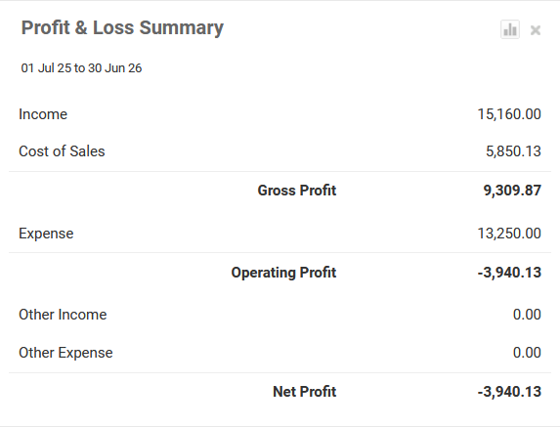
Figure 1: Profit Loss Summary (Source: Author)
Figure 1 shows an income of 15,160.00 and a cost of sales of 5,850.13, giving a gross profit of 9,309.87. Operating expenses of 13,250.00 then produce an operating and net loss of –3,940.13. This loss is driven mainly by overpurchasing materials and tax-coding errors, which increase costs without an immediate increase in revenue. The extract illustrates how apparently healthy sales can still translate into a loss when purchasing discipline and data entry in the ERP system are weak.
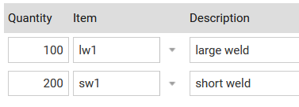
Figure 2: Over-purchasing of short welds (Source: Author)

Figure 2 shows that 100 large welds and 200 short welds were purchased, including 100 short welds more than required. This overpurchasing reduces gross profit in the short term because extra inventory has been bought without matching sales. Although the additional welds remain as assets that can generate future revenue, the mistake ties up cash unnecessarily and exposes weaknesses in demand forecasting and approval controls within the purchasing process.
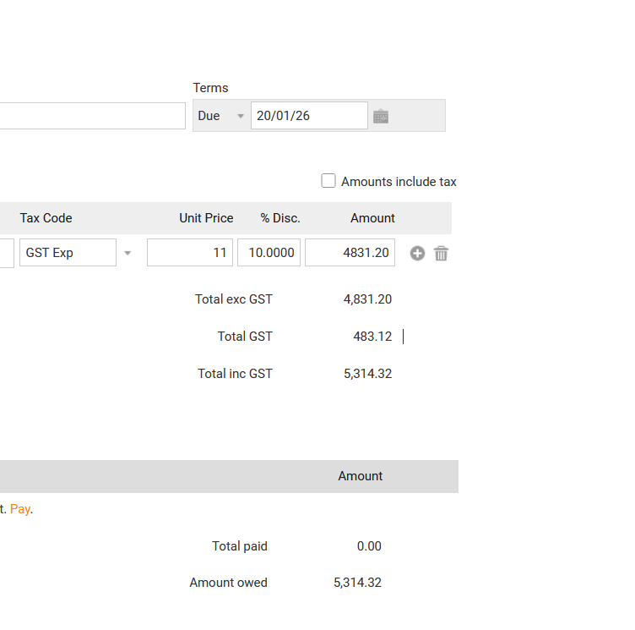
Figure 3: Without tax (Source: Author)

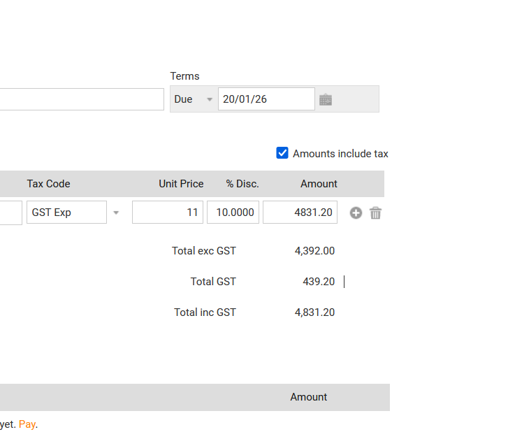
Figure 4: After tax (Source; Author)
Figures 3 and 4 present the same supplier invoice entered with different GST settings. In Figure 3, “Amounts include tax” is ticked, so Saasu treats 4,831.20 as GST-inclusive and calculates GST of 439.20. In Figure 4, the box is unticked, and 4,831.20 is treated as GST-exclusive; GST of 483.12 is added again, increasing the payable to 5,314.32. If the second setting were used, the company would effectively pay GST twice. This example shows how small configuration errors in ERP tax settings can directly reduce profit and cash flow, and why user training and clear procedures are essential.

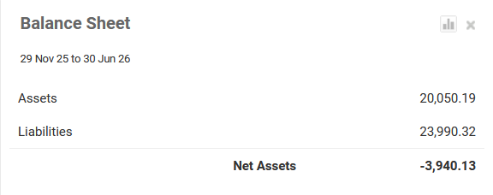
Figure 5: Balance Sheet (Source: Author)
Figure 5 reports total assets of 20,050.19 and liabilities of 23,990.32, resulting in negative net assets of –3,940.13. The excess of liabilities over assets reflects the loss shown in Figure 1 and is worsened by the unnecessary inventory from overpurchased welds and the overstated GST. This weak financial position highlights the need for Diet Center to tighten purchasing and tax controls so that future ERP-based Balance Sheets reflect genuine, sustainable profitability.
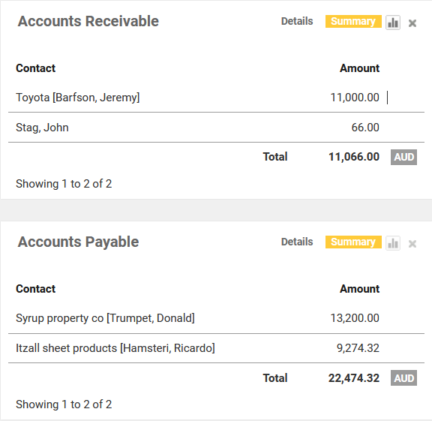
Figure 6 shows Accounts Receivable of 11,066.00 compared with Accounts Payable of 22,474.32. Supplier obligations are therefore roughly double the customer amounts due, creating short-term liquidity pressure. In practice, a cash-constrained business may prioritise paying smaller invoices first while delaying larger ones, but this increases the risk of overdue balances and damaged supplier relationships. The ERP extract makes this imbalance visible, helping management plan collections and payments more carefully to protect cash flow.
A recommendation on whether SAASU is the right software for the organisation, justifying why:
Saasu offers DC affordable cloud integration for its fragmented systems (El Hajj, 2018). However, functional gaps make it a temporary solution. While Sage is an option, Odoo better supports DC’s long-term production and inventory needs. A phased transition from Saasu to Odoo ensures a sustainable fit.
Saasu is primarily an online accounting and small business ERP platform. It provides a general ledger, accounts payable and receivable, bank reconciliation, inventory tracking, basic payroll, and budgeting (Saasu, 2026). For DC, these capabilities directly address current weaknesses in financial consolidation. Instead of manually merging figures from four systems, management could generate standard profit and loss statements, balance sheets, and ageing reports from a single interface.
As a cloud system, Saasu offers remote access, automated backups, and regular updates without the need for on-premises infrastructure. Its interface is driven by a dashboard, and the configuration is relatively simple, which makes it likely to be easier for the staff at DC who are not technical. This is important for a family-run enterprise with limited IT capacity (Odoo, 2026; Sage, 2026; Saasu, 2026). In this sense, Saasu can lower the barrier to management that is more data-driven while improving transparency over margins, expenses, and working capital.
A critical limitation, however, is localisation. Experience from classwork shows that the bank feed functionality in Saasu is focused on Australian institutions, and Lebanese banks are currently unsupported. This forces manual imports and reconciliations, which erodes one of the main efficiency gains of cloud accounting and risks a return to the delays and errors that DC already faces (Odoo, 2026; Sage, 2026). This issue is central to assessing the overall fit of the software.
Saasu centralises DC’s financial reporting by consolidating sales from clinics and shops. It manages supplier invoices and taxes while providing more reliable inventory tracking than current systems. These improvements allow the company to monitor costs effectively and identify its most profitable products and outlets.
However, the operations at DC also depend on production based on recipes, kitchen scheduling, and the management of diet programmes. These tasks require linking nutritional information, portion sizes, and ingredient usage. Saasu lacks specialised manufacturing or recipe management modules comparable to those found in broader ERP suites (Odoo, 2026; Sage, 2026; Saasu, 2026). Consequently, important decisions about menu design, batch production, and wastage would still rely on spreadsheets or separate tools, which limit fully integrated process analytics.
Saasu can mitigate several short-term issues. It would reduce fragmentation in financial data, provide more timely and consistent reports, and support basic internal controls through user roles and audit trails. For a company that currently struggles to obtain reliable income statements, these are meaningful gains. The subscription pricing is modest relative to an enterprise ERP, which aligns with the financial constraints at DC.
Yet, Saasu cannot fully address deeper structural problems highlighted in the case. These include a lack of visibility from the start of a diet consultation through to production, delivery, and cash collection. It also fails to address weak cost control at the menu and outlet level, and the need for scalable systems to support franchising. Research into ERP systems shows that such a lack of alignment between system capabilities and organisational processes often leads to disappointing outcomes and cost overruns (Moon, 2007; Malhotra and Temponi, 2010).
Odoo, by contrast, offers a modular architecture with dedicated applications for manufacturing, inventory, CRM, and accounting, along with broader international support (Odoo, 2026). Sage Business Cloud provides strong accounting and compliance for multiple currencies, but it has more limited manufacturing functionality (Sage, 2026). Overall, Odoo appears to provide the closest fit to the combined financial and production requirements of DC, assuming that customisation and implementation are carefully managed.
Saasu should therefore not be adopted as the long-term strategic ERP for DC, but it is good for the short term. A better strategy is to implement Saasu in the short term to stabilise financial reporting and implement strong control over different departments. DC should concurrently plan a phased migration to Odoo once the company has clarified and standardised its production and franchise processes. This approach is focused on fit and respects the resource constraints of DC while delivering immediate improvements in transparency and governance. This positions the company to implement a more comprehensive ERP aligned with its processes that can support margin recovery and future growth.

A reflective statement on how you have used Generative AI in developing the answer for this essay. If you have not used Generative AI, then you should discuss why you did not do so.
I have used generative AI for this paper, but it was done with human oversight, following University of Birmingham guidelines. Core ideas, case analysis and source selection were developed independently through reading the Diet Center case and academic literature. AI was used to understand ERP and its features, to compare different ERPs, as a proofreader and to translate certain elements into the native language. By using its features to help support my study, I learned how to use GEN AI ethically.
The benefits of GenAI include menial tasks like proofreading, translation, summarising key points, and sometimes providing an alternative explanation using references, which can be useful. It is expected that Gen AI will be implemented at many levels, so using it in an ethical way with human oversight helps us to learn how to be more efficient with work and get an understanding of Gen AI’s positives and negatives with every update.
However, it is important to consider the current shortcomings of Gen AI, which include hallucinating answers, limited understanding of the context, limited access to more accurate models and providing false references. The issues with GEN AI are a result of the fact that it is an LLM model, which is heavily dependent on supervised learning from the internet rather than just focusing on Academic resources, which are peer-reviewed. GEN AI lacks the human capability of understanding context in real time and critical thinking, which makes it limited to supporting software.

References: -
Abd Elmonem, M.A., Nasr, E.S. and Geith, M.H. (2016) ‘Benefits and challenges of cloud ERP systems – A systematic literature review’, Future Computing and Informatics Journal, 1(1–2), pp. 1–9. doi: 10.1016/j.fcij.2017.03.003.
Anbalagan, B. and Pasumarthi, A. (2022) ‘Building Enterprise Resilience through Preventive Failover: A Real-World Case Study in Sustaining Critical Sap Workloads’, International Journal of Computer Technology and Electronics Communication, 5(4). doi: 10.15680/IJCTECE.2022.0504004.
Appari, A. and Johnson, M.E. (2010) ‘Information security and privacy in healthcare: current state of research’, International Journal of Internet and Enterprise Management, 6(4), pp. 279–314.
BBC News (2021) ‘Kronos ransomware: Payroll chaos after cyber-attack on HR software’, BBC News, 18 December. Available at: https://www.bbc.co.uk/news/technology (Accessed: 12 January 2026).
Bernardo, B., São Mamede, H., Barroso, J.M.P. et al. (2024) ‘Data governance & quality management: Innovation and breakthroughs across different fields’, Journal of Innovation & Knowledge, 9(4), Article 100598, pp. 1–35.
Bjelland, E. and Haddara, M. (2018) ‘Evolution of ERP Systems in the Cloud: A Study on System Updates’, Systems, 6(2), Article 22.
Botta-Genoulaz, V., Millet, P.-A. and Grabot, B. (2005) ‘A survey on the recent research literature on ERP systems’, Computers in Industry, 56(6), pp. 510–522. doi: 10.1016/j.compind.2005.02.004.
Butarbutar, Z.T. (2023) ‘Systematic literature review of critical success factors on enterprise resource planning projects post-implementation’, Cogent Business & Management, 10(3), Article 2264001.
Cao, L. and Zhu, Y. (2013) ‘Normal accidents: data quality problems in ERP-enabled manufacturing’, Journal of Data and Information Quality, 4(3), Article 10.
El Hajj, S. (2018) The Diet Center: The SAP ERP decision. London, ON: Ivey Business School Foundation. Case No. 9B18M084. [Also available via University of Birmingham Canvas module materials].
Fernández-Alemán, J.L., Señor, I.C., Lozoya, P.Á.O. and Toval, A. (2013) ‘Security and privacy in electronic health records: a systematic literature review’, Journal of Biomedical Informatics, 46(3), pp. 541–562.
Hashizume, K., Rosado, D.G., Fernández-Medina, E. and Fernandez, E.B. (2013) ‘An analysis of security issues for cloud computing’, Journal of Internet Services and Applications, 4, Article 5.
Hustad, E. and Olsen, D.H. (2014) ‘ERP Implementation in an SME: A Failure Case’, in Devos, J., Van Landeghem, H. and Deschoolmeester, D. (eds.) Information Systems for Small and Medium-sized Enterprises. Progress in IS. Berlin: Springer, pp. 213–228.
Kobelsky, K.W. (2014) ‘A conceptual model for segregation of duties: Integrating theory and practice for manual and IT-supported processes’, International Journal of Accounting Information Systems, 15(4), pp. 304–322.
Leyh, C., Lorenz, A., Faruga, M.J. and Koller, L. (2024) ‘Critical Success Factors for ERP Projects Revisited: An Update of Literature Reviews’, in Proceedings of the 19th Conference on Computer Science and Intelligence Systems (FedCSIS), 39, pp. 131–140. doi: 10.15439/2024F6271.
Malhotra, R. and Temponi, C. (2010) ‘Critical decisions for ERP integration: Small business issues’, International Journal of Information Management, 30(1), pp. 28–37.
Martins, E.J. and Belfo, F.P. (2023) ‘Major concerns about Enterprise Resource Planning (ERP) systems: A systematic review of a decade of research (2011–2021)’, Procedia Computer Science, 219, pp. 378–387.
Misra, S.C., Kumar, V. and Kumar, U. (2016) ‘Modeling privacy issues in distributed enterprise resource planning systems’, International Journal of Information Management, 36(3), pp. 325–335. doi: 10.1016/j.ijinfomgt.2016.01.002.
Moon, Y.B. (2007) ‘Enterprise Resource Planning (ERP): a review of the literature’, International Journal of Management and Enterprise Development, 4(3), pp. 235–264.
Nwankpa, J.K. (2015) ‘ERP system usage and benefit: A model of antecedents and outcomes’, Computers in Human Behavior, 45, pp. 335–344. doi: 10.1016/j.chb.2014.12.019.
Odoo (2026) Odoo Open Source ERP & CRM. Available at: https://www.odoo.com/ (Accessed: 12 January 2026).
Opara-Martins, J., Sahandi, R. and Tian, F. (2016) ‘Critical analysis of vendor lock-in and its impact on cloud computing migration: a business perspective’, Journal of Cloud Computing, 5(1), Article 4. doi: 10.1186/s13677-016-0054-z.
Pearson, S. and Benameur, A. (2010) ‘Privacy, security and trust issues arising from cloud computing’, in 2010 IEEE Second International Conference on Cloud Computing Technology and Science (CloudCom). IEEE, pp. 693–702.
SaaSu (2025) Online Accounting Software. Available at: https://www.saasu.com/ (Accessed: 12 January 2026).
Sabbarwal, A. and Pandey, P. (2021) ‘Review on security and privacy of cloud ERP system’, International Journal of Advanced Computer Science and Applications, 12(8), pp. 45–56. doi: 10.14569/IJACSA.2021.0120805.
Sage (2026) Sage ERP Software. Available at: https://www.sage.com/en-gb/erp/ (Accessed: 12 January 2026).
SAP (2025) What is ERP? The essential guide. Available at: https://www.sap.com/india/products/erp/what-is-erp.html (Accessed: 24 December 2025).

