Contents
Contents 1
List of Tables 3
List of Figures 4
Executive Summary 5
Acknowledgements 7
1. Introduction 8
1.1 Background and Context 8
1.2 Defining “Attendance”: an Umbrella Term 8
1.3 Problem Statement 8
1.4 Aim and Objectives 9
1.5 Research Questions and the Data-to-Decision Map 9
1.6 Scope, Significance and Deliverables 10
1.7 Risks, Assumptions and Points for Clarification 10
2. Literature Review 12
2.1 The Strategic Value - and Limits - of Visitor Measurement 12
2.2 People-Counting Technologies: a Critical Comparison 12
2.3 Indirect and Proxy Estimation of Occupancy 13
2.4 Heritage and Non-Invasive Installation Constraints 13
2.5 Privacy, Data Protection and a Shifting Regulatory Landscape 14
2.6 Data Quality, Missing Data and the Change of Measurement Method 14
2.7 From Data to Decisions: Dashboards and Task–Technology Fit 15
2.8 Multi-Criteria Decision Analysis for Technology Selection 15
2.9 Synthesis and Research Gap 15
2.10 Conceptual Framework 16
3. Methodology 17
3.1 Research Philosophy, Approach and Design 17
3.2 Phase I - Technology Evaluation Method 17
3.3 Phase II - Data-Analytics Method 18
3.4 Data Sources: the Four Data Families, Inventory and Dictionary 18
3.5 Quality, Validity, Reliability and Ethics 19
4. Data Preparation, Quality Assurance and Readiness for Analysis 20
4.1 The Preprocessing Pipeline and its Cleaning Decisions, with Numbers 20
4.2 The Missing-Value Policy: Blanks, “No Data”, Closed Days and True Zeros 21
4.3 The Weekend-Accumulation Artefact and its Correction 22
4.4 Corroboration and Confirmation of Analysis-Readiness 23
4.5 Descriptive Statistical Profile - and What It Means for Management 24
5. Findings and Dashboard Results 26
5.1 Technology Evaluation Results (RQ1) 26
5.2 Seasonal and Monthly Patterns (RQ2a) 27
5.3 The Weekly Rhythm (RQ2b) 28
5.4 Within-Day Occupancy: the Working Lounge (RQ2c) 28
5.5 Footfall by Entrance and Proxy Corroboration (RQ2d) 29
5.6 Dashboard Structure and Results (RQ3) 30
5.7 Summary against the Research Questions 32
6. Discussion, Recommendations and Limitations 33
6.1 Discussion 33
6.2 Recommendations and the Implementation Budget 33
6.3 Limitations 37
7. Conclusion 38
References 39
Appendix A - Data-Preparation Technical Narrative 43
A.1 The Raw Material 43
A.2 Cleaning Decisions and Rationale 43
A.3 The Missingness Diagnosis 44
A.4 The Measurement Artefact and its Correction 44
A.5 Supporting Sources, Standardisation and Profile 44
A.6 Why the Dataset Is Trusted 44
Appendix B - Data-Quality Audit Trail (31 Entries) 46

List of Tables
Table 1.1 Project objectives 11
Table 1.2 Research questions mapped to analyses and decisions 11
Table 1.3 Principal project risks and mitigations 12
Table 2.1 Candidate technology families and their fit to The Exchange 15
Table 3.1 Phase I evaluation criteria and weights 19
Table 3.2 The four data families and their role in the analysis 20
Table 3.3 Data dictionary 21
Table 4.1 Structure of the analysis-ready workbook 22
Table 4.2 Missing-value and anomaly policy 23
Table 4.3 Principal data-quality issues 24
Table 4.4 Residual limitations after the correction 25
Table 4.5 Descriptive statistics of the prepared variables 26
Table 4.6 Managerial reading of the descriptive profile 27
Table 5.1 Weighted multi-criteria scores 28
Table 5.2 Score justification for Table 5.1 28
Table 5.3 Sensitivity of the ranking to re-weighting 29
Table 5.4 The seven-page dashboard: pages, decisions, filters and warnings 32
Table 5.5 Findings against the research questions 34
Table 6.1 Recommendations in priority order 36
Table 6.2 Success metrics and risk of non-implementation 37
Table 6.3 Full cost of the plan against the sponsor's budget 38
Table 6.4 Implementation roadmap 38
Table 6.5 Limitations and their consequence for interpretation 39
Table B.1 The 31-entry data-quality audit trail 48

List of Figures
Figure 2.1 The Measurement–Insight–Decision–Value (MIDV) conceptual framework: the two sub-models, the heritage and privacy gates, and fitness-for-use as the linking construct based on (Wang & Strong, 1996) 18
Figure 4.1 The same counter data under naïve differencing (red) and gap-aware distribution (blue). The spurious Monday peak collapses; Thursday emerges as the true busiest day. 25
Figure 4.2 Distribution of daily building footfall with kernel density; the mean sits right of the median - the signature of right skew. 26
Figure 4.3 Box-and-whisker plots by weekday: Thursday has the highest median; high outliers mark event days rather than errors. 27
Figure 5.1 Monthly corrected crossings, July 2025 – June 2026 (June 2026 partial: 11 days). Recorded-day counts accompany each month on the dashboard. 30
Figure 5.2 Mean corrected crossings by weekday: Thursday busiest; Sunday and Monday quietest. Saturday–Monday values are partly apportioned (Section 4.3). 30
Figure 5.3 Working Lounge mean occupancy by hour (Oct 2024 – Dec 2025; 47% of hour-slots recorded). Peak ≈14:00 at ≈6% of capacity. 31
Figure 5.4 Share of corrected crossings by gate (labels state exact shares; beams overlap, so shares describe activity, not exclusive routes). 31
Figure 5.5 Weekday profiles of footfall and café sales, each normalised to its own peak: both peak on Thursday. 32
Figure 5.6 The implemented Executive Overview page: reporting-period KPIs, anomaly-flagged daily footfall (threshold = mean + 2SD), weekday profile and footfall–café scatter. 33
Figure 5.7 Working Lounge day × hour heat-map (Oct 2024 – Dec 2025): mean occupancy by weekday and hour; the Thursday 14:00 peak (4.9) stands out, Sundays are empty. 34
Figure 5.8 Proxy Comparison: monthly footfall (left axis) and café gross sales (right axis) move together, r ≈ 0.97; May 2026 excluded as anomalous. 34

Executive Summary
The University of Birmingham's civic venue, The Exchange, occupies the Grade II-listed former Birmingham Municipal Bank. It is free to enter, so no ticket trail records attendance. Its manual room counts, automated entrance counters, hourly occupancy log and café and energy records had never been integrated into one documented evidence base. Two questions were addressed: which capture technology suits a heritage-listed, free-to-enter public building (RQ1), and what the historical data reveals, and can honestly support, once cleaned, integrated and visualised (RQ2 and RQ3).
Approach. Phase I evaluated six technology options against five weighted, client-derived criteria: heritage compliance, data privacy, operational efficiency, cost-effectiveness and user-friendliness, with feasibility gates and sensitivity analysis. Phase II built a reproducible data pipeline that converted roughly fifteen operational workbooks (January 2022 – June 2026) into a two-layer, analysis-ready dataset: seat-based manual room counts (Layer 1) and crossing-based counter footfall (Layer 2), reported in parallel and never summed. Blanks were kept as missing, never zeros; closure days were separated from unrecorded days; and a weekend-accumulation artefact in the counter readings was corrected by distributing multi-day increments across the days they span.
Findings. The installed break-beam counters, under an improved reading protocol, rank first (4.45 of 5) and stay first in all twelve sensitivity scenarios; camera- and Wi-Fi-based options fail heritage or privacy gates. The corrected series records 158,093 crossings over 326 open days, median typical day 447 crossings. Thursday is busiest (mean 631) with Wednesday close behind (598). Contrary to expectation, Friday (559) sits level with Saturday (558), while Sunday (272) and Monday (284) are quietest. Seasonality follows the academic calendar, with a March 2026 peak and late-summer and Christmas troughs. The North entrance carries 75.4 per cent of crossings. The Working Lounge peaks at about 3.6 people - roughly six per cent of its sixty-seat capacity. An independent café-sales proxy corroborates these patterns (monthly r ≈ 0.97). Throughout, counter figures are crossings - an upper-bound activity index, not unique visitors - and proxies corroborate patterns rather than validate counts.
Conclusions. The Exchange already owns primary technology that suits the building; what it lacked was a reading protocol, reporting discipline and an integrated, honestly bounded evidence base. The largest gain came from fitness for use, not data volume: one change in how existing readings are interpreted reversed the apparent weekly pattern.

Recommendations. Six actions are proposed, each with a success target, a risk of inaction and a roadmap position, all within the confirmed budget. Two concern data capture: adopt the improved counter-reading protocol (fixed reading time, weekend capture, reset log, never-sum rule, quarterly ground-truth checks) and formalise recording governance with one template and canonical space names. Two concern data use: adopt the published dashboard and its median headline KPI, and staff to the measured rhythm (peak provision Wednesday and Thursday, lighter Mondays, Vaults by the events calendar). Two close gaps: pilot one or two image-free thermal sensors, subject to privacy screening and conservation confirmation, and obtain the event and booking records held by other University teams.

Acknowledgements
The group thanks The Exchange venue team for sponsoring the project, for supplying the operational records on which the analysis rests, and for their generosity in meetings and on site in explaining the building's history, its recording practice and its operational constraints.

1. Introduction

1.1 Background and Context
The Exchange occupies the former Birmingham Municipal Bank, built in 1933 and reopened by the University of Birmingham in 2021 (University of Birmingham, 2026a; 2026b). Grade II listing bars significant alteration without Birmingham Conservation Office consent, and the fabric - the former vault sits behind two metres of concrete - makes routing power and data impractical in many places; this constraint conditions every technology decision that follows. A free-to-enter civic hub (café, exhibitions, events, workspaces, vaults, heritage tours), the venue has no ticket trail recording attendance and the client requires assurance the asset is used to its potential.

1.2 Defining “Attendance”: an Umbrella Term
The term “attendance” is used loosely in the venue's records, where it describes several different measurements. Within this study it is therefore defined as an umbrella term for four constructs, all of which are used throughout the report: (i) room usage/space occupancy - a seat-based manual headcount of those present at the moment of observation: a snapshot, not a total; (ii) entrance footfall - a crossing-based count of beam interruptions, recording movements rather than unique individuals; (iii) hourly occupancy - room usage resolved through the day (Working Lounge only); and (iv) commercial and utility proxies - café sales and energy, which correlate with presence but count nobody. This distinction is the project's organising principle: the study does not produce one attendance number, but identifies which measure is fit for which decision - a logic carried through the research questions (Table 1.2), the methodology (Section 3.3), the dashboard (Section 5.6) and the recommendations (Section 6.2). A seat-based count is never combined with a crossing-based one.

1.3 Problem Statement
The venue faces four practical problems: inaccurate and incomplete footfall reporting, poorly evidenced space utilisation, an under-evidenced funding and civic-impact case, and unsupported operational planning. First, manual logging is labour-intensive and prone to omission, while the counters cannot distinguish visitors from staff, re-count every re-entry and, because the South and Vaults beams are crossed by people already inside, produce overlapping totals that cannot be summed. Second, the venue cannot show which rooms are under- or over-used, and when. Third, a free-to-enter venue must evidence usage to justify investment, yet its records are fragmentary. Fourth, rotas, opening hours and café and event provision run without a dependable picture of demand.
Underlying all four is a data problem - value lies in fitness for use, not volume (Wang and Strong, 1996): spaces have been renamed, definitions shift across years, and the two measurement regimes were never reconciled. The venue therefore lacks both an evidence-based technology choice for a listed building (Comai et al., 2025) and the cleaned, visualised record that decision support requires (Few, 2006; Sarikaya et al., 2019); this report addresses both.

1.4 Aim and Objectives
Aim: to help The Exchange capture and use visitor-attendance data more effectively - evaluating capture technologies suited to a listed building and compliant with data-protection law, and cleaning, analysing and visualising the historical data so each measure supports the decisions it is fit for. Table 1.1 sets the seven objectives.
Table 1.1 Project objectives
Obj. | Objective
O1 | Investigate, evaluate and rank modern attendance-capture technologies suitable for a public, heritage-listed venue
O2 | Apply a transparent multi-criteria framework spanning heritage compliance, data privacy (UK GDPR), operational efficiency, cost-effectiveness and user-friendliness
O3 | Ingest, clean and combine the historical datasets into one analysis-ready resource, preserving the distinction between the manual and automated measurement methods
O4 | Assess data quality, characterise the mechanisms of missing and anomalous records, and apply transparent treatments so figures are neither understated nor inflated
O5 | Analyse visitor trends, peak periods and space utilisation within the stated limits of the records
O6 | Design a client-facing dashboard that communicates attendance, coverage and limitations honestly to a non-technical audience
O7 | Document the data gaps and limitations encountered, and produce the academic report and client presentation

1.5 Research Questions and the Data-to-Decision Map
Table 1.2 links each research question to its analysis, output and the decisions it supports.
Table 1.2 Research questions mapped to analyses and decisions
Research question | Analysis performed | Output/dashboard view | Decisions supported
RQ1. Which attendance-capture technologies are most suitable for The Exchange, and how do they compare on cost, operational efficiency, usability, privacy and heritage compliance? | Weighted multi-criteria scoring of six options; feasibility gates; ±10/±20 pp sensitivity analysis | Section 5.1 scoring matrix and recommendation | Technology choice and investment; counter-protocol improvement
RQ2a. What seasonal and month-on-month patterns exist in room usage and entrance footfall? | Monthly aggregation of the corrected counter series, coverage-aware | Section 5.2; “Weekly & Seasonal Patterns” page | Programming calendar; opening hours; maintenance scheduling
RQ2b. What weekly rhythm is present - do the data corroborate the sponsor's view that Thursdays are busiest and Fridays quietest? | Weekday profile of corrected daily footfall; café weekday profile | Section 5.3; “Executive Overview” page | Staffing rotas; café rostering; event scheduling
RQ2c. What does the Working Lounge hourly log reveal about within-day peak and off-peak occupancy? | Hourly occupancy profile of the Working Lounge log | Section 5.4; “Working Lounge Hourly Profile” page | Within-day staffing; space repurposing and promotion
RQ2d. How is footfall distributed across entrances, and to what extent do café-sales and energy proxies corroborate the counted figures? | Gate shares of corrected footfall; footfall–café correlation (monthly and daily) | Section 5.5; “Footfall by Entrance” and “Proxy Comparison” pages | Entrance operations and wayfinding; confidence in reported figures
RQ3. How can the disparate datasets be combined, standardised and visualised - preserving the two measurement methods and honestly representing coverage - to support operational and strategic decisions? | Two-layer integration, quality flags, coverage metrics; seven-page dashboard implemented in Tableau Public | Chapter 4; Section 5.6; “Data Quality & Coverage” page | Funding and civic reporting; data governance and recording practice

1.6 Scope, Significance and Deliverables
This is a single-venue case study. Phase I evaluates technology classes at the decision-support level, and Phase II works exclusively with client-supplied secondary data. No primary data collection, procurement, installation, individual-level processing or live build is undertaken; the recommendation is advisory, and financial figures are limited to the supplied energy data and the sponsor's declared budget (Table 6.3).
The venue receives a defensible technology recommendation, a cleaned and documented dataset, and a published interactive dashboard. Methodologically, the study offers a replicable template for attendance measurement under joint heritage and privacy constraints. Deliverables: the technology evaluation (Section 5.1); the analysis-ready dataset (Sections 3.4 and 4.1); the data-quality documentation (Chapter 4; Appendix B); the dashboard (Section 5.6); this report and the client presentation.

1.7 Risks, Assumptions and Points for Clarification
Table 1.3 summarises the principal risks; the supplied datasets are assumed to represent the sponsor's available attendance data, with no personal data.
Table 1.3 Principal project risks and mitigations
Risk (specific to The Exchange) | Likelihood/impact | Mitigation
Booking, event and tour records sit with other University teams; requests may be delayed | High / High | Issue a precise, itemised data request the sponsor can forward; proceed on documented assumptions and revise when data arrives
Break-beam counters double-count: North, South and Vaults beams are crossed by the same people moving inside | High / High | Never sum entrances into a venue figure without confirmation; report entrances separately; label the building total as a crossings index
Manual (seat-based) and automated (crossing-based) methods measure different things | High / High | Two-layer model; state what each method measures; never splice the series
Missing readings cluster on weekends and closure days, so naïve fills would distort totals | Medium / High | Classify blanks (closed vs unrecorded) before treatment; report coverage beside every figure
Counters cannot identify who is counted (staff, cleaners, repeat entries), so crossings overstate visitors | Medium / Medium | Obtain the sponsor's staff-share estimate; disclose any deflator; present crossings as an upper bound
Seat capacities are documented for one year, and layouts change daily, so utilisation ratios are imprecise | Medium / Medium | Use fixed fire capacities as a stable denominator; treat utilisation as indicative
Vendor-published accuracy figures may overstate real-world performance | Medium / Medium | Weight independent evidence; check counts against on-site manual ground-truth observation
Note. Points awaiting sponsor confirmation: dates of renames and method changes; event/booking records held by other teams; any counter reset routine; IT-security constraints; the sponsor’s priority metric. The implementation budget is confirmed at approximately £3,000 (Section 6.2).

2. Literature Review
The review ties each strand to The Exchange, closing each subsection with its implication for this project and ending with the research gap and conceptual framework.

2.1 The Strategic Value - and Limits - of Visitor Measurement
Visitor data is a strategic asset. For free-entry, publicly funded venues, attendance is the headline performance indicator: the DCMS-sponsored national museums, whose permanent collections are free to enter, report the number of visits first among their agreed indicators, one of the few based on actual physical counts rather than surveys (Department for Culture, Media and Sport, 2010; 2026). Museum-review evidence shows that both core and peripheral services shape satisfaction (Huo et al., 2024). The limits are equally documented: a headcount is a thin proxy for value, engagement mattering more than volume (Serrell, 1997; Yalowitz and Bronnenkant, 2009); the complexities of the visit data used to evidence UK free admission went largely unexamined (Cowell, 2007); and much of the data the subsidised sector produces has been criticised as methodologically flawed, saying more about policy intention than about impact (Selwood, 2002). Both the value and the limits bear directly on The Exchange. Free entry removes the ticket trail (Section 1.1), so attendance must be counted deliberately, and the sponsor needs it for funding, space allocation, rotas and opening hours (Section 1.3); yet the DCMS definition of a visit - one trip by one individual, excluding staff and contractors, with café visits never added to the total - is one the venue's beam counters cannot meet, since they record crossings, count staff and overlap across gates (Section 1.3). For this project: figures are reported as crossings, never ‘visitors’; each measure is matched to the decision it is fit for (Section 1.2; propositions P2–P3, Section 2.10); and dashboards built from crossings and snapshots answer “how many”, not “how engaged”, stating that limit rather than hiding it (Section 5.6).

2.2 People-Counting Technologies: a Critical Comparison
Surveys of human-sensing technology distinguish five levels of detection - presence, count, location, tracking and identity - and note that cost, intrusiveness and error all rise as systems move towards identifying individuals (Teixeira, Dublon and Savvides, 2010). The Exchange needs only the second of these: a count. Within that need, the non-intrusive methods fall into families (Table 2.1), each carrying its own balance of accuracy, cost and privacy (Abade, Perez Abreu and Curado, 2018; Drahanský et al., 2023; Comai et al., 2025). The venue's own break-beam counters belong to one such family and register beam interruptions rather than people; field studies show that counters of this kind perform adequately only when checked on site (dos Santos et al., 2022), whereas vendor claims of 98 per cent accuracy derive from staged conditions (Terabee, 2023). For this project: no accuracy figure is accepted on trust; Phase I weighs accuracy against cost, privacy and heritage fit, and every counter is checked against manual ground truth (Section 3.2).
Table 2.1 Candidate technology families and their fit to The Exchange
Technology family | Accuracy/usefulness | Privacy risk | Heritage fit | Implication for The Exchange
Manual tally/headcount | Low–medium; depends on staff routine and timing | Very low | Excellent; no installation | Retained as validation ground truth, not the future primary system
Infrared break-beam counter | Medium; vulnerable to groups, repeats, staff; bidirectional models better (dos Santos et al., 2022) | Very low; no image or identifier | Good; compact, reversible | Describes the installed North/South/Vaults counters; totals must not be summed without correction
Thermal / passive-infrared array | Medium–high for presence and approximate counts (Drahanský et al., 2023) | Low if configured to avoid identifiable imagery | Good if battery- or surface-mounted | Strong candidate for room-level occupancy where constraints bind
Depth / stereo-video sensor | High where mounting and lighting suit | Low–medium; image-free outputs possible but DPIA needed | Fair; may require cabling and mounting | Accurate but hard to justify in protected areas
Wi-Fi / Bluetooth probe sensing | Low–medium; undermined by MAC randomisation (Uras et al., 2022) | Medium; device identifiers can be personal data | Good; reuses infrastructure | Not recommended as a primary method
Bookings / QR / ticketing | High for scheduled events; misses walk-ins | Medium; may collect personal data | Excellent if digital only | Useful complement for events and tours
Energy/café proxy | Low as a headcount; useful for corroboration (Kleiminger, Beckel and Santini, 2015) | Very low where aggregated | Excellent; no new hardware | Corroboration only; never used to calculate visitor totals
Note. Synthesised from the comparative literature.

2.3 Indirect and Proxy Estimation of Occupancy
Occupancy can also be inferred indirectly. Whole-building electricity data indicates occupancy with useful accuracy (Kleiminger, Beckel and Santini, 2015), whereas Wi-Fi/Bluetooth probing has been undermined by MAC-address randomisation (Uras et al., 2022). Counts from different micro-locations are not directly comparable (Philp et al., 2022), a caution for the venue's three gates. For this project: café sales and energy are strictly corroborating proxies - never substitutes for, or validation of, counted figures.

2.4 Heritage and Non-Invasive Installation Constraints
Works affecting a listed building's character may require Listed Building Consent and early conservation-officer involvement (Historic England, 2021), making the Birmingham Conservation Office a statutory gate. Wireless, battery-powered deployments monitor protected settings without harming fabric (Mecocci and Abrardo, 2014; Centorrino et al., 2021): the least invasive viable technology is preferred, even at some accuracy cost. For this project: compact, reversible, battery-powered sensors are favoured, invasive cabling penalised, and heritage compliance carries the largest weight.

2.5 Privacy, Data Protection and a Shifting Regulatory Landscape
Counting technologies engage data-protection law even when the aim is only to count: device identifiers such as MAC addresses can be personal data under the UK GDPR, whose processing must satisfy lawfulness, purpose limitation and data minimisation (European Parliament and Council of the European Union, 2016; Information Commissioner's Office, 2022). Consent being impractical in open public spaces, organisations must document a legitimate-interests assessment and prefer less intrusive designs (Information Commissioner's Office, 2022; Cavoukian, 2011); and the Data (Use and Access) Act 2025 amends the framework (Information Commissioner's Office, 2025; UK Government, 2025). For this project: image- or identifier-collecting technologies are higher-risk, not recommended without a data protection impact assessment and institutional review; the installed break-beams store neither; recommendations are contingent on the rules in force at implementation.

2.6 Data Quality, Missing Data and the Change of Measurement Method
Wang and Strong (1996) define data quality in terms of fitness for use, a definition whose strength - that quality is judged by the consumer's purpose, not by the data alone - is also its weakness: because fitness is relative, data adequate for one use may be inadequate for another (Tayi and Ballou, 1998), and quality can be judged only within the context of a task (Strong, Lee and Wang, 1997) - at The Exchange, a seat-count fit for space allocation is unfit for a funding total. The DAMA UK Working Group (2013) operationalises the concept as completeness, accuracy, consistency and timeliness, but treats the dimensions as separable; at The Exchange they interact, because incomplete weekend recording produces a consistency failure in the derived daily values. The missing-data literature (Rubin, 1976; Little and Rubin, 2019) offers the necessary diagnostic - the treatment of a gap depends on why it arose - yet its remedies are designed for statistical inference, where imputation recovers estimates; for a coverage report to a venue manager, an imputed weekend fabricates evidence, so the venue's systematic gaps argue for disclosure rather than repair. A further limitation is that this literature presumes a single measuring process: the shift from manual tallies to counters is not ‘missingness’ but a change of instrument, and no imputation can reconcile a seat-based snapshot with a crossing-based count. Wickham's (2014) tidy-data principles provide a common structure across the two eras but not a common meaning. For this project, four rules follow: blanks are never zeros; imputation is rejected in favour of coverage reporting; the layers join only by date; and every cleaning decision is logged (Chapter 4; Appendix B).

2.7 From Data to Decisions: Dashboards and Task–Technology Fit
Dashboards are intended to bridge data and managerial action, though Yigitbasioglu and Velcu (2012) note that evidence of their effect on decisions remains limited and the literature largely prescriptive. Its prescriptions do converge: position-based encodings are read more accurately than area or colour (Cleveland and McGill, 1984), though this tells a designer how to show a number, not which number to show; Shneiderman's (1996) "overview first, zoom and filter, details on demand" assumes a user who knows what to seek; and restraint over decoration (Few, 2006) is qualified by Sarikaya et al. (2019), who find dashboards used for far more than monitoring. Task–technology fit (Goodhue and Thompson, 1995) supplies the unifying test - value depends on match to task. Least attended to is uncertainty: Spiegelhalter, Pearson and Short (2011) treat conveying the data's limits as a design responsibility, which sits in tension with Few's minimalism; here, the tension is resolved in favour of disclosure, because a single confident trend across the venue's change of method would mislead. For this project: every page shows coverage and quality warnings, the eras are visually separated, and each page is defined by the decisions it supports (Section 5.6).

2.8 Multi-Criteria Decision Analysis for Technology Selection
Choosing between technologies that trade off along incommensurable dimensions is itself a decision problem (Triantaphyllou, 2000): the Analytic Hierarchy Process decomposes it into weighted criteria and scored alternatives (Saaty, 1980; 1990; Vaidya and Kumar, 2006). A simplified weighted-scoring variant suits a single-venue advisory decision: transparent, though weights and scores are judgements. For this project: weights are stated openly for the client to adjust, feasibility gates stop a high total overriding a heritage or privacy failure, and sensitivity analysis tests robustness (Section 5.1).

2.9 Synthesis and Research Gap
Together, the strands establish the value of visitor data, the trade-offs of counting and proxy technologies, the narrowing imposed by heritage and privacy constraints, the binding role of data quality and the change of method, and the need for task-aligned dashboards that depict uncertainty. Largely absent is a venue-specific treatment that both selects a capture technology under those constraints and cleans, combines and visualises real historical data - the gap this study addresses; one gap the data cannot close, the event and tour records held elsewhere, is itself a finding pursued through a data request.

2.10 Conceptual Framework
The framework (Figure 2.1) integrates the two strands into one logic: attendance measurement creates value only when its data is fit for use (Wang and Strong, 1996) and is delivered through tools that fit the decisions managers face (Goodhue and Thompson, 1995). In the Measurement → Insight → Decision → Value pipeline, under Measurement sit the venue's three signal types - manual room counts, counter footfall, café/energy proxies - gated by heritage listing and privacy law (Sub-model A, Phase I); under Insight sit cleaning with the weekend correction, descriptive analytics and the dashboard (Sub-model B, Phase II); Decisions span staffing, opening hours, space allocation, funding and technology choice. Value lies outside the evidential scope: the project shows decisions are better supported, not the value that results. Three propositions follow, revisited in Section 6.1: P1 - suitability is determined less by raw accuracy than by constraint fit; P2 - measurement quality increases decision-relevance more than data volume; P3 - a dashboard's value depends on aligning indicators with specific decisions, not sophistication.
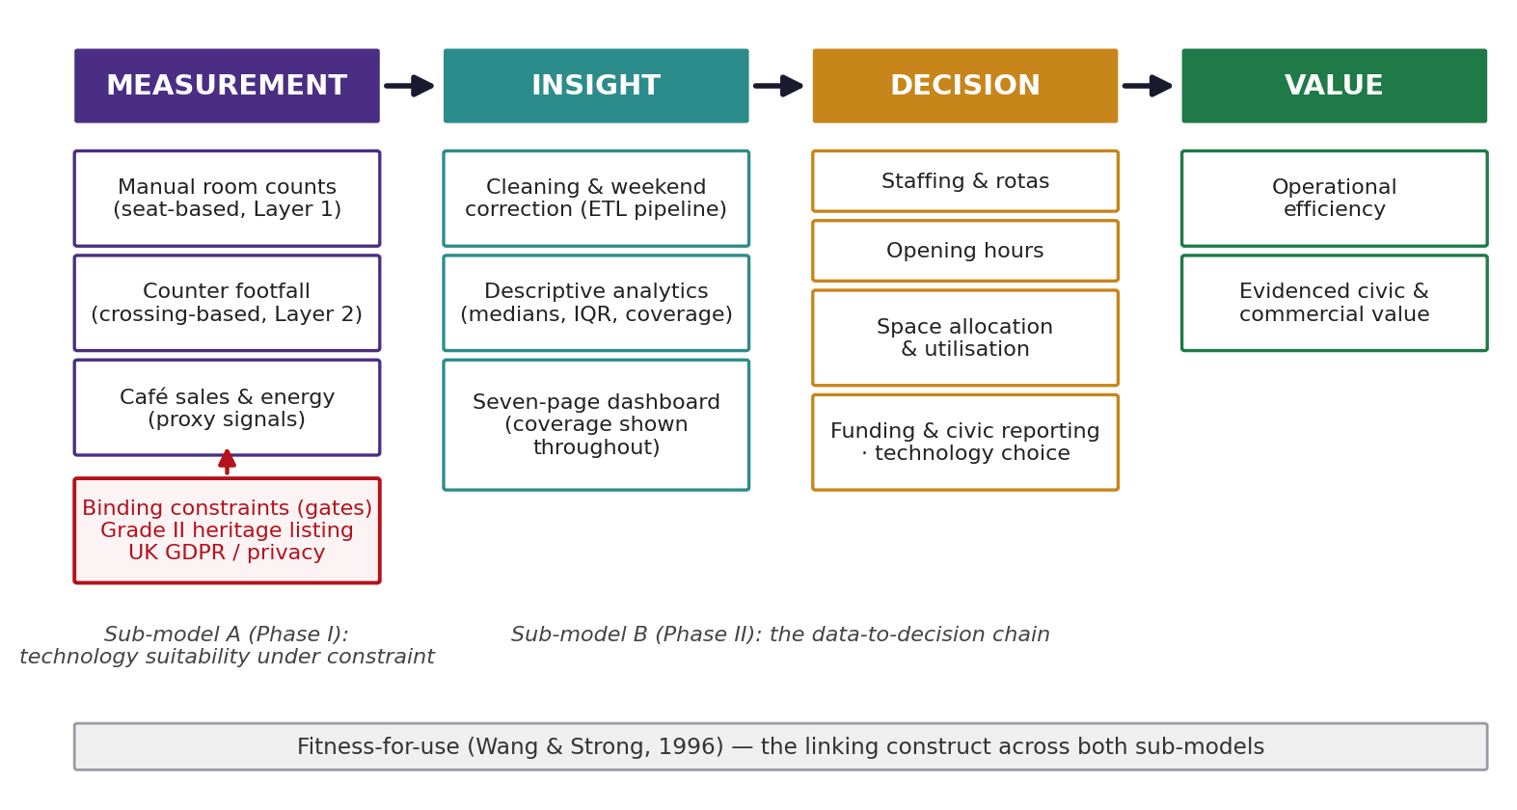
Figure 2.1 The Measurement–Insight–Decision–Value (MIDV) conceptual framework: the two sub-models, the heritage and privacy gates, and fitness-for-use as the linking construct based on (Wang & Strong, 1996)

3. Methodology

3.1 Research Philosophy, Approach and Design
The study adopts a pragmatist philosophy, which favours whatever answers the client's questions over paradigm allegiance (Saunders, Lewis and Thornhill, 2019). It is framed as a single-venue applied case study (Yin, 2018) with mixed methods: a structured multi-criteria evaluation (RQ1) and quantitative analysis of secondary data (RQ2a–d, RQ3). Phase I evaluates capture technologies (Sub-model A); Phase II cleans, analyses and visualises the historical data (Sub-model B); the phases converge in integrated recommendations.

3.2 Phase I - Technology Evaluation Method
Phase I applies a weighted scoring model - a transparent simplification of multi-criteria decision analysis informed by the Analytic Hierarchy Process (Saaty, 1980; 1990; Vaidya and Kumar, 2006). Options shortlisted from Section 2.2 are scored 1–5 against five weighted, client-derived criteria (Table 3.1); the weighted score is Σ(weight × score); heritage and privacy carry the greatest weight, the venue being a listed, free-to-enter public building.
Table 3.1 Phase I evaluation criteria and weights
Evaluation criterion | Weight | What it captures
Heritage compliance | 0.25 | Non-invasive, reversible installation appropriate to a Grade II-listed building
Data privacy (UK GDPR) | 0.20 | Avoidance of personal data; alignment with anonymisation and data minimisation
Operational efficiency | 0.20 | Accuracy, directionality, reliability and maintenance burden
Cost-effectiveness | 0.20 | Capital and running cost relative to value delivered, within the sponsor's budget
User-friendliness | 0.15 | Ease of installation, day-to-day staff use and reporting
Note. Weights sum to 1.00.
Four safeguards protect integrity. First, the weights are stated and adjustable. Second, feasibility gates exclude any option scoring below 3 on heritage compliance or privacy, regardless of its total. Third, sensitivity analysis varies the heritage, privacy and cost weights by ±10 and ±20 percentage points, re-scaling the others. Fourth, an evidence hierarchy ranks peer-reviewed tests first, then regulatory and heritage guidance, then site observation, with unverified vendor claims last. Cost-effectiveness is scored on declared relative-cost scenarios assessed against the sponsor's confirmed budget. Before any counter is relied upon, ground-truth checks are specified: 30–60-minute windows per entrance in busy and quiet periods, comparing manual and counter counts (signed bias, mean absolute and percentage error), logging discrepancy causes.

3.3 Phase II - Data-Analytics Method
The central design decision: the data describes two quantities measured two ways, so it is modelled as two layers - Layer 1, manual room occupancy (seat-based snapshots); Layer 2, automated entrance footfall (crossing-based counts) - reported in parallel, never silently summed. A reproducible extract–transform–load pipeline standardises dates, harmonises space names, keeps blanks missing (never zero), preserves operational notes as quality flags, converts cumulative readings to daily footfall by gap-aware differencing (Section 4.3), separates closure from unrecorded days and resolves duplicates deterministically. Outputs are fixed and auditable - a seven-sheet analysis-ready workbook (Table 4.1), a descriptive-statistics CSV and ten exploratory figures - every number traceable to the raw files through the logged cleaning steps (Appendix B). The cleaned data feeds descriptive analysis of coverage (RQ3), seasonality (RQ2a), weekly rhythm (RQ2b), within-day occupancy (RQ2c) and gate distribution with proxy corroboration (RQ2d); the dashboard is seven task-aligned Tableau Public pages (Section 5.6) with global filters, era shading and a coverage indicator beside every metric.

3.4 Data Sources: the Four Data Families, Inventory and Dictionary
The client supplied roughly fifteen operational workbooks spanning January 2022 to mid-June 2026; profiling them established four data families (Table 3.2) - the classification the two-layer model formalises; Table 3.3 defines the standardised terms.
Table 3.2 The four data families and their role in the analysis
Data family | Files/period | What it measures | Role in analysis | Key limitations
1. Manual room usage | Room Usage 2022, 2023, 2024, early-2025 workbooks (Jan 2022 – 2025) | A staff member's headcount of people present in a specific room at the moment of observation - a snapshot, not a total | Layer 1 (seat-based) | Snapshot timing varies; many unrecorded days; space labels change across years
2. Automated counter footfall | Room Usage 2025-“New” and 2026 workbooks (Jul 2025 – Jun 2026) | Cumulative readings from bi-directional break-beam counters at the North and South entrances and the Vaults | Layer 2 (crossing-based) | Counts crossings, not people; read on working days only; gates overlap
3. Hourly occupancy | Working Lounge usage log (Oct 2024 – Dec 2025) | People present in one space, each hour 08:00–18:00 | Within-day detail (RQ2c) | One space; collected for a one-off purpose; 47% of hour-slots carry a value
4. Proxies & references | Café daily/hourly sales and wastage (Jun 2025 – May 2026); energy meters (2023–2026); room capacities & sizes | Signals that co-move with attendance but do not count people; capacity denominators | Corroboration and utilisation denominators | Café records transactions; energy is whole-building; capacities documented for one year

Table 3.3 Data dictionary
Term/field | Standardised definition
Visitor attendance | Umbrella term for any measure of how many people are present at, or pass through, the venue; never reported as a single combined number without qualification
Room usage/occupancy | Seat-based, point-in-time manual headcount of people in a room when observed
Entrance footfall | Crossing-based count of beam interruptions at an entrance; records movements and re-entries, not unique individuals
Cumulative counter reading | The running lifetime total on a counter's display; increases until reset
Daily footfall (derived) | Daily crossings derived from consecutive cumulative readings by gap-aware differencing; the analytical unit of Layer 2
Utilisation % | Count for a space divided by its capacity (fire capacity as stable denominator); indicative where layouts vary
Coverage/completeness | The proportion of expected observations carrying a valid value; reported alongside every figure
Quality flag | A preserved note explaining a non-numeric or anomalous cell (e.g. “no data”, “closed due to snow”)

3.5 Quality, Validity, Reliability and Ethics
Reliability rests on reproducibility: every transformation is automated and repeatable, and the two-layer model forestalls the most serious validity threat - conflation of non-comparable measures. Construct validity comes from aligning each indicator with a defined decision (Table 1.2); independent sources afford pattern-level triangulation (Yin, 2018); raw files are preserved unchanged, and every published figure traces to a logged transformation (Appendix B). The work uses only aggregate operational data - no personal data and privacy considerations relate to the prospective technology choice, handled through data minimisation under the UK GDPR (European Parliament and Council of the European Union, 2016). Limitations are consolidated in Section 6.3.

4. Data Preparation, Quality Assurance and Readiness for Analysis
This chapter reports the completed preparation stage, judging quality as fitness for use against completeness, accuracy, consistency and timeliness (Wang and Strong, 1996; DAMA UK Working Group, 2013); detail sits in Appendix A, every decision logged in the 31-entry audit trail (Appendix B).

4.1 The Preprocessing Pipeline and its Cleaning Decisions, with Numbers
Preparation ran as an automated pipeline targeting tidy long format (Wickham, 2014). Extraction parsed every daily sheet of the six room-usage workbooks: 9,555 raw daily space records plus 888 cumulative counter readings. Cleaning took four documented decisions: the overlapping 2025 workbooks were de-duplicated - 1,375 duplicate Date × Space × Method rows removed, the richer “New” workbook kept on conflict; 237 operational notes (“no data”, “CLOSED DUE TO SNOW”, “UoB closed day”) were preserved in a Quality_Flag field, split as Table 4.2 records; space names were harmonised to one canonical identity per space (KBU Office → Hilda Lloyd; Working Lounge ↔ Graham Turner swap, September 2022) and three duplicating helper columns removed; and blanks were kept missing, never zero (Section 4.2). Result: Layer 1 - 8,180 space-day records (2022–2026): 7,088 manual counts plus 1,092 counter-derived daily values retained for lineage, flagged by measurement type. Transformation converted the counter series: 846 usable readings became 983 distributed gate-day values (Layer 2, July 2025 – June 2026) by gap-aware differencing (Section 4.3), with 13 increments excluded (5 North, 3 South, 5 Vaults) as resets or unreliable gaps; the Working Lounge grid became 4,895 hour-records; 294 café trading days were aggregated as the proxy. Every step was logged in the 31-entry audit trail; Table 4.1 shows the resulting workbook.
Table 4.1 Structure of the analysis-ready workbook
Workbook sheet | Contents | Rows
L1_Manual_RoomUsage | Layer 1 - room usage, 2022–2026: 7,088 manual seat-based counts plus 1,092 counter-derived daily values retained for lineage; floor, zone, measurement type, quality flag and source lineage | 8,180
L2_Counter_Footfall | Layer 2 - corrected crossing-based daily footfall per gate, Jul 2025 – Jun 2026 | 983
Daily_Total_Building | Building-level daily crossings index (sum of gate crossings; caveat in Section 4.3) with z-scores | 326
WorkingLounge_Hourly | Tidy hourly occupancy, 08:00–18:00, Oct 2024 – Dec 2025 | 4,895
Cafe_Sales_Proxy | Daily gross café sales, Jun 2025 – May 2026 (May 2026 flagged anomalous) | 294
Descriptive_Stats | Full descriptive profile of the six analysis variables (Table 4.5) | 6
DataQuality_Audit | The complete data-quality audit trail (Appendix B) | 31
Note. Workbook: Exchange_AnalysisReady_Dataset.xlsx.

4.2 The Missing-Value Policy: Blanks, “No Data”, Closed Days and True Zeros
The treatment of absent values is stated exactly because every average depends on it. A blank means that no one recorded a value, whereas a zero means that someone recorded that nobody was present; conflating them would deflate averages on under-recorded days. Blanks are therefore missing, excluded from averages - “no data” is never converted to zero in the dataset, statistics or dashboard (an annotation in one working file suggesting otherwise described the raw material, not the treatment applied). True zeros are retained; closure days are excluded from open-day averages rather than counted as quiet days. Table 4.2 gives the policy and volumes.
Table 4.2 Missing-value and anomaly policy
Value as received | Volume | Treatment | Why it matters
Blank cell (no annotation) | 2,618 records | Left missing; excluded from averages; counted in coverage | Treating blanks as zeros would understate averages on under-recorded days
Note inside a count cell (“no data”, “TBC”, “CLOSED DUE TO SNOW”) | 105 records | Note moved to Quality_Flag; count left missing | Preserves the explanation for the gap; closures stay distinguishable from non-recording
Day-level note beside valid counts (e.g. “bank holiday”) | 132 records | Note attached as Quality_Flag; counts retained | Context kept without discarding valid data
True zero | 1,024 records | Retained as a recorded observation | A recorded “nobody present” is information, not a gap
Closed day (weather, UoB closure, bank holiday) | 26 flagged records | Flagged; excluded from open-day averages; shown as “closed” in the dashboard | Closures must not drag down open-day averages
Negative or over-long counter increment (reset or unreliable gap) | 13 readings | Excluded from Layer 2 | A reset produces a spurious negative day; an increment spanning more than seven days cannot be apportioned reliably
Café May 2026 (one implausible entry of £350,929 on 30 May, ≈150× the median day) | 24 days | Flagged anomalous; kept in the export; excluded from correlation work | One implausible entry would distort the proxy analysis
Coverage: manual completeness runs 73–81 per cent across 2022–2024, dips to 52.1 per cent in transitional 2025 as effort shifted to the counters, and stands at 70.7 per cent for 2026. Counter-era direct readings exist for ≈82 per cent of days; after correction, daily values cover ≈95 per cent per gate and the building series holds 326 open days. The gaps are structured - counters are read after closing on working days only, so absence depends on weekday: missing not at random (Rubin, 1976). Hence mean-substitution and forward-filling were rejected (Little and Rubin, 2019) in favour of coverage reporting. Table 4.3 summarises the five principal issues.
Table 4.3 Principal data-quality issues
Issue | Treatment | Dashboard implication | Remaining limitation
Systematic missingness (weekend/closure clustering; MNAR) | No imputation; explicit coverage metrics; closure days separated from unrecorded days | Coverage % beside every metric; “Data Quality & Coverage” page; low-coverage warnings | Totals understate true activity; weekend manual behaviour unobserved
Operational notes inside numeric cells | 237 notes preserved as Quality_Flags; affected counts left missing | Closed days rendered as “closed”, not zero; flags filterable | Some gaps remain unexplained (no note recorded)
Unstable space identities (renames, room swap) | One canonical name per physical space, from sponsor-confirmed history | Consistent space filter across all years | Pre-rename usage context differs (e.g. office vs meeting room)
Duplicated sources and helper columns (two 2025 workbooks) | 1,375 duplicate rows removed by a deterministic completeness-and-priority rule | Single authoritative series per space | The discarded duplicates cannot serve as an independent check
Measurement artefact in counter series (weekend accumulation) | Gap-aware distribution of multi-day increments; resets excluded (Section 4.3) | Corrected series used throughout; eras shaded; no trend drawn across the method change | Crossings still ≠ unique visitors; distributed weekend values are apportioned estimates

4.3 The Weekend-Accumulation Artefact and its Correction
Each automated daily value is the difference of consecutive cumulative readings - taken after closing on working days only, so a Monday reading silently contains the whole weekend, which naïve differencing books to Monday. The first pass reproduced exactly this distortion: Monday appeared busiest (mean ≈ 1,617 crossings), late-opening Wednesday among the quietest, and the North entrance carried only about 60 per cent of footfall - contradicting the sponsor's experience and an earlier cohort's estimate. The anomaly was traced to the reading routine and corrected by distributing each multi-day increment uniformly across the days it spans, excluding resets and gaps over seven days. The picture inverts and coheres (Figure 4.1): the artificial Monday peak collapses to 284, Thursday emerges as busiest (mean 631), Wednesday reads as genuinely busy (598), the North entrance settles at 75.4 per cent - the share cited independently by the sponsor and the previous cohort - and the mean (484.9) closes on the median (447.0). No new data was collected: one change in interpretation converted a misleading result into an actionable one - the project's clearest illustration of fitness for use (Wang and Strong, 1996).
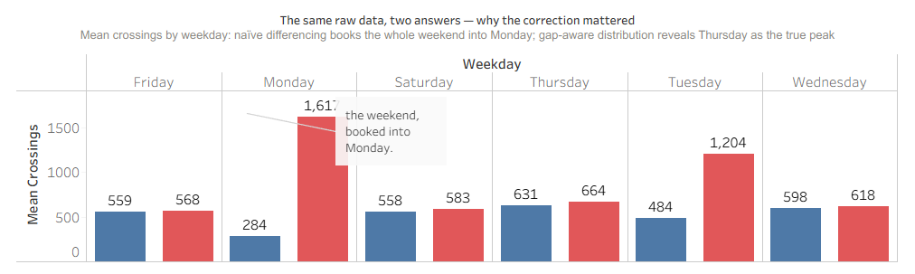
Figure 4.1 The same counter data under naïve differencing (red) and gap-aware distribution (blue). The spurious Monday peak collapses; Thursday emerges as the true busiest day.
What the correction does not fix: it removes a measurement artefact without upgrading what the counters measure; four limitations remain (Table 4.4).
Table 4.4 Residual limitations after the correction
Residual limitation | Consequence for interpretation
(i) Crossings, not unique visitors | Groups, re-entries and staff movements (estimated on site at under 100 crossings/day) are all counted; levels are an upper-bound activity index even where patterns are reliable
(ii) Gate overlap | One person entering at the North doors, visiting the Vaults and leaving by the South doors crosses three beams; the building series is a crossings index, and gate figures are never summed into a claimed headcount
(iii) Apportioned weekend values | Saturday–Monday values assume a uniform split of multi-day increments - the identical 1,862-crossing values for Sunday 3 and Monday 4 May 2026 make the assumption visible
(iv) Unrecoverable gaps | Days with no reading cannot be reconstructed; residual gaps are reported as coverage, never filled

4.4 Corroboration and Confirmation of Analysis-Readiness
Readiness is claimed in bounded language: independent sources can support the corrected series at pattern level; they cannot validate exact visitor numbers, and no such claim is made. Convergence with prior knowledge: the corrected Thursday peak and 75.4 per cent North share match the sponsor's account and the previous cohort's ~75 per cent estimate. Proxy corroboration: café takings, an independent system, follow the same weekly rhythm and co-move with footfall monthly (r ≈ 0.97 over ten overlapping months; daily r ≈ 0.49) - pattern-level agreement as the proxy literature predicts (Kleiminger, Beckel and Santini, 2015): corroboration, not confirmation, of counts. Internal consistency: after correction the mean (484.9) sits close to the median (447.0) - the earlier extreme skew was an accumulation artefact, not demand. The dataset is therefore confirmed ready for descriptive pattern analysis and dashboard development - not for unique-visitor counting or causal inference - subject to Section 4.3's caveats, with coverage accompanying every figure.

4.5 Descriptive Statistical Profile - and What It Means for Management
Each variable was profiled before interpretation, in the spirit of exploratory data analysis (Tukey, 1977), z-score standardised across scales for comparability (Table 4.5; Hair et al., 2019). Every attendance variable is right-skewed: a minority of event days stretches the right tail, so the mean exceeds the median throughout (building total 484.9 vs 447.0; Figure 4.2). The magnitudes matter: café sales sit inside the |skewness| < 2, |kurtosis| < 7 robustness envelope (West, Finch and Curran, 1995); the attendance counts far exceed it (skewness 3.2–4.8, kurtosis 20–28) and Shapiro–Wilk rejects normality throughout (p < 0.001; Shapiro and Wilk, 1965) - medians, interquartile ranges and non-parametric methods are required, not merely preferred. Extreme days are information, not noise: the largest cluster on event days (1 May 2026: 3,682 crossings) and are analysed as a segment, not deleted (Figure 4.3); Table 4.6 translates the profile into managerial meaning.
Table 4.5 Descriptive statistics of the prepared variables
Variable | Unit | n | Mean | Median | SD | IQR | Skewness | Kurtosis | Shapiro p
Daily building footfall | crossings/day | 326 | 484.9 | 447.0 | 335.1 | 342.0 | +3.64 | 26.91 | <0.001
North Entrance daily | crossings/day | 328 | 363.4 | 337.5 | 251.8 | 268.5 | +3.36 | 24.54 | <0.001
South Entrance daily | crossings/day | 330 | 57.6 | 51.5 | 40.8 | 47.2 | +3.17 | 20.72 | <0.001
Vaults daily | crossings/day | 325 | 61.3 | 30.0 | 99.7 | 55.0 | +4.79 | 28.42 | <0.001
Café gross sales (ex. anomaly) | £/day | 270 | 2,364.4 | 2,337.2 | 618.9 | 735.3 | +0.64 | 1.98 | <0.001
Working Lounge occupancy | people/hour | 2,304 | 2.2 | 2.0 | 2.8 | 3.0 | +3.90 | 28.23 | <0.001
Note. All skewness values are positive (right-skewed).
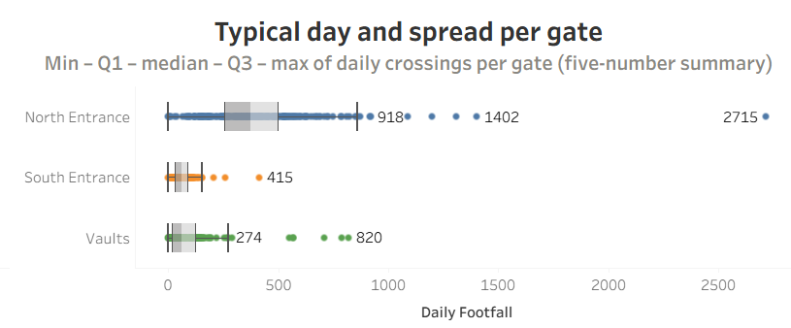
Figure 4.2 Distribution of daily building footfall with kernel density; the mean sits right of the median - the signature of right skew.
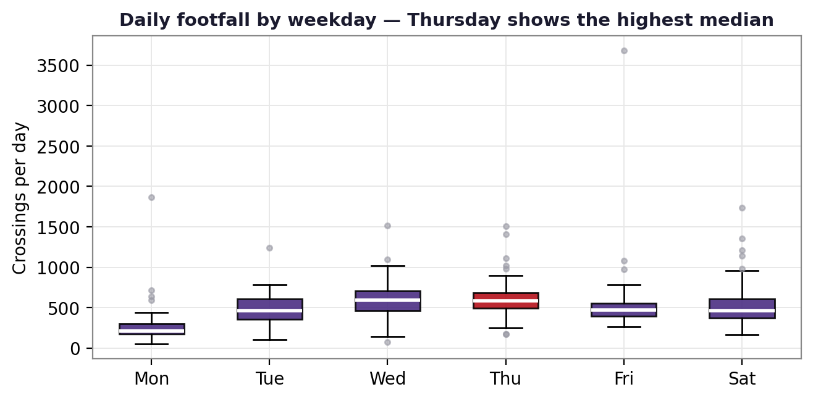
Figure 4.3 Box-and-whisker plots by weekday: Thursday has the highest median; high outliers mark event days rather than errors.
Table 4.6 Managerial reading of the descriptive profile
Statistical finding | Practical, managerial meaning
Mean (484.9) > median (447.0) for daily footfall | A minority of busy event days pulls the average up. Plan routine staffing around the median “typical day” of ≈447 crossings; plan stewarding and capacity for the event tail (up to 3,682)
High kurtosis (20–28) in all attendance series | Extreme days are rare but recurrent - treat them as a plannable event segment, not one-off surprises
Normality rejected for every variable (Shapiro–Wilk p < 0.001) | Averages and standard deviations mislead on their own; dashboards and reports headline medians and interquartile ranges
Vaults median 30 vs mean 61.3 (max 820) | The Vaults are normally quiet but spike for events: a programme-driven space whose staffing should follow the events calendar, not an average
Working Lounge mean 2.2 people/hour against capacity 60 | Chronic under-use (~4–6% of capacity): a candidate for repurposing, promotion or hire - a space-allocation decision the dashboard monitors
Café sales only mildly skewed (+0.64) | Café demand is comparatively stable; weekday-pattern-based rostering and stock planning are reliable

5. Findings and Dashboard Results
All attendance figures below are corrected crossings (Section 4.3) and carry their coverage.

5.1 Technology Evaluation Results (RQ1)
Six options were scored by the method of Section 3.2 (Table 5.1), following the evidence hierarchy - independent tests (dos Santos et al., 2022; Uras et al., 2022; Drahanský et al., 2023), regulatory guidance, site observation, vendor claims last; Table 5.2 states the rationale behind every score, and cost scenarios are assessed against the sponsor's budget (Section 6.2).
Table 5.1 Weighted multi-criteria scores
Option (scores 1–5) | Heritage (0.25) | Privacy (0.20) | Operational (0.20) | Cost (0.20) | User (0.15) | Weighted total
A. Break-beam counters retained + improved reading protocol | 5 | 5 | 3 | 5 | 4 | 4.45 (rank 1)
B. Thermal / passive-infrared overhead sensors (room-level) | 4 | 4 | 4 | 3 | 4 | 3.80 (rank 2)
E. Bookings / QR / ticketing (events & tours complement) | 5 | 3 | 2 | 4 | 4 | 3.65 (rank 3)
F. Manual tally (ground-truth role only) | 5 | 5 | 2 | 2 | 3 | 3.50 (rank 4)
C. Depth / stereo-video people counter | 2 ✗gate | 3 | 5 | 2 | 3 | 2.95 (excluded)
D. Wi-Fi / Bluetooth probe analytics | 4 | 2 ✗gate | 2 | 3 | 3 | 2.85 (excluded)
Note. ✗gate: fails the minimum feasibility threshold (score < 3 on heritage or privacy) and is excluded regardless of total. Declared cost scenarios: A - no new capital (counters installed), negligible running cost; B - low-to-moderate capital per room sensor, within the budget; C - high capital plus installation and assessment, exceeding the budget; D - moderate capital plus licensing; E - minimal capital reusing existing booking systems; F - no capital but sustained staff time.
Table 5.2 Score justification for Table 5.1
Option | Rationale for the five scores (Heritage · Privacy · Operational · Cost · User)
A. Break-beam + protocol | Heritage 5 - already installed; no new intervention to protected fabric. Privacy 5 - stores no image or identifier. Operational 3 - counts crossings, not people: misses side-by-side entries, re-counts re-entries, and field accuracy is deployment-dependent (dos Santos et al., 2022). Cost 5 - no new capital; negligible running cost. User 4 - simple to read, but manual logging remains a burden until R1's logging upgrade.
B. Thermal / PIR sensors | Heritage 4 - battery or surface mounting is reversible, though conservation confirmation is still required (Historic England, 2021). Privacy 4 - image-free by design (Drahanský et al., 2023); a screening assessment is still specified. Operational 4 - strong room-level presence and count performance indoors. Cost 3 - low-to-moderate capital per room, within the budget. User 4 - simple gateway reporting.
E. Bookings / QR | Heritage 5 - nothing installed. Privacy 3 - booking records hold personal data, so minimisation applies. Operational 2 - captures scheduled events only and misses free walk-ins, the venue's defining flow. Cost 4 - reuses existing systems. User 4 - familiar staff workflow.
F. Manual tally | Heritage 5 - nothing installed. Privacy 5 - a tally holds no personal data. Operational 2 - labour-intensive and inconsistent: the 2022–2025 record achieved only 52–81% coverage (Section 4.4). Cost 2 - sustained staff time. User 3 - easy but tedious, so quality decays.
C. Depth / stereo-video | Heritage 2 (gate) - ceiling mounting and cabling in protected interiors is hard to justify (Historic England, 2021). Privacy 3 - image-free outputs are possible but a DPIA is required (Section 2.5). Operational 5 - the highest counting accuracy where mounting suits. Cost 2 - high capital plus installation and assessment. User 3 - calibration and maintenance overhead.
D. Wi-Fi / Bluetooth | Heritage 4 - reuses existing infrastructure. Privacy 2 (gate) - device MAC addresses can be personal data (Information Commissioner's Office, 2022). Operational 2 - MAC randomisation degrades counting (Uras et al., 2022). Cost 3 - moderate, with licensing. User 3 - analytics-platform overhead.
Note. Scores follow the Section 3.2 evidence hierarchy; feasibility-gate failures are marked in Table 5.1.
Sensitivity. Varying the heritage, privacy and cost weights by ±10 and ±20 percentage points (others re-scaled proportionally) leaves option A first in all twelve scenarios (totals 4.30–4.60; Table 5.3); even a stress test raising the operational-efficiency weight by 20 points - the scenario most favourable to sensor upgrades - leaves A first (4.09 vs 3.85).
Table 5.3 Sensitivity of the ranking to re-weighting
Weight varied | Scenario range | Leader (weighted total) | Runner-up
Heritage compliance | 0.05 – 0.45 (±20 pp) | A in all four scenarios (4.30 – 4.60) | B at lower weights; E at higher
Data privacy | 0.00 – 0.40 (±20 pp) | A in all four scenarios (4.31 – 4.59) | E / B / F across the range
Cost-effectiveness | 0.00 – 0.40 (±20 pp) | A in all four scenarios (4.31 – 4.59) | B at lower weights; E at higher
Stress: operational +20 pp | 0.40 | A (4.09) | B (3.85)
Note. Option A leads in every scenario tested.
The clear answer to the client's question: the existing break-beam counters are sufficient - provided the reading protocol is improved; The Exchange does not need a different primary technology. The devices' weaknesses stem from how they are read, not what they sense (Section 4.3), and the protocol upgrade - fixed reading time with weekend capture, reset log, never-sum rule, quarterly ground-truth checks - needs staff time rather than capital (R1, Table 6.1). Two qualified additions follow, affordable within the budget (Table 6.3): a thermal/PIR pilot in one or two priority rooms - image-free time-of-flight/thermal units are battery- or LoRa-capable, suiting a listed interior (Terabee, 2023) - conditional on privacy screening and conservation confirmation (R5); and booking/QR records as an events-and-tours complement. Camera- and Wi-Fi-based options fail a feasibility gate and would anyway require a data protection impact assessment and institutional review (Section 2.5). Caveats: options B–D are scored on published evidence, not on-site trials; costs await quotes; regulatory change triggers re-assessment.

5.2 Seasonal and Monthly Patterns (RQ2a)
The corrected year shows clear academic-calendar seasonality (Figure 5.1): March 2026 is the highest complete month (20,367 crossings over 31 recorded days), and May and April close behind with a secondary autumn peak; the troughs are August 2025 (10,030) and Christmas (December 2025: 8,274 over 20 recorded days). In total the series records 158,093 crossings across 326 open days (2 July 2025 – 11 June 2026). Decision link: programming and staffing follow the term rhythm; the troughs are the natural maintenance windows; month-on-month comparisons must quote recorded-day counts.
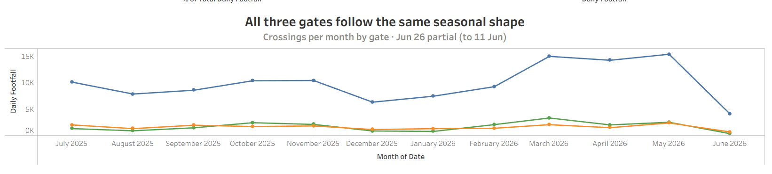
Figure 5.1 Monthly corrected crossings, July 2025 – June 2026 (June 2026 partial: 11 days). Recorded-day counts accompany each month on the dashboard.

5.3 The Weekly Rhythm (RQ2b)
The weekday profile (Figure 5.2) confirms half the sponsor's intuition and corrects half: Thursday is the busiest day (mean 631), with late-opening Wednesday close behind (598) - the sponsor corroborated; but Friday is not the quietest day (559), sitting level with Saturday (558) - the quiet days are Sunday (272) and Monday (284). The café proxy reproduces the pattern independently - Thursday takings peak at £2,722, Monday lowest at £2,070. Saturday–Monday levels are partly apportioned (Section 4.3): ordering stable, levels estimates. Decision link: staffing and café rostering peak Wednesday–Thursday, not Friday by default; Monday is the light-staffing day; apparent Saturday activity warrants direct observation before weekend service changes.
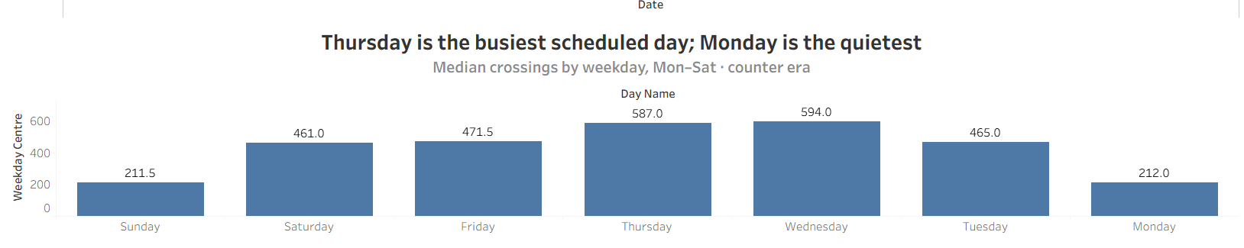
Figure 5.2 Mean corrected crossings by weekday: Thursday busiest; Sunday and Monday quietest. Saturday–Monday values are partly apportioned (Section 4.3).

5.4 Within-Day Occupancy: the Working Lounge (RQ2c)
The venue's only within-day signal builds from near-empty at 08:00 (mean 0.2) to a plateau of ≈3.6 people at 13:00–14:00, tailing to 0.6 by 18:00 (Figure 5.3); Thursday is busiest here too (mean 3.1). The absolute level is the sharper finding: the peak is ≈6 per cent of the room's capacity of 60. Coverage: 2,304 of 4,895 hour-slots (47 per cent) carry a value; the profile is indicative. Decision link: presence-based staffing is unneeded outside 11:00–16:00; sustained single-digit occupancy makes the room the clearest space-allocation question - promote, repurpose or offer for hire.
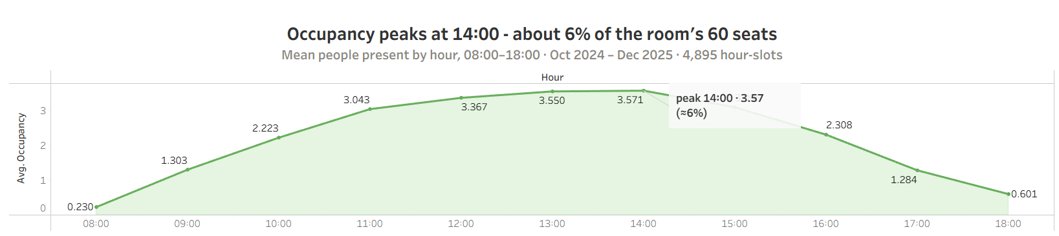
Figure 5.3 Working Lounge mean occupancy by hour (Oct 2024 – Dec 2025; 47% of hour-slots recorded). Peak ≈14:00 at ≈6% of capacity.

5.5 Footfall by Entrance and Proxy Corroboration (RQ2d)
The North entrance dominates with 75.4 per cent of corrected crossings; the South carries 12.0 and the Vaults 12.6 per cent (Figure 5.4). The gates differ in kind: the North is high and regular (median 337.5/day); the South is a steady low flow (median 51.5); the Vaults are event-driven (median 30, mean 61.3, maximum 820). Because one person can cross more than one beam, shares describe crossing activity, not exclusive routes (Section 4.3). Monthly café revenue and monthly footfall co-move at r ≈ 0.97 across ten overlapping months, and both series peak on Thursday (Figure 5.5), with daily r ≈ 0.49 - pattern-level, not count-level, agreement (Kleiminger, Beckel and Santini, 2015). The energy series is retained for future corroboration. Decision link: reception, wayfinding and future sensor investment concentrate at the North doors; Vaults staffing follows the events calendar; proxy agreement grounds confidence in reported patterns - corroboration, not validation.
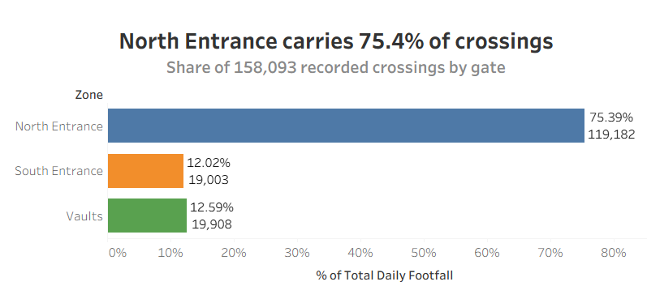
Figure 5.4 Share of corrected crossings by gate (labels state exact shares; beams overlap, so shares describe activity, not exclusive routes).
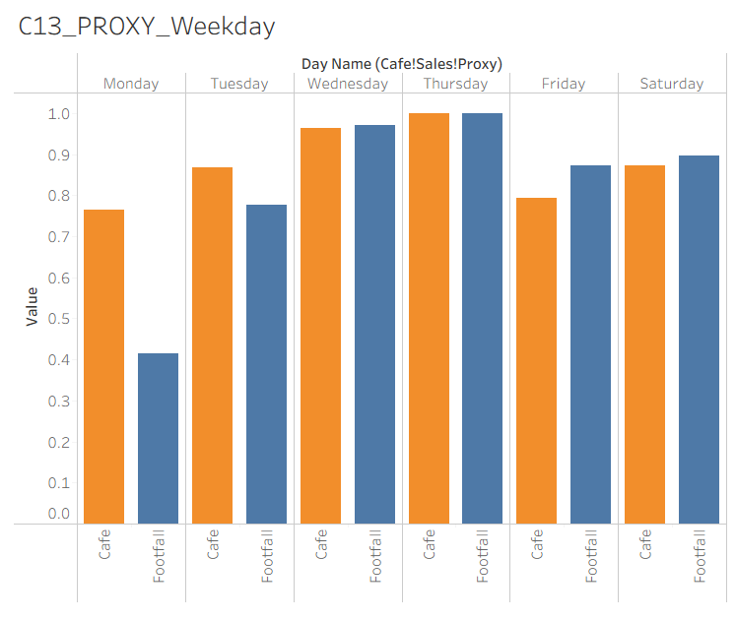
Figure 5.5 Weekday profiles of footfall and café sales, each normalised to its own peak: both peak on Thursday.

5.6 Dashboard Structure and Results (RQ3)
The dashboard operationalises the project's principle - each measure presented for the decisions it is fit for, with its quality visible. It is implemented as seven Tableau Public pages each defined by purpose, audience, decisions, filters and quality warnings (Table 5.4). It is interactive, as the sponsor requested: date, space and gate filters propagate across all views, and every filter carries a hover tooltip stating what it filters and the caveat that applies. Three rules bind every page (Sections 2.7, 4.2): no trend crosses the method change, the eras shaded distinctly; every metric carries its coverage; closed days render as “closed”, never zero.
Table 5.4 The seven-page dashboard: pages, decisions, filters and warnings
Page | Purpose | Primary audience | Decisions supported | Key filters | Quality warnings shown
1. Executive Overview | Headline KPIs: median typical day (447), monthly trend, weekday profile, gate split | Director / venue management | Overall performance review; reporting upward | Date range; era | Coverage %; “crossings ≠ visitors” note
2. Footfall by Entrance | Per-gate daily series, shares and medians | Operations | Reception & wayfinding; entrance staffing; sensor placement | Gate; date; weekday | Gate overlap caveat; reset exclusions
3. Room Usage & Utilisation | Layer 1 room counts vs capacity denominators | Space planning | Space allocation, repurposing, hire | Space; year | Snapshot-method note; capacity vintage
4. Working Lounge Hourly Profile | Hour-by-hour occupancy curve and heat-map | Operations / space planning | Within-day staffing; promotion of under-used space | Hour; weekday; term | 47% slot coverage; single-space scope
5. Weekly & Seasonal Patterns | Weekday and monthly rhythms, event-day segment | Managers / programming | Rotas; opening hours; programming calendar; maintenance windows | Month; weekday; event flag | Apportioned weekend note; recorded-day counts
6. Proxy Comparison | Footfall vs café sales (monthly and weekday), r statistics | Management / finance | Confidence in reported patterns; café rostering and stock | Month; weekday | “Corroboration, not validation”; May-2026 anomaly excluded
7. Data Quality & Coverage | Coverage heat-map by month × layer; flags; audit summary | All users; data owners | Recording practice; where to trust, where to fix | Layer; year; flag type | MNAR explanation; unexplained-blank counts
Note. Every filter on every page carries an explanatory tooltip - what it filters, the measure it applies to, and the caveat that travels with it.
The Executive Overview (Figure 5.6) is the Director's screen: period totals (158,093 crossings; mean 485, median 447), the daily series with event days flagged above mean + 2SD (1,155), the weekday profile and the footfall–café scatter. The Working Lounge heat-map (Figure 5.7) is the within-day staffing view: occupancy concentrates 11:00–16:00, peaks on Thursday afternoons (mean 4.9 at 14:00) and is absent on Sundays. The Proxy Comparison view (Figure 5.8) plots monthly footfall against café takings (r ≈ 0.97; May 2026 excluded). Views that broke the binding rules (a zone chart summing snapshots with uncorrected crossings; month-on-month bars distorted by partial months) were rejected during prototyping.
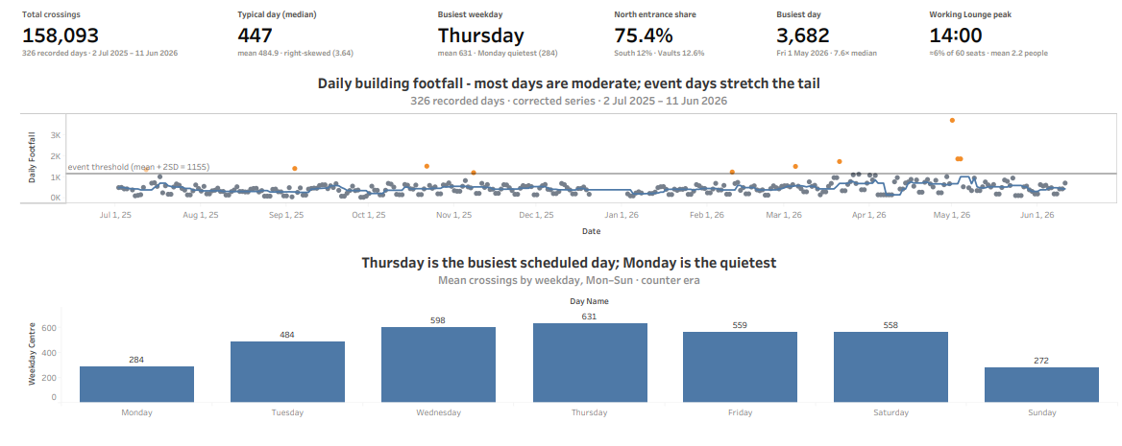
Figure 5.6 The implemented Executive Overview page: reporting-period KPIs, anomaly-flagged daily footfall (threshold = mean + 2SD), weekday profile and footfall–café scatter.
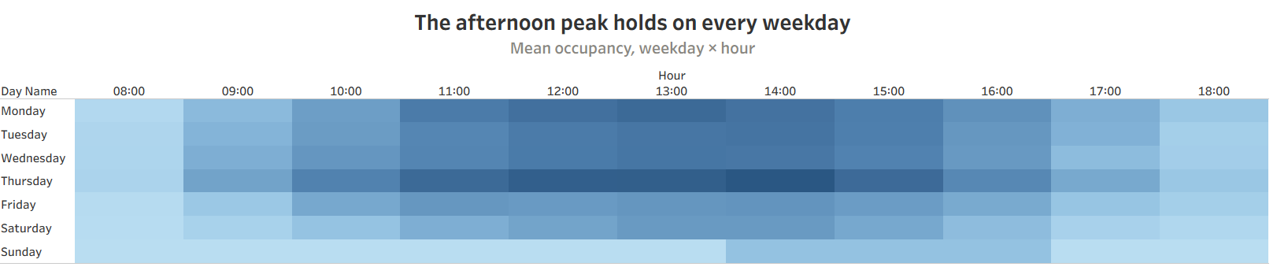
Figure 5.7 Working Lounge day × hour heat-map (Oct 2024 – Dec 2025): mean occupancy by weekday and hour; the Thursday 14:00 peak (4.9) stands out, Sundays are empty.
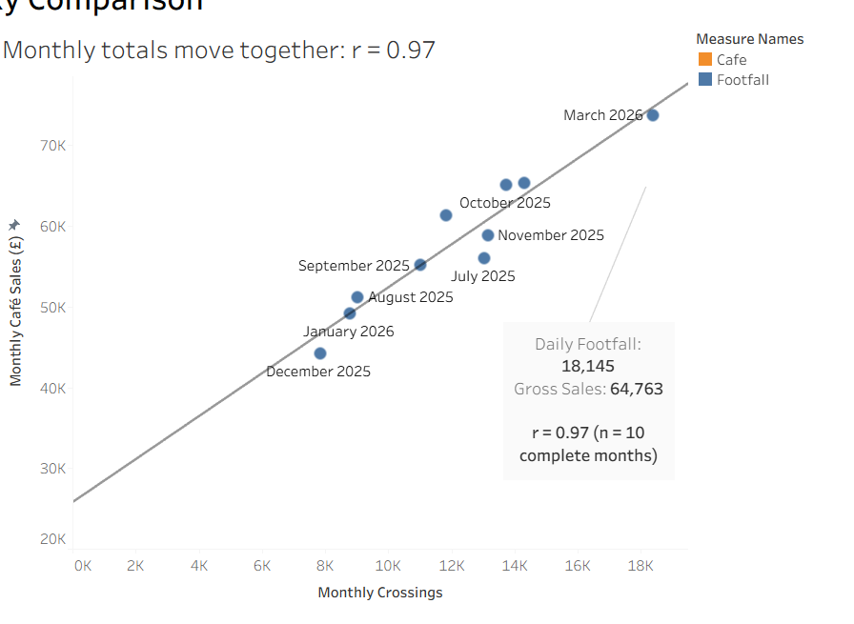
Figure 5.8 Proxy Comparison: monthly footfall (left axis) and café gross sales (right axis) move together, r ≈ 0.97; May 2026 excluded as anomalous.

5.7 Summary against the Research Questions
Table 5.5 Findings against the research questions
RQ | Headline answer | Decision supported
RQ1 | Retain the break-beam counters with an improved reading protocol (4.45/5; first in all sensitivity scenarios); optional thermal pilot; camera/Wi-Fi options fail feasibility gates | Technology and investment choice
RQ2a | Academic-calendar seasonality: March 2026 peak (20,367 crossings); troughs in late summer and at Christmas | Programming; opening hours; maintenance windows
RQ2b | Thursday busiest (631) and Wednesday strong (598) - sponsor corroborated; Friday not quietest (559): Sunday (272) and Monday (284) are the quietest | Staffing rotas; café rostering
RQ2c | Working Lounge peaks 13:00–14:00 at ≈3.6 people, ≈6% of capacity 60 | Within-day staffing; space repurposing
RQ2d | North gate 75.4% of crossings; Vaults event-driven; café proxy corroborates patterns (monthly r ≈ 0.97) | Entrance operations; confidence in reporting
RQ3 | Two-layer integration with quality flags and coverage; seven-page decision-mapped dashboard implemented in Tableau Public | Funding & civic reporting; data governance

6. Discussion, Recommendations and Limitations

6.1 Discussion
The findings bear on the three propositions of Section 2.10: constraint fit over raw accuracy (P1), measurement quality over data volume (P2) and decision alignment over sophistication (P3). P1 is supported: the evaluation was decided by constraint fit - the most accurate option (depth-video) fell at the heritage gate; the winner's advantage was zero incremental risk under both gates. P2 is clearly supported: the largest gain came from re-interpreting existing readings, not more data - the weekend correction reversed the apparent weekly pattern and reconciled the series with two independent accounts (Wang and Strong, 1996). P3 is embedded in the design: each dashboard page exists because a named decision requires it (Table 5.4; Goodhue and Thompson, 1995). More broadly, the results behaved as the literature predicts - MNAR missingness, pattern-level proxy agreement, heavy tails requiring robust summaries. Where results depart from the sponsor's prior beliefs - Friday is not the quiet day; Saturday activity is material - better measurement changes decisions; both are flagged for direct observation before action.

6.2 Recommendations and the Implementation Budget
Table 6.1 sets out six recommendations, each anchored to the evidence that produced it and ranked by an explicit rule: dependency first, then evidence certainty, then value per pound of total cost - staff time counted as a real cost throughout, so nothing is treated as free. R1 leads because every later action inherits its data; R2–R3 lock in and operationalise the corrected series; R4 is the first pure value capture from it; the sole capital item (R5) follows only once approvals and quotes exist; R6 runs across terms. Table 6.2 attaches a measurable success target and the risk of non-implementation to each, following the SMART convention for actionable objectives (Doran, 1981). Table 6.3 allocates the sponsor's confirmed budget and prices the plan's ≈136 hours of year-one staff time in kind, and Table 6.4 sequences delivery as a sponsor-facing roadmap. Costs are ceilings from indicative ranges, to be confirmed by quotes; if the pilot fails R5's conditions, its allocation reverts to the counter data-logging upgrade or is returned. The set is robust: the same recommendations follow under every moderate re-weighting of the evaluation (Table 5.3).
Table 6.1 Recommendations in priority order
Recommendation | Detail | Decision area served | Evidence base | Priority - why this rank | Staff time (est., year 1)
R1. Adopt the improved counter-reading protocol | Fixed daily reading time with weekend capture (or automated logging/export if supported); written reset log; never-sum reporting rule; a photograph of each display at reading; quarterly ground-truth checks per entrance | Technology; reporting integrity | 4.3 weekend artefact (Fig. 4.1); 5.1 evaluation - first in all 12 scenarios | 1st (immediate) - prerequisite: every later action inherits its data; highest certainty at the lowest total cost | ≈60 h/yr: ≈10 min/day reading; set-up; quarterly ground-truth checks
R2. Formalise recording governance | One recording template; canonical space names; the Quality_Flag convention of Table 4.2 (“closed” ≠ blank ≠ zero); monthly coverage review on Page 7 | Data governance; utilisation evidence | 4.1–4.2: 1,375 duplicates, 237 recovered notes, renamed spaces | 2nd (immediate) - locks in R1's gains before definitions drift again; high value per staff-hour | ≈16 h yr 1: 4 h set-up; ≈1 h/month coverage review
R3. Adopt the dashboard and its KPI definitions | Maintain the published seven-page Tableau Public dashboard; headline the median “typical day” (447 crossings); report coverage beside every figure; keep eras separated | Staffing; hours; funding & civic reporting | 4.5 right-skew (Table 4.6); 2.7 task–technology fit | 3rd (weeks) - turns R1–R2's data quality into decisions; no licence fee (Tableau, no date), so its cost is staff time alone | ≈14 h/yr: termly refresh; monthly reporting
R4. Staff to the measured rhythm | Peak provision Wednesday–Thursday; light Monday; café rosters and stock follow the weekday sales pattern; Vaults staffing follows the events calendar | Staffing & rotas; café planning | 5.3 weekday means (Fig. 5.2); 5.5 Vaults profile; café proxy | 4th - first direct payoff from the corrected series; depends on R1–R3 keeping that series true | ≈7 h/yr rota planning; staffed hours reallocated, not added
R5. Pilot one or two thermal/PIR room sensors (conditional) | Working Lounge or Vaults pilot; screening data-protection assessment; conservation-officer confirmation of reversible mounting; evaluate against manual ground truth for one term | Space utilisation; technology | 5.4: peak ≈6% of 60 seats; 5.1 option B rank 2 | 5th (one term) - the sole capital item, deliberately last: spends only after approvals, quotes and R1 ground truth exist | ≈27 h one-off: DPIA screening, approvals, install, ground-truth counts, evaluation
R6. Close the evidence gaps | Obtain event/booking/tour records from the holding teams; confirm capacity documents annually; re-run the pipeline each term and refresh the descriptive profile | Funding case; programming | 2.9 research gap; 5.2 unattributed peaks | 6th (ongoing) - enabler whose value accrues across terms; blocks nothing, so sequenced last | ≈12 h/yr: correspondence; annual capacity confirmation
Note. Ranked by dependency, then evidence certainty, then value per pound of total cost. Each row gives the decisions served, the evidence defending the recommendation, and the staff time it consumes (estimates; year-one total ≈136 hours, valued in kind in Table 6.3).
Table 6.2 Success metrics and risk of non-implementation
Rec. | Success metric (target · when measured) | Risk if not implemented
R1 | Counter coverage ≥95% of open days including weekends within one term; quarterly ground-truth error documented, with mean absolute percentage error ≤10% as the working threshold; entry-error rate (monthly sample of entries checked against photographs) below 1% | The weekend artefact returns with the next reporting cycle: decisions revert to a series whose busiest day is wrong (Monday 1,617 vs true 284)
R2 | 100% of new records carry canonical space names and the closed ≠ blank ≠ zero convention; unexplained blanks fall term on term (baseline: 2,618) | Definitions drift again - renames and mixed conventions rebuild, within a year, exactly the fragmentation this project removed
R3 | Dashboard reviewed at the monthly management meeting; termly refresh completed; the median typical-day KPI (447) quoted in upward reporting | Reporting reverts to anecdote and event-inflated averages; the funding and civic-impact case stays unevidenced
R4 | Rota hours track the demand curve - peak provision Wednesday–Thursday - at no increase in total staffed hours | Staffing keeps over-covering the quiet days (Sun 272 / Mon 284) and under-covering the demonstrated peak (Thu 631)
R5 | Pilot sensor ≥90% uptime; 100% open-hours coverage in the pilot room for one term; a documented promote / repurpose / hire decision follows | The Working Lounge question stays unanswerable and a 60-seat space continues at single-digit utilisation
R6 | Event, booking and tour records received and joined to the dataset; ≥80% of peak days attributable to a documented cause | Peaks stay unexplained, so programming cannot learn from them and month-on-month reporting stays incomplete
Note. Targets are measurable within one to two terms (Doran, 1981) and reviewable on the dashboard’s Data Quality page.
Human error. Every counter-era reading passes through a person - read from a display, typed into a workbook - and human-error research is unambiguous that this step cannot be made error-free by care alone. Base error rates for simple entry tasks run at one to five per hundred actions, experience reduces them by at most half, and checking figures for reasonableness catches few of the errors made (Panko, 2000; Panko, 2015); automated checkers perform little better on naturally occurring errors (Aurigemma and Panko, 2010). The plan therefore treats human error as a design problem rather than a training problem: the template removes the opportunities for the slips that dominate the historical record, the pipeline takes calculation out of staff hands, a photograph of each display gives every entry an independent check at negligible cost in staff time, and an entry-error metric makes the residual error visible rather than assumed. The counter-logging upgrade (B5) is the only measure that eliminates transcription outright; it does not remove the need for ground-truth checks, since errors then move to configuration and interpretation.
Table 6.3 Full cost of the plan against the sponsor's budget
Item | Purpose (recommendation served) | Basis | Capital ceiling | Cumulative capital
B1 | Reading protocol, reset log, recording template and governance (R1, R2) | Working-practice change; ≈76 h/yr staff time (Table 6.1), costed in kind | None - in-kind staff time | £0
B2 | Dashboard hosting and termly refresh on Tableau Public (R3) | No licence fee on the free tier (Tableau, no date); ≈14 h/yr staff time (Table 6.1), costed in kind | None - in-kind staff time | £0
B3 | Ground-truth kit: mechanical tally counters and log sheets for quarterly checks (R1) | Low-cost consumables; checking time is within R1's hours (Table 6.1) | £40 | £40
B4 | Thermal/PIR pilot: one or two image-free room sensors with LoRa gateway and reversible mounting (R5) | Low-to-moderate capital class - image-free units on battery/LoRa links avoid mains cabling and personal-data processing (Terabee, 2023); conditional on DPIA screening and conservation confirmation; ≈27 h staff time (Table 6.1) | £1,400 | £1,440
B5 | Counter data-logging/export upgrade if the installed devices support it - removing the weekend-reading gap at source (R1); otherwise second-phase sensor or returned | Conditional; quote-dependent | £1,300 | £2,740
B6 | Contingency (≈ 8.7 per cent) | Standard project allowance | £260 | £3,000
Note. Capital ceilings from indicative market ranges; procurement quotes to confirm; unspent conditional allocations return to the sponsor. B1–B2 draw no capital but are not cost-free: every recommendation is costed in staff time in Table 6.1 - ≈136 hours in year one, ≈£1,730 valued in kind at the £12.71/hour National Living Wage (GOV.UK, 2026) - a real cost the plan states rather than hides.
Table 6.4 Implementation roadmap
Phase | Actions | Owner | Depends on
Weeks 0–2 · Adopt | Protocol live with weekend capture and reset log; recording template issued; dashboard bookmarked by management and the median KPI adopted in reporting (R1–R4 start) | Venue Manager | Handover pack (this report, dataset, pipeline, dashboard)
Weeks 2–6 · Embed | First quarterly ground-truth check per entrance; first monthly coverage review on the Data Quality page; procurement quotes obtained for the sensor pilot and the counter logging upgrade | Venue Manager; Finance | R1–R2 operating
Term 1 · Pilot (conditional) | Screening data-protection assessment; conservation-officer confirmation of reversible mounting; install one–two sensors (B4) and run against manual ground truth | Venue Manager; UoB Data Protection; Conservation Office | Quotes within ceilings; both approvals granted
Term 2 · Decide | Pilot evaluation against ground truth; documented Working Lounge decision (promote / repurpose / hire); counter logging upgrade if supported (B5); budget reconciliation - unspent returned | Director of Campus Services | One term of pilot and protocol-quality data
Every term · Sustain | Re-run the pipeline on the term's files; refresh the dashboard; confirm capacity documents; review Table 6.2 metrics | Nominated data owner | R6 records request progressed
Note. Adopt, embed, pilot, decide, sustain. No step commits capital before its evidence and approvals exist; each phase’s exit condition is the entry condition of the next. The staff time each phase consumes is part of the Table 6.1 year-one estimates.

6.3 Limitations
Seven limitations bound the claims (Table 6.5); none undermines the deliverable - trustworthy, honestly bounded patterns on which decisions can rest.
Table 6.5 Limitations and their consequence for interpretation
Limitation | Basis | Consequence for interpretation
1. Crossings, not visitors | Counters register beam interruptions: groups, re-entries and staff are all counted | Levels are an upper-bound activity index; patterns are the reliable content
2. Gate overlap | One person can cross the North, South and Vaults beams on a single visit | The building-level series must not be read as a headcount; gates reported separately
3. Apportioned weekends | Saturday–Monday values derive from multi-day increments split uniformly | Weekend/Monday ordering is stable; their levels are estimates
4. Incomplete coverage | Manual-era completeness 52–81% by year; counter-era direct readings ≈82% of days; nothing imputed | Totals understate true activity; coverage accompanies every figure
5. Denominators, proxies and costs | Capacities documented for one year; energy/cost data partial; café is a proxy; budget ceilings and staff-time hours are indicative pending quotes and first-term experience | Utilisation, cost linkage and allocations are indicative; proxies corroborate patterns only
6. Generalisability | Single-venue case study | Transfers as a template and method, not as findings
7. Judgement in the evaluation | MCDA weights/scores are judgements resting partly on published evidence | Mitigated - not removed - by gates, declared cost scenarios and sensitivity analysis

7. Conclusion
This project set out to help The Exchange capture and use attendance data effectively - without pretending the data says more than it does. Its answer to the technology question is deliberately unglamorous: The Exchange already owns primary technology that suits the building; what it lacked was a reading protocol and reporting discipline worthy of it. Its answer to the data question converts four and a half years of fragmented records into a two-layer, audited, analysis-ready dataset whose headline patterns - a median typical day of 447 crossings, a Thursday peak, a dominant North entrance, term-driven seasonality, an under-used Working Lounge - are corroborated by an independent commercial proxy and delivered through a published dashboard in which every figure carries its coverage. Every recommendation is actionable within the sponsor's budget, capital reserved for one conditional, privacy-screened sensor pilot. Beyond the venue, the contribution is a replicable template for measurement under joint heritage and privacy constraints: define the constructs before counting; model a change of instrument as a boundary; treat missingness as evidence; map every metric to the decision it serves. Next steps: hand over the dashboard, pipeline and dataset for termly regeneration, and review the pilot after one term of protocol-quality data.

References
Abade, B., Perez Abreu, D. and Curado, M. (2018) 'A non-intrusive approach for indoor occupancy detection in smart environments', Sensors, 18(11), 3953. doi:10.3390/s18113953.
Aurigemma, S. and Panko, R.R. (2010) 'The detection of human spreadsheet errors by humans versus inspection (auditing) software', Proceedings of the EuSpRIG 2010 Conference. Available at: https://arxiv.org/abs/1009.2785 (Accessed: 26 August 2026).
Cavoukian, A. (2011) Privacy by Design: The 7 Foundational Principles. Toronto: Information and Privacy Commissioner of Ontario.
Centorrino, P., Corbetta, A., Cristiani, E. and Onofri, E. (2021) 'Managing crowded museums: visitors flow measurement, analysis, modeling, and optimization', Journal of Computational Science, 53, 101357. doi:10.1016/j.jocs.2021.101357.
Cleveland, W.S. and McGill, R. (1984) 'Graphical perception: theory, experimentation, and application to the development of graphical methods', Journal of the American Statistical Association, 79(387), pp. 531–554. doi:10.1080/01621459.1984.10478080.
Comai, S., Stabile, G.M., Vavassori, E., Zerilli, M., Masciadri, A. and Salice, F. (2025) 'Review of methods and technologies to detect, count and identify people in indoor environments', Internet of Things, 29, 101466. doi:10.1016/j.iot.2024.101466.
Cowell, B. (2007) 'Measuring the impact of free admission', Cultural Trends, 16(3), pp. 203–224. doi:10.1080/09548960701479375.
DAMA UK Working Group (2013) The Six Primary Dimensions for Data Quality Assessment. DAMA UK.
Department for Culture, Media and Sport (2010) Performance Indicator Guidance 2010/11: Museums & Galleries. London: DCMS. Available at: https://assets.publishing.service.gov.uk/government/uploads/system/uploads/attachment_data/file/71228/Museum-Performance-Indicator_Guidancenote_201011.pdf (Accessed: 27 August 2026).
Department for Culture, Media and Sport (2026) DCMS-sponsored museums and galleries annual performance indicators 2024/25: headline release. Available at: https://www.gov.uk/government/statistics/dcms-sponsored-museums-and-galleries-annual-performance-indicators-202425/dcms-sponsored-museums-and-galleries-annual-performance-indicators-202425-headline-release (Accessed: 27 August 2026).
Doran, G.T. (1981) 'There's a S.M.A.R.T. way to write management's goals and objectives', Management Review, 70(11), pp. 35–36.
dos Santos, R.L., de Oliveira, H.C., de Almeida, M.C., Vieira, D.F., Lacusta Junior, E.P. and Ji, T. (2022) 'A low-cost bidirectional people counter device for assisting social distancing monitoring for COVID-19', Journal of Control, Automation and Electrical Systems, 33, pp. 1148–1160. doi:10.1007/s40313-022-00916-z.
Drahanský, M., Charvát, M., Macek, I. and Mohelníková, J. (2023) 'Thermal imaging detection system: a case study for indoor environments', Sensors, 23(18), 7822. doi:10.3390/s23187822.
European Parliament and Council of the European Union (2016) Regulation (EU) 2016/679 (General Data Protection Regulation). Official Journal of the European Union, L 119, pp. 1–88.
Few, S. (2006) Information Dashboard Design: The Effective Visual Communication of Data. Sebastopol, CA: O'Reilly Media.
Goodhue, D.L. and Thompson, R.L. (1995) 'Task–technology fit and individual performance', MIS Quarterly, 19(2), pp. 213–236. doi:10.2307/249689.
GOV.UK (2026) National Minimum Wage and National Living Wage rates. Available at: https://www.gov.uk/national-minimum-wage-rates (Accessed: 14 August 2026).
Hair, J.F., Black, W.C., Babin, B.J. and Anderson, R.E. (2019) Multivariate Data Analysis. 8th edn. Andover: Cengage Learning.
Historic England (2021) Listed Building Consent: Historic England Advice Note 16. Swindon: Historic England. Available at: https://historicengland.org.uk/images-books/publications/listed-building-consent-advice-note-16/ (Accessed: 3 July 2026).
Huo, H., Shen, K., Han, C. and Yang, M. (2024) 'Measuring the relationship between museum attributes and visitors: an application of topic model on museum online reviews', PLOS ONE, 19(7), e0304901. doi:10.1371/journal.pone.0304901.
Information Commissioner's Office (2022) What is personal data? Available at: https://ico.org.uk/for-organisations/uk-gdpr-guidance-and-resources/personal-information-what-is-it/what-is-personal-data/ (Accessed: 3 July 2026).
Information Commissioner's Office (2022) Guidance on video surveillance including CCTV. Available at: https://ico.org.uk/for-organisations/uk-gdpr-guidance-and-resources/cctv-and-video-surveillance/ (Accessed: 3 July 2026).
Information Commissioner's Office (2025) The Data (Use and Access) Act 2025: what does it mean for organisations? Available at: https://ico.org.uk/about-the-ico/what-we-do/legislation-we-cover/data-use-and-access-act-2025/ (Accessed: 3 July 2026).
Kleiminger, W., Beckel, C. and Santini, S. (2015) 'Household occupancy monitoring using electricity meters', in Proceedings of the 2015 ACM International Joint Conference on Pervasive and Ubiquitous Computing (UbiComp '15). New York: ACM, pp. 975–986. doi:10.1145/2750858.2807538.
Little, R.J.A. and Rubin, D.B. (2019) Statistical Analysis with Missing Data. 3rd edn. Hoboken, NJ: John Wiley & Sons.
Mecocci, A. and Abrardo, A. (2014) 'Monitoring architectural heritage by wireless sensors networks: San Gimignano - a case study', Sensors, 14(1), pp. 770–778. doi:10.3390/s140100770.
Panko, R.R. (2000) 'Spreadsheet errors: what we know. What we think we can do', Proceedings of the Spreadsheet Risk Symposium, European Spreadsheet Risks Interest Group, Greenwich, 17–18 July. Available at: https://arxiv.org/abs/0802.3457 (Accessed: 26 August 2026).
Panko, R.R. (2015) 'What we don't know about spreadsheet errors today: the facts, why we don't believe them, and what we need to do', Proceedings of the EuSpRIG 2015 Conference. Available at: https://arxiv.org/abs/1602.02601 (Accessed: 26 August 2026).
Philp, S., Dolega, L., Singleton, A. and Green, M. (2022) 'Archetypes of footfall context: quantifying temporal variations in retail footfall in relation to micro-location characteristics', Applied Spatial Analysis and Policy, 15(1), pp. 161–187. doi:10.1007/s12061-021-09396-1.
Rubin, D.B. (1976) 'Inference and missing data', Biometrika, 63(3), pp. 581–592. doi:10.1093/biomet/63.3.581.
Saaty, T.L. (1980) The Analytic Hierarchy Process: Planning, Priority Setting, Resource Allocation. New York: McGraw-Hill.
Saaty, T.L. (1990) 'How to make a decision: the analytic hierarchy process', European Journal of Operational Research, 48(1), pp. 9–26. doi:10.1016/0377-2217(90)90057-I.
Sarikaya, A., Correll, M., Bartram, L., Tory, M. and Fisher, D. (2019) 'What do we talk about when we talk about dashboards?', IEEE Transactions on Visualization and Computer Graphics, 25(1), pp. 682–692. doi:10.1109/TVCG.2018.2864903.
Saunders, M., Lewis, P. and Thornhill, A. (2019) Research Methods for Business Students. 8th edn. Harlow: Pearson Education.
Selwood, S. (2002) 'The politics of data collection: gathering, analysing and using data about the subsidised cultural sector in England', Cultural Trends, 12(47), pp. 13–84. doi:10.1080/09548960209390330.
Serrell, B. (1997) 'Paying attention: the duration and allocation of visitors' time in museum exhibitions', Curator: The Museum Journal, 40(2), pp. 108–125. doi:10.1111/j.2151-6952.1997.tb01292.x.
Shapiro, S.S. and Wilk, M.B. (1965) 'An analysis of variance test for normality (complete samples)', Biometrika, 52(3/4), pp. 591–611. doi:10.1093/biomet/52.3-4.591.
Shneiderman, B. (1996) 'The eyes have it: a task by data type taxonomy for information visualizations', in Proceedings 1996 IEEE Symposium on Visual Languages. Los Alamitos, CA: IEEE, pp. 336–343. doi:10.1109/VL.1996.545307.
Spiegelhalter, D., Pearson, M. and Short, I. (2011) 'Visualizing uncertainty about the future', Science, 333(6048), pp. 1393–1400. doi:10.1126/science.1191181.
Strong, D.M., Lee, Y.W. and Wang, R.Y. (1997) 'Data quality in context', Communications of the ACM, 40(5), pp. 103–110. doi:10.1145/253769.253804.
Tableau (no date) Tableau Public. Available at: https://public.tableau.com/ (Accessed: 14 August 2026).
Tayi, G.K. and Ballou, D.P. (1998) 'Examining data quality', Communications of the ACM, 41(2), pp. 54–57. doi:10.1145/269012.269021.
Teixeira, T., Dublon, G. and Savvides, A. (2010) A Survey of Human-Sensing: Methods for Detecting Presence, Count, Location, Track, and Identity. ENALAB Technical Report 09-2010. New Haven, CT: Yale University.
Terabee (2023) How people counter sensors work: a tech comparison. Available at: https://www.terabee.com/how-people-counter-sensors-work-a-tech-comparison/ (Accessed: 14 August 2026).
Triantaphyllou, E. (2000) Multi-Criteria Decision Making Methods: A Comparative Study. Dordrecht: Kluwer Academic Publishers.
Tukey, J.W. (1977) Exploratory Data Analysis. Reading, MA: Addison-Wesley.
UK Government (2025) Data (Use and Access) Act 2025: data protection and privacy changes. Available at: https://www.gov.uk/guidance/data-use-and-access-act-2025-data-protection-and-privacy-changes (Accessed: 3 July 2026).
University of Birmingham (2026a) About The Exchange. Available at: https://www.birmingham.ac.uk/the-exchange/about-the-exchange (Accessed: 3 July 2026).
University of Birmingham (2026b) History and redevelopment. Available at: https://www.birmingham.ac.uk/the-exchange/history-and-redevelopment (Accessed: 3 July 2026).
Uras, M., Ferrara, E., Cossu, R., Liotta, A. and Atzori, L. (2022) 'MAC address de-randomization for WiFi device counting: combining temporal- and content-based fingerprints', Computer Networks, 218, 109393. doi:10.1016/j.comnet.2022.109393.
Vaidya, O.S. and Kumar, S. (2006) 'Analytic hierarchy process: an overview of applications', European Journal of Operational Research, 169(1), pp. 1–29. doi:10.1016/j.ejor.2004.04.028.
Wang, R.Y. and Strong, D.M. (1996) 'Beyond accuracy: what data quality means to data consumers', Journal of Management Information Systems, 12(4), pp. 5–33. doi:10.1080/07421222.1996.11518099.
West, S.G., Finch, J.F. and Curran, P.J. (1995) 'Structural equation models with nonnormal variables: problems and remedies', in Hoyle, R.H. (ed.) Structural Equation Modeling: Concepts, Issues, and Applications. Thousand Oaks, CA: Sage, pp. 56–75.
Wickham, H. (2014) 'Tidy data', Journal of Statistical Software, 59(10), pp. 1–23. doi:10.18637/jss.v059.i10.
Yalowitz, S.S. and Bronnenkant, K. (2009) 'Timing and tracking: unlocking visitor behavior', Visitor Studies, 12(1), pp. 47–64. doi:10.1080/10645570902769134.
Yigitbasioglu, O.M. and Velcu, O. (2012) 'A review of dashboards in performance management: implications for design and research', International Journal of Accounting Information Systems, 13(1), pp. 41–59. doi:10.1016/j.accinf.2011.08.002.
Yin, R.K. (2018) Case Study Research and Applications: Design and Methods. 6th edn. Thousand Oaks, CA: Sage.

Appendix A - Data-Preparation Technical Narrative
This appendix records, in order, the work performed on The Exchange attendance data - every file received, every cleaning decision and its rationale, the measurement problem discovered and corrected, and the checks supporting readiness. It accompanies Chapter 4; everything described regenerates from the raw files in a single run of the pipeline, and every decision is logged in the audit trail (Appendix B).

A.1 The Raw Material
The sponsor supplied the venue's operational records as they exist - roughly fifteen working spreadsheets accumulated over four and a half years by different people for different purposes, not a dataset. Every file was opened and profiled before any processing, yielding the four-family classification of Table 3.2. That classification was the first substantive decision: manual counts and counter readings are not the same quantity measured two ways but different quantities, so the two regimes were committed to separate layers - cleaned, stored and analysed apart, joined only by date, never summed. In time-series terms the venue changed its measuring instrument in mid-2025, and data on either side of such a change must not be spliced into one continuous series.

A.2 Cleaning Decisions and Rationale
Dynamic header detection. The daily sheets do not keep their header row in a fixed position across years, so headers are detected dynamically in every sheet - the difference between a pipeline that survives new files and one that silently misreads them. Blanks are missing, never zero. An empty cell asserts that no one recorded a value; a zero asserts that somebody recorded an empty room; conflating them would deflate every average on under-recorded days. Notes recovered from numeric cells. 237 operational annotations were preserved in a Quality_Flag column (105 replacing uncountable cells, 132 attached as day-level context), so closures remain distinguishable from non-recording. One identity per physical space. Labels were harmonised using the sponsor-confirmed history - the former KBU Office is now the Hilda Lloyd room; the Working Lounge and Graham Turner physically swapped rooms in September 2022 - and three single-letter helper columns duplicating the counters were removed. De-duplication. The two overlapping 2025 workbooks were resolved deterministically in favour of the richer “New” workbook: 1,375 duplicate Date × Space × Method rows removed and logged. After these steps, the attendance data stood as 8,180 manual space-day records (Layer 1) plus 846 usable cumulative readings awaiting transformation.

A.3 The Missingness Diagnosis
Mapping the counter gaps against the calendar showed they fall almost entirely on weekends, and the site visit explained why: counters are read after closing, at about 17:00, on working days only. The probability that a value is absent therefore depends on the day of the week - missing not at random (Rubin, 1976) - which rules out naïve imputation and, more importantly, revealed that the reading routine itself was distorting the derived daily values.

A.4 The Measurement Artefact and its Correction
Because each daily value is the difference of consecutive cumulative readings, Monday readings silently contained the whole weekend. The first descriptive pass made Monday the busiest day (≈1,617 mean crossings) and put the North entrance near 60 per cent of footfall - both contradicting the sponsor's experience and the prior cohort's estimate. The anomaly was traced to the reading routine and corrected by distributing each multi-day increment uniformly across the days it spans, excluding 13 negative or over-long increments (5 North, 3 South, 5 Vaults). The 846 readings became 983 gate-day values; the corrected series reverses the weekday ranking (Thursday 631; Monday 284), settles the North share at 75.4 per cent, and brings the mean (484.9) close to the median (447.0) - each shift corroborated by an independent source (Section 4.4).

A.5 Supporting Sources, Standardisation and Profile
The Working Lounge grid was reshaped to 4,895 tidy hour-records (08:00–18:00; 2,304 carrying values), showing a mid-afternoon peak of ≈3.6 people - about 6 per cent of the room's capacity of 60. The café till reports were parsed into 294 trading days (June 2025 – May 2026); May 2026 - its total lifted to roughly seven times a typical month by a single implausible entry of £350,929 on 30 May - was flagged and excluded from correlation work while retained in the export. The sponsor's capacity document (Banking Hall 714; whole building 943; per-room fire and layout figures) was standardised as the utilisation denominator table. The three analysis variables were z-score standardised for comparability, with raw values retained (Hair et al., 2019). The full statistical profile appears as Table 4.5; the ten exploratory figures regenerate from the pipeline.

A.6 Why the Dataset Is Trusted
Confidence rests on demonstration rather than assertion: convergence of the corrected series with the sponsor's account and the prior cohort's estimate; independent proxy corroboration by café takings (monthly r = 0.97; daily r = 0.49); internal consistency of mean and median after correction; and full auditability - every decision above is recorded in the 31-entry audit trail (Appendix B) and the entire chain regenerates identically from the raw files. Two caveats travel with every figure: counter crossings are a relative index (re-entries and staff included, the latter estimated on site at fewer than 100 crossings per day), and coverage accompanies every reported number.

Appendix B - Data-Quality Audit Trail (31 Entries)
The complete audit trail as written by the pipeline into the analysis-ready workbook (sheet DataQuality_Audit). The pipeline's Stage 7 is labelled “Validate” in the pipeline; consistent with Section 4.4, its checks are corroboration checks and are reported as such in the main text.
Table B.1 The 31-entry data-quality audit trail
Stage | Item | Action | Detail
Extract | Room-usage workbooks | Parsed | 9,555 raw daily space-records; 888 cumulative counter readings set aside for transformation
Clean | 2025 workbook overlap | De-duplicated | 1,375 duplicate Date × Space × Method rows removed (richer “New” workbook retained on conflict)
Clean | Notes inside numeric cells | Preserved as Quality_Flag | 237 operational notes (“no data”, “CLOSED DUE TO SNOW”, “UoB closed day”…); affected counts left missing - blanks ≠ zero
Clean | Space identities | Harmonised | Canonical names applied incl. sponsor-confirmed renames (KBU → Hilda Lloyd; Working Lounge ↔ Graham Turner swap, Sep 2022)
Transform | North Entrance counter | Excluded readings | 5 reset/negative or >7-day-gap increments removed
Transform | South Entrance counter | Excluded readings | 3 reset/negative or >7-day-gap increments removed
Transform | Vaults counter | Excluded readings | 5 reset/negative or >7-day-gap increments removed
Transform | Cumulative readings | Gap-aware differencing | 846 cumulative readings → 983 distributed gate-day footfall values (weekend-accumulation artefact removed)
Transform | Working Lounge hourly log | Reshaped to tidy (Wickham, 2014) | 4,895 hour-records, 08:00–18:00
Transform | Café daily sales | Aggregated; anomaly flagged | 294 trading days; May-2026 total far above trend → excluded from correlation/modelling (kept in export)
Standardise | Footfall / café sales / WL occupancy | z-scored (Hair et al., 2019) | Unit-free comparability; raw columns retained alongside
Describe | Daily building footfall | mean=484.9, median=447.0, SD=335.1 | skew=3.64 (right); kurtosis=26.91; Shapiro p<0.001
Describe | North Entrance daily | mean=363.4, median=337.5, SD=251.8 | skew=3.36 (right); kurtosis=24.54; Shapiro p<0.001
Describe | South Entrance daily | mean=57.6, median=51.5, SD=40.8 | skew=3.17 (right); kurtosis=20.72; Shapiro p<0.001
Describe | Vaults daily | mean=61.3, median=30.0, SD=99.7 | skew=4.79 (right); kurtosis=28.42; Shapiro p<0.001
Describe | Café gross sales (ex. anomaly) | mean=2364.4, median=2337.2, SD=618.9 | skew=0.64 (right); kurtosis=1.98; Shapiro p<0.001
Describe | Working Lounge occupancy | mean=2.2, median=2.0, SD=2.8 | skew=3.90 (right); kurtosis=28.23; Shapiro p<0.001
Visualise | F01_footfall_histogram.png | Figure saved | Histogram + KDE with mean/median markers
Visualise | F02_boxplot_by_gate.png | Figure saved | Tukey boxplots per gate
Visualise | F03_boxplot_by_weekday.png | Figure saved | Weekday boxplots (Thursday highlighted)
Visualise | F04_artefact_before_after.png | Figure saved | Naïve vs corrected weekday means
Visualise | F05_monthly_seasonality.png | Figure saved | Monthly totals (seasonality)
Visualise | F06_weekday_means.png | Figure saved | Weekday means bar (Thursday highlighted)
Visualise | F07_working_lounge_hourly.png | Figure saved | Hourly occupancy curve
Visualise | F08_gate_share.png | Figure saved | Gate share (75/12/13)
Visualise | F09_proxy_agreement.png | Figure saved | Footfall vs café weekly rhythm
Visualise | F10_correlation_heatmap.png | Figure saved | Monthly correlation heat-map
Corroborate* | Busiest weekday = Thursday | PASS | Matches the sponsor's operational account
Corroborate* | North gate ≈ 75% of crossings | PASS | Computed 75.4% vs the prior cohort's independent ~75% estimate
Corroborate* | Café proxy corroborates pattern | PASS | Monthly r = 0.97; daily (weekday) r = 0.49 - pattern-level agreement as the proxy literature predicts
Corroborate* | Mean ≈ median after correction | PASS | Right-skew reduced to expected level; accumulation artefact removed
Note. *Logged under the pipeline’s “Validate” stage label; reported in this document as corroboration (Section 4.4).

Tableau Public: LINK

