Governing Generative AI Before It Reaches Users
Harsh Gupta · October 2026
Abstract. The controls proposed in an earlier MSc report for AI-generated metadata at Netflix (Gupta, 2026) are small, everyday versions of four problems that AI safety research studies: unreliable outputs, optimisation of proxy objectives, shifting user preferences, and human oversight that does not scale. This short report revisits that proposal and maps each of its controls to the AI safety literature. It argues that the design holds for accidental errors but would need stronger assumptions, borrowed from AI control and scalable oversight research, to hold for more capable systems.

1. Introduction
Recommender systems are optimisers that many people meet every day, which makes them a practical place to study AI safety problems. Russell (2019) uses social media content-selection algorithms as an example of misaligned optimisation: a system rewarded for clicks can learn to make users more predictable rather than better served. Netflix is a useful case because its recommender combines many algorithms across several product surfaces (Gómez-Uribe and Hunt, 2015).
The original MSc report proposed an ontology-informed Responsible AI metadata platform for Netflix (Gupta, 2026). Generative models would draft content descriptors, and humans would validate them before they reached recommendation and search. That report was written as a data-management evaluation, not as an AI safety paper. Reading it again against the safety literature shows that several of its controls address problems that Amodei et al. (2016) set out as concrete problems in AI safety, in particular reward hacking and scalable oversight.
This report asks two questions:
- Which AI safety problems does the original design already anticipate, and how?
- Where would the design fail if the generating model were more capable, or if errors were not accidental?

2. The original proposal in brief
The proposal adds a governed layer around Netflix's existing recommender rather than replacing it. It has four connected components (Gupta, 2026):
- a multimodal generative service that drafts candidate descriptors from subtitles, audio-visual features and existing tags
- a human-in-the-loop validation workflow with regional checks and quality thresholds
- an explanation and audit service that records model versions, feature families and validation decisions
- a governance layer that assigns decision rights, access controls, lifecycle rules and escalation routes
The key technical choice is a quarantined store. Generated descriptors are written there first, linked to their source assets, model version, confidence score and reviewer status. Only validated descriptors are promoted into search indexes or recommender features. The original report also recommended a three-phase rollout and argued that the platform should be judged on metadata accuracy, hallucination and regional error rates, calibration and audit completeness, not on engagement alone.
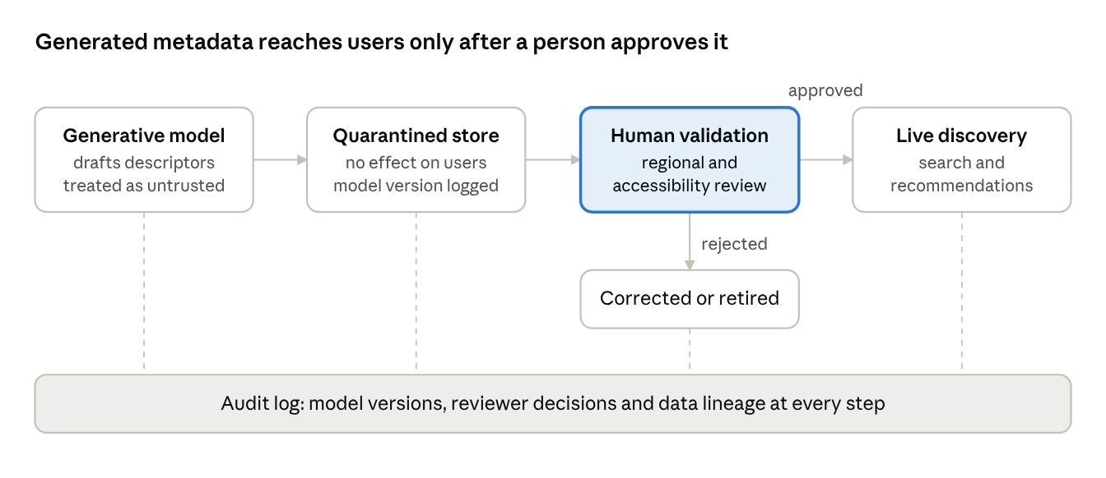
Figure 1. The controlled metadata pipeline in the original proposal. Source: author, based on Gupta (2026)
Nothing the model drafts reaches subscribers until a reviewer approves it, and every step is written to the audit log.

3. Safety problems the design anticipates

3.1 Unreliable outputs
The design treats every generated descriptor as possibly wrong until a person has checked it. This matches what is known about generative models. Ji et al. (2023) show that hallucination, meaning fluent output that is unfaithful to its source, appears across summarisation, dialogue and other generation tasks. The International AI Safety Report also lists reliability failures, including confident falsehoods, among the main risks of general-purpose AI (Bengio et al., 2025). For this reason the original report proposed measuring hallucination and cultural error rates directly, rather than treating metadata completeness as quality.

3.2 Proxy objectives
The original report's main argument was that engagement is the wrong success measure. In safety terms, engagement is a proxy for user value, and optimising a proxy hard enough separates it from the goal. Manheim and Garrabrant (2018) describe several forms of this Goodhart effect, and Amodei et al. (2016) treat reward hacking as a core safety problem. Steck (2018) gives a concrete Netflix example: a recommender tuned for ranking accuracy can push out a user's lesser interests altogether. Tracking calibration and exposure diversity alongside accuracy is therefore a guard against proxy optimisation, not only a fairness check.

3.3 Shifting user preferences
The original ethics section drew on Viljoen (2021) to argue that one subscriber's data shapes how similar viewers are classified. Carroll et al. (2022) take this further, showing that recommenders can change what users want, and proposing that designers estimate these shifts before deployment. The original design only partly covers this. Its cohort-level audits would catch narrowing after it happened, but it had no way to anticipate how the system might change preferences.

4. Oversight and control

4.1 The quarantine as a control protocol
The quarantined store means generated output has no effect until it passes checks. Greenblatt et al. (2024) study the same idea at a larger scale. They treat a capable model as untrusted and test protocols, such as having a weaker trusted model edit its output, that keep safety high even if the capable model is deliberately trying to slip harmful output through. The original design assumed that errors are accidental. An AI control view would ask whether the review sampling and confidence thresholds still hold if the generator learned which descriptors reviewers tend to approve.

4.2 Human validation and automation bias
Human review is only a safeguard if reviewers keep exercising judgment. Parasuraman and Manzey (2010) show that people who use reliable automation become complacent and tend to accept its suggestions, and that these effects appear in experts as well as novices. The original report raised this risk through a sociotechnical lens (Kudina and van de Poel, 2024; Oosthuizen and van't Wout, 2019) and asked for the pilot to evaluate human-AI interaction, not only model accuracy. A practical extension would be to seed review queues with descriptors known to be wrong and track how many reviewers catch.

4.3 Oversight that has to scale
Regional specialists checking culturally specific descriptors is an everyday version of scalable oversight. Bowman et al. (2022) frame this as studying tasks where unaided non-experts cannot judge AI output reliably, and asking whether AI assistance helps them supervise it. As a catalogue grows, reviewers can only sample, so the audit trail matters as much as the review itself. Raji et al. (2020) argue that internal audits need documentation at every stage of development, which is the role the original explanation and audit service was designed to play.

5. Staged deployment and evaluation
The original rollout moves to subscriber-facing features only after quality, privacy and bias thresholds are met. Phase 1 limits the system to internal enrichment for one region and one content category, Phase 2 adds internal explanation dashboards and audit logs, and Phase 3 pilots visible generative features (Gupta, 2026). This follows the same logic as frontier AI policies that tie deployment to evaluation results. Anthropic's Responsible Scaling Policy, for example, requires stronger safeguards once models reach set capability thresholds (Anthropic, 2026). The lesson for a smaller system is that thresholds should be agreed before results are seen, so that a promising engagement figure cannot be used to justify moving on early.
Table 1 summarises how each control maps to the safety literature and what it would need for a more capable generator.
Table 1. Controls in the original design and their AI safety counterparts
Control in the original design | Safety problem addressed | Literature | Needed for a more capable generator
Quarantined store, promotion after validation | Unreliable or harmful output reaching users | Ji et al. (2023); Greenblatt et al. (2024) | Test checks against a generator that may be optimising to pass them
Accuracy, hallucination and calibration metrics instead of engagement | Proxy optimisation, reward hacking | Amodei et al. (2016); Manheim and Garrabrant (2018); Steck (2018) | Agree metrics and thresholds before deployment
Human-in-the-loop regional review | Oversight of output non-experts cannot judge | Bowman et al. (2022) | AI-assisted review, with known-error items to measure reviewer accuracy
Pilot that evaluates human-AI interaction | Automation bias and complacency | Parasuraman and Manzey (2010) | Track reviewer agreement rates over time
Cohort-level audits and exposure diversity | Preference shift and cultural narrowing | Carroll et al. (2022); Viljoen (2021) | Estimate preference shifts before rollout, not only after
Three-phase rollout with thresholds | Deployment ahead of evidence | Anthropic (2026); Bengio et al. (2025) | Independent sign-off at each gate
Source: author, based on Gupta (2026) and the sources listed.

6. Limits of the analysis
This is a desk-based reading of a proposal, not an empirical study. The platform was never built or tested, and Netflix's internal systems are known here only through public sources. Content metadata is also low-stakes compared with the risks that frontier AI safety work addresses, so the mapping in Table 1 is an analogy, not evidence that the same controls would work for advanced models. The clearest gap is that every control assumes a person can tell a good descriptor from a bad one. For tasks where that is no longer true, the design would depend on the scalable oversight methods that Bowman et al. (2022) describe, which are still open research problems.

7. Conclusion
The original proposal already contains the basic shape of a safety case: untrusted output is held back, measured on the right objectives, checked by people and released in stages. What it lacks is the assumption that the system might work against its own checks, and a plan for when human reviewers can no longer judge its output. AI control and scalable oversight research address exactly those gaps. Data-management practice, with its audit trails, lineage and staged releases, offers a practical starting point for applying them.

Note on AI use
This report adapts my MSc report on a Responsible AI metadata platform for Netflix (Gupta, 2026). The original analysis and proposal are my own. I used Claude (Anthropic) to help reframe that argument around the AI safety literature and to edit the text, and I have checked the added sources against the originals.

References
Amodei, D. et al. (2016) 'Concrete problems in AI safety', arXiv preprint, arXiv:1606.06565. doi:10.48550/arXiv.1606.06565.
Anthropic (2026) Responsible Scaling Policy, version 3.4. Available at: https://www.anthropic.com/responsible-scaling-policy (Accessed: 17 October 2026).
Bengio, Y. et al. (2025) International AI Safety Report. DSIT research series 2025/001. London: Department for Science, Innovation and Technology. Available at: https://internationalaisafetyreport.org/publication/international-ai-safety-report-2025 (Accessed: 17 October 2026).
Bowman, S.R. et al. (2022) 'Measuring progress on scalable oversight for large language models', arXiv preprint, arXiv:2211.03540. doi:10.48550/arXiv.2211.03540.
Carroll, M. et al. (2022) 'Estimating and penalizing induced preference shifts in recommender systems', in Proceedings of the 39th International Conference on Machine Learning. PMLR 162, pp. 2686-2708. Available at: https://proceedings.mlr.press/v162/carroll22a.html (Accessed: 17 October 2026).
Gómez-Uribe, C.A. and Hunt, N. (2015) 'The Netflix recommender system: Algorithms, business value, and innovation', ACM Transactions on Management Information Systems, 6(4), article 13, pp. 1-19. doi:10.1145/2843948.
Greenblatt, R. et al. (2024) 'AI control: Improving safety despite intentional subversion', in Proceedings of the 41st International Conference on Machine Learning. PMLR 235, pp. 16295-16336. Available at: https://proceedings.mlr.press/v235/greenblatt24a.html (Accessed: 17 October 2026).
Gupta, H. (2026) 'A critical evaluation of an ontology-informed Responsible AI metadata platform at Netflix'. Unpublished MSc report. University of Birmingham.
Ji, Z. et al. (2023) 'Survey of hallucination in natural language generation', ACM Computing Surveys, 55(12), article 248, pp. 1-38. doi:10.1145/3571730.
Kudina, O. and van de Poel, I. (2024) 'A sociotechnical system perspective on AI', Minds and Machines, 34, article 21. doi:10.1007/s11023-024-09680-2.
Manheim, D. and Garrabrant, S. (2018) 'Categorizing variants of Goodhart's law', arXiv preprint, arXiv:1803.04585. doi:10.48550/arXiv.1803.04585.
Oosthuizen, R. and van't Wout, C. (2019) 'A sociotechnical system perspective on artificial intelligence implementation for modern intelligence systems', paper presented at the 24th International Command and Control Research and Technology Symposium (ICCRTS), paper 12.
Parasuraman, R. and Manzey, D.H. (2010) 'Complacency and bias in human use of automation: An attentional integration', Human Factors, 52(3), pp. 381-410. doi:10.1177/0018720810376055.
Raji, I.D. et al. (2020) 'Closing the AI accountability gap: Defining an end-to-end framework for internal algorithmic auditing', in Proceedings of the 2020 Conference on Fairness, Accountability, and Transparency (FAT* '20). New York: ACM, pp. 33-44. doi:10.1145/3351095.3372873.
Russell, S. (2019) Human compatible: Artificial intelligence and the problem of control. London: Allen Lane.
Steck, H. (2018) 'Calibrated recommendations', in Proceedings of the Twelfth ACM Conference on Recommender Systems (RecSys '18). New York: ACM, pp. 154-162. doi:10.1145/3240323.3240372.
Viljoen, S. (2021) 'A relational theory of data governance', The Yale Law Journal, 131(2), pp. 573-654. Available at: https://www.jstor.org/stable/45400961

