**MINDANAO STATE UNIVERSITY MAIN CAMPUS**

**COLLEGE OF INFORMATION AND COMPUTING SCIENCES**

**ACTIVITY IN ISY108-FfGg**

**“A WEB-BASED INTELLECTUAL PROPERTY DATA MANAGEMENT SYSTEM (IPDMS) IN MINDANAO STATE UNIVERSITY - MARAWI CAMPUS”**

**DANGCO, OMAIMAH B.**

**DIMALOTANG, MOHAMMAD NAMAR M.**

**MACALANDONG, MOHAMMAD NOOR G.**

**MUDAG, MOHAMMAD NOR P.**

**MA’AM JOGIE A. VISTAL**

**NOVEMBER 22, 2023**

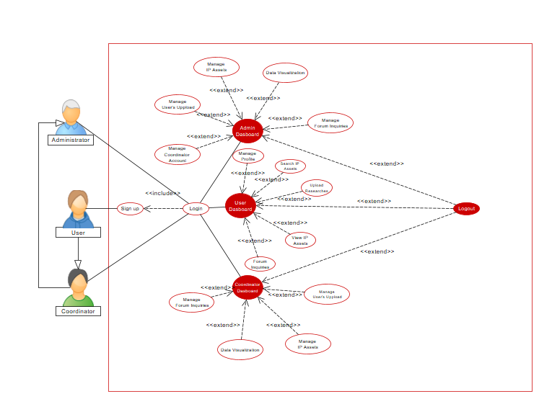 This figure illustrates the use case diagram of the IPDMS. The admin features include managing coordinator accounts, managing user account, managing IP assets, the admin can add, update, delete, and categorize the intellectual property assets that are added to the system. This comprehensive functionality empowers the admin to not only facilitate the inclusion of new assets but also to ensure that the existing assets are kept up-to-date and appropriately categorized for efficient organization and retrieval within the system. Supervising the data visualization of assets registered in the system, the data visualization feature serves the specific purpose of offering a visual representation of the registered IP assets within the system. Through intuitive charts, graphs, and other visual elements, users, including administrators and coordinators, can easily grasp and analyze the quantitative aspects of the IP assets. This includes gaining insights into the total count of registered assets, trends in asset registration over time, and other relevant analytics. It enables stakeholders to quickly measure the system's performance, track growth, and make informed decisions based on the presented visual data. And can manage forum inquiries, in managing forum inquiries, the admin has the authority to delete comments that are not conducive to a positive environment for everyone. The forum serves as a collaborative space for users and researchers, fostering interaction and knowledge exchange. The admin's ability to moderate and remove inappropriate comments ensures a conducive and respectful platform for productive collaboration within the community. And the upload logs feature serves as a historical record of when and where assets are added to the system, along with detailed information about each upload. This functionality allows administrators and coordinators to track the progression of asset uploads, providing transparency into the system's activity. Administrator can review the timeline and specifics asset added, and the feature also contribute a comprehensive understanding of the system's history and facilitating effective management and analysis of intellectual property assets. The coordinator, like the admin, can manage user accounts, handle IP assets, supervise data visualization of the registered assets, manage forum inquiries, and upload logs. Users have the capability to manage their profiles, search for IP assets for viewing, add, edit, and delete content in the forum section. Additionally, users can upload assets, but approval is required from the coordinator or administrator. This comprehensive use case diagram outlines the functionalities and interactions among admins, coordinators, and users within the IPDMS.