**“A WEB-BASED INTELLECTUAL PROPERTY DATA MANAGEMENT SYSTEM (IPDMS) IN MINDANAO STATE UNIVERSITY - MARAWI CAMPUS”**

A Capstone Project

presented to the Faculty of the

College of Information Technology

Mindanao State University

In Partial Fulfillment of the Requirements

for the degree Bachelor of Science in Information Technology

By

Dangco, Omaimah B.  
 Mangompia, Aisah D.  
 Sanchez, Vilmalyn M.

Mr. Amer Hussien T. Macatotong  
 Adviser

Ms. Jogie A. Vistal  
 Co-adviser

September 2023

**Chapter 1**

**Introduction**

Over the years, data management and physical storage in library archives storing research data in a single library location have limitations, including the risk of duplication and plagiarism were what MSU did until the increasing volume of research output and the growing need for collaboration among researchers and stakeholders demanded a more efficient and secure system.

The IPMDS is a centralized system that stores, protects, and manages all of MSU's intellectual property assets in one place. It can be accessed by authorized users from anywhere in the world, and it provides a variety of features to help MSU manage its intellectual property assets more effectively.

The capstone project entitled "A Web-Based Intellectual Property Data Management System (IPDMS) at Mindanao State University" aims to address several challenges and concerns within the university. The primary concern is the need for a more efficient and secure method of managing and safeguarding research and intellectual property assets. This project seeks to enhance the university's existing processes by computerizing the management of these assets.

The project is essential because it addresses critical challenges within the university's research and intellectual property management domain. It seeks to modernize and streamline processes, enhance security, and promote collaboration, ultimately ensuring that MSU's intellectual property assets are efficiently managed and protected.

The project's beneficiaries include the entire MSU community, as it will provide a streamlined and secure platform for managing their research output. Additionally, the project will involve IT professionals for its development.

The development of the project will follow established Software Engineering techniques, ensuring that the software and hardware requirements and specifications are systematically designed and implemented to meet the project's objectives. This approach will help create a reliable and user-friendly Intellectual Property Data Management System for Mindanao State University.

**1.1 Project Context**

The capstone project aims to address several concerns within the university. The primary concern is the need for a more efficient and safeguarding research and intellectual property assets. This project seeks to enhance the university's existing processes by computerizing the management of these assets.

The respondents for this project include university faculty, researchers, students, and administrative staff who are involved in research and intellectual property activities. The project's beneficiaries encompass the entire MSU community, as it will provide a streamlined and secure platform for managing their research output. Additionally, the project will involve IT professionals, system analysts, and software engineers responsible for its development.

The project was started in September 2023 and is projected to finish by the end of May 2024, with an approximate duration of nine months. The implementation of the project will primarily occur within the premises of Mindanao State University. The proposal for this project arises from the need to modernize and improve the university's research and intellectual property management processes. The current traditional methods of storing research data in a single library location have limitations, including the risk of duplication and plagiarism. Therefore, the researchers propose the development of the IPMDS to overcome these challenges and enhance the efficiency and security of managing intellectual property.

The development of the project will follow established Software Engineering techniques, ensuring that the software and hardware requirements and specifications are systematically designed and implemented to meet the project's objectives. This approach will help create a reliable and user-friendly Intellectual Property Data Management System for Mindanao State University.

**1.2 Purpose and Description**

This project serves as a tool to address several challenges and opportunities that have emerged over time and seeks to enhance the existing processes in terms of intellectual property assets including patents, trademarks, copyrights, and trade secrets.

The traditional methods of managing these assets, predominantly reliant on physical storage in library archives, present several challenges. These challenges include the risk of data duplication, difficulties in tracking and retrieving relevant information, and plagiarism. Increasing volume of research output demands a more efficient and secure system for collecting, organizing, and safeguarding intellectual property.

The primary purpose of this project is to develop a comprehensive Intellectual Property Data Management System (IPMDS) that caters to the specific needs of MSU researchers. The IPDMS aims to streamline and modernize the university's research and intellectual property management processes by leveraging technology.

The project is essential because it addresses critical challenges within the university's research and intellectual property management domain. It seeks to modernize and streamline processes, enhance security, and promote collaboration, ultimately ensuring that MSU's intellectual property assets are efficiently managed and protected. By embracing technology and best practices, the IPMDS project aligns with MSU's commitment to excellence in research, innovation, and education, positioning the university for continued growth and impact in the academic and innovation landscape.

Moreover, this capstone project aims to implement a comprehensive IP data management system for MSU. The system will be designed to track and manage all of MSU's IP assets, including patents, trademarks, copyrights, and trade secrets. The following are the beneficiaries of this project.

**MSU Researchers.** The MSU IPDMs provide a central repository for all MSU-owned intellectual property, including patents, copyrights, trademarks, and trade secrets. This will make it easier for MSU researchers to find and use existing intellectual property, and to develop new intellectual property.

**MSU Students**. Students will be able to use the system to learn about MSU’s intellectual property assets and to identify potential research topics. They will also be able to use the system to find and use existing intellectual property assets for their own research projects. It not only benefits MSU researchers but also plays a crucial role in the academic and research journey of undergraduate (UG), masteral (MA), and doctoral (Ph.D.) students.

**MSU College Coordinator.** College coordinators are responsible for managing the intellectual property assets of their college. They want to check to see if there are any new IP assets that have been created by researchers and faculty at their college. They can log in to the web-based IPDMS and view a list of all new IP assets that have been submitted to the system.

**OVCRED Administrators.** Administrators will be able to use the system to track the development and managing the intellectual property portfolio of the university. They will check to see if there are any new IP assets that have been created by researchers and faculty at the university. They can log in to the web-based IPDMS and view a list of all new IP assets that have been submitted to the system. Once the OVCRED Administrator has reviewed the information about the IP asset, they can decide whether or not to take any further action.

**1.3 Objectives**

This capstone project aims to develop a Web-based Intellectual Property Data Management System that enables stores, protects, and manages all of Mindanao State University’s intellectual property assets including patents, trademarks, copyrights, and trade secrets.

Specifically, the project aims to:

* To create an easy-to-use data management system for storing and managing research and intellectual property data, such as patents, copyrights and trademarks, in one central location.
* To promote collaboration among researchers and stakeholders by providing seamless access to research and intellectual property records.
* To make it easier to find, evaluate, and market the university's intellectual property, and to encourage the sharing of technology.
* To visualize the data based on the research given by the college coordinator.
* To introduce strong reporting and data visualization capabilities to oversee and assess the effectiveness of intellectual property assets, aiding in strategic decision-making of MSU-Intellectual Property Office.
* To identify the system requirements or system specifications based on the rules, roles, guidelines and activities given by the Mindanao State University;
* To develop a digital repository designed for MSU.
* To create a database schema that holds the digital assets of MSU.
* Test and debug the implemented system.

**1.4 Scope and limitations**

This capstone project is focused on developing a comprehensive repository that stores and manages all researchers within Mindanao State University, regardless if it is undergraduate (UG), masteral (MA), and doctoral (Ph.D.) students. This capstone can be accessed by faculty, staff, researchers and students from a variety of disciplines.

This capstone is limited to all MSU constituents that allows them to track, submit, view and collaborate within the system. Also, it will be limited to published research including patents, trademarks, copyrights, and trade secrets. It will not include any confidential or sensitive information and is not responsible for the accuracy or completeness of the information it contains.

**1.5 Significance of the Project**

The project addresses critical challenges within the university's research and intellectual property management domain, such as the need for a more efficient and protection system for managing and safeguarding research and intellectual property assets. The project seeks to modernize and streamline existing processes and enhance protection.

The IPDMS will provide a central repository for all MSU's intellectual property assets in one place, making it easier for researchers, faculty, staff, and students to track, manage, and share their intellectual property. This will improve the efficiency and productivity of intellectual property management at MSU, and reduce the risk of losing or misplacing intellectual property assets, and duplication.

The IPDMS will also help MSU to protect and commercialize its intellectual property. By automating many of the manual tasks associated with intellectual property management, the IPDMS will free up MSU college coordinators to focus on supporting researchers and commercializing MSU's intellectual property.

The IPDMS project is significant because it has the potential to transform the way that MSU manages and protects its intellectual property assets. The project will help MSU to accelerate research.

**Chapter 2**

**Review of Related Theories and Systems**

This section focuses on the review of theories or concepts related to the proposed project.

**2.1 Review of Related Theories**

**2.1.1 Data Management System**

Data management is the practice of collecting, keeping, and using data securely, efficiently, and cost-effectively. The goal of data management is to help people, organizations, and connected things optimize the use of data within the bounds of policy and regulation so that they can make decisions and take actions that maximize the benefit to the organization. A robust [data management strategy](https://www.oracle.com/in/database/) is becoming more important than ever as organizations increasingly rely on intangible assets to create value (Oracle).

Today’s organizations need a data management solution that provides an efficient way to manage data across a diverse but unified data tier. Data management systems are built on data management platforms and can include; [databases](https://www.oracle.com/in/database/what-is-database/), [data lakes](https://www.oracle.com/in/big-data/what-is-data-lake/) and [data warehouses](https://www.oracle.com/in/database/what-is-a-data-warehouse/), big data management systems, data analytics, and more. All these components work together as a “data utility” to deliver the data management capabilities an organization needs for its apps, and the analytics and algorithms that use the data originated by those apps (Oracle).

**2.1.2 Intellectual Property**

An Intellectual property is a broad categorical description for the set of [intangible assets](https://www.investopedia.com/terms/i/intangibleasset.asp) owned and legally protected by a company or individual from outside use or implementation without consent. An intangible asset is a non-physical asset that a company or person owns (Investopedia).

Intellectual property relates to the fact that certain products of human intellect should be afforded the same protective rights that apply to physical property, which are called [tangible assets](https://www.investopedia.com/terms/t/tangibleasset.asp). Most [developed economies](https://www.investopedia.com/terms/d/developed-economy.asp) have legal measures in place to protect both forms of property (Investopedia).

Some of the most common IPs are; patent, trademark and copyright. Patents when a legally protected patent is used by another person or company without permission.. Trademark when an unauthorized party uses a licensed trademark or a mark resembling the licensed trademark. Copyright when an unauthorized party recreates all or a portion of an original work, such as a work of art, music, or a novel (Investopedia).

Intellectual property encompasses a wide range of assets that stem from human creativity and intellect, including elements such as artwork, symbols, logos, brand names, and designs. In today's knowledge-driven economy, businesses place great emphasis on identifying and protecting their intellectual property because it holds significant value. Creating valuable intellectual property often necessitates substantial investments of time and expertise, making it a costly endeavor for both organizations and individuals. This translates into heavy investments by organizations and individuals that should not be accessed with no rights by others.

**2.1.3 Technology Innovation Center**

Technology and Innovation Centers are mission-driven organizations that work with higher education institutions to develop in-house knowledge and capability that can facilitate the activities that bridge research and technology commercialization (ResearchGate).

TICs are prominent members of many innovation ecosystems around the world. However, it is important to distinguish them from other centers that also play an important innovation intermediary role. Research-oriented centers, namely “competence centers,” or “centers of excellence,” bring together academic and business partners to collaborate on research projects. They tend to run multi-annual research programs in a specific field in which they receive a mix of public and private funding (ResearchGate).

TICs play a central role in boosting national and regional levels of innovation, which in turn, advances economic growth and wealth creation in competitive, knowledge economies (ResearchGate).

As such, Technology Innovation Centers are organizations that provide firms with on-demand services and open access to technology to help them innovate and grow. It can help firms of all sizes to develop or commercialize new products and services, breaking into a new market, and increasing their exports.

**2.2 Technical Background**

In response to the limitations of traditional centralized physical storage, Mindanao State University (MSU) adapts the digital transformation journey to modernize the management of intellectual property (IP) and research assets. MSU Intellectual Property Office is committed to promote intellectual property awareness, safeguard all IP’s and IPRS by filing for protection and facilitate all assets.

Historically, valuable studies, research, theses, and IP data like patents, copyrights, trademarks, and trade secrets were confined to a physical archive. However, this approach presented issues, including limited accessibility, data vulnerability, inefficient retrieval, and constrained collaboration opportunities. To overcome these challenges, the researchers have introduced a digital repository, an Intellectual Property Database Management System (IPDMS), and cloud-based storage solutions. These digital tools provide secure, accessible, and organized storage for research materials and IP data, ensuring protection, scalability, and collaboration across the university community. By embracing digital technology, The researchers aim to promote IP awareness, safeguard intellectual property rights, and enhance the management of valuable research assets while fostering innovation and interdisciplinary collaboration.

The challenges associated with data storage and management, particularly the risks of duplication and plagiarism, have posed significant hurdles for Mindanao State University (MSU). These issues became increasingly apparent as the volume of research output grew over time. To address these challenges effectively, researchers have recognized the need for a comprehensive and modernized solution. The proposed system represents a significant step forward in this regard, serving as a valuable tool for all MSU constituents. Its primary objective is to safeguard the intellectual property and research efforts of the university's scholars, students, and faculty members. By implementing this system, MSU is not only mitigating the risks of duplication and plagiarism but also creating an environment where originality and innovation are protected and valued. It will empower all members of the MSU community to securely archive their works, thereby preserving their contributions to the university's academic heritage while upholding the principles of academic integrity and research ethics.

**2.2.1 Organizational Chart**

Figure 2.2.1 below shows the organizational chart of Intellectual Property Office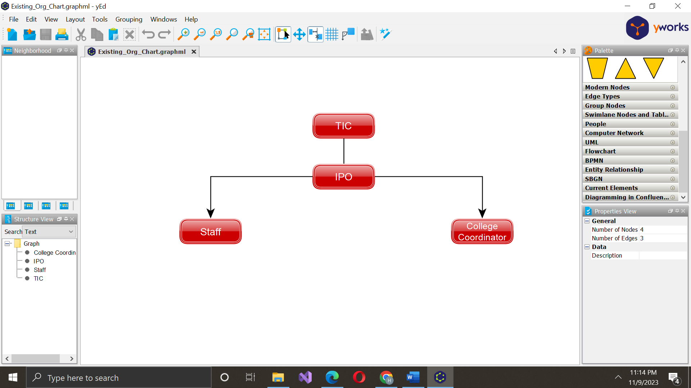

Figure 2.2.1 Organizational Chart of Intellectual Property Office

Figure 2.2.1 above shows the organizational chart of Technology Innovation Center. At the top of TIC is the Director, overseeing strategic initiatives and collaborations. The structure then branches into key divisions, notably connecting to the Intellectual Property Office (IPO) responsible for managing and protecting intellectual assets. The organizational flow further extends to the dedicated staff and college coordinators, forming a cohesive network within the TIC framework for efficient communication, coordination, and implementation of intellectual property initiatives.

**2.2.2 Existing Workflow**

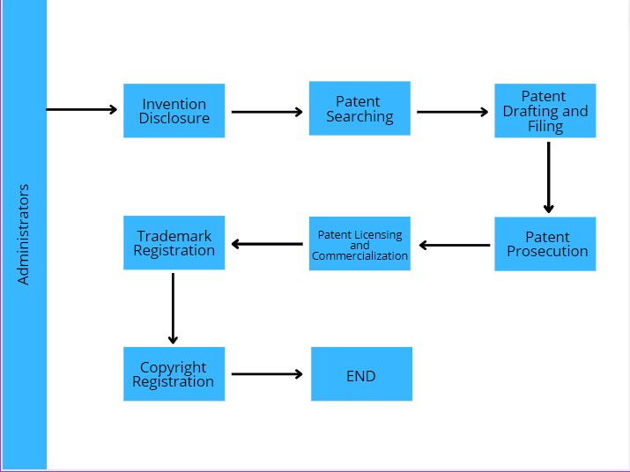

**2.2.3 Proposed Workflow**

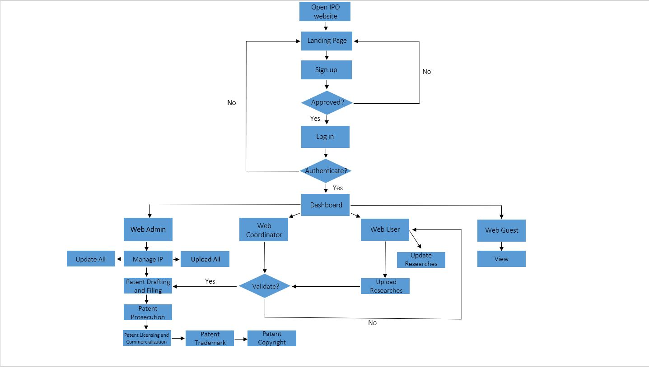

**2.3 Review of Related Systems**The following related systems gave the proponents an idea about the process of storing, protecting, and managing all of Mindanao State University’s intellectual property assets including patents, trademarks, copyrights, and trade secrets through the system during the development of the system.

**2.3.1 Digital Public Library of America**

 *Figure 2.3.1 Digital Public Library of America Homepage*

The DPLA's website provides a single access point to millions of digital items from libraries, archives, museums, and other cultural heritage institutions across the United States. The DPLA's collection includes a wide range of materials, including photographs, manuscripts, maps, books, newspapers, films, and sound recordings.

The DPLA's website offers a variety of features to help users explore and discover its collection. Users can browse by topic, search for specific items, or view curated exhibitions and primary source sets. The DPLA also offers a variety of educational resources for students, teachers, and researchers.

The feature that we will use in the proposed project that is similar to the feature of DLPA, is categorization by topic; it involves classifying content, data, or information into distinct categories or topics. Each category represents a specific subject area or theme. And also, tagging or labeling items with relevant keywords or metadata that describe their content and subject matter. This metadata helps the system organize and categorize the items correctly.

**2.3.2 ACM Digital Library**

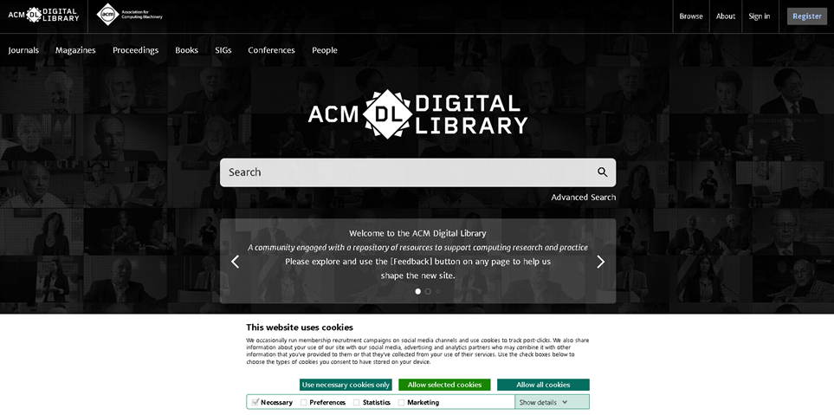

*Figure 2.3.2 ACM Digital Library Homepage*The ACM Digital Library (DL) is a comprehensive digital collection of computing literature. It contains over 7 million full-text articles from ACM journals, conference proceedings, technical magazines, and books. The DL also includes the ACM Guide to Computing Literature, a bibliographic database that indexes over 6 million computing publications.

The ACM Digital Library is a valuable resource for students, researchers, and practitioners in the field of computing. It provides a single access point to a wide range of high-quality computing literature. The DL is also easy to use and navigate.

The feature that we will be adapting is similar to the web-based system of ACM digital library, the search bar, it is typically located prominently on the website's homepage or at the top of the page for easy access. Users can enter keywords, phrases, or queries related to their research interests or topics of study into this search bar. This allows them to specify additional search criteria, such as author names, publication dates, or specific publication titles, to narrow down their results.

**2.3.3 University of the Philippines- Diliman Library  
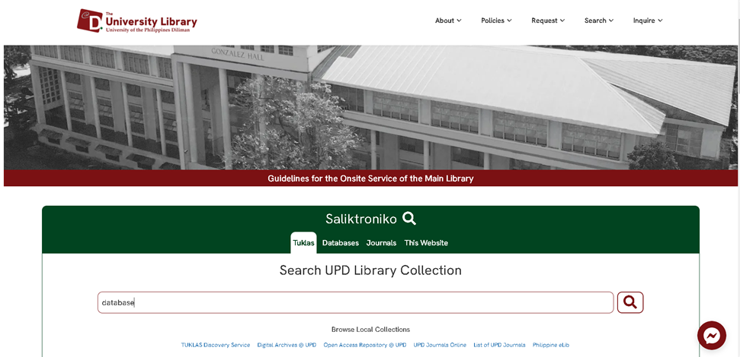** *Figure 2.3.3 University of the Philippines- Diliman Library Homepage*The UP Diliman Library is a comprehensive academic library that provides access to a vast collection of print and digital resources across various disciplines. It serves as the primary information hub for the UP Diliman campus, offering a wide range of services and resources to support teaching, learning, and research activities. And its central academic and research library that serves the University of the Philippines Diliman campus community in Quezon City, Philippines. It plays a crucial role in supporting the educational and research needs of students, faculty, and researchers.

The features that we are adapting based on the University of the Philippines- Diliman Library website is the repository of the IP assets, the website may serve as a repository or database where various types of intellectual property assets are cataloged and organized. This could include patents, research papers, copyrighted materials, and trademarks.

**2.3.4 Digital Commons- University of South Florida** 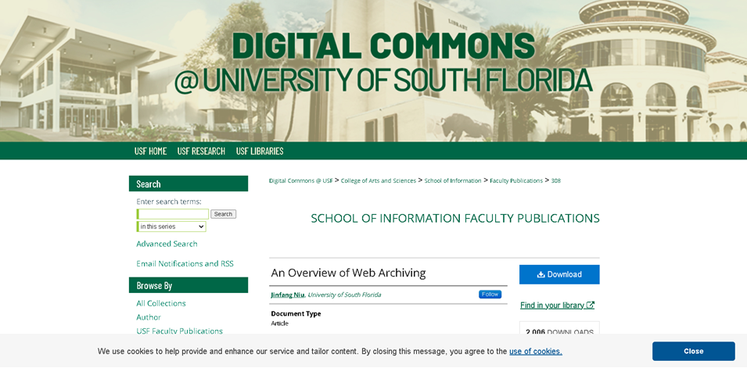

**Figure 2.3.4 Digital Commons- University of South Florida** **Homepage**

It is a digital repository that serves as a platform for preserving, showcasing, and disseminating scholarly and creative works produced by faculty, students, and researchers affiliated with the university. It provides a central location where users can access a diverse range of materials, including research articles, theses and dissertations, conference proceedings, open-access journals, student publications, and other types of digital content.

The feature that will be adapting is the forum inquiries, users can use this feature to reach out to authors for various purposes, including asking questions, seeking clarifications, requesting additional information, or expressing interest in collaboration on related research or projects.

**2.3.5 Internet Archive**

**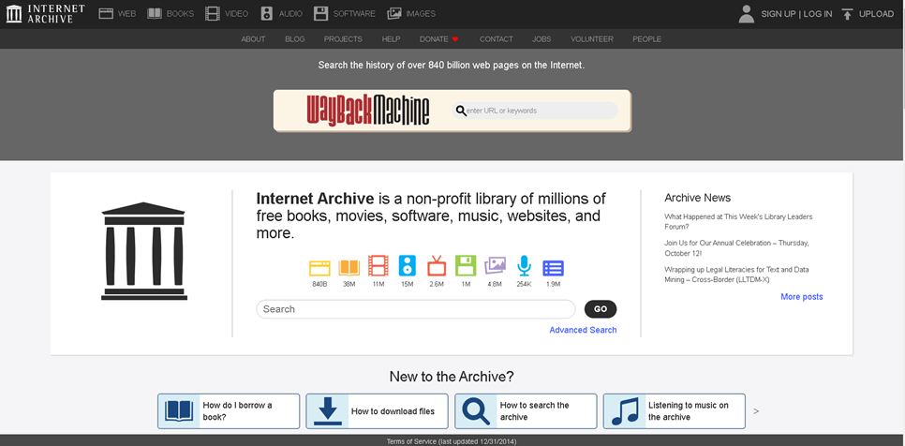  
 Figure 2.3.5 Internet Archive** **Homepage**

Internet Archive is a digital library with a mission to provide "Universal Access to All Knowledge." It seeks to archive and make accessible a wide range of digital content from the internet and beyond. The Internet Archive's most well-known tool is the "Wayback Machine," which allows users to access archived versions of websites dating back to the early days of the World Wide Web.The vast majority of the content on the Internet Archive, including archived websites, books, audio, video, and other materials, can be freely accessed by anyone without the need for a user account.

The features that we are adapting similar to this system is, users who wish to contribute their own digital content, such as books, audio recordings, or videos, to the Internet Archive's collections may need to create accounts. This allows them to upload, manage, and describe their contributions effectively. And also, account holders have the ability to create and curate collections within the Internet Archive, organizing content around specific themes, subjects, or interests.

The feature of login and sign up can be useful to the proposed project.

**2.3 Summary of Related Systems**

| **Related Systems** | **User-friendly Interface** | **Document Tracking** | **View Notifications** | **Forum Inquiries** | **Reporting and Analytics** | **Manage IP Assets** | **Log in and Log out** | **Search IP Assets** |
| --- | --- | --- | --- | --- | --- | --- | --- | --- |
| **Digital Public Library of America** | **✓** |  |  |  |  |  |  | **✓** |
| **ACM Digital Library** | **✓** |  |  |  |  |  | **✓** | **✓** |
| **University of the Philippines - Diliman Library** | **✓** |  |  |  |  | **✓** |  |  |
| **Digital Commons- University of Florida** | **✓** |  |  | **✓** |  |  |  |  |
| **Internet Archive** | **✓** |  |  |  |  |  | **✓** |  |

**Chapter 3**

**Methodology**

The researcher will be using the waterfall model as methodology for the development and implementation of the system. The waterfall model illustrates the software development process in a linear sequential flow that means any phase in the development process begins only if the previous phase is complete.

The waterfall model consists of five phases: requirement analysis, system analysis and design, architectural design, implementation phase and testing phase.

**3.1 Requirements Analysis**

**3.1.1 PIECES Evaluation Framework**

|  |  |
| --- | --- |
| **P**erformance | The system may be slow to respond to queries, making it difficult for users to find the information they need. And may crash or experience other errors, making it unavailable to users. |
| **I**nformation | Intellectual property assets may be lost or corrupted. |
| **E**conomy |  |
| **C**ontrol/Security | The system stores sensitive intellectual property data, which could make it a target for hackers. If the system is not properly secured, it could be compromised, which could lead to data breaches and performance problems. |
| **E**fficiency | IPDMS is not regularly updated with new features and bug fixes, it could become outdated and inefficient. This could lead to performance problems and security vulnerabilities. |
| **S**ervices | Difficult to maintain and upgrade the system, which could lead to performance problems, or the services offered. |

**3.1.2 Cause and Effect Analysis**

|  |  |  |  |  |
| --- | --- | --- | --- | --- |
|  | Problem/Opportunity | Cause and Effect | System Objective | System Constraints |
| **Performance** | Website crash | **C-** many users use the system simultaneously  E- difficult to access and it become unavailable for other uses | optimizing server capacity, enhancing security protocols, and improving overall system resilience. | limitations in scalability, making it difficult to accommodate sudden spikes in traffic or increased user activity. |
| **Information** | Loss and corrupted | **C-** Failure to regularly backup and create redundant copies of intellectual property **E-** system failures, hardware malfunctions, or accidental deletions. | identifying and addressing the root causes of data loss or corruption, whether they be due to hardware failures, software bugs, human error, or malicious activities. | technological constraints, such as reliance on outdated hardware or software, may limit the ability to implement the latest features and encryption methods. |
| **Economy** |  |  |  |  |
| **Control/Security** | Attack by hackers | **C-** cyber-attacks can lead to unauthorized access, theft, or corruption of intellectual property stored digitally. **E**- loss of sensitive information, potential misuse of IP and damage to reputation. | identify and neutralize the security breach, regaining control and preventing unauthorized access. | human error constraints often contribute to successful hacking attempts. |
| **Efficiency** | Outdated | **C-** failure to regularly update software, operating systems, and applications  **E-** vulnerabilities to security threats, diminished performance, and compatibility issues with newer technologies. | improve system responsiveness, reduce downtime, and enhance user experience. | technical constraints arise from the interoperability issues between outdated systems and newer applications |
| **Services** | Difficult to maintain | **C**- insufficient knowledge or expertise to upgrade or migrate to newer technologies. **E**- limited scalability, challenges in adapting to changing needs, and potential operational inefficiencies. | empowering the technical support team with the necessary training and resources to efficiently handle maintenance tasks. | complexity of the system architecture, which can hinder efficient maintenance. |

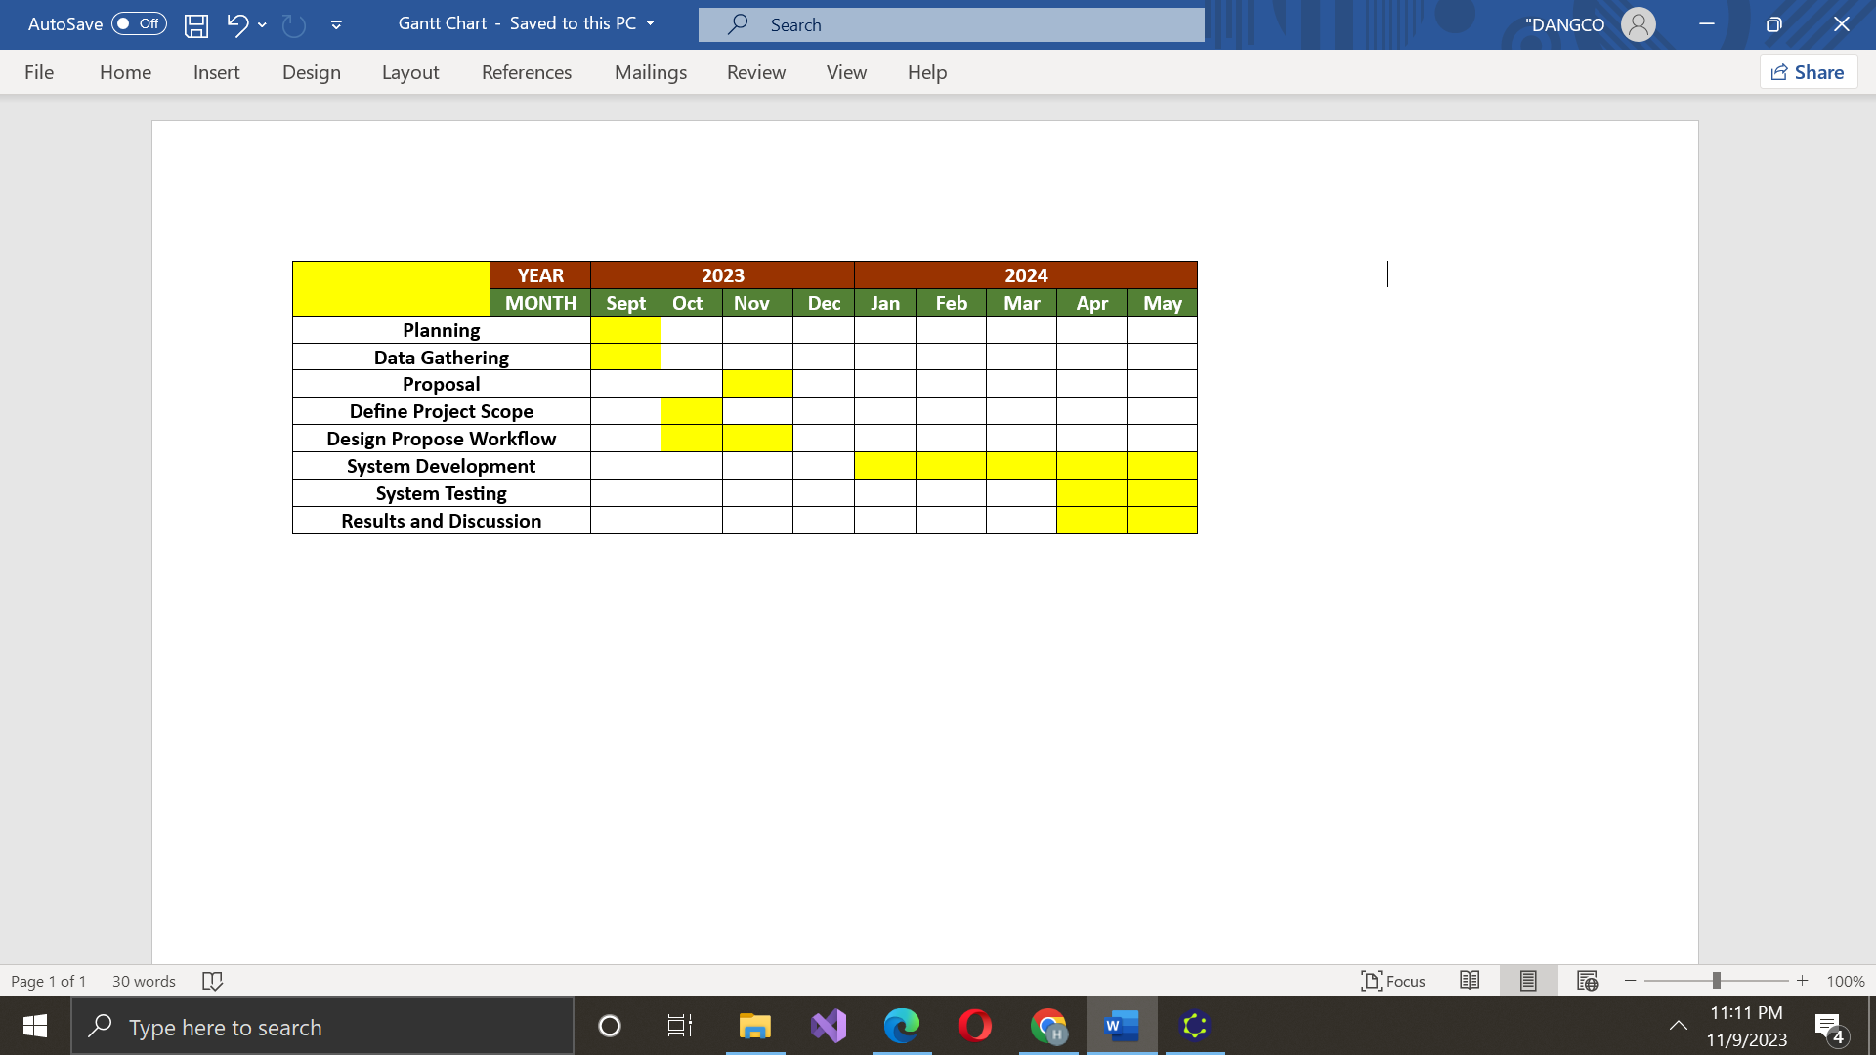

*Figure 4.1.4 Gantt Chart in developing the system*

**3.1.3 Gantt Chart development of Intellectual Property Data Management System**

Figure 3.1.3 shows the Gantt Chart development of the system. The system was proposed in mid 2023, the planning and data gathering began in the same month, followed by defining project scope and design proposed workflow the next month. Then, the research proposal was successfully approved by the system panels the next month. From early December 2024, the proponents began developing the system up until April 2024. The proponents started testing the system early in March while the system was under development. The system’s testing was completed in May 2024. The result and discussion of the project began in April up to May.

**3.2 Design**

This design provides modeling tools that describe the systems and its processes including developer and user specifications and software testing plans.

**3.2.1 Hierarchical Input- Process- Output**

Figure 4.2.1 shows the hierarchical input-process-output of the system. This process consists of Admin, Coordinator, User, and Guest who were involved in the system’s functionality.

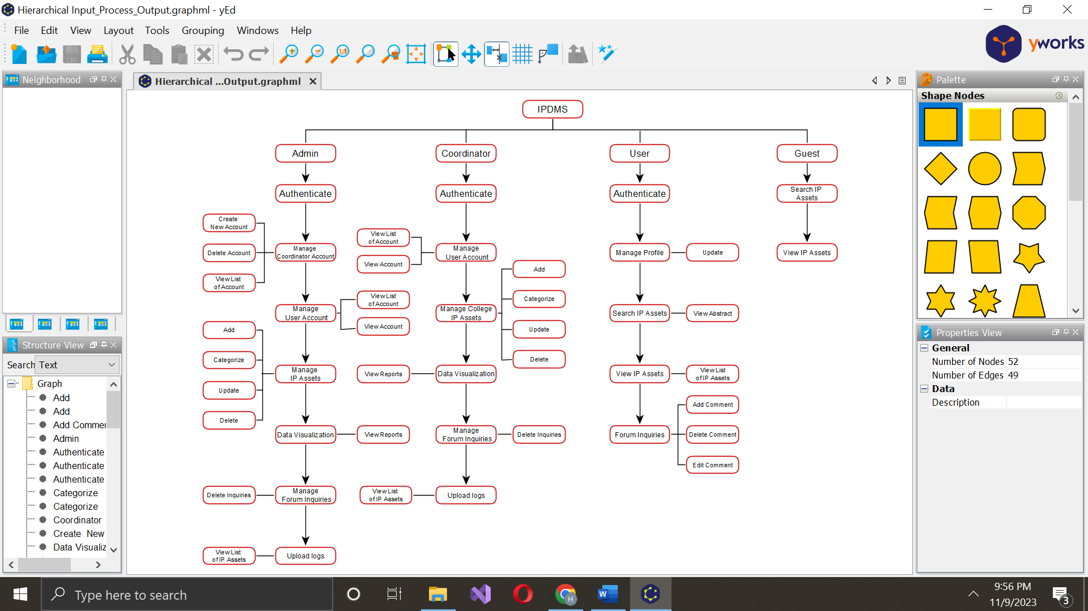

**3.2.2 Input-Process-Output**

**3.2.2.1 Login**

### 

### 

### 

### 

### 

### 

### 

### 

### 

### 

### 

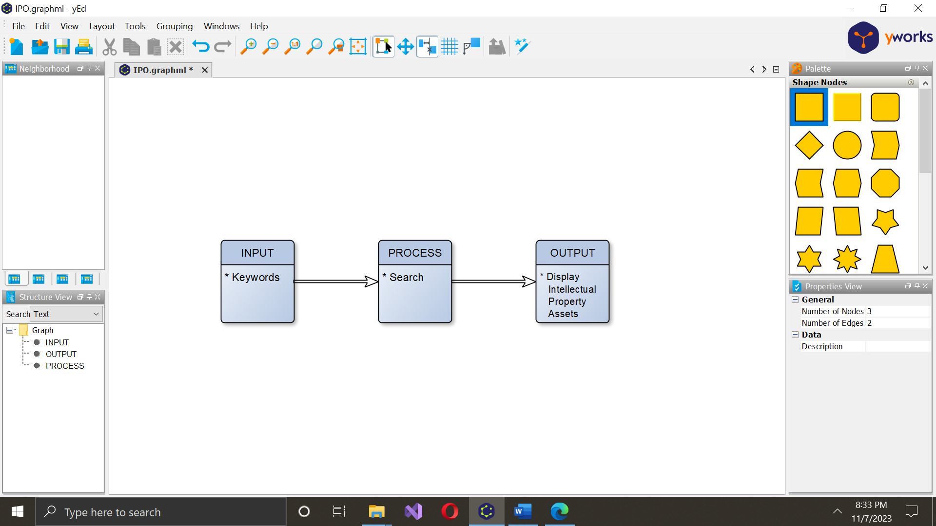

### 

### **3.2.3. Use Case Diagram**

### 

### **3.2.4. Entity-Relationship Diagram**

### **3.2.5. Architectural Design**

### **3.3 Development and Testing**

This section discusses the test plan, the software, and hardware specification that are used in the development and testing of the system.

### **3.3.1. Software Specification**

Table 3.3.1.a shows the software specification for developer and user. It also shows the minimum software requirement for the end user.

*Table 3.3.1.a Developer’s Software Requirements*

|  |  |
| --- | --- |
| **Name** | **Description** |
| Operating System (OS) | Windows 11 |
| Programming Language | JavaScript, CSS, HTML, PHP |
| SQL Database | MySQL |
| Web Server | XAMPP |
| System Type | 64bit |
| Editor | Notepad++ |
| Web Browser | Google Chrome/Microsoft Edge |

### 

### *Table 3.3.1.b**User’s Software Requirements*

|  |  |
| --- | --- |
| **Name** | **Description** |
| Operating System (OS) | Windows 9 |
| System Type | 32bit or 64bit |
| Web Browser | Google Chrome/Microsoft Edge |

### Table 3.3.1.b shows the user's software requirement. The user must have at least a windows 9 operating system, a system type of either 32bit or 64bit and a browser preferably, Google Chrome browser.

### **3.3.2. Hardware Specification**

Table 3.3.2.a shows the hardware specifications of the laptop for the developer.

*Table 3.3.2.a Developer’s Hardware Requirements*

|  |  |
| --- | --- |
| **Name** | **Description** |
| Processor | 2.60 GHz |
| Memory (RAM) | 8 GB |
| Storage | 500 GB |
| Data Connectivity | Local Area Network |

### 

*Table 3.3.2.b User’s Hardware Requirements*

|  |  |
| --- | --- |
| **Name** | **Description** |
| Processor | Intel Core i7 or better |
| Memory (RAM) | 3GB or better |
| Storage | 500 GB or higher |
| Data Connectivity | Local Area Network |

### Table 3.3.2.b shows the user's hardware requirement. The user must comply with recommended requirements to experience better usage of the project.

### 

### 

### **3.3.5. Deployment Diagram**

### 

### 

### 

### 

### **3.3.6. Test Plan**

In this section, comprehensive procedures will be outlined to systematically evaluate the functionality and performance of the Intellectual Property Data Management System in Mindanao State University - Marawi Campus.. Rigorous testing protocols will ensure the reliability, protection, and seamless user experience of the web-based platform across various scenarios.

**3.3.6.1. Test Data**