**1.1 Project Context**

  The capstone project aims to address several concerns within the university. The risk of duplication and plagiarism of creation, works, and inventions. The primary concern is the need for more efficient and protecting research and intellectual property assets. The project seeks to enhance the university's existing processes by computerizing the management of these assets.

  The respondents for this project are the university faculty members of various colleges, the researchers among those colleges, the students, and the administrative staff of various colleges who are involved in research and intellectual property activities. The project's beneficiaries encompass the entire MSU community, as it will provide an efficient platform for managing their research and intellectual property assets. Additionally, the project will involve IT professionals, system analysts, and software engineers responsible for its development.

  The project was started in September 2023 and is projected to finish by the end of May 2024, with an approximate duration of nine months. The implementation of the project will primarily occur within the premises of Mindanao State University-Marawi. The proposal for this project arises from the need to modernize and improve the university's research and intellectual property management processes. Therefore, the researchers propose the development of the IPDMS to overcome these challenges and enhance the efficiency and security of managing intellectual property.

  The development of the project will follow established Software Engineering techniques, ensuring that the software and hardware requirements and specifications are systematically designed and implemented to meet the project's objectives. This approach will help create a reliable and user-friendly Intellectual Property Data Management System for Mindanao State University

**1.2 Purpose and Description**

  This project serves as a tool to address several challenges like the duplication and plagiarism of inventions, creations and works, and opportunities that have emerged over time and seeks to enhance the existing processes in terms of intellectual property assets including patents, and copyrights.

  The traditional methods of managing these assets, predominantly reliant on physical storage in library archives, present several challenges. These challenges include the risk of data duplication, difficulties in tracking and retrieving relevant information, and plagiarism. The increasing volume of research output and intellectual property assets demands a more efficient and secure system for collecting and organizing the different assets.

  The primary purpose of this project is to develop a comprehensive Intellectual Property Data Management System (IPDMS) that caters to the specific needs of MSU researchers. The IPDMS aims to modernize the university's research and intellectual property management processes by leveraging technology.

  The project is essential because it addresses critical challenges within the university's research and intellectual property management domain. It seeks to modernize processes, enhance security, and promote collaboration, ultimately ensuring that MSU's intellectual property assets are efficiently managed and protected. By embracing technology and best practices, the IPDMS project aligns with MSU's commitment to excellence in research, innovation, and education, positioning the university for continued growth and impact in the academic and innovation landscape.

  Moreover, this capstone project aims to implement a comprehensive IP data management system for MSU. The system will be designed to manage all of MSU's IP assets, including patents, trademarks, and copyrights. The following are the beneficiaries of this project.

**MSU Researchers.** The MSU IPDMS provide a central repository for all MSU-owned intellectual property, including patents, copyrights, and trademarks. This will make it easier for MSU researchers to find and use existing intellectual property, and to develop new intellectual property.

**MSU Students**. Students will be able to use the system to learn about MSU’s intellectual property assets and to identify potential research topics. They will also be able to use the system to find and use existing intellectual property assets for their own research projects. And also, the system will play a crucial role in the academic and research journey of undergraduate (UG), masteral (MA), and doctoral (Ph.D.) students.

**MSU College Managers.** College managers are responsible for managing the intellectual property assets of their college. They can check and see if any new IP assets have been created by researchers and faculty at their college. They can log in to the web-based IPDMS and view a list of all new IP assets that have been submitted to the system.

**IPO Administrators.** Administrators will be able to use the system to track the development and manage the intellectual property portfolio of the university. They can manage the user and coordinator account and they can monitor if any new IP assets have been created by researchers at the university. They can log in to the web-based IPDMS and view a list of all new IP assets that have been submitted to the system. Once the Administrator has reviewed the information about the IP asset, they can decide whether or not to take any further action.

**1.3 Objectives**

  This capstone project aims to develop a Web-based Intellectual Property Data Management System that serves as a repository that manages Mindanao State University’s intellectual property assets including patents, trademarks, and copyrights.

Specifically, the project aims to:

* To create an easy-to-use data management system for storing and managing research and intellectual property data, such as patents, copyrights, and trademarks, in one central location.
* To introduce strong reporting and data visualization capabilities to oversee and assess the effectiveness of intellectual property assets, aiding in strategic decision-making of MSU-Intellectual Property Office.
* To conduct user-centric requirements gathering with IP managers via interview to tailor the system to MSU's intellectual property needs.
* To create a database schema that holds the digital assets of MSU.
* To test the implemented system.

**1.4 Scope and limitations**

This capstone project is focused on developing a comprehensive repository that stores and manages research and intellectual property assets within Mindanao State University, regardless of, if it is from undergraduate (UG), masteral (MA), and doctoral (Ph.D.) students. This capstone can be accessed by faculty, staff, researchers, and students from a variety of disciplines.

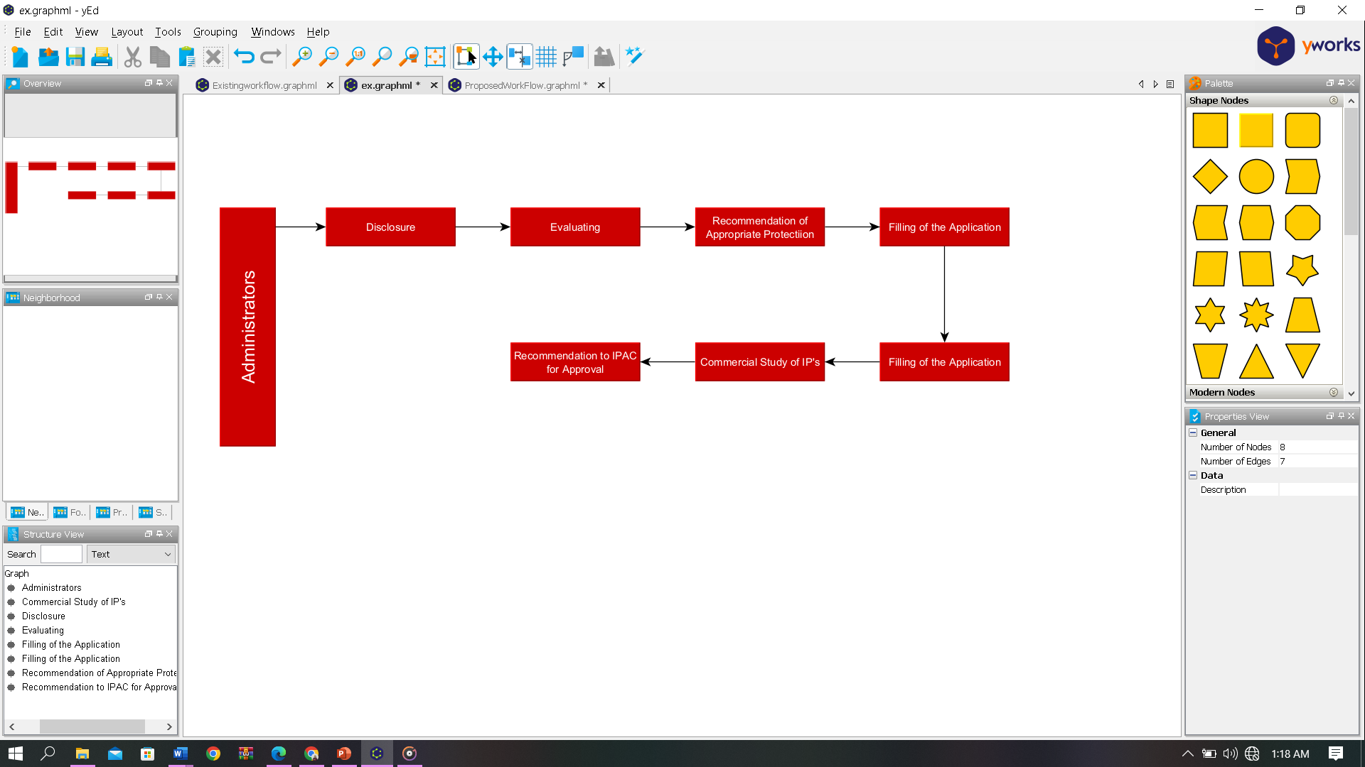**2.2.2 Existing Workflow**

*Figure 2.2.2 Existing Workflow of Intellectual Property Office*

Figure 2.2.2 above shows the existing workflow of the Intellectual Property Office. First, the administrator’s role at this stage is to receive and document these disclosures. It involves capturing details about the invention, such as its description, potential applications, and inventors’ information. After the disclosure phase, the evaluation process, the experts in Intellectual Property assess the novelty of the assets. Subsequently, the office recommends the appropriate protection for the specific intellectual property to the inventor or originator. The filing of the application follows, where the office initiates the application process to establish the rights of the intellectual property originator. Concurrently, a commercial assessment study is conducted for intellectual property, and then it will recommend to the Intellectual Property Advisory Council for approval. This comprehensive workflow ensures a systematic and thorough approach to managing intellectual property, from disclosure to approval.

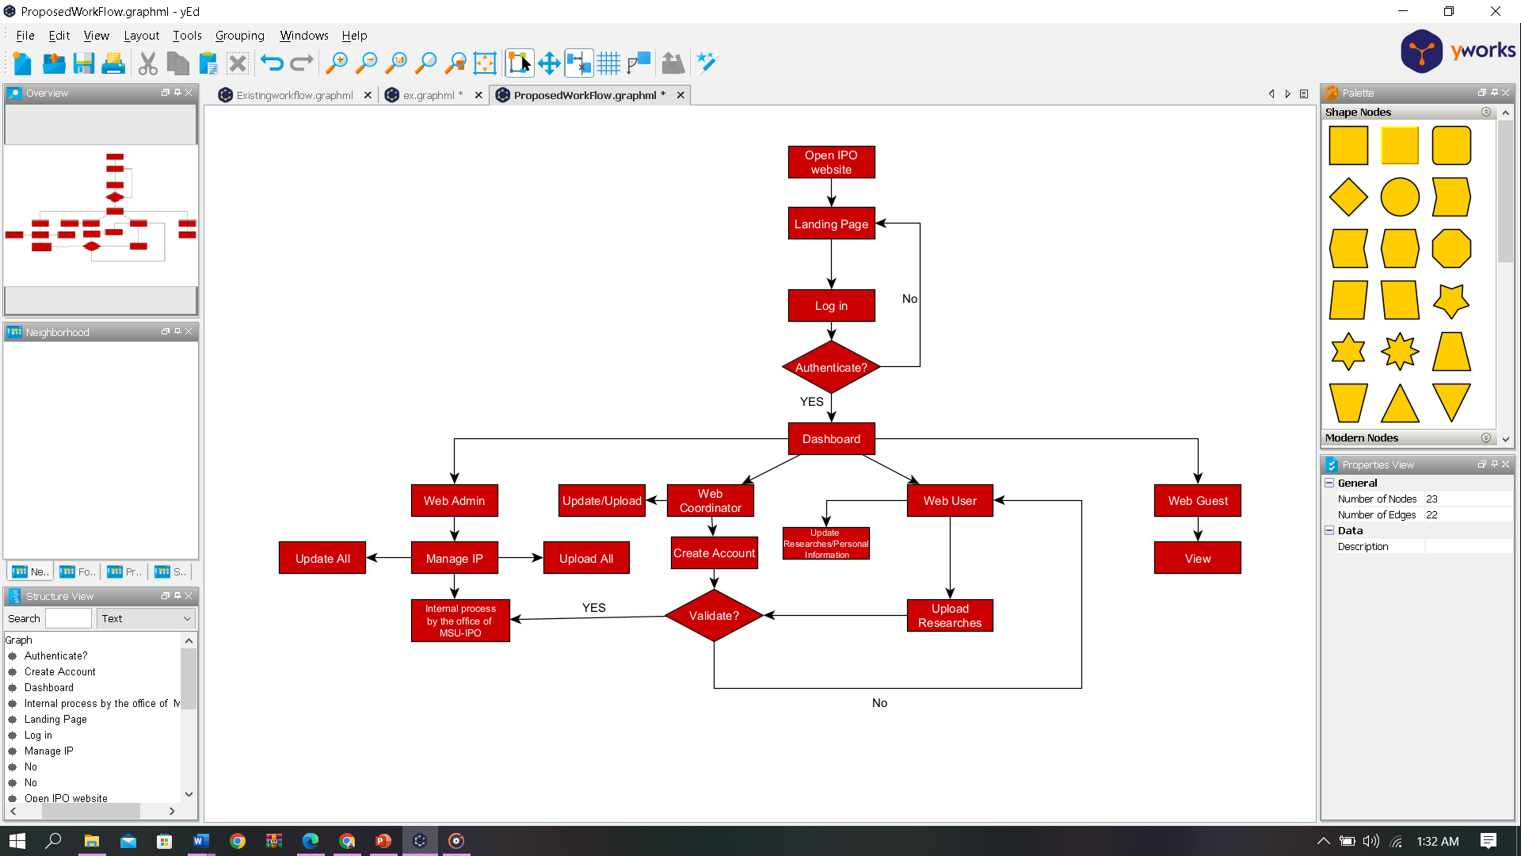**2.2.3 Proposed Workflow**

*Figure 2.2.3 Proposed Workflow of Intellectual Property Office*

Figure 2.2.3 above shows the proposed workflow of the Intellectual Property Office. The workflow begins with the user visiting the IPO website and signing up or logging in. Once the user is authenticated, they can access the dashboard to manage their intellectual property (IP).

The admin can manage the IPO system, including creating and managing users, assigning roles, managing the database – uploading research, drafting, and filing patents, and managing IP licensing and commercialization.

The college coordinator can manage the IP for their college. This includes creating accounts and managing users within their college, viewing user activity within their college, and managing the settings for their college.

The user can view and update their own profile information and access resources that have been granted to them by the admin or college coordinator. This may include the ability to upload research. The IPO will validate the uploaded research and patents, and then process the applications. Once approved, the IP will be granted to the user.

The guest can only view public resources. This may include information about the IPO and the patents – only abstract.

**3.2.3. Use Case Diagram**

*Figure 3.2.3 Use Case Diagram*

This figure illustrates the use case diagram of the IPDMS. The admin features include managing accounts, managing IP assets, the admin can add, update, delete, and categorize the intellectual property assets that are added to the system. This comprehensive functionality empowers the admin to not only facilitate the inclusion of new assets but also to ensure that the existing assets are kept up-to-date and appropriately categorized for efficient organization and retrieval within the system. And can manage forum inquiries, in managing forum inquiries, the admin has the authority to delete comments that are not conducive to a positive environment for everyone. The forum serves as a collaborative space for users and researchers, fostering interaction and knowledge exchange. The admin's ability to moderate and remove inappropriate comments ensures a conducive and respectful platform for productive collaboration within the community. And the upload logs feature serves as a historical record of when and where assets are added to the system, along with detailed information about each upload. This functionality allows administrators and coordinators to track the progression of asset uploads, providing transparency into the system's activity. Administrator can review the timeline and specifics asset added, and the feature also contribute a comprehensive understanding of the system's history and facilitating effective management and analysis of intellectual property assets. The validator, like the admin, can manage user accounts, handle IP assets, supervise data visualization of the registered assets, manage forum inquiries, and upload logs. Users have the capability to manage their profiles, search for IP assets for viewing, add, edit, and delete content in the forum section. Additionally, users can upload assets, but approval is required from the validator or administrator. This comprehensive use case diagram outlines the functionalities and interactions among admins, validator, and users within the IPDMS.