Q1

A)

In relational databases there are typical three tiers which are

* External level
* Logical/conceptual level
* And Internal/physical Level

The external level is where the user can view the specific data in which they are interested in. This external level schema shows only what certain user groups need and hides the remaining details from the database from the specific user group.

Logical/Conceptual Level is where all the database entities are defined with their attributes and their relationships, this makes the up the security and integrity of the information. All the data derivable comes from the physical level.

The internal/physical level is the lowest level of the of data abstraction. It holds information about the actual representation of the entire database like the actual storage of the data on the disk. We can tell what data is stored on the disk and how in this level.

B)

CREATE OR REPLACE VIEW parent AS

SELECT BNAME, TITlE, LOANDATE

FROM BOOK_LOANS_SPRINGFIELD_PRIMARY_SCHOOL;

CREATE OR REPLACE VIEW teacher AS

SELECT BNAME, TITlE, LOANDATE, COUNT(BID)

FROM BOOK_LOANS_SPRINGFIELD_PRIMARY_SCHOOL;

C)

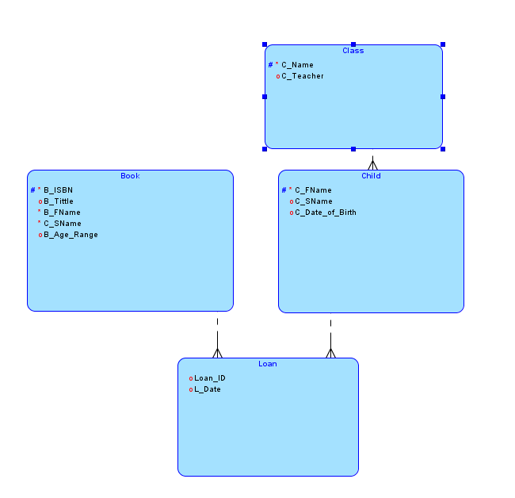

Q2)

A)

Tables that are not fully normalized result in delete anomalies due to not being fully normalized. An example of this from table 1 would be that, If by chance the staff library wanted to delete a loan that had occurred, then instead of only deleting the entry in the loan table, the Barrowers name my also be deleted from their class, by accident

B)

There are three normal forms called First Normal form(1NF), Second Normal Form(2NF), and the third Normal Form(3NF).

The first normal form indicates that all the sections should have a single value per column, values should not be duplicate, everything should have a unique identifier/name.

Second normal form states that it should have everything the first has and should have no partial dependencies.

Third normal form should not have any more transitive dependencies.

Looking at table 1 it violates all the normal forms:

* in first normal form table 1 violates the rule of all must be unique in that it had “J.K”, “Rowling” for multiple tables without separating them in to smaller tables,
* for the second normal form it broke the rule that all prime attributes should be separated and should not be in the same table as non-prime and
* for 3NF all the other steps have been violated by not having anything in a different group, and nothing has been edited to change it.

C)

create or replace function loan (

p_isbn loans.isbn%type,

p_id loans.id%type

)

return varchar1 as

v_checkisbn integer;

v_checkid integer;

begin

select count(isbn) into v_checkisbn from books where (isbn = p_isbn);

select count(id) into v_checkid from students where (id = p_id);

if v_checkisbn > 0 then

v_checkid > 0 then

insert into loans values

(sysdate,p_isbn,p_id);

commit;

return 'Loan successful';

Q3)

A)

The CAP theorem stands for Consistency, Availability, Partition Tolerance.

* Consistency- This is a given in a relational database. If a RDBMS is not in a consistent state, it is not available.
* Availability- A MongoDB database will always have data available because it has replicas of every piece of data and it only promises "eventual consistency”
* Partition Tolerance- In a distributed situation, RDBMS will not allow a transaction to go through unless all nodes involved are in a consistent state. In a distributed situation, MongoDB will go ahead with transactions for available nodes and let the others catch up

B)

{

"Student" :{

"BorrowerName" : "Michael",

"BorrowerSurname" : "Scofield",

"Book": {

"Title":"Artemis Fowl and the Arctic Incident",

"Age":"8-12"

"Author" : {

"First Name":"Eoin",

"SurName":"Colfer"

}

"Loan Date": "08-SEP-2021"

}

}

{

"Book" :{

"ISBN": "123456",

"Author" : {

"First Name":"Eoin",

"SurName":"Colfer",

"Title":"Artemis Fowl and the Arctic Incident"

}

}

}

C)

1. It would be simpler to perform this on a relational as compared to collection store as it only requires an update to be performed.
2. It would be simpler to perform this on a relational as compared to collection store as it only requires an update to be performed in a very straight forward manner.
3. On the collection store it is more time consuming to do a wide update compared to a relational data store.
4. It is slightly easier to make a query to group the popular books in a collection store, than in a relational data.
5. In Relational or collection data store you can make Boolean function to check the value, to find out if a book has been returned or not yet. However relational stores make this process easier.
6. In Relational or collection data store you can easily make Boolean function to check the value to allow books to be loaned out. However relational stores make this process easier.