SWDD- [01]

MrDresser

Software Design Document

Name (s): Umair Ahmad Aqeel Abass

Date: (05/20/2025)

TABLE OF CONTENTS
1.0 INTRODUCTION 3
1.1 Purpose 3
1.2 Scope 3
1.3 Overview 3
1.4 Reference Material 3
1.5 Definitions and Acronyms 3
2.0 SYSTEM OVERVIEW 3
3.0 SYSTEM ARCHITECTURE 4
3.1 Architectural Design 4
3.2 Decomposition Description 4
3.3 Design Rationale 4
4.0 DATA DESIGN 4
4.1 Data Description 4
4.2 Data Dictionary 5
5.0 COMPONENT DESIGN 5
6.0 HUMAN INTERFACE DESIGN 5
6.1 Overview of User Interface 5
6.2 Screen Images 6
6.3 Screen Objects and Actions 8
7.0 REQUIREMENTS MATRIX 9
8.0 APPENDICES 9

INTRODUCTION

Purpose
This SWDD describes the system architecture, component design, and data organization of MrDresser – a smart outfit recommendation system using biometric and contextual data. It is intended for developers, testers, and system architects.

Scope
MrDresser is a mobile/web application offering personalized outfit suggestions based on face shape, skin tone, weather, event, and user profile data. It aims to streamline the outfit selection process with ML-powered recommendations.

Overview
This document includes system architecture, module design, data schemas, component descriptions, and interface layouts required for MrDresser implementation.

Reference Material
  - IEEE 830-1998
  - OpenWeatherMap API
  - Google Maps API
  - SRS Document
.

Definitions and Acronyms
- API: Application Programming Interface
- ML: Machine Learning
- UI: User Interface
- DFD: Data Flow Diagram

SYSTEM OVERVIEW
MrDresser provides a smart fashion experience using a user’s biometric profile, environmental conditions (like weather), and event context to recommend clothing. The system uses AI-based image processing, real-time APIs, and vendor integration.

SYSTEM ARCHITECTURE

Architectural Design
The system is modular, consisting of the following major subsystems:
- User Management: Handles user profile creation, authentication.
- ML Engine: Performs face detection, skin tone analysis, and recommendation logic.
- Vendor Module: Manages vendor profiles, product listings.
- Search & Location: Enables product filtering and map integration.
- Admin Dashboard: Handles content moderation and approval.

Decomposition Description

Object-Oriented Description:
- User: Attributes (name, age, gender, profile image), Methods (editProfile, getRecommendations)
- Vendor: Attributes (shopName, productList), Methods (uploadProduct, editShop)
- Admin: Methods (approveVendor, deleteProduct)
- MLService: Methods (detectFaceShape(), recommendOutfit())
    - Sequence Diagram:
- User submits image → MLService processes → Recommendations returned
- Vendor adds product → Validated → Admin approval → Published
.

Design Rationale
The modular OO design was selected for scalability and maintenance. External APIs were chosen for reliability (OpenWeatherMap, Google Maps). MongoDB was selected for its flexibility with user data and image storage.

DATA DESIGN

Data Description
  - User Data: JSON documents in MongoDB with biometric and contextual fields.
  - Vendor Data: Product metadata and media files.
  - Recommendation Data: Stored temporarily and refreshed on demand.

Data Dictionary

Entity | Attributes
User | userID, name, age, weight, image, gender
Vendor | vendorID, shopName, location, productList
Product | productID, name, category, price, image
AdminLog | logID, actionType, timestamp

COMPONENT DESIGN

Each function (OO):
- User::getRecommendations()
  - Input: profileData, weatherData, event
  - Process: analyzeFace(profileImage), matchClothes(skinTone, weather, event)
  - Output: List of outfits

- Vendor::uploadProduct()
- Input: productDetails
- Process: validate(), storeInDB(), notifyAdmin()
- Admin::approveVendor()
- Input: vendorID
- Process: updateStatus("approved"), logAction()

HUMAN INTERFACE DESIGN

Overview of User Interface

  - User Panel: Profile editor, photo upload, recommendation viewer
  - Vendor Panel: Shop creation, product upload
  - Admin Panel: Content review, analytics dashboard

Screen Images

Home screen
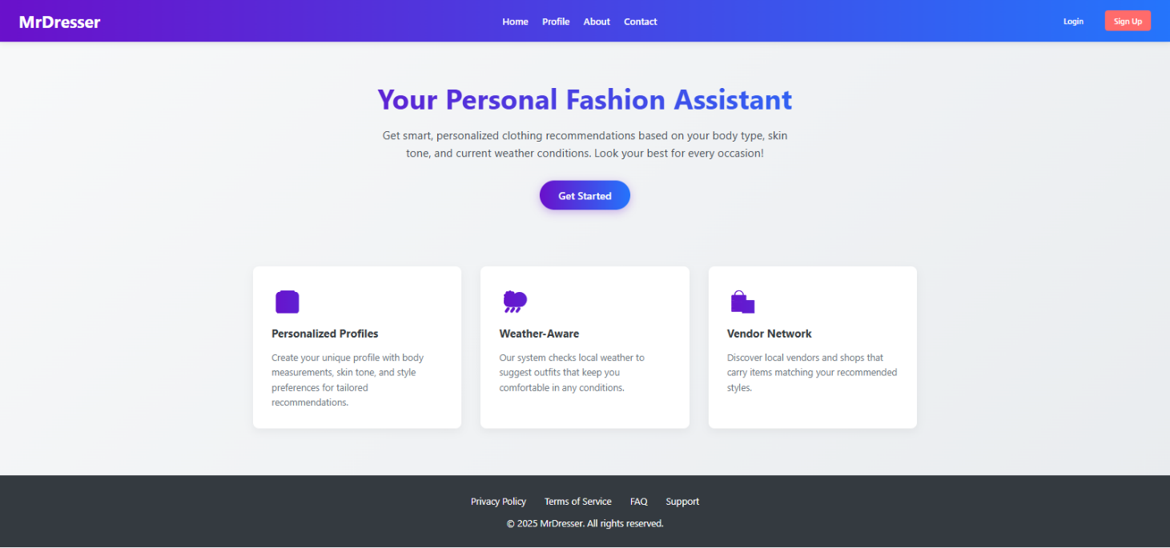

Profile editor
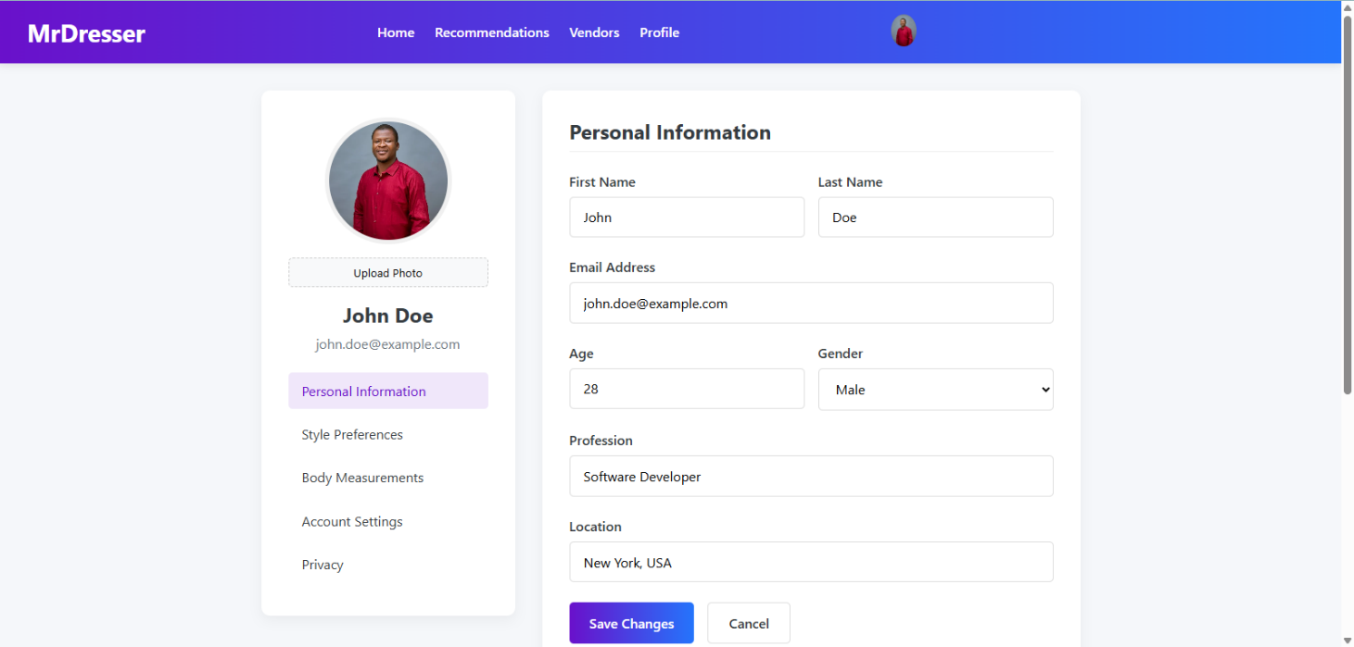
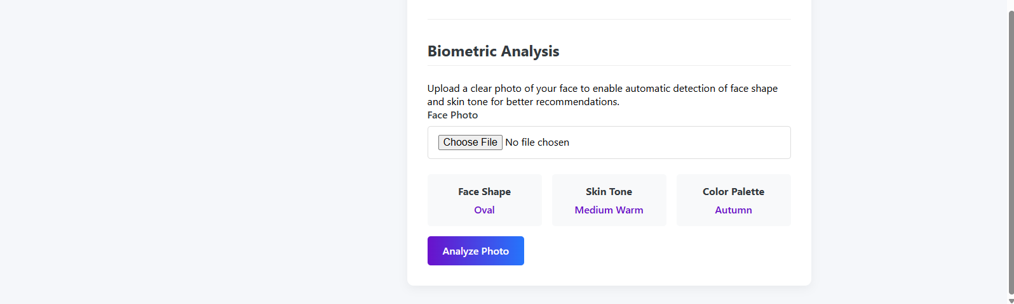

Product recommendation results
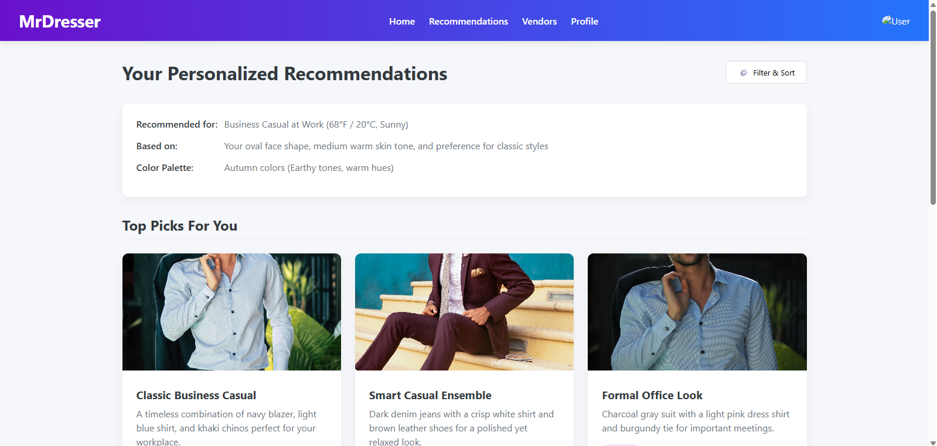
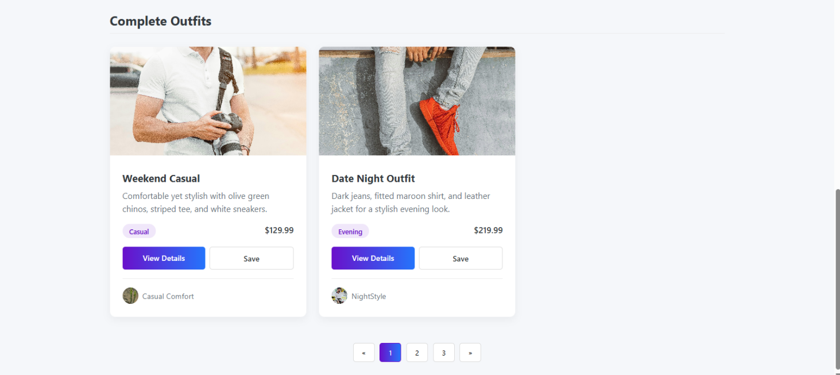

Vendor dashboard
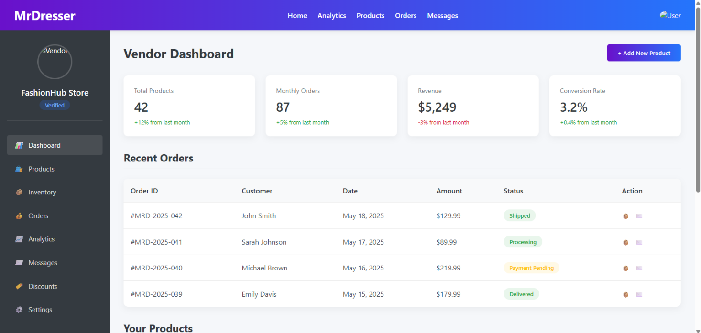

Admin approval interface
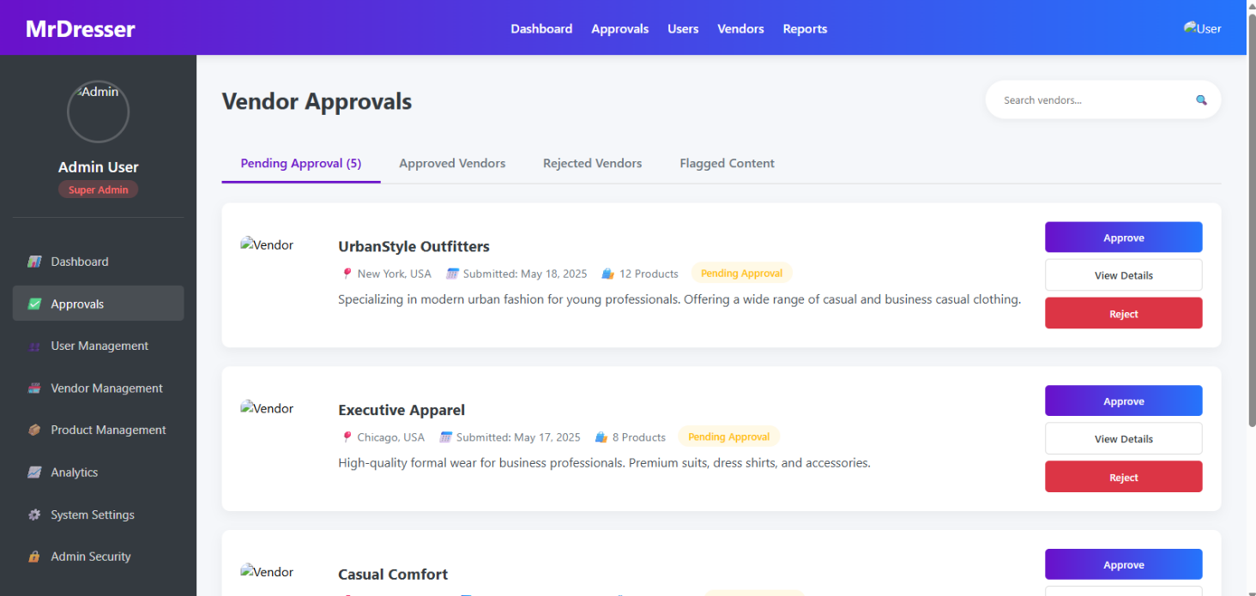

Screen Objects and Actions

Screen | Objects | Actions
Profile Page | TextFields, UploadBtn | Enter data, upload image
Vendor Dashboard | Form, SubmitBtn | Create profile, add products
Search Page | SearchBar, Filters | Keyword search, filter list
Admin Panel | Table, ActionBtns | Approve, Reject, Delete

REQUIREMENTS MATRIX

Requirement ID | Description | Component
REQ-1 to REQ-7 | User Profile & Personalization | User Module, ML Engine
REQ-6 to REQ-9 | Vendor Management | Vendor Module
REQ-10 to REQ-13 | Product Search | Search & Location Module
REQ-14 to REQ-17 | Location-based Services (optional) | Location Module, Map API
REQ-18 to REQ-21 | Admin Dashboard | Admin Module

APPENDICES

Appendix A: Technologies Used
- Frontend: React.js, HTML, CSS
- Backend: Python (Flask/Django)
- Database: MongoDB
- APIs: OpenWeatherMap, Google Maps
- Libraries: OpenCV, TensorFlow Lite

Appendix B: Diagrams

Use Case Diagram
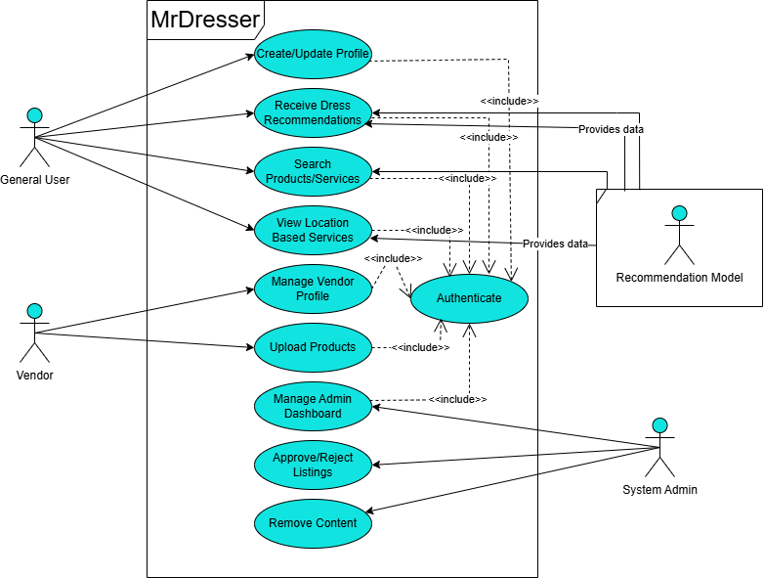

Level 0 DFD
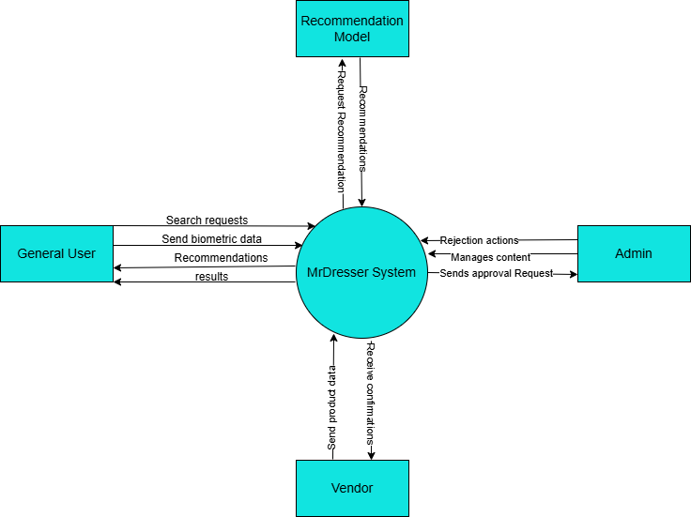

Level 1 DFD
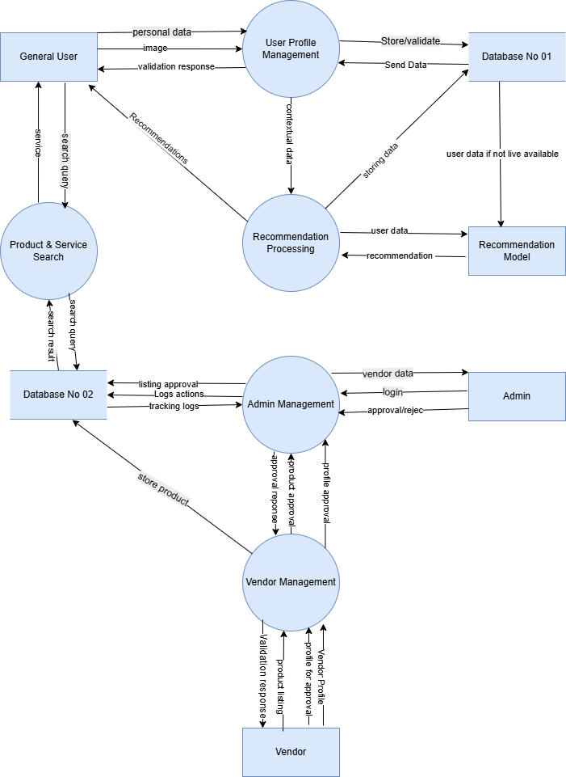

Sequence Diagrams

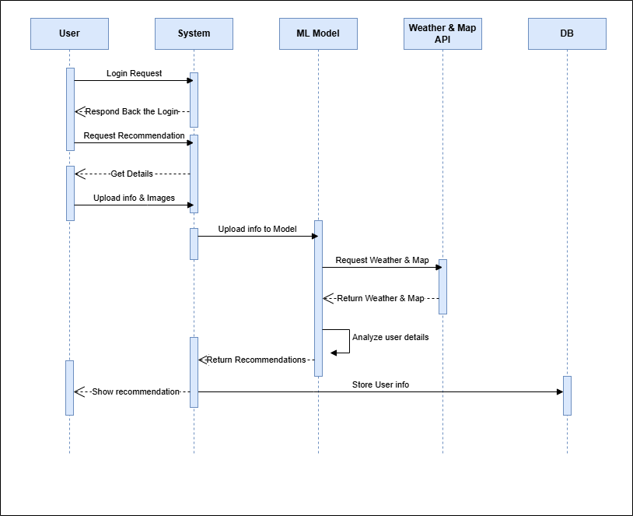

Class Diagram
