ABC Dental

Program: ABC Dental Database
Name: Tomas O’Malley
E-mail – G00361128@gmit.ie
Application
Create a database application for a dentistry name (your choice) ABC incorporated as a linked List. The application must store certain information:
PPS Number, First Name, Second Name, Year Born, Gender, Email Address, Next of Kin Name Weight ,
Last Appointment, Height, allergies, cigarette Smoker, alcohol consumed and exercise.
The system Requirements
The system requirements:
1.Add patient 2. Display all patient details to screen 3. Display patient details 4. Update a patient detail 5. Delete patient 6. Generate statistics 7. Print all patient details into a report file 8. List all the patient of the following countries in order of their last appointment:

Development

I started development straight after reading the project specification . I took a modular apprcoach and created the menu as the skeleton first to allow me to know how the user would interact with the program
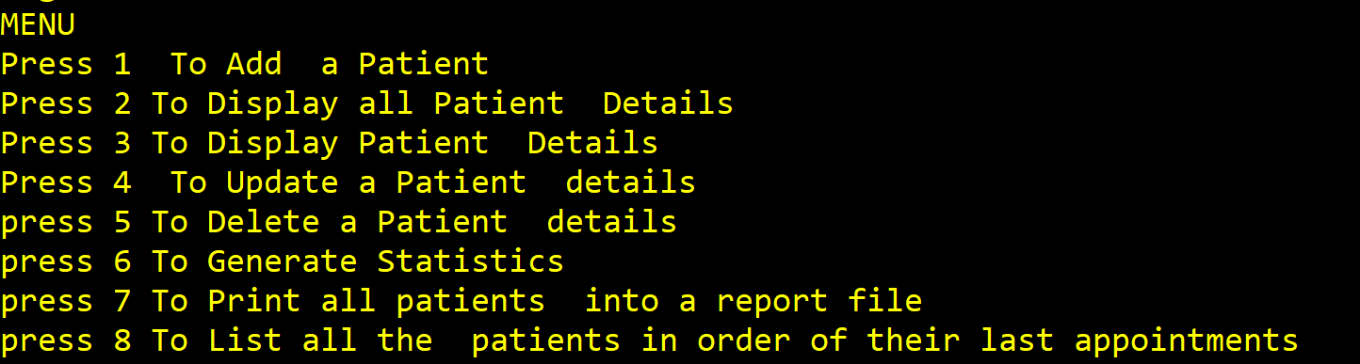

Here the user can choose between options 1-8 depending on how they want the program to execute
- Login

Next I started with the Login Verify () function which verified the users into the project and hides the users password. I did not hide the user’s names and passwords for testing purposes. The function was a success and works as intended.

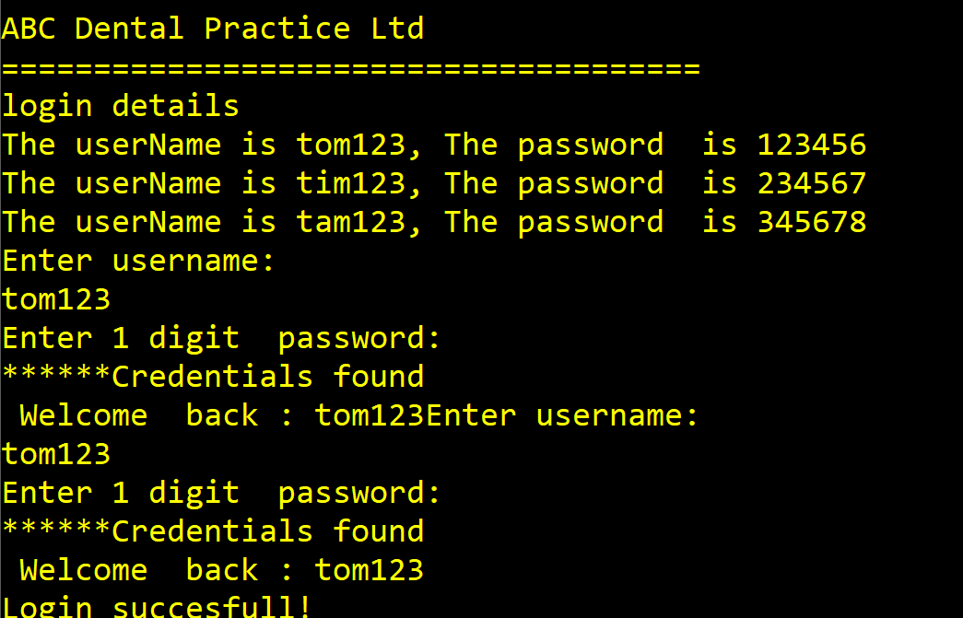

- Add Element function

I then began to create the add element function. This function was responsible for taking in the details of a new patient and adding them to the end of the linked list. I recycled a lot of my codse from this function throughout the program. The function was a success see below .

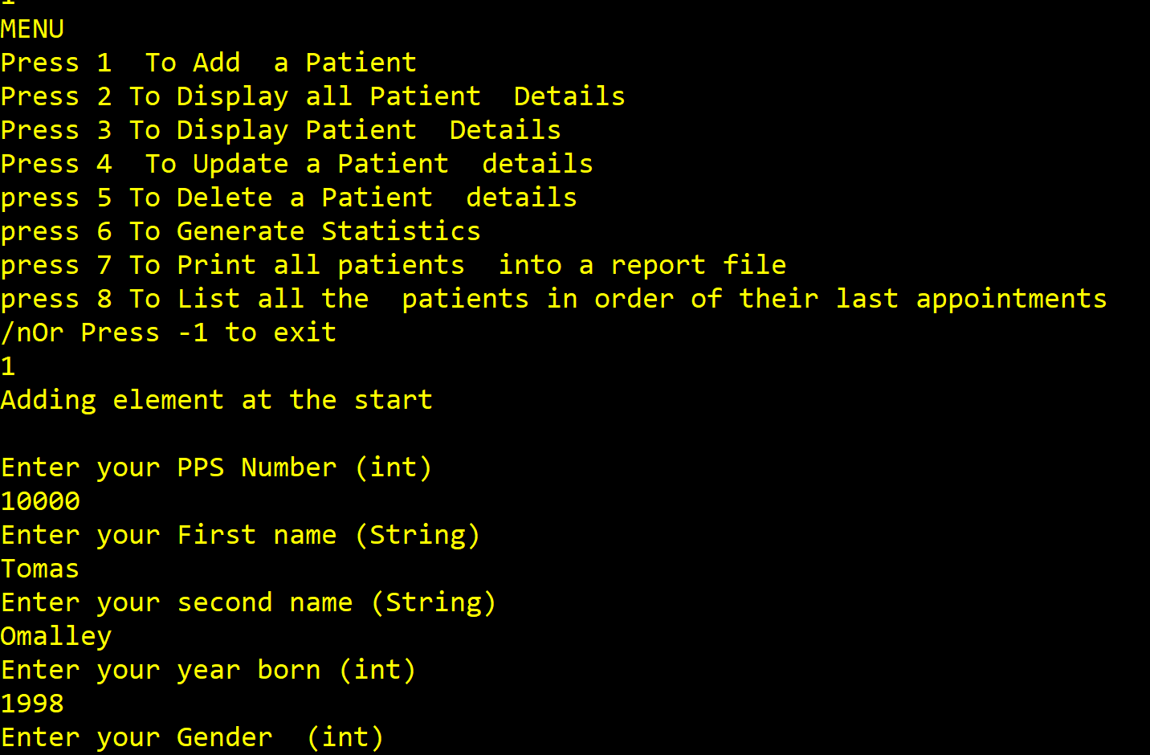

3.Display patients’ function

This function was responsible for displaying all of the current patients added into the linked list.
I coded this function straight after creating the linked list to test whether the program was holding the patient’s data correctly. The function was a success see below output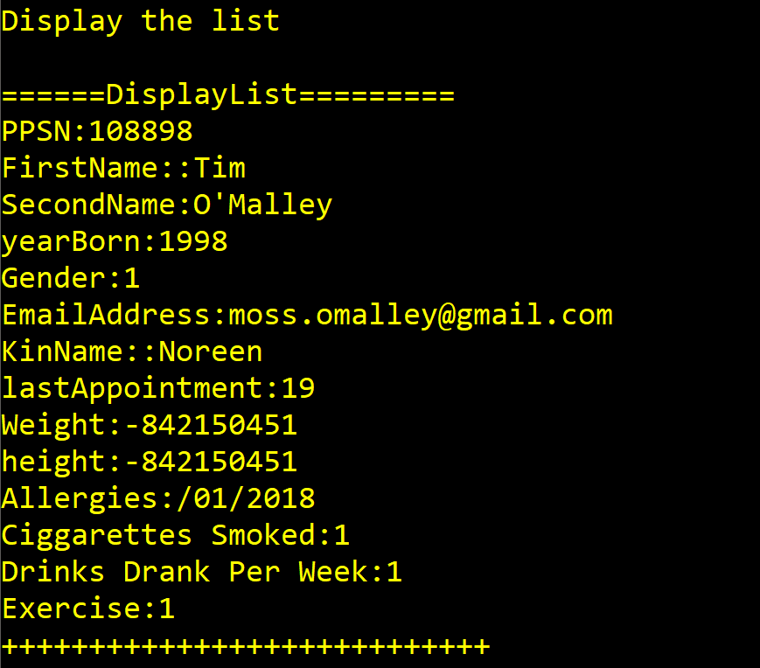

4.Search user function
After storing and displaying all the users I implemented the search user function
The search user function uses the strcmp method to return the user if the result is =0 (returns an integer value) . The function was a success here is sample output .

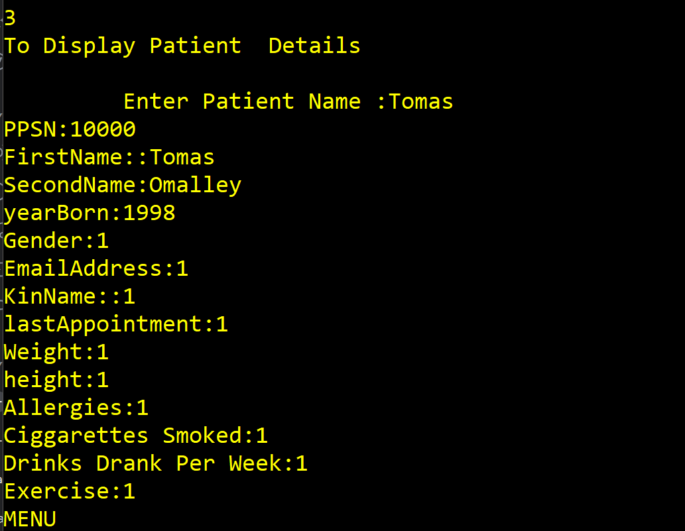
5.Update the user Information

Next, I wrote the update function which is responsible for updating a user’s information which has changed recently. essentially this function finds the info by their surname and them overwrites the current information by asking for the new data to be entered. The function was a success you can see the sample output below .

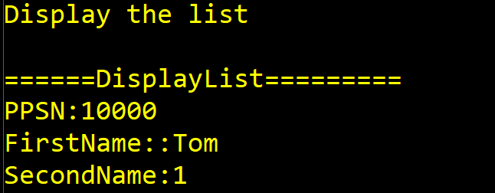
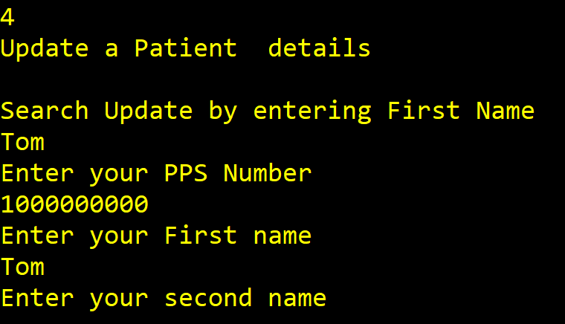

6.Load File function
The load file was not a success it decided to show garbage and I couldn’t fix this problem
Here’s the output.

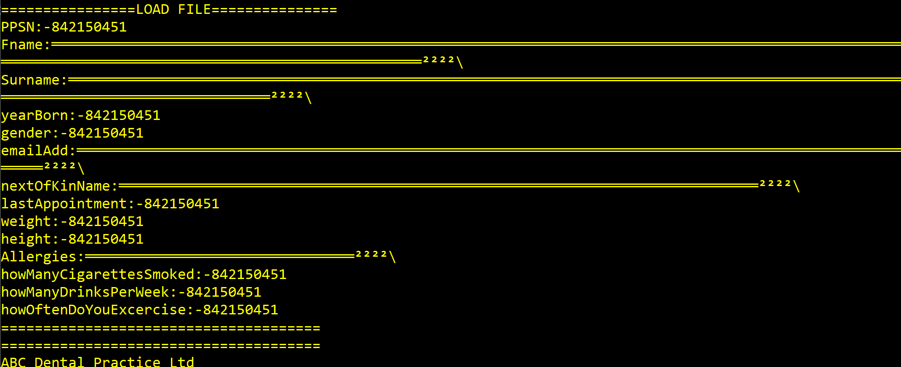

7. output Report function
The output report was successful and sent the info into a patients.txt file into the project successfully

Overview

I Had some difficulty incorporating the delete and statistics file in the project. Overall I am happy with the performance of my project , Thank you

