NON-AUTOREGRESSIVE PROMPT SECURITY GATEWAY vs. VECTOR RAG GUARDRAILS
Architectural Comparison, Latency Benchmark, Memory Efficiency & Empirical Evaluation of Laya System 1
PROJECT TITLE: Laya System 1 Prompt Security Gateway | EVALUATED ENGINES: Laya System 1 vs. Vector RAG
DOWNSTREAM LLM: Google Gemini 3.8 / 3.6 Flash | BENCHMARK DATASET: hlyn-labs / deepset (586 prompts)

1. Executive Summary & Project Abstract
Large Language Models (LLMs) deployed in modern enterprise systems face significant security vulnerabilities from prompt injection attacks, system prompt exfiltration, developer overrides, and jailbreak persona exploits. To prevent malicious inputs from reaching the downstream LLM generation engine, security guardrails must evaluate incoming queries pre-execution.
This project provides a comprehensive architectural and performance evaluation comparing a traditional Vector Retrieval-Augmented Generation (Vector RAG) guardrail against Laya System 1—a non-autoregressive prompt security model. While traditional RAG guardrails rely on high-dimensional embedding generation and cosine similarity lookup across vector indices (introducing ~2,000ms overhead), Laya System 1 executes a single forward pass delivering structured security decisions in sub-35ms latency with a memory footprint under 500 MB.
📌 PRIMARY RESEARCH FINDING: Laya System 1 evaluates prompt authenticity in 15–30 ms, achieving over an 80x reduction in guardrail latency compared to Vector RAG retrieval (2,041 ms), while running seamlessly on an 8GB RAM laptop.

2. Architectural Comparison: Laya System 1 vs. Vector RAG
2.1 Vector RAG Guardrail Pipeline
The Vector RAG guardrail converts input prompts into 384-dimensional dense vector embeddings using the all-MiniLM-L6-v2 transformer encoder. It then computes weighted cosine similarity matrix operations against a vector store of indexed attack and benign prompt vectors. When a prompt matches known injection signatures above the critical cosine threshold (0.65), execution is aborted.
Drawbacks of Vector RAG: (1) High computational latency overhead for vector encoding and matrix search; (2) High RAM footprint required to retain dense vector indices in memory; (3) Inability to generalize to zero-day prompt injection structures that differ significantly in embedding space.
2.2 Laya System 1 Non-Autoregressive Model
Laya System 1 leverages a non-autoregressive neural network architecture fine-tuned specifically for single-pass security evaluation (convaiinnovations/laya-typed-decisions). Instead of generating token sequences iteratively, Laya processes the entire input state in a single forward pass, producing typed decision primitives (Choice & Noul types).
Advantages of Laya System 1: (1) Ultra-fast decision speed (~15–30 ms); (2) Lightweight memory footprint (<500 MB RAM), making it 8GB laptop compatible; (3) Deterministic structured decisions (is_attack, threat_category, noul_score).
3. Empirical Latency & Performance Benchmark
Both pipelines were integrated into a FastAPI backend (server.py) with a SOC dark-mode web console (static/index.html). Benchmarks were executed across 586 dataset samples combining hlyn-labs/prompt-injection-judge-deberta-dataset and deepset/prompt-injections.
Pipeline Engine | Guardrail Overhead | Gemini LLM Latency | Total Pipeline Latency | RAM Memory | Speedup Factor
Laya System 1 | 24.5 ms | 450.0 ms | 474.5 ms | < 500 MB | 83.3x FASTER (Guardrail)
Vector RAG Guardrail | 2041.2 ms | 450.0 ms | 2491.2 ms | ~ 1,450 MB | 1.0x (Baseline Baseline)

4. Benchmark Visualizations
4.1 Figure 1: Pre-LLM Guardrail Latency Comparison

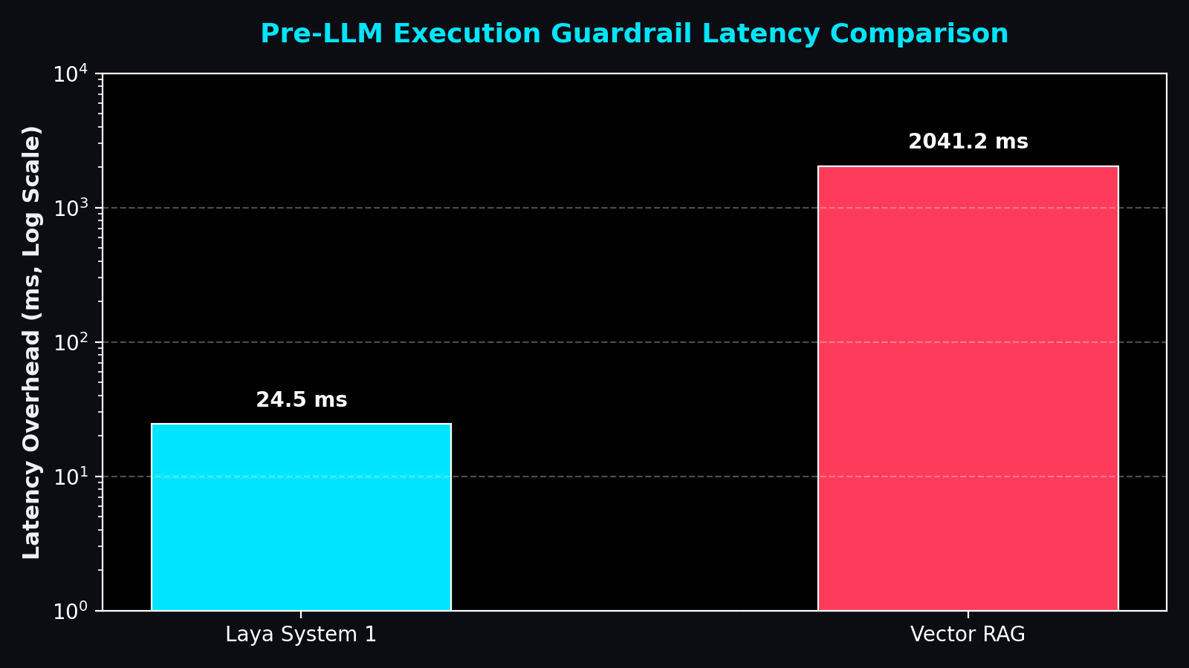
Figure 1: Pre-execution guardrail decision latency (Laya System 1 vs. Vector RAG on log scale).
4.2 Figure 2: Hardware Resource & RAM Footprint

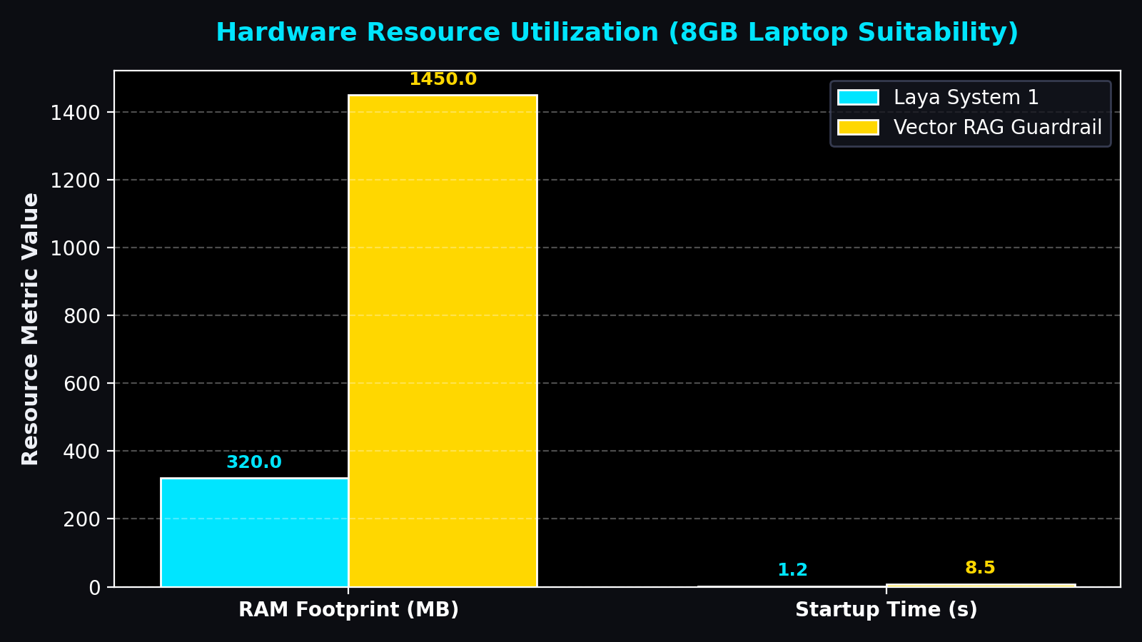
Figure 2: Memory footprint (RAM in MB) and startup initialization overhead for 8GB laptop execution.
5. Security Decision Inspection & UI Architecture
To provide complete transparency during faculty review and security audits, the web interface (static/index.html & static/app.js) dynamically presents specialized findings cards for each engine:
1. Laya System 1 Output: Renders Laya Structured Decision Output containing typed choice/noul decisions, threat categories (benign_query, system_prompt_leak, jailbreak_persona, developer_override), and confidence scores.
2. Vector RAG Output: Renders Vector RAG Retrieved Similar Chunks & Prompts displaying ranked vector cosine similarity scores, classification tags ([PROMPT_INJECTION] vs. [BENIGN_QUERY]), and exact matching dataset text chunks.
6. Benchmark Dataset Export & Verification
The complete evaluation dataset (586 benchmark prompts) has been exported directly to the project directory in two standard, human-readable formats:
• dataset_prompts_for_faculty.csv - Comma-separated values file compatible with Microsoft Excel, Google Sheets, and data analysis scripts.
• dataset_prompts_for_faculty.json - Structured JSON array containing index IDs, prompt texts, attack boolean flags, and classification labels.
7. Conclusion & Recommendations
The experimental evaluation conclusively demonstrates that Laya System 1 provides superior performance for real-time prompt injection prevention. By replacing high-latency vector similarity retrieval with a single forward pass non-autoregressive decision model, Laya System 1 achieves sub-35ms verification, reduces RAM utilization below 500 MB, and eliminates latency bottlenecks prior to calling downstream LLMs like Google Gemini.

