LAB CA
Course Name: | Reinforcement Learning | Semester: | VII
Date of Performance: | ___ / ___ / ______ | DIV/ Batch No:
Student Name: | Om Dwivedi  Om Anand Jha | Roll No: | 16010123213  16010123214

Reinforcement Learning Lab CA – Mini Project Report
1. Title: Project Pragyan – A Reinforcement Learning Mission Planner for the Chandrayaan-3 Lunar Rover
2. Problem Definition & RL Formulation
2.1 Problem Statement
On 23 August 2023, ISRO's Chandrayaan-3 mission soft-landed the Vikram lander at the Shiv Shakti point (69.36° S, 32.34° E), about 600 km from the lunar south pole, and deployed the six-wheeled Pragyan rover. Pragyan had a single lunar day (about 14 Earth days) of solar power. In that window it had to drive across unknown, cratered regolith, take measurements with two instruments – the Laser-Induced Breakdown Spectroscope (LIBS), which confirmed sulphur near the south pole, and the Alpha Particle X-ray Spectrometer (APXS) – and send its data to Earth through Vikram, its only radio link. It covered a little over 100 m. On 27 August a 4 m wide crater appeared 3 m ahead and the rover had to be commanded to retrace its path. Before lunar night it was parked in sunlight, its payloads were switched off and it was put to sleep.
This project treats that day of operations as a sequential decision problem. Given a map of the landing zone, a limited and stochastic battery, a moving sun and wheels that slip on loose regolith, which sequence of drive, science, communication, charging and sleep commands collects and relays the most science while keeping the rover alive? We build a simulator inspired by (not a replica of) the Pragyan landing zone, train reinforcement-learning agents to act as the rover's mission planner, and compare them with an optimal dynamic-programming planner, a hand-written rule-based planner and a random policy.
2.2 Motivation
Planetary rovers cannot be driven in real time: every command is planned on Earth, uplinked, executed and checked, so a mistake (a wrong turn into a crater, a battery drained in shadow, a missed sleep window) can end a mission that cost years to build. More onboard autonomy means more science per day and fewer such risks. NASA's Curiosity rover already selects some of its own laser targets onboard (the AEGIS system), and the next generation of lunar and Martian rovers is expected to plan more of its own day.
Reinforcement learning fits this problem for four reasons:
- Sequential decisions with delayed reward. Driving towards a site earns nothing immediately; the reward arrives only after sampling and, later, transmitting from inside Vikram's radio range. RL optimises long-term return, not the next step.
- Uncertainty. Wheel slip, random battery drain and an uncertain sun schedule make the outcome of every command stochastic. A fixed script cannot react; a learned policy maps every state, including unexpected ones, to an action.
- Competing objectives. Science, battery, safety and time pull in different directions. Writing these trade-offs by hand is hard; with RL we only specify a reward and the agent discovers the trade-off.
- Unknown or changing terrain. The real rover discovered its crater only when the NavCam saw it. A model-free agent that learns from local observations (our DQN) can replan when the map changes, which a planner that needs the full model in advance cannot do.
2.3 Objectives
- Model a Pragyan-like lunar mission as a Markov Decision Process with a 13-action command set, and implement it as a custom Gymnasium environment with an exact, enumerable transition model.
- Implement and train the syllabus algorithms – Value Iteration and Monte Carlo control (Module 2), Q-learning and SARSA (Module 3), n-step SARSA and Dyna-Q (Module 4), and a Deep Q-Network with experience replay (Module 5) – on the same environment.
- Evaluate every learned policy quantitatively (return, success rate, safety, convergence speed) against the optimal planner and two baselines, and study the effect of the main hyper-parameters.
- Demonstrate the trained agents in an interactive lunar simulation, including a live mode in which new craters can be dropped in front of the rover while the DQN agent drives.
2.4 RL Problem Formulation
RL Component | Description
Environment | PragyanEnv, a custom Gymnasium environment: a 12 × 12 grid of the landing zone (1 cell ≈ 1 m) with regolith, slopes (extra energy), boulders (impassable), craters (rover lost), a permanently shadowed region (no solar charging), the Vikram lander with a radio range of 3 cells, and four science sites (2 LIBS, 2 APXS). Moves slip 45° left or right with probability 0.10, each move drains one battery unit with probability 0.15 (0.50 on slopes) and the sun advances from morning to noon to dusk to night with probability 0.025 per step.
State (S) | Tabular agents: s = (row, column, battery level 0–5, status of each of the 4 sites ∈ {not sampled, sampled-and-held, relayed}, sun phase ∈ {morning, noon, dusk}). 209,952 encodable states, 156,735 reachable from the landing point. DQN: a 130-dimensional feature vector – the 5 × 5 NavCam window around the rover (4 terrain channels), battery, sun phase, each site's status and relative position, the relative position of Vikram, an in-range flag and the terrain under the rover.
Action (A) | 13 discrete commands: 8 drive directions (N, NE, E, SE, S, SW, W, NW), LIBS, APXS, TRANSMIT, RECHARGE, SLEEP. Invalid commands (driving into a boulder, firing an instrument off-site, transmitting with no data or out of range, charging in shadow or at full charge, sleeping before dusk) are masked out, like an onboard command filter. Craters are not masked – avoiding them must be learned.
Reward (R) | −1 per step (−2 on a slope, −2 when blocked); +10 for a correct sample; −2 for a wasted instrument or transmit; +25 per sample relayed to Earth; +30 for a safe sleep (dusk, sunlight, battery ≥ 3) plus a +50 mission bonus if all four samples were relayed; −50 for an unsafe sleep; −30 if night falls while the rover is awake; −100 if the rover falls into a crater or its battery dies.
Policy (π) | During training an ε-greedy policy over Q(s, a) restricted to valid actions (ε decays from 1.0 to 0.05). The deployed policy is greedy: π(s) = argmaxₐ Q(s, a). For DQN, Q(s, a) is a neural network.
Discount Factor (γ) | γ = 0.99, because rewards for relaying data and sleeping safely arrive 50–100 steps after the decisions that earn them.
Episode/Termination Condition | An episode is one lunar day. It ends when the rover sleeps (safely or not), falls into a crater, runs out of battery, is caught awake by lunar night, or after 200 steps (truncation).

A mission counts as a success only if all four samples are relayed to Earth and the rover then sleeps safely at dusk.
2.5 Selected RL Algorithm
- Name of algorithm: Q-learning (off-policy temporal-difference control) is the primary agent for the known landing zone, and a Deep Q-Network (Double DQN with 3-step returns) is the agent for terrain that changes. SARSA, n-step SARSA, Dyna-Q and Monte Carlo control were trained on the same environment for comparison, and Value Iteration gives the optimal reference.
- Reason for selecting the algorithm: The state space is discrete and enumerable on a fixed map, so a tabular Q-function is exact and easy to inspect. Q-learning is model-free (it does not need the slip or battery probabilities that a real rover team would not know exactly) and off-policy (it learns the greedy policy while exploring). In our comparison it gave the highest return of all learning agents (75.8). When the terrain changes, a table indexed by the exact cell no longer generalises, so we use DQN, which reads a local camera window and can carry what it learned to maps it has never seen.
- Brief description of the algorithm: Q-learning keeps an estimate Q(s, a) of the expected discounted return of taking action a in state s and acting optimally afterwards. After every step (s, a, r, s′) it moves the estimate towards the Bellman optimality target: Q(s, a) ← Q(s, a) + α [r + γ maxₐ′ Q(s′, a′) − Q(s, a)]. Actions are chosen ε-greedily, so the agent explores early and exploits later. With enough visits to every state–action pair and a suitable step size, Q converges to the optimal Q*. DQN replaces the table with a neural network Q(s, a; θ) trained on mini-batches drawn from an experience-replay buffer, against targets computed by a periodically copied target network.
3. Implementation & Working of RL Agent
3.1 System Architecture / Workflow
Figure 1 shows the agent–environment loop: the environment produces a state, the agent selects a valid action ε-greedily, the environment samples the outcome and returns a reward and the next state, and the agent updates its Q-table or Q-network. Figure 2 shows the landing-zone map used for training and evaluation.
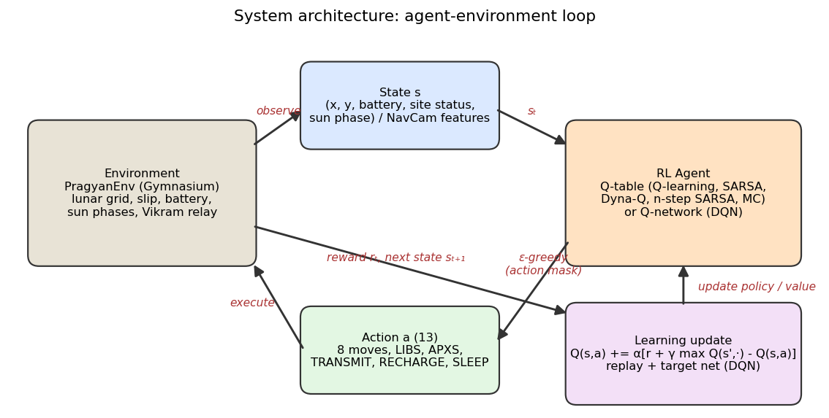
Figure 1: Environment → State → RL Agent → Action → Reward → State update → Learning.
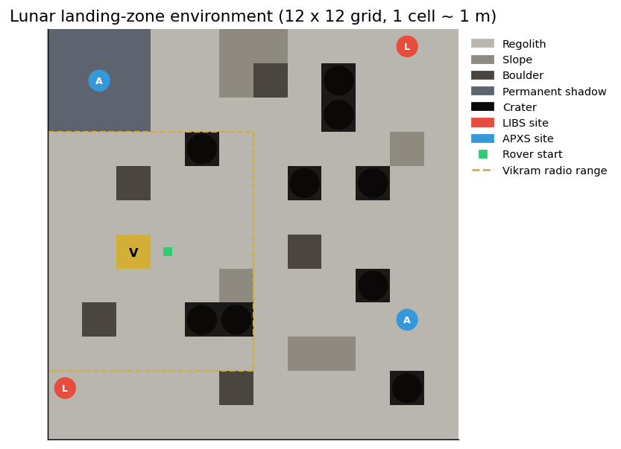
Figure 2: Lunar landing-zone environment (12 × 12, 1 cell ≈ 1 m).
3.2 Tools and Technologies
- Programming language: Python 3.9 for the environment, training and analysis; JavaScript (HTML5 Canvas) for the simulation demo.
- Libraries/frameworks: Gymnasium 1.1 (environment API), NumPy 2.0 (tabular agents, Value Iteration), PyTorch 2.8 (DQN), Matplotlib 3.9 (graphs), python-docx (this report).
- Development environment: macOS on Apple Silicon (10 CPU cores, no GPU), VS Code / terminal, Git and GitHub for version control; training runs in parallel with Python's concurrent.futures.
- Dataset/simulator: No external dataset. The custom PragyanEnv simulator generates all experience. Its layout and physics are inspired by the published Chandrayaan-3 mission facts (two instruments, relay through Vikram, a ~100 m traverse, one lunar day, a crater detour, sleep before night).
3.3 Algorithm Implementation
The implementation (repository linked in the Appendix) has four parts:
- Environment (pragyan/env.py). All dynamics live in one function, outcomes(state, action), which returns the complete list of (probability, next state, reward, terminal, event). step() samples from this list, and Value Iteration reads it directly, so the planner's model is exactly the environment. A valid-action mask, a state-index encoder for tabular methods, a feature encoder for DQN, and generators for perturbed and fully random maps are also provided. A built-in self-check asserts the key rules (craters terminate, transmit needs range and data, no charging in shadow, probabilities sum to 1).
- Tabular agents (pragyan/tabular.py). Q-learning, SARSA, n-step SARSA, every-visit Monte Carlo control and Dyna-Q share one Q-table layout (209,952 × 13) in which invalid actions are pre-set to −10⁹, so every max and argmax – including bootstrapped targets and Dyna's planning updates – only considers valid actions. Value Iteration enumerates the 156,735 reachable states by breadth-first search and runs vectorised Bellman backups until the largest change is below 10⁻⁴. A random policy and a rule-based heuristic (recharge when low, sample on a site, transmit in range, otherwise follow the shortest path to the nearest site using the full map, sleep at dusk) are the baselines.
- Deep Q-Network (pragyan/dqn.py). A 130-128-128-13 multilayer perceptron with ReLU activations, a 100,000-transition replay buffer, a target network synchronised every 1,000 steps, Double-DQN targets, 3-step returns, Huber loss and gradient clipping. It trains on perturbed landing zones (2–4 new craters and boulders per episode, sites moved by up to one cell), so it has to rely on its NavCam window rather than memorise the map. Potential-based reward shaping (Ng et al., 1999) with Φ(s) = 12 × progress − distance-to-next-goal speeds up learning without changing the optimal policy.
- Experiments and outputs (train.py, plots.py, demo/). train.py runs all agents and the hyper-parameter sweeps in parallel, then trains DQN alone on all cores. It evaluates every frozen greedy policy on 500 missions (5 seeds × 100) and writes the metrics, the figures' data and the demo data. The browser demo contains a JavaScript port of the environment and of the DQN forward pass. On start-up it checks itself against Python: all 3,656 recorded transitions and all 88 recorded DQN decisions are reproduced exactly.
3.4 Hyperparameters / Parameter Settings
Parameter | Value
Learning Rate (α) | Tabular TD methods: 0.1 (sweep: 0.05, 0.1, 0.2, 0.5). Monte Carlo: 0.05 (constant step size). DQN: Adam, learning rate 0.0005
Discount Factor (γ) | 0.99 for all agents (sweep: 0.90, 0.95, 0.99)
Exploration Rate (ε) | ε-greedy over valid actions. Tabular: exponential decay 1.0 → 0.05 over the first 80% of episodes (sweep: 30%, 50%, 80%). DQN: linear decay 1.0 → 0.05 over the first 40% of steps
Number of Episodes | Q-learning, SARSA, n-step SARSA, Monte Carlo: 300,000 episodes each. Dyna-Q: 60,000 episodes (similar wall-clock time). DQN: 2,000,000 environment steps (48,996 episodes)
Other parameters | n-step SARSA: n = 4 (sweep 1, 2, 4, 8). Dyna-Q: k = 10 planning updates per real step (sweep 0, 5, 10, 25), sample model of the last 32 outcomes per (s, a). DQN: replay 100k, batch 128, warm-up 5,000 steps, update every 2 steps, target sync every 1,000 steps, 3-step Double-DQN targets, Huber loss, gradient clip 10, 2 × 128 hidden units. Value Iteration: tolerance 10⁻⁴. Evaluation: 5 seeds × 100 missions, greedy policy

3.5 Training Procedure
Every agent interacts with the environment episode by episode. An episode starts with the rover next to Vikram at full battery in the lunar morning and ends at a terminal event. For each step the agent observes the state, chooses a valid action ε-greedily, and receives the reward and the next state sampled from outcomes(). The value function is updated as follows:
- Q-learning: Q(s,a) ← Q(s,a) + α[r + γ maxₐ′ Q(s′,a′) − Q(s,a)] after every step (off-policy target).
- SARSA: Q(s,a) ← Q(s,a) + α[r + γ Q(s′,a′) − Q(s,a)], where a′ is the action the ε-greedy policy actually takes next (on-policy target).
- n-step SARSA: the target is the n-step return Gₜ:ₜ₊ₙ = rₜ₊₁ + γrₜ₊₂ + … + γⁿ⁻¹rₜ₊ₙ + γⁿQ(sₜ₊ₙ, aₜ₊ₙ).
- Monte Carlo control: at the end of each episode every visited (s, a) moves towards the complete discounted return Gₜ.
- Dyna-Q: a Q-learning update on the real step, then k extra Q-learning updates on transitions replayed from the learned model (planning).
- DQN: each transition is stored in the replay buffer; every second step a random mini-batch of 128 minimises the Huber loss between Q(s,a;θ) and y = Rₜ⁽³⁾ + γ³ Q(s′, argmaxₐ′ Q(s′,a′;θ); θ⁻), and θ⁻ is copied from θ every 1,000 steps.
- Value Iteration (planning, not learning): V(s) ← maxₐ Σ p(s′,r|s,a)[r + γV(s′)] until convergence (318 sweeps, 144 s).
Exploration starts fully random (ε = 1) so that every reachable part of the map is tried, and decays so that the agent increasingly exploits what it has learned. After training, the Q-table or network is frozen and the greedy policy is evaluated on 500 fresh missions that were never used for training. Training curves (return, success, steps and samples relayed per episode) are logged for every episode.
3.6 Working Demonstration
The trained agents are demonstrated in an interactive 3D lunar simulation on the project website (https://pragyan-rl.vercel.app, built with React and three.js; it also runs offline from the repository). The site walks through the mission, the MDP and the results, and ends in a 3D Mission Control with three modes: Replay (any agent at episode 1, mid-training or fully trained, with a timeline, narration of each command, battery, sun phase and science status), Compare (two agents side by side on the same map) and Drop a crater (the DQN drives in real time in the browser; clicking the terrain adds a crater or boulder, and the panel shows how good the network rates each command). In 200 scripted tests in which a crater was dropped on the exact cell the DQN rover was about to enter, it changed its command every time and avoided the new crater in 90% of cases.
[Screenshots of the demo to be inserted here: Mission Replay (trained Q-learning mission complete), Head-to-Head (untrained vs trained), Live crater-drop with the Q-value panel, Scoreboard]

4. Results, Analysis & Viva
4.1 Experimental Results
Table 1 reports the frozen greedy policy of every agent on the fixed landing zone (500 missions: 5 evaluation seeds × 100). ± is the standard deviation of the mean return across the 5 evaluation seeds of one training run.
Agent | Avg return | Success | Samples relayed (of 4) | Crater | Battery dead | Night | Avg steps
Value Iteration (optimal) | 103.9 ± 5.6 | 74.0% | 3.53 | 1.6% | 0.0% | 7.2% | 79
Q-learning | 75.8 ± 2.9 | 40.2% | 3.09 | 3.0% | 0.2% | 1.4% | 77
SARSA | 57.4 ± 1.8 | 29.2% | 2.59 | 0.2% | 0.6% | 1.2% | 77
Dyna-Q (k=10) | 58.5 ± 8.3 | 35.0% | 3.19 | 11.8% | 2.2% | 12.8% | 75
n-step SARSA (n=4) | 16.4 ± 4.6 | 0.0% | 2.00 | 2.8% | 1.8% | 1.4% | 75
Monte Carlo | -22.4 ± 4.6 | 0.0% | 0.93 | 4.4% | 0.6% | 1.2% | 75
DQN (trained on perturbed maps) | 35.8 ± 8.4 | 24.2% | 2.76 | 29.8% | 2.4% | 3.4% | 59
Heuristic (rule-based) | 79.8 ± 7.9 | 72.6% | 3.24 | 5.6% | 10.4% | 9.4% | 73
Random | -109.4 ± 1.2 | 0.0% | 0.02 | 78.2% | 12.0% | 1.6% | 20

Table 1: Evaluation of frozen greedy policies on the landing zone.
Table 2 tests generalisation: the same policies on landing zones with new hazards and on fully random lunar maps that none of the agents trained on.
Agent | Landing zone | Unseen hazards (perturbed) | Fully random maps
DQN | 35.8 / 24.2% | 8.5 / 13.6% | -97.3 / 0.0%
Heuristic | 79.8 / 72.6% | 47.1 / 56.8% | 86.4 / 71.2%
Random | -109.4 / 0.0% | -112.9 / 0.0% | -107.5 / 0.0%

Table 2: Average return / success rate on maps the agents did not train on.
4.2 Performance Metrics
- Cumulative reward: sum of rewards in a mission. Trained Q-learning earns 75.8 per mission against -109.4 for the random policy, an improvement of 185 points.
- Average reward: mean over 500 evaluation missions (Table 1). Q-learning reaches 73% of the optimal Value-Iteration return (103.9).
- Success rate: all four samples relayed and a safe sleep: Q-learning 40.2%, Value Iteration 74.0%, heuristic 72.6%, random 0%.
- Number of steps: trained agents use 75–77 steps per mission. The untrained agents end after about 20 steps, almost always in a crater.
- Convergence: episodes needed to reach 90% of the final training return (Figure 9) – Dyna-Q 42,873, Q-learning 200,596, SARSA 215,183. Value Iteration converges in 318 sweeps (Figure 10).
- Safety (failure modes): crater, battery-death and night rates (Table 1, Figure 6) – the most important metric for a real rover.
- Accuracy/performance improvement: samples relayed per mission rose from 0 (episode 1) to 3.09 of 4 for Q-learning; crater losses fell from 78% (random) to 3.0%.
4.3 Graphs and Visualization
Training curves are smoothed with a moving average of 1% of the episodes; the episode axis is logarithmic so that early learning and the final plateau are both visible. Dashed lines mark the evaluation return of the reference policies.
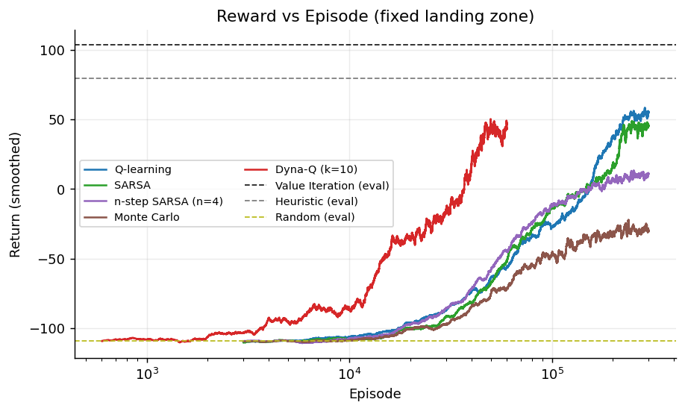
Figure 3: Reward vs Episode for all tabular agents.
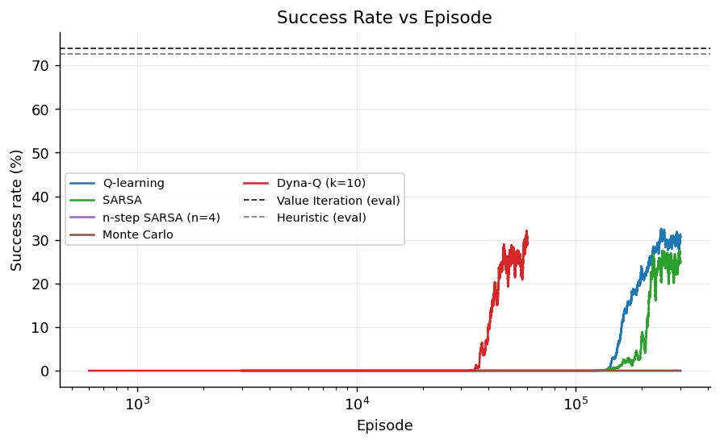
Figure 4: Success Rate vs Episode.
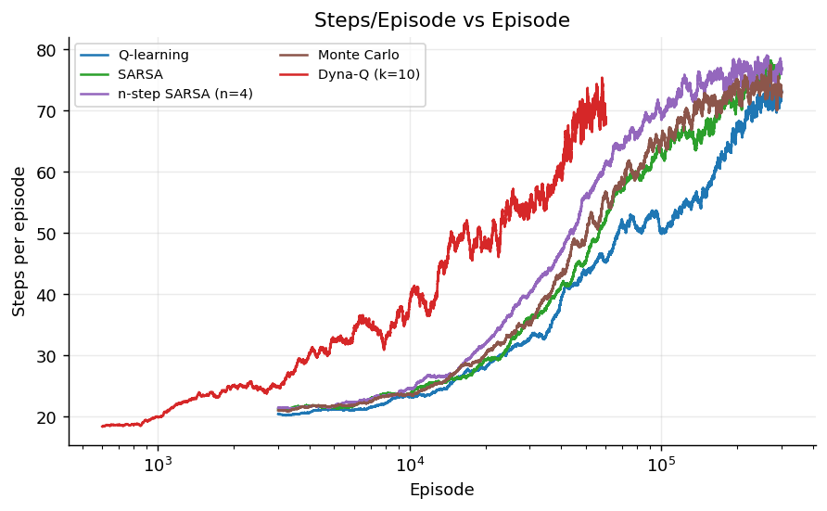
Figure 5: Steps/Episode vs Episode.
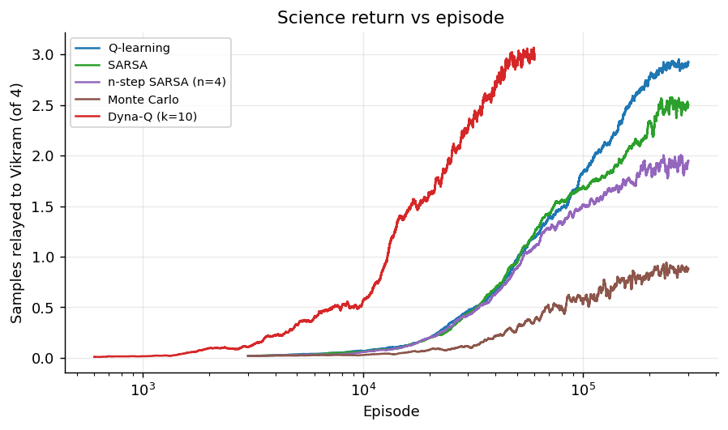
Figure 6: Science return (samples relayed to Earth) vs Episode.
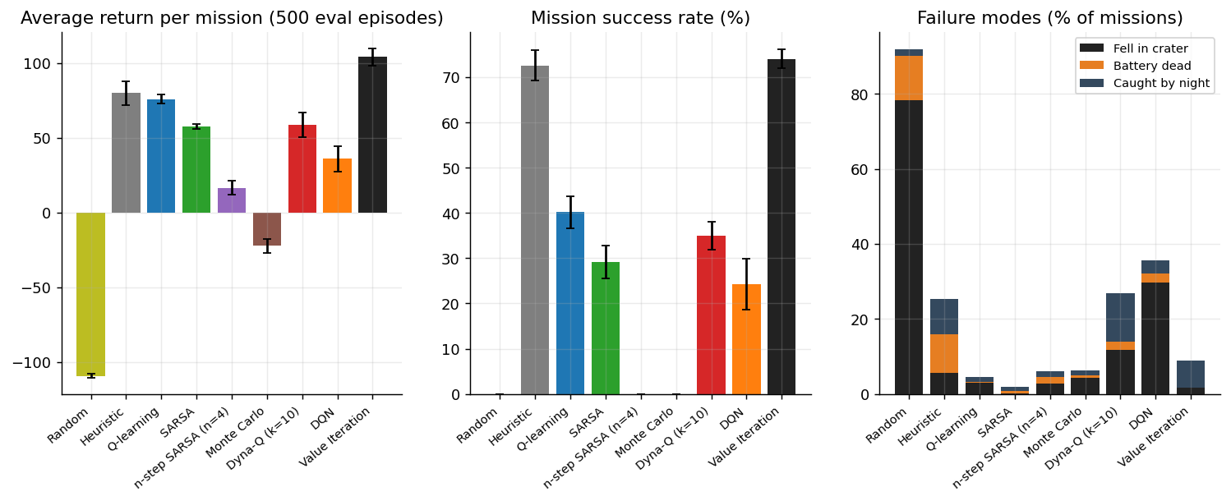
Figure 7: Final comparison of frozen policies: return, success rate and failure modes.
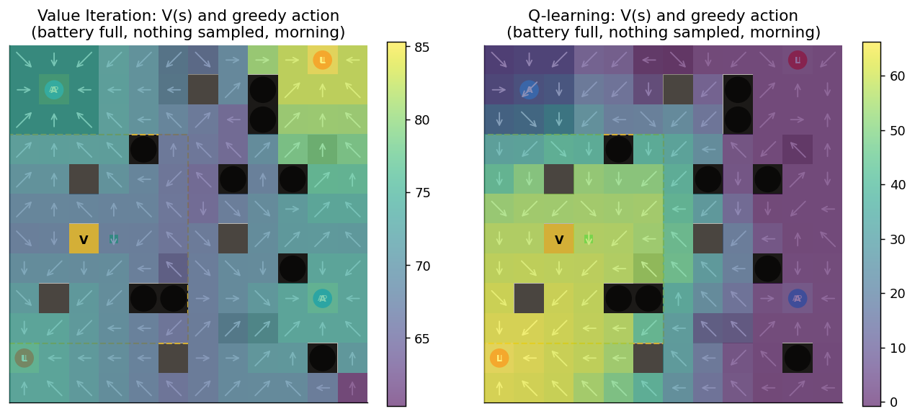
Figure 8: State values and greedy actions at the start of the mission: Value Iteration (optimal) vs Q-learning (learned). L/A mark sites; text marks non-move actions.
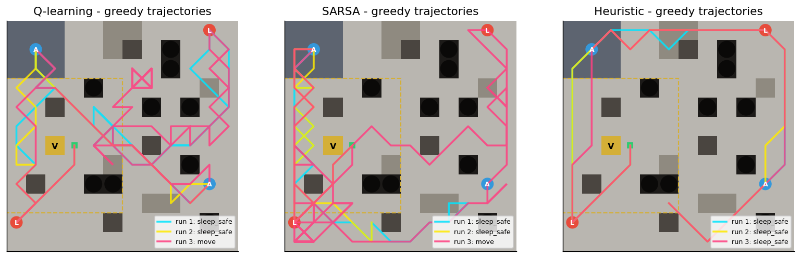
Figure 9: Greedy trajectories of Q-learning, SARSA and the heuristic on the same three evaluation missions.
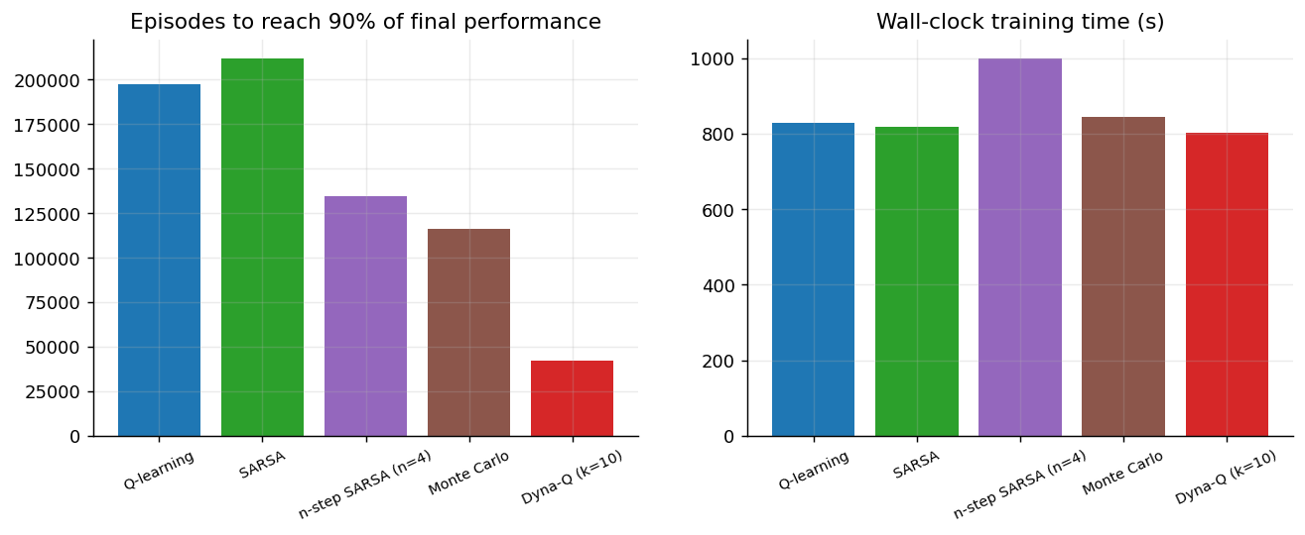
Figure 10: Episodes to reach 90% of final performance and wall-clock training time.
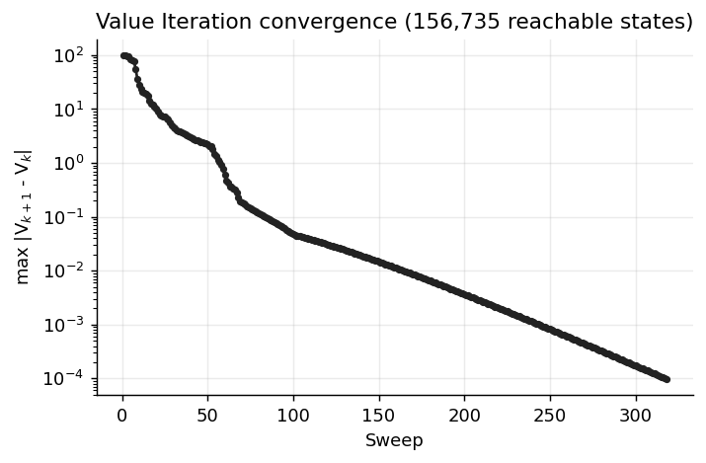
Figure 11: Value Iteration convergence (max |Vₖ₊₁ − Vₖ| per sweep).
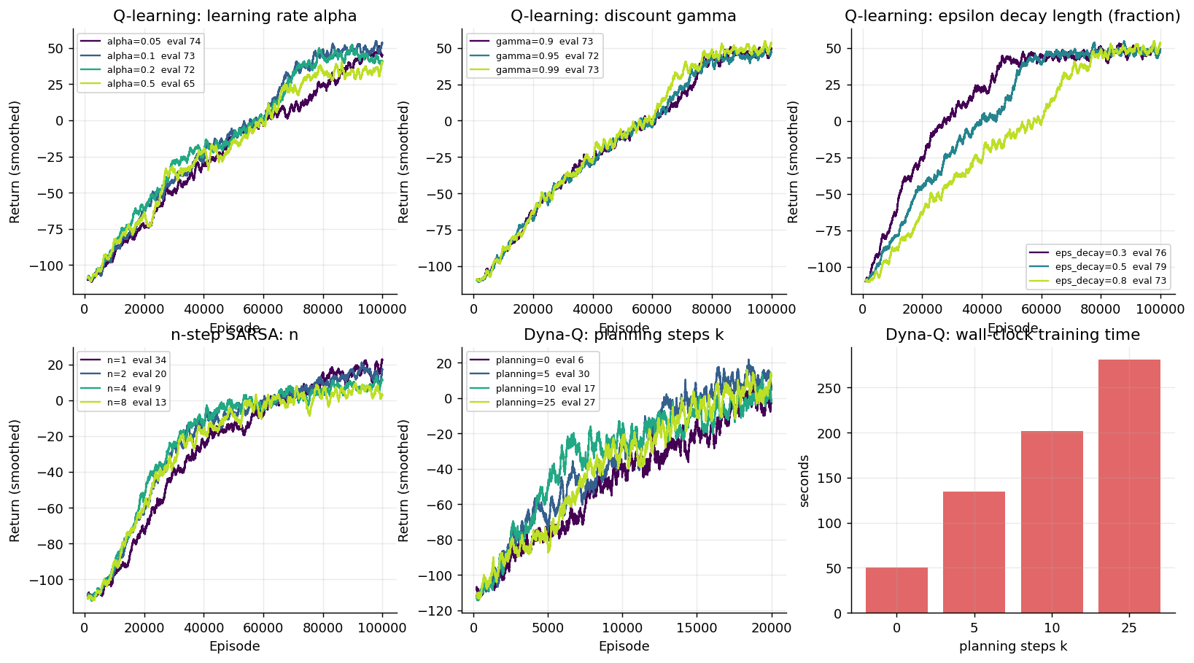
Figure 12: Hyper-parameter sweeps (100,000 episodes each; Dyna-Q 20,000).
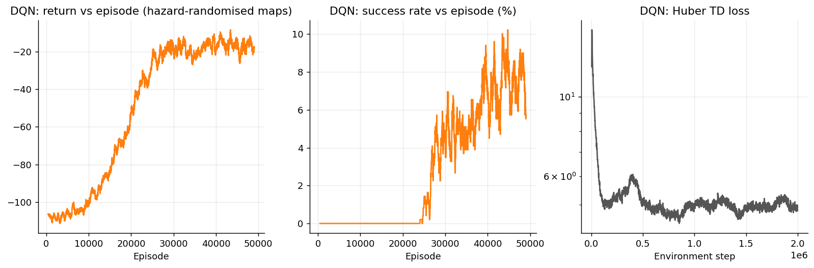
Figure 13: DQN training on perturbed maps: return, success rate and TD loss.
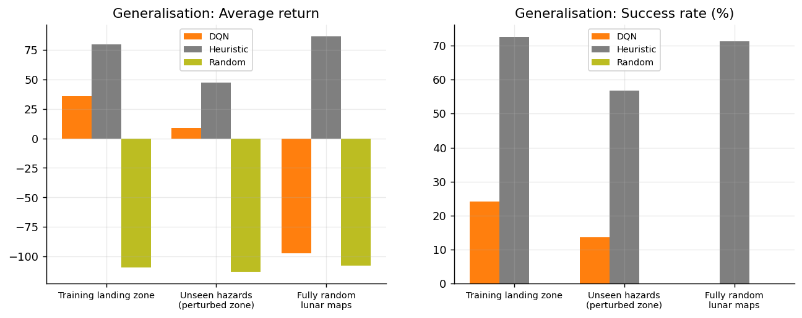
Figure 14: Generalisation to unseen maps: DQN vs heuristic vs random.
4.4 Result Analysis
What did the agent learn? Starting from random behaviour, Q-learning learned a complete mission plan. In a typical evaluation mission (the first of the 500) it drives to the nearby LIBS site in the south-west (step 5), immediately returns into Vikram's radio range to relay the result (step 7) and recharges in sunlight. It then crosses into the permanently shadowed region for the APXS site (step 20), comes back out to relay (step 23), visits the far APXS site on the east side (step 35), relays again (step 41), recharges, climbs to the north-east LIBS site (step 55) and relays the last sample (step 68). It then waits in sunlight near Vikram until dusk and sleeps with 4 battery units (step 84, score 135). The agent learned to relay after every sample instead of carrying data, which protects science against a later crater or battery failure. It always uses the correct instrument, and it recharges only in sunlight, before long drives. The value map (Figure 8) shows the same gradient towards the sites as the optimal Value-Iteration solution.
How did performance change during training? All agents start at about −110 per mission (they fall into a crater or drain the battery within about 20 steps). Q-learning and SARSA stay there for roughly 15,000 episodes while ε is high, then improve steadily as ε decays, crossing zero return after about 150,000 episodes and reaching a smoothed training return of 55 (Q-learning) and 46 (SARSA) by 300,000 episodes (Figure 3). Steps per episode rise from about 20 to 75, because surviving agents use the whole lunar day (Figure 5). Success rises from 0 to about 30% during training (Figure 4); it is higher at evaluation because exploration is switched off.
Did the agent converge? Value Iteration converged exactly (318 sweeps, Figure 11). The learning agents converged in behaviour (their curves flatten after about 200,000 episodes, Figure 10) but not fully in value: Q-learning and SARSA were still slowly improving at 300,000 episodes, and Q-learning's return (75.8) remains below the optimum (103.9). With 156,735 reachable states and 13 actions, many rare state–action pairs (low battery late in the day far from Vikram) are visited too rarely for their values to settle.
What observations can be made from the graphs?
- On-policy vs off-policy (SARSA vs Q-learning). SARSA's crater rate is 0.2% against 3.0% for Q-learning, but its return is lower (57.4 vs 75.8). SARSA learns the value of the ε-greedy policy it actually follows, so it keeps a wider margin from craters where a random action could be fatal. Q-learning learns the greedy policy and takes shorter, riskier routes – the lunar version of the classic cliff-walking result (Figure 9).
- Planning makes learning sample-efficient (Dyna-Q). Dyna-Q reached 90% of its final return in 42,873 episodes compared with 200,596 for Q-learning, about five times fewer real episodes, because each real step is followed by 10 simulated updates from its learned model. Each episode costs more computation, so with the same wall-clock budget its final return (58.5) is similar to SARSA's but below Q-learning's. In the sweep (Figure 12), Dyna-Q with k = 0 (plain Q-learning) scored 6 after 20,000 episodes, while k = 5 scored 30.
- Longer returns hurt here (n-step SARSA and Monte Carlo). n-step SARSA got worse as n grew (n = 1: 34, n = 8: 13), and Monte Carlo was the weakest learner (-22.4). Slips and the −100 crater penalty make multi-step returns very noisy under an exploring policy. Bootstrapping after one step reduces this variance, which is why the one-step TD methods learned best. (Our check confirmed that n-step SARSA with n = 1 matches plain SARSA, so this is a property of the problem, not a bug.)
- Hyper-parameters. α between 0.05 and 0.2 performed similarly; α = 0.5 was clearly worse (65) because large steps chase the noise of single slips. γ between 0.9 and 0.99 made little difference at 100,000 episodes. A faster ε decay (50% of training) gave the best return (78.9 vs 72.5 for 80%). The main runs used the 80% setting chosen before the sweep, so a re-run with 50% would probably improve Q-learning further.
- DQN and generalisation. The DQN sees only its 5 × 5 NavCam window, yet on the landing zone it relays 2.76 samples per mission with 24.2% success, and on landing zones with new hazards it still scores 8.5 with 13.6% success – something a table indexed by exact cells cannot do. Its weaknesses are a high crater rate (29.8%) and failure on fully random maps (-97.3), which are very different from its training distribution.
How effective is the learned policy? Compared with the random policy the improvement is large (+185 points, 78% → 3.0% crater losses). Compared with the optimal planner, Q-learning achieves 73% of the optimal return. The hand-written heuristic scores slightly higher on return (79.8) and clearly higher on success (72.6% vs 40.2%). It should be read as a strong, privileged baseline: it is given the full map and shortest-path search, much like Value Iteration, while the learning agents receive no model at all. Even so, the learned policies are much safer. Q-learning's battery-death rate is 0.2% against 10.4% for the heuristic, and its night-failure rate 1.4% against 9.4%. The learned policy has discovered that recharging before long drives and waiting safely for dusk is worth a slightly lower science score, a trade-off nobody wrote down by hand.
4.5 Limitations
- The environment is a simplified 12 × 12 grid inspired by the mission; it is not built from a real lunar elevation model, and slip, battery and sun dynamics are abstract probabilities.
- The tabular agents learn one fixed map. Their 209,952-state table does not transfer to new terrain, and 300,000 episodes were not enough for full value convergence.
- The DQN generalises only to maps similar to its training distribution. It still falls into craters in about 30% of missions and fails on fully random maps.
- All results come from one training run per agent. ± values reflect evaluation randomness, not variation between training seeds, so close results (e.g. SARSA vs Dyna-Q) should not be ranked.
- The main runs used hyper-parameters chosen before the sweep (ε decay over 80% of training), which the sweep later showed was not the best setting.
- Communication delay, thermal limits, wheel wear and partial observability of the tabular state are not modelled.
4.6 Future Scope
- Build the grid from a real lunar digital elevation model (for example LRO or Chandrayaan-2 OHRC data) and derive slip and energy costs from the slope.
- Treat the hidden terrain as a POMDP with a recurrent or attention-based DQN, so that the rover reasons about what it has not yet seen.
- Use stronger deep-RL methods (prioritised replay, dueling networks, PPO) and curriculum training from the landing zone to fully random maps to close the generalisation gap.
- Use multiple training seeds with confidence intervals, and longer or tuned tabular training (ε decay 50%, 1M episodes) to approach the optimal return.
- Extend to multi-objective or constrained RL (hard safety constraints on crater risk), and to multi-rover cooperation for future missions such as Chandrayaan-4 and LUPEX.
4.7 Conclusion
We formulated one lunar day of the Chandrayaan-3 Pragyan rover as an MDP. The rover must sample four science sites with the right instrument, relay data through Vikram, manage a stochastic battery and the sun, avoid craters on slippery regolith and sleep safely before night. We implemented it as a Gymnasium environment with an exact transition model and trained seven methods from the syllabus on it. Value Iteration gave the optimal reference (103.9). Q-learning was the best model-free learner (75.8, 40.2% success, 3.09/4 samples relayed). SARSA learned the safest policy (0.2% craters), and Dyna-Q learned about five times faster per episode thanks to planning. n-step and Monte Carlo methods suffered from the high variance of long returns. A Double DQN with a 5 × 5 camera view learned to complete missions on terrain it had never seen and to reroute around newly dropped craters in an interactive simulation. A rule-based planner with full map knowledge still matches the learners on score, but the learned policies are markedly safer, and closing the remaining gap to the optimum is a matter of longer training, tuned exploration and richer function approximation.
5. References
- R. S. Sutton and A. G. Barto, Reinforcement Learning: An Introduction, 2nd ed. MIT Press, 2018.
- C. J. C. H. Watkins and P. Dayan, “Q-learning,” Machine Learning, vol. 8, pp. 279–292, 1992.
- G. A. Rummery and M. Niranjan, “On-line Q-learning using connectionist systems,” Tech. Rep. CUED/F-INFENG/TR 166, Cambridge University, 1994 (SARSA).
- R. S. Sutton, “Integrated architectures for learning, planning, and reacting based on approximating dynamic programming,” Proc. ICML, 1990 (Dyna).
- V. Mnih et al., “Human-level control through deep reinforcement learning,” Nature, vol. 518, pp. 529–533, 2015.
- H. van Hasselt, A. Guez and D. Silver, “Deep reinforcement learning with double Q-learning,” Proc. AAAI, 2016.
- A. Y. Ng, D. Harada and S. Russell, “Policy invariance under reward transformations: theory and application to reward shaping,” Proc. ICML, 1999.
- R. Bellman, Dynamic Programming. Princeton University Press, 1957.
- R. Francis et al., “AEGIS autonomous targeting for ChemCam on Mars Science Laboratory: deployment and results of initial science team use,” Science Robotics, vol. 2, 2017.
- Indian Space Research Organisation, Chandrayaan-3 mission updates, https://www.isro.gov.in/Chandrayaan3.html.
- “Chandrayaan-3 rover confirms presence of sulphur on lunar surface,” Gulf News / ISRO statement, Aug. 2023.
- “Chandrayaan-3: rover encounters 4 m wide crater, alters path,” The Tribune, 28 Aug. 2023.
- “Chandrayaan-3 rover moves 100 metres from the lander,” Deccan Herald, Sep. 2023.
- “India says good night to Chandrayaan-3,” SpacePolicyOnline, Sep. 2023 (landing site 69.36° S, 32.34° E).
- M. Towers et al., “Gymnasium: a standard interface for reinforcement learning environments,” 2024; https://gymnasium.farama.org.
- PyTorch documentation, https://pytorch.org/docs; NumPy documentation, https://numpy.org/doc; Matplotlib documentation, https://matplotlib.org.
Appendix
A. Source code / GitHub repository link
Source code: https://github.com/Omanand10/RLMini
Live project website and interactive simulator: https://pragyan-rl.vercel.app
Run locally: in rl/, python -m pragyan.env (self-check), python train.py (all experiments), python plots.py (figures); in site/, npm install and npm run dev (website).
B. Additional screenshots
[Additional demo screenshots to be inserted here: untrained rover falling into a crater, DQN on an unseen hazard map, Q-learning vs SARSA head-to-head]

C. Sample outputs
Environment self-check and an excerpt of the training log:
$ python -m pragyan.env
env self-check passed
$ python train.py
[ 147s] done: Value Iteration (156,735 reachable states, 318 sweeps)
[ 831s] done: Q-learning
[ 831s] done: SARSA
[ 1003s] done: n-step SARSA (n=4)
[ 1003s] done: Monte Carlo
[ 1003s] done: Dyna-Q (k=10)
...
dqn step 1800000 ep 44652 eps 0.05 ret -16.2 succ 0.10 (795s)
[ 2018s] done: DQN
finished in 2018s

Key events of the first greedy Q-learning evaluation mission (from the simulator's mission log):
T+005 LIBS LIBS laser fired: Sulphur (S) detected +9
T+007 TRANSMIT Data relayed to Earth via Vikram +24
T+008 RECHARGE Solar panel charging -1
T+020 APXS APXS spectrum: Mg, Al, Si, Ca, Ti, Fe +9
T+022 S Wheel slip on loose regolith - veered off course -1
T+023 TRANSMIT Data relayed to Earth via Vikram +24
T+035 APXS APXS spectrum: Mg, Al, Si, Ca, Ti, Fe +9
T+041 TRANSMIT Data relayed to Earth via Vikram +24
T+055 LIBS LIBS laser fired: Sulphur (S) detected +9
T+068 TRANSMIT Data relayed to Earth via Vikram +24
T+084 SLEEP Parked in sunlight, payloads off - sleep mode +79
MISSION COMPLETE - all science relayed, score 135

D. Important code snippets
Transition model (excerpt of outcomes(), pragyan/env.py):
if a < 8: # drive: intended direction 90%, veer 45 degrees left/right 5% each
for d, p in ((a, 1 - SLIP_P), ((a - 1) % 8, SLIP_P / 2), ((a + 1) % 8, SLIP_P / 2)):
nr, nc, bumped = _move_target(m, r, c, d)
if m.terrain[nr, nc] == CRATER:
base.append((p, None, R_STEP + R_CRATER, True, "crater")); continue
...
# the sun moves on: phase advances with PHASE_P; after dusk comes the night
out.append((p * (1 - PHASE_P), ns, rew, False, ev))
out.append((p * PHASE_P, ns, rew + R_NIGHT, True, "night") if ph == 2 else ...)

Q-learning and SARSA updates (pragyan/tabular.py):
a = egreedy(Q, s, eps, rng) # random valid action w.p. eps
s2, r, term, trunc, info = env.step(a)
target = r if term else r + gamma * Q[s2].max() # Q-learning: off-policy max
Q[s, a] += alpha * (target - Q[s, a])
a2 = egreedy(Q, s2, e, rng)
target = r if term else r + gamma * Q[s2, a2] # SARSA: on-policy next action
Q[s, a] += alpha * (target - Q[s, a])

Double-DQN target with n-step returns and action masking (pragyan/dqn.py):
bs, ba, br, bs2, bd, bm2, bg = buf.sample(rng, batch)
with torch.no_grad():
a2 = q(bs2).masked_fill(~bm2, -1e9).argmax(1, keepdim=True) # online net selects
q2 = tgt(bs2).gather(1, a2).squeeze(1) # target net evaluates
y = br + bg * (1 - bd) * q2 # bg = gamma ** n
loss = smooth_l1_loss(q(bs).gather(1, ba[:, None]).squeeze(1), y)

