Name: Omar Ahmad Ayesh
Secure web application project documentation
Table of contents:
- Environment
- Security controls discuss and code :
- Input Validation and Sanitization

- CSRF Protection

- Secure Session Management(cookies and JWT tokens)

- Using HTTPS

- Using Registration and Authentication using 2F

- Hashing function
Environment
In this project I use the following environment:
1)Ampps : is software stack that provides tools and configurations to implement a web application.
2)Frontend language : Html , CSS , JavaScript .
3)backend language : PHP / Database: MySQL .
4)server : Apache server .
Security controls implementation and code :
1) Input Validation and Sanitization : the purpose of validation and sanitization is to Ensure all user inputs are validated and sanitized and to prevent malicious input from users and to avoid XSS and SQL injection attacks.
- XSS (Cross-Site Scripting): is a web security vulnerability that allows an attacker to compromise the interactions that users have with a malicious scripts .
- SQL injection : is a web security vulnerability that allows an attacker to change the queries that an application makes to its database and get sensitive information.
- How to prevent XSS :
First -Sanitize Code :
- filter_input(INPUT_POST, 'field',FILTER_SANITIZE_SPECIAL_CHARS)
this code Sanitizes fields by converting special characters like
(<, >, ‘ , “ and &) into their HTML entity equivalents, preventing XSS.
- filter_input(INPUT_POST, 'email', FILTER_SANITIZE_EMAIL): this code Removes unwanted characters from the email input, ensuring it only contains valid email characters.
Second-validation code:
- $email = filter_var($email, FILTER_VALIDATE_EMAIL) : Checks if the sanitized email input is in a valid email format. If the validation fails, $email will be false.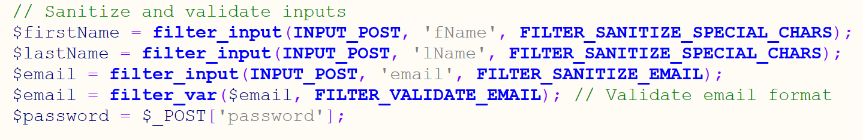
- How to prevent SQL injection : use prepared statements with bound parameters instead of directly including user input in SQL queries. This ensures that user input is treated as data, not executable code.
Code: bind_param("s", $email); takes the email as ? and then bind it to the sql query not direct .
2) CSRF Protection : (Cross-Site Request Forgery) : generally CSRF tokens are implemented in any form submission in the website to protect against cross site request forgery this attack happen when a malicious website tricks a user’s browser into making an unwanted request to a different site that the user is already authenticated on by forms submitted like (sign in and sign up).
A CSRF token is a unique, random value generated by the server and included in every form that needs protection. When the user submits the form, the token is sent along with the request. The server then checks if the token matches the one stored in the user's session. If it does, the request is valid; if not, it’s rejected.
Code: generation function generate the random token and but it in the users session , then the CSRF token is included in the HTML form as a hidden input field to send it with the form . then before the submission process the token is validated to check if it is valid if not error will occur.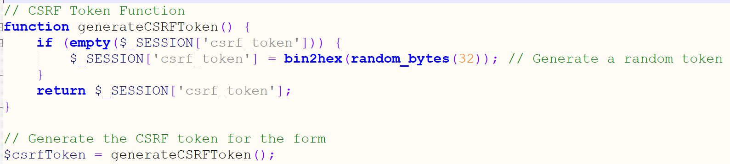 .

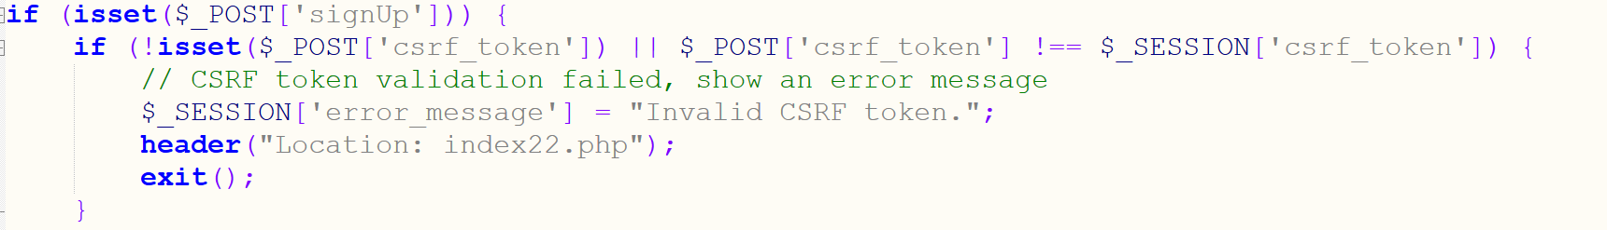
3) Secure Session Management: Using secure cookies to store JWT tokens with HttpOnly and Secure flags.
ensures that sensitive information like authentication tokens (e.g., JWT tokens) is safely stored and transmitted between the client and the server using cookies.
When a user logs in successfully A JWT(Jason web token) is created during the login and signed using secret key. This token contains information like the user's email, securely encoded. We should not put sensitive info.
The JWT is sent to the user’s browser as a secure cookie. When the user visits a page like homepage.php or otp_verify : The server checks the cookie containing the JWT.
The JWT is decoded and verified to : Ensure it wasn’t tampered and Ensure it hasn’t expired. If the JWT is valid, the server retrieves the user’s data (like email) from the token.
HTTPOnly flag: Prevents JavaScript access to cookies, protecting against XSS attacks.
Secure flag : Ensures the cookie is sent over HTTPS only.
Library needed: php-jwt-main and Firebase\JWT\JWT .
Then it produce (auth_token) cookies then in the homepage the server decodes the cookies and checks the JWT if it has the right data the user will be able to move to the homepage.
Code : generate a jwt token and set into cookies after the user successful sign in contain the gmail and expiration time.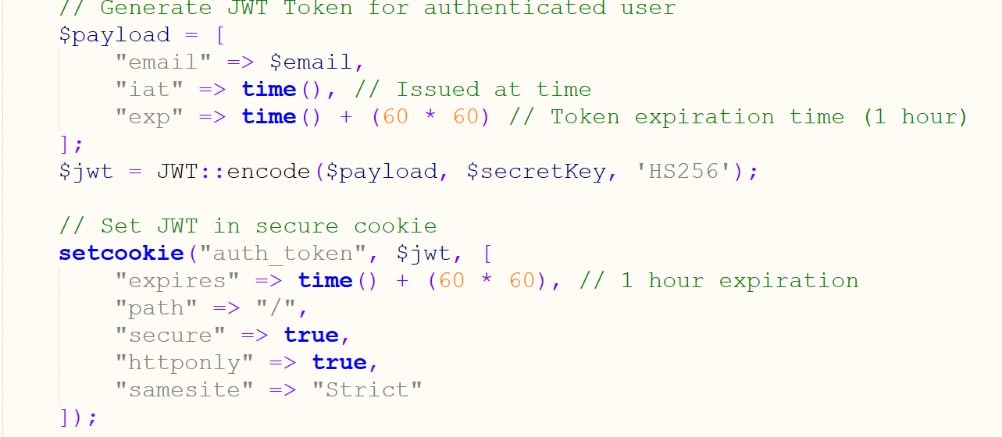
Code: in the homepage decoding and checking then retrieve the data from the database using the gmail in the JWT :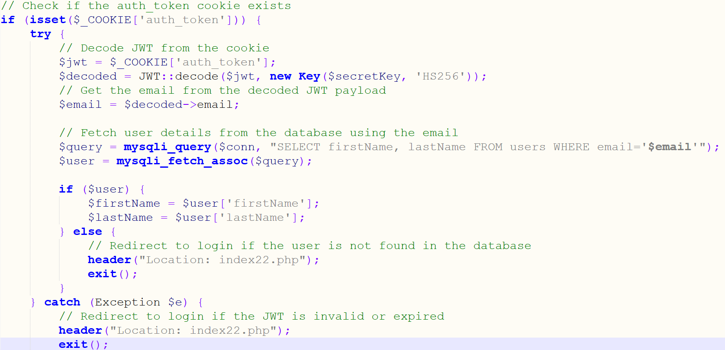
4) Use HTTPS: to Ensure the application is served over HTTPS so encrypt data in transit. (HyperText Transfer Protocol Secure) is an extension of HTTP that uses encryption to secure data during transmission, it ensures that all data exchanged between the server and the user is encrypted.
How to implement : Generate a self signed trusted https certification
Require installation of openssl-64bit : this is used to generate ssl trusted certification by running commands in the admin command prompt.
First generate a private key using : openssl genrsa -out localhost.key 2048
to create localhost.key file
Second create a certificate: openssl req -new -key localhost.key -out localhost.csr . to create localhost.crt file
Then go to Apache server configurations and include the files .
Then go to the control panel-manage computer certificates and add it there.
Then access the web page and press trust certificate then navigate to https.
Then when you go to inspect then security you will notice that :
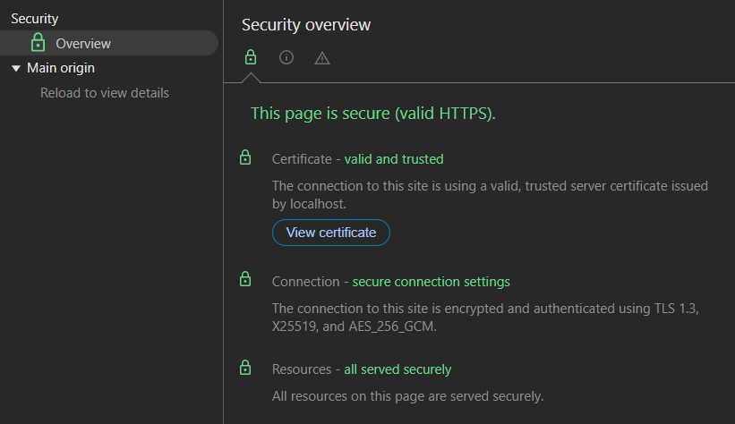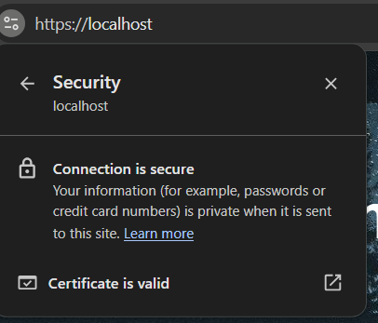

5) User Registration and Authentication using 2F
User registration if user have an account (sign in ) the user will put the Gmail and password .
If the user don’t have an account (sign up ) the user will put the first,last name and Gmail and password .
Two-Factor Authentication (2FA) adds an additional layer of security by requiring a second form of verification after entering a Gmail and password.an OTP(one time password )(6-digit) will be sent to the user Gmail. using SMTP(simple mail transfer protocol)
Code Requirements: install PHPMailer library .
Include the PHP-Mailer.php in the code and include the SMTP.php .
In the code a random number is generated using (rand(000000,999999) ; and sent by the Gmail and stored in the PHP session of the user so the server can validate the code later. The mail is sent by Gmail defined during the coding process . 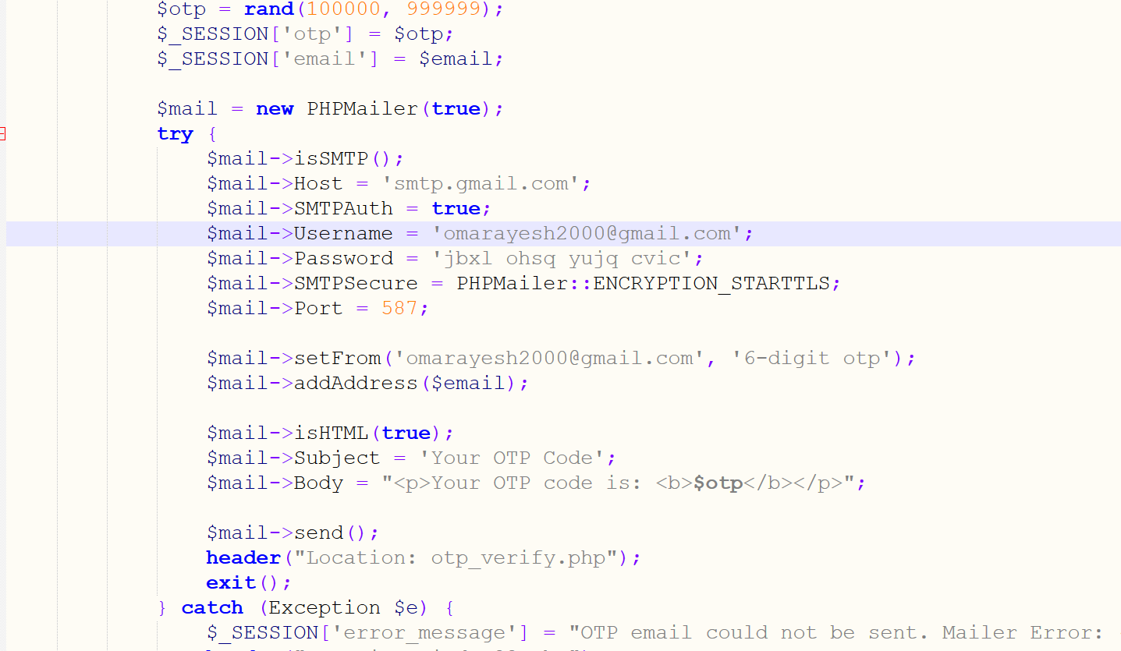
Then the validation process in the otp_verify code file it first check if the otp is submitted then check if the user session otp match the entered otp if yes the user will have access to homepage if not the user can’t access the homepage . and check if the session expired or no otp is sent.
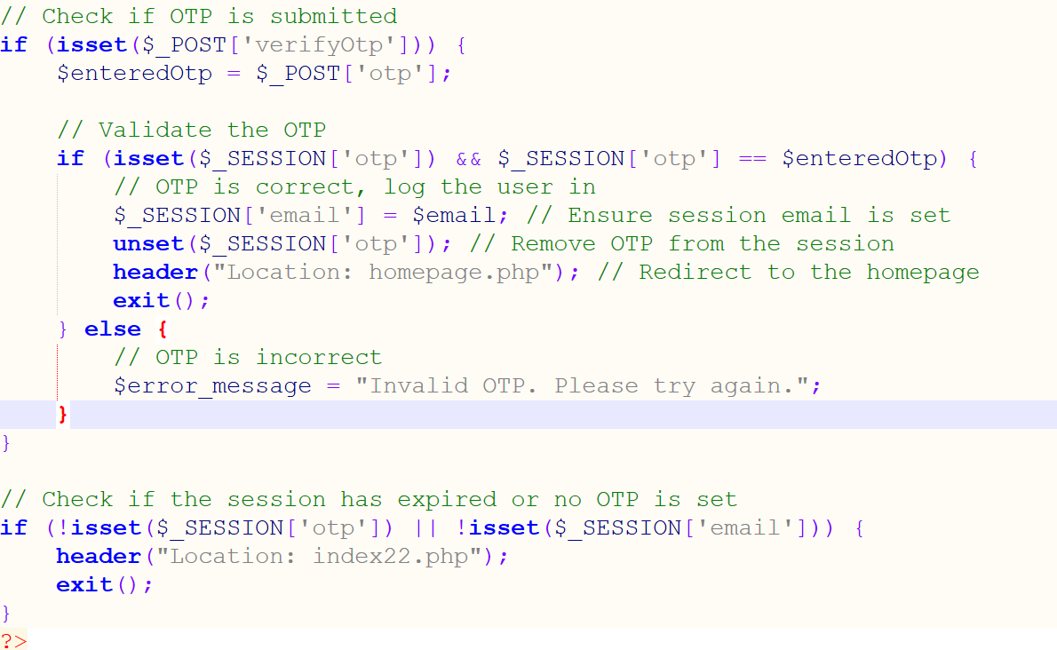

6)hashing function : ensuring that in the Database the user password is stored hashed. By (bcrypt)
Passwords are hashed before storage using the password_hash function.
$hashedPassword = password_hash($password, PASSWORD_DEFAULT);
Hashes are verified during login with password_verify(inserted, hashed)
password_verify($password, $hashedPassword); in the Database it should look like this:

