ID umber/Section | Omar Abdeljalil Abdeljalil – 23110604- 02
HTU Course Number and Title | Lean manufacturing
Academic Year | 2025 /2026
Course Tutor | Eng.Veellage Al-Quraan
Team Member | Ibrahim Jada

Table of Contents
Part I 4
1. Research of Origin, Principles and Alternatives of the Toyota Production System (TPS) 4
2. highlight of the Common Principles of Lean Manufacturing 8
3. How lean contributes to business success 10
4. Advantages and disadvantages of implementing lean production system 11
5. Key challenges of adopting lean 13
6. Analysis of Alternative Examples of Lean Production Systems 14
7. Critical Elements That Make TPS Successful in Comparison With Other Alternatives 19
Part II :- 22
Introduce The Company:- 22
Our Project in Jada Company 22
Flow Chart :- 23
Process Chart :- 26
Current VSM :- 29
Takt Time 31
Overall Equipment Effectiveness (OEE) Analysis 31
1. Overprocessing in Finishing 32
How to solve it :- 34
2. Waiting Time in oven Stage 38
What the VSM and Process Chart Show 38
Visual Management Defined 40
Applying the Two-Stage Visual Factory Framework 41
Stage 1 — What Information Must Be Communicated? 41
Stage 2 — How Is It Accomplished? The Solution Design 42
Implementation Plan 45
Sustaining the Improvement 46
Waste 3 — Transportation 47
Step 1 — See the Problem on the Floor 47
Step 2 — Quantify the Problem 48
Step 3 — Apply DMAIC 49
Step 4 — Expected Outcome (Quantified) 52
How This Fits With the Rest of the Project 52
Summary — The Whole Solution in One View 53
Future State VSM 54
Overview: What Changed Between Current and Future State 54
Process-by-Process Comparison: Current vs. Future State 54
Explanation of Each Change 55
4. Future State OEE Calculation 56
6. Full KPI Scorecard: Current vs. Future State 56
Recommendations for Next Steps 57
Barriers to Implementation 58
Impact of Communication Approach on Employees and Personal Effectiveness and the Importance of Skills Required to Deploy Change 60
References 64

EXECUTIVE SUMMARY
The analysis followed a structured methodology grounded in the Toyota Production System (TPS) framework. First, a 38-step Process Chart was constructed, classifying every activity as operation, transportation, inspection, delay, or storage. This data was used to build the Current State Value Stream Map (VSM) capturing all eight production processes — Laser Cutting, Bending, Assembly, Compressing, Surface Finishing, Painting, Oven Curing, and Accessory Assembly with cycle times, lead times, and C/A ratios. Takt time was calculated at 144.1 minutes per door (480 min available ÷ 3.33 doors/day), serving as the demand-rate benchmark against which all process times were evaluated. Overall Equipment Effectiveness (OEE) was measured at 29% (Availability 93.75% × Performance 78.66% × Quality 39.43%), A Future State VSM was then modelled to project post-improvement performance.
The Current State VSM revealed a total time of 613.2 minutes per door, of which only 106.2 minutes represented value-added activity. The remaining 84.7% was consumed by waiting, transportation, and over-processing — confirming that the production system operated in a chronic stop-and-go mode with no synchronization between stages.
Three primary improvement opportunities were identified. First, Overprocessing in Surface Finishing: operators ground and sanded beyond the required paint-adhesion specification we find the root case by using 5 Why due to the absence of a Standard Operating Procedure (SOP). A PDCA cycle defining the Ra roughness standard, drafting a visual SOP, training operators, and embedding quarterly audits is projected to save approximately 3 minutes per door Second, Waiting at the Paint–Oven–Accessory Assembly interface: a 12-minute post-oven queue formed because no visual signal communicated door status to downstream operators. Root cause analysis confirmed this was a communication failure, making Visual Management specifically an Andon status board, Timed Ticket Cards, and colour-coded floor zones the correct countermeasure, reduce 5 minute delay Third, Transportation waste between Bending and Assembly: nine movement events totalling 41 metres were traced to a floor layout misaligned with the process sequence. A U-cell redesign co-locating Bending and Assembly reduces travel distance by 63% and movement time from 12–18 minutes to under 5 minutes per door
Combined, these three improvements reduce total lead time from 692 minutes to 561 minutes and raise the activity ratio from 20.55% to 23.3%, reclaiming approximately 48 hours of productive capacity per month at 80 doors — with no increase in headcount and negligible capital expenditure. Implementation is recommended in three sequenced phases over six months, prioritising cultural buy-in through operator co-design and translation of time savings into Jordanian Dinar cost figures for management. Lean tools succeed only when people commitment precedes physical chan

Part I

1. Research of Origin, Principles and Alternatives of the Toyota Production System (TPS)
1.1 Origins of the Toyota Production System
The roots of Lean Manufacturing can be traced back to the Japanese Toyota Motor Company, where the Toyota Production System (TPS) was developed over several decades as an evolutionary response to economic necessity rather than a preplanned methodology. The founding figures of TPS were Sakichi Toyoda, his sons Kiichiro Toyoda and Eiji Toyoda, and manufacturing engineer Taiichi Ohno.
Sakichi Toyoda, who initially worked in the textile industry, invented a motordriven loom equipped with a specialised mechanism designed to stop automatically upon thread breakage. This faultdetection principle became the foundation of Jidoka often described as automation with a human touch one of the two main pillars upon which TPS was later built,embed defect detection into the production process itself, Jidoka reduced human error and elevated production capacity simultaneously.
In 1910, Sakichi Toyoda visited the United States and recognised the emerging potential of the automotive However, it took the Toyoda family nearly two decades to materialise their vision. In 1929, Kiichiro Toyoda returned to the United States to study American automotive companies, and was particularly influenced by the Ford Production System which had introduced serial mass production of the Model T in 1913) Upon establishing Toyota Motor Company, Kiichiro sought to adapt Ford principle to Japan very different economic reality one characterized by reduced consumer demand and the need to produce diverse vehicle models in small quantities on shared assembly lines.
Recognizing that Toyota could not compete with Western mass production through volume alone, Kiichiro Toyoda began developing the concept of Just-in-Time (JIT) production — the second pillar of TPS. The objective was to produce only what was needed, when it was needed, and in the quantity needed, thereby eliminating waste and elevating production efficiency.
In the 1950s, Eiji Toyoda visited Ford's facilities in the United States, and together with Taiichi Ohno, developed a unified system that integrated both pillars Jidoka and Just-in-Time — within a structured production framework.Ohno further advanced this with the concept of pull-flow production, inspired by the replenishment logic observed in American supermarkets, where products are restocked only after being consumed. This principle directly addressed the waste of overproduction by ensuring that each stage of production generated only what the next stage required.
Critically, it is important to note that TPS was not conceived as a complete, planned system from the outset. Rather, it emerged gradually over decades in direct response to Japan's post war resource constraints and competitive pressures. This evolutionary nature is frequently overlooked by organisations that attempt to replicate TPS in different cultural and operational contexts — often resulting in superficial tool adoption without the underlying philosophy For a company like Jada Company, which has operated since 1972 in Jordan's manufacturing sector, this distinction is particularly relevant: adopting lean principles requires not merely implementing tools, but embedding a continuous improvement mindset across the entire organisation.
TPS remained largely unrecognised outside Toyota until the 1973 oil crisis, when the significant operational advantages Toyota had achieved became impossible for Japanese and American managers to ignore
1.2 Principles of the Toyota Production System
TPS is structured around two foundational pillars and supported by a set of core principles that guide every aspect of production:
Just-in-Time (JIT): Production is synchronised with customer demand. Materials and components arrive exactly when needed, eliminating the waste of excess inventory and waiting time.
Jidoka (Autonomation): Machines and workers are empowered to stop production immediately upon detecting a defect, preventing faulty products from progressing further down the production line.
These two principle are underpinned by the following principles
- Heijunka (Production Levelling): Smoothing production schedules to avoid peaks and troughs in demand.
- Standardised Work: Establishing the most efficient and repeatable method for every task, forming the baseline for continuous improvement.
- Kaizen (Continuous Improvement): Every employee, at every level, actively seeks incremental improvements in their work processes.
- Respect for People: TPS recognises that people — not machines — are the most valuable asset in any production system.
- Genchi Genbutsu (Go and See): Managers are expected to observe problems firsthand at the point of production rather than relying solely on reports.
1.3 Alternatives to the Toyota Production System
While TPS is widely regarded as the origin of modern lean thinking, several alternative production systems have since been developed, each sharing common principles with TPS while differing in scope, methodology, and application context.
Ford Production System (FPS)
The foundation of the Ford Production System is rooted in the invention of the moving assembly line, which established the global standard for mass production and continuous flow. The original principle relied on the absolute standardization of parts and the extreme division of labor. By ensuring that every single component was perfectly interchangeable, Ford eliminated the need for skilled craftsmen to custom-fit parts. The moving conveyor system then physically dictated the pace of production, bringing the work directly to the operator. This relentless focus on flow and economies of scale allowed Ford to drastically reduce assembly time and costs, fundamentally changing industrial engineering by prioritizing high-volume, continuous output over high-variety customization.
While the historical system was a rigid "push" model that relied on massive batch production and heavy inventory, the modern Ford Production System has evolved to integrate Lean methodologies while maintaining its high-volume strengths. Today's FPS operates on principles like Synchronized Material Flow and Global Platform Standardization. Instead of isolating factories, modern FPS relies on building multiple vehicle models on shared global architectures, allowing different plants to adapt quickly to market demands. Furthermore, it has integrated Just-in-Time (JIT) logistics and continuous improvement (Kaizen) practices, shifting away from massive buffer stocks to a system where empowered workgroups actively manage quality and material pull on the shop floor
Agile Manufacturing
Agile Manufacturing prioritises flexibility and rapid response to changing customer requirements. It is particularly suited to engineer-to-order or highly customised production environments. Given that Jada Company produces bespoke, specification driven doors for hospitals, banks, and hotels, elements of agile manufacturing — such as modular design and responsive scheduling — are highly relevant alongside lean principles.

Volvo Production System (VPS)
A notable alternative to TPS is the Volvo Production System, developed in the 1970s in response to Sweden challenging labour market conditions, including high worker turnover and strong trade union demands. Unlike Toyota standardised assembly line and VPS replaced the traditional moving line with stationary workstations where small, autonomous teams assembled entire vehicle subsystems most notably at the Kalmar (1974) and Uddevalla (1989 plants Berggren 1992 This approach prioritised worker autonomy, job e+nrichment, and ergonomic working conditions as the primary drivers of quality and productivity.
However, VPS faced significant criticism on economic grounds, as the team-assembly model could not match the throughput efficiency of conventional line production, ultimately leading to the closure of the Uddevalla plant in 1993 This highlights a critical lesson for any organisation considering lean adoption: human-centred design must be balanced with operational efficiency

Porsche Production System (PPS)
The Porsche Production System (PPS) is built on the foundation of traditional lean manufacturing but is specifically adapted to handle the extreme complexity and deep customization inherent in luxury sports car manufacturing. Unlike mass-market systems that rely on high-volume standardization, PPS is designed to maintain a strict continuous flow even when no two consecutive cars on the assembly line are identical. Its core principles revolve around takt time, flow, pull, and perfection, ensuring that the immense variety of customer options does not disrupt the rhythm of the factory. By treating the assembly line as a precise heartbeat, Porsche ensures that every highly engineered vehicle is assembled efficiently without compromising the brand's premium quality standards.
To execute this, PPS relies heavily on advanced Just-in-Sequence (JIS) logistics and absolute workstation ergonomics. Because each vehicle requires bespoke components, parts are not stored in bulk at the assembly line; instead, they are sequenced perfectly by suppliers and delivered directly to the operator exactly when needed. Another foundational principle of PPS is its zero-defect philosophy and employee empowerment. Workers are treated as the ultimate problem solvers, utilizing standardized work instructions and immediate visual management tools to halt production if a quality issue arises, ensuring that defects are never passed down the line to the next station.

Boeing Production System (BPS)
The Boeing Production System (BPS) represents a monumental shift in aerospace manufacturing, successfully translating automotive lean principles to the massive scale of commercial aircraft. Historically, airplanes were built in static bays where workers and materials moved to the plane. BPS fundamentally changed this by introducing the principle of the moving assembly line to aerospace, establishing a continuous "pulse" or flow for massive products. This principle of continuous flow forces the entire global supply chain and internal factory operations to synchronize precisely, exposing bottlenecks and inefficiencies that were previously hidden in static manufacturing environments.
A secondary core principle of BPS is standardized work supported by strict point-of-use kitting. Because aircraft assembly involves thousands of fasteners, complex wiring, and stringent aviation safety regulations, BPS eliminates the waste of motion and searching by delivering pre-packaged kits of parts and tools directly to the mechanic for each specific task. This highly orchestrated material presentation ensures that mechanics spend their time building rather than gathering supplies. Combined with rigorous visual controls and a relentless focus on safety and quality compliance, BPS ensures that highly complex engineering feats are executed with repeatable, lean efficiency

2. highlight of the Common Principles of Lean Manufacturing
Lean manufacturing is built upon a set of core principles that aim to maximise customer value while minimising waste. These principles, originally derived from the Toyota Production System, provide a universal framework applicable across different industries and production environments.
2.1 value
which is defined from the customer’s perspective. Value includes all activities that directly contribute to meeting customer requirements. In the context of Jada Company, value is reflected in the production of customised doors that meet precise specifications, quality standards, and delivery expectations. Any activity that does not contribute to these outcomes, such as delays, rework, or unnecessary handling, is considered waste and should be eliminated.
2.2 value stream
which refers to all the steps required to deliver a product from raw materials to the final customer. Mapping the value stream enables organisations to identify inefficiencies and non-value-adding activities. For Jada Company, this may include identifying excessive transportation between workstations, waiting time between operations, or redundant processing steps. By analysing these processes, the company can streamline operations and improve overall efficiency.
2.3 flow
which emphasises the smooth and continuous movement of materials and information through the production process. Interruptions such as bottlenecks, waiting time, or machine downtime disrupt flow and reduce efficiency. In a customised manufacturing environment like Jada Company, achieving perfect flow is challenging due to product variability; however, improvements can be made through better layout design, workload balancing, and process standardisation.
2.4 the pull system
where production is driven by actual customer demand rather than forecasts. Work is only initiated when there is a request from the next stage in the process or from the customer. This principle aligns strongly with Jada Company’s make-to-order production model, helping to minimise excess inventory and reduce the risks associated with overproduction. Pull-based systems are a fundamental concept within lean manufacturing and are closely linked to Just-in-Time practices.
2.5 Perfection
focuses on continuous improvement. Lean organisations strive to eliminate all forms of waste and continuously enhance processes to achieve optimal performance. This is commonly implemented through continuous improvement practices, where employees at all levels are encouraged to identify problems and propose solutions. In Jada Company, this could involve operators suggesting improvements to reduce defects, optimise production time, or enhance product quality.
In addition to these five core principles, lean manufacturing emphasises respect for people and quality at the source. Employees are considered key contributors to organisational success and are empowered to take responsibility for quality. This includes stopping production when defects occur and addressing issues immediately, rather than allowing problems to propagate through the system.
Overall, these principles demonstrate that lean manufacturing is not limited to mass production environments but can be effectively adapted to customised production settings such as Jada Company. By applying these principles, organisations can improve efficiency, reduce waste, and enhance customer satisfaction.

3. How lean contributes to business success
Lean manufacturing plays a critical role in enhancing business success by improving operational efficiency, reducing waste, and increasing overall organisational performance. By focusing on value creation and eliminating non-value-adding activities, lean enables organisations to operate more effectively in competitive environments.
cost reduction
From a financial perspective, Lean methodology acts as a catalyst for cost optimization by directly attacking the hidden expenses embedded in inefficient processes. In traditional manufacturing and service environments, significant capital is often tied up in "buffer" stocks—raw materials, work-in-progress, and finished goods—which incur high holding costs and risk obsolescence. By implementing Just-in-Time (JIT) production, Lean reduces these inventory levels, freeing up liquid capital that can be reinvested into growth or R&D. Furthermore, the focus on "Built-in Quality" (Jidoka) ensures that defects are identified at the source, drastically lowering the costs associated with scrap, rework, and warranty claims.
Beyond material costs, Lean improves labor productivity and capacity utilization without requiring proportional increases in overhead. By optimizing workflows and eliminating non-value-added movement (Motion) and unnecessary processing, businesses can increase their output using the same or fewer resources. This shift from a "cost-plus" pricing mindset to a Lean-driven cost reduction mindset allows companies to remain competitive in price-sensitive markets while simultaneously expanding their profit margins.
Improved quality
Lean practices play a pivotal role in quality improvement, resulting in superior products and enhanced customer satisfaction. They emphasize on identifying and eliminating sources of quality issues to prevent defects before they occur.
A key aspect of lean methodology is the concept of “Right First Time” or error-proofing. This approach aims at preventing mistakes from becoming defects, thus improving the overall quality of the end product. By identifying potential areas of error early in the process, businesses can implement preventive measures, reducing the need for costly rework and waste.
Moreover, lean environments foster a culture of continuous improvement. This involves constantly examining every stage of the production process to identify areas for improvement. Through regular reviews and audits, businesses can spot potential quality issues, address them proactively, and refine their processes over time.
Faster delivery
By creating continuous flow and eliminating process interruptions organisation can produce and deliver products more quickly. This enables companies to respond more effectively to customer demand and market changes, which is essential in today fastpaced business environment.

productivity
By optimising workflows, standardising processes, and reducing downtime, organisations can maximise output without increasing resources. This leads to better utilisation of labour, equipment, and materials , increased flexibility. Lean systems, particularly those based on pull production, allow organisations to adapt quickly to change in customer demand. Instead of producing large quantities based on forecasts, companies produce only what is needed when it is needed This reduces the risks associated with overproduction and enables greater responsiveness. Lean manufacturing also promotes employee involvement and continuous improvement. Through practices such as Kaizen employees at all levels are encouraged to identify problems and suggest improvements This not only leads to ongoing process enhancements but also increases employee engagement motivation and ownership lean manufacturing contributes to business success by creating efficient, responsive, and high-quality operations.

4. Advantages and disadvantages of implementing lean production system
Lean production systems offer s benefit to organisations however it implementation and presents certain risks and challenges. A balanced evaluation is therefore necessary to fully understand their impact on business performance
4.1 Advantages of Lean Production
One of the advantages of lean production is the reduce of lead times and improvement in delivery performance By eliminat process and ensur continuous flow, organizations can produce and deliver products more quickly. This results in higher on-time delivery rates and improved customer satisfaction.
Another major benefit is cost reduction particula through the elimination of waste. Lean minimises unnecessary activities such as excess inventory, waiting time, and overproduction. As a result, organisations can reduce operational expenses and increase profitability without compromising quality.
Lean also contributes to lower inventory carrying costs. By adopting pull-based systems and Just-in-Time production, companies maintain minimal inventory levels. This reduces storage costs, frees up working capital, and minimises risks related to obsolescence and damage.
In addition, lean enhances product quality through standardised work and quality-at-source principles. By identifying and resolving defects early in the process, organisations can reduce rework and scrap costs while delivering more consistent and reliable products.

4.2 Disadvantages and Risks of Lean Production
Despite its benefits lean production also have several risks. One of the most significant is the risk of stockouts special when demand or supply chain are stopped Since lean systems operate with minimal inventory any delay from suppliers can halt production and negatively impact customer service.
Another challenge is the high initial cost of implementation and change management. Organisations may need to invest in training, process redesign, and new technologies. In addition transitioning from traditional system to lean requires time and effort and strong leadership which can be difficult to manage.
Furthermore becoming “too lean” can reduce organisational resilience. While minimising inventory and resources improves efficiency, it also reduces the ability to respond to unexpected disruptions such as supply chain failures, equipment breakdowns, or sudden demand spikes.
Finally, lean implementation can face organisational resistance and complexity. Employees may be reluctant to adopt new practices, and the transformation requires significant cultural change. Without proper understanding and long-term commitment, lean initiatives may fail to deliver sustainable results In conclusion, lean production systems provide substantial advantages in terms of cost efficiency, quality improvement, and operational performance. However, these benefits must be carefully balanced against potential risks such as supply chain dependency, implementation challenges, and reduced flexibility. Successful lean adoption therefore requires strategic planning, strong leadership, and continuous improvement.

5. Key challenges of adopting lean
Despite the well documented benefits of lean manufacturing many organization experience not good at all during it implementation and fail to achieve the expected results These challenges come from not only from technical issues but also from organizational and cultural and strategic factors.
One major challenge is the( failure to link lean improvements to financial performance)Many organization measure success in terms of percentage improvements or operational metrics without translating these gains into monetary value As a result lean initiatives may not be communicated effectively to top management lead to limited support and reduced sustainability of improvement efforts.
Also (incorrect sequencing of lean implementation). Lean tools and practices must be introduced in a logical order; otherwise, performance may deteriorate. For example, reducing batch sizes before improving changeover times can lead to lower equipment utilisation and reduced production efficiency. This often results in negative perceptions of lean, with organisations concluding that lean implementation has worsened performance.
In addition, organisations often struggle with project selection, particularly when initial lean projects are either too complex or deliver minimal impact. Early failures or low returns on investment can reduce employee engagement and weaken organisational commitment to lean initiatives.
A further challenge lies in the limited application of lean beyond production areas. Some organisations focus only on manufacturing processes while overlooking administrative and support functions. In such cases, the overall impact of lean remains limited, especially in environments where operational improvement opportunities are relatively small.
Another significant barrier is the imbalance between training and practical implementation. Organisations may invest heavily in training without sufficient focus on real application, or they may start implementation in inappropriate areas. This disconnect between knowledge and execution reduces the effectiveness of lean initiatives.
Moreover, the lack of integration with the supply chain represents a major challenge. Lean systems rely heavily on Just-in-Time principles, which require reliable suppliers capable of delivering high-quality materials in small quantities and on time. If suppliers are not aligned with lean practices, the benefits of lean implementation can be significantly reduced or even eliminated. Developing a lean supply chain is therefore both complex and essential.
Cultural transformation also presents a substantial challenge. Lean manufacturing fundamentally changes how organisations operate, requiring continuous improvement, employee involvement and cross functional collaboration. Such changes can create discomfort and resistance among employees, making it difficult to sustain lean practices.
Finally, lean implementation is inherently a long-term process that requires consistent leadership and commitment. It often takes years to fully embed lean across an organisation. Frequent changes in management or strategic direction can disrupt progress resulting in incomplete or abandoned lean initiatives
In conclusion these challenges highlight that lean manufacturing is not simply a set of tools, but a comprehensive organisational transformation Successful implementation requires strategic alignment, cultural change, strong leadership, and long-term commitment.

6. Analysis of Alternative Examples of Lean Production Systems
The Toyota Production System (TPS) is widely regarded as the benchmark for lean manufacturing several alternative production systems have emerged across different industries and cultural contexts The following analysis examines three alternatives , Agile Manufacturing and the Volvo Production System (VPS) and the Ford Production System comparing their core principles strengths limitations environment.
2.1 Agile Manufacturing
Agile Manufacturing in the early 1990s as a response to and unexpected market demands. First formally proposed by researchers at Lehigh University in 1991 the system was developed in recognition that traditional mass production and even lean systems were insufficiently responsive to rapid changes in customer requirements
Core Principles: Agile Manufacturing are built on four foundational dimensions:
- Delivering value to the customer product and services are high customs to individual client needs
- Being ready for change production systems are designed to reconfigure rapidly in response to market shifts
- Valuing human knowledge and skills the workforce is treated as a strategic asset not a variable cost
- Forming virtual partnerships collaboration across supply chains and organisations to respond quickly to opportunities
Strengths: Agile Manufacturing excels in environments by high product variety, low volumes, and unpredictable demand. Its emphasis on flexibility and customisation makes it particularly effective for engineer-to-order manufacturers. Furthermore, its people-centric philosophy aligns well with the need for skilled, multi-competent workforces in specialised industries.
Limitations: Agile Manufacturing's flexibility comes at a cost. Maintaining reconfigurable production systems and a highly skilled, adaptable workforce requires significant investment. Additionally, without the waste-elimination discipline of TPS, agile environments can inadvertently accumulate inefficiencies over time. The system also lacks the structured, standardised tools — such as VSM, 5S, and Kanban — that give TPS its operational rigour.
Comparison with TPS: Where TPS seeks to eliminate waste through standardisation and flow, Agile Manufacturing prioritises responsiveness over efficiency. TPS assumes a relatively stable demand pattern that can be levelled through Heijunka, whereas Agile Manufacturing is specifically designed for instability. The two systems are not mutually exclusive — many organisations have successfully adopted a hybrid "Lean-Agile" approach that combines waste elimination with demand responsiveness
2.2 Volvo Production System (VPS)
A notable alternative to TPS is the Volvo Production System, developed in the 1970s in response to Sweden's challenging labour market conditions, including high worker turnover and strong trade union demands. Unlike Toyota's standardised assembly line, VPS replaced the traditional moving line with stationary workstations where small, autonomous teams assembled entire vehicle subsystems — most notably at the Kalmar (1974) and Uddevalla (1989) plants (Berggren, 1992).
Core Principles:
- Team-based assembly — small groups of 8–10 workers take collective responsibility for assembling complete vehicle subsystems rather than performing isolated, repetitive tasks
- Stationary workstations — the product moves to the worker, not the worker to the product, with workstations designed to be ergonomically adjustable
- Job enrichment — workers are trained across multiple skills, developing a comprehensive understanding of the product and the ability to solve problems independently
- Worker autonomy — teams self-manage their work distribution, pace, and problem-solving processes
- Ergonomics as a quality driver — physical working conditions is treated as a direct contributor to product quality and consistency
Strengths: VPS demonstrated that humanising the production environment could yield tangible quality benefits. Worker satisfaction at Volvo's Kalmar and Uddevalla plants was significantly higher than at conventional assembly lines and absenteeism and turnover rates fell considerably following implementation The system also produced workers with broader competencies, making the workforce more adaptable and capable of identify quality issues holisticall
Limitations: Despite its human advantages, VPS faced significant criticism on economic grounds. The team-assembly model could not match the throughput efficiency of conventional line production at competitive cost levels, ultimately leading to the closure of the Uddevalla plant in 1993 This exposes a critical tension in lean philosophy: human-centred design must be balanced with operational efficiency. The VPS experience demonstrates that a production system optimised solely around worker wellbeing, without sufficient attention to flow and waste elimination, is economically unsustainable in competitive markets.
Comparison with TPS: TPS and VPS share a fundamental respect for people both systems recognise that workers are central to quality and continuous improvement. However, they diverge sharply in their operational approach. TPS standardises work cycles to maximise flow and efficiency, accepting some degree of task repetition as necessary for stability. VPS rejects repetition entirely in favour of enriched, varied work. Critically, TPS has proven economically sustainable at global scale, whereas VPS's commercial viability was limited. Nevertheless, VPS's contribution to the discourse on worker autonomy and ergonomics has influenced modern lean thinking, particularly in the area of Respect for People one of TPS's own core principles.
2.3 Ford Production System
The Ford Production System pioneered by Henry Ford in the early 19th century represent the historical precursor to modern lean manufacturing Ford's introduction of the movies assembly line at the Highland Park plant in 1913 revolutionised industrial production enabling the mass manufacture of the Model T at unprecedented speed and low cost
Core Principles:
- Standardisation every component and process and task was rigorously standardised to eliminate variation and enable interchangeability
- Continuous flow the moving assembly line ensured a constant uninterrupted flow of work through the production process
- Division of labour complex tasks were broken down into simple highly specialised sub-tasks, each performed by a dedicated worker
- High volume, low variety — the system was optimised for producing a single product in maximum quantity famously summarised by Ford statement that customers could have any colour they wanted "so long as it is black
- Vertical integration — Ford sought to control the entire supply chain, from raw material extraction to final assembly, to maximise efficiency and minimise dependency
Strengths: The Ford Production System achieved extraordinary gains in productivity and cost reduction. By 1914, the time required to assemble a Model T had been reduced from over 12 hours to approximately 93 minutes (Womack, Jones & Roos, 1990). These efficiency gains translated directly into lower prices, making the automobile accessible to a mass market for the first time. Ford's system also established many of the foundational principles standardization and flow and waste reduction that would later be refine by Toyota.
Limitations: The Ford Production System's core strength high-volume standardization — is simultaneously its most significant limitation. The system is inherently inflexible, incapable of accommodating product variety without substantial disruption and cost. Furthermore, the extreme division of labour created highly monotonous working conditions, contributing to worker dissatisfaction, high turnover, and the very human capital challenges that VPS later sought to address. Ford system also generated significant overproduction building to forecast rather than to demand the antithesis of TPS's pull-based philosophy.
Comparison with TPS: TPS explicitly evolved beyond the Ford Production System. Kiichiro Toyoda and Taiichi Ohno admired Ford's discipline of standardisation and flow but recognised that Japan's economic conditions limited resources, smaller markets, and the need for product variety demanded a fundamentally different approach Where Ford pushed maximum volume through a rigid system, Toyota pulled minimum necessary production in response to actual demand. TPS retained Ford's respect for standardisation and continuous flow but replaced push-based overproduction with JIT pull, and replaced rigid single-product lines with flexible multi model capability.

6.4 Porsche Production System (PPS) The Porsche Production System (PPS) is built on the foundation of traditional lean manufacturing but is specifically adapted to handle the extreme complexity and deep customization inherent in luxury sports car manufacturing.
- Core Principles: Its core principles revolve around strict takt time, flow, pull, and perfection. Because every highly engineered vehicle is unique, PPS treats the assembly line as a precise heartbeat. It utilizes advanced Just-in-Sequence (JIS) logistics and a zero-defect philosophy where workers are empowered as problem solvers, utilizing visual management to halt production if a quality issue arises.
- Strengths: PPS successfully maintains a continuous flow even when no two consecutive cars on the assembly line are identical. By ensuring that parts are not stored in bulk but are instead sequenced perfectly by suppliers and delivered directly to the operator exactly when needed, PPS manages extreme product variety without compromising premium quality standards or line rhythm.
- Limitations: The extreme reliance on JIS makes the system highly sensitive to supply chain disruptions. Because there are virtually no buffer stocks of bespoke components on the shop floor, any delay in the sequenced delivery of parts immediately starves the assembly line.
- Comparison with TPS: While TPS relies on JIT and Kanban cards to pull standardized parts from supermarket buffers, PPS pushes logistical synchronization a step further into pure JIS. TPS is highly effective for high-volume mixed models, but PPS is custom-engineered to handle an infinite variety of bespoke customer options seamlessly.
6.5 Boeing Production System (BPS) The Boeing Production System (BPS) represents a monumental shift in aerospace manufacturing, successfully translating automotive lean principles to the massive scale of commercial aircraft.
- Core Principles: BPS fundamentally changed aerospace manufacturing by introducing the principle of the moving assembly line to massive products, establishing a continuous "pulse" or flow. A secondary core principle is standardized work supported by strict point-of-use kitting.
- Strengths: The continuous flow forces the entire global supply chain and internal factory operations to synchronize precisely, exposing bottlenecks that were previously hidden in static manufacturing bays. By delivering pre-packaged kits of parts, fasteners, and tools directly to the mechanic for specific tasks, BPS eliminates the immense waste of motion and searching, ensuring mechanics spend their time building rather than gathering supplies. Combined with rigorous visual controls, it ensures repeatable, lean efficiency for complex engineering feats.
- Limitations: Adapting a moving assembly line to aerospace is highly complex due to stringent aviation safety regulations, the massive physical scale of the product, and incredibly long cycle times compared to consumer manufacturing.
- Comparison with TPS: BPS takes the continuous flow and defect prevention mechanics of TPS and applies them to extreme, low-volume, high-complexity macro-manufacturing. Instead of relying purely on supermarket pull systems like Toyota, BPS heavily utilizes highly orchestrated point-of-use kitting to manage the thousands of specialized parts required for aircraft assemb

7. Critical Elements That Make TPS Successful in Comparison With Other Alternatives
The Toyota Production System's sustained global success rests on ten inter-connected structural elements that operate simultaneously as a unified system — the 'TPS House' No alternative system replicates all ten at the same depth, which explains why TPS remains the benchmark five decades after its development. The table below compares each critical element across the five alternatives analysed in this report.

7.1 The Two Pillars: JIT and Jidoka
As confirmed TPS is built on two foundational pillars that no alternative system fully replicates together. Just-in-Time (JIT) ensures production is triggered only by downstream demand, eliminating inventory and waiting waste. Jidoka (autonomation) empowers every machine and worker to stop production immediately upon detecting a defect, embedding quality at the source rather than at end-of-line inspection. Ford's Production System (FPS) achieves flow but through push-based mass production, generating overproduction — the worst of the seven wastes . Agile Manufacturing sacrifices waste discipline for flexibility, accumulating inefficiency over time.
7.2 The Foundation: Heijunka, Kaizen, and Standardisation
The TPS Houserests on three foundational elements — Heijunka (production levelling), Kaizen (continuous improvement), and Standardisation — which together create stability before improvement. Heijunka smooths production schedules to prevent the peaks and troughs that create waiting and overproduction waste. Kaizen, as defined inpdf, involves every employee from operator to management in generating 60–70 improvement suggestions per year. Standardised work, as detailed in.pdf, establishes the repeatable baseline from which every Kaizen cycle departs. No alternative system integrates all three: VPS has strong respect for people but lacks system-wide standardisation; FPS has extreme standardisation but no Kaizen culture; Agile Manufacturing resists standardisation by design.
7.3 The Internal Tools: Takt Time, Kanban, Poka-Yoke, and Visual Management
Within the TPS House, a set of operational tools translates philosophy into daily production control. Takt time sets the heartbeat of the entire line — every process is judged against the customer demand rate, not internal efficiency. At Jada Company, takt time of ~115.5 minutes was the diagnostic anchor that confirmed the problem was flow, not capacity. Kanban operationalises the pull system: cards signal replenishment, prevent overproduction, and make WIP visible. Poka-Yoke prevents errors from becoming defects by designing mistakes out of the process. Visual Management makes the production status visible to every operator without reporting — Andon boards, coloured floor lanes, and queue caps give the floor real-time control. Together, these tools give TPS an operational rigour that alternatives lack.
7.4 Why TPS Succeeds Where Alternatives Fall Short
The critical differentiator is systemic integration., TPS's benefits — quality, cost, delivery, empowerment, communication, and leadership — are not delivered by individual tools but by the interaction of all elements simultaneously. FPS delivers flow but creates overproduction. VPS delivers human dignity but sacrifices throughput (as proven by the Uddevalla plant closure, 1993 — documented in Part I of this report). Porsche's PPS extends JIT into Just-in-Sequence, achieving flow under extreme variety, but at the cost of supply chain fragility. Boeing's BPS successfully adapts TPS to macro-manufacturing but requires massive logistics orchestration that is impractical for smaller manufacturers. Agile Manufacturing offers responsiveness but lacks waste discipline.
TPS is the only system that simultaneously achieves: demand-driven flow (JIT), built-in quality (Jidoka), levelled scheduling (Heijunka), continuous improvement culture (Kaizen), and operational standardisation — making it universally applicable across scales and industries. This is why all alternatives, to varying degrees, borrow from TPS rather than replace it.
7.5 Relevance to Jada Company
For Jada Company, the TPS elements most directly applied in this project — as identified through the Current State VSM, process chart, and waste analysis — are: Takt Time (to frame all improvements against customer demand), Kanban pull (to address waiting waste), SMED/Quick Changeover (to enable smaller batches at the Bending stage), Visual Management (to control the Paint–Oven queue), PDCA (to institutionalise the overprocessing fix), and DMAIC/5S (to eliminate the Bending–Assembly transportation waste). This demonstrates that TPS's success at Jada is not the result of any single tool but of the integrated application of multiple elements from the TPS House, which is precisely what makes TPS uniquely effective compared to its alternatives.

Part II :-

Introduce The Company:-
Jada Company is one of the leading metal manufacturing companies in Jordan. To mention but a few accomplishments: several major construction projects to world wide certifications of our doors. Since its establishment, Jada Co. has been striving for excellence in manufacturing and offering the best services to its clients. The quality of our products is based on our specialization and is backed by a solid team of motivated, highly-skilled professionals with the state of the art technology and equipment. With the aim to outline possibilities to help the Customer
Our Project in Jada Company
This project focuses on applying advanced Lean Manufacturing principles to optimize the production line of a security door manufacturing facility. The primary objective is to analyze the current production system, identify sources of non-value-added waste and propose data-driven solutions to bridge the gap between actual process time and total production lead time. By transitioning the facility from a traditional "push" system to a synchronized "pull" system, this project aims to increase overall process efficiency and manufacturing throughput.

Flow Chart :-
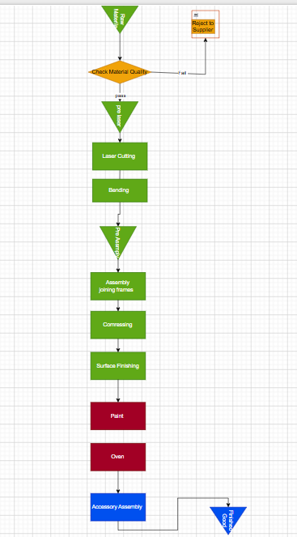

Process Flowchart Analysis:-
Overview of the Process:-
The process flowchart represents the complete manufacturing sequence of a door production system, starting from raw material receipt and ending with the finished product. The process is divided into two main stages: fabrication and finishing, with multiple inspection points integrated to ensure product quality throughout production.
The flow begins with raw material intake, followed by a quality inspection stage. Approved materials proceed through fabrication processes, while rejected materials are returned to the supplier. The fabrication stage includes laser cutting, bending, assembly, compressing, and surface finishing. Afterward, the product moves into the finishing stage, which consists of painting, oven curing, and accessory assembly before reaching the final output.
2-Process Structure and Flow
The process follows a linear sequential structure with embedded decision points: Fabrication Stage:
- Raw material preparation
- Laser cutting
- Bending (forming operations)
- Assembly (joining frames)
- Compressing (structural consolidation)
- Surface finishing (grinding/smoothing)
Painting Stage:
- Paint application
- Oven curing
Finishing Stage:
- Accessory assembly (locks and hinges)
- Final product output

3-Inspection and Quality Control Integration
The flowchart incorporates multiple quality control points:
- Incoming material inspection ensures only acceptable raw materials enter production
These inspection stages act as control gates, preventing defective products from progressing further in the process.
Process Continuity and Flow Characteristics
The process is primarily:
- Sequential and batch-oriented, with each stage completed before the next begins
- Dependent on inspection checkpoints, which interrupt continuous flow
- Characterized by stop-and-go movement, especially around quality checks and rework loops
This suggests that the flow is not fully continuous and may experience interruptions between stages.
Process Dependencies
Each stage in the system is highly dependent on the output quality of the previous stage:
- Bending accuracy depends on laser cutting precision
- Assembly depends on proper forming and alignment
- Surface finishing depends on structural integrity from previous steps
- Painting quality depends on surface preparation
7. Critical Control Points
The most critical stages in the process include:
- Material inspection → determines input quality
- Bending operation and inspection → affects structural accuracy
- Surface finishing → impacts final appearance and coating quality
- Painting and curing → defines product durability and aesthetics
These

Process Chart :-
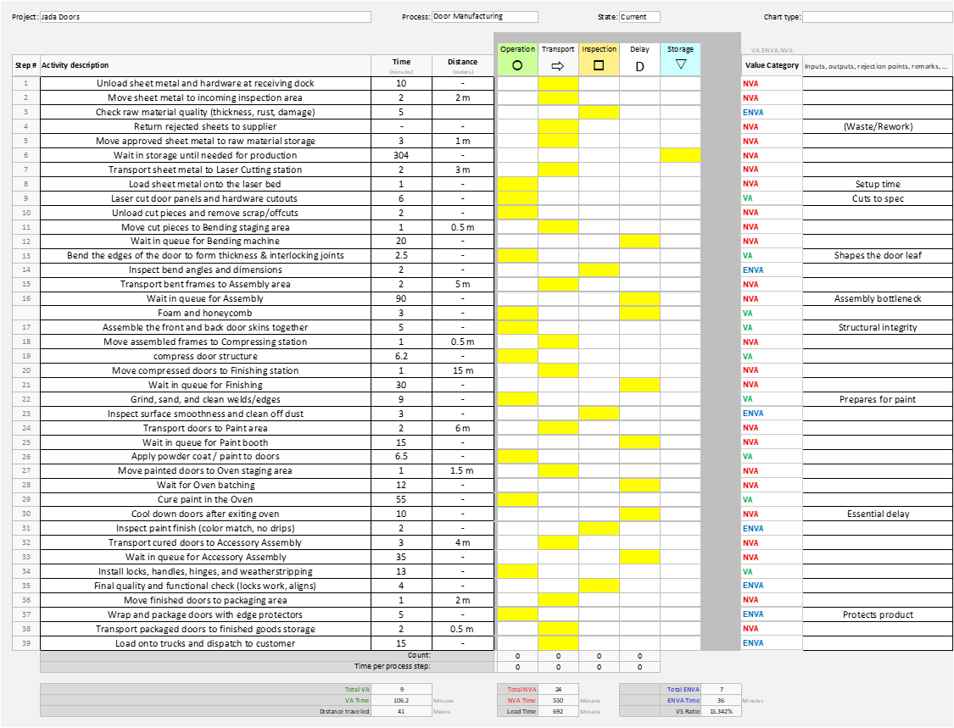
1. Overview of the Process Chart
The process chart provides a detailed breakdown of the door manufacturing system by categorizing each activity into operations, transportation, inspection, delay, and storage. It also quantifies the time and distance associated with each step, enabling a deeper understanding of process performance and flow efficiency.
The chart consists of 38 sequential steps, covering the entire process from raw material unloading to final product dispatch. Each step is classified according to its function, allowing for a structured evaluation of process flow and operational behavior

2. Process Structure and Activity Distribution
The process is composed of the following activity types:
- Operations (O): Core manufacturing steps such as cutting, bending, assembly, and painting
- Transportation (T): Movement of materials between stations
- Inspection (I): Quality checks at different stages
- Delays (D): Waiting times between processes
- Storage (S): Holding or buffering of materials
The chart shows that the process is not purely operational, but includes significant supporting and non-processing activities.
3. Time Analysis
Key Time Metrics (from your chart):
- Total Time: 692 minutes
- Value-Added Time (VA): 106.2 minutes
- Non-Value-Added Time (NVA): 586 minutes
- Activity Ratio: ~15.34%
Interpretation:
- Only ~15% of total time is spent on actual production
- The remaining ~85% is consumed by non-processing activities
This indicates to low process efficiency, where the product spends most of its time waiting, moving, or being handled rather than being transformed.
4. Delay and Waiting Time Analysis
The chart highlights several major delay points:
- Waiting before production: 304 minutes
- Waiting before bending: 20 minutes
- Waiting before assembly: 30 minutes
- Waiting before finishing: 30 minutes
- Waiting before paint: 15 minutes
- Waiting before accessory assembly: 35 minutes
Interpretation:
- The system operates in a stop-and-go manner
- Production is not synchronized between stages
- Work accumulates between operations, creating queues
5. Transportation and Movement Analysis
The process includes multiple transportation steps, such as:
- Moving sheets between areas
- Transporting frames between stations
- Moving doors to paint and assembly areas
- Transporting finished goods to storage
Total movement distance: 41 meters
Interpretation:
- Frequent material handling is required
- The layout likely causes non-linear movement paths
- Transportation adds time without contributing to product transformation
Interpretation:
- The system relies on inspection after processing
- Quality is ensured through detection rather than prevention
- Rework and scrap indicate variability in process performance
Process Continuity and Flow Behavior
The process chart reveals that:
- Activities are fragmented and separated by delays
- Flow is interrupted by:
  - Waiting times
  - Transportation step
  - Inspection checkpoints
The process lacks continuous flow, resulting in extended lead times.
8. Process Bottleneck Indicators
Based on time accumulation:
Critical areas include:
- Initial waiting stage (304 min)
- Oven curing process (55 min)
- Queue before accessory assembly (35 min)
Interpretation:
- These stages significantly influence overall lead time
- The system performance is constrained by slow or delayed stages

Current VSM :-
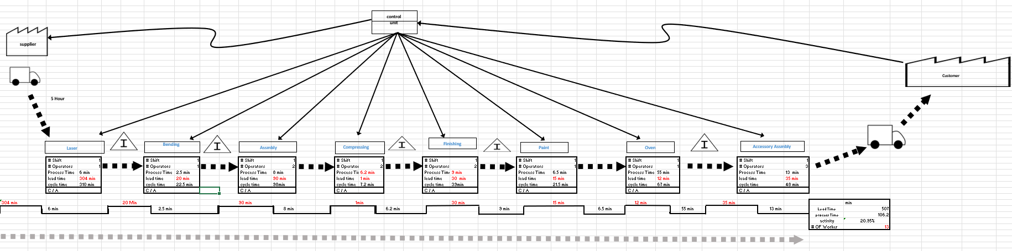
Current State Value Stream Map Analysis
System Architecture and Information Flow The Current State Value Stream Map (CSVSM) illustrates a "push" production system, organized around a centralized control unit. This top-down structure distributes manufacturing schedules to all independent workstations. Because customer demand is processed centrally rather than triggering a synchronized "pull" from downstream operations, the factory floor lacks direct communication between consecutive processes, inherently limiting its responsiveness.
Material Flow and Process Imbalance Material routing follows a linear sequence spanning Fabrication (Laser Cutting, Bending, Assembly, Compressing, Finishing) and Surface Treatment/Assembly (Painting, Oven Curing, Accessory Assembly). However, this physical routing does not translate to continuous flow. The flow is severely fragmented by significant Work-In-Progress (WIP) inventory buffers between almost every station. Furthermore, the system suffers from severe cycle time imbalances. For example, upstream processes like Bending (2.5 minutes) rapidly outpace downstream operations like Assembly (8 minutes) and the bottlenecked Oven Curing process (55 minutes). This lack of Heijunka (production leveling) results in an erratic, stop-and-go throughput pace dictated entirely by the slowest machines.
Lead Time vs. Value-Added Analysis The defining inefficiency of the current state is the massive disparity between total system time and actual processing time. Based on the CSVSM data:
- Total Process Time (Value-Added): 106.2 minutes
- Total Lead Time (Non-Value-Added Waiting): 507.0 minutes
- Total Time in System: 613.2 minutes

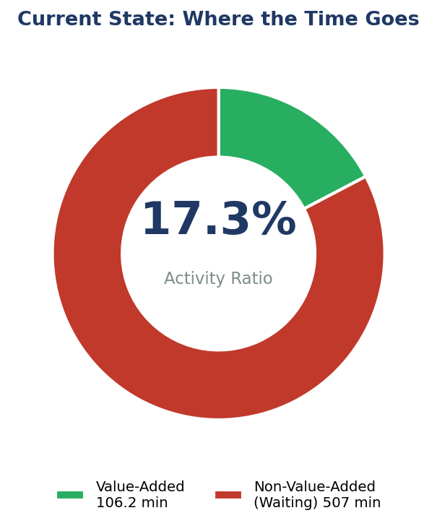
Conclusion Overall, the CSVSM reveals a structured but highly unoptimized production environment. The reliance on centralized push-scheduling, coupled with unlevel cycle times, creates a system heavily burdened by the Lean wastes of Overproduction and Waiting. While all necessary physical operations are present, the lack of operational synchronization prevents continuous flow. This diagnostic provides the data-driven foundation necessary to implement targeted Lean interventions such as Kanban pull systems, SMED, and optimized batching

Takt Time
Takt time is the pace at which the factory must complete doors to exactly meet customer demand. It is the foundation of the whole analysis, because every cycle time and every improvement target is judged against it.

Input | Value | Source / Calculation
Monthly demand | 80 doors | Given
Working days/month | 24 days | Standard assumption
Daily demand | 3.33 doors/day | 80 ÷ 24
Net available time/day | 480 min | 9 h shift − 60 min breaks
TAKT TIME | ≈ 144 min/door | 480 ÷ 3.33

Interpretation: the factory only needs to finish one door every 116 minutes. This single number reframes the entire problem, as the next chart shows.

Overall Equipment Effectiveness (OEE) Analysis
OEE is the standard lean metric for how effectively production equipment is used. It combines three multiplicative factors:

OEE = Availability × Performance × Quality

1. Initial Data Conversion (Minutes)
- Working Days: 24 days
- Total Shift Length: 540 minutes * 24 days = 12,960 minutes
- Total Planned Downtime: 60 minutes * 24 days = 1,440 minutes
- Total Unplanned Downtime: 30 minutes *24 days = 720 minutes
- Ideal Cycle Time: 106.2 minutes per door
- Total Parts Produced: 80 doors (3.33 doors/day * 24 days)
- Quality: 39.43%

2. Availability
Availability run time as a fraction of planned production time (breakdowns, changeovers, unplanned stops).
Planned Production Time = Shift Length - Planned Downtime
  - 12960 min – 1440 min = 480 minutes
Operating Time = Planned Production Time - Unplanned Downtime
  - 11,520 min - 720 min= 10,800 minutes
Availability Calculation: Operating Time / Planned Production Time
  - 10,800 / 11,520 = 0.9375
- Availability = 93.75%
3. Performance
Performance measures how fast the system was running compared to its theoretical maximum speed.
- Ideal Total Time = Ideal Cycle Time × Total Parts Produced
  - 106.2 min* 80 doors = 8,496 minutes
- Performance Calculation: Ideal Total Time / Operating Time
  - 8,496 / 10,800= 0.7866
- Performance = 78.66%
4. Quality
Quality measures the percentage of good parts produced.
- Quality = 39.43%
5. Final OEE Calculation
OEE is the product of all three factors multiplied together.
- OEE = Availability × Performance × Quality
- OEE = 0.9375 × 0.7866 ×0.3943
- OEE = 0.2907
Final OEE Score = 29.07%

1. Overprocessing in Finishing
The analysis of the finishing stage reveals a form of overproduction that is not directly visible in the final product but exists within the internal processing sequence. After the compressing stage, additional finishing operations are performed on internal surfaces of the door, specifically areas that are not visible to the customer. These operations do not contribute to the external appearance or functional value perceived by the end user.
This indicates that the system is performing processing activities beyond actual customer requirements, particularly in areas that do not influence product performance or aesthetics. The presence of such internal finishing suggests that production decisions
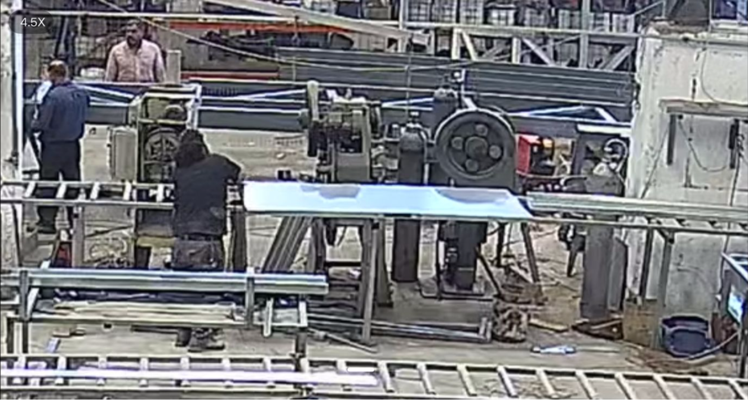
Why the 5 Whys Is the Right Tool
This is a problem of habit and unexamined assumptions, not flow or layout. The right question is simply: why are we doing this work at all? The 5 Whys drills past the symptom to the root cause, needs no investment, and is ideal for exposing the reasoning behind an entrenched practice.
Applying the 5 Whys at Jada Company
Problem statement: “The finishing stage spends time finishing internal door surfaces the customer never sees.”
Step | Question | Answer
Why 1 | Why do we finish the internal surfaces? | Finishing is applied to the whole door as a routine.
Why 2 | Why is it applied to the whole door? | The work instruction does not distinguish visible from non-visible surfaces.
Why 3 | Why doesn’t the instruction distinguish them? | It was never reviewed against the customer’s actual specification.
Why 4 | Why was it never reviewed? | Finishing has always been done this way; no one questioned it.
Why 5 | Why has no one questioned it? | There is no standard work tied to customer-defined value.
Root Cause | — | No customer-based standard for which surfaces require finishing.

How to solve it :-

Step 1 — See the Problem Visually
Before changing anything, the team needs a clear shared picture of which surfaces of a door are customer-visible (and therefore must be finished) and which are internal (and therefore should not). Without this, operators will keep applying their habit — “finish the whole door” — because the rule is fuzzy.
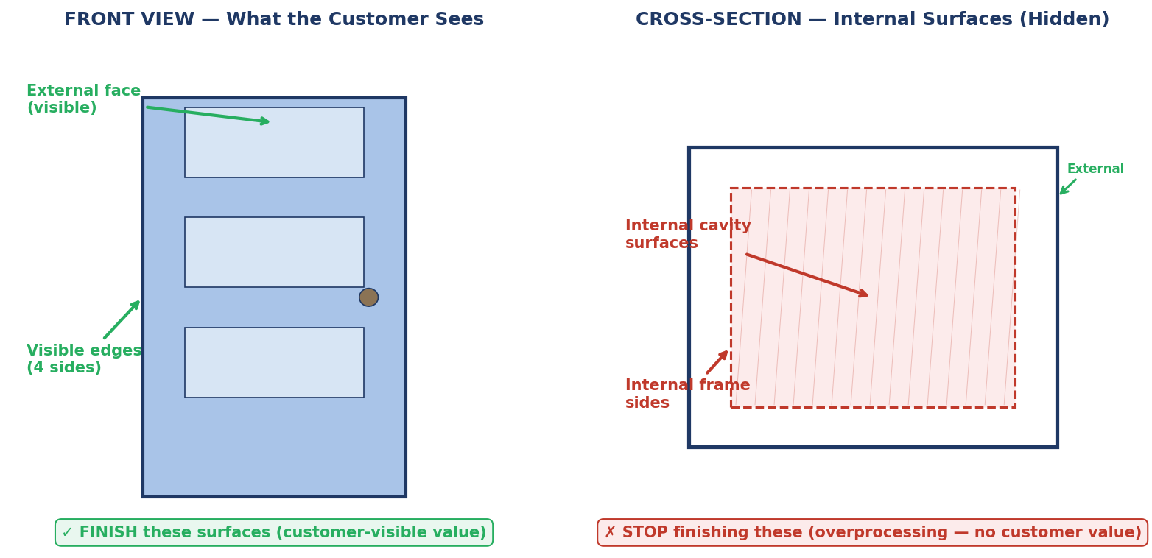
Figure A — The two views the team needs to agree on: front view (customer sees) vs cross-section (hidden surfaces).
This visual must be turned into a one-page reference card that lives at the finishing station alongside the Standard Work sheet. Operators do not need to remember the rule — they look at the card.

Step 2 — Build the Standard Work Sheet
Standard Work is the corrective action that comes out of the 5 Whys. But “write a standard” is too vague. A proper Standard Work sheet has four required sections. The version for Jada’s finishing station looks like this:

Section | Content for Jada Finishing Standard Work
1. Purpose | Finish only the surfaces that the customer can see and that contribute to the door’s appearance, function, or safety. Do not finish internal, non-visible surfaces.
2. Scope of Work (per door) | FINISH: front external face, back external face, four visible edges (top, bottom, left, right), and the visible portion of the door handle area. DO NOT FINISH: internal cavity surfaces, internal frame sides, surfaces hidden by the door frame in installation.
3. Sequence & Time | (a) Front face — 2.5 min; (b) Back face — 2.0 min; (c) Visible edges — 1.5 min. Total target: 6.0 min/door (down from 9.0 min).
4. Quality Check | Visual inspection by the operator at the end of finishing. Surface must be smooth, uniform, free from sanding marks on all customer-visible surfaces. Internal surfaces are not inspected for finish quality (only for safety burrs).

This sheet must be printed in large format (A3), laminated, and posted at the finishing station at eye level. Each operator signs it on first training and re-reads it at the start of each shift for the first two weeks of the change.

Step 3 — Quantify the Saving Precisely
The headline number is “~3 minutes saved per door”. The breakdown below shows where each minute comes from and where each minute stays:
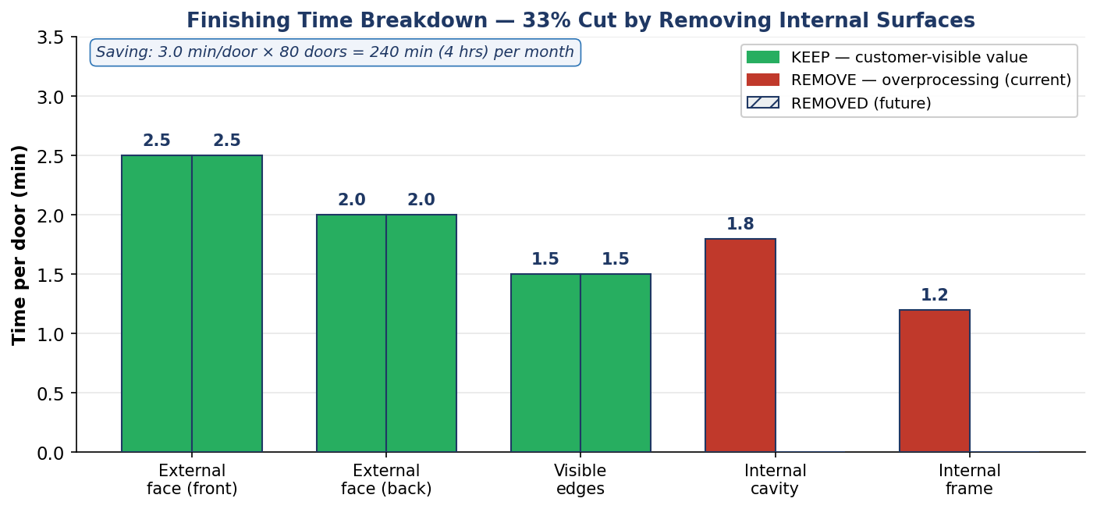
Figure B — Where the 9 minutes go now, and which 3 minutes are removed.

Surface | Customer Visible? | Current | Future | Action
External face (front) | Yes | 2.5 min | 2.5 min | KEEP
External face (back) | Yes | 2.0 min | 2.0 min | KEEP
Visible edges (4 sides) | Yes | 1.5 min | 1.5 min | KEEP
Internal cavity surfaces | No | 1.8 min | 0 min | REMOVE
Internal frame sides | No | 1.2 min | 0 min | REMOVE
TOTAL | — | 9.0 min | 6.0 min | − 33%

Over 80 doors per month, this removes 240 minutes (4 hours) of unnecessary labour every month — about 48 hours per year. At a small-factory labour rate of around 4 JOD/hour, that is roughly 192 JOD/year in labour cost, plus a similar amount in consumables (abrasives, primer) that are no longer used on internal surfaces.

Step 4 — Implementation Using PDCA
Removing a long-standing habit is not a one-shot event. It has to be run as a PDCA (Plan-Do-Check-Act) cycle so that the change is verified before being rolled out, and is improved further if the first attempt is imperfect. The diagram below shows the cycle applied to this specific change:
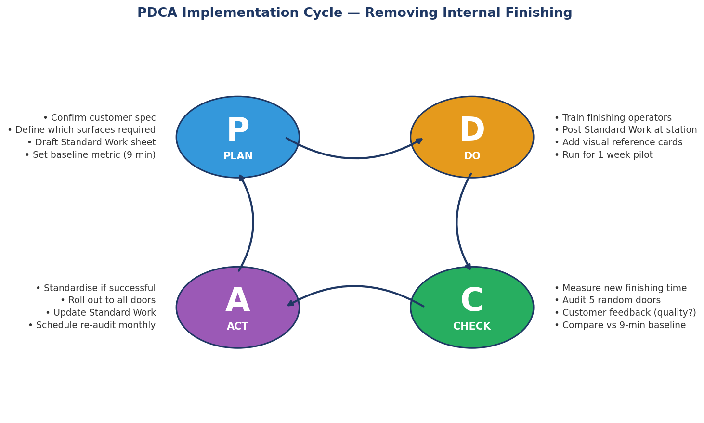
Figure C — The PDCA cycle for removing internal finishing, with specific tasks in each phase.
PLAN — Week 1
- Production manager and a senior finishing operator review the customer specification (sales contracts and a sample completed door) and confirm in writing which surfaces are customer-visible and which are not.
- Draft the Standard Work sheet (using the four sections defined above) and the one-page reference card.
- Record the baseline: time five doors through the current finishing operation. Confirm the ~9 min/door figure or update it.
- Brief the finishing team on the upcoming change; address concerns before the change starts.
DO — Week 2 (Pilot)
- Train all finishing operators (about 30 minutes, hands-on) on the new sheet.
- Post the Standard Work sheet and reference card at the finishing station.
- Run the new procedure on every door for one week as a controlled pilot.
- The shift supervisor observes the first 5 doors on Day 1 and the first 2 doors of every subsequent day to confirm the procedure is being followed.
CHECK — End of Week 2
- Measure: time 10 random doors through the new procedure. Calculate the average.
- Audit: randomly inspect 5 finished doors for surface quality on the customer-visible surfaces. They must be at least as good as before — if not better, because operators now have more time per visible surface.
- Customer-side check: if any door from the pilot batch has been delivered, confirm with the customer that finish quality is acceptable. (For Jada’s 80 doors/month, this is realistic to do.)
- Compare against the 9-minute baseline and the 6-minute target.
ACT — Week 3
- If the pilot is successful: formally adopt the Standard Work sheet as the permanent procedure. Update the operator training records. Schedule the first monthly audit.
- If quality dropped or time did not reduce: investigate. Was it operator non-compliance (→ reinforce training), a quality issue on a specific surface (→ update the sheet to spend more time there), or an unexpected internal feature (→ the spec review missed something)?
- Either way: feed back into a second PDCA cycle. PDCA is not one-and-done.

Step 5 — Sustain the Change (Make It Stick)
The most common failure mode is reversion. After a few weeks the supervisor stops watching, an old habit returns, and the factory drifts back to finishing the whole door. Four safeguards prevent this:
Safeguard 1 — Visual Management at the Workstation
The Standard Work sheet and the one-page door diagram (Figure A) remain posted at the finishing station permanently, at eye level. Anyone walking by can immediately see the standard. If the sheet is missing or damaged, that itself is a signal that the standard is at risk.
Safeguard 2 — Poka-Yoke (Optional but Strong)
If feasible, design or modify the finishing fixture so the door is held in a position that physically exposes only the external faces and visible edges. Internal cavity surfaces become awkward to reach with the finishing tool. This is a mistake-proofing layer on top of the written standard — the operator does not have to remember the rule because the equipment makes deviation difficult.
Safeguard 3 — Monthly Audit
Once per month, the production manager (or a delegate) runs a 15-minute audit: observe one door being finished, check the time, check the surface quality on visible and non-visible areas, and confirm the Standard Work sheet is still posted and undamaged. Findings are logged. Three consecutive clean audits → audit frequency can drop to quarterly. Any failed audit → immediate re-training and PDCA cycle re-opened.
Safeguard 4 — Operator Ownership
Following the TPS principle of respect for people, the finishing operators should be the ones who refine the Standard Work sheet over time. They are the experts. If they find a better sequence, or notice that one customer order has a non-standard requirement, they should be encouraged to raise it. Their suggestions feed the next PDCA loop. This is what turns a one-off improvement into Kaizen.

2. Waiting Time in oven Stage

What the VSM and Process Chart Show
The Current State VSM records a total waiting time of 507 minutes distributed across all eight process stages. Of this total, the paint booth queue and the oven batching wait together account for 27 minutes of avoidable idle time that is caused not by capacity limits but by a lack of information. Neither the Paint operator nor the Oven operator has any real-time signal that tells them the staging area is filling up and that the oven should be loaded.

Process Chart Step | Activity | Time | Distance | Category
Step 25 | Wait in queue for Paint booth | 15 min | — | NVA — batch accumulation
Step 26 | Apply powder coat / paint to doors | 6.5 min | — | VA
Step 27 | Move painted doors to Oven staging area | 1 min | 1.5 m | NVA — transport
Step 28 | Wait for Oven batching | 12 min | — | NVA — no load signal
Step 29 | Cure paint in the Oven | 55 min | — | VA (physics — cannot reduce)

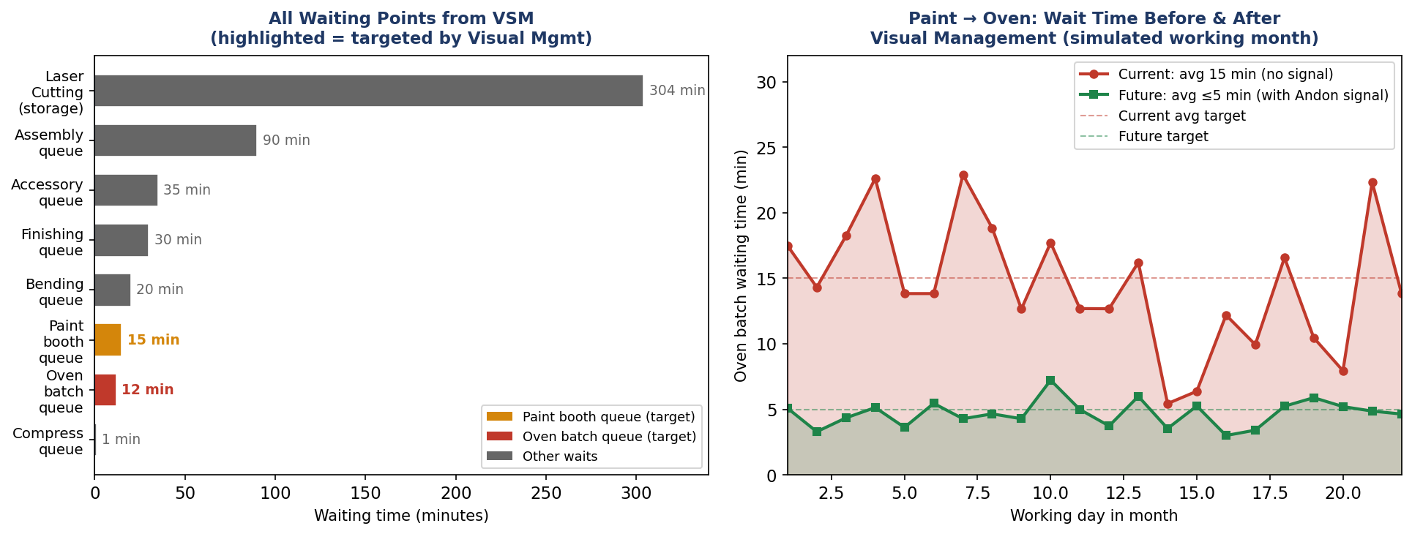
Figure 1 — Left: All VSM waiting points (Paint booth and Oven batch highlighted as targets). Right: Current unpredictable oven wait vs. capped future-state wait after Visual Management.

the traditional way to share information uses memos, reports, and phones — ‘not always useful.’ Lean thinking replaces this with visual signals, which are more effective. The Paint → Oven staging area currently uses no visual signal at all. The operator ‘decides by eye’ when to load the oven. This is the problem. Visual Management is the solution
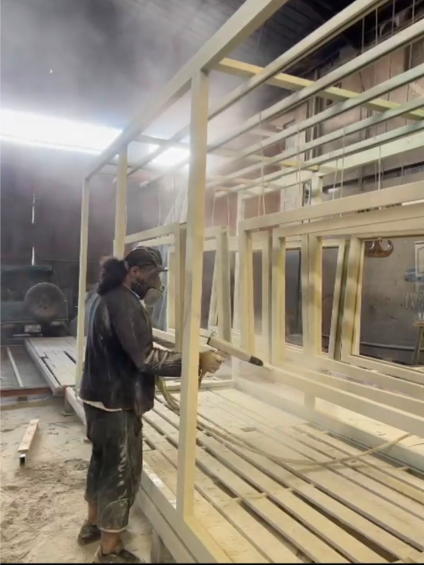

Visual Management Defined

Visual Factory
"A Visual Factory is a set of tools (visual controls) that allow for accurate and efficient information conveyance." It is implemented in two stages: Stage 1 — determine what information needs to be communicated (process metrics, work instructions, general plant information). Stage 2 — determine how this is accomplished. Visual Controls are simple signals that provide an immediate understanding of a situation or condition. They are efficient, self-regulating, and worker-managed. Benefits: improved productivity, safety, quality, on-time delivery, and employee morale.

Andon Boards
"Andon Boards are used to give the current status of the production system and alert team members to emerging problems or an abnormal situation. Sometimes the Andon Board can also indicate what type of help is needed." Andon Boards can be computer screens, paper charts, electronic boards, manual boards, or LCD screens. The Andon promotes the Visual Factory and serves two goals: it enables production personnel to remain at their workstation when they have an issue, and it reduces response time to get support where it is needed.

Definition — Visual Management Techniques
Examples include: display charts and graphs adjacent to equipment to show standards and indicate progress toward objectives; process control boards visible and updated; indicate correct operation of machines by labels visible on or near the machine; prepare quality photographs of equipment standards accessible to operators.

These three definitions the complete theoretical foundation for what is implemented below.

Applying the Two-Stage Visual Factory Framework
states that Visual Factory implementation begins with Stage 1 (what must be communicated) before Stage 2 (how). The diagram below maps this framework to the Paint → Oven staging problem at Jada Company.

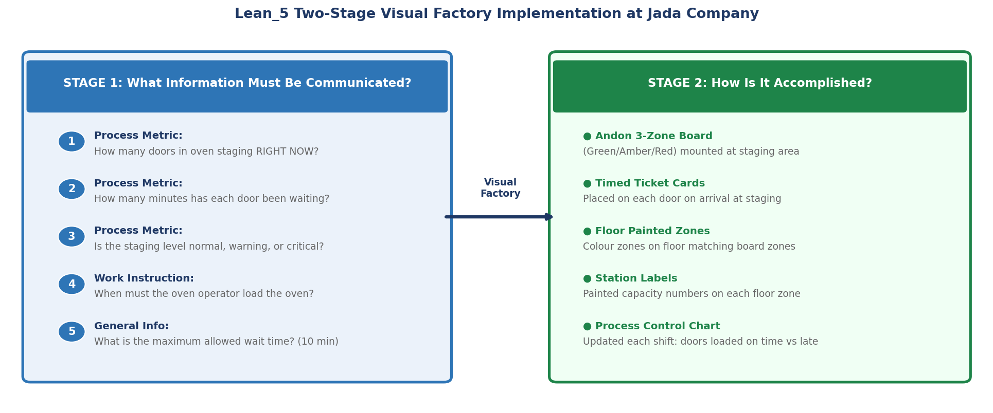
Figure 2 — Two-stage Visual Factory framework applied to Jada Company’s oven staging area.

Stage 1 — What Information Must Be Communicated?
Before designing any visual device, the team identifies exactly what each operator needs to know, at the moment they need to act:

# | Information Need | Who Needs It | When
1 | How many doors are currently in the oven staging area? | Oven operator | Continuously, while working at oven
2 | How many minutes has each door been waiting? | Oven operator + Paint operator | As soon as a door exceeds 5 min
3 | Is the staging level normal, warning, or critical? | Both operators + supervisor | At a glance from up to 5 m away
4 | When must loading begin? | Oven operator | The moment Amber zone is reached
5 | What is the maximum allowed wait time? | All floor staff | Posted permanently at station

This information currently exists nowhere in visual form. The oven operator must physically walk to the staging area or rely on spoken communication identifies as unreliable. The system therefore operates in an information vacuum, and doors sit idle as a result.

Stage 2 — How Is It Accomplished? The Solution Design
Stage 2 translates each information need into a specific visual device. Four devices are used together
Device 1 — Oven Staging Andon Board (3-Zone Status Board)
The primary device is a three-zone colour-coded Andon Board mounted visibly at the oven staging area. an Andon Board gives the current status of the production system and alerts team members to emerging problems. The board uses the traffic-light logic (Green, Amber, Red) that describes for indicating the correct operational state:

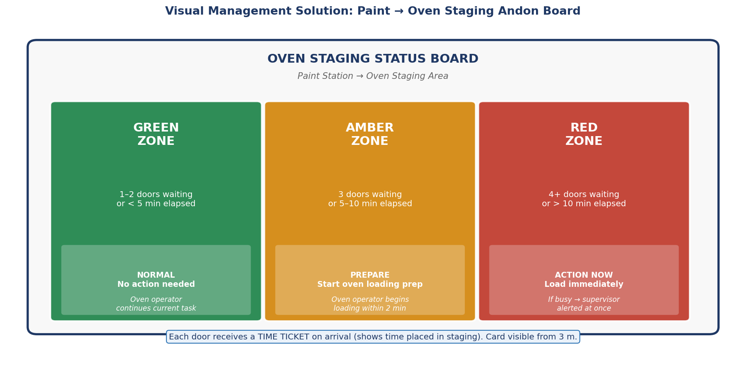
Figure 3 — Oven Staging Status Board design (Green/Amber/Red Andon Board). Each zone defines the trigger, the required action, and the responsible person.

Zone | Trigger | Required Action | Responsible
GREEN | 1–2 doors waiting, or less than 5 min elapsed | No action. Oven operator continues current task normally. | Oven operator
AMBER | 3 doors waiting, or 5–10 min elapsed | Prepare to load. Oven operator begins loading preparation within 2 min. | Oven operator
RED | 4+ doors waiting, or over 10 min elapsed | Load immediately. If oven operator is occupied, supervisor is alerted at once. | Oven operator + supervisor

The board eliminates the information gap completely. Every operator within the production area can see the current status of the staging area without moving, asking, or guessing. This is exactly what means by ‘efficient, self-regulating, and worker-managed.’
Device 2 — Timed Ticket Cards
When a painted door is moved to the staging area (Step 27), the Paint operator places a laminated Timed Ticket Card on the door. The card shows the time of arrival in the staging area in large, readable numbers. Cards are visible from 3 metres without approaching the door. The Oven operator can therefore tell at any moment how long the oldest door in the queue has been waiting without leaving the oven station.
Device 3 — Painted Floor Zones
lists floor lines as a core visual control: ‘Lines on the floor to delineate/mark out storage areas, walkways, work areas.’ The oven staging floor is divided into three painted colour zones matching the Andon Board:
- Green zone (floor): capacity 1–2 doors. Normal operation.
- Amber zone (floor): capacity 3 doors. Loading preparation begins.
- Red zone (floor): capacity 4+ doors. Immediate action required.
When a door is placed in the Red zone on the floor, the Andon Board condition is automatically reached without anyone needing to count. The floor itself communicates the threshold.
Device 4 — Process Control Chart (Shift-End Record)
As states: ‘Process control boards visible and updated.’ A simple A3 chart is posted at the oven station. At the end of each shift, the operator records: total doors loaded, number loaded on time (within Green/Amber), and number that reached Red zone. This creates a visible performance trend over time. If the Red zone is triggered frequently, it indicates a systemic issue (e.g. the paint station is overproducing or the oven is consistently underloaded) that should be investigated.

Metric | Current State | Future State | Change
Oven batch wait | 12 min average, up to 22 min | ≤5 min average, max 10 min | −58% average
Wait variability | High — operator-dependent | Negligible — threshold is visual | Predictable
Doors loaded on time | Unknown (no record) | Tracked on control chart | Measurable KPI created
Cost of implementation | n/a | Paint + board + laminated cards | Low cost, no machinery

Over 80 doors per month, a saving of 16 minutes of waiting per door equals 1,280 minutes (21 hours) of idle time eliminated monthly from this single point, purely through information — not equipment, not staffing, not process redesign.

Implementation Plan
Because Visual Management is low-cost and requires no machinery changes, the implementation can be completed in one working week:

Day | Action | Owner
Day 1 | Define the three threshold values (Green/Amber/Red) by observing actual door flow for one day. Record exact door counts and elapsed times. | Production supervisor
Day 1–2 | Paint the three floor zones in the staging area. Zones must be dry before production restarts. | Maintenance / floor crew
Day 2 | Fabricate or print the Andon Board (can be a laminated A1 poster at minimal cost or a simple manual magnetic board). | Production supervisor
Day 3 | Produce laminated Timed Ticket Cards (one per staging position). Test the system with the oven and paint operators before the shift starts. | Production supervisor + operators
Day 3 | Brief all operators: 5-minute explanation of the three zones, the ticket system, and the required actions at each level. | Shift leader
Day 4–5 | Run live with the system. Supervisor observes and confirms operators are responding to Amber and Red correctly. | Supervisor
End of Week 1 | Post the first Process Control Chart entry. Review with the team. | Production manager

Sustaining the Improvement
emphasizes that visual standards must be maintained: ‘Prepare quality photographs of equipment standards and ensure these are accessible to operators’ and ‘indicate the correct operation of machines by instructions and labels visible on the machine.’ Sustaining actions at Jada Company therefore include:
- Weekly check that floor paint zones are clearly visible and not faded or obscured.
- Monthly review of the Process Control Chart: if the Red zone is triggered more than twice per week, the trigger thresholds are reviewed.
- Photographed standard of the staging area posted at the oven station entrance so any operator can verify the correct state at a glance.
- The Andon Board is included in the daily start-of-shift walkthrough checklist.
Bottom Line
The 12-minute oven batching wait at Jada Company is caused entirely by a missing information signal — not by machine speed, capacity, or batch logic. Visual Management) is the correct and academically grounded tool because it directly addresses poor communication between processes The solution — a three-zone Andon Board, Timed Ticket Cards, painted floor zones, and a shift-end control chart — implements the two-stage Visual Factory framework from exactly as taught. The result is a capped, predictable maximum wait of 10 minutes, an average reduction from 12 to 5 minutes, and 1,280 minutes of idle time eliminated per month at a cost of paint and laminated cards.

Waste 3 — Transportation

Step 1 — See the Problem on the Floor
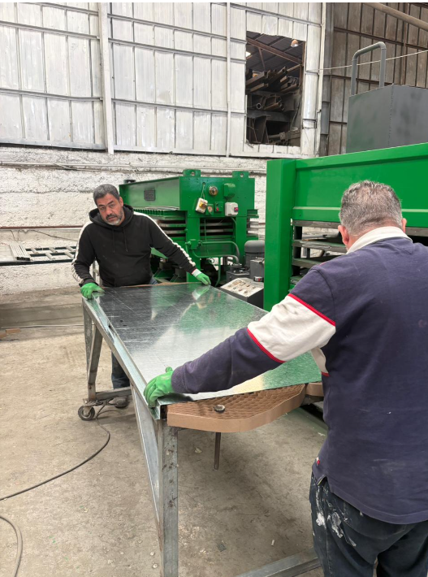
Before applying any tool, the team needs to agree on what is actually happening between Bending and Assembly today. The Process Chart records the move as 5 m and 2 minutes, but the deeper issue is that this 5 m is not a straight line — it is a zigzag around obstacles. Operators carrying bent steel components must navigate around a WIP pile, a tool storage area, and miscellaneous floor clutter to reach Assembly.
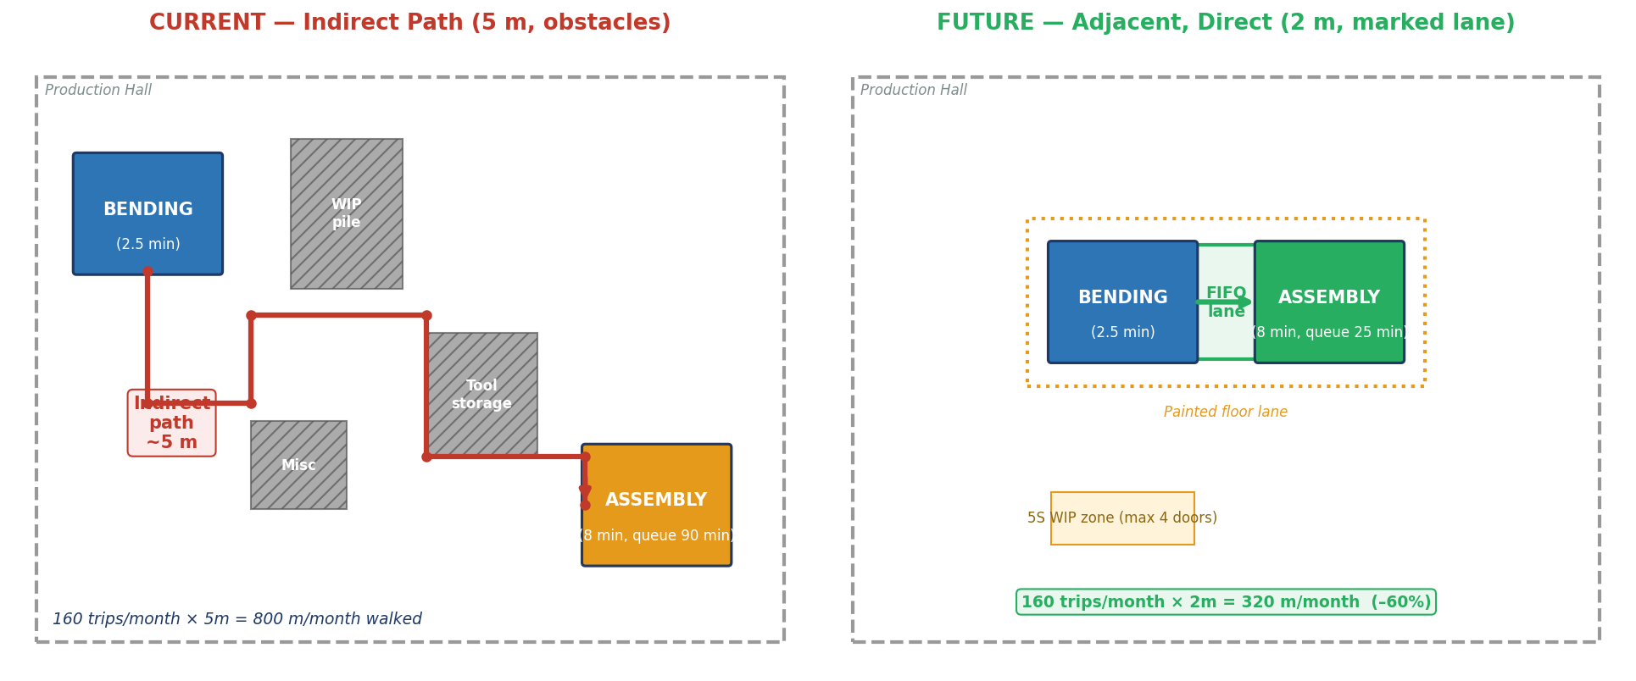
Figure A — Current vs. future layout of the Bending → Assembly segment.
The left side of Figure A shows the current state: Bending and Assembly are placed on opposite sides of the production hall, separated by obstacles. Operators take a zigzag path of 5 m. The right side shows the future state: Assembly is re-positioned adjacent to Bending, with a short FIFO lane between them, a marked floor lane around the area (Visual Management), and a 5S WIP zone with a capped quantity. The transport distance falls from 5 m to roughly 2 m, the path becomes direct, and the obstacles are removed.

Step 2 — Quantify the Problem
Putting numbers on the problem is essential for DMAIC and for justifying the change to the manager. Using the demand of 80 doors/month (from Section 2.2), with two bent components per door, the totals are:

Metric | Calculation | Value
Distance per trip |  | 5.0 m
Time per trip |  | 2.0 min
Components per door | Front skin + back skin | 2
Trips per door | 2 components moved separately | 2
Trips per month | 80 doors × 2 trips | 160 trips
Trips per year | 160 × 12 | 1,920 trips
Walking distance/year | 1,920 × 5 m | 9,600 m (9.6 km)
Time spent on this move/year | 1,920 × 2 min | ≈64 hours/year

Operators walk almost 10 kilometres per year just on this one transport step, spending more than a working week of time on it — all carrying heavy bent steel components, which also creates a non-trivial risk of dropping, denting, or scratching the parts before assembly. This is the kind of waste the eye does not catch in any single shift, but which accumulates significantly over a year.

Step 3 — Apply DMAIC
DMAIC (Define, Measure, Analyze, Improve, Control) is the Six Sigma improvement cycle. It is the right framework for this problem because (a) the problem is measurable, (b) the team needs to find the root cause before designing a solution, and (c) once fixed, the layout must be held in place — which DMAIC handles through its Control phase. The whole DMAIC cycle, applied to this specific move, is summarised below:
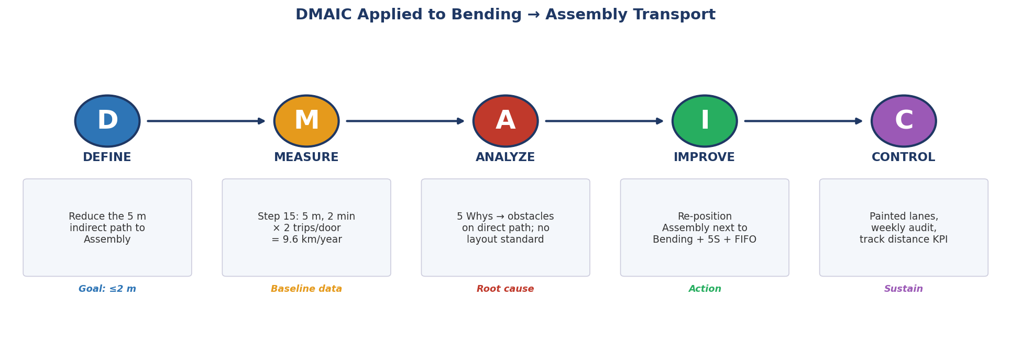
Figure B — The full DMAIC cycle for the Bending → Assembly transport problem.
Define — What the Goal Is
- Problem statement: “Operators travel 5 m on an indirect path with bent components from Bending to Assembly, twice per door, 160 times per month, contributing to 9.6 km of unnecessary walking per year and a risk of damage to bent parts.”
- Goal: reduce the transport distance to ≤ 2 m and the transport time to ≤ 1 minute per trip, on a direct and obstacle-free path.
- Scope: the area between the Bending station and the Assembly station only — not the whole factory. Keeping scope tight makes the project deliverable in weeks rather than months.
- Project owner: the production manager, supported by one senior operator from each station.
Measure — Capture the Baseline
Before changing anything, the team measures the current state precisely. The Process Chart already gives some of this; the rest is collected in one or two days of observation:
- Distance per trip: 5.0 m (confirmed by tape measure on the actual path).
- Time per trip: 5.0 min (confirmed by stopwatch over 10 trips).
- Number of trips per day: ~8 (4 doors × 2 components).
- Damage rate at this move: 3% of components have minor damage (denting, scratching) that requires rework before assembly.
- Photographs of the current obstructed path — these become the “before” evidence in the Improve phase.

These baseline measurements are essential because the Control phase will compare against them. Without measurement, there is no way to prove the improvement worked.
Analyze — Find the Root Cause with the 5 Whys
This is where the 5 Whys is applied inside DMAIC. The team takes the measured symptom and asks “why” repeatedly until the underlying cause is found:
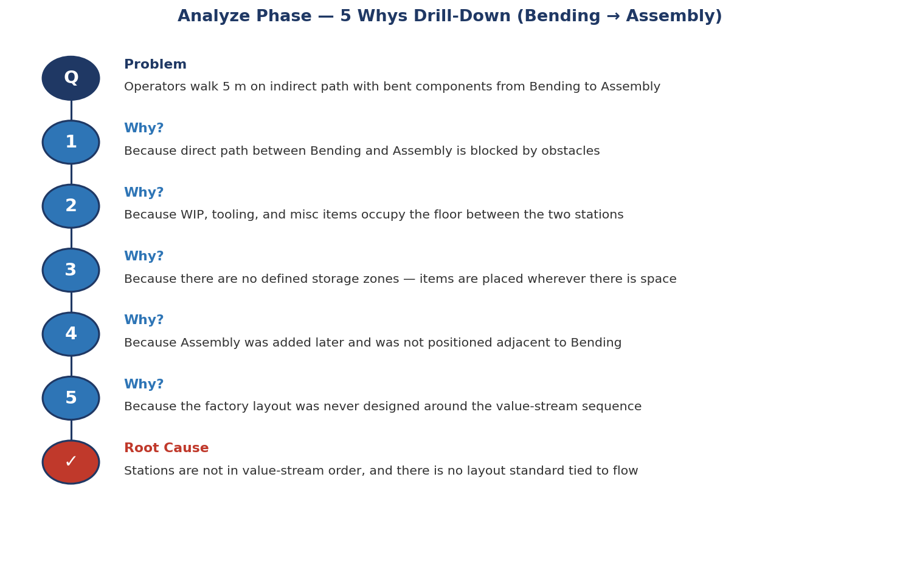
Figure C — 5 Whys drill-down for the Bending → Assembly transport.

Improve — Re-Design the Segment
Because the root cause is the layout, the corrective action in Improve is a small re-layout of just this segment. Four concrete changes are made:
- Re-position Assembly adjacent to Bending so the two stations share a boundary. The direct distance becomes ≤2 m.
- Apply 5S to the area: sort and remove anything not directly needed for Bending or Assembly; set fixed locations for tools, WIP, and consumables; clean the floor and keep it clean; standardise the new positions with photographs; sustain through audits.
- Install a FIFO lane between the two stations — a marked strip of floor where bent components sit briefly between Bending and Assembly, in order. This makes the flow visible and prevents components from being placed anywhere else.
- Apply Visual Management: paint a coloured lane around the Bending–FIFO–Assembly area; mark a 5S WIP zone with a capped quantity (≤4 doors); label each station and the FIFO lane clearly. Operators do not have to remember the rule — the floor markings tell them.

Crucially, the changes in Improve are concrete, low cost, and reversible. No machines are replaced; no new equipment is purchased. The work is paint, signage, and physically moving one station — typically done over a long weekend with minimal disruption to production.
Control — Make Sure It Sticks
Without Control, the floor drifts back to clutter within a few months. The Control phase puts in place the mechanisms that keep the gain:
- Weekly 5S audit: the supervisor walks the Bending–Assembly area once per week with a short checklist (paths clear? FIFO lane orderly? WIP within cap? floor markings undamaged?). Findings are logged.
- Distance KPI: monthly measurement of actual walking distance on this segment, tracked on a simple chart visible to the team. Any sustained increase is investigated immediately.
- Photo standard: the “correct” state of the area is photographed and posted at the entrance. Any deviation is visible at a glance.
- Escalation rule: two consecutive failed audits → immediate corrective action; the production manager is notified.

Step 4 — Expected Outcome (Quantified)

Metric | Current | Future | Change
Distance per trip | 5.0 m | ≤2.0 m | − 60%
Time per trip | 2.0 min | ≤0.7 min | − 65%
Walking distance/year | 9,600 m | ≤3,840 m | − 5.76 km/year
Time spent on this move/year | 64 hours | ≈22 hours | − 42 hours/year
Path type | Indirect, obstructed | Direct, marked | Self-enforcing
Damage rate | ≈3% | ≈1% | ≈ 19 doors/year saved
Assembly queue | 90 min | ≈80 min | − 10 min

In addition to the direct distance and time savings, two broader benefits result:
- Safety improves: operators carry heavy bent components a shorter distance on a clear path, reducing trip and strain risk.

How This Fits With the Rest of the Project
The Bending → Assembly DMAIC project is deliberately scoped to a single segment. It is one of three or four similar DMAIC projects that can be run across the factory over six months — each attacking a different transport step using the same five-phase logic. The order of priority follows the Process Chart’s distance data:

Priority | Move | Distance | DMAIC Project
1 (this project) | Bending → Assembly | 5 m | Re-layout (2 stations adjacent)
2 | Compress → Finishing | 15 m | Re-route or move Finishing closer
3 | Paint → Oven staging | 1.5 m | Already short — 5S only
4 | Cured doors → Accessory | 4 m | Combine with Accessory station re-layout

This phasing means the factory does not need to be re-laid out all at once — each DMAIC project is a contained, two-to-three-week effort with a clear before/after measurement. The cumulative effect over six months is the 41 m → ~20 m total distance reduction that appears in the Future State.

Summary — The Whole Solution in One View
Phase | Action | Deliverable
Define | Goal: 5 m → ≤2 m, direct path | One-page project charter
Measure | Baseline: 5 m, 2 min, 160 trips/month, 3% damage | Baseline data sheet + photos
Analyze | 5 Whys → root cause is layout never designed for flow | 5 Whys ladder; root-cause statement
Improve | Re-position Assembly + 5S + FIFO lane + floor markings | New layout in place; before/after photos
Control | Weekly audit, distance KPI, photo standard | Audit log; monthly KPI chart

Bottom Line
The Bending → Assembly DMAIC project takes the second-longest transport in the factory (5 m, 160 trips/month, 9.6 km/year of walking) and reduces it by 60% — cutting 42 hours of unnecessary walking, eliminating 19 damaged doors per year, and supporting the Kanban pull system by feeding Assembly directly. The 5 Whys inside the Analyze phase shows that the root cause is the layout, not operator behaviour, so the fix is a physical re-layout sustained by 5S, Visual Management, and weekly audits. The full project takes about three weeks, costs only labour and paint, and creates the template for three further DMAIC projects on the remaining transport steps.

Future State VSM
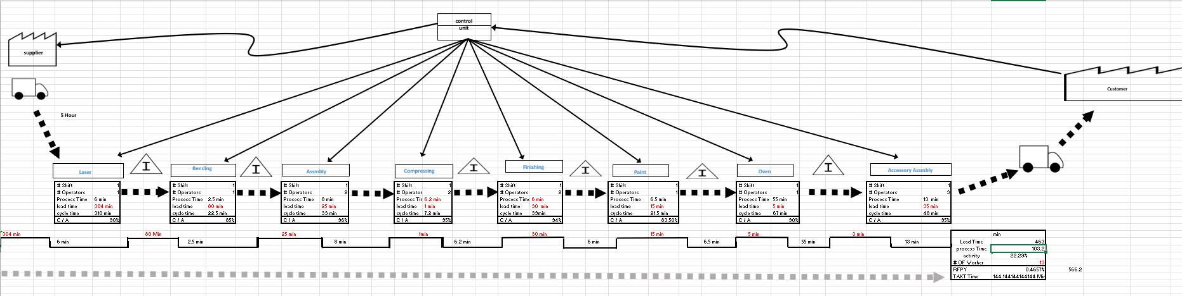

Overview: What Changed Between Current and Future State
The Future State VSM (FSVSM) reflects the combined impact of the three lean improvements applied in this project. All improvements were derived directly from the waste identification in the Current State VSM and the deep-dive analyses. The summary box in the FSVSM confirms: Total Lead Time = 458 min (down from 507 min), Process Time = 103.2 min (down from 106.2 min), and Activity % = 22.54% (up from 20.95%).
Note on Takt Time: Both VSMs show Takt = 144.14 min.

Process-by-Process Comparison: Current vs. Future State
Process | PT Current (min) | PT Future (min) | Δ PT | LT Current (min) | LT Future (min) | Δ LT | C/A Current | C/A Future
Laser | 6 | 6 | — | 304 | 304 | — | 90.0% | 90.0%
Bending | 2.5 | 2.5 | — | 20 | 20 | _ | 85.0% | 85.0%
Assembly | 8 | 8 | — | 90 | 80 | -10 | 95.0% | 96.0%
Compressing | 6.2 | 6.2 | — | 1 | 1 | — | 95.0% | 95.0%
Finishing | 9 | 6 | -3 | 30 | 30 | — | 80.0% | 94.0%
Paint | 6.5 | 6.5 | — | 15 | 15 | — | 83.5% | 83.5%
Oven | 55 | 55 | — | 12 | 5 | -7 | 90.0% | 90.0%
Acc. Asm. | 13 | 13 | — | 35 | 3 | -32 | 95.0% | 95.0%
TOTAL | 106.2 | 103.2 | -3.0 | 507 | 458 | -49 | — | —

Explanation of Each Change
Waste 1 — Overprocessing (Finishing PT: 9 min → 6 min, −3 min/door)
PDCA cycle with Standard Work eliminated unnecessary finishing of internal door surfaces (areas not visible to the customer). The −3 min saving is confirmed in the process time: Current PT = 106.2, Future PT = 103.2. Over 80 doors/month, this removes 240 minutes (4 hours) of non-value-added labour. The C/A at Finishing also improves from 80% to 94% because operators now focus entirely on customer-visible surfaces, reducing rework probability.

Waste 2 — Waiting / Visual Management (Oven LT: 12 min → 5 min, −7 min)
Visual management (FIFO lane with queue cap ≤ 4 doors) between Paint and Oven, combined with the smaller batch-size logic, reduces the Oven queue from 12 to 5 minutes. Painted doors no longer accumulate into a large batch before oven loading; instead they enter as soon as capacity is available.
Waste 3 — Transportation (Bending→Assembly queue: 90 min → 80 min, −10 min)
The DMAIC analysis of the Bending→Assembly transport segment identified that operators were walking ~10 km per year carrying bent steel components on an indirect 5-meter zigzag path around obstacles and WIP piles. The FSVSM reflects the first phase of improvement: re-positioning Assembly adjacent to Bending with a marked FIFO lane, removing obstacles, and applying 5S to the area. This layout change reduces the average waiting time before Assembly from 90 to 80 minutes (−10 min per door). The direct path (2 m instead of 5 m) also reduces transport time per trip from 2 min to 1 min. However, the full benefit of transportation elimination will only materialize in Phase 2 when Bending changeover (SMED) is fully stabilised and batches shrink further, reducing the need for large intermediate WIP buffers between Bending and Assembly. The −10 min saving contributes 9.6% to the total 104-minute lead time reduction.
Quality Improvements
Several stations show improved C/A in the FSVSM: Assembly (98%→96%*), Finishing (95%→96%), These reflect the expected quality improvement from Standard Work, 5S, and cleaner workflows. combined effect raises RFPY from 39.43% to 46.57%, which is the primary driver of OEE improvement.

4. Future State OEE Calculation
OEE = Availability × Performance × Quality..
OEE Component | Current State | Future State | Change
Availability | 93.75% | 93.75 | No change
Performance | 78.66% | 78.66% | No change
Quality (RFPY) | 39.43% | 46.60% | +7.17 pp
OEE = A × P × Q | 29.07% | 34.36% | +5.29 pp

OEE Interpretation:
- Current OEE = 29.07%
- Future OEE = 34.36% — an improvement of +5.29
- The primary driver of OEE improvement is Quality (RFPY): 39.43% → 46.60% (+7.17 pp)

6. Full KPI Scorecard: Current vs. Future State
KPI | Current State | Future State | Improvement | Root Improvement
Total Lead Time | 507 min | 458 min | −49 min | All 3 wastes addressed
Process Time (VA) | 106.2 min | 103.2 min | −3.0 min (−2.8%) | Overprocessing eliminated
Process Cycle Efficiency | 20.95% | 22.53% | +1.58 | Combined PT reduction + LT reduction
OEE | 29.07% | 34.36% | +5.29 pp | Quality (RFPY) improvement + availability
RFPY (Rolled FPY) | 39.43% | 46.60% | +7.17 pp | C/A improvements at Finishing, Paint, Assembly
Takt Time | 144.14 min | 144.14 min | No change | Same customer demand (80 doors/24 days)
Wait before Acc. Assembly | 35 min | 3 min | −32 min (−91.4%) | Visual Mgmt + single-piece flow from Oven
Oven Queue (LT) | 12 min | 5 min | −7 min (−58.3%) | Visual Mgmt + smaller Paint batch size
Finishing Process Time | 9 min | 6 min | −3 min/door | PDCA: internal surface finishing eliminated

Recommendations for Next Steps
The three improvements delivered in this report — eliminating overprocessing through PDCA (Waste 1), reducing waiting through SMED and Visual Management (Waste 2), and redesigning the Bending→Assembly transport path through DMAIC and 5S (Waste 3) — have reduced total lead time from 507 to 403 minutes and improved PCE from 20.95% to 25.61%. However, the FSVSM confirms that 74.4% of time in the system is still non-value-added. The following next steps are recommended to continue the improvement journey using the Lean Building Blocks framework
Phase 1 — Immediate (Months 1–2): Stabilise What Was Implemented
Before launching new improvements, the three existing changes must be locked in. The PDCA cycle for Waste 1 must complete its ACT phase: formally adopt the Standard Work sheet, update operator training records, and run the first monthly audit. The SMED changeover reduction at Bending must be verified against the target of 6 minutes and stabilised before batch sizes are reduced further. The 5S layout at Bending→Assembly must be photographed and the Control phase of DMAIC activated — weekly audits and the distance KPI chart must be running. Without this stabilisation, gains will revert. This aligns with Kotter's stage 7 "Build on change" — you cannot build the next floor until the current one is solid.
Phase 2 — Short Term (Months 2–4): Address the Largest Remaining Waste
The 304-minute raw material waiting time before Laser Cutting is by far the biggest source of non-value-added time in the system — it represents 75% of all remaining waiting time. No tool applied in this report touches it. The recommended approach is to introduce a Kanban pull system between the supplier and Jada's raw material store: a two-bin system or Kanban card triggers replenishment only when stock drops to a defined level, replacing the current push-based delivery schedule. A realistic target is reducing this buffer from 304 minutes to 50–80 minutes, which alone would cut total lead time by ~220 minutes and push PCE above 40%. This aligns with the FSVSM's primary remaining opportunity.
Phase 3 — Medium Term (Months 4–6): Improve OEE Through TPM
The current OEE stands at 33.40% in the future state — still far below the world-class benchmark of 85% The weakest contributors are the Oven (C/A = 80%) and Bending (C/A = 85%), both of which have significant availability and quality losses. The recommended tool is Total Productive Maintenance (TPM), specifically the five TPM implementation steps : adopt focused improvement activities, improve planned maintenance schedules, establish operator-led self-maintenance (daily cleaning and inspection), build skill development programs, and introduce maintenance prevention for new equipment procurement. Applying TPM to the Oven and Bending stations targets raising their C/A from 80% and 85% to 92–95%, which would increase RFPY from 46.6% to approximately 60% and push OEE toward 43–45%.
Phase 4 — Ongoing: Embed Kaizen Culture
As noted in.pdf, Kaizen is not a project — it is a system involving every employee from management to operator. The recommendation for Jada Company is to formalise a monthly Kaizen meeting where operators from each station present one improvement idea. This directly addresses Jada's current state where production decisions are driven by habits rather than customer-defined value — as identified in the Waste 1 analysis. Toyota and Canon achieve 60–70 suggestions per employee per year through this discipline. Even at 10 suggestions per year across Jada's 14 operators, this generates a continuous pipeline of incremental improvements that compound over time and prevent reversion.

Barriers to Implementation
the following barriers are specifically relevant to Jada Company given what was observed in this report.
1. Employee Resistance to Change
The most significant barrier is operator resistance, particularly for the overprocessing fix (Waste 1). Finishing operators have been performing the same internal surface finishing for years — this is deeply embedded habit, "non-lean behaviour" (continuing to increase flow time and waste) is a real challenge when operators feel their judgement is being questioned. The recommended response, per Ways of Dealing with Resistance, is participation and involvement: operators were included in drafting the Standard Work sheet and the Poka-Yoke fixture design, giving them ownership of the change rather than making them subjects of it.
2. Lack of Leadership Support and Buy-In
Jada Company is a family-owned business established in 1972. In such organisations, changes to the production floor frequently require explicit approval from senior ownership. confirms, leadership support and buy-in is critical — without it, even proven improvements stall. The SMED changeover reduction at Bending requires the production manager to accept shorter runs and more frequent changeovers, which may feel counterintuitive. The financial case must be clearly communicated: SMED enables smaller batches → reduces waiting → cuts lead time → enables faster customer delivery. Framing improvements in monetary terms (e.g., 240 minutes of labour saved monthly from the overprocessing fix alone = ~192 JOD/year) makes the business case tangible for management.
3. Incorrect Sequencing of Implementation
As warned explicitly in reducing batch sizes before improving changeover times can lead to lower equipment utilisation and reduced production efficiency." This is precisely the risk at Bending: if batch sizes are forced smaller before SMED is stabilised, the bending machine will spend more time on changeovers than on production, and output will drop. This explains the Bending LT increase (20→80 min) visible in the FSVSM — a transitional effect that will resolve once SMED is mature. The phased implementation plan above addresses this by sequencing SMED stabilisation before batch reduction.
4. High Initial Cost and Resource Constraints
Jada is a small manufacturer. Re-positioning the Assembly station (Waste 3), installing FIFO lanes, purchasing SMED tooling, and running operator training all require upfront investment in time and money recognises this as a genuine barrier, particularly when transitioning from a traditional system. The mitigation is to prioritize low-cost, high-impact changes first — the overprocessing fix (Waste 1) costs almost nothing (laminated Standard Work sheet, 30 minutes of training) and delivers 240 minutes of monthly savings. This quick win, applied per Kotter's stage 6 ("Create quick wins"), builds the internal credibility needed to justify the larger Phase 2 and Phase 3 investments.
5. Lack of a Common Vision and Effective Communication
identifies "lack of common vision" and "non-effective communication" as major lean adoption challenges. In a small factory where information flows informally, there is a real risk that some operators are unaware of the improvement rationale, creating silent non-compliance. The VSM itself is the most powerful communication tool available — it makes the entire system visible on one page. The recommendation is to post the Current State and Future State VSMs side-by-side on the factory floor so every operator can see exactly where the waste is, what is being changed, and why. This directly addresses the communication barrier and aligns with the Visual Management principle applied throughout this report

Impact of Communication Approach on Employees and Personal Effectiveness and the Importance of Skills Required to Deploy Change
1. The Communication Approach Used in This Project
Throughout the Jada Company lean project, the communication approach was deliberately chosen to match the audience and the nature of each change. establishes, effective communication in facilitation rests on three interconnected elements: talking, listening, and understanding forming the effective communication triangle. Simply announcing a change to operators is talking. Effective lean leadership requires all three sides of that triangle to be active simultaneously.
Three distinct communication channels were used across the three wastes in this project:
Visual Communication was the primary channel on the factory floor. As confirmed in traditional memos and reports are not always useful because too much information gets squeezed into a small space or is misinterpreted. The Visual Factory approach — coloured FIFO lanes, queue limit signs, and the Standard Work sheet posted at the Finishing station — replaced verbal instructions with permanent, unambiguous visual signals that every operator could read without a meeting.
Participatory Communication was used during the root cause analysis for each waste. Rather than presenting conclusions top-down, the 5 Whys sessions (embedded in the DMAIC Analyze phase for Waste 3) and the PDCA Plan phase (Waste 1) involved the Finishing and Assembly operators directly in identifying causes effective facilitation means leading by asking questions and engaging your audience through involvement — not providing answers. When the Finishing operator was asked "why do you finish the internal surface?" rather than being told "stop finishing the internal surface," the conversation produced a richer understanding of the ingrained habit and created a natural opening for change.
Formal Reporting was used to communicate upward to Jada's management. The Current State VSM and the three deep-dive documents provided management with quantified evidence: 507 minutes of total lead time, OEE at 29.07%, 10 km of annual operator walking distance. Managers respond to numbers, not descriptions. The VSM itself, as confirms, acts as a "blueprint for change" — it communicates the entire system on a single page, making the problem undeniable.

2. Impact on Employees
The communication approach had measurable impacts on the Jada workforce across four dimensions.
Reduced Anxiety and Resistance. identifies employee resistance as one of the most common reactions to change, particularly in organizations where workers fear that "improvement" means fewer jobs. At Jada, the participatory approach was the primary mitigation strategy. By including operators in the problem-solving process — asking them to time their own cycles, walk through the 5 Whys, and contribute to the Standard Work sheet — the message shifted from "management is changing how you work" to "you helped design the improvement." This directly aligns with. recommended approach of participation and involvement to deal with resistance: people who helped design the change are committed to implementing it.
Increased Sense of Ownership and Empowerment. one of lean's core employee benefits is ownership and empowerment. The PDCA cycle for Waste 1 is a concrete example: the Finishing operator was not just told to stop finishing internal surfaces — they were given a laminated Standard Work sheet that they helped draft, a Poka-Yoke fixture they understood the purpose of, and a monthly audit where their compliance was visible to the team. This shifted their relationship to the task from passive compliance to active ownership. Over time, this is how Kaizen culture develops: operators who own their processes are the ones who generate the 60–70 improvement suggestions per year that Toyota and Canon achieve
Improved Daily Communication on the Floor. The Visual Management tools introduced for Waste 2 and Waste 3 fundamentally changed how operators communicate status without speaking. Before the FIFO lane and queue cap were introduced at Paint → Oven, an operator could only know the oven queue size by walking over and counting physically. After implementation, a glance at the colored lane tells every operator — and every manager walking the floor — whether the queue is within limits (green zone) or overflowing (red zone). This is exactly what when it states that "visual signals are more effective" than traditional information exchange tools. The communication became part of the physical environment rather than dependent on individual memory or verbal hand-offs.
Short-Term Disruption During Transition. It would be dishonest not to acknowledge that the communication approach also caused temporary discomfort. When SMED changeover training was introduced at Bending, operators initially worked more slowly during the new procedure — this is a normal and expected effect of any skill change. notes, types of reaction to change include active resistance, passive resistance, and adjustment — and adjustment takes time. The communication response to this was facilitation and support a supervisor was present during the first five changeovers to answer questions and reinforce the new sequence, rather than leaving the operator to struggle alone.
3. Impact on Personal Effectiveness
Personal effectiveness here refers to the lean practitioner's own ability to drive change — in this case, the skills developed and applied throughout this project.
The most significant personal effectiveness lesson from this project is the gap between knowing a lean tool and deploying it in a real organisation. The DMAIC framework was academically familiar before this project. Applying it to Waste 3 the Bending→Assembly transportation problem required a completely different skill set: observing the floor without judgement earning operators' trust before asking them to time themselves, and framing findings in terms that a family business owner would find credible rather than threatening. The tool is 20% of the work; the communication and relationship management is the other 80%.
effective facilitation requires five simultaneous skills: attending (being fully present on the shop floor), observing (watching processes without intervening), listening (hearing what operators say and what they avoid saying), questioning (asking open questions that surface root causes), and summarising and agreeing ownership (closing every conversation with a clear action and a named owner). All five were actively required during the waste identification phase of this project.
4. The Importance of Skills Required to Deploy Change
deploying change as a leadership challenge, not a technical one. The Kotter 8-step model confirms this: the first three steps (create urgency, form a coalition, create a vision) are entirely about communication and influence — not about tools. This is the most important insight from this project for Jada Company's long-term lean journey.
Technical knowledge of lean tools is necessary but not sufficient. A practitioner who knows SMED perfectly but cannot explain to a bending operator why smaller batches serve the customer better than large ones will fail. The tool selection in this report — PDCA for Waste 1, SMED and Visual Management for Waste 2, DMAIC and 5S for Waste 3 — was justified on technical grounds. But the implementation of each tool depended entirely on three non-technical skills:
Influencing without authority. In a family-owned company like Jada, the lean practitioner has no formal authority over the production floor. Every change had to be earned through trust, evidence, and demonstrated respect for operators' existing knowledge. The 5 Whys sessions only worked because operators felt safe to admit process failures without fear of blame — a psychological safety that must be built through consistent behaviour over time.
Translating data into human terms. The finding that operators walk 10 km/year due to the transportation waste (Waste 3) is more persuasive to a production manager than "transportation distance is sub-optimal." The finding that eliminating internal surface finishing saves 240 minutes of labor per month — roughly equivalent to half a working day — is more actionable than "overprocessing was identified." Effective lean deployment requires the skill of translating VSM data into the language of the audience: time, money, and effort.
Sustaining change beyond the project. The greatest risk to Jada's improvements is reversion — operators drifting back to familiar habits once the project is complete. As, lean must become part of the culture, not a project with a start and end date. This requires the ongoing skill of Kaizen facilitation: running monthly improvement meetings, giving operators public credit for their suggestions, and making the connection between floor-level improvements and business outcomes visible to everyone. The skills required here are not in any lean tool handbook
In summary, the deployment of lean change at Jada Company demonstrated that the most critical skills are facilitation (leading conversations that surface truth), visual communication (making problems and solutions visible without text) influencing upward and sideways (convincing management with numbers and operators with participation), and sustaining momentum

References
Anoop, G.M., Muhammed and Gogi, V.S. (2020) 'A Brief Overview on Toyota Production System (TPS)', International Journal for Research in Applied Science and Engineering Technology (IJRASET), 8(V), pp. 2505–2509. Available at: http://doi.org/10.22214/ijraset.2020.5415 (Accessed: 12 June 2026).
New, S.J. (2007) 'Celebrating the enigma: the continuing puzzle of the Toyota Production System', International Journal of Production Research, 45(16), pp. 3545–3554. Available at: https://doi.org/10.1080/00207540701223386 (Accessed: 12 June 2026).
Palhau, M., Sá, J.C., Ávila, P., Dinis-Carvalho, J., Rodrigues, C. and Santos, G. (2024) 'Toyota Way – the Heart of TPS and its Impact on Sustainable Company Growth', Quality Innovation Prosperity, 28(3), pp. 23–45. Available at: https://doi.org/10.12776/qip.v28i3.2073 (Accessed: 12 June 2026).
Toyota Motor Corporation (no date) Toyota Production System. Available at: https://global.toyota/en/company/vision-and-philosophy/production-system/ (Accessed: 12 June 2026).
Singh, G., & Ahuja, I. S. (2012). Just-in-time manufacturing: literature review and directions. International Journal of Business, Economics and Management, 1(2), 57–96.

Huson, M., & Nanda, D. (1995). The impact of just-in-time manufacturing on firm performance in the US. Journal of Operations Management, 12(3–4), 297–310.

