Data Analytics Project Report

Prepared for: Data Analytics Course
Prepared by: Omar Abdel Jalil- 23110604
Al Hussein Technical University (HTU)
Instructor: Dr. Saleem Ramadan

1. Introduction
This project aims to analyze customer behavior and purchasing trends by examining the relationship between customer demographics and their total sales. The dataset includes information about customers’ income, age, and purchase records. By performing data cleaning, merging, and regression analysis, we explore how age and income impact total sales. The final output includes visualizations and statistical models to provide meaningful insights into customer spending pattern

3. Data Cleaning

3.1 Cleaning the Customer Table in SQL Server
To ensure data accuracy and consistency in the Customers table, several cleaning operations were performed using SQL:

- Outlier Removal:
Remove customers with unrealistic ages.
DELETE FROM Customers WHERE Age < 10 OR Age > 100;

- Gender Standardization:
UPDATE Customers SET Gender = TRIM(Gender);
UPDATE Customers SET Gender = 'Female' WHERE Gender = 'F';
UPDATE Customers SET Gender = 'Male' WHERE Gender = 'M';

- Region Labeling:
UPDATE Customers SET Region = 'North' WHERE Region = 'N';
UPDATE Customers SET Region = 'South' WHERE Region = 'S';
UPDATE Customers SET Region = 'East' WHERE Region = 'E';
UPDATE Customers SET Region = 'West' WHERE Region = 'W';

- Duplicate Removal:
WITH Ranked AS (
SELECT *, ROW_NUMBER() OVER (PARTITION BY Name ORDER BY Name) AS rn
FROM Customers
)
DELETE FROM Ranked WHERE rn > 1;

- Name Formatting:
Format names to have the first letter uppercase.
UPDATE Customers
SET Name = UPPER(LEFT(Name, 1)) + LOWER(SUBSTRING(Name, 2, LEN(Name)));

3.2 Handling Missing Values in Python
Missing data was handled in Python using random sampling and median imputation:

- Random Imputation for Income:
Clean income values by removing special characters and converting to numeric.
df['Income'] = df['Income'].apply(lambda x: np.random.choice(df['Income'].dropna()) if pd.isnull(x) else x)

- Median Imputation for Age:
Fill missing age values using the median.
df['Age'].fillna(df['Age'].median(), inplace=True)

- Cleaning Income Column (Python):
import pandas as pd
import re
df = pd.read_csv(r'C:\Users\Omar\Desktop\data\Customers.csv')
def clean_income(val):
if pd.isnull(val):
return None
cleaned = re.sub(r'[^\d.]', '', str(val))
if cleaned == '' or cleaned == '.':
return None
try:
num = float(cleaned)
if num.is_integer():
return int(num)
return num
except:
return None
df['Income'] = df['Income'].apply(clean_income)
df.to_csv(r'C:\Users\Omar\Desktop\Customers.csv', index=False)

- Trimming Whitespace in Gender Field (SQL):
Trim whitespace characters from gender values.
UPDATE Customers SET Gender = TRIM(Gender);

4. Database Design
A relational database was created using MS SQL Server, consisting of the following core tables:
- Customers
- Products
- Sales
- Marketing Campaigns
The database is named: Data Project.

4.1 Tables and Relationships

Customers Table
This table stores customer demographic data.
- 'CustomerID' is the primary key and auto-incremented to ensure each customer is uniquely identified.
- Fields include name, age, gender, income, and region for segmentation and analysis.
- Data types like NVARCHAR and INT provide flexibility and efficiency.
Why: Proper structure supports demographic analysis and allows linking to sales records.
This table stores customer demographic data.
- 'CustomerID' is the primary key and auto-incremented.
- Fields include name, age, gender, income, and region.
- Data types like NVARCHAR and INT are used for flexibility and efficiency.
CREATE TABLE Customers (
CustomerID INT PRIMARY KEY IDENTITY(1,1),
Name NVARCHAR(100),
Age INT,
Gender NVARCHAR(10),
Income NVARCHAR(20),
Region NVARCHAR(20)
);

Products Table
This table contains product details.
- 'ProductID' is the primary key to uniquely identify each product.
- Fields include product name, category, price (DECIMAL for precision), and stock quantity.
Why: Enables inventory management, category grouping, and pricing analysis.
This table contains product details.
- 'ProductID' is the primary key.
- Includes product name, category, price (as DECIMAL), and stock quantity.
CREATE TABLE Products (
ProductID INT PRIMARY KEY,
ProductName NVARCHAR(100),
Category NVARCHAR(50),
Price DECIMAL(10,2),
StockQuantity INT
);

Sales Table
This transactional table links customers and products using foreign keys.
- 'SaleID' is the primary key to ensure transaction uniqueness.
- 'CustomerID' and 'ProductID' create relational links to customer and product details.
- Includes date, quantity, and total amount to track each purchase.
Why: Allows tracking purchase behavior, calculating sales trends, and building revenue reports.
This transactional table links customers and products through foreign keys.
- 'SaleID' is the primary key.
- 'CustomerID' and 'ProductID' are foreign keys referencing the Customers and Products tables.
- Includes date, quantity, and total amount fields.
CREATE TABLE Sales (
SaleID INT PRIMARY KEY,
CustomerID INT NOT NULL,
ProductID INT NOT NULL,
SaleDate DATE,
Quantity INT,
TotalAmount INT,
FOREIGN KEY (CustomerID) REFERENCES Customers(CustomerID),
FOREIGN KEY (ProductID) REFERENCES Products(ProductID)
);

Marketing Campaigns Table
This table stores marketing campaign data.
- 'CampaignID' is the primary key to distinguish each campaign.
- 'ProductID' is a foreign key to identify which product was promoted.
- Includes campaign name, start/end dates, and budget.
Why: Helps analyze campaign performance and link marketing to sales impact.
This table stores data about marketing campaigns.
- 'CampaignID' is the primary key.
- 'ProductID' is a foreign key referencing the Products table.
- Contains campaign name, start/end dates, and allocated budget.
CREATE TABLE Marketing_Campaigns (
CampaignID INT PRIMARY KEY,
CampaignName NVARCHAR(100),
StartDate DATE,
EndDate DATE,
Budget MONEY,
ProductID INT NOT NULL,
FOREIGN KEY (ProductID) REFERENCES Products(ProductID)
);

5. SQL Queries

5.1 SQL Functions and Clauses Used
The following SQL queries utilize a combination of essential SQL clauses and functions to extract, group, and analyze data from multiple tables within a relational database.
- GROUP BY: Groups records based on one or more columns to perform aggregation.
- JOIN: Combines data from two or more tables based on related keys.
- WHERE: Filters records that meet specified criteria.
- SUM(): Returns the total value of a numeric column.
- COUNT(): Counts the number of records in each group.
- AVG(): Calculates the average value of a numeric column.
- ORDER BY: Sorts the result set in ascending or descending order.
- CASE: Implements conditional logic for categorizing data.
- DATEPART(), YEAR(), MONTH(): Extract components from date fields to support time-based reporting.
These functions are applied in a variety of queries to address business questions

Top 2 Regions by Customer Count
SELECT TOP 2 Region, COUNT(*) AS CustomerCount
FROM Customers
GROUP BY Region
ORDER BY CustomerCount DESC;
Result: The result showed that the North regions have the highest number of customers.

Products with Stock Less Than 170 Units
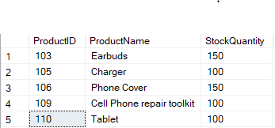
SELECT ProductID, ProductName, StockQuantity
FROM Products
WHERE StockQuantity < 170;
Result: The query returned a list of products that are at risk of stock-out

Total Sales for Each Product in January 2024
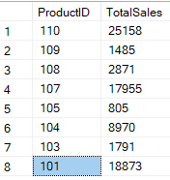
SELECT Products.ProductName, SUM(Sales.TotalAmount) AS TotalSales
FROM Sales
JOIN Products ON Sales.ProductID = Products.ProductID
WHERE SaleDate >= '2024-01-01' AND SaleDate < '2024-02-01'
GROUP BY Products.ProductName
ORDER BY TotalSales DESC;
Result: The output highlighted that 'Product 110' achieved the highest sales in January 2024.

Segment Customers by Income Group
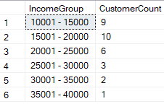
SELECT IncomeGroup, COUNT(*) AS CustomerCount
FROM (
SELECT CASE
WHEN Income BETWEEN 0 AND 5000 THEN '0 - 5000'
WHEN Income BETWEEN 5001 AND 10000 THEN '5001 - 10000'
WHEN Income BETWEEN 10001 AND 15000 THEN '10001 - 15000'
WHEN Income BETWEEN 15001 AND 20000 THEN '15001 - 20000'
WHEN Income BETWEEN 20001 AND 25000 THEN '20001 - 25000'
WHEN Income BETWEEN 25001 AND 30000 THEN '25001 - 30000'
WHEN Income > 30000 THEN 'Above 30000'
ELSE 'Unknown'
END AS IncomeGroup
FROM Customers
) AS GroupedData
GROUP BY IncomeGroup
ORDER BY IncomeGroup;
Result: The result indicated that the majority of customers fall into the '15001 - 20000' and '10001 - 15000' income brackets.

Sales by Product Category and Region
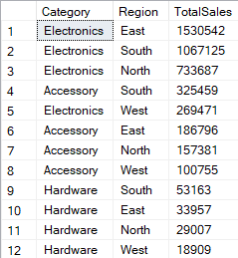
SELECT Products.Category, Customers.Region, SUM(Sales.TotalAmount) AS TotalSales
FROM Sales
JOIN Products ON Sales.ProductID = Products.ProductID
JOIN Customers ON Sales.CustomerID = Customers.CustomerID
WHERE SaleDate >= '2020-01-01' AND SaleDate < '2024-02-01'
GROUP BY Products.Category, Customers.Region
ORDER BY TotalSales DESC;
Result: The data revealed that the Electronics category performed best in the East region and at all electronics have highest Sales.

Average Purchase by Age Group
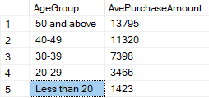
SELECT
CASE
WHEN Age < 20 THEN 'Under 20'
WHEN Age BETWEEN 20 AND 29 THEN '20–29'
WHEN Age BETWEEN 30 AND 39 THEN '30–39'
WHEN Age BETWEEN 40 AND 49 THEN '40–49'
ELSE '50 and above'
END AS AgeGroup,
AVG(Sales.TotalAmount) AS AveragePurchase
FROM Sales
JOIN Customers ON Sales.CustomerID = Customers.CustomerID
GROUP BY
CASE
WHEN Age < 20 THEN 'Under 20'
WHEN Age BETWEEN 20 AND 29 THEN '20–29'
WHEN Age BETWEEN 30 AND 39 THEN '30–39'
WHEN Age BETWEEN 40 AND 49 THEN '40–49'
ELSE '50 and above'
END
ORDER BY AveragePurchase DESC;
Result: The analysis showed that customers aged above 50 had the highest average purchase amount.

Monthly Sales and Transaction Counts
SELECT
YEAR(SaleDate) AS SaleYear,
MONTH(SaleDate) AS SaleMonth,
SUM(TotalAmount) AS TotalSales,
COUNT(*) AS TransactionCount
FROM Sales
GROUP BY YEAR(SaleDate), MONTH(SaleDate)
ORDER BY SaleYear, SaleMonth;
🧾 Result: The query identified that December had the highest transaction count and total revenue.

Quarterly Sales Summary
SELECT
DATEPART(YEAR, SaleDate) AS Year,
DATEPART(QUARTER, SaleDate) AS Quarter,
SUM(TotalAmount) AS TotalSales
FROM Sales
GROUP BY DATEPART(YEAR, SaleDate), DATEPART(QUARTER, SaleDate)
ORDER BY Year, Quarter;
🧾 Result: Q4 showed a significant increase in total sales compared to the previous quarters.

Average Spending per Customer by Income Bracket
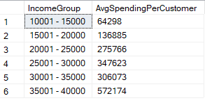
SELECT IncomeGroup, AVG(CustomerSpending) AS AvgSpendingPerCustomer
FROM (
SELECT
CASE
WHEN CAST(Income AS INT) BETWEEN 0 AND 5000 THEN '0 - 5000'
WHEN CAST(Income AS INT) BETWEEN 5001 AND 10000 THEN '5001 - 10000'
WHEN CAST(Income AS INT) BETWEEN 10001 AND 15000 THEN '10001 - 15000'
WHEN CAST(Income AS INT) BETWEEN 15001 AND 20000 THEN '15001 - 20000'
WHEN CAST(Income AS INT) BETWEEN 20001 AND 25000 THEN '20001 - 25000'
WHEN CAST(Income AS INT) > 25000 THEN 'Above 25000'
ELSE 'Unknown'
END AS IncomeGroup,
Customers.CustomerID,
SUM(ISNULL(Sales.TotalAmount, 0)) AS CustomerSpending
FROM Customers
LEFT JOIN Sales ON Customers.CustomerID = Sales.CustomerID
GROUP BY Customers.CustomerID, Customers.Income
) AS SpendingPerCustomer
GROUP BY IncomeGroup
ORDER BY IncomeGroup;
Result: The results confirmed that customers in the ' $25000 to $30000 ' income group spent the most on average.

6. Data Visualization with Python

6.1 Data Extraction from SQL
To extract data from the MS SQL Server database, the `pyodbc` library was used. The relevant tables (Customers, Products, and Sales) were imported into Python using SQL queries executed through `pandas.read_sql()`.
The connection setup code used was as follows:
import pyodbc
import pandas as pd
conn = pyodbc.connect(
"Driver={ODBC Driver 17 for SQL Server};"
"Server=DESKTOP- FLTSJMO\SQLEXPRESS;"
"Database=Data_Project;"
"Trusted_Connection=yes;")
customers_df = pd.read_sql("SELECT * FROM Customers", conn)
products_df = pd.read_sql("SELECT * FROM Products", conn)
sales_df = pd.read_sql("SELECT * FROM Sales", conn)

6.2 Visualization Tasks

1. Total Sales per Product – January 2024
A bar chart was created to visualize the total sales for each product during January 2024. The result shows that Product ID 110 had the highest sales, followed by IDs 107 and 101.
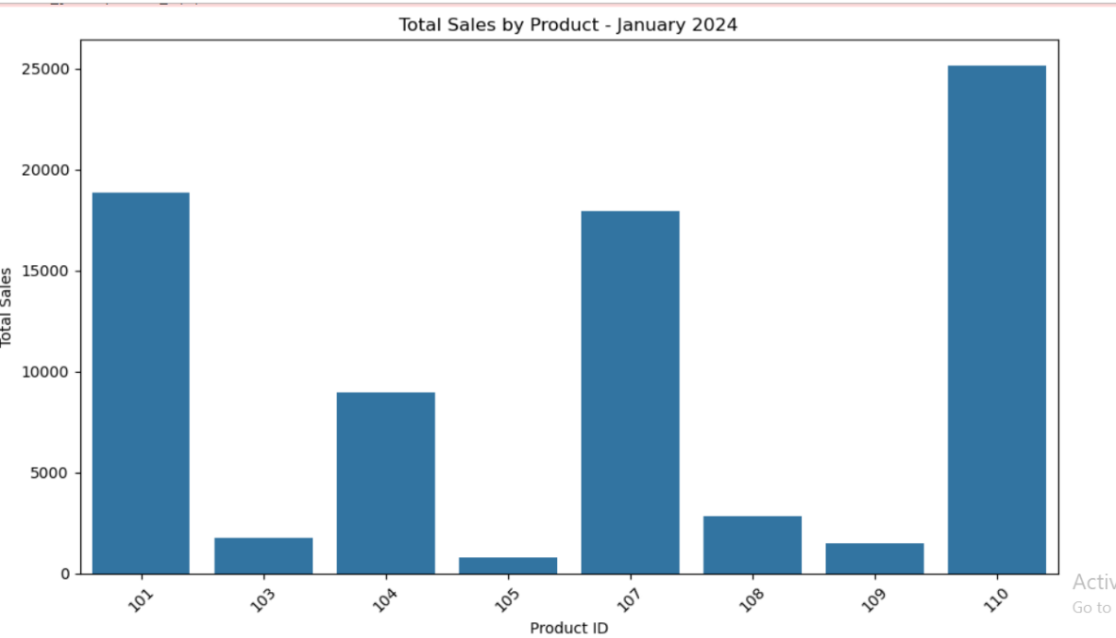
Code used to generate the chart:
# Load SQL result into df
sales_jan = pd.read_sql("""
SELECT ProductID, SUM(TotalAmount) AS TotalSales
FROM Sales
WHERE SaleDate >= '2024-01-01' AND SaleDate < '2024-02-01'
GROUP BY ProductID
""", conn)
# Plot
plt.figure(figsize=(10, 6))
sns.barplot(data=sales_jan, x='ProductID', y='TotalSales')
plt.title('Total Sales by Product - January 2024')
plt.xlabel('Product ID')
plt.ylabel('Total Sales')
plt.xticks(rotation=45)
plt.tight_layout()
plt.show()

2. Products with Stock Levels < 170
This horizontal bar chart displays all products with stock levels below 170 units. Products such as Charger, Cell Phone Repair Toolkit, and Tablet are at low inventory levels and may require restocking.
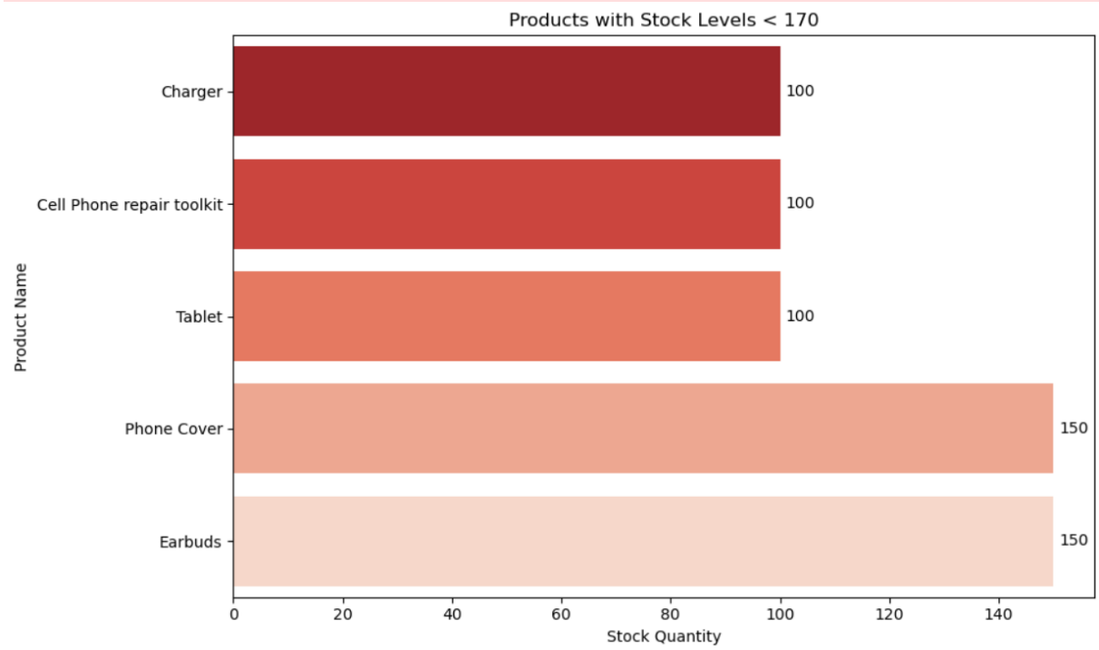
Code used to generate the chart:
query = """
SELECT ProductName, StockQuantity
FROM dbo.Products
WHERE StockQuantity < 170
ORDER BY StockQuantity ASC;
"""
df_low_stock = pd.read_sql(query, conn)
plt.figure(figsize=(10, 6))
ax = sns.barplot(data=df_low_stock, x='StockQuantity', y='ProductName', palette='Reds_r')
plt.title('Products with Stock Levels < 170')
plt.xlabel('Stock Quantity')
plt.ylabel('Product Name')
# Add values to bars
for p in ax.patches:
ax.text(p.get_width() + 1,
p.get_y() + p.get_height() / 2,
int(p.get_width()),
va='center')
plt.tight_layout()
plt.show()

3. Age Frequency of Customers
The histogram below represents the distribution of customer ages. Most customers fall between the ages of 18 and 30, indicating a younger target audience for marketing strategies.
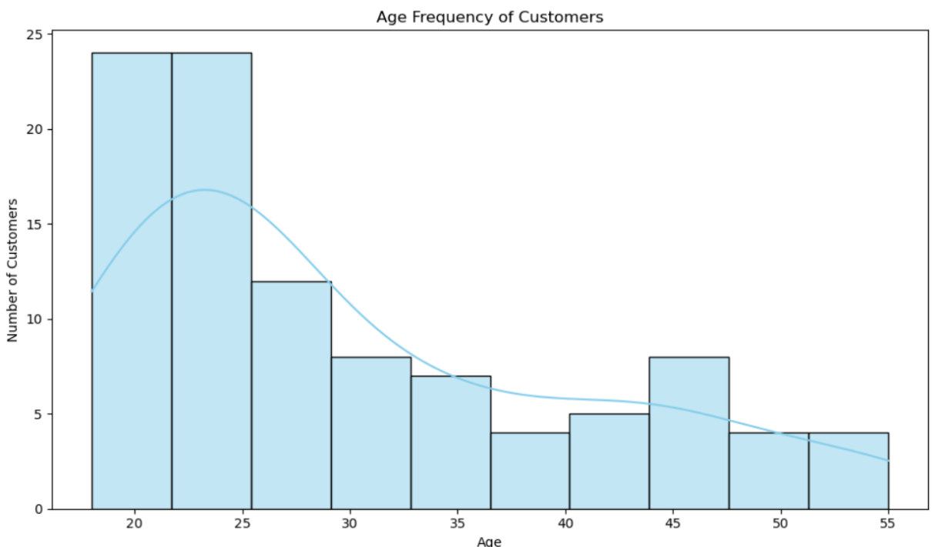
Code used to generate the chart:
query = """
SELECT Age
FROM dbo.Customers
WHERE Age IS NOT NULL
"""
df_age = pd.read_sql(query, conn)
plt.figure(figsize=(10, 6))
sns.histplot(data=df_age, x='Age', bins=10, kde=True, color='skyblue')
plt.title('Age Frequency of Customers')
plt.xlabel('Age')
plt.ylabel('Number of Customers')
plt.tight_layout()
plt.show()

7. Regression Analysis: Age, Income, and Sales

7.1 Objective
This analysis investigates how customer Income and Age influence their Total Sales. A multiple linear regression model was used to quantify and predict total sales based on these two predictors.

7.2 Methodology in Python
The following Python code was used to conduct the analysis:
import pandas as pd
import numpy as np
import matplotlib.pyplot as plt
from sklearn.linear_model import LinearRegression
customers_df = pd.read_csv(r"C:\Users\Omar\Desktop\Customers.csv")
sales_df = pd.read_csv(r"C:\Users\Omar\Desktop\Data\Sales.csv")
merged_df = pd.merge(sales_df, customers_df, on="CustomerID")
X = merged_df[['Income', 'Age']]
y = merged_df['TotalAmount']
model = LinearRegression().fit(X, y)
r_squared = model.score(X, y)
intercept = model.intercept_
coefficients = model.coef_
print("R² (Model Accuracy):", r_squared)
print("Intercept :", intercept)
print("Coefficient for Income:", coefficients[0])
print("Coefficient for Age:", coefficients[1])
y_pred = model.predict(X)
merged_df['PredictedSales'] = y_pred
merged_df['Error'] = merged_df['TotalAmount'] - merged_df['PredictedSales']
plt.figure(figsize=(10, 6))
plt.scatter(y, y_pred, color='green', alpha=0.6)
plt.plot([y.min(), y.max()], [y.min(), y.max()], 'r--', lw=2)
plt.xlabel('Actual Total Sales')
plt.ylabel('Predicted Total Sales')
plt.title('Multilinear Regression: Actual vs Predicted Sales')
plt.grid(True)
plt.tight_layout()
plt.show()

7.3 Results
The model produced the following results:
- R² (Model Accuracy): 0.318
- Intercept: -5532.95
- Coefficient for Income: 0.1497
- Coefficient for Age: 277.19
The R² value of 0.318 indicates that around 31.8% of the variance in total sales can be explained by age and income. While not very high, it shows a moderate predictive capability.
- The intercept represents the base sales when both predictors are zero, which is not practically meaningful but required in the model.
- The income coefficient (0.1497) means that for each additional unit of income, total sales increase by approximately 0.15 units, assuming age remains constant.
- The age coefficient (277.19) shows that each additional year in age increases total sales by 277 units, suggesting that older customers tend to spend more.

7.4 Regression Chart: Actual vs Predicted Sales
The following scatter plot visualizes the predicted total sales against the actual total sales.
Each green dot represents a customer’s actual vs predicted spending, while the red dashed line shows the ideal prediction line (perfect fit).
The more the points cluster around the line, the better the model fits the data.
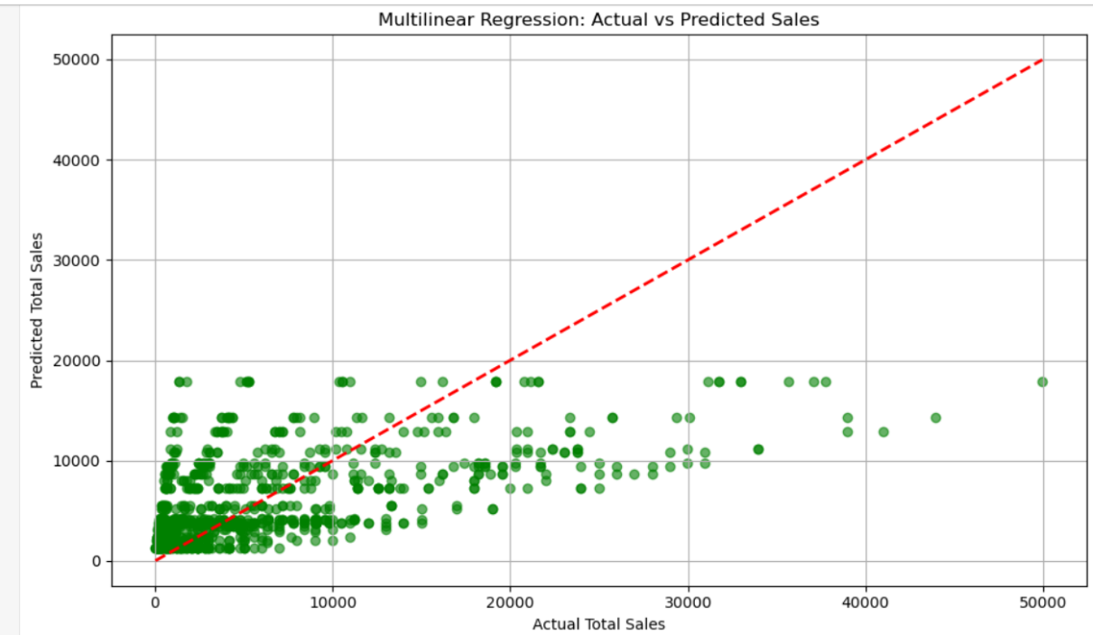
Code used to generate the chart:
plt.figure(figsize=(10, 6))
plt.scatter(y, y_pred, color='green', alpha=0.6)
plt.plot([y.min(), y.max()], [y.min(), y.max()], 'r--', lw=2)
plt.xlabel('Actual Total Sales')
plt.ylabel('Predicted Total Sales')
plt.title('Multilinear Regression: Actual vs Predicted Sales')
plt.grid(True)
plt.tight_layout()
plt.show()

8. Power BI Dashboard Analysis
This section presents each Power BI visual used in the dashboard along with detailed explanation. Each chart is analyzed in terms of structure, purpose, and the business insights it reveals.

1. Total Amount by Year (Pie Chart)
- Chart Type: Line Chart
- X-axis: SaleYear
- Y-axis: Sum of TotalAmount
Explanation:
This line chart shows how total sales evolved over the years. It captures the trend in performance, where:
- Sales slightly declined from 2020 (0.72M) to 2021 (0.70M)
- Then sharply increased in 2022 (1.64M)
- Dropped to 1.37M in 2023
- Slightly recovered in 2024 (1.40M)
Why this chart type is used:
A line chart is ideal for time-series data. It allows us to track changes and spot trends over consecutive years clearly.
What the result means:
The peak sales occurred in 2022, followed by a drop in 2023. The recovery in 2024 may indicate successful adjustments or continued demand.

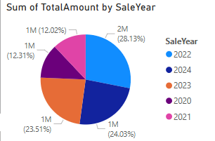

2. Marketing Campaign Budget by Product
Chart Type: Treemap
Group By:ProductName
Size Metric:** Budget
Explanation:
This treemap shows how the marketing budget is distributed among various products. Products with larger rectangles, such as Smartphone and Laptop Bag, received the highest marketing investment. This layout allows for a quick comparative overview of resource allocation.
Why this chart type is used:
Treemaps are effective for showing part-to-whole relationships in hierarchical data. It allows comparison between many categories in limited space, making large allocations stand out clearly.
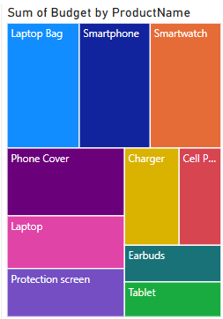

3. Customer Demographics vs. Spending (Stacked Bar Chart)
Chart Type: Stacked Bar Chart
Y-axis: Gender
X-axis: TotalAmount
Legend:Age
Explanation:
This chart compares how different age groups contribute to total sales within each gender. It shows that male customers aged 30 and above contributed the highest total sales. Female spending is more distributed across mid-age ranges. This is useful for targeted demographic marketing.
Why this chart type is used:
Stacked bar charts display composition and allow visual comparison between groups. It clearly shows both gender-wise and age-wise spending contributions.
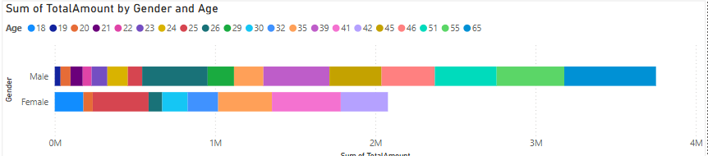

4. Sales Over Time (Line Chart)
Chart Type: Line Chart
X-axis:SaleYear
Y-axis: Sum of TotalAmount
Explanation:
This line chart shows how total sales evolved over the years. It captures the trend in performance, where:
- Sales slightly declined from 2020 (0.72M) to 2021 (0.70M)
- Then sharply increased in 2022 (1.64M)
- Dropped to 1.37M in 2023
- Slightly recovered in 2024 (1.40M)
**Why this chart type is used:**
A line chart is ideal for time-series data. It allows us to track changes and spot trends over consecutive years clearly.
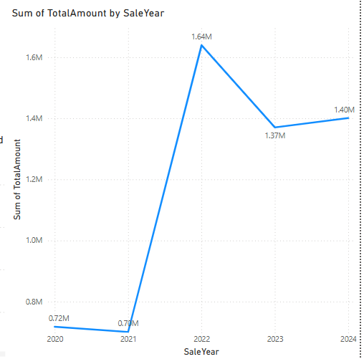

5. TotalAmount by ProductName and Region (Stacked Column Chart)
Chart Type:** Stacked Column Chart
X-axis: ProductName
Y-axis: TotalAmount
Legend: Region
**Explanation:**
This chart compares the total sales of each product across regions. It shows that Laptops and Smartphones are the top-performing products across all four regions. Products like Chargers and Phone Covers have lower sales. East and South regions generally contribute the most.
**Why this chart type is used:**
Stacked columns let us compare both the total sales and regional contributions within each product category. It's ideal for multi-category comparative analysis.
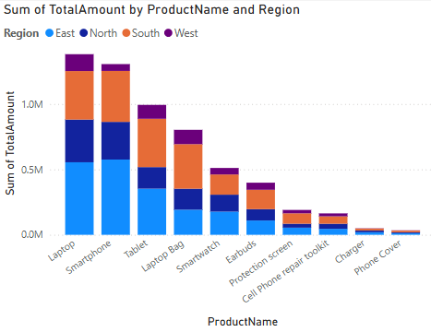

6. Total Sales Before and After Campaigns (Clustered Column Chart)
Chart Type: Clustered Column Chart
X-axis: ProductName
Y-axis: TotalAmount
Legend: Campaign Phase (Before, During, After)
Explanation:
This visual compares sales for each product before, during, and after marketing campaigns. Most products, such as Laptops and Smartphones, saw a sharp increase in sales post-campaign. It confirms the effectiveness of the promotional activities.
Why this chart type is used:
Clustered columns are excellent for side-by-side comparison across time phases. They help isolate the effect of campaigns on product sales.
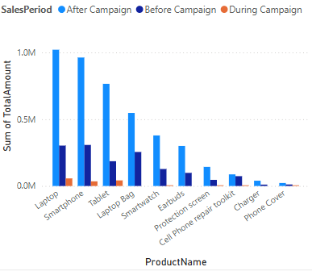

7. Product Name Filter (Slicer)
Chart Type: Slicer
Field: ProductName
Explanation:
This slicer allows users to filter all charts in the dashboard by product name. By selecting a single product or multiple products, users can focus the analysis and remove irrelevant data.
Why this chart type is used:
Slicers add interactivity to dashboards. They allow users to customize the view in real-time, supporting dynamic business exploration.
