ID umber/Section | Omar Abdeljalil Abdeljalil – 23110604- 04
HTU Course Number and Title | 106260 / Financial Analysis
Academic Year | Fall 2024 – 2025
Course Tutor | Eng.Veellage Al-Quraan

PART 1:-
JORDAN POULTRY PROCESSING & MARKETING Company:-

2017:
- Total Assets: Total Current Assets + Total Fixed Assets+ other Assets = 72,630,513
- Total Liabilities: Total Current Liabilities + Long Term Loans & Notes Payable +Other Liabilities = 49,698,939
- Total Revenue = net sales : Operating Revenue + Other Revenues = 40,708,523
- Total Assets = Total Shareholders' Equity + Total Liabilities
- Total Shareholders' Equity: Total Assets - Total Liabilities = 82,546,554

2018:
- Total Assets: Total Current Assets + Total Fixed Assets+ other Assets = 78,585,678
- Total Liabilities: Total Current Liabilities + Long Term Loans & Notes Payable +Other Liabilities = 56,369,691
- Total Revenue = net sales : Operating Revenue + Other Revenues = 67,753,787
- Total Shareholders' Equity: Total Assets - Total Liabilities = 22,215,987
- Total Assets = Total Shareholders' Equity + Total Liabilities

2019:
- Total Assets: Total Current Assets + Total Fixed Assets+ other Assets = 83,685,366
- Total Liabilities: Total Current Liabilities + Long Term Loans & Notes Payable +Other Liabilities = 61,767,101
- Total Revenue = net sales : Operating Revenue + Other Revenues = 41,559,661
- Total Assets = Total Shareholders' Equity + Total Liabilities
- Total Shareholders' Equity: Total Assets - Total Liabilities = 21,918,265

2020:
- Total Assets: Total Current Assets + Total Fixed Assets + other Assets = 84,183,768
- Total Liabilities: Total Current Liabilities + + Long Term Loans & Notes Payable +Other Liabilities = 66,664,897
- Total Revenue: Operating Revenue + Other Revenues = 34,579,364
- Total Assets = Total Shareholders' Equity + Total Liabilities
- Total Shareholders' Equity: Total Assets - Total Liabilities = 17,518,871

2021:
- Total Assets: Total Current Assets + Total Fixed Assets + other Assets = 86,101,252
- Total Liabilities: Total Current Liabilities + + Long Term Loans & Notes Payable +Other Liabilities = 67,230,651
- Total Revenue: Operating Revenue + Other Revenues = 41,320,291
- Total Shareholders' Equity: Total Assets - Total Liabilities = 18,8870,601
- Total Assets = Total Shareholders' Equity + Total Liabilities

“Analyzing The balance sheet”
Vertical Analysis:-
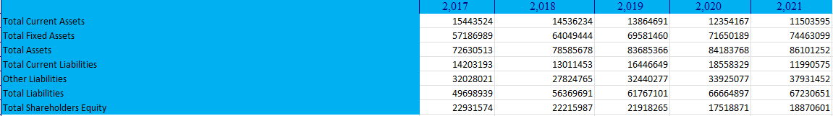
Horizontal Analysis:-
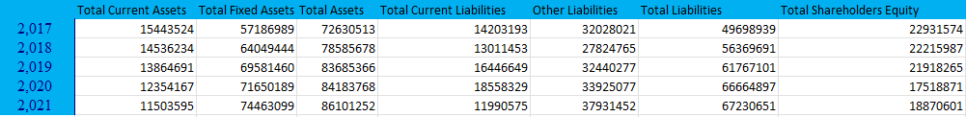
Assets:-

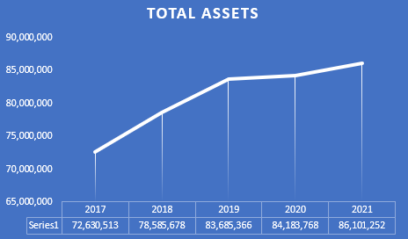
Total Assets
This is the sum of all current and fixed assets the company owns, illustrating the overall scale of its possessions and financial strength.
A - It’s a good sign to see the total assets increase from (72 to 86) Million in 5 year this indicates the company has Overhead with high management skills . the increase in assets reflects business expansion or an improvement in financial strength.
B - They improve fixed assets by having land and maybe making a new corporation with other company
C - But the total current assets decrease by %2.34 it’s not a huge decrease but they should improve it maybe by starting a new Short Term Investments .

Liabilities:-
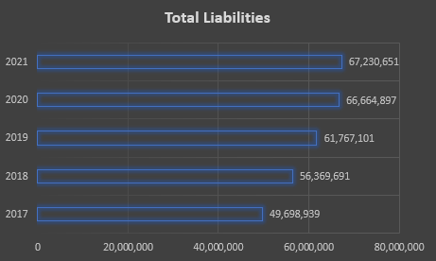
- It’s a bad sign to see the total Liabilities increase from (49 to 67) Million in 5 year but with the increase in assets , It indicates the company is using Liabilities money to finance growth.
- There is huge different in Long Term Loans & Notes Payable and Accounts and Notes Payable

Shareholder’s equity:-
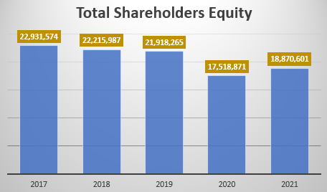
The decrease in equity from ( 22- 18.8) million and increase in assets & liabilities may indicate the company rely on liabilities to finance expansion. Its not a bad thing if The level of liabilities in control , and a balance must be achieved between equity and liabilities to ensure financial sustainability.

“Studying the income statement”
Vertical Analysis:-
Horizontal Analysis:-
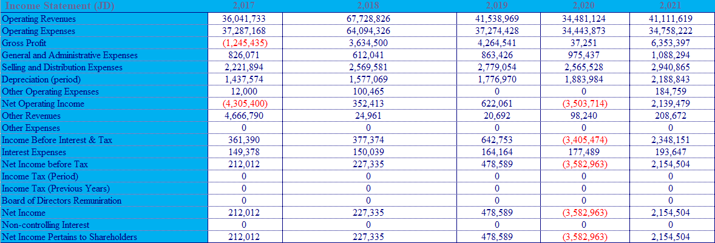

- Operating Revenues
These are the all earnings the company generates from its core business operations (sales of goods or services )
  - Increase from ( 36.04 to 41.11) Million
  - Sales growth due to higher needs for products.
  - Better pricing strategies, such as raising prices
  - Market expansion by entering new markets or having more customer
  - This increase shows the company’s success in making more income from its main activities.

- Operating Expenses
These are the regular costs on company to run its core operations like salaries, rent, utilities, and marketing expenses
  - decrease from ( 37.04 to 34.75) Million
  - Cost efficiency by managing resources better
  - reducing unnecessary costs.
  - Use of technology to automate processes
  - The decrease reflects the company ability to reduce costs & increasing revenues.

- Gross Profit
This equals total revenue minus total expenses
  - Increase from ( -1.24 to 6.34) Million
  - A higher gross profit show the company is generating better profit from its operations.

- Net Income
The net profit this is the total profit after all expenses, including operating costs, interest, and taxes.
  - Increase from ( 0.21 to 2.15) Million
  - Revenue growth from higher sales.
  - Reduced operating expenses by better cost management.
  - Reduce in Interest Expenses
  - No Tax from government
  - This improvement reflects better overall financial performance and increase efficiency in converting revenues into profits

“Cash flow statement”
Vertical Analysis:-
Horizontal Analysis:-
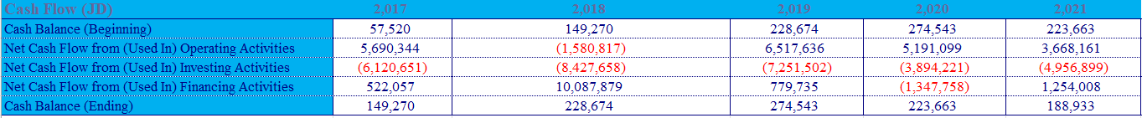

Vertical analysis:-

Horizontal analysis:-

Horizontal Analysis: -

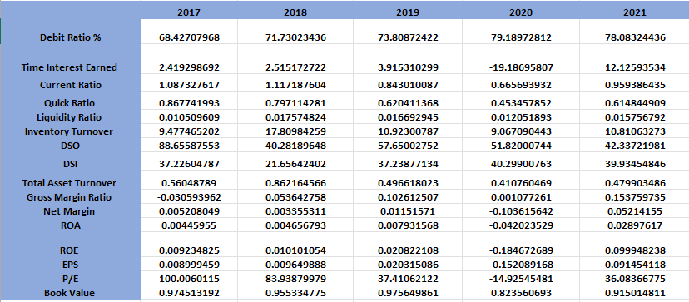

How to calculate Ratio 2017:-

Debt Ratio = Total Liabilities / Total Assets
$$debt Ratio=100\%*\frac{49,698,939}{72,630,513}=\%68.42$$
Times Interest Earned = EBIT/INTREST EXPENSE
Times Interest Earned = Net Income before Tax / Income Before Interest & Tax = 2.4

Current Ratio = Current assets/current liabilities
$$Current Ratio= \frac{15,443,524}{14,203,193}=1.08$$

Quick Ratio = (Current assets - Inventories) / current liabilities

$$quick Ratio= \frac{(15,443,524-3,118,817)}{14,203,193}=0.86$$

Liquidity Ratio = (cash + cash equivalents) / current liabilities
$$liquidity Ratio= \frac{149,270}{14,203,193}=0.01$$

Inventory Turnover Ratio = sales / avarege Inventory

$Inventory Turnover Ratio= \frac{36,041,733}{({\frac{3,118,817+4,164,619+3,661,003+3,938,747+4,131,251}{5})}_{}}$= 9.477

DSO = Accounts Receiveable / Avarege sales per day(/365)

$$DSO=\frac{(\frac{9,056,785+7,073,537+5,887,320+4,890,087+4,031,689 }{5})}{(\frac{36,041,733+4,666,790}{365})}=55.48$$

Average Inventory / Avarege cost per day

$$DSI= \frac{\frac{(3,118,817+4,164,619+3,661,003+3,938,747+4,131,251)}{5}}{\frac{37,287,168}{365}}=37.22$$

Total Asset Turnover = Net sales / Total assets

Total Asset Turnover =$\frac{36,041,733+4,666,790}{15,443,524+57,186,989}$=0.56

Gross Margin Ratio = Gross profit / Net sales

$$Gross Margin Ratio= \frac{-1245435}{(36,041,733+4,666,790)}=-0.03$$

Net Margin Ratio = ( Net income - Preferred stock Dividends) / Net Sales

$$Net Margin Ratio= \frac{212,012-0 }{(36,041,733+4,666,790)}=0.0052$$
ROA = Net Income + interest expense(1 - tax rate) / Average total asets

$$RoA= \frac{212,012+149,378*\left(1-\left(\frac{0}{212,012}\right)\right)}{\frac{\left(72,630,513+\&78585678+\&83685366+\&84183768\&+86,101,252\right)}{5}}=$$
$$=0.00445955$$

ROE = Net income / Stockholders’ equity

$$ROE= \frac{212,012 }{22,957,879}=0.009234825$$

EPS = Net income / Subscribed Capital

$$EPS= \frac{212,012 }{23,558,305 }=0.009$$

P/E = Closing Price (JD) / EPS

P / E = 0.9 / 0.009 = 100
Book Value = Total Shareholders Equity / No. of Subscribed Shares

Book value = 22,957,879 / 23,558,305 = 0.974

-RATIOS-

Debt ratio :-
debt ratio :- It use to evaluate the level of financial risk and the company's ability to meet its long-term Liabilities .
2017 = %68.42
2018 increase to %71.73
2019 increase to %73.80
2020 increase to %79.18
2021 decrease to %78.08
Increase Negative sign
Decrease positive sign
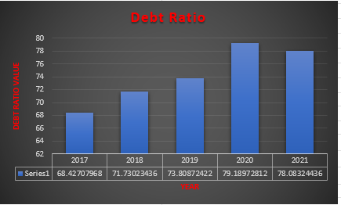
Current Ratio:-
If current ratio greater than 1 the company can cover its short-term liabilities. But if it less than 1 the company faced some obstacles in short term .
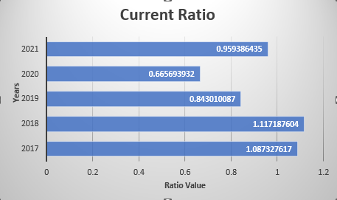
2017 = 1.08
2018 increase to 1.117
2019 decrease to 0.843
2020 decrease to 0.66
2021 increase to 0.959
Increase Positive sign
Decrease Negative sign
Quick Ratio:-
If quick ratio greater than 1 indicates the company can cover its short-term liabilities without relying on inventory sales .
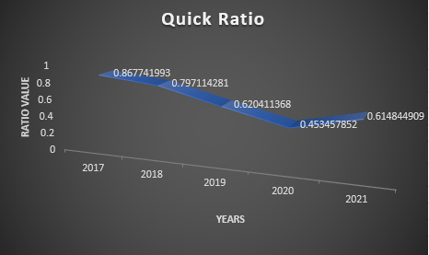
2017 = 0.8677
2018 decrease to 0.79
2019 decrease to 0.62
2020 decrease to 0.4534
2021 increase to 0.6148
Increase Positive sign
Decrease Negative sign
Liquidity Ratio:-
liquidity ratio Reflect that if the company is financially stable every time we get closer to 1 or more it is positive sign .
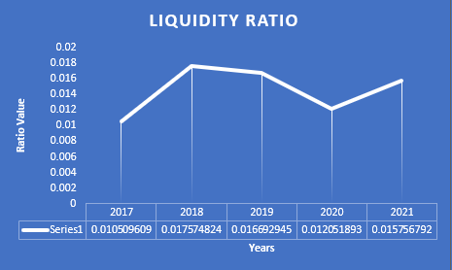
2017 =0.01
2018 increase to 0.017
2019 decrease to 0.0166
2020 decrease to 0.012
2021 increase to 0.015
Increase Positive sign
Decrease Negative sign
Inventory Turnover:-
high inventory turnover indicate efficient inventory management as the company is selling stock quickly. as well as, A low inventory turnover show the company has overstocking or poor sales performance.
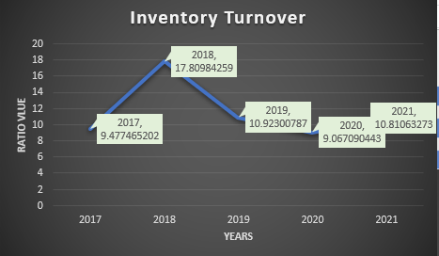
2017 =9.477
2018 increase to 17.8
2019 decrease to 10.9
2020 decrease to 9.06
2021 increase to 10.81
Increase Positive sign
Decrease Negative sign

DSO;-
Is a financial Ratio use to measure the average number of days it takes the company can collect payment after a sale has made.
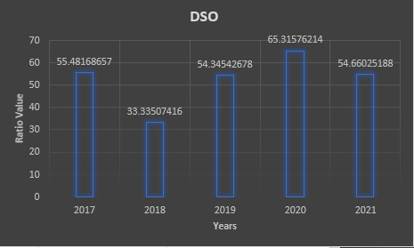
2017 =55.48
2018 decrease to 33.33
2019 increase to 54.34
2020 increase to 65.31
2021 decrease to 54.66
High DSO negative
Low DSOPositive
DSI:-
A financial metric that calculate the average number of days a company takes to sell its inventory during a specific period.
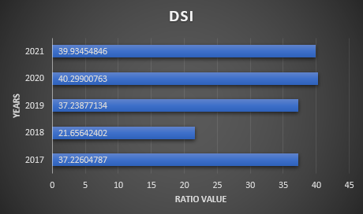
2017 =37.22
2018 decrease to 21.65
2019 increase to 37.23
2020 increase to 40.29
2021 decrease to 39.9
High DSI negative
Low DSI Positive

Total Asset Turnover:-
Total asset turnover is the financial efficiency ratio that calculate the efficiency of sales revenue generated with total assets of a company. This reflects the efficiency of managing the assets to create maximum revenue.
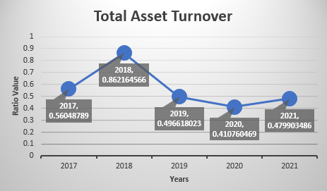
2017 =0.56
2018 increase to 0.86
2019 decrease to 0.49
2020 decrease to 0.41
2021 increase to 0.47
High Total Asset Turnover positive
Low Total Asset Turnover negative
Gross Margin Ratio:-
The gross margin ratio represents the profitability level showing that portion of each dollar in sales is left after delete the operating cost.
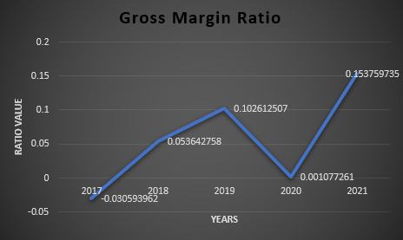
2017 =-0.03
2018 increase to 0.053
2019 increase to 0.1
2020 decrease to 0.001
2021 increase to 0.15
High Gross Margin Ratio positive
Low Gross Margin Ratio negative
Net Margin:-
is a profitability ratio that show the percentage of revenues that rest as profit after all expenses

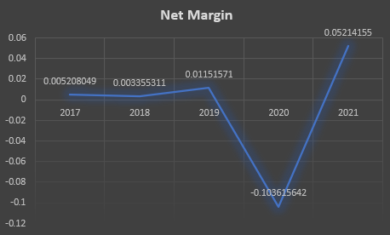
2017 =0.0052
2018 decrease to 0.033
2019 increase to 0.011
2020 decrease to - 0. 1
2021 increase to 0.052
High Net Margin Ratio positive
Low Net Margin Ratio negative

ROA & ROE :-
ROA : measures a company’s ability to generate profit from its total assets.
ROE : measures a company’s ability to generate profit from its shareholders' equity.
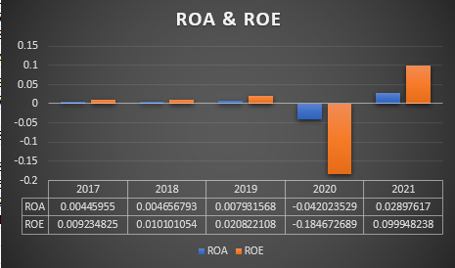
ROA | ROE
2017 =0.0044 | 2017 =0.0092
2018 increase to 0.046 | 2018 decrease to 0.01
2019 increase to 0.079 | 2019 increase to 0.02
2020 decrease to - 0. 042 | 2020 decrease to - 0. 18
2021 increase to 0.0289 | 2021 increase to 0.099
High ROA Ratio positive | High ROE Ratio positive
Low ROA Ratio negative | Low ROE Ratio negative

Time interest earned :-

2017 =2.419
2018 increase to 2.515
2019 increase to 3.915
2020 great decrease to - 19.18
2021 increase to 12.12
High positive
Low negative

EPS:-
It provides shareholders with a clear view of the company's profitability on a per-share basis.
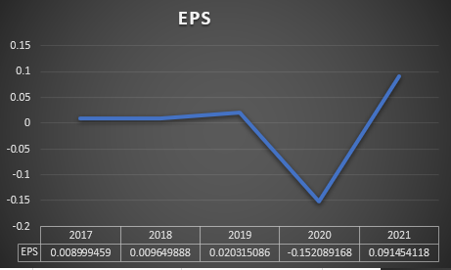
2017 =0.0089
2018 increase to 0.0096
2019 high increase to 0.02
2020 great decrease to - 0. 152
2021 increase to 0.091
High EPS positive
Low EPS negative
P/E
A financial ratio show the expectation for company growth
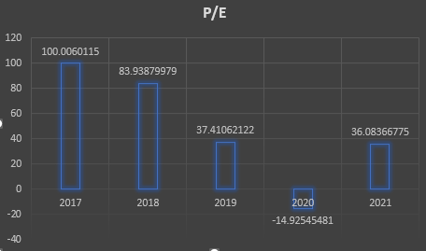
2017 =100
2018 decrease to 83.93
2019 high decrease to 37.41
2020 great decrease to -14.92
2021 good increase to 36.08
Increase Positive sign
Decrease Negative sign

Book Value:-
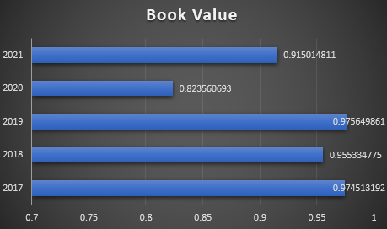
2017 =0.97
2018 decrease to 0.955
2019 increase to 0.97
2020 decrease to 0.82
2021 good increase to 0.91
Increase Positive sign
Decrease Negative sign

Conclusion for JORDAN POULTRY PROCESSING & MARKETING Company:-
When Cash on Hand & at Banks remains constant while Account Receivables increases, Total Current Assets should rise, but since Inventory also increases, cash gets tied up, leading to a net decrease in Total Current Assets. With Total Current Liabilities also decreasing, the Current Ratio and Quick Ratio slightly decline, signaling weaker short-term liquidity, though the Liquidity Ratio sees a minor improvement. A higher DSI due to increased inventory means slower turnover, reducing operational efficiency.
Meanwhile, Fixed Assets increase, raising Total Assets but causing a decline in Total Asset Turnover, meaning the company is using assets less efficiently to generate revenue. However, higher Operating Revenues and lower Operating Expenses boost Gross Profit, improving the Gross Margin Ratio, though the Net Margin remains constant, suggesting other costs like interest offset gains.
Higher Other Revenues and lower Other Expenses push EBIT up, but with Interest Expenses also rising, Total Liabilities and the Debt Ratio increase, signaling greater reliance on debt. Despite this, Net Income rises, improving ROA and ROE, though a decline in Shareholders’ Equity indicates increased financial leverage. While profitability improves, rising debt and declining asset turnover weaken efficiency, highlighting the need to manage leverage and liquidity carefully for sustainable growth.

DAR AL DAWA DEVELOPMENT & INVESTMENT

2017:
• Total Assets: Total Current Assets + Total Fixed Assets+ other Assets = 100,414,723
• Total Liabilities: Total Current Liabilities + Long Term Loans & Notes Payable +Other Liabilities = 55,220,388
• Total Shareholders' Equity: Total Assets - Total Liabilities = 44,42,481
________________________________________
2018:
• Total Assets: Total Current Assets + Total Fixed Assets+ other Assets = 108,404,364
• Total Liabilities: Total Current Liabilities + Long Term Loans & Notes Payable +Other Liabilities = 76,424,090
• Total Shareholders' Equity: Total Assets - Total Liabilities = 30,800,999
________________________________________
2019:
• Total Assets: Total Current Assets + Total Fixed Assets+ other Assets = 99,734,102
• Total Liabilities: Total Current Liabilities + Long Term Loans & Notes Payable +Other Liabilities = 75,311,019
• Total Shareholders' Equity: Total Assets - Total Liabilities = 23,406,935
________________________________________

2020:
• Total Assets: Total Current Assets + Total Fixed Assets + other Assets = 101,601,806
• Total Liabilities: Total Current Liabilities + + Long Term Loans & Notes Payable +Other Liabilities = 66,664,897
• Total Shareholders' Equity: Total Assets - Total Liabilities = 31,117,620
________________________________________
2021:
• Total Assets: Total Current Assets + Total Fixed Assets + other Assets = 99,280,594
• Total Liabilities: Total Current Liabilities + + Long Term Loans & Notes Payable +Other Liabilities = 56,911,264
• Total Shareholders' Equity: Total Assets - Total Liabilities = 41,736,882

Vertical Analysis :-

Horizontal Analysis :-
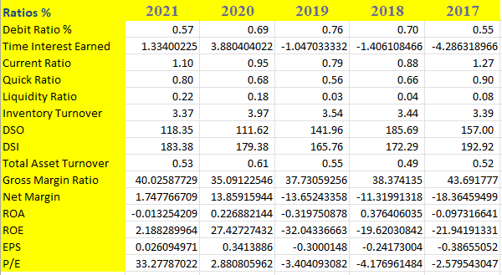

RATIOS :-

Debt Ratio :-

2017 = %55
2018 increase to %70
2019 increase to %76
2020 decrease to %69
2021 decrease to %57
Increase Negative
Decrease positive
Time Interest Earned:-

2017 = -4.28
2018 increase to -1.4
2019 increase to -1.04
2020 increase to 3.88
2021 decrease to 1.33
Increase Negative
Decrease positive
Current Ratio :-

2017 = 1.27
2018 decrease to 0.88
2019 decrease to 0.79
2020 increase to 0.95
2021 increase to 1.1
Quick Ratio :-

2017 = 0.9
2018 decrease to 0.66
2019 decrease to 0.56
2020 increase to 0.68
2021 increase to 0.8
Liquidity Ratio:-

2017 = 0.08
2018 decrease to 0.04
2019 decrease to 0.03
2020 increase to 0.18
2021 increase to 0.22
Inventory Turnover

2017 = 3.39
2018 increase to 3.44
2019 increase to 3.54
2020 decrease to 3.97
2021 decrease to 3.37

DSO

2017 = 157
2018 increase to 185.69
2019 decrease to 141.96
2020 decrease to 111.62
2021 increase to 118.35
DSI

2017 = 192.92
2018 decrease to 172.29
2019 decrease to 165.76
2020 increase to 179.38
2021 increase to 183.38
Total Asset Turnover:-

2017 = 0.52
2018 decrease to 0.49
2019 increase to 0.55
2020 increase to 0.61
2021 decrease to 0.53
Gross Margin Ratio

2017 = 43.69
2018 decrease to 38.37
2019 decrease to 37.73
2020 decrease to 35.09
2021 increase to 40.02
Net Margin :-

2017 = -18.36
2018 increase to -11.3
2019 decrease to -13.65
2020 increase to 13.85
2021 decrease to 1.74

ROA & ROE :-

ROA | ROE
2017 = -0.09 | 2017 = -21.94
2018 increase to 0.37 | 2018 increase to -19.62
2019 decrease to -0.31 | 2019 decrease to -32.04
2020 increase to 0.22 | 2020 increase to 27.42
2021 decrease to -0.013 | 2021 decrease to 2.18
EPS :-

2017 = -0.38
2018 increase to -0.24
2019 decrease to -0.3
2020 increase to 0.34
2021 decrease to 0.026
P/E

2017 = -2.57
2018 decrease to -4.17
2019 increase to -3.4
2020 increase to 2.88
2021 increase to 33.27

Conclusion for DAR AL DAWA DEVELOPMENT & INVESTMENT
Cash on Hand & at Banks increased slightly, while Account Receivables, Net also increased, indicating higher credit sales. Since DSO increased, it suggests a slower collection period, which weakens liquidity despite the rise in receivables. Additionally, Inventory increased, leading to a rise in DSI, meaning the company is holding inventory longer before selling, which further ties up cash and reduces efficiency. As a result, Total Current Assets increased, but Total Current Liabilities decreased, leading to a slight increase in the Current Ratio and Quick Ratio, reflecting a short-term liquidity improvement. However, the Liquidity Ratio remains low, suggesting that despite higher current assets, cash availability is still a concern.

On the asset side, Fixed Assets, Net decreased, which contributed to a decline in Total Fixed Assets and Total Assets. This led to a higher Total Asset Turnover, meaning the company is utilizing its assets more efficiently to generate revenue. However, despite this improvement in efficiency, Total Liabilities decreased, mainly due to lower long-term loans and notes payable, leading to a decline in the Debt Ratio. While reduced debt lowers financial risk, it could also mean fewer investments in expansion or growth opportunities.

In terms of profitability, Operating Revenues decreased, but Operating Expenses fell at a similar rate, keeping Gross Profit stable. The Gross Margin Ratio increased, indicating improved cost control. However, Net Operating Income declined, showing that despite better gross margins, non-operating expenses, such as selling, distribution, and administrative costs, impacted overall profitability. Other Revenues increased, which provided some financial support, but Other Expenses remained high, limiting overall gains.

As a result, Income Before Interest & Tax dropped, and with Interest Expenses still significant, Net Income Before Tax was lower compared to the previous year. Additionally, a tax credit was recorded, reducing the overall tax burden and allowing the company to report a positive Net Income, though significantly lower than the prior year. Consequently, ROA and ROE declined, indicating weaker returns on assets and equity. Despite this, Gross Margin improvements and reduced liabilities suggest the company is focusing on cost control and risk reduction, though liquidity challenges and declining profitability remain areas of concern.

Critical analysis between the two company: -
1. Net Income:-

- Dar Al Dawa shows negative net income in most recent years but jump in 2020 then drop but still positive in 2021.
- Jordan Poultry trends negative in 2019–2020 but appears to recover into positive territory by 2021.
^ Dar Al Dawa net income history appears high frequency negative , while Jordan Poultry profitability appears more consistently positive and it is improving.

2. Total Assets

- Dar Al Dawa has higher total assets than Jordan Poultry, its asset fluctuated slightly from 2017 to 2021.
- Jordan Poultry has a smaller but gradually growing asset base until 2020, after that it down slightly in 2021.
^ A larger asset base can mean more capacity for expansion or production especially for a pharmaceutical firm like Dar Al Dawa. Jordan Poultry despite smaller assets but its Growing continuously suggesting potential but at a smaller scale.

3. Total Liabilities:-

- Dar Al Dawa have higher liabilities overall but shows a downgrade trend from around 2019 up to 2021 indicating it has been paying down or restructuring debt successfully.
- Jordan Poultry liabilities are lower in absolute terms compared to Dar Al Dawa but have increased over much of the period leveling off by 2010–2021.
^ Although Dar Al Dawa carries more absolute debt, the decline in liabilities is a good sign of improving balance sheet strength. Jordan Poultry liabilities have increase Continuously so future investors would watch if debt is used for expansion or simply to cover operating costs.

  - Closing Price (Market Performance)

- Dar Al Dawa share price declined from about 2.0 JOD in 2017 down to around 1.2 JOD in 2021, stabilizing in the last two years.
- Jordan Poultry share price increase dramatically after 2019, going from below 1.0 JOD to over 3.0 JOD by 2021.
^ A rapidly rising share price (Jordan Poultry) can reflect optimism about future earnings or industry output . Dar Al Dawa’s reflect stable, moderate share price may more
reflective of slower, steadier growth.

Overall Assessment and Which Has Better To invest ?
- Dar Al Dawa show :
  - More high frequency net income negative in most recent years.
  - A high asset base useful for expansion.
  - Liabilities trending downward improving balance sheet & Company Stability.
  - A stable or slow-moving share price attract to more conservative long-term investors who focusing on fundamentals and market reputation .
- Jordan Poultry show:
  - A turnaround in net income after negative results, suggesting a recovery phase.
  - More modest total assets compare with Dar Al Dawa but it increasing well and slightly rising liabilities investors should watch debt levels vs. revenue growth
  - A significant jump in share price which could indicate growth optimism but also suggests greater volatility and the need for careful evaluation of if that rise is fully by fundamentals.
In terms of future development potential, both companies have positive indicators:
- Dar Al Dawa improving balance sheet and larger scale may position it well if it continues to manage debt and invests in product line.
- Jordan Poultry recent profitability and rapid share price growth hint at market expansion , possibly reflecting strong demand in the regional poultry sector or new market opened like Syria .
Conclusion:-
the choice depends on your risk tolerance and investment strategy:
- A more conservative stability oriented investor may prefer Dar Al Dawa.
- An investor seeking higher growth and willing to accept volatility might consider Jordan Poultry though it merits extra due diligence to confirm that fundamentals justify the recent share‐price surge.

Part 2 :-
JORDAN POULTRY PROCESSING & MARKETING Company: -
The trends in Property, Plant, and Equipment (PPE) and other long-term assets.
- Long Term Investments

- Fixed Assets, Net
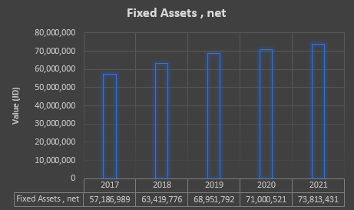

- Lands
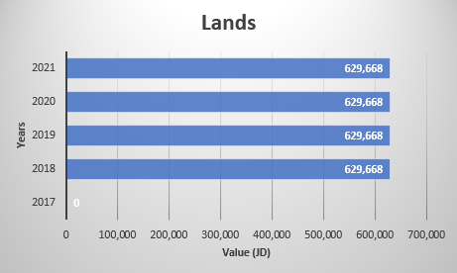

- Projects in Progress
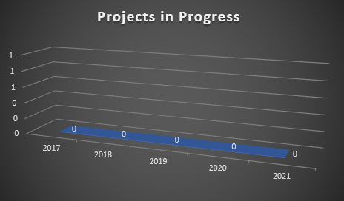

( No Projects in Progress )

Q2
Initial Investment = -72,656,818
Year | Net income
0 (Initial Investment) | -$72,656,818
1 | $227,335
2 | $478,589
3 | $3,582,963
4 | $2,154,504

A – IRR
IRR (Sum of all net income include initial investment , Guess)
IRR | -51 %

-Exception why IRR negative: -
a - The company in its early stages or has invested in expansion (such as establish new farms or purchase equipment), a negative IRR might be in the period and will improve by production increases and generated revenues.
b – Maybe the negative IRR is due to cost structure or poor pricing, the negative IRR may continue unless fundamental changes they made.
-Lets Estimated i
the inflation in Jordan equal 2.5 %
Our study cover 4 Y so i will estimated i = 41%
A - Perform present-worth :-
Year | PV at 2017
0 | (72,630,513)
1 | $161,230.50
2 | $240,726.82
3 | $1,278,159.30
4 | $9,833,672.53
i | 0.41

PV(Rate,nper,pmt,[fv])
B - Future-worth: -
Year | FV at 2021
0 | ($287,075,124.79)
1 | $637,270.25
2 | $951,482.79
3 | $5,051,977.83
4 | $2,154,504.00
i | 0.41

FV(Rate,nper,pmt,[pv])

C - Annual-Worth Analyses
AE | -$38,642,894.81

PMT(Rate,nper,NPW)
NPW = NPV(Rate, net income ) + initial investment
Negative sign mean Annual costs are higher than annual returns
Payback Period
Year | Cumilative Cash flows
0 | -(72,630,513)= Initial investment
1 | - (72,403,178) = Initial investment + net income in 1y
2 | (71,924,589)
3 | (68,341,626)
4 | (66,187,122)
No payback within 5 Years

Q3 -
ɣ Critically analyze and My recommend future asset management and investment strategies.
Analyzing: -
The data provided showcases that the company has been struggling to maintain financial stability. It can be seen that the company is struggling to maintain growing profitability by noticing the shifting gross profit over the years. Behind this unstable situation are many factors that we need to shed light on to enhance the situation. Starting with the cash flow, although the revenue reached an all-time high in 2018, it kept dropping until 2021. Two possible reasons are external challenges and internal inefficiencies. Moreover, operating expenses are still high, even though they have decreased to 34.7 million, putting further pressure on profitability. Another significant issue is the increasing debt ratio over the years (from around 68% in 2017 to 78% in 2021), which indicates the heavy and increasing reliance on debt capital to operate the company. In contrast, shareholder equity is decreasing, suggesting the decline in returns for investors. It’s important to mention that inconsistent revenues are usually the cause of high debt and unstable profits. Keeping this in mind and observing the change in liabilities compared to assets emphasizes the high-risk situation that the company is facing as the revenue might drop. As a result, the company will face a serious challenge to meet its debt obligations. Furthermore, the liquidity ratio has been consistently low, as it has remained below 1.0 in all years, which threatens the company’s ability to pay off its short-term debt. These are major attributes in the financial instability of the company. To avoid potential crises, I recommend the following:-
My recommendation :-
A- Reduce debt:-
To start the financial recovery, the company needs to reduce reliance on debt by focusing on paying down loans and exploring alternative funding sources like issuing new shares, attracting strategic investors and so on .

B - Control Expenses:-
The company must apply strict cost management to reduce operating expenses. Like renegotiating with supplier to reduce the cost of raw or contact with new supplier , improve supply chain processes, maybe buy soler power systems to cut costs. As well as cut off non-essential expenses all of these can controlled expenses.

C- Focus on Long-term Investments :-
Investing in growth projects is important for long-term stability. The company should prioritize investments with sort payback period to improve liquidity like market expansion or high demand product . This will ensure increase in cash Flow while minimizing reliance on short-term lone or liabilities .
D - Improve Liquidity:-
Working on liquidity ratio is important for the company short-term financial stability. This can be achieved by better inventory management and collecting accounts receivable and negotiating longer payment terms with suppliers also save more cash for emergencies will help the company navigate future challenge more comfortability .

Part 3 :-
The product I am working on is medium-sized chickens from JORDAN POULTRY PROCESSING & MARKETING Company.

Budget Preparation for 2025 :-

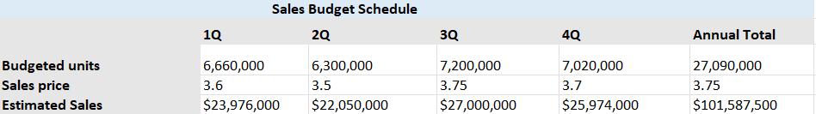
Budget units = units produced per hour * num of working day per Q * num of working hour pre day
- units produced per hour = 10,000
- num of working hour pre day = 9 hour
Based on JORDAN POULTRY PROCESSING & MARKETING Web site .
- working day per Q :-
Q1 (January - March): 74 working days.
Q2 (April - June): 70 working days.
Q3 (July - September): 80 working days.
Q4 (October - December): 78 working days.
Sales Price for medium – sized chickens = 3.5
Based on Owner of Al Majid Commercial Markets.
Estimated Sales = Budget unit * Sales Price.
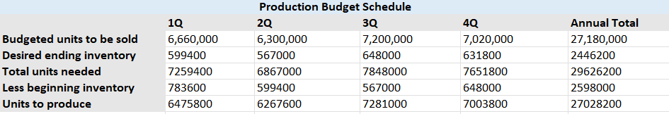
- Budgeted units to be sold = Budget unit
- Desired ending inventory :- The minimum amount to storage in inventory is 5% of the factory’s Budgeted units to be sold, and the maximum amount is 20%. I assumed 9%, and I think it is an stable percentage as an average for all Q .

- Total units needed = Budget units * Desired ending inventory

- Less beginning inventory = Desired ending inventory from previous Q

- Units to produce = Less beginning inventory * Total units needed

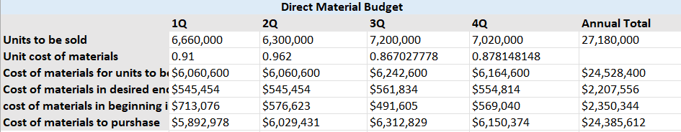
- Unit cost of materials :-
Materials Price per ton: 260 JOD From Al-Saeed Green Fodder Trading Company
Total Materials required for all chickens in Q almost (23,310 tons) It varies according to the Budget unit.
Unit cost of materials = $\frac{Total Materials required*Materials Price per ton*1000}{Unit to be sold }$
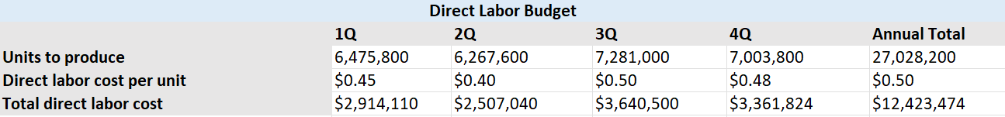
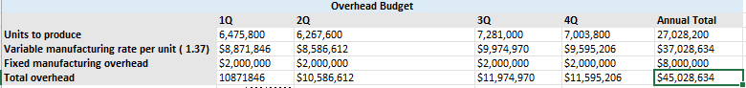
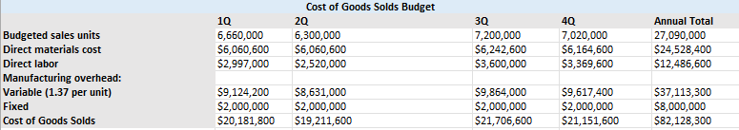
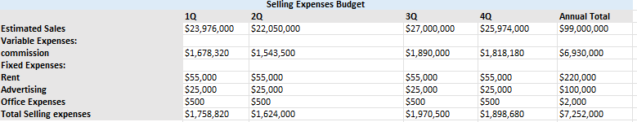 a- The normal commission limit for a sales employee is 6%.
b - With the rapid development and expansion of technology in Jordan, especially the world of marketing, it may cost millions of dinars to carry out media or marketing campaigns for companies starting from Zero , but we JORDAN POULTRY PROCESSING & MARKETING Company ,have a popular base and a very strong name in the Jordanian market, which reduces marketing costs.
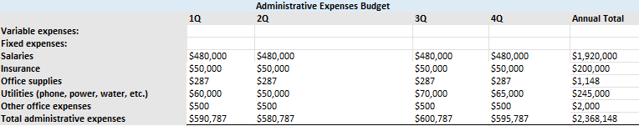
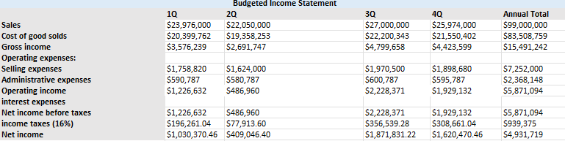

Account receivable = monthly volume * number of months * price
• Finished good inventory = monthly volume * number of months * (cost of raw materials + labor + overhead)
• Raw material inventory = monthly volume * number of months * cost of raw material
• Account payable = monthly volume * number of months * cost of raw material

Account recievable | $12,321,000.00
Finished good inventory | $87,374,466,960,000
Raw material inventory | 26164822320000
Account payable | -39247233480000
Net change in Working capital | $74,292,068,121,000.00
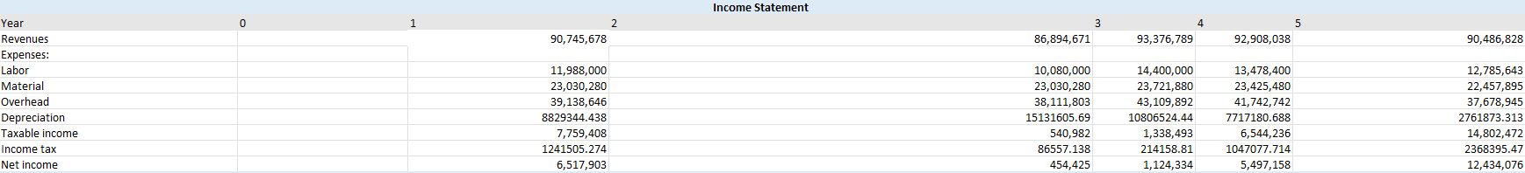

Enhance Profitability
a. Improve Net Income
• Enhance Revenues: Utilize effective marketing strategies or develop an expansion of product lines or markets.
• Pricing Optimization: The pricing strategy should be reviewed to ensure accurate reflection of market demand and ensure profitability.
• Reduce Operating Expenses: Locate and eliminate non-value-added/wasteful expenses that do not add quality or satisfaction for the customers.
• Improve Operational Efficiency: Streamline the processes, automate repetitive tasks, and invest in technology to lower costs and raise productivity.
b. Leverage Depreciation
• Maximize Tax Benefits: Depreciation reduces taxable income, hence improving cash flow.
• Reassess Asset Lives: The useful lives of assets should be realistic to avoid over-depreciation or under-depreciation.
2. Cash Flow Management Effectively
a. Operating Activities
• Accelerate Receivables: The company should grant discounts for early payments or reduce credit terms to reduce the cash conversion cycle.
• Delay Payables: The companies need to negotiate with suppliers to have longer payment terms to retain cash for a longer period.
• Monitor Inventory Levels: Avoid overstocking and deal in just-in-time inventory management in order to keep cash available.
• Control Costs: Periodically review variable and fixed costs with the intent of maintaining positive cash flow.
b. Investment Activities
• Anna Evaluate Investment: Prioritize those investments that yield high returns, thereby aligning them with the long-term goals of strategic decisions.
• Anna Recognize Salvage Value: On the disposal of assets, maximize salvage value through proper resale or reuse.
• Gain Tax: Plan the realization of gains in asset sales with a view to avoiding unexpected outflows of cash due to taxes.
c. Cash Flow
• Cash Flow: Have the right cash flow estimations for being adequately prepared during surplus or shortage of cash.
• Cash Buffer: Always keep an emergency amount of money to meet contingencies or a fall in sales.
• Lines of Credit and Other Financing Arrangements: To be prepared for moments of temporary insufficient funds.
3. Strategic Actions
a. Focus on High Margin Products/Services
• Identify the highest margin products or services and make them a priority in operation to optimize net income.
b. Invest in Growth Opportunities
• Invest in high-return projects/markets that would result in long-term profitability.
c. Ongoing Financial Performance Review
• The financial statements should be reviewed monthly or quarterly to identify trends, risks, and opportunities.
d. Optimize Capital Structure
• Debt and equity need to be balanced in order to minimize the cost of capital and ensure sustainable cash flow.
4. Technology and Tools
• Cash Flow Management Software: Implement tools that can help track and project cash flow in real time.
• ERP Systems: Integrate financial and operational data into one system to enhance decision-making efficiency.
5. Risk Management
• Diversification of Income Streams: Decrease dependence on one product, service, or market.
• Hedging Against Market Fluctuations: Financial instruments to neutralize the negative effect of any fluctuation in currency rates or commodity prices.

