

ECOWIN
AI-Based Application for Wastes
Recycling Process Facilitating

Team Members:
Omar Ibrahim Taha
Ali Mohamed Ali
Omar Mohamed Elawamy
Kareem Azam Marey
Loai Medhat Yousef
Fathy Mohamed Mohsen
Ahmed Abdelmaksod Abdelgawad
Mohamed Mostafa Ibrahim
Ali Abdelrahman Mahmoud
Amr Khaled Saad

Faculty of Computer and Information Science
Mansoura University 2024

ECOWIN

AI-Based Application for Wastes
Recycling Process Facilitating

Team Members:
Omar Ibrahim Taha
Ali Mohamed Ali
Omar Mohamed Elawamy
Kareem Azam Marey
Loai Medhat Yousef
Fathy Mohamed Mohsen
Ahmed Abdelmaksod Abdelgawad
Mohamed Mostafa Ibrahim
Ali Abdelrahman Mahmoud
Amr Khaled Saad

Under supervision of:
Dr.Rasha Elhadry - Eng. Alaa Galal

Abstract
Recycling has become an essential practice in today's world to promote environmental sustainability and reduce waste accumulation. This project aims to develop an intelligent mobile application that enhances the recycling process through innovative and efficient solutions. The application utilizes artificial intelligence to recognize recyclable materials via the camera, enabling users to categorize waste accurately and conveniently. Additionally, it provides a comprehensive educational guide on recycling, a rewards-based system that allows users to collect points and redeem them for special offers, and a platform for exchanging recyclable materials among users. The significance of this project lies in its ability to encourage individuals to engage in environmentally friendly behaviors by making recycling more accessible and rewarding. By leveraging AI-powered image recognition, the application minimizes human error in waste sorting and enhances the accuracy of material classification. Moreover, the digital wallet feature enables users to track and utilize their earned rewards effectively, further incentivizing sustainable practices. A key innovation introduced in this project is the AI-driven material recognition system, which automates the recycling process and ensures efficiency. Unlike conventional recycling applications, this system enhances user experience by simplifying decision-making and providing real-time feedback on recyclable materials. Additionally, the integration of a material exchange platform fosters community engagement and promotes the circular economy by encouraging users to repurpose materials rather than discard them. By combining smart technology with user-centric design, this project aspires to make recycling an effortless and rewarding experience. The application not only addresses environmental challenges but also fosters a culture of sustainability, making a significant impact on waste reduction and resource conservation.
Keywords
- Recycling -Environmental sustainability -Artificial intelligence -Mobile application -Image recognition -Reward system -Eco-exchange -Waste classification -Circular economy -Smart technology

Acknowledgment
We would like to express our deepest gratitude to our project supervisor, whose valuable guidance, continuous support, and encouragement played a crucial role in the successful completion of this project. Their insights and expertise have been instrumental in shaping our work and overcoming challenges along the way. Additionally, we extend our heartfelt appreciation to our academic institution for providing us with the necessary resources and a conducive environment for research and development. Special thanks go to our colleagues and friends for their unwavering support and constructive feedback throughout the project journey. Finally, we are immensely grateful to our families for their patience, motivation, and constant encouragement, which have been our driving force throughout this endeavor.

Table of contents
Abstract…………………………………………………………………….3
Acknowledgment……………………………………………………………4
List of figures………………………………………………………………...6
1.Chapter 1: Introduction…………………………………………………….7
1.1 Introduction……………………………………………………………….8
1.2 Problem Definition……………………………………………………….8
1.3 Project Objectives………………………………………………………..9
1.4 Project Scope…………………………………………………………….10
1.5 Project Timeline…………………………………………………………11
1.6 Document Organization…………………………………………………12
2.Chapter 2: Literature Review…………………………………………….13
2.1 Introduction…………………………………………………………….14
2.2 Background…………………………………………………………….14
2.3 Review of Relevant Work……………………………………………..15
2.4 Relationship between the Relevant Work and Our Work……………..17
2.5 Summary……………………………………………………………..17
3.Chapter 3: System Analysis……………………………………………19
3.1 Introduction………………………………………………………….20
3.2 User Requirements…………………………………………………..20
3.3 System Architecture…………………………………………………24
3.4 Business Model Canvas (BMC)…………………………………….25
3.5 SWOT Analysis…………………………………………………….27
3.6 Use Case Diagram………………………………………………….28
3.7 Sequence Diagram…………………………………………………31
3.8 Activity Diagram…………………………………………………..37
3.9 Class Diagram…………………………………………………….41
3.10 Tools and Technologies………………………………………….42
3.11 Summary………………………………………………………...43
4.Chapter 4: System Design…………………………………………44

List of Figures
- Figure 1.1: Project Timeline ......................................………………11
- Figure 3.2: System Architecture Overview ...................................... 24
- Figure 3.3: Business Model Canvas (BMC) .................................... 25
- Figure 3.4: SWOT Analysis ........................................................... 27
- Figure 3.5: Use Case Diagram (User) ............................................28
- Figure 3.6: Use Case Diagram(Admin)…………………………..29
- Figure 3.7: Sequence Diagram (Sign-Up Process) ........................ 31
- Figure 3.8: Sequence Diagram (Sign-In Process)…………………32
- Figure 3.9: Sequence Diagram (Exchange Process) .................... 33
- Figure 3.10: Sequence Diagram (Charity Process) .................... 34
- Figure 3.11: Sequence Diagram (Redeem Process) .................... 35
- Figure 3.12: Sequence Diagram (AI Model Process) ..................... 36
- Figure 3.13: Activity Diagram (Exchange Flow) ..............................37.
- Figure 3.14: Activity Diagram (Donation Flow) ................................. 38
- Figure 3.15: Activity Diagram (Redeem Process) .......................... 39
- Figure 3.16: Activity Diagram (AI Material Recognition) ............... 40
- Figure 3.17: Class Diagram ............................................................ 41
- Figure 3.18: Tools and Technologies....................……………….42

Chapter(1)

Introduction

1.1 Introduction

Recycling has become an increasingly important solution to address the growing waste crisis and promote environmental sustainability. Improper waste disposal contributes to pollution, resource depletion, and environmental degradation. Our project introduces a smart mobile application designed to revolutionize the recycling process by integrating artificial intelligence for waste classification, incentivizing users through a rewards system, and fostering community participation.

The key focus of this project is to simplify recycling efforts by providing an easy-to-use platform where users can scan waste materials with their phone camera to determine recyclability. Through AI-powered material recognition, users receive immediate guidance on how to sort and dispose of their waste correctly. Additionally, the platform includes an educational section to raise awareness about recycling benefits and techniques, as well as a digital wallet that stores reward points and coupons, encouraging users to participate actively in sustainable practices.

This chapter will provide an overview of the project, including:

Problem Definition: Highlighting the issues related to improper recycling and the lack of user-friendly solutions.

Project Significance: Explaining the environmental impact of improved recycling habits and the benefits for users and society.

Main Features: Discuss the primary components of the application, such as AI-powered waste recognition, reward systems, and community exchange.

Chapter Overview: A roadmap of the topics covered in this document, including system analysis, design, implementation, and future improvements.

By leveraging technology to promote recycling, this project aims to encourage individuals and businesses to adopt environmentally responsible behaviors, ultimately contributing to a cleaner and more sustainable future.

1.2 Problem Definition

Waste management has become a significant global challenge, with increasing amounts of waste being generated daily. Traditional recycling methods often suffer from inefficiencies, lack of user engagement, and improper waste sorting, leading to environmental hazards and increased landfill accumulation. Many individuals find the recycling process cumbersome due to the lack of knowledge about proper waste categorization, resulting in recyclable materials being disposed of incorrectly.

Motivation for the Project

The primary motivation behind this project is to address these recycling challenges by introducing an intelligent mobile application that simplifies waste sorting and incentivizes users to recycle responsibly. The key driving factors include:

Environmental Impact: Reducing landfill waste and promoting a cleaner environment.

Lack of Awareness: Many individuals are unaware of correct recycling practices, leading to ineffective waste management.

Inefficiency of Current Systems: Existing recycling programs lack automation and user engagement, making them less effective.

Encouraging Sustainable Behavior: Rewarding users for recycling can serve as an incentive to promote eco-friendly habits.

Proposed Solution

To address these issues, our project introduces a mobile application that leverages AI-powered image recognition to identify recyclable materials through a smartphone camera. The application offers:

Automated Waste Recognition: Users can scan items to determine whether they are recyclable, eliminating uncertainty in waste sorting.

Green Guide: A built-in resource center provides detailed information on best recycling practices.

Reward-Based System: Users earn points for correctly recycling items, which can be redeemed for various benefits.

Material Exchange Platform: Encourages users to trade recyclable materials, promoting a circular economy.

By implementing this solution, our project aims to revolutionize the recycling process, making it more accessible, engaging, and environmentally sustainable.

1.3 Project Objectives
The primary objectives of this recycling mobile application are as follows:
- Enhance Recycling Efficiency: Implement AI-powered image recognition to accurately identify recyclable materials and reduce human errors in waste sorting.
- Educate Users: Provide an interactive educational guide to inform users about proper recycling practices and environmental sustainability.
- Encourage Participation: Develop a rewards-based system that motivates users to engage in recycling by offering points and redeemable benefits.
- Facilitate Material Exchange: Create a platform for users to trade recyclable materials, reducing waste and promoting a circular economy.
- Improve User Experience: Ensure a user-friendly interface and seamless navigation to make recycling a hassle-free process.
- Reduce Environmental Impact: Contribute to lowering landfill waste by encouraging responsible disposal and recycling of materials.
- Promote Community Engagement: Foster a digital community where users can share insights, and recycling tips, and collaborate on environmental initiatives.
- Digital Wallet Integration: Provide a feature to store earned points and track rewards efficiently, enhancing user motivation and retention.
- Expand Accessibility: Ensure the application is available on both Android and iOS platforms to reach a broader audience.
- Support Sustainable Business Practices: Encourage businesses to participate by offering incentives for sustainable waste management solutions.

1.4 Project Scope
This project aims to develop a smart recycling mobile application that leverages artificial intelligence to enhance waste classification and recycling efficiency. The key features that distinguish our application from existing solutions include:
- AI-Powered Material Recognition: The application utilizes computer vision to identify recyclable materials through the user's camera, making sorting easier and more accurate.
- Green Guide: A comprehensive educational section provides users with recycling tips, material classification guidelines, and best practices to promote sustainability.
- Reward System: Users earn points for proper recycling and can redeem them for discounts, coupons, or other incentives.
- Digital Wallet: A built-in wallet stores users’ earned points and manages redemption history efficiently.
- Material Exchange Platform: Users can list and exchange recyclable items with others in their community, promoting reuse and reducing waste.
- Gamification and Challenges: The app introduces recycling challenges and leaderboards to encourage user participation and competition.
- Environmental Impact Tracking: Users receive insights into their recycling habits, including statistics on waste reduction and contributions to sustainability.
By integrating these features, the application provides an innovative and user-friendly approach to recycling, making it more engaging and rewarding for individuals and communities alike.

1.5 Project Timeline
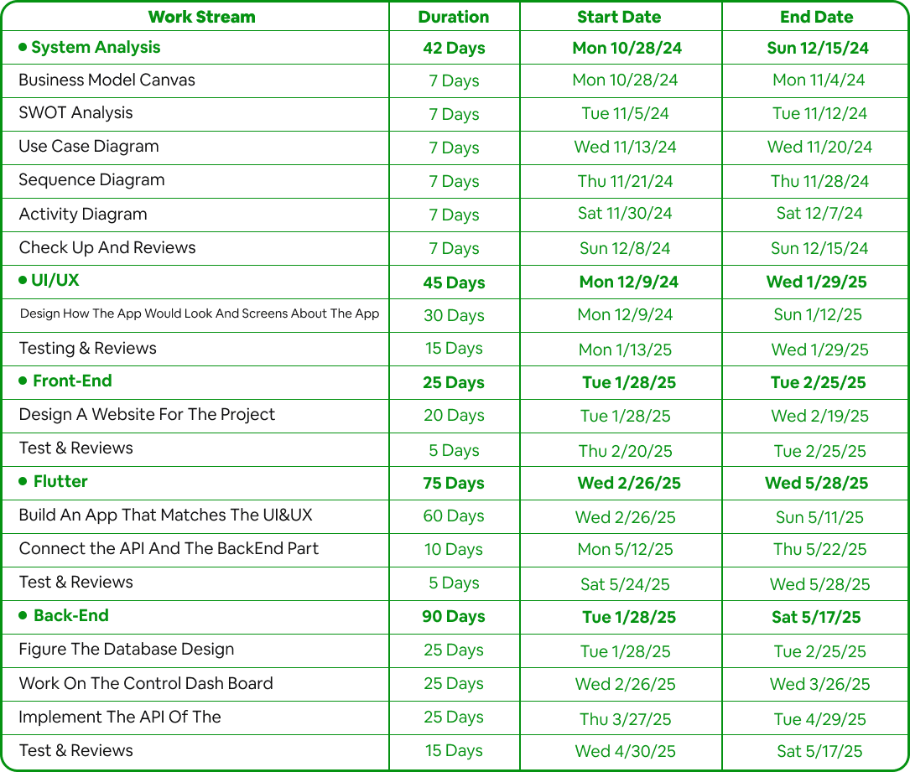
Figure 1.1 Project Timeline

1.6 Document Organization
This document comprises six chapters and one appendix. Each chapter is described
below:
Chapter 1: Introduction, outlines the project objectives, motivation, approach, and
scope.
Chapter 2: Literature Review, presents an overview of related work, common
technologies, and the relationship between our work and relevant research.
Chapter 3: System Analysis, analyzes the existing system, swot, BMC, use case, sequence diagram, activity diagram, system architecture, and the tools and languages used in our system.
Chapter 4: System Design, details the system design, including class diagram, database
design, and interface design.
Chapter 5: System Implementation, illustrates the process of mapping design into
implementation, sample application code, system testing, investigation results, and goals
achieved.
Chapter 6: Conclusion, future features and summarizes the research, and suggests improvements for the system.

Chapter (2)
Literature Review

2.1 Introduction
Recycling has become an essential component of modern waste management, aiming to reduce environmental impact, conserve natural resources, and promote sustainability. With the increasing global waste crisis, technological advancements have been leveraged to enhance recycling efficiency and user participation. This chapter explores existing research, methodologies, and technologies related to recycling systems, emphasizing how mobile applications and artificial intelligence (AI) are being integrated to improve waste sorting and management.
The chapter begins by reviewing previous research on recycling applications, including studies on user behavior, incentives, and smart waste management solutions. Following this, we examine the technologies employed in similar projects, such as AI-based material recognition, blockchain for transparency, and gamification techniques to encourage user engagement. Lastly, a comparative analysis highlights the gaps in current solutions and how our proposed system addresses these limitations, particularly through AI-powered material recognition and a reward-based recycling ecosystem.
By evaluating prior work and existing technologies, this chapter lays the foundation for understanding the significance of our recycling application and how it contributes to advancing waste management practices. The insights gained will guide the development of a robust, user-friendly, and efficient recycling system.

2.2 Background
This project is a mobile application that acts as an intermediary between users and recycling industries, facilitating the collection and transfer of recyclable materials from users to factories. To achieve this, the system is composed of several key components and utilizes various tools and technologies.
System Components
- User Interface (UI/UX)
  - Designed for an intuitive and seamless user experience.
  - Built using Figma
- Front-End Development
  - Developed using Figma and Visual Studio Code and Flutter using Dart programming language
  - Implements modern design principles for an accessible and engaging interface.

- Back-End Development
  - Built using PHP Storm Core for efficiency and Xampp and Visual Studio Code.

2.3 Review of Relevant Work
In developing our recycling application, it is essential to analyze existing similar applications that serve the same purpose. Two of the most notable recycling applications currently available are Plstka and Bekia. Below is an analysis of these applications, highlighting their functionalities, strengths, and limitations.
1. Plstka
Description: Plstka is a mobile application that facilitates recycling by connecting users with recycling stations and companies that collect recyclable materials. Users can exchange recyclable items for rewards, encouraging sustainability efforts through gamification.
Pros
Reward system by redeeming points
Leaderboard for top users
Cons
Lack of AI assistance for material identification.
No educational support to guide users on recycling. Restricted area

2. Bekia
Description: Bekia is an application designed to promote sustainable recycling practices by enabling users to exchange recyclable materials for goods or services. It provides an easy-to-use platform where users can schedule pickups for their recyclable items.
Pros
Reward system by redeeming points
Donate old clothes for charities
Cons
Lack of AI assistance for material identification.
No educational support to guide users on recycling.

2.4. Relationship between the Relevant Work and Our Work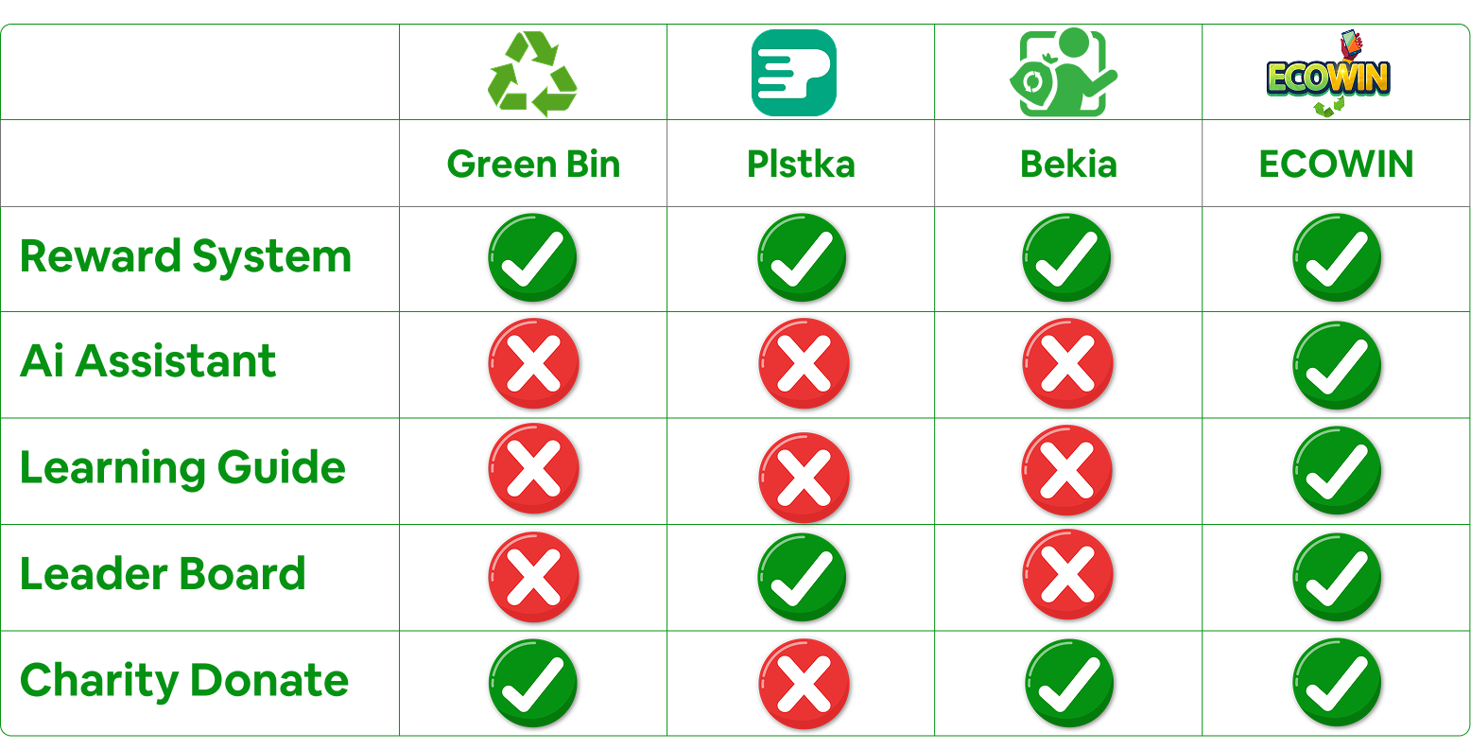
3. Key Innovations in Our System
While many recycling apps provide awareness and reward-based systems, our project introduces the following new elements:
- AI-powered Recycling Recognition: Unlike most apps that require users to manually input recycling details, our system employs computer vision to identify materials in real-time.
- Seamless User-to-Industry Connection: Unlike traditional apps that direct users to recycling centers, we bridge the gap between users and recycling factories through an integrated material exchange platform.
- Gamification for Engagement: To encourage consistent recycling behavior, we introduce gamification elements such as levels, achievements, and challenges.
2.4. Summary
Existing recycling applications primarily focus on user education and reward-based tracking. However, they often lack automation, AI-powered recognition, and direct industry integration. Our project addresses these shortcomings by introducing an AI-driven system that connects users with industries, simplifies the recycling process, and enhances engagement through gamification and AI assistance.
This literature review establishes how our app significantly improves upon existing solutions and provides an innovative, efficient, and engaging recycling experience.

Chapter (3)

System Analysis

3.1 Introduction
The System Analysis chapter serves as a cornerstone for understanding the structural and functional components of the EcoWin project. This chapter delves into the essential aspects of analyzing and designing the system to ensure that it meets user requirements and operational goals. By comprehensively outlining the processes, components, and interactions, the analysis aims to provide a robust foundation for the development phase.
EcoWin, a mobile application designed to promote sustainable recycling practices, relies on artificial intelligence to offer users an engaging and innovative experience. The system's analysis phase identifies the key functionalities, user interactions, and operational workflows to create an efficient and user-friendly platform.
3.2 User Requirements
The system should provide a user-friendly experience for individuals, businesses, and administrators who engage with the recycling application. The app is designed to promote sustainable waste management through education, material exchange, rewards, and AI-assisted material recognition.
Functional Requirements
These describe the core functionalities the system must implement to fulfill its purpose.
- User Registration & Authentication
  - Users must be able to sign up using email, phone number, or social media accounts.
  - The system must support secure login and password recovery.
- Green Guide
  - The system should provide a knowledge base with information on how to recycle different materials.
  - The app should offer step-by-step guides for proper disposal.
- Material Exchange System
  - Users should be able to list recyclable materials they want to give away.
  - Users should be able to donate for charities
- Rewards and Points System
  - Users should earn points based on their recycling activities.
  - The app should track points and allow users to redeem them for coupons or other benefits.
- AI-Based Recycling Assistance
  - The app must include an AI-powered camera feature that recognizes different recyclable materials.
  - Users should receive real-time feedback on whether an item is recyclable.
- User Dashboard & Profile Management
  - Users should be able to edit their profiles (name, email, preferences, etc.).
  - The dashboard should display personal recycling statistics and achievements.
- Admin
  - Admins should have access to manage user accounts and monitor system activity.
- Notifications
  - Notification should be sent for important events, such as the arrival of delivery team .
Non-Functional Requirements
These define the quality attributes and constraints of the system.
- Performance & Scalability
  - The app should respond to user interactions.
- Security & Privacy
  - All user data should be encrypted, including login credentials and transactions.
  - Users should have control over their data, with options to delete accounts and manage privacy settings.
- Usability & Accessibility
  - The interface should be designed with intuitive navigation for all user roles.
- Maintainability & Extensibility
  - The system should allow easy updates for future improvements.
  - The codebase should be modular to support the addition of new features without significant rework.
- Availability & Reliability
  - The app should be maintained to ensure continuous availability.
  - The system should have backup and disaster recovery mechanisms in place.
- Compatibility & Cross-Platform Support
  - The app should be available on Android, iOS, and web platforms.
  - It must be compatible with different screen sizes and devices.
- Legal & Compliance
  - The system must comply with environmental laws and local waste management regulations.
  - Terms of service and user agreements should be clearly stated within the app.

This chapter is divided into several sections:
- System Architecture: defining how different components interact, communicate, and function together to achieve the system's objectives. It provides a high-level blueprint of the system
- Business Model Canvas (BMC): A high-level representation of the EcoWin business model, highlighting its value propositions, customer segments, revenue streams, and other critical aspects.
- SWOT Analysis: A detailed evaluation of EcoWin's strengths, weaknesses, opportunities, and threats, offering insights into its strategic positioning in the recycling industry.
- Use Case Diagrams: Visual representations of the system's functionalities, illustrating how different user types interact with various features of the EcoWin application.
- Sequence Diagrams: Demonstrates the interaction between system components over time for specific scenarios
- Activity Diagram: Describes the sequential flow of operations within key processes.
- Class Diagram: relationships between different objects in a system. It is widely used in object-oriented design to illustrate how the system's components interact.
3.2 System Architecture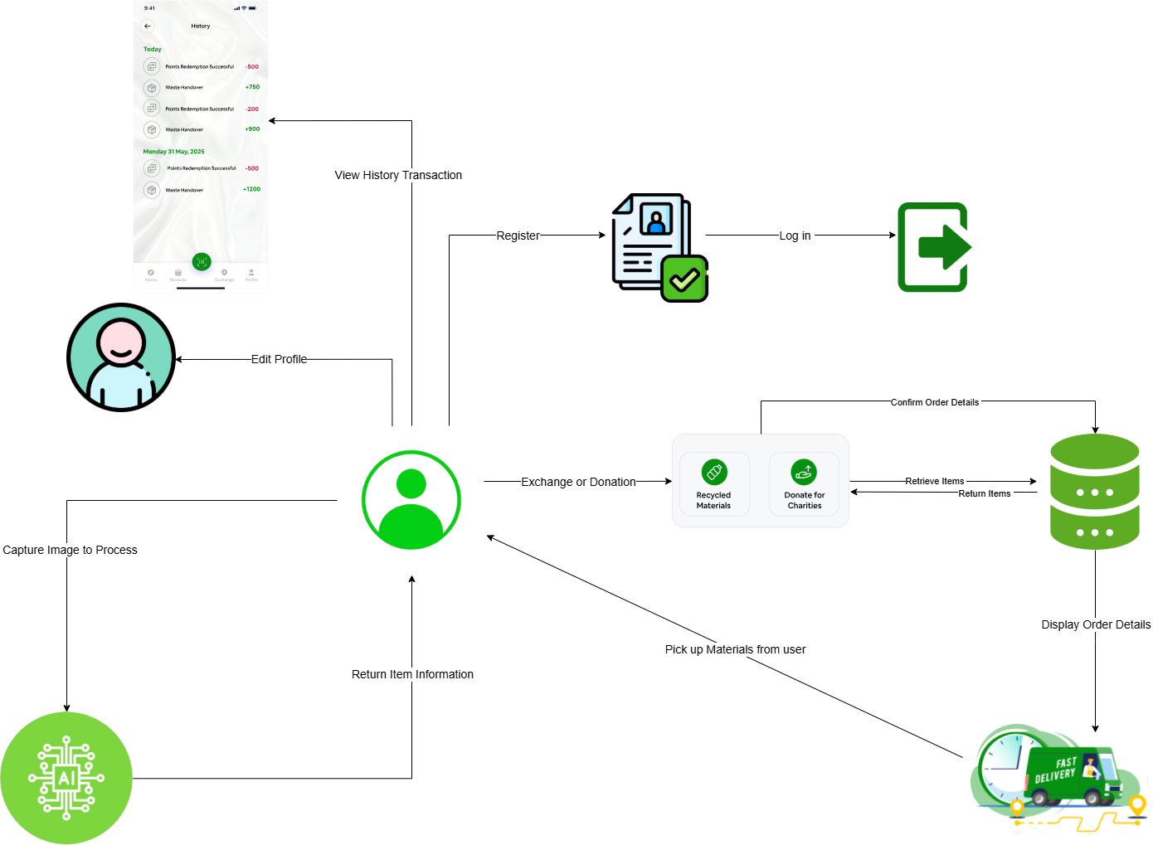
Figure 3.2: System Architecture Overview

1. User View
- The user interacts with the mobile app to perform various actions like registering, logging in, editing their profile, and viewing transaction history.
- The UI also allows users to capture images of recycling materials for AI processing

2. AI Role
- When the user captures an image, it is sent to an AI model that processes and classifies the material as recyclable or not.
- The AI then returns detailed information about the item.

3. Backend Layer
- The mobile app communicates with the backend via APIs to process requests.
- The backend handles user authentication, transaction processing, and order confirmation

- Database Layer
- Stores user data, transaction history, order details, and processed recycling materials

- Delivery Team
- When users request a material pickup for recycling or donation, the request is processed and sent to a delivery team.
- The delivery team collects materials and updates the order status in the system.

3.3 Business Model Canvas (BMC)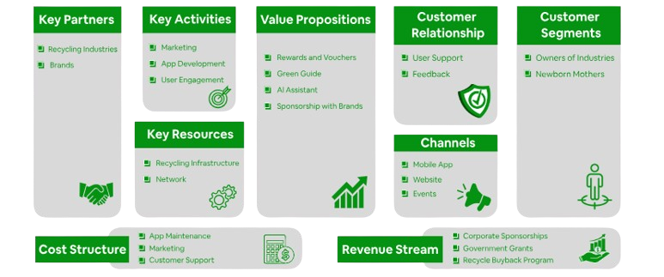
Figure 3.3: Business Model Canvas (BMC)
1. Key Partners
These are the external organizations, suppliers, or individuals that help the business operate efficiently. Partnerships can reduce risks, lower costs, and provide access to additional resources.
Our partners are: Recycling Industries and Brands
2. Key Activities
The most important tasks or processes the business must perform to deliver value to customers. These activities are essential to sustaining operations and achieving business goals.
Our activities are: Marketing, App Development, and User Engagement
3. Key Resources
The essential assets (physical, intellectual, human, or financial) that a company needs to operate and deliver its value proposition.
Our resources are: Recycling Infrastructure and Network

4. Value Proposition
The unique value a business offers to its customers. This defines what differentiates the company from competitors and why customers should choose its products or services.
Our value propositions are: Rewards and Vouchers, Green Guide, AI Assistant, and Sponsorship with Brands
5. Customer Relationships
The type of relationship a business establishes and maintains with its customers. This can range from automated self-service to personalized support.
Our customer relationships are: Customer Support and Feedback

6. Customer Segments
The different groups of people or businesses that the company targets and serves. Identifying customer segments helps in tailoring products and marketing strategies.
Our customer segments are: Owners of Industries and Newborn Mothers

7. Channels
The methods and platforms used to deliver the value proposition to customers. These include direct and indirect channels that facilitate customer interaction and product/service delivery.
Our channels are: Mobile App, Web Page, and Events
8. Cost Structure
The major expenses associated with running the business. This includes fixed and variable costs that affect profitability.
Our cost structures are: App Maintenance, Marketing, and Customer Support
9. Revenue Streams
The ways a business generates income from its customers. This can include multiple revenue models depending on the business strategy.
Our revenue streams are: Corporate Sponsorships, Government Grants, and Recycle Buyback Program

3.4 SWOT Analysis

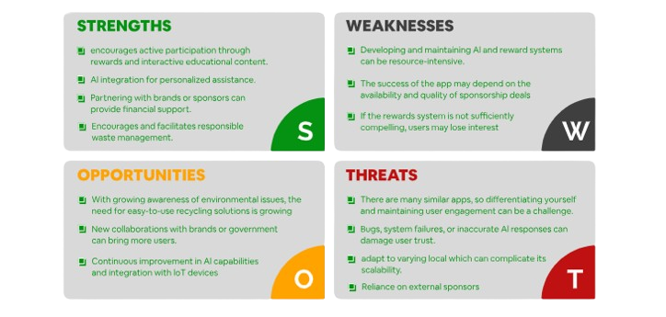
Figure 3.4: SWOT Analysis

3.5 Use Case Diagram 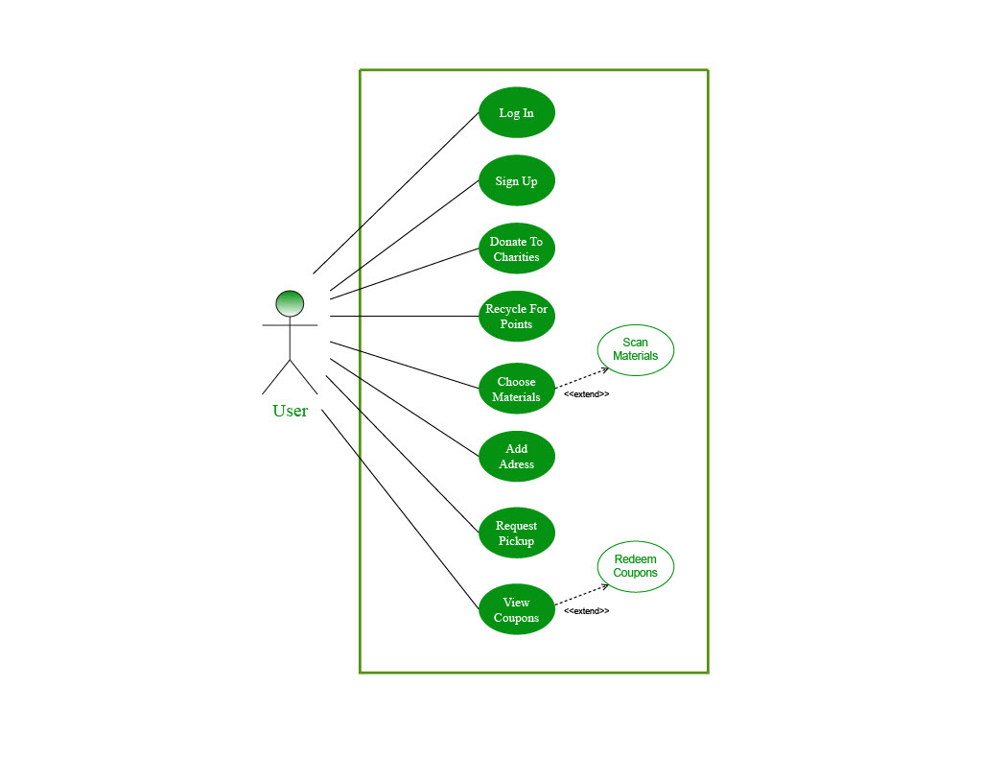
Figure 3.5: Use Case Diagram (User)

1. Actor:
- User: A general app user who interacts with recycling features.
2. User Use Cases:
- Log In / Sign Up: Authenticate or create an account.
- Donate to Charities: Donate collected points to charities.
- Recycle for Points: Earn points by recycling materials.
- Choose Materials: Select materials for recycling.
  - (Extends to "Scan Materials"): Users can scan items for identification.
- Add Address: Provide a location for pickups.
- Request Pickup: Schedule a recycling pickup.
- View Coupons: Check available rewards.
  - (Extends to "Redeem Coupons"): Users can redeem their points for coupons.

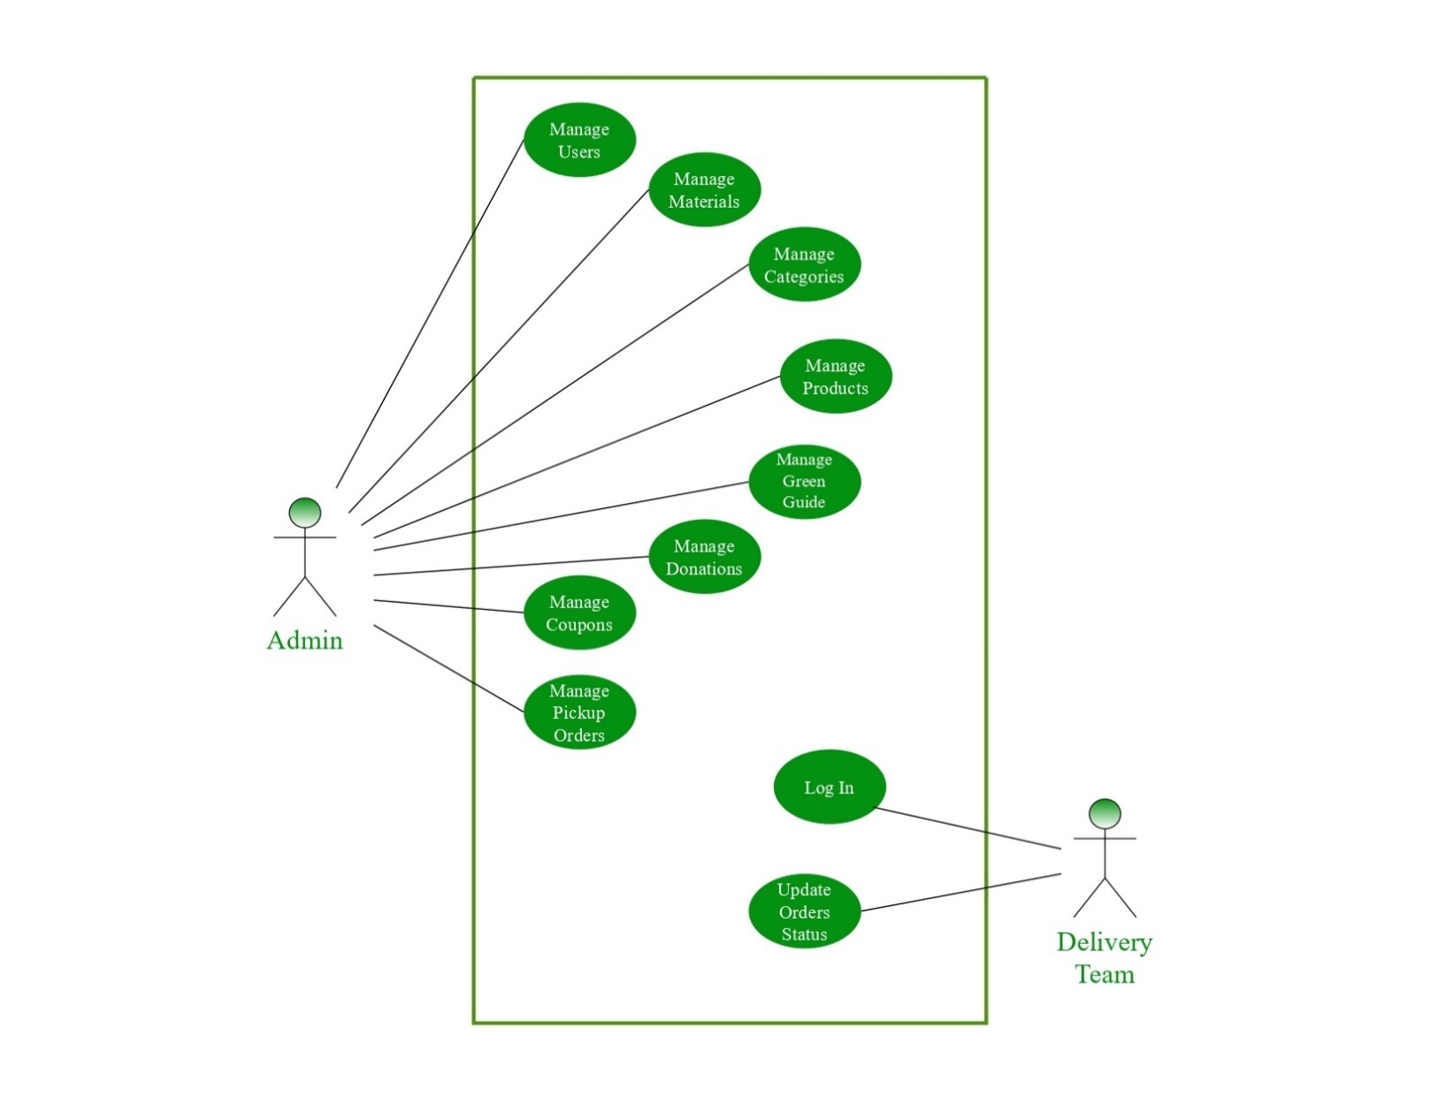
Figure 3.6: Use Case Diagram(Admin(

1.Actors:
- Admin: Responsible for managing different aspects of the app.
- Delivery Team: Handles order status updates.
2.Admin Use Cases:
  - Manage Users: Add, edit, or remove users.
  - Manage Materials: Define materials for recycling.
  - Manage Categories: Categorize recyclable materials.
  - Manage Products: Oversee the products available in the system.
  - Manage Green Guide: Maintain an educational guide for recycling.
  - Manage Donations: Handle donations made within the system.
  - Manage Coupons: Oversee reward system coupons.
  - Manage Pickup Orders: Organize and manage user pickup requests.
3. Delivery Team Use Cases:
  - Log In: Authenticate into the system.
  - Update Orders Status: Mark orders as completed, pending, etc.

3.6 Sequence Diagram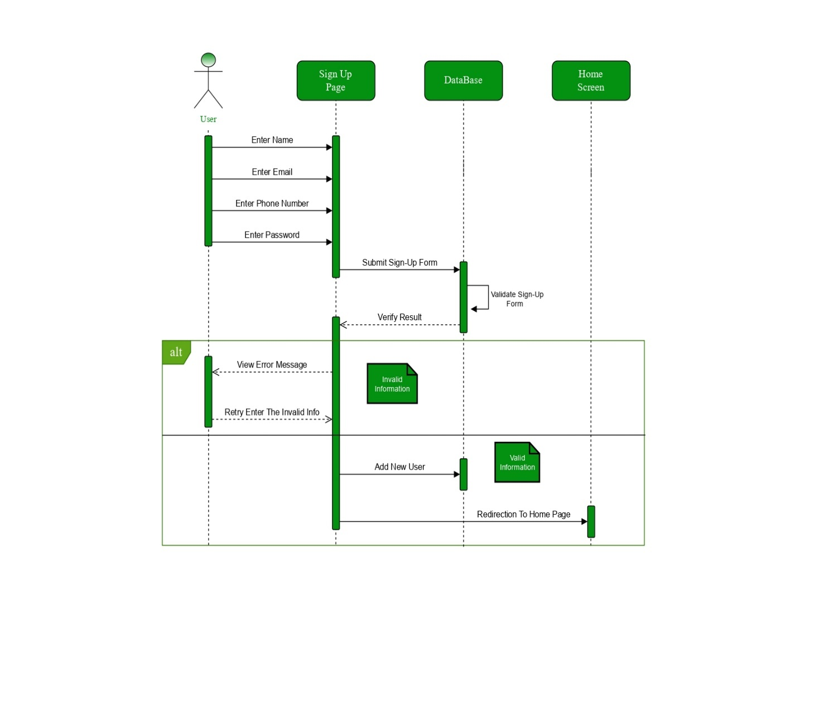
Figure 3.7: Sequence Diagram (Sign-Up Process)

Sign-Up Sequence
- The user enters their details (name, email, password, etc.).
- The system verifies the information.
- If valid, the system creates a new user account and confirms successful registration.
- If the information is invalid or already exists, the user is notified.

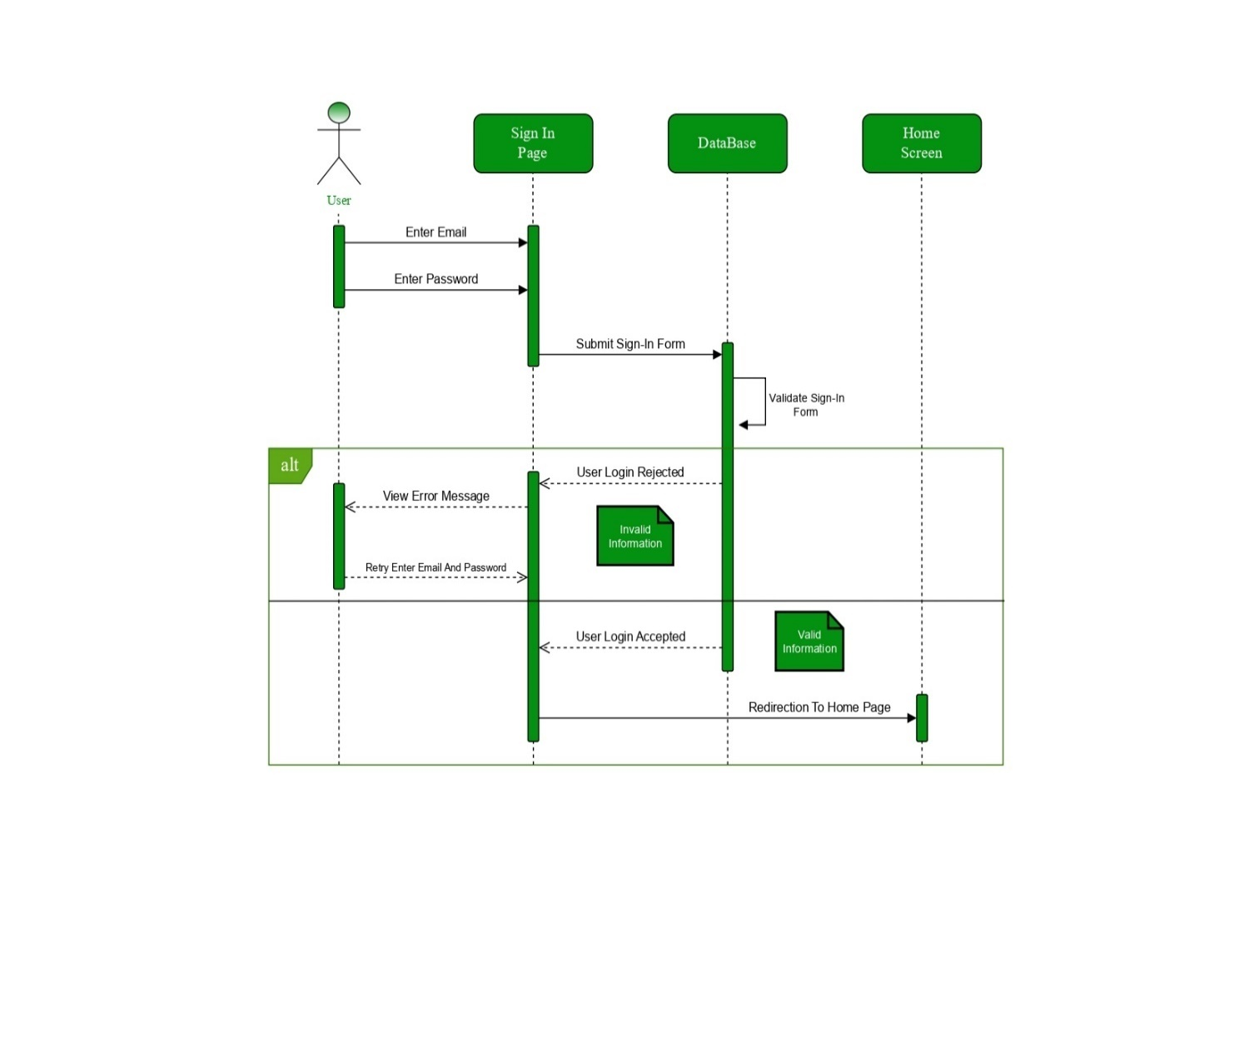
Figure 3.8: Sequence Diagram (Sign-In Process)
Sign-In Sequence
- The user initiates the sign-in process.
- The system validates the credentials.
- If credentials are correct, the user is granted access to the app.
- If credentials are incorrect, an error message is displayed, prompting the user to try again

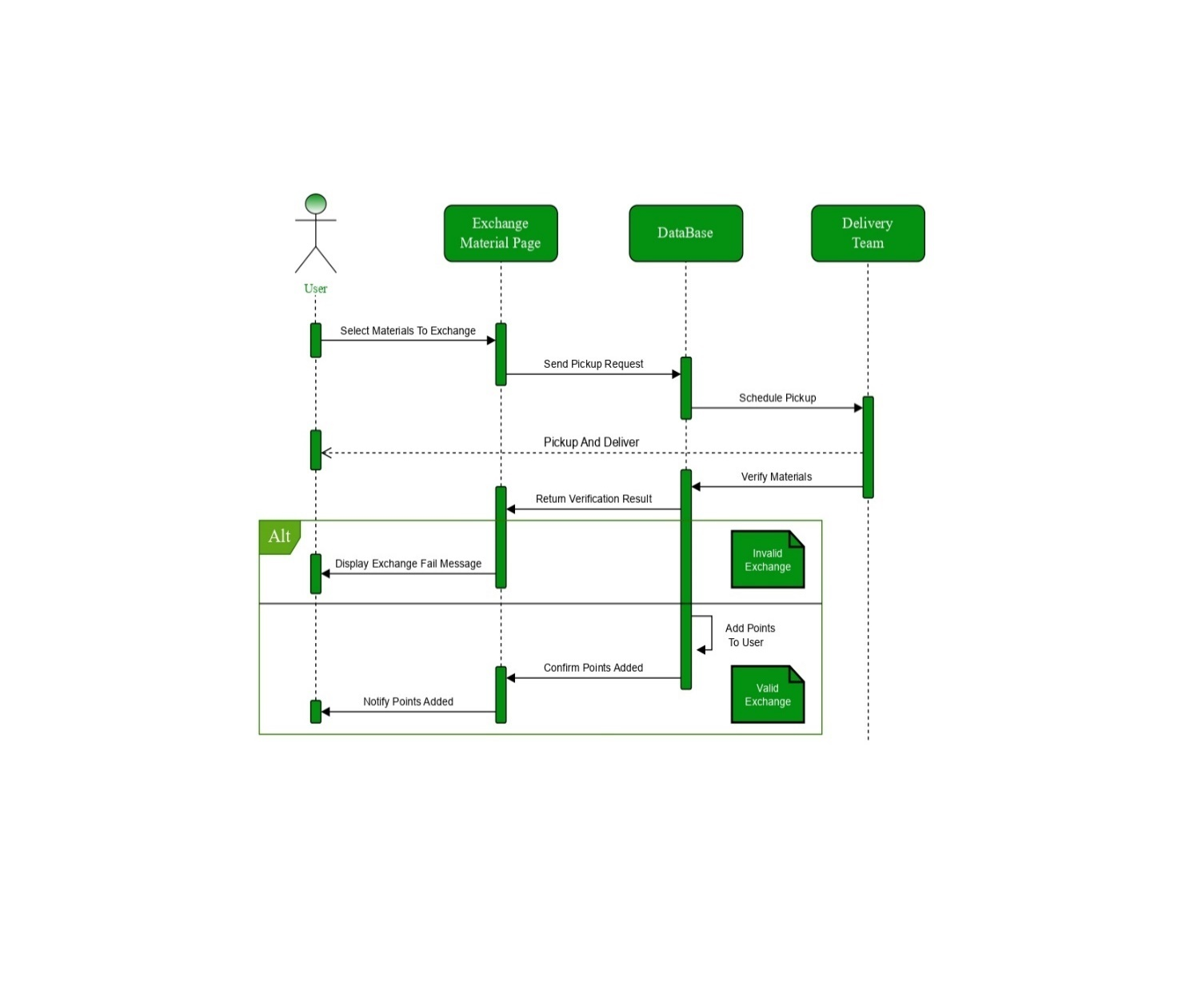
Figure 3.9: Sequence Diagram (Exchange Process(
Exchange Process
- The user selects materials for exchange.
- The system calculates the exchange value (e.g., points or rewards).
- The user confirms the exchange.
- The system updates the user’s wallet with points or rewards.

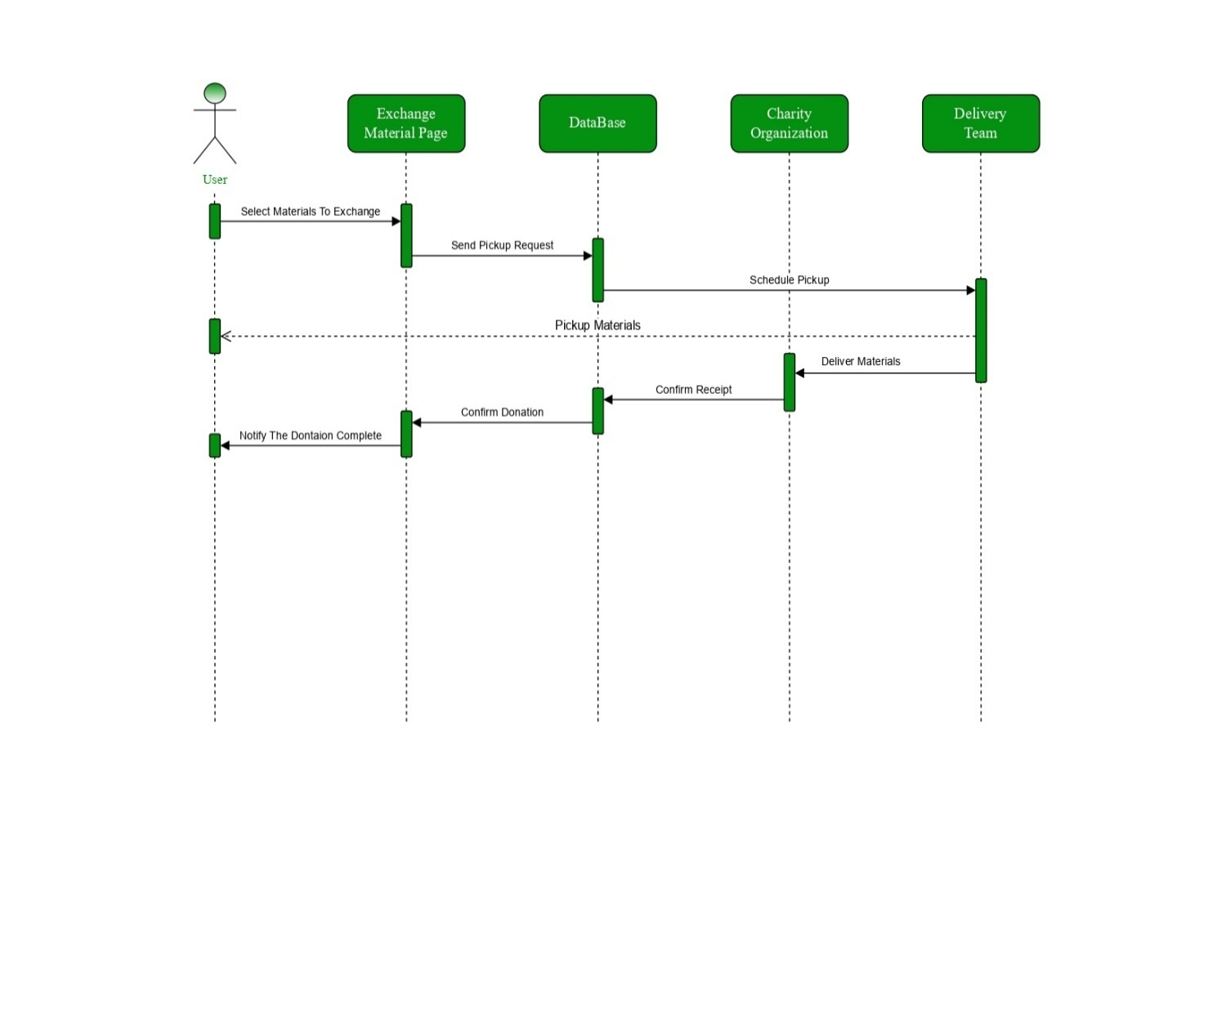
Figure 3.10: Sequence Diagram (Charity Process)
Donate Process
- The user selects items to donate.
- The system verifies the donation details.
- The user confirms the donation.
- The system records the donation and updates the user’s profile.

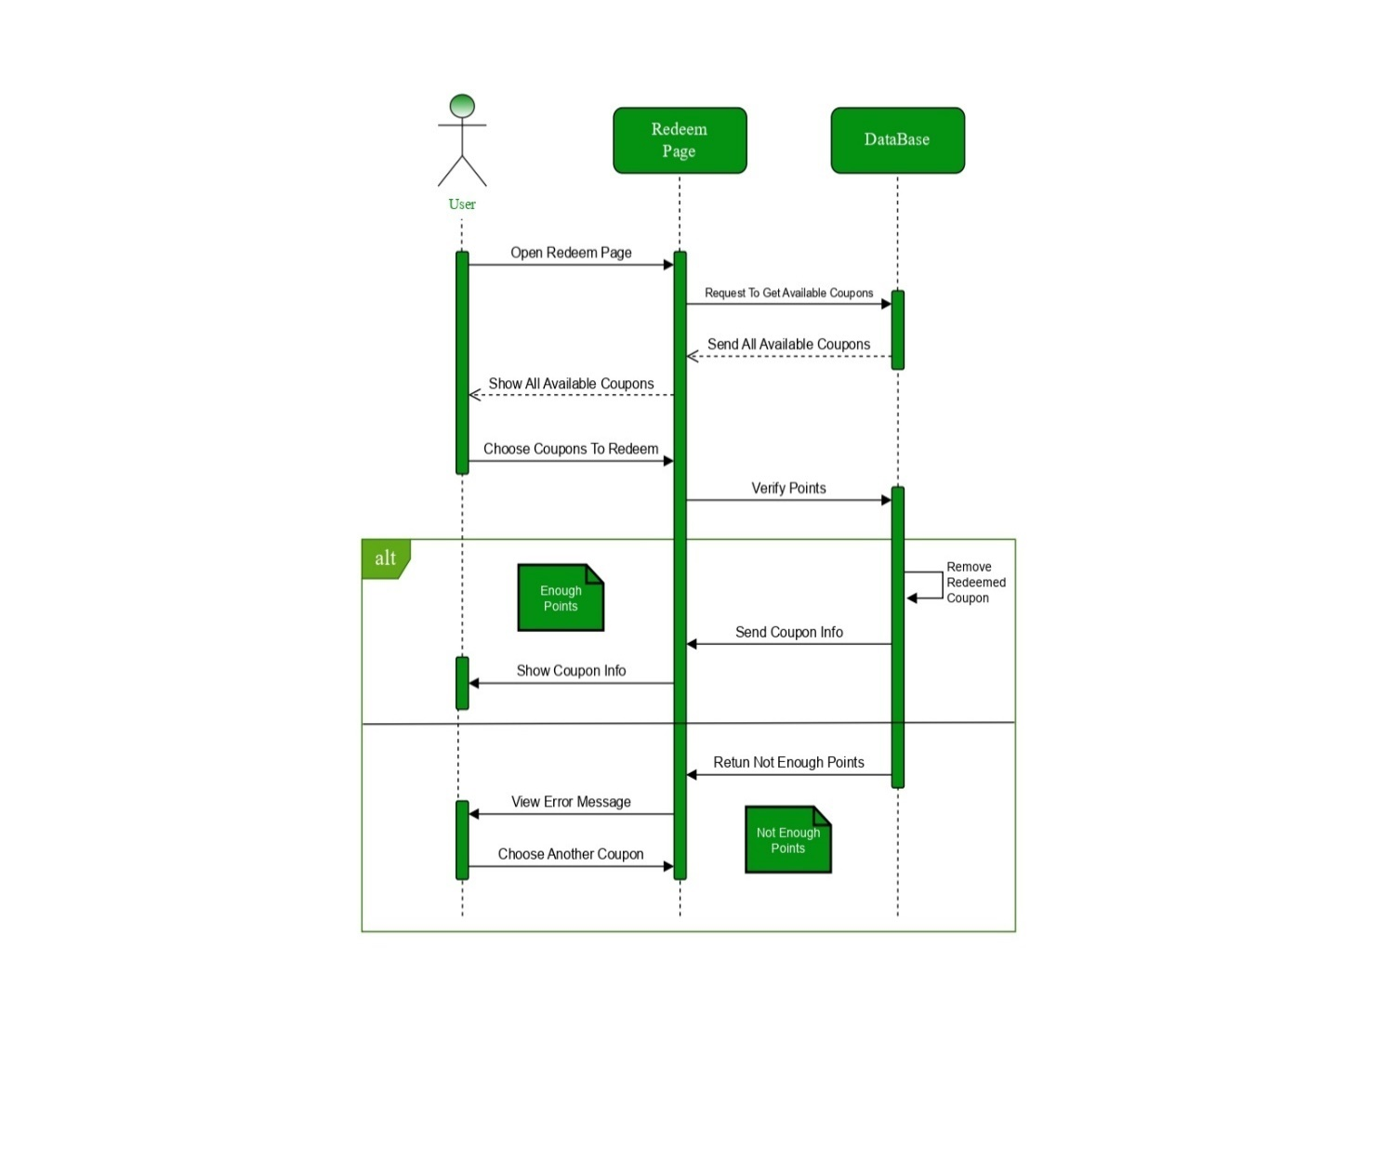
Figure 3.11: Sequence Diagram (Redeem Process)
Redeem Process
- The user selects a reward to redeem.
- The system verifies if the user has enough points.
- If sufficient points exist, the system processes the redemption.
- The user receives confirmation and details on how to claim the reward.

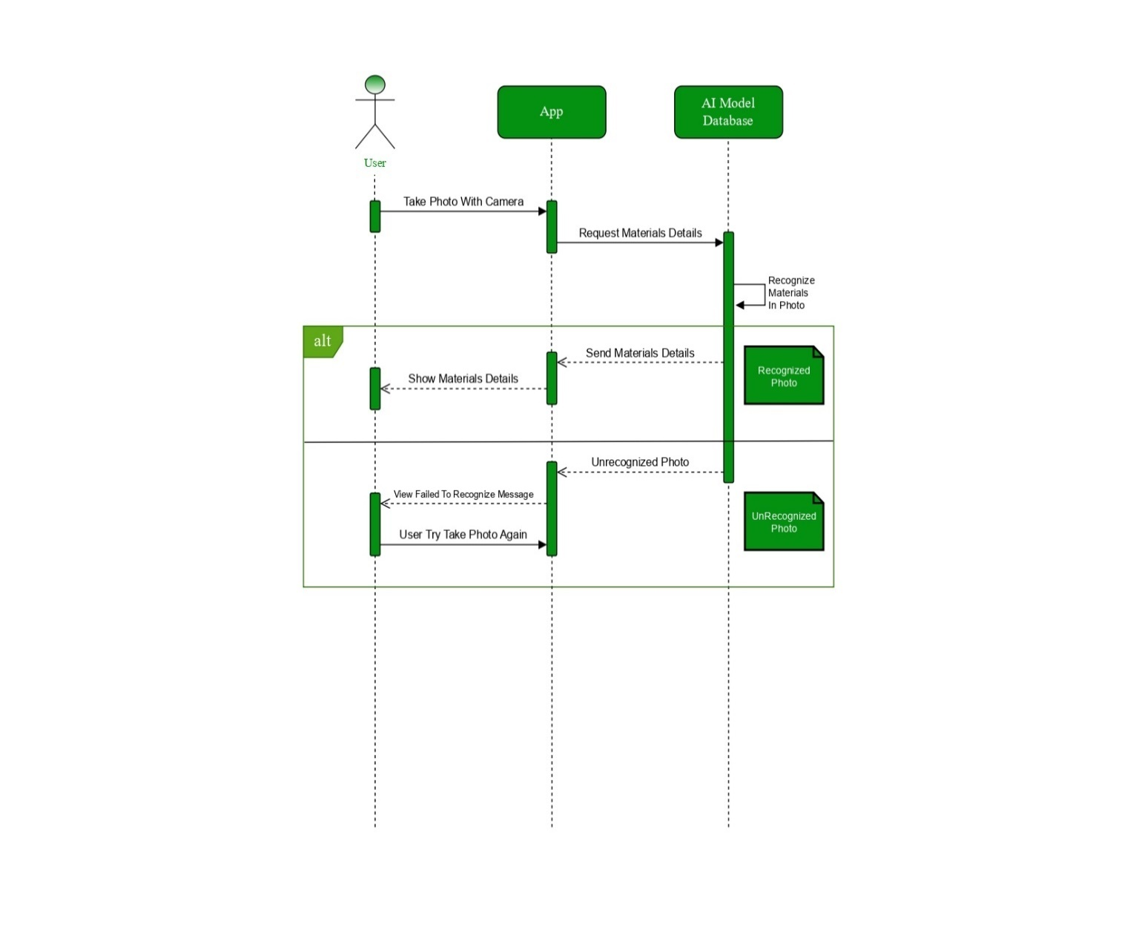
Figure 3.12: Sequence Diagram (AI Model Process)
AI Model Process
- The user uploads an image or scans a material using the camera.
- The AI model analyzes the material.
- The system classifies the material and provides feedback.
- The user receives suggestions on how to recycle or exchange the material.

3.7 Activity Diagram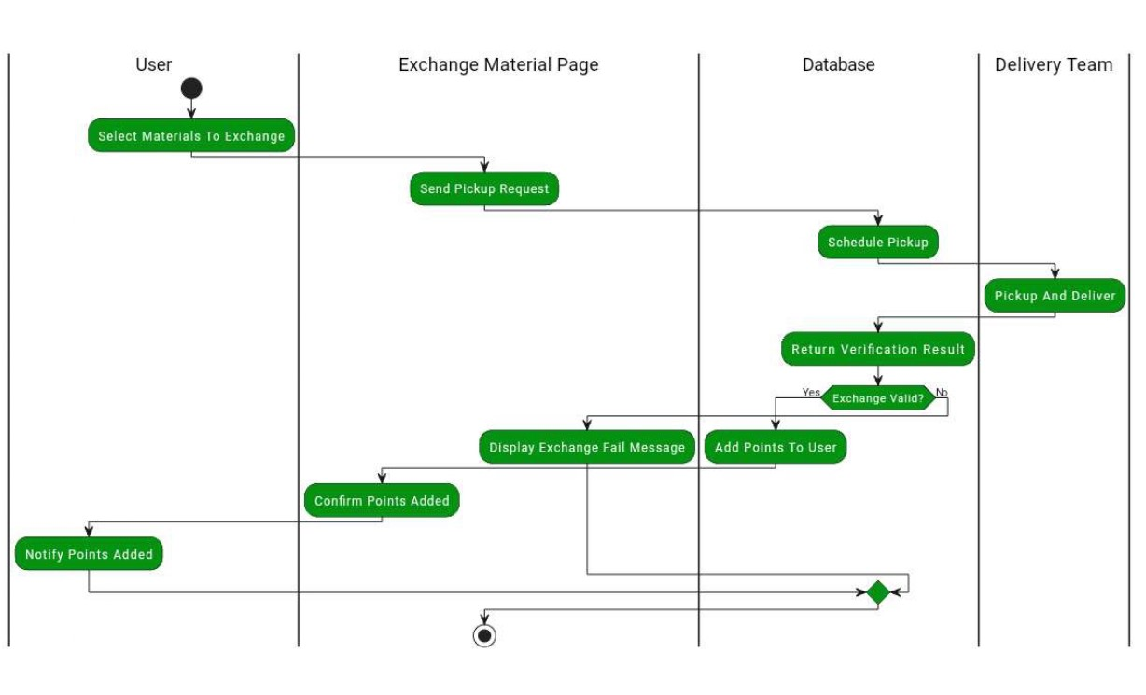
Figure 3.13: Activity Diagram (Exchange Flow)
Explanation:
User Action:
- The user selects materials to exchange.
- A pickup request is sent.
System (Exchange Material Page) Processes the Request:
- The system receives the request and processes it.
- If everything is correct, it proceeds; otherwise, it may return an error message.
Database Actions:
- The system schedules the pickup in the database.
- A verification process determines if the exchange is valid.
Delivery Team Execution:
- If valid, the delivery team picks up and delivers the materials.
- If invalid, an error message is displayed to the user.

Reward Processing:
- If the exchange is successful, points are added to the user’s account.
- The system confirms and notifies the user about the points added.

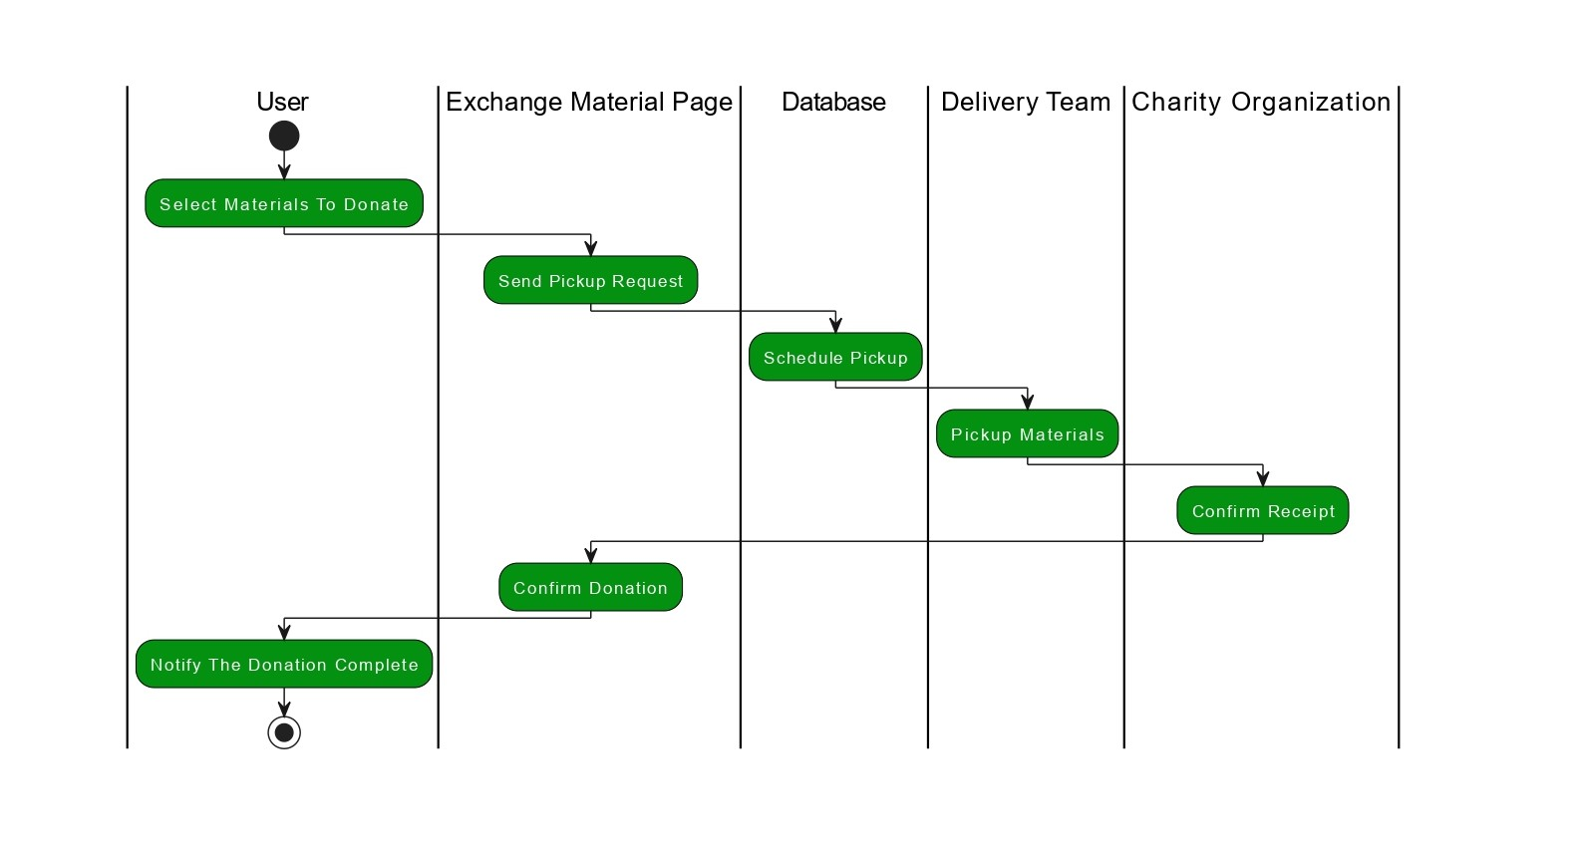
Figure 3.14: Activity Diagram (Donation Flow)
Explanation:
- The user initiates the donation process.
- The system verifies the available materials/points.
- The user selects a donation option.
- The donation is processed
- A confirmation message is sent to the user.
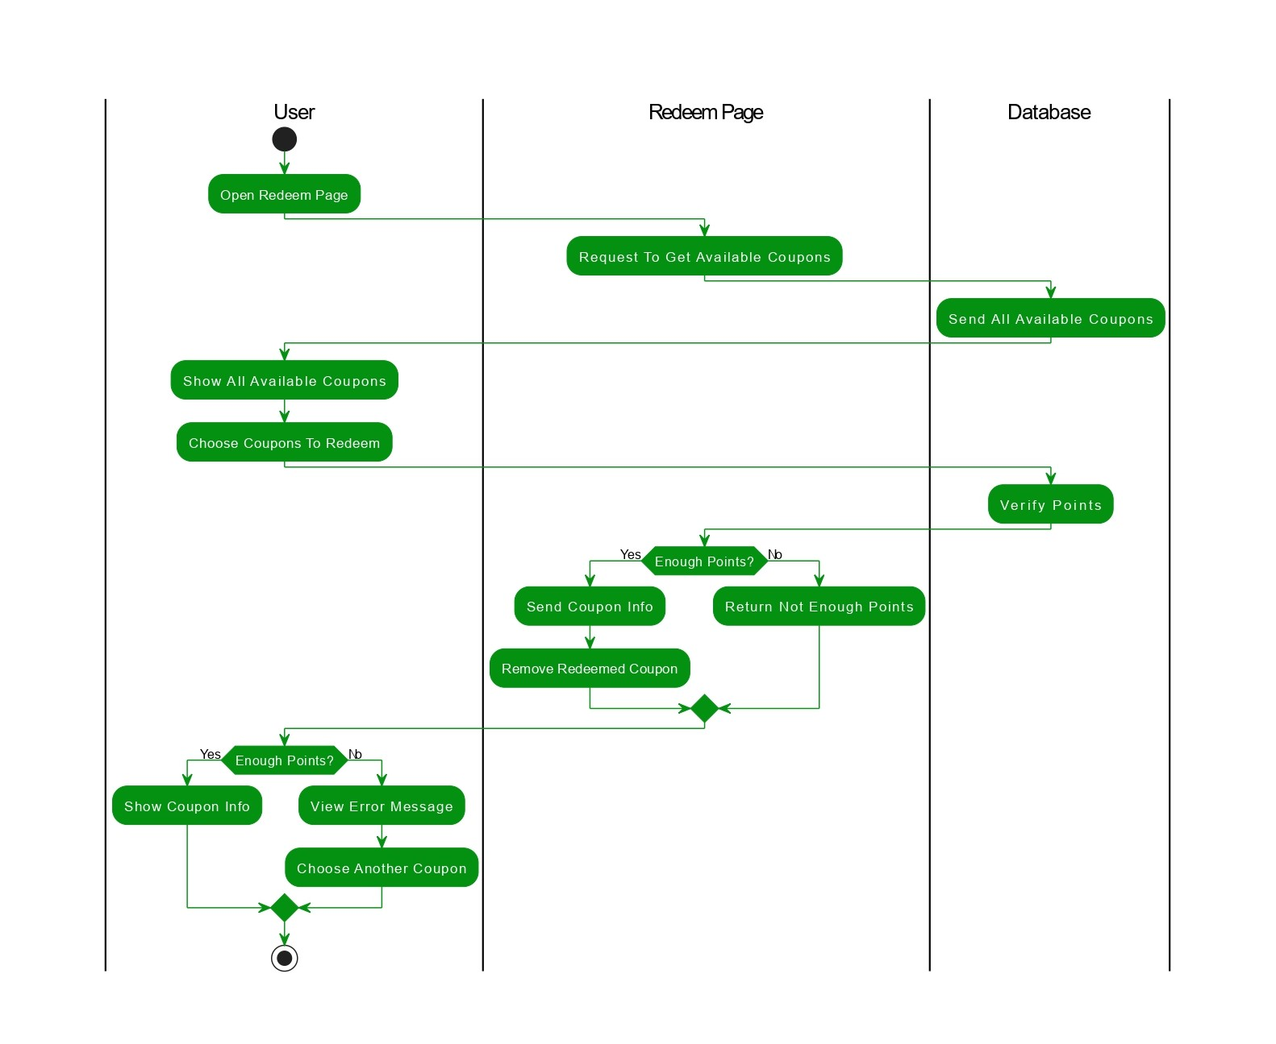
Figure 3.15: Activity Diagram (Redeem Process)
Explanation:
- The user opens the redeem section in the app.
- The system checks available points.
- The user selects a reward.
- The system validates the request and deducts the required points.
- A confirmation or coupon code is generated and displayed to the user.

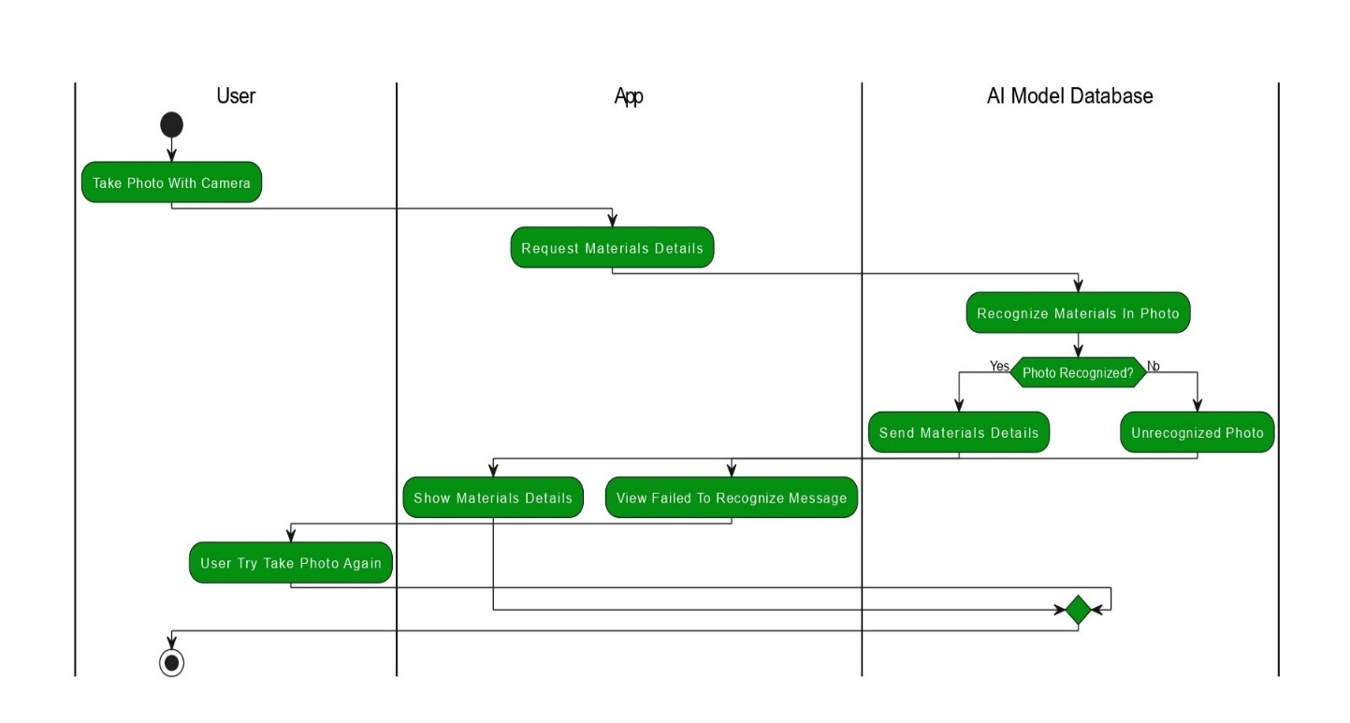
Figure 3.16: Activity Diagram (AI Material Recognition)
Explanation:
- The user captures an image of the material.
- The system processes the image using an AI model.
- The AI determines the type of material (plastic, metal, paper, etc.).
- The user receives information about the item

3.7 Class Diagram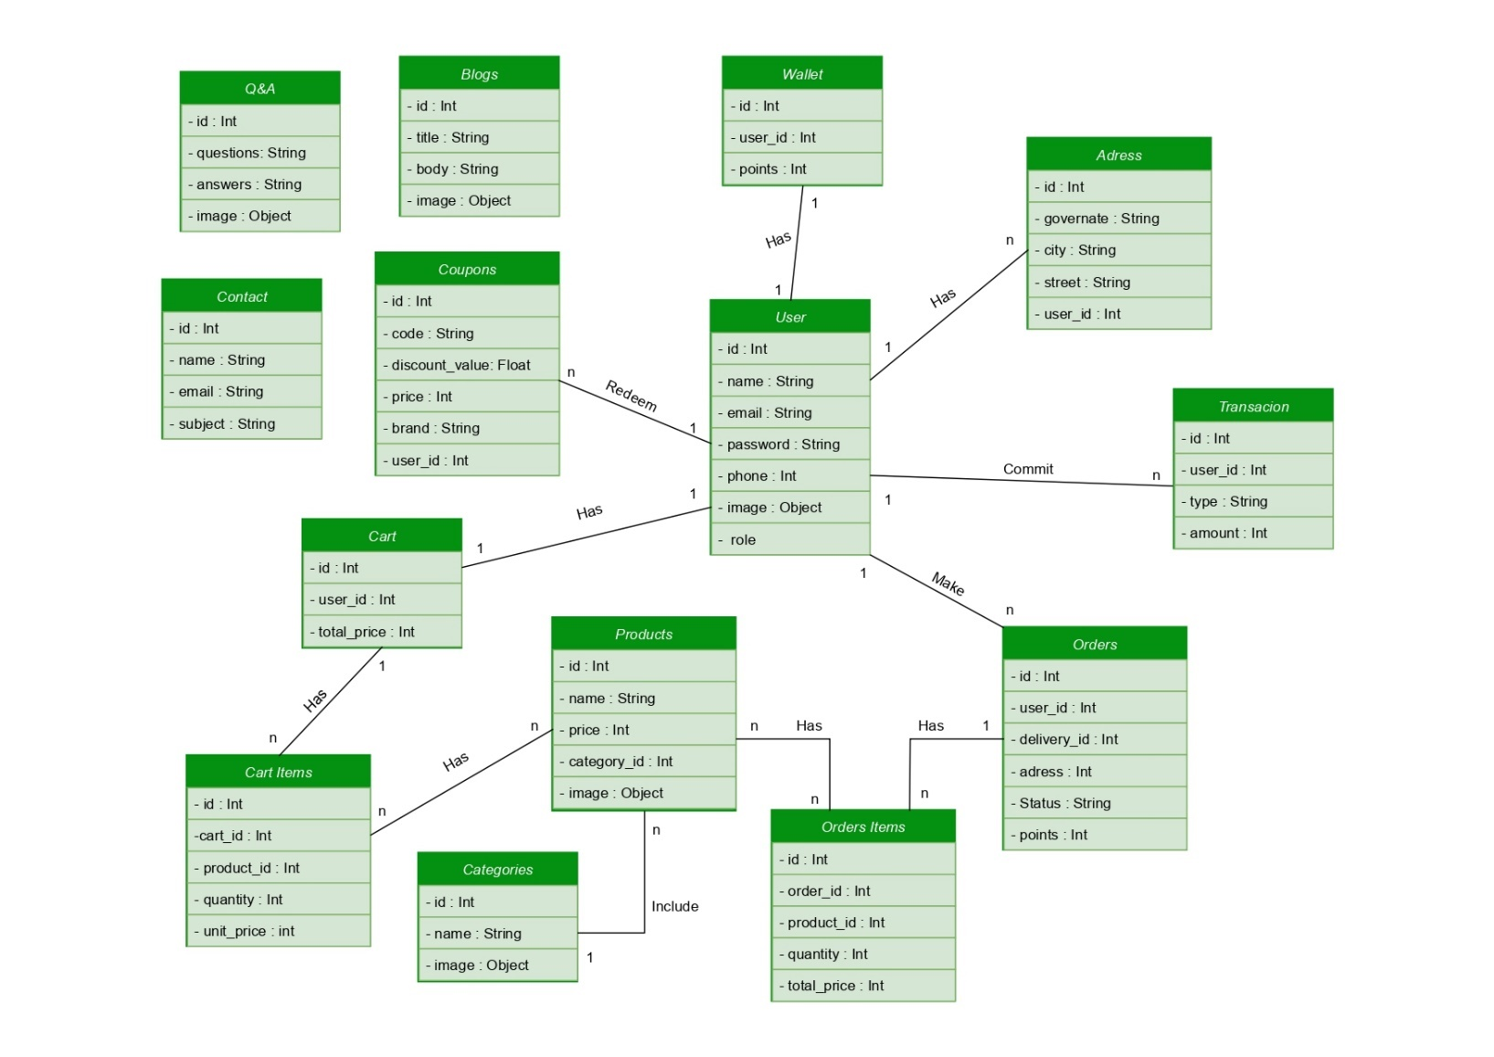
Figure 3.17: Class Diagram
Explanation:
- It consists of different classes such as User, Admin, Material, AI Model, Reward, and Charity (depending on what’s in your diagram).
- Relationships like associations (e.g., a User can have multiple Rewards) or inheritance (e.g., Admin is a type of User) are defined.
- Each class contains attributes (e.g., userID, materialType) and methods (e.g., scanMaterial(), redeemPoints()).

3.9 Tools and Technologies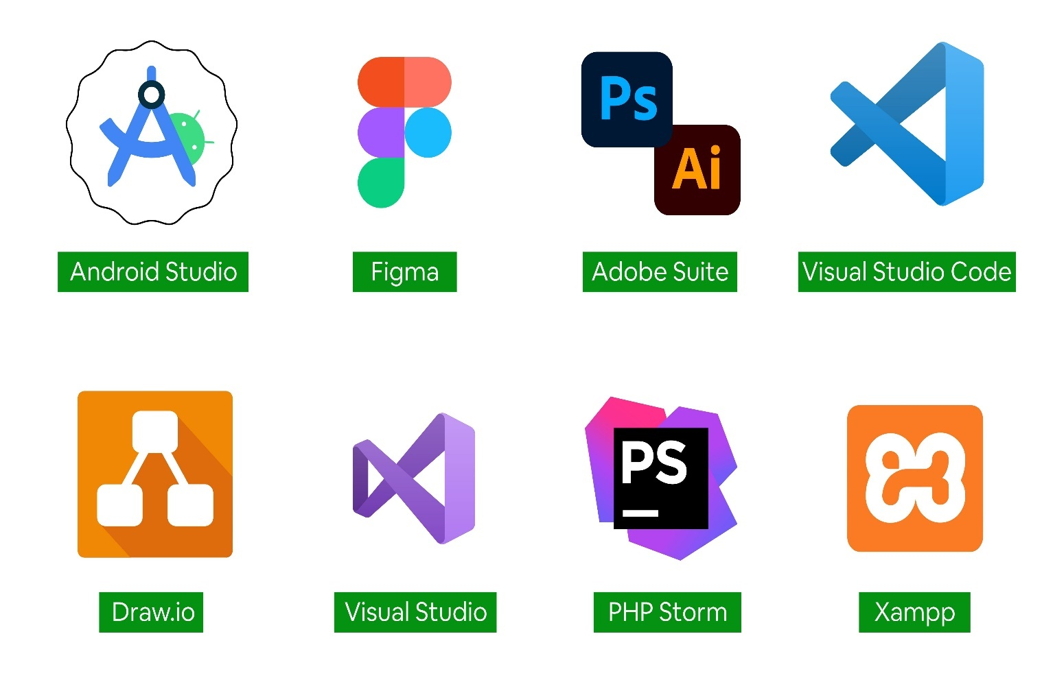
Figure 3.18: Tools and Technologies
In System analysis
- We used draw io for drawing the diagrams

In Backend
- We used PHP storm and Xampp

In UI/UX and Frontend
- We used Figma and Vs code with frontend methods like Html and Css

In AI
- We used Vs code and Python libraries

In Cross-Platform
- We used Android Studio to develop and launch our app

3.10 Summary
We give the reader comprehensive information on our system's functional and non-
functional needs as well as user requirements in this chapter. We offer UML diagrams
that illustrate the specifics of the system's operation. We enumerated the tools we would
need to construct the system at the end of the chapter.

Chapter (4)

System Design

