# Mastering Embedded System Online Diploma

**www.learn-in-depth.com**

**First term (Final Project 1)**

**Eng. Omar Ahmed**

**My Profile**

---------

Contents

Mastering Embedded System Online Diploma 0

1. Chapter One: Requirement Diagram 2

Chapter Two: System Analysis 3

Chapter Three: System Design 6

Chapter four: Code Analysis 11

Chapter 5: Simulation 15

# Chapter One: Requirement Diagram

* 1. Case Study:

1. The system shall measure Pressure.

2. Give alarm if Pressure value greater than threshold value.

3. The system shall store pressure Value (not mandatory).

* 1. Requirement Diagram

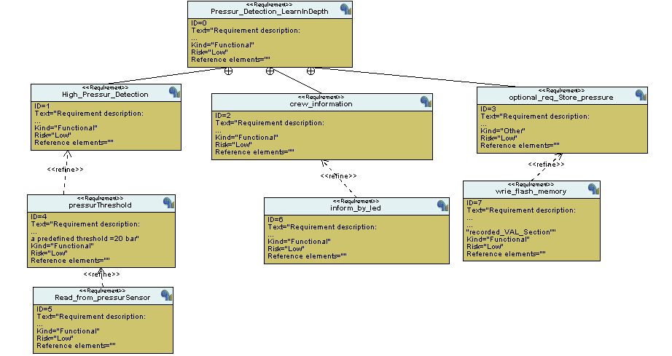

Assumption about the system:

1. The Pressure Sensor will never fail.

2. The Alarm will never fail.

3. The system is powered on.

# Chapter Two: System Analysis

2.1 System Analysis:

1. Use Case Diagram:

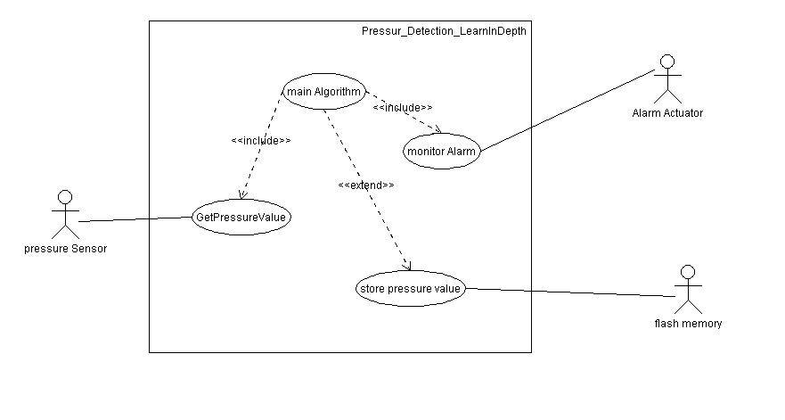

2. Activity Diagram:

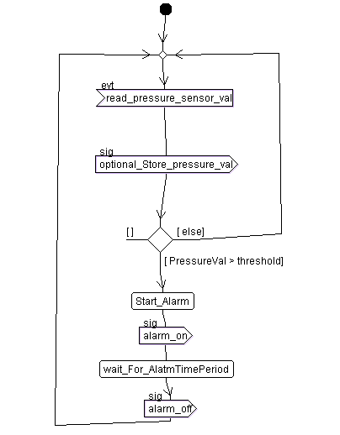

3 . Sequence Diagram :

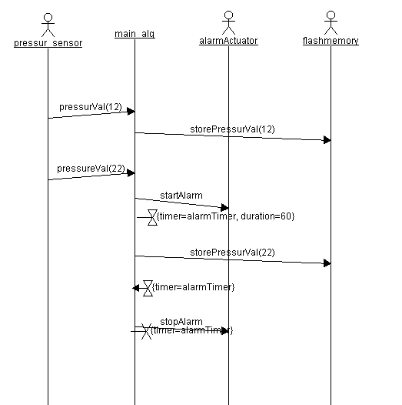

# Chapter Three: System Design

3.1System Design

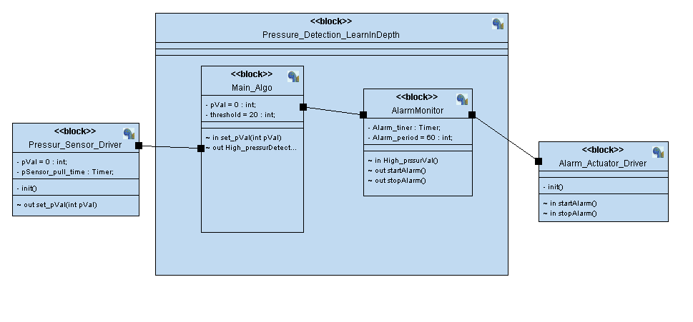

3.2 Simulation Diagram

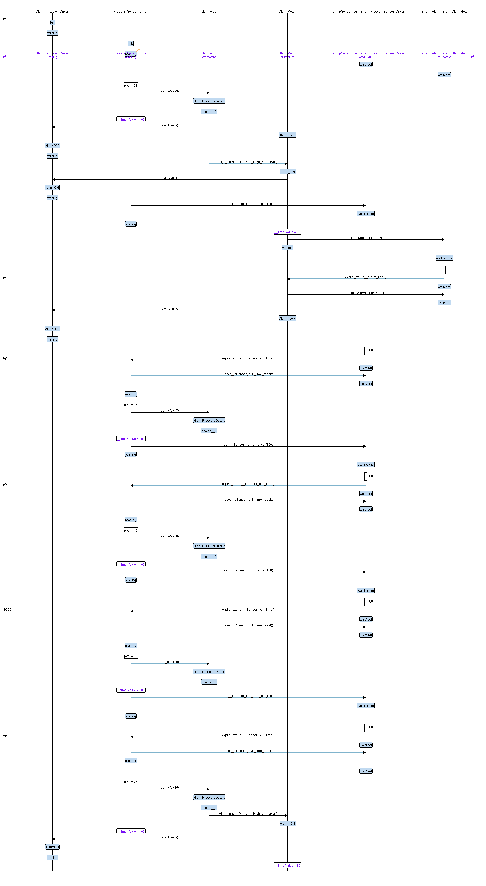

3.3 Pressure Sensor Driver

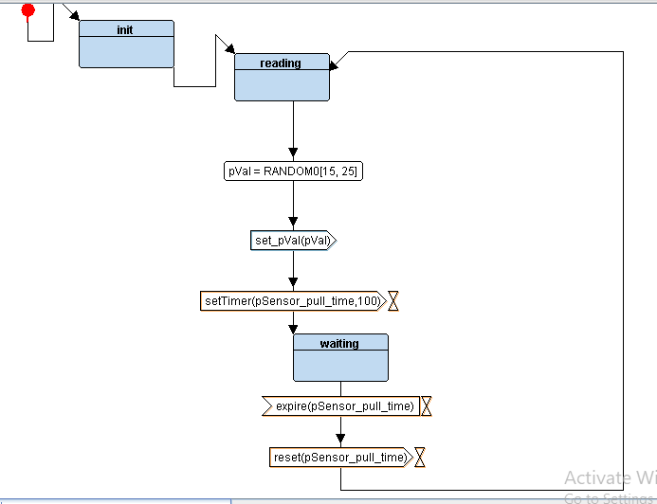

3.4 main Alg

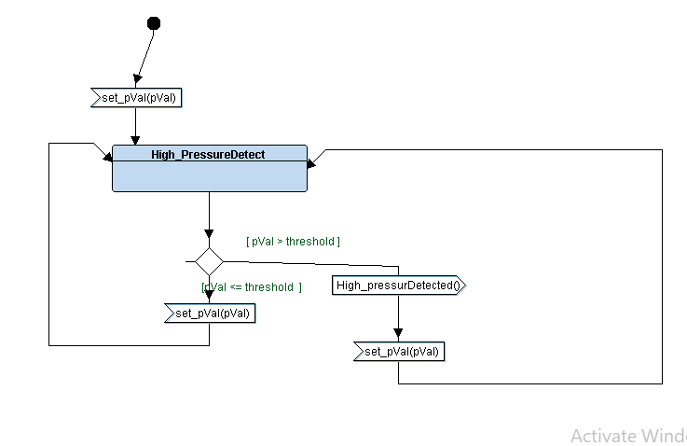

3.5 Alarm Monitor

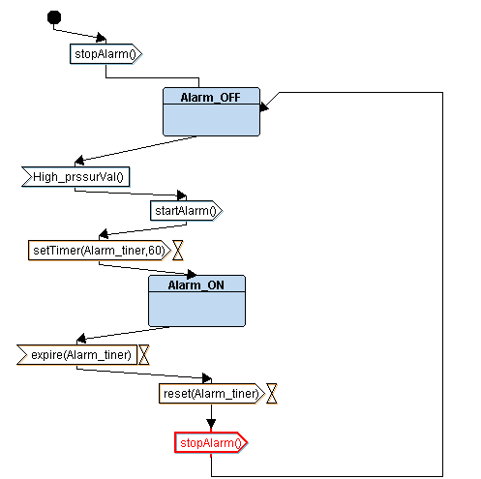

3.5 Alarm Actuator Driver

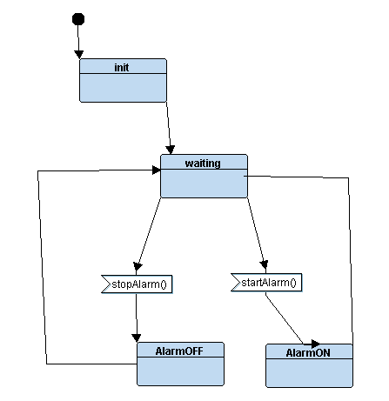

# Chapter four: Code Analysis

4.1 Map File

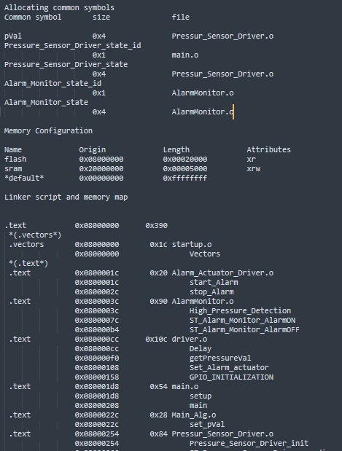

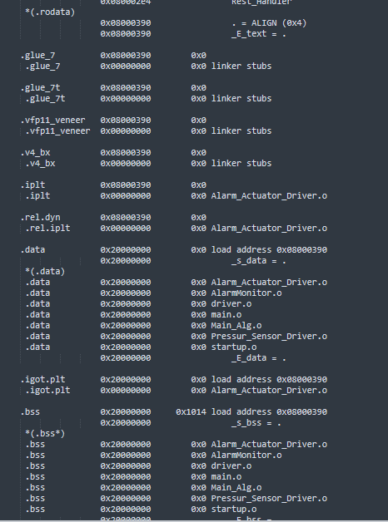

4.2 Pressure Controller Alarm Sections

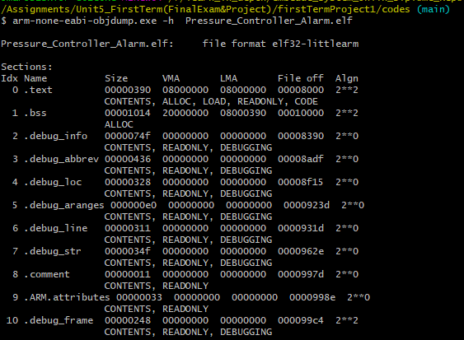4.3 Pressure Controller Alarm symbols

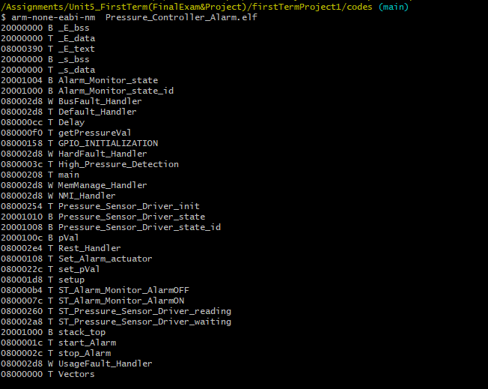

# Chapter 5: Simulation

5.1 main circuits

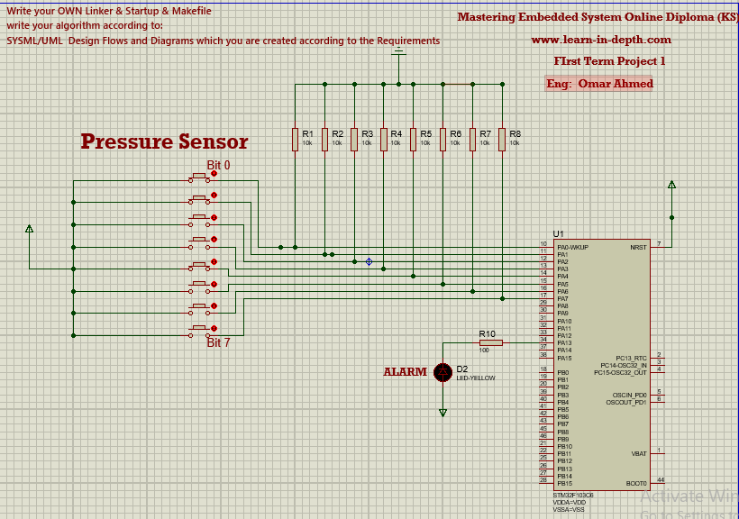

5.2 In case pressure value less than threshold

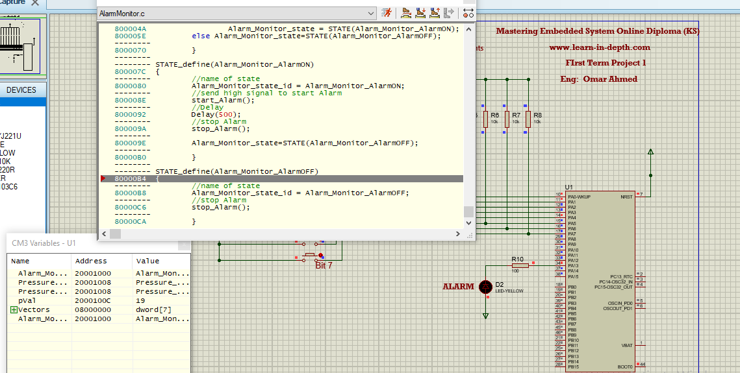

5.3 In case Pressure value greater than threshold

