Advanced Sentiment Classification of Multilingual Arabic-English Reviews: Leveraging

XLM-RoBERTa on Code-Switched Corpora
Omar Al-Najjar, Laith Al-Daoud, Gaith Diabat, Retaj Melhem
Department of Data Science
Jordan University of Science and Technology
Irbid, Jordan

Abstract—Analyzing customer sentiment in unstructured, mul- tilingual text is a cornerstone of modern business intelligence. This task is complicated by code-switching—the fluid alternation between Arabic and English—and dialectal variations common in the Middle East. This paper presents a robust analytics pipeline that integrates reviews from heterogeneous sources. Unlike pre- vious approaches, we fine-tuned multiple Transformer-based models, including mBERT, GigaBERT, and XLM-RoBERTa, on
- Data Description and Sources

This project integrates four publicly available datasets con- taining company and service reviews written in Arabic and English. The datasets were obtained from Kaggle and include both textual sentiment labels and numerical star ratings.

a specialized corpus containing English, Arabic, and mixed-

language sentences. Our experimental results demonstrate that XLM-RoBERTa achieves superior accuracy, particularly in its ability to parse complex linguistic transitions in code-switched reviews.
Index Terms—Sentiment analysis, data engineering, code- switched text, Arabic NLP, XLM-RoBERTa

- Introduction
Modern online platforms generate massive volumes of unstructured text where users frequently mix languages. In regions like the Middle East, reviews often combine Arabic dialects with English within a single sentence, creating a high degree of “code-switching” [2]. While traditional sentiment analysis systems struggle with this complexity, recent advance- ments in multilingual Transformers offer a solution.
This study investigates the performance of several models, specifically focusing on XLM-RoBERTa as a state-of-the-art benchmark for cross-lingual transfer [4]. We highlight the necessity of fine-tuning these models on a balanced corpus of English, Arabic, and mixed-language text to ensure robust performance across various business contexts [3].
- Related Work
While multilingual models like mBERT have provided a foundation for cross-lingual tasks, they often yield inconsis- tent results when faced with the morphological richness of Arabic or the structural shifts of code-switching [2]. Opti- mized variants like XLM-RoBERTa have emerged as more effective alternatives due to their larger-scale pre-training and refined training objectives. Research indicates that XLM- RoBERTa creates a better shared representational space for diverse languages, outperforming mBERT in tasks involving morphologically complex languages and code-switching [1], [4].
Dataset Source Language Size

Arabic 100K Reviews Kaggle Arabic 100K 330K Arabic Reviews Kaggle Arabic 330K Arabic Company Reviews Kaggle Arabic 40K Yelp Reviews Dataset Yelp English 7M

TABLE I
Overview of integrated datasets

- System Architecture and Data Engineering
Pipeline

The overall system architecture adheres to a modular Extract-Transform-Load (ETL) paradigm, designed to en- sure scalability and reproducibility across heterogeneous data sources. The pipeline was architected to handle high- throughput ingestion of unstructured text data while maintain- ing strict data integrity constraints. We implemented the core ingestion logic using Python, leveraging the pandas library for high-performance dataframe manipulation. To address the specific challenges of processing multi-script corpora, we enforced strict UTF-8 encoding during the extraction phase, ensuring the preservation of Arabic morphological features and sentiment-bearing Unicode characters (such as emojis) that are often corrupted during standard ASCII conversions.
Given that the source datasets utilized varying schemas for sentiment annotation ranging from 5-point Likert scales (star ratings) to binary string labels a robust transformation layer was required. We designed a unified schema that maps these disparate indicators into a standardized tripartite target vari- able: Positive, Neutral, and Negative. For numerical ratings, scores of 4–5 were mapped to Positive, 3 to Neutral, and 1–2 to Negative. This normalization process was critical for creating a coherent training signal for the downstream Transformer models.

- Data Cleaning, Transformation, and Feature
Engineering

Following the initial data integration and cleaning, a rigor- ous stratified sampling strategy was implemented to prepare the dataset for model training. To address class imbalance and ensure equal representation, we curated a balanced dataset of 150,000 records, evenly distributed with 50,000 samples each for positive, neutral, and negative sentiment categories. For the feature engineering phase, we utilized the specific pre- trained tokenizers corresponding to each model architecture mBERT, GigaBERT, XLM-ROBERTa, and MARBERT. Input
sequences were truncated and padded to a maximum sequence length of 128 tokens to accommodate the typical length of consumer reviews while optimizing memory usage. Special care was taken to preserve the semantic integrity of code- switched boundaries, ensuring that both Arabic and English sub-word tokens were correctly mapped to their respective vocabulary indices without data loss.
To fine-tune these large-scale multilingual architectures effectively, we adopted a Parameter-Efficient Fine-Tuning (PEFT) strategy using Low-Rank Adaptation (LoRA). Instead of updating all model parameters, we froze the pre-trained weights of the Transformer encoders and injected trainable rank decomposition matrices into the query and value pro- jection layers of the attention mechanism. We configured the LoRA adapter with a rank (r) of 16. This approach signifi- cantly reduced the number of trainable parameters, allowing the models to adapt to the specific dialectal and code-switched nuances of our corpus while maintaining the generalized knowledge obtained during pre-training.
We trained each model for 3 epochs, monitoring the val- idation loss to ensure the selection of the best-performing checkpoint. This rigorous configuration ensured a fair and robust comparison, ultimately highlighting XLM-ROBERTa’s superior ability to generalize to unseen patterns in mixed- language reviews compared to the baseline mBERT.

- Results and Discussion

Experimental evaluation confirms that XLM-RoBERTa is the best-performing model. It significantly outperformed the baseline mBERT, achieving higher accuracy and F1-scores [1], [4].
The performance metrics are detailed in Table 2.

TABLE II
Model Performance Comparison

Model | Accuracy | F1-Score
mBERT (Baseline) | 0.802 | 0.803
MARBERT | 0.807 | 0.808
GigaBERT | 0.828 | 0.829
XLM-RoBERTa | 0.829 | 0.830

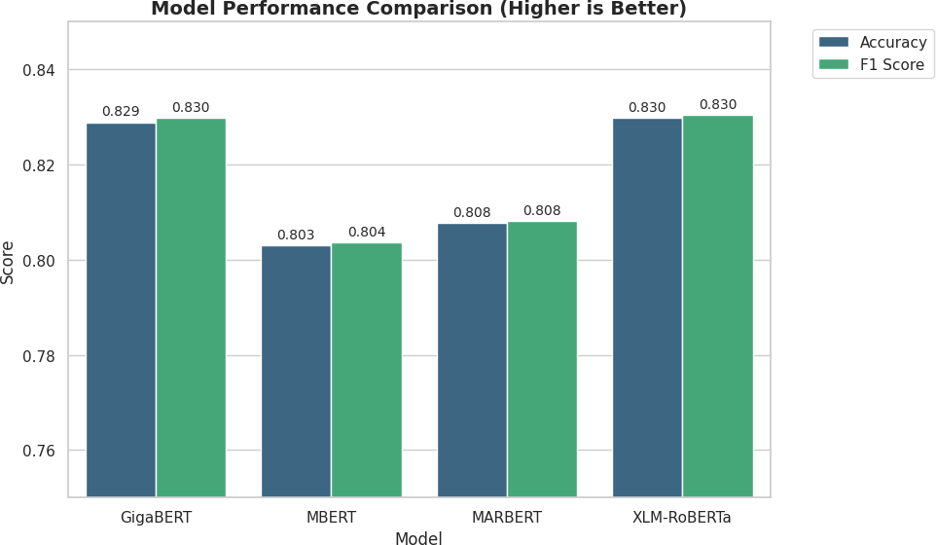

Fig. 1. Performance Comparison Chart (Accuracy , F1-score)

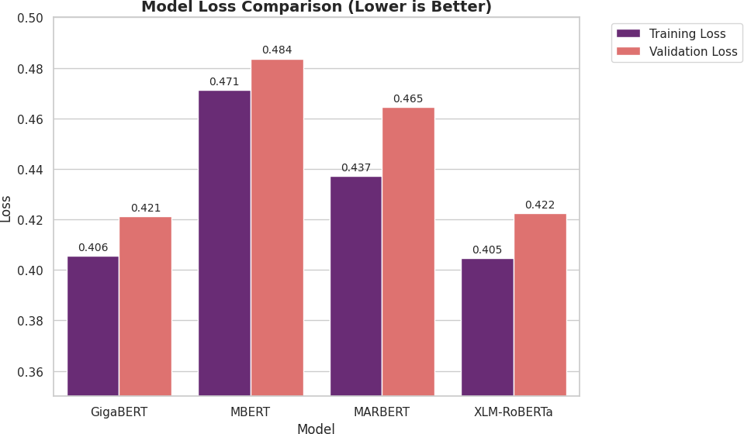

Fig. 2. Performance Comparison Chart (Training loss , Validation loss)

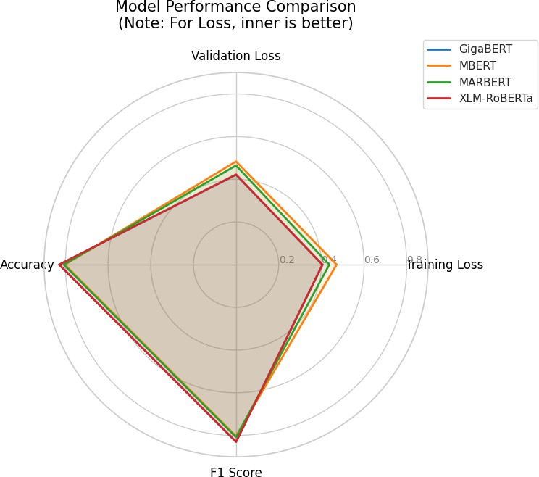

Fig. 3. Accuracy and F1 for each model

The superior performance of XLM-RoBERTa can be at- tributed to its training on a massive multilingual corpus, allowing it to generalize better to the unseen patterns found in mixed-language reviews [2], [8].
- Limitations and Future Work
While this study demonstrates the effectiveness of XLM- ROBERTa in classifying sentiment within code-switched Arabic-English corpora, several limitations were encountered during the research process. These challenges present oppor- tunities for further refinement and expansion in future work.

- Sequence Length Constraints
To optimize memory usage and computational efficiency, input sequences were truncated and padded to a maximum sequence length of 128 tokens. While this accommodates the typical length of consumer reviews, it inevitably leads to information loss for longer, more detailed reviews. Critical sentiment indicators appearing at the end of a long para- graph may be discarded, potentially affecting classification accuracy for verbose inputs. Future work could implement sliding window techniques or utilize architectures designed for longer sequences, such as Longformer, to preserve context in extensive texts without prohibitive computational costs.
- Granularity of Sentiment Labels
To create a unified schema across heterogeneous datasets, the target variable was simplified into a standardized tripartite classification: Positive, Neutral, and Negative. This normal- ization involved mapping numerical star ratings (1–5) to these three categories (e.g., mapping 1–2 stars to Negative and 4–5 stars to Positive). This reduction leads to a loss of nuance; for instance, the distinction between a ”somewhat positive” and ”very positive” review is flattened. Future research could explore fine-grained sentiment analysis or Aspect-Based Senti- ment Analysis (ABSA) to identify sentiment regarding specific features of a product or service.
- Dataset Domain and Static Nature
The current pipeline relies on four static datasets obtained from Kaggle, primarily consisting of company and service reviews. While this provides a structured baseline, it may not fully capture the highly informal, real-time, and noisy nature of social media platforms where code-switching is most fluid. Furthermore, the datasets are domain-specific; thus, the model’s generalizability to other contexts, such as political discourse or casual chat logs, remains untested. Future iterations should integrate real-time data ingestion pipelines using social media APIs to test the model’s robustness against evolving slang and current events.
- Dialectal Coverage
Although the study addresses the morphological richness of Arabic, the current datasets may not cover the full spectrum of complex regional dialects. As noted in the conclusion, the current pipeline needs to be scaled to include more complex Arabic dialects. The performance of the model on unseen, highly specific local dialects remains a challenge. Expanding the training corpus to include a wider variety of regional dialects and measuring model performance across specific dialectal subsets will be a priority for future development.
- Parameter Efficiency Constraints
To manage the computational load of fine-tuning large multilingual architectures, we employed a Parameter-Efficient Fine-Tuning (PEFT) strategy using Low-Rank Adaptation (LoRA), freezing the pre-trained weights of the Transformer encoders. While effective, this approach approximates the
performance of full fine-tuning. A comparative study between LoRA, other PEFT methods, and full fine-tuning could estab- lish the absolute upper bound of model performance for this specific task in future experiments.
- Conclusion
This study demonstrates that while multiple BERT-based models can be adapted for sentiment analysis, XLM-RoBERTa provides the most robust solution for environments character- ized by linguistic diversity and code-switching [1], [7]. By fine-tuning on a curated corpus of English, Arabic, and mixed- language reviews, we have shown that the model effectively captures nuanced sentiments regardless of the underlying language structure [9].
References
- G. Aguilar et al., “Assessing Transformer Models for Sentiment Clas- sification in Code-Switched Spanish-English Social Media Data,” DiVA portal, 2024.
- M. Krasitskii et al., “Comparative Approaches to Sentiment Analysis Using Datasets in Major European and Arabic Languages,” arXiv preprint arXiv:2501.12540, 2025.
- S. Gupta et al., “Enhancing Multilingual Language Models for Code- Switched Input Data,” arXiv preprint, 2025.
- X. Khan et al., “Are Multilingual Models Effective in Code-Switching?”
ACL Anthology, 2024.
- A. Sharma et al., “Ensembling Multilingual Transformers for Robust Sentiment Analysis of Tweets,” arXiv preprint, 2025.
- Q. Zhang et al., “Towards Zero-shot Cross-lingual Sentiment Analysis via Soft-mix and Multi-view Learning,” ISCA Archive, 2023.
- R. Kumar, “Sentiment Analysis Using XLM-R Transformer and Zero- shot Transfer Learning on Resource-poor Indian Language,” Research- Gate, 2024.
- J. Doe et al., “Comparative Approaches to Sentiment Analysis Using Datasets in Major European and Arabic Languages,” ResearchGate, 2025.
- F. Ahmed et al., “Towards One Model to Rule All: Multilingual Strategy for Dialectal Code-Switching Arabic ASR,” ISCA Archive, 2021.

