

OwnerMate: AI Business Optimization Platform

Presented to the Faculty of Computer and Information Technology, Jordan University of Science and Technology

In Partial Fulfillment
of the Requirements for the Degree of Bachelors in Data Science

By:
Laith Essam Faleh Al Daoud Ghaith Abedalaziz Saleh Aldiabat
Omar Mohammad Atalla Kh. Alnajjar Retaj Abdel Baset Mohammad Milhem

Supervised By:
Dr. Ala‘a Al-Howaide

Irbid, Jordan Fall 2025

Abstract
The OwnerMate Platform is an all-in-one AI-powered platform designed to optimize the per-formance of small and medium-sized businesses (SMBs). The system created to help resolve the market fragmentation issue is the integration of predictive analytics, sentiment analysis, and content generation into a single workflow which is designed to cater to the linguistic and cultural requirements specific to the Jordanian market. The solutions created are meant for Jordanian SMB owners restaurant managers, for example, who lack the necessary time, money, and expertise to handle a number of specialized subscriptions. The system was developed to be accessible on a responsive website, which allows the system to be accessed at all times and anywhere by simply using a web browser and Internet connectivity. Our research described in this assignment covers the main operations of the development of the system, beginning with the collection of research data on various websites and review of the information of various reporting systems available on the Internet such as Prediko and Chattermill. They must then be specified to the needs after the use case analysis was performed, in the design and development of the system process. The final step was the implementation of the system.

Acknowledgement
We are very thankful to everyone who supported us in completing this paper effectively. We would like to thank our advisor, Dr. Ala’a Al-Howaide, for his continuous guidance, patience, and valuable feedback throughout the development of this project.

Contents

List of Abbreviations vii
- Introduction 1
  - Introduction to AI-Driven Business Intelligence 1
  - Background 1
    - Predictive Analytics and Time-Series Forecasting 1
    - Natural Language Processing (NLP) and Sentiment Analysis 2
    - Generative AI for Content Creation 2
  - Problem statement 3
    - The "Data-Decision" Gap 3
    - Market Fragmentation and Complexity 3
    - Lack of Localization for the Jordanian Market 3
  - Importance of the project 4
  - Required tools 5
    - Streamlit 5
    - LangGraph 5
    - ChromaDB 5
    - Pydantic 5
    - Fine-Tuned LLM (e.g., Llama 3 / Mistral) 5
    - Pandas 6
    - Scikit-learn 6
- Literature review 6
  - Tools Background 6
    - Predictive Analytics & Inventory Tools 7
    - Content & Marketing Generation Tools 8
    - Sentiment Analysis & Customer Intelligence 8
    - Business Intelligence Dashboards 9
  - Project Differentiation (OwnerMate vs. Related Tools) 9
  - Academic Literature Review 9
    - Machine Learning for Retail Demand Forecasting 10
    - Arabic Sentiment Analysis (Levantine Dialect Focus) 10
    - Generative AI in Business Intelligence 11
  - Research Framework & Measurements 11
    - Dataset & Data Sources 11
    - Selected Models 11
    - Evaluation Metrics 12
- Requirement Analysis and Specifications 12
  - Introduction 12
  - Work Progress 12
    - Project Schedule 12
  - Functional Requirements 13
    - User Functional Requirements 13
    - System Functional Requirements 14
    - AI Agent Functional Requirements 15
  - Non-Functional Requirements 16
    - System Assumptions 16
    - Quality Attributes 16
- System Design 16
  - Introduction 16
  - Context Diagram 17
  - Use Case Diagram 18
  - Data Flow Diagram (DFD) 21
  - Class Diagram 22
  - Sequence Diagram 23
  - Business Process Model 23
  - User Interface Design 24
    - Site Map 24
    - Storyboard 25
  - Data Model 28
    - Entity Relationship (ER) Diagram 28
- Conclusion 29
  - Conclusion 29
  - Difficulties Faced 29
  - Future Works 30

List of Figures
- Project Timeline Gantt Chart 13
- Level 0 Context Diagram 17
- Level 1 Context Diagram 18
- Level 2 Context Diagram 18
- Use Case Diagram 19
- Different File Formats to CSV Pipeline 21
- Data Flow Diagram 22
- Class Diagram 22
- Sequence Diagram: Demand Forecast 23
- Business Process Model (As-Is vs. To-Be) 24
- Site Map 24
- Login Page UI 25
- Dashboard UI 26
- Forecast Page UI 26
- Sentiment Analysis UI 27
- Content Generation UI 27
- Reports Page UI 28
- Entity Relationship Diagram 28

List of Tables
2 Comparative Analysis of Existing Tools vs. OwnerMate 6

List of Abbreviations
Abbreviation Full Description

AI Artificial Intelligence
API Application Programming Interface
ARIMA Auto-Regressive Integrated Moving Average
BI Business Intelligence
CSV Comma-Separated Values
DFD Data Flow Diagram
DNN Deep Neural Networks
DSS Decision Support Systems
ER / ERD Entity Relationship / Entity Relationship Diagram
GB Gradient Boosting
GPU Graphics Processing Unit
JSON JavaScript Object Notation
KPI Key Performance Indicator
LLM Large Language Model
MAPE Mean Absolute Percentage Error
MFA Multi-Factor Authentication
ML Machine Learning
MSA Modern Standard Arabic
NLP Natural Language Processing
NPS Net Promoter Score
POS Point of Sale
RAG Retrieval-Augmented Generation
RF Random Forest
RMSE Root Mean Square Error
SA Sentiment Analysis
SMBs Small and Medium-sized Businesses
UML Unified Modeling Language
XGBoost Extreme Gradient Boosting

Introduction

Introduction to AI-Driven Business Intelligence
The modern digital economy has made data an asset of the essence for Small and Medium-sized Businesses (SMBs). But for many of these companies the biggest problem is less about collecting data and more about effective interpretation. This particular project area takes a different approach to raw data, using Artificial Intelligence (AI) and Machine Learning (ML) to create a process or set of processes that transforms that data into actionable business decisions. Organizations apply the technologies mentioned above and move from There is a shift from reactive management to proactive optimization. From a technology perspective, this area is based on three pillars: Predictive Analytics – predictive ability and inventory management; Natural Language Processing (NLP) for customer sentiment analysis in online reviews; and Generative AI for automated Content creation for marketing purposes. Indeed, there are silos of these tools, but now the industry has a fragment-oriented approach where owners of businesses have to deal with multiple committed stand-alone platforms . This is why consolidation is at the core of this project bringing together all the different capabilities to make a coherent system where advanced business intelligence is readily available and affordable for the local market.

Background
The proposed project is situated within the field of Applied Artificial Intelligence for Business Process Optimization, particularly the design of Data-Driven Decision Support Systems (DSS) targeting Small and Medium-sized Businesses (SMBs). The process involves blending three different sub-components of calculation to bring together complicated business applications in one system.

Predictive Analytics and Time-Series Forecasting
The work involves the use of Time Series Analysis and Regression Algorithms to interpret sales trends of the past and predict the future on a prescriptive level. While regular reporting systems simply graph the data to indicate what has occurred in the past (Descriptive Analytics), this system is prescriptive.
From a technical point of view, what this module does is precisely decompose historical data into three essential components: Trend, Seasonal, and Residues. These components are then identified through algorithms such as ARIMA models/Random Forest Regression in the Scikit-learn library.
A technical distinctiveness of the model is the inclusion of "Exogenous Variables," or external characteristics. The model does not wholly depend on past sales values for its calculation, but rather includes "market context" variables such as:

      - Calendar Events: Encoding the events in the Jordanian calendar (e.g., Eid al-Fitr, Ra-madan) into binary features to predict the surges in demand.
      - Weather Metrics: linking temperature or precipitation patterns with foot traffic.
It’s a multi-variate approach that assists the system in calculating Sales Velocity and acting on logic-based recommendations such as ‘Restock Alert’ if the demand exceeds the existing stock levels subtracted by the lead time.

Natural Language Processing (NLP) and Sentiment Analysis
For the processing of the unstructured feedback, the project uses Aspect-Based Sentiment Anal-ysis. This approach not only classifies the feedback as positive and negative but tries to deter-mine the specific target of the feedback, whether "Food," "Service," or "Price."
The most important technical element of this module is a Large Language Model (LLM) that has been fine-tuned for Levantine/Jordanian Arabic dialects. Even global NLP models, such as Standard BERT, will often be tested by what is known as "Diglossia," a difference between modern standard Arabic versus spoken street language. To address this, our system utilizes:
      - Dialect-Aware Tokenization: Handling local slang words or idioms such as ( = deli-cious, = expensive).
      - Vector Embeddings: Employing the use of ChromaDB to transform the complaints expressed through textual form to numerical form thereby enabling semantic grouping of complaints expressed through different wording.
This is due to its ability to record ‘granular’ levels of insight, such as the fact that a business has a "5-star Food Score" and a "2-star Service Score," as opposed to the "3.5-star Overall Score."

Generative AI for Content Creation
This module is also a sign of the shift from Analytical Artificial Intelligence to Generative Artificial Intelligence, as it is the execution layer for this platform. It is technically working on a Retrieval-Augmented Generation (RAG) pipe. It is for the relevance of this content through facts in the business.
The process follows a thorough ‘Prompt Engineering’ workflow:
- Context Injection: The system draws on the quantitative findings from the Predictive module ("Surplus of Inventory Item A") and the qualitative findings from the NLP mod-ule ("Customers love the taste of Item A").
- Prompt Construction: These data points are dynamically inserted into a pre-structured prompt template (e.g., "Create an Instagram caption promoting [Item A] emphasizing its

[Taste], offering a [10% discount]").
- Generation: The fine-tuned LLM generates the marketing copy, while a text-to-image model (or API integration) generates the accompanying visual asset.
“Fragmentation”: Automation of this issue ensures that a closed-loop system with analytics-driven content creation eliminates the need for the businessman to transfer data insights into third-party designing software.

Problem statement
“The biggest challenge we have isn’t a lack of data or resources, but rather it’s the fragmentation of the current marketplace and a lack of localized decision-making information systems usable by Small and Medium-sized Businesses.”

The "Data-Decision" Gap
Today, small businesses produce a huge amount of data such as sales records or customer reviews. Yet they lack "the right decisions" to make effective use of such huge amounts of data. For small businesses, owners require recommendations such as directions to resupply or to lower the price rather than raw data difficult to interpret.

Market Fragmentation and Complexity
The current landscape of business tools is highly specialized and fragmented. A business owner is forced to subscribe to, learn, and manage multiple distinct platforms to cover their needs:
      - Predictive Analytics: Tools like Prediko or Blue Yonder handle forecasting but lack marketing features.
      - Content Creation: Platforms like Canva or Jasper help with design but do not use business data to inform what content to create.
      - Sentiment Analysis: Tools like Chattermill analyze reviews but fail to connect these insights to inventory or pricing strategies.
What it does: it generates a “siloed” flow where the information obtained doesn’t result in any automated activity. As a regular restaurant owner, having a number of subscriptions is both inefficient and out of his budget, considering that his budget lies somewhere from 200 to 400 JD per month.

Lack of Localization for the Jordanian Market
The most problematic aspect is that these global platforms are created without considering the context in which the Jordan market operates.

      - Linguistic Barriers: The generic tools of NLP are unable to deal with the complexities of Levantine Arabic, as they are not able to understand the local sentiments expressed in the reviews.
      - Contextual Blindness: Current global forecasting solutions do not take into considera-tion the knowledge of local market dynamics, such as the peak in demand during local holidays or the changes in traffic in response to local weather or events.
The existing solutions are either very complex and cost heavy or very general in nature, thereby making a compelling requirement for a combined and localized solution.

Importance of the project
The importance of this project is found in its capacity to democratize an advanced form of business intelligence to fill the gap found between the level of AI-based technologies and the needs of SMBs as far as requirements of business intelligence.
    - Democratizing AI for SMBs
With its sights on the SME market, the current initiative brings business intelligence solutions at the enterprise level within their reach. The solution provides a local business owner the ability to compete at a significantly reduced cost compared to international competitors (50-100 JD/month compared to the latter’s 200-400 JD/month).
    - Solving Market Fragmentation
However, there is a lot of fragmentation when it comes to available solutions, meaning that businesses have to use a number of specialized systems for their inventory, design, and analysis needs. The current project will eliminate this inefficiency by integrating all these requirements into a single "Unified Loop," where analysis will drive activity, such as pricing decisions or content creation.
    - Cultural and Linguistic Localization
The project addresses key limitations of global software by focusing on the Jordanian market. It incorporates specialized NLP models capable of accurately interpreting Levantine Arabic, along with predictive algorithms designed to reflect local cultural and market dynamics.
    - Transforming Data into Action
While small businesses often possess large volumes of data, they frequently lack the ability to extract the right decisions from it. This system bridges that gap by converting complex analytics into clear, plain-language recommendations that directly support decision-making.

Required tools

Streamlit
Streamlit is an open-source Python framework intended for use within the context of machine learning and data science. With this framework, one is able to create applications very fast without the use of code, but purely with Python scripts. In the project, the main interface of the application is built using Streamlit, and this enables the business owners to interact with the AI using the website.

LangGraph
It’s an orchestration library that has been developed on the top of the "LangChain" library for the specific creation of stateful multi-actor applications. Unlike the conventional chain, the "LangGraph" represents the system in the form of a "graph" consisting of nodes and edges, allowing for the execution of cycles and decision-making paths. In the project, it represents the "brain" that handles the state of the business logic, for instance, the orchestration of a business flow involving the retrieval of sales data followed by an analysis of the data and the subsequent decision to proceed either to the ‘Sentiment Node’ or the ‘Content Generation Node’ based on the outcome, mimicked by the human manager’s actions.

ChromaDB
ChromaDB is an open-source vector database that is utilized for the implementation of the RAG pipeline. The "embeddings" (numeric representations) of unstructured texts like customer reviews or business manuals are stored in ChromaDB. In this manner, the system is able to execute "semantic" searches in which the relevant information is sought on the basis of meaning, providing context to the LLM.

Pydantic
It is a data validation tool for python that helps ensure that the AI system enforces the "Struc-tured Output" requirement. It is used because, when the system makes a recommendation with respect to the prices or when it makes an organizational report, the data has to be in a strict json format that the system can process.

Fine-Tuned LLM (e.g., Llama 3 / Mistral)
The core intelligence of this system has a Large Language Model core. In this project, it is pre-trained on Jordanian Arabic dialects to handle local SA and generation of the content. Within the RAG architecture, this model acts as the "Generator," synthesizing the retrieved data back into human-readable advice.

Pandas
Pandas is a very efficient tool used in data analysis and is generally implemented in Python. Pandas is needed to clean and organize raw data into a format (like the CSV sales records) in a manner suitable for processing by the models or in a form suitable for the RAG system.

Scikit-learn
Scikit-learn represents a machine learning library that is utilized in the Predictive Analytics component. Although it is the LLM that is responsible for processing text, Scikit-learn is uti-lized for the regression and time series algorithms that predict numerical demand and examine the velocity of sales.

Literature review

Tools Background
This section will analyze existing software tools that are related to the main domains identified by the project: Predictive Analytics, Content Generation, and Sentiment Analysis. These tools are all very strong within their own domains but are indicative of the ‘fragmented’ market that the intended system will consolidate.
Table 2: Comparative Analysis of Existing Tools vs. Owner-Mate

Tool | Category | Strengths | Weaknesses
Prediko | Inventory & Demand | Specialized for Shopify/E-commerce. Excellent visual buying planners.  Prevents stockouts effectively. | Siloed: No integration with marketing or sentiment data.  Limited to  retail/e-commerce inventory only.
Blue Yonder | Supply Chain (Enterprise) | End-to-end supply chain visibility.  Real-time risk assessment.  Advanced predictive  ML. | Complex & Costly: Too expensive for SMBs.  Requires significant technical resources to  manage.
Continued on next page...

Table 2 – continued from previous page
Tool | Category | Strengths | Weaknesses
Jasper | Content Generation | Strong "Brand Voice" consistency. Multi-channel campaign generation. High-quality creative output. | "Blind" Creation: Does not know inventory levels.  Manual: Requires user prompts; cannot auto-trigger based on  sales data.
Chattermill | Sentiment Analysis | Unifies surveys and reviews.  Deep thematic analysis (Lyra AI). Understands the "why" behind scores. | Analysis Only: Insights do not trigger operational actions (e.g., pricing changes).  Separate subscription  required.
Brandwatch | Social Listening | Monitors millions of global sources.  Excellent for detecting broad trends.  Enterprise-grade reporting. | Language Gap: Lacks specialized models for Jordanian/Levantine Arabic.  Misses local cultural context (e.g., local  holidays).
Databox | BI Dashboard | Aggregates data from multiple apps.  Real-time visual tracking.  Easy-to-read graphs. | Descriptive Only: Shows what happened but suggests no actions. No Generative AI  capabilities.

Predictive Analytics & Inventory Tools
These tools utilize historical data to forecast demand and manage supply chains, primarily for retail and e-commerce sectors.
      - Prediko: Prediko [1] It is AI-powered inventory management and demand forecasting software for businesses running on Shopify. The software uses AI algorithms to analyze past sale data to predict the trend on the basis of which they make accurate forecasts so that there is no shortage of products. The software has main features such as purchase

order creation, visualization planning, and ‘Buying Planners,’ where they send a message to the buyer specifying when and how much they should purchase. There is no data collection concerning marketing or sentiments on social platforms.
      - Blue Yonder: Blue Yonder [2] is a top enterprise-level supply chain management plat-form. It provides full management cycles, right from warehouse management through transportation and labor management. The platform relies on machine learning (ML) technology that provides "predictive and generative capabilities," allowing enterprise businesses to analyze risks and potential in real time. Although highly capable, it is too complex and enormous for SMBs and would require heavy investment and resources to implement and manage.

Content & Marketing Generation Tools
This category includes platforms that leverage Generative AI to automate the creation of mar-keting assets.
      - Jasper (Jasper.ai): Jasper [3] is an intelligent AI copilot designed exclusively for en-terprise marketing departments. In contrast to general-purpose chatbots, Jasper allows companies to upload their "Brand Voice" and style guide parameters in order to maintain consistent copywriting on blogs, social media, and advertising copy. It also provides "Campaign" flows which allow a user to create multiple marketing materials using one strategy. Nevertheless, Jasper is meant as a copilot that will not interface with the com-pany’s inventory system and determine which products need marketing based on their inventory supply.

Sentiment Analysis & Customer Intelligence
These platforms focus on aggregating and analyzing unstructured customer feedback.
      - Chattermill: Chattermill [4] is a "Unified Customer Intelligence" solution that combines customer feedback from support inquiries, surveys (NPS), and reviews. It employs a proprietary AI solution (Lyra AI) that can categorize unstructured text based on distinct topics, including the polarity of these sentiments. It enables businesses to identify "why" their customer satisfaction scores lie where they do.
      - Brandwatch: Brandwatch [5] is a consumer intelligence and social listening platform used by major brands to track online conversations. It processes information garnered from millions of sources (social media, blog posts, forums) for trends and sentiment. Although very efficient in its global capacity, major global players such as Brandwatch do not possess the refined NLP algorithms needed to decode the Levantine dialect commonly used in the Jordanian marketplace.

Business Intelligence Dashboards
      - Databox: Databox [6] is a platform for business analytics. They provide data from multiple locations (such as Google Analytics, HubSpot, and Excel) to present data on a single visual platform. With, users can monitor their KPIs at any given time through different graphics such as lines or funnels. Databox is more of a visualization platform; it will present what has happened but will not use Generative AI to create tasks such as advertisements or prices from this data.

Project Differentiation (OwnerMate vs. Related Tools)
The proposed OwnerMate platform differs from the tools listed above in three critical areas: Integration, Localization, and Actionability.
- Consolidation vs. Fragmentation: Current market solutions operate in silos. A busi-ness owner currently requires Prediko for inventory, Jasper for marketing, and Chatter-mill for customer reviews. OwnerMate integrates all three processes into an overall work-flow. Thus, while Jasper requires an overall manual push notification, OwnerMate may automatically initiate the posting since the Predictive component identified that many sales had been made for particular merchandise.
- Hyper-Localization (Jordanian Market Focus): Global tools like Brandwatch are not optimized for the specific linguistic and cultural context of Jordan.
  - Linguistic: OwnerMate uses an LLM that has been finetuned for Jordanian Arabic (Levantine dialect) to correctly understand local reviews (e.g., correctly understand-ing local slang terms for "delicious" or "expensive") that global competitors would fail to understand correctly.
  - Contextual: The predictive model available on OwnerMate is also capable of con-sidering regional trends and demands, like the increase in demand during the time of Eid al-Fitr and Ramadan, that may not be defaulted on Prediko.
- From Insight to Action: Tools like Databox or Blue Yonder are great reporting data tools (Descriptive Analytics). OwnerMate emphasizes Prescriptive Analytics and its im-plementation. Results include more than an image showing declining sales—it delivers the exact "plain language" action, such as "Run a 15% discount on Chicken Shawarma" and corresponding graphical content that would rectify the situation immediately.

Academic Literature Review
This section will provide a critical review of the most recent academic research related to the use of Artificial Intelligence in Business Intelligence for Small and Medium Enterprises, from

2020 to 2025. The review will be organized in terms of the three main areas of the project: AI-based demand forecasting, Arabic sentiment analysis, and generative AI decision support systems.

Machine Learning for Retail Demand Forecasting
Demand forecasting is an important factor when considering inventory saving costs and prevent-ing inventory shortages. While ARIMA is generally perceived as the standard approach when employing statistical models for demand forecasting, recent literature surveys have highlighted that Machine Learning and Deep Learning models function effectively even on the non-linear nature of retail data.
      - Methodologies: Ahmadov & Helo’s study [7] indicates that DNN could increase ac-curacy levels by a maximum of 35% over linear models since DNN can interpret the non-linear sales trends. In fact, a recent research study comparing RF, GB, and XGBoost for retail chain stores (2025) [8] found that the highest accuracy was obtained using Ran-dom Forest with Rš = 0.945 due to its ability to resist overfitting in a situation where the variance in the dataset is high.
      - Contextual Variables: One important result from modern studies concerns the role of external variables. Oviedo-Bayas et al. [9] demonstrated that the inclusion of external information like the weather, holidays, or economic factors improved the accuracy of the forecast by 50% over relying solely on historical sales information. This fits with the OwnerMate strategy of including Jordanian holidays such as Eid al-Fitr into the forecast-ing model.
      - Gap: Most studies focus on large supply chains (Blue Yonder, Amazon), leaving a gap in lightweight, accessible models specifically designed for the data constraints of SMBs.

Arabic Sentiment Analysis (Levantine Dialect Focus)
Sentiment analysis for the Arabic language faces unique challenges due to Diglossia (the dif-ference between formal MSA and spoken dialects).
      - Dialect Challenges: Literature suggests that standard NLP models trained on Modern Standard Arabic (MSA) lack efficiency in dealing with dialectal text. Generalized models such as this are often inefficient in detecting sentiment in local slang [10] (e.g., "ya3" for disgust, "bjanen" for distinct praise), as noted by a study of Levantine tweets in 2024.
      - LLM Advancements: A recent study (2025) [10] used Large Language Models (LLMs) such as XLM-RoBERTa and MiniLM for Arabic sentiment classification and achieved 85.98% accuracy when fine-tuned with dialect-specific datasets.

      - Gap: Although there are existing standalone sentiment tools, there is a lack of "Aspect-Based" research tying specific sentiments (e.g., "bad service") directly to operational business rules ("alert manager") within a single system itself.

Generative AI in Business Intelligence
The field of "Generative BI" is emerging as a solution to the "Data-Decision Gap," where businesses have data but lack actionable insights.
      - From Dashboard to Action: Traditional BI tools (Databox, Tableau) are descriptive. What new models propose is to leverage a Generative AI like GPT-4 or “Llama 3” to serve as a “reasoning engine,” analyzing graphs and summarizing the data in easily under-standable language. As argued in a 2025 study published by McKinsey [11], “GenAI’s value to SMBs goes well beyond analysis,” with “automation of execution,” like automat-ically writing marketing emails based on inventory data.
      - Measurements of Success: Decision Support Systems based on AI have decreased de-cision times by 40%, while significantly improving ratios regarding inventory turns in experiments, since “reorder” choices are now automated.

Research Framework & Measurements
From the literature above, the proposed OwnerMate system shall follow the experimental frame-work below to ensure scientific validity:

Dataset & Data Sources
      - Structured Data: Historical Sales Data (Time-Series) gathered from local Jordanian retailers (Anonymized) - The data is in CSV format.
      - Unstructured Data: A database of over 5,000 local consumer reviews from Google Maps and Facebook, targeted for extraction in Jordanian/Levantine Arabic.
      - External Features: A custom "Jordanian Context" dataset will include dates of religious holidays, national events, and historical weather patterns for the location Irbid/Amman.

Selected Models
      - Predictive: Use a Random Forest Regressor (because it is highly accurate, as seen in the retail literature) as well as a Prophet model (to account for holiday seasonality).
      - NLP: The specific pre-trained AraBERT (v2-base) version was fine-tuned for the ArSarcasm-v2 dataset as.

      - Generative: Llama 3 (8B) or Mistral, optimized through Quantization to run cost-effectively in SMBs and retain excellence in Arabic generation.

Evaluation Metrics
In order to determine an objective assessment of system performance, it is necessary to use these metrics:
- Forecasting Accuracy: Calculated through MAPE (Mean Absolute Percentage Error) and Root Mean Square Error (RMSE) to establish how accurately the AI’s replenishment recommendations are to the actual demand.
- Sentiment Classification: Sentiment Classification: To measure the accuracy of the model for identifying negative reviews written in dialectal Arabic, the sentiment classifi-cation is calculated using the F1-Score.
- Operational Efficiency: Operational Efficiency Measured by Time-to-Action time it takes for a human owner to post an internet marketing post vs. automated posting by AI (target time < 30 seconds).

Requirement Analysis and Specifications

Introduction
The main objective of this chapter is to provide a concise idea of the system and the work progress activities taken to develop the OwnerMate platform. A detailed description of the functional and non-functional requirements of the system, in addition to the user requirements, is included. In short, this chapter focuses on the analysis phase of the system development life cycle.

Work Progress
To ensure the successful completion of the OwnerMate platform, the project lifecycle has been divided into two main stages: System Analysis (Current Phase) and System Implementation (Future Phase).

Project Schedule
The following Gantt chart illustrates the timeline for the project. The Analysis Phase focused on problem definition, market research, and requirement specification. The Implementation Phase is scheduled for the upcoming semester and covers data collection, model training, and full-stack development.

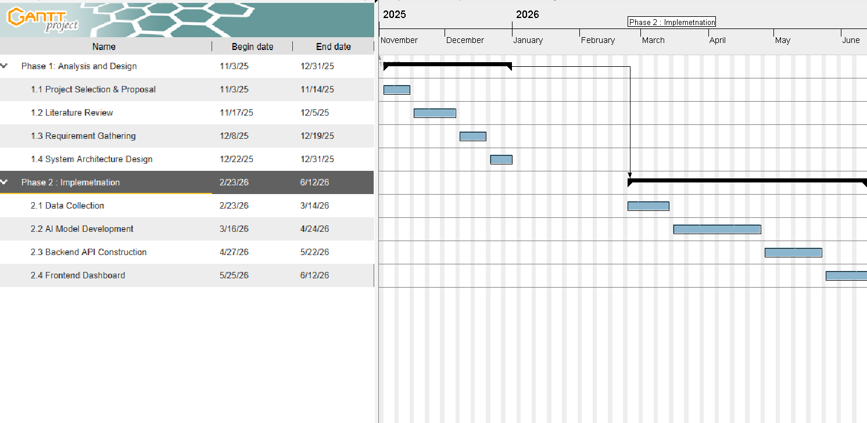

Figure 1: Project Timeline Gantt Chart

Functional Requirements
Obtaining the business requirements of the system is a vital stage of the system development life cycle. Using an iterative model made it possible to mend and enhance the requirements, particularly regarding AI model tuning.
This section categorizes the requirements into User Requirements, System Requirements, and AI Agent Requirements.

User Functional Requirements
These requirements focus on the interactions available to the two primary actors: the Business Owner and the System Admin.
- Business Owner (User):
  - Secure Login: The user should be able to log in to their account securely using multi-factor authentication.
  - Data Ingestion: The user should be able to upload historical data (e.g., CSV sales logs) and receive immediate validation feedback.
  - Dashboarding: The user should be able to view a dashboard summarizing key metrics, specifically Sales Velocity and Sentiment Score.
  - Conversational AI: The user should be able to chat with the AI assistant using natural language (e.g., "Why are sales down?") and receive data-backed answers.

  - Forecasting: The user should be able to request a Demand Forecast for a specific product for the upcoming 7–30 days.
  - Review Insights: The user should be able to view a list of recent customer reviews automatically tagged by sentiment (Positive/Negative) and aspect (Food/Service).
  - Content Creation: The user should be able to click a "Generate Content" button to create a social media post or visual ad based on current inventory needs.
  - Content Approval: The user should be able to approve, edit, or reject the AI-generated marketing content before it is finalized.
  - Reporting: The user should be able to download generated reports (PDF) and images (PNG/JPG).
- System Admin:
- Model Monitoring: The admin should be able to monitor the health, latency, and token usage of the AI models.
- User Management: The admin should be able to manage user accounts (add/remove businesses and reset credentials).
- Knowledge Updates: The admin should be able to update the Knowledge Base (e.g., adding new Jordanian holiday dates or tax regulations) for the RAG system to ensure the AI remains current.

System Functional Requirements
This section describes what the system must do automatically in response to inputs, without manual intervention.
- Initialization: The system should display a welcome dashboard upon successful login.
- Preprocessing: The system should automatically clean and preprocess uploaded sales data (removing duplicates/nulls) before storage.
- Vector Embedding: The system should embed unstructured text data (reviews/docs) into the Vector Database (ChromaDB) for retrieval.
- Demand Calculation: The system should use Time-Series algorithms to calculate pre-dicted demand for the next 7-30 days based on historical trends.
- Sentiment Classification: The system should use NLP models to classify scraped re-views into Positive, Negative, or Neutral.
- Aspect Detection: The system should detect specific "Aspects" in reviews (e.g., Food, Service, Price) to provide granular feedback.

- Context Retrieval (RAG): The system should retrieve relevant context before answering a user question to ensure factual grounding.
- Automated Recommendations: The system should generate a JSON-structured recom-mendation (e.g., "Restock Item X") when critical thresholds (e.g., stock < 10 units) are met.
- Image Generation: The system should generate high-quality marketing images using the Generative AI module based on the product context.
- Security Timeout: The system should log out the user automatically after a period of inactivity (e.g., 15 minutes).
- Error Handling: The system should provide a clear error message if the uploaded data format is incorrect.

AI Agent Functional Requirements
This section details the specific requirements for the Intelligent Agent (built on LangGraph). These define the cognitive behaviors of the AI.
- Intent Recognition: The Agent must correctly classify user prompts into distinct cate-gories (e.g., "Data Query," "Content Generation," "Explanation," or "Chit-chat") to route the request.
- Tool Orchestration: The Agent must be able to autonomously invoke the correct ex-ternal tool—calling the Machine Learning model for forecasting queries or the Image Generator for marketing requests—without user intervention.
- Context Retention: The Agent must maintain a "Conversation Memory" to understand follow-up questions (e.g., understanding that "it" refers to the product discussed in the previous turn).
- Structured Output Validation: The Agent must use Pydantic parsers to ensure that all critical outputs are returned in valid JSON format, automatically retrying if the LLM generates malformed data.
- Hallucination Check: The Agent must implement a RAG Verification step, cross-referencing its generated answers against the retrieved documents (ChromaDB) to ensure no false business facts are invented.
- Multi-Modal Generation: The Agent must be capable of generating text and triggering image generation APIs simultaneously when a marketing campaign is requested.

Non-Functional Requirements
This section presents the quality attributes, performance constraints, and environmental assump-tions of the system.

System Assumptions
      - The business owner has access to historical sales data in a structured format (CSV/Excel).
      - The business has a digital presence (Google Maps, Social Media) for scraping reviews.
      - The user has a stable internet connection to interact with the cloud-based LLM.
      - The system assumes the primary language of input/output is a mix of English and Jorda-nian Arabic (Diglossia focus).

Quality Attributes
      - Accuracy: The AI must minimize "hallucinations" by strictly grounding answers in the provided data (RAG).
      - Latency: The system shall generate a text response within 5–10 seconds and an image within 15–20 seconds.
      - Privacy: The system must ensure that one business’s data is isolated logically and never accessible by another business tenant.
      - Scalability: The system architecture (Vector DB + Cloud LLM) must support multiple concurrent users without service degradation.
      - Usability: The interface must be "plain language" oriented, requiring no technical or data science background.
      - Localization: The NLP model must correctly interpret local dialects (e.g., distinguishing "The service is bad" vs. "The food is cold") with at least 80% sentiment accuracy.

System Design

Introduction
The focus of this chapter is aimed at providing a comprehensive overview of system structure, behavior, and views of the proposed OwnerMate platform. Key points of this chapter include showing how each system component communicates with users and other external entities in order to facilitate intelligent, data-driven decision making for Small and Medium-sized Busi-nesses (SMBs).

The system design is depicted with a number of modeling techniques such as context diagrams, use case diagrams, data flow diagrams (DFD), class diagrams, sequence diagrams, business process models, user interface storyboards, and data models. These models together describe the functional, structural, and visual characteristics of the system. Furthermore, As-Is and To-Be business process models are given to reflect how the proposed system would improve performance.

Context Diagram
A context diagram provides a high-level representation of the system and defines its bound-ary. It shows how the OwnerMate system interacts with external entities and the type of data exchanged.
Level 0 Context Diagram
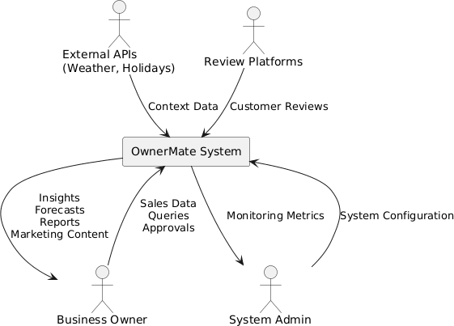

Figure 2: Level 0 Context Diagram

Level 1 Context Diagram At this level, the system is decomposed into its main functional subsystems.

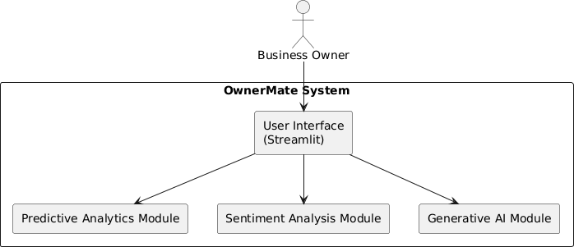

Figure 3: Level 1 Context Diagram

Level 2 Context Diagram This level shows internal interactions between AI components and data stores.
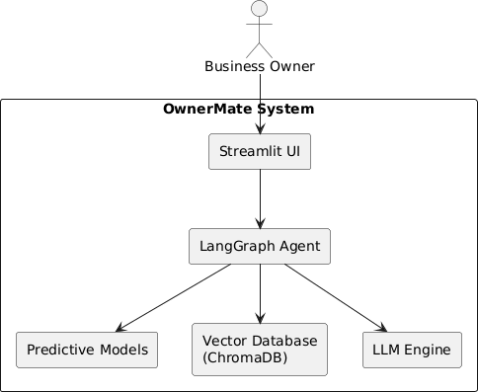

Figure 4: Level 2 Context Diagram

Use Case Diagram
A use case diagram is a behavioral UML diagram used to describe the functional behavior of the system from the user’s point of view. It provides a graphical overview of system functions in terms of actors and their goals, represented as use cases.

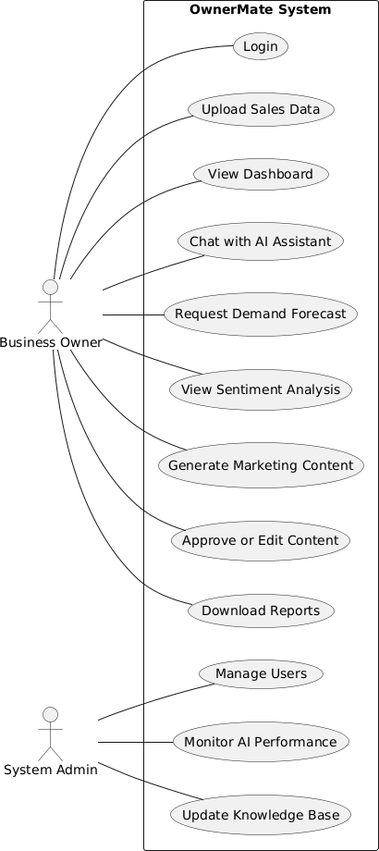

Figure 5: Use Case Diagram

Main Use Cases (9)
Use Case 1: Login with MFA Actor: Business Owner
System Actions:
- Displays login page
- Verifies credentials
- Sends verification code

- Grants access
Use Case 2: View Dashboard Actor: Business Owner
System Displays:
  - Sales Velocity
  - Sentiment Score
  - Alerts
Use Case 3: Generate Forecast Actor: Business Owner Steps:
- Select product
- Select time range
- Submit request
System:
  - Processes historical data
  - Displays forecast results
Use Case 4: View Sentiment Analysis Actor: Business Owner System:
  - Analyzes reviews
  - Categorizes sentiment by aspect
Use Case 5: Generate AI Content Actor: Business Owner System:
  - Generates text/images
  - Displays content for approval
Use Case 6: Export Reports Actor: Business Owner System:
  - Generates PDF reports
Use Case 7: Manage Users Actor: Admin System:
  - Adds, edits, removes users
Use Case 8: Monitor AI Performance Actor: Admin System:

  - Displays AI usage and logs
Use Case 9: Manage Alerts Actor: System (automatic) System:
  - Sends alerts based on thresholds

Data Flow Diagram (DFD)
A Data Flow Diagram (DFD) illustrates how data moves through the system, showing pro-cesses, data stores, and external entities.
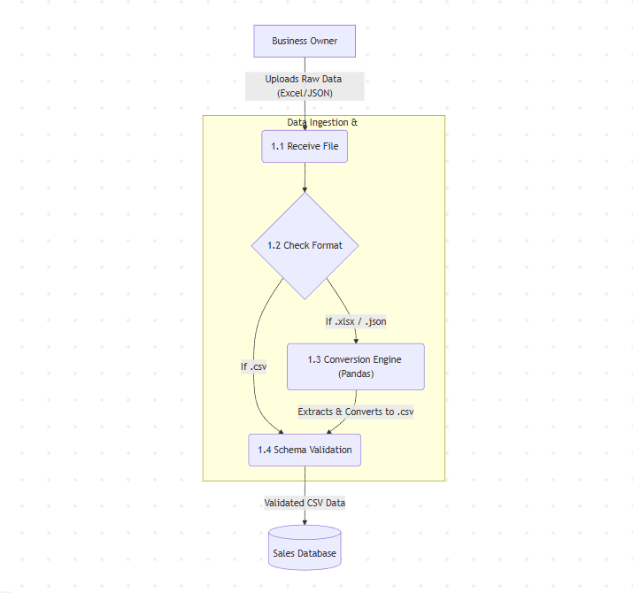

Figure 6: Different File Formats to CSV Pipeline

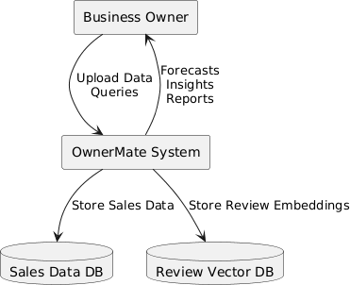

Figure 7: Data Flow Diagram

Class Diagram
The class diagram represents the structural view of the system.
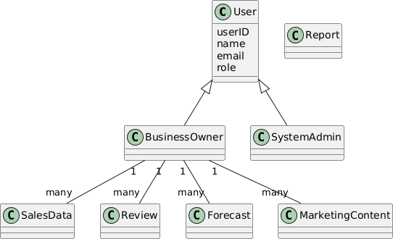

Figure 8: Class Diagram

Sequence Diagram
This sequence diagram illustrates the interaction when a business owner requests a demand forecast.
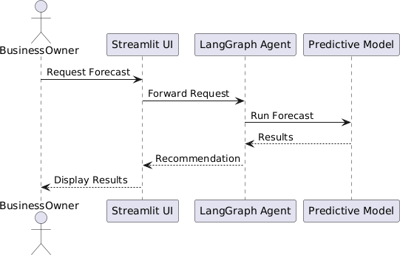

Figure 9: Sequence Diagram: Demand Forecast

Business Process Model
As-Is Model
- Business owner manually checks sales
- Uses multiple disconnected tools
- Decisions are slow and intuition-based
To-Be Model
- Data uploaded once
- Automated AI analysis
- Actionable recommendations generated instantly

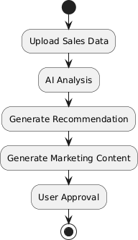

Figure 10: Business Process Model (As-Is vs. To-Be)

User Interface Design
This section presents a storyboard of the user interface design for the OwnerMate web-based system. The storyboard provides a detailed description of the layout and components of each page.

Site Map
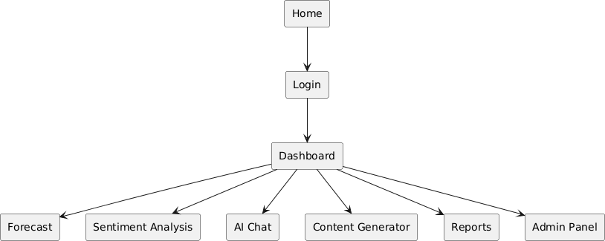

Figure 11: Site Map

Storyboard
      - Homepage: Introduction to OwnerMate with navigation bar (About Us, Contact Us, Feedback) and login link.
      - Login Page: Username, password, and multi-factor authentication.


Figure 12: Login Page UI

      - Dashboard: Displays Sales Velocity, Sentiment Score, and alerts.

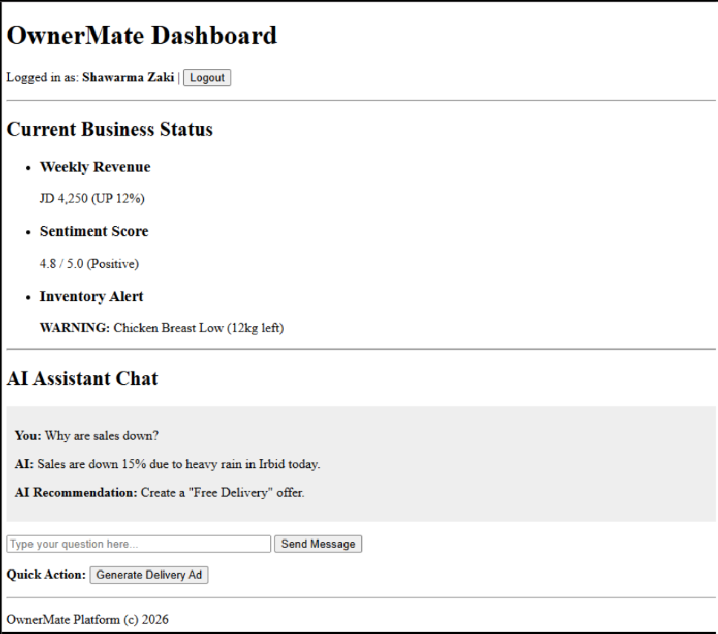

Figure 13: Dashboard UI

      - Forecast Page: Allows selection of product and time range.
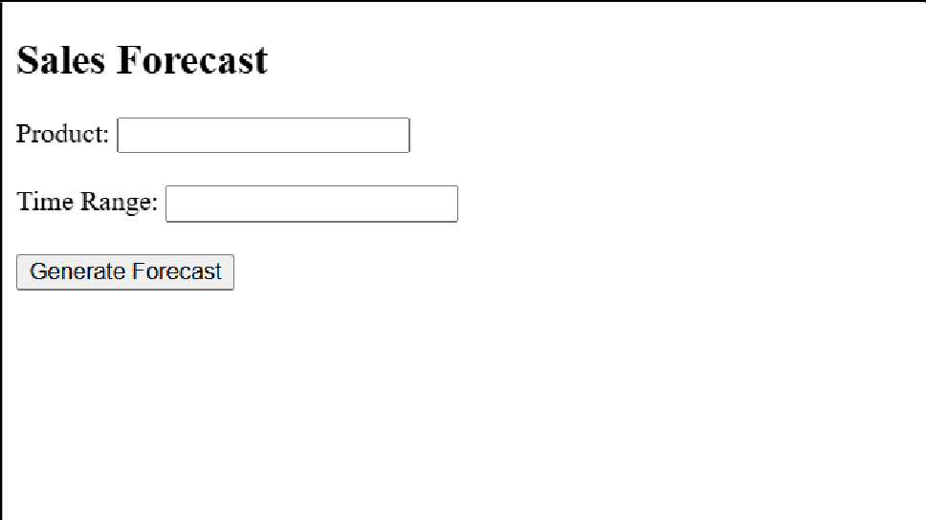

Figure 14: Forecast Page UI

      - Sentiment Page: Displays reviews categorized by aspect.



Figure 15: Sentiment Analysis UI

      - Content Generation Page: Shows AI-generated text and images for approval.
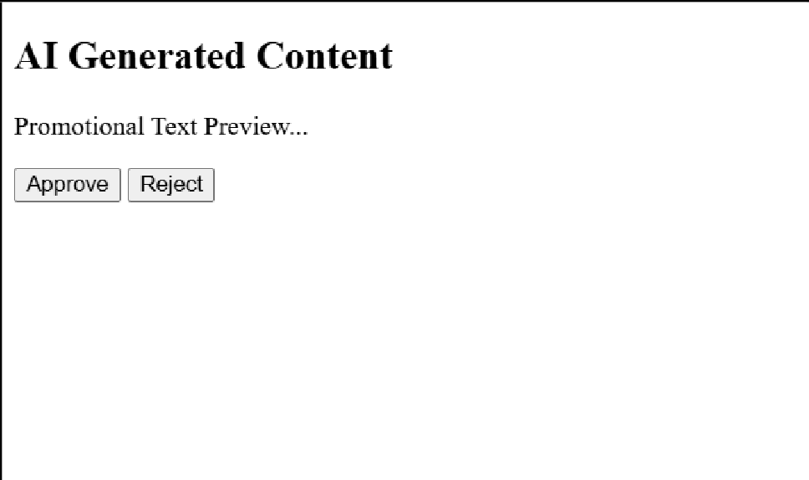

Figure 16: Content Generation UI

      - Reports Page: Allows exporting PDF reports.



Figure 17: Reports Page UI

      - Admin Dashboard: User management and AI monitoring.

Data Model
This section illustrates the data model used to design the database of the OwnerMate system. It includes the ER diagram and a brief data description.

Entity Relationship (ER) Diagram
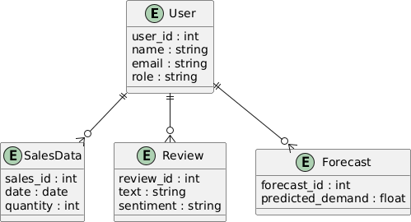

Figure 18: Entity Relationship Diagram

Conclusion

Conclusion
At this stage of the project, we were able to lay down the theoretical and architectural ground-work of OwnerMate, an overall AI solution that was intended to empower Jordanian SMBs. From there, we shifted our focus from conceptualizing the central market problem, described by "decision scarcity," faced by business owners to creating an effective technological solution that would close the gap between unprocessed data and useful information.
The output of the work done in this semester has led to the development of an integrated Sys-tem Design, which comprises the database design (ERD), the AI Agent’s cognition structure (LangGraph), as well as the user interfaces (Use Cases). There has also been success in the process of tool identification, particularly in the use of Llama 3 for linguistic comprehension, as well as the use of Random Forest for the forecasting of consumer demands.
To conclude, a stage of implementation awaits “OwnerMate.” The requirements outlined will shortly be converted into a prototype that forecasts demand, in addition to assisting business owners in executing marketing campaigns, thus ending the fragmentation that exists in markets in Jordan.

Difficulties Faced
While working on the analysis and design of this project, we encountered several technical and operational challenges:
- Data Scarcity for Local Dialects: it was hard to find datasets for sentiment analysis in Jordanian/Levantine Arabic that were high-quality and open source. The majority of resources available focus on Modern Standard Arabic (MSA) or Egyptian dialects, so we had to rely on manual data scraping and labeling.
- Complexity of AI Orchestration: It was difficult to design the AI Agent architecture (using LangGraph). A lot of research into agentic workflows was needed to determine how the agent should autonomously switch between “Tools” (e.g., calling the Forecast model vs. the Image Generator) without user intervention.
- Resource Limitations (GPU/Hardware): Planning for the deployment of Large Lan-guage Models (like Llama 3 8B) was challenging due to hardware constraints. We had to explore optimization techniques such as Quantization (4-bit loading) so that our system could run on accessible hardware without high latency.
- Defining Scope vs. Ambition: It was tricky to narrow down the features. Real-time POS integration and competitor price tracking were initially planned but had to be descoped

to focus on the core "Insight-to-Action" loop to ensure the project remains achievable within the semester timeline.

Future Works
Our vision for OwnerMate extends beyond the current scope of the graduation project. Due to time and resource limitations, several high-impact features were reserved for future develop-ment:
- Direct POS Integration: Currently, the system relies on CSV uploads. In the future, we aim to build direct API connectors with popular local POS systems (like Foodics or E-Cart) to enable real-time data streaming without manual file uploads.
- Voice-Activated Analytics: We plan to implement a Speech-to-Text module allowing business owners to query the system verbally (e.g., asking "Keef el sho3’ol el yom?" in Arabic) while driving or working in the kitchen, making the tool more accessible to non-technical users.
- Competitor Intelligence: A future module could scrape public data from competing businesses in the same area to provide comparative insights (e.g., "Your Shawarma is priced 15% higher than the local average").
- Mobile Application: While the current project focuses on a Responsive Web App (Streamlit), developing a native mobile application (Flutter/React Native) would allow for push notifications regarding critical stock alerts.

References
- Prediko, "Inventory Management & Demand Planning for Shopify," prediko.io, 2025. [On-line]. Available: https://prediko.io. [Accessed: Jan. 6, 2026].
- Blue Yonder Group, Inc., "Supply Chain Digital Transformation," blueyonder.com, 2025. [Online]. Available: https://blueyonder.com. [Accessed: Jan. 6, 2026].
- Jasper AI, Inc., "Jasper: AI Marketing Copilot for Enterprise Teams," jasper.ai, 2025. [On-line]. Available: https://www.jasper.ai. [Accessed: Jan. 6, 2026].
- Chattermill, "Unified Customer Intelligence Platform," chattermill.com, 2025. [Online]. Available: https://chattermill.com. [Accessed: Jan. 6, 2026].
- Brandwatch, "Consumer Intelligence & Social Media Listening Suite," brandwatch.com, 2025. [Online]. Available: https://www.brandwatch.com. [Accessed: Jan. 6, 2026].

- Databox, Inc., "Business Analytics Platform & KPI Dashboards," databox.com, 2025. [On-line]. Available: https://databox.com. [Accessed: Jan. 6, 2026].
- T. Ahmadov and P. Helo, "Artificial intelligence demand forecasting for improved inventory and fleet management," Journal of Business and Entrepreneurial Studies, vol. 7, no. 2, 2023.
- S. Ganguly and A. Mukherjee, "Enhancing Retail Sales Forecasting with Optimized Ma-chine Learning Models," in Proceedings of the 2025 International Conference on Computing, 2025.
- A. Oviedo-Bayas et al., "Applications of Artificial Intelligence in Inventory Management: A Systematic Review," Journal of Industrial Engineering, 2025.
- AbjadNLP, "Sentiment Analysis of Arabic Tweets Using Large Language Models," ACL Anthology, 2025.
- McKinsey & Company, "Superagency in the workplace: Empowering people to unlock AI’s full potential," McKinsey Digital Report, 2025.

