Graduation Project I and II
Handbook
CIS Department
(Data Science Program)

Prepared by:
- Dr. Alaa Al-Howaide
- Dr. Amera Al-Amery
- Dr. Deya Alzoubi

Handbook Table of Contents
GRADUATION PROJECT GENERAL REQUIREMENTS 3
CHECKLIST FOR STUDENT ORAL PRESENTATION 5
1. Presentation Structure 5
2. Problem Understanding 5
3. Data Understanding 5
4. Methodology 5
5. Results and Analysis 5
6. Critical Thinking 6
7. Communication Skills 6
8. Professional and Ethical Conduct 6
9. Learning Outcomes Coverage 6
10. Final Check 6
PURPOSE OF THIS HANDBOOK 7
FORMS 8
GRADUATION PROJECT TEMPLATE 20
PHASE I – DESIGN & PLANNING 20
PHASE II – IMPLEMENTATION, TESTING & DEPLOYMENT 20

GRADUATION PROJECT GENERAL REQUIREMENTS
- Format
You can easily use the template attached to this document as reference
A. Minimum of 20 typed pages
B. Title page (not included in 20-page requirement)
C. Times New Roman font
D. 12-point font
E. One-inch margins
F. 3 hard copies of your project (submitted to the project coordinator) + 2 CDs of the implementation code
G. Students MUST work as a team
- Using the Template
Once your data and content are ready, create a .doc file that contains the project template. Save the document using the following file-naming convention:

Year Semester – Phase I/II – Project Title

Example:
2026 First – Phase I – Customer Relationship Management System
  - Contents
Once your data and content are ready, create a .doc file that contains the project template. Save the document using the following file-naming convention:

Year Semester – Phase I/II – Project Title

Example:
2026 First – Phase I – Customer Relationship Management System
  - Figures and Tables
All figures and tables must be placed on the same page where they are first referenced in the text. Figures may be cited using the abbreviation “Fig.” followed by the corresponding number (e.g., Fig. 1).

Titles for both figures and tables must be:

- Bold
- Centered
- Written in 10-point Times New Roman

The title of a table should appear above the table, while the title of a figure should be placed below the figure.

Figures and tables should be numbered sequentially using the chapter-based numbering format. For example, the Third table in Chapter 4 should be labeled as Table 4.3.
- Evaluation
- Grading
Graded by the adviser (60%) and project committee (40%)
B. Content
1. Specific, accurate, precise information/data
2. Thoughtful conclusions supported by information or data
3. Precise, accurate vocabulary
4. Insight regarding the importance and value of the project
C. Organization
1. Logical order of information based on topic
2. Engaging beginning and thoughtful ending
3. Clear focus on controlling ideas.
4. Transitions between ideas
D. Research
1. Variety of sources appropriate to study
2. Credible, timely resources
E. Conventions of Language
1. Varied and structurally correct sentences
2. Correct mechanics, grammar and word usage

CHECKLIST FOR STUDENT ORAL PRESENTATION
Students must ensure that all items below are satisfied before the oral presentation for Phase II (DS481).

1. Presentation Structure
☐ Title slide includes project title, student names, supervisor, and department
☐ Clear agenda or outline slide
☐ Logical flow from problem → solution → results → conclusion
☐ Presentation duration complies with allocated time

2. Problem Understanding
☐ Problem statement is clearly defined
☐ Real-world relevance is explained
☐ Project objectives are explicitly stated
☐ Scope and limitations are acknowledged

3. Data Understanding
☐ Dataset source is clearly mentioned
☐ Key features and variables are explained
☐ Data challenges (missing values, imbalance, bias) are discussed
☐ Ethical and privacy considerations are addressed

4. Methodology
☐ Chosen methods and models are justified
☐ Clear explanation of preprocessing steps
☐ Architecture or workflow diagram is included
☐ Tools and technologies are identified

5. Results and Analysis
☐ Appropriate evaluation metrics are used
☐ Results are presented clearly using tables or graphs
☐ Results are interpreted, not just displayed
☐ Comparison with baseline or related work is included

6. Critical Thinking
☐ Strengths of the proposed solution are highlighted
☐ Limitations and weaknesses are discussed honestly
☐ Possible improvements or future work are proposed

7. Communication Skills
☐ Slides are clear, readable, and not overcrowded
☐ Font size and colors are presentation-friendly
☐ Technical terms are explained clearly
☐ Team members participate equally

8. Professional and Ethical Conduct
☐ Proper academic referencing is used
☐ No plagiarism in content or visuals
☐ Respectful and professional language
☐ Answers questions confidently and honestly

9. Learning Outcomes Coverage
☐ Demonstrates problem-solving ability
☐ Applies data science and computing knowledge
☐ Uses modern tools effectively
☐ Shows awareness of ethical and societal issues
☐ Communicates effectively with technical and non-technical audiences

10. Final Check
☐ Presentation rehearsed
☐ Time tested
☐ Backup copy available
☐ All team members prepared for Q&A

PURPOSE OF THIS HANDBOOK
This handbook serves as the official guide for students enrolled in the Data Science Undergraduate Graduation Project. It is written using APET Self-Study Report (SSR) language to ensure alignment with Course Learning Outcomes (CLOs), and Student Outcomes (SOs). Students are expected to adhere strictly to this handbook when planning, implementing, and documenting their projects.

FORMS
The Below forms are listed in this section:
- Project Proposal Form
- Bi-weekly Meeting Minutes Form
- General Request Form
- DS480- Graduation Project (1) (Phase I) Supervisor Evaluation Form
- DS480- Graduation Project (1) (Phase I) Committee Member Evaluation Form
- DS481- Graduation Project (2) (Phase II) Supervisor Evaluation Form
- DS481- Graduation Project (2) (Phase II) Committee Member Evaluation Form

PROJECT PROPOSAL
Project Information
Project Title: …………………………………………………………………………...……………………….
Outline of the Project (please attach an additional sheet/document, if necessary)
……………………………………………………………………………………………………………………
……………………………………………………………………………………………………………………
……………………………………………………………………………………………………………………
……………………………………………………………………………………………………………………
……………………………………………………………………………………………………………………
Keywords:……………………………………………………………………………………………………….
Required Resources:……………………………………………………………………………………………
……………………………………………………………………………………………………………………
……………………………………………………………………………………………………………………

Supervisor |  | Department
Co-Supervisor (if any) |  | Affiliation

Proposed Committee Members
Name of Faculty Member |  | Department/College
1
2

Name of Student |  | Student ID | Department | Email | Signature
1
2
3

Supervisor’s Signature |  | Date
Department Head’s Signature |  | Date

For Official Use:
Project ID (to be assigned by the Department Graduate Project Coordinator after the approval of the project):

Bi-weekly Meeting Minutes
Project Title
Date |  | Time

Main tasks completed in the last two weeks (use bullet points)

Pending activities and unresolved challenges from earlier weeks, if applicable

Agreed-upon tasks planned for the next two weeks | Student assigned to the tasks

Summary of the discussions

Name of Student |  | ID | Signature
1
2
3

Supervisor’s Signature | Date

General Request Form
Project Title
Supervisor
Supervisor’s Signature  (See note below) |  | Date

Type of Request (Select one or more)
Minor changes in project title
Major changes in project
Amendment of project committee
Request for additional resources/support
Report a dispute (Supervisor’s signature is optional)
Request for extension of time
Others (please specify)

Detailed Request with Justification (You may attach an additional sheet/document, if necessary)

Name of Student |  | ID | Signature
1
2
3

Approved Not Approved

Department Head’s Signature |  | Date
Note: This form is to be submitted to the department head to make any request related to the graduation project.

DS480 – Graduation Project (1) (Phase I)
Supervisor Evaluation Form

Project Title: ______________________________________________________ Group No.: _____________
Supervisor: _____________________________________ Semester: _________ Academic Year: _________

No. | Student Name | ID
S1
S2
S3

Expected Outcomes (Evaluation Criteria) |  | Max Marks | Marks Obtained
 |  |  | S1 | S2 | S3
CLO1: Deepen the knowledge of computing principles to analyze a real-world problem and design a solution with a problem-solving orientation. [SO1]
Background and problem statement |  | 6
Requirement analysis |  | 6
Modelling quality |  | 6
Mock designs |  | 6
CLO3: Apply relevant legal and ethical principles during the project development life-cycle. [SO4]
Novelty |  | 5
Citation |  | 2
Ethical/Legal concerns |  | 2
CLO4: Learn and apply adequate teamwork and project management skills. [SO5]
Teamwork/participation |  | 3
Attendance |  | 3
Meeting minutes |  | 3
CLO2: Demonstrate skills in oral and written communications in a project context. [SO3]
Report | Technical contents (comprehensiveness, clarity and accuracy) | 6
 | English language (grammar and spelling) | 3
 | Style and formatting | 3
Presentation | Technical contents (comprehensiveness, clarity and accuracy) | 2
 | Questions and answers | 1
 | Presentation skills | 2
 | Style and formatting | 1
 | Total | 60

Remarks and Suggestions (Please attach an additional sheet if necessary):
____________________________________________________________________________________________________________________________________________________________________________________________________________________________________________________________________________________________________________________________________________
______________________________________________________________________________________________________________________________________________________________________________________________________________________________________________________________________________________________________________________________________________
______________________________________________________________________________________________________________________________________________________________________________________________________________________________________________________________________________________________________________________________________________
______________________________________________________________________________________________________________________________________________________________________________________________________________________________________________________________________________________________________________________________________________
______________________________________________________________________________________________________________________________________________________________________________________________________________________________________________________________________________________________________________________________________________
________________________________________________________________________________________________________________________________________________________________________________________________________________________________________________________________________________________________________________________________________________
________________________________________________________________________________________________________________________________________________________________________________________________________________________________________________________________________________________________________________________________________________
________________________________________________________________________________________________________________________________________________________________________________________________________________________________________________________________________________________________________________________________________________
________________________________________________________________________________________________________________________________________________________________________________________________________________________________________________________________________________________________________________________________________________
________________________________________________________________________________________________________________________________________________________________________________________________________________________________________________________________________________________________________________________________________________
________________________________________________________________________________________________________________________________________________________________________________________________________________________________________________________________________________________________________________________________________________
________________________________________________________________________________________________________________________________________________________________________________________________________________________________________________________________________________________________________________________________________________
________________________________________________________________________________________________________________________________________________________________________________________________________________________________________________________________________________________________________________________________________________
________________________________________________________________________________________________________________________________________________________________________________________________________________________________________________________________________________________________________________________________________________
________________________________________________________________________________________________________________________________________________________________________________________________________________________________________________________________________________________________________________________________________________
________________________________________________________________________________________________________________________________________________________________________________________________________________________________________________________________________________________________________________________________________________
________________________________________________________________________________________________________________________________________________________________________________________________________________________________________________________________________________________________________________________________________________
________________________________________________________________________________________________________________________________________________________________________________________________________________________________________________________________________________________________________________________________________________
________________________________________________________________________________________________________________________________________________________________________________________________________________________________________________________________________________________________________________________________________________
________________________________________________________________________________________________________________________________________________________________________________________________________________________________________________________________________________________________________________________________________________
________________________________________________________________________________________________________________________________________________________________________________________________________________________________________________________________________________________________________________________________________________
________________________________________________________________________________________________________________________________________________________________________________________________________________________________________________________________________________________________________________________________________________
________________________________________________________________________________________________________________________________________________________________________________________________________________________________________________________________________________________________________________________________________________
________________________________________________________________________________________________________________________________________________________________________________________________________________________________________________________________________________________________________________________________________________
________________________________________________________________________________________________________________________________________________________________________________________________________________________________________________________________________________________________________________________________________________
________________________________________________________________________________________________________________________________________________________________________________________________________________________________________________________________________________________________________________________________________________
________________________________________________________________________________________________________________________________________________________________________________________________________________________________________________________________________________________________________________________________________________
________________________________________________________________________________________________________________________________________________________________________________________________________________________________________________________________________________________________________________________________________________
________________________________________________________________________________________________________________________________________________________________________________________________________________________________________________________________________________________________________________________________________________
________________________________________________________________________________________________________________________________________________________________________________________________________________________________________________________________________________________________________________________________________________
________________________________________________________________________________________________________________________________________________________________________________________________________________________________________________________________________________________________________________________________________________

Examiner’s Name: _____________________________________________________ Signature: ___________________________ Date: _________________

DS480 – Graduation Project (1) (Phase I)
Committee Member Evaluation Form

Project Title: ______________________________________________________ Group No.: _____________
Supervisor: _____________________________________ Semester: _________ Academic Year: _________

No. | Student Name | ID
S1
S2
S3

Expected Outcomes (Evaluation Criteria) |  | Max Marks | Marks Obtained
 |  |  | S1 | S2 | S3
CLO1: Deepen the knowledge of computing principles to analyze a real-world problem and design a solution with a problem-solving orientation. [SO1]
Background and problem statement |  | 4
Requirement analysis |  | 3
Modelling quality |  | 6
Mock designs |  | 3
CLO3: Apply relevant legal and ethical principles during the project development life-cycle. [SO4]
Novelty |  | 2
Citation |  | 2
Ethical/Legal concerns |  | 2
CLO4: Learn and apply adequate teamwork and project management skills. [SO5]
Teamwork/participation |  | 2
Attendance |  | 2
Meeting minutes |  | 2
CLO2: Demonstrate skills in oral and written communications in a project context. [SO3]
Report | Technical contents (comprehensiveness, clarity and accuracy) | 3
 | English language (grammar and spelling) | 2
 | Style and formatting | 1
Presentation | Technical contents (comprehensiveness, clarity and accuracy) | 2
 | Questions and answers | 1
 | Presentation skills | 2
 | Style and formatting | 1
 | Total | 40

Remarks and Suggestions (Please attach an additional sheet if necessary):
____________________________________________________________________________________________________________________________________________________________________________________________________________________________________________________________________________________________________________________________________________
______________________________________________________________________________________________________________________________________________________________________________________________________________________________________________________________________________________________________________________________________________
______________________________________________________________________________________________________________________________________________________________________________________________________________________________________________________________________________________________________________________________________________
______________________________________________________________________________________________________________________________________________________________________________________________________________________________________________________________________________________________________________________________________________
______________________________________________________________________________________________________________________________________________________________________________________________________________________________________________________________________________________________________________________________________________
________________________________________________________________________________________________________________________________________________________________________________________________________________________________________________________________________________________________________________________________________________
________________________________________________________________________________________________________________________________________________________________________________________________________________________________________________________________________________________________________________________________________________
________________________________________________________________________________________________________________________________________________________________________________________________________________________________________________________________________________________________________________________________________________
________________________________________________________________________________________________________________________________________________________________________________________________________________________________________________________________________________________________________________________________________________
________________________________________________________________________________________________________________________________________________________________________________________________________________________________________________________________________________________________________________________________________________
________________________________________________________________________________________________________________________________________________________________________________________________________________________________________________________________________________________________________________________________________________
________________________________________________________________________________________________________________________________________________________________________________________________________________________________________________________________________________________________________________________________________________
________________________________________________________________________________________________________________________________________________________________________________________________________________________________________________________________________________________________________________________________________________
________________________________________________________________________________________________________________________________________________________________________________________________________________________________________________________________________________________________________________________________________________
________________________________________________________________________________________________________________________________________________________________________________________________________________________________________________________________________________________________________________________________________________
________________________________________________________________________________________________________________________________________________________________________________________________________________________________________________________________________________________________________________________________________________
________________________________________________________________________________________________________________________________________________________________________________________________________________________________________________________________________________________________________________________________________________
________________________________________________________________________________________________________________________________________________________________________________________________________________________________________________________________________________________________________________________________________________
________________________________________________________________________________________________________________________________________________________________________________________________________________________________________________________________________________________________________________________________________________
________________________________________________________________________________________________________________________________________________________________________________________________________________________________________________________________________________________________________________________________________________
________________________________________________________________________________________________________________________________________________________________________________________________________________________________________________________________________________________________________________________________________________
________________________________________________________________________________________________________________________________________________________________________________________________________________________________________________________________________________________________________________________________________________
________________________________________________________________________________________________________________________________________________________________________________________________________________________________________________________________________________________________________________________________________________
________________________________________________________________________________________________________________________________________________________________________________________________________________________________________________________________________________________________________________________________________________
________________________________________________________________________________________________________________________________________________________________________________________________________________________________________________________________________________________________________________________________________________
________________________________________________________________________________________________________________________________________________________________________________________________________________________________________________________________________________________________________________________________________________
________________________________________________________________________________________________________________________________________________________________________________________________________________________________________________________________________________________________________________________________________________
________________________________________________________________________________________________________________________________________________________________________________________________________________________________________________________________________________________________________________________________________________
________________________________________________________________________________________________________________________________________________________________________________________________________________________________________________________________________________________________________________________________________________
________________________________________________________________________________________________________________________________________________________________________________________________________________________________________________________________________________________________________________________________________________
________________________________________________________________________________________________________________________________________________________________________________________________________________________________________________________________________________________________________________________________________________

Examiner’s Name: _____________________________________________________ Signature: ___________________________ Date: _________________

DS481 – Graduation Project (2) (Phase II)
Supervisor Evaluation Form

Project Title: ______________________________________________________ Group No.: _____________
Supervisor: _____________________________________ Semester: _________ Academic Year: _________

No. | Student Name | ID
S1
S2
S3

Expected Outcomes (Evaluation Criteria) |  | Max Marks | Marks Obtained
 |  |  | S1 | S2 | S3
CLO1: Deepen the knowledge of computing principles to analyze a real-world problem and design a solution with a problem-solving orientation. [SO1]
Overall understanding |  | 6
Implementation |  | 6
Testing |  | 6
Designs and QoS |  | 6
CLO5: Apply fundamentals of computing and software engineering to develop a professional-quality solution. [SO6]
Project life-cycle |  | 3
Progress |  | 3
Ethical/Legal concerns |  | 3
CLO4: Learn and apply adequate teamwork and project management skills. [SO5]
Teamwork/participation |  | 3
Attendance |  | 3
Meeting minutes |  | 3
CLO2: Demonstrate skills in oral and written communications in a project context. [SO3]
Report | Technical contents (comprehensiveness, clarity and accuracy) | 6
 | English language (grammar and spelling) | 3
 | Style and formatting | 3
Presentation | Technical contents (comprehensiveness, clarity and accuracy) | 2
 | Questions and answers | 1
 | Presentation skills | 2
 | Style and formatting | 1
 | Total | 60

Remarks and Suggestions (Please attach an additional sheet if necessary):
____________________________________________________________________________________________________________________________________________________________________________________________________________________________________________________________________________________________________________________________________________
______________________________________________________________________________________________________________________________________________________________________________________________________________________________________________________________________________________________________________________________________________
______________________________________________________________________________________________________________________________________________________________________________________________________________________________________________________________________________________________________________________________________________
______________________________________________________________________________________________________________________________________________________________________________________________________________________________________________________________________________________________________________________________________________
______________________________________________________________________________________________________________________________________________________________________________________________________________________________________________________________________________________________________________________________________________
________________________________________________________________________________________________________________________________________________________________________________________________________________________________________________________________________________________________________________________________________________
________________________________________________________________________________________________________________________________________________________________________________________________________________________________________________________________________________________________________________________________________________
________________________________________________________________________________________________________________________________________________________________________________________________________________________________________________________________________________________________________________________________________________
________________________________________________________________________________________________________________________________________________________________________________________________________________________________________________________________________________________________________________________________________________
________________________________________________________________________________________________________________________________________________________________________________________________________________________________________________________________________________________________________________________________________________
________________________________________________________________________________________________________________________________________________________________________________________________________________________________________________________________________________________________________________________________________________
________________________________________________________________________________________________________________________________________________________________________________________________________________________________________________________________________________________________________________________________________________
________________________________________________________________________________________________________________________________________________________________________________________________________________________________________________________________________________________________________________________________________________
________________________________________________________________________________________________________________________________________________________________________________________________________________________________________________________________________________________________________________________________________________
________________________________________________________________________________________________________________________________________________________________________________________________________________________________________________________________________________________________________________________________________________
________________________________________________________________________________________________________________________________________________________________________________________________________________________________________________________________________________________________________________________________________________
________________________________________________________________________________________________________________________________________________________________________________________________________________________________________________________________________________________________________________________________________________
________________________________________________________________________________________________________________________________________________________________________________________________________________________________________________________________________________________________________________________________________________
________________________________________________________________________________________________________________________________________________________________________________________________________________________________________________________________________________________________________________________________________________
________________________________________________________________________________________________________________________________________________________________________________________________________________________________________________________________________________________________________________________________________________
________________________________________________________________________________________________________________________________________________________________________________________________________________________________________________________________________________________________________________________________________________
________________________________________________________________________________________________________________________________________________________________________________________________________________________________________________________________________________________________________________________________________________
________________________________________________________________________________________________________________________________________________________________________________________________________________________________________________________________________________________________________________________________________________
________________________________________________________________________________________________________________________________________________________________________________________________________________________________________________________________________________________________________________________________________________
________________________________________________________________________________________________________________________________________________________________________________________________________________________________________________________________________________________________________________________________________________
________________________________________________________________________________________________________________________________________________________________________________________________________________________________________________________________________________________________________________________________________________
________________________________________________________________________________________________________________________________________________________________________________________________________________________________________________________________________________________________________________________________________________
________________________________________________________________________________________________________________________________________________________________________________________________________________________________________________________________________________________________________________________________________________
________________________________________________________________________________________________________________________________________________________________________________________________________________________________________________________________________________________________________________________________________________
________________________________________________________________________________________________________________________________________________________________________________________________________________________________________________________________________________________________________________________________________________
________________________________________________________________________________________________________________________________________________________________________________________________________________________________________________________________________________________________________________________________________________

Examiner’s Name: _____________________________________________________ Signature: ___________________________ Date: _________________

DS481 – Graduation Project (2) (Phase II)
Committee Member Evaluation Form

Project Title: ______________________________________________________ Group No.: _____________
Supervisor: _____________________________________ Semester: _________ Academic Year: _________

No. | Student Name | ID
S1
S2
S3

Expected Outcomes (Evaluation Criteria) |  | Max Marks | Marks Obtained
 |  |  | S1 | S2 | S3
CLO1: Deepen the knowledge of computing principles to analyze a real-world problem and design a solution with a problem-solving orientation. [SO1]
Overall understanding |  | 4
Implementation |  | 4
Testing |  | 4
Designs and QoS |  | 4
CLO5: Apply fundamentals of computing and software engineering to develop a professional-quality solution. [SO6]
Project life-cycle |  | 3
Ethical/Legal concerns |  | 3
CLO4: Learn and apply adequate teamwork and project management skills. [SO5]
Teamwork/participation |  | 3
Meeting minutes |  | 3
CLO2: Demonstrate skills in oral and written communications in a project context. [SO3]
Report | Technical contents (comprehensiveness, clarity and accuracy) | 3
 | English language (grammar and spelling) | 2
 | Style and formatting | 1
Presentation | Technical contents (comprehensiveness, clarity and accuracy) | 2
 | Questions and answers | 1
 | Presentation skills | 2
 | Style and formatting | 1
 | Total | 40

Remarks and Suggestions (Please attach an additional sheet if necessary):
____________________________________________________________________________________________________________________________________________________________________________________________________________________________________________________________________________________________________________________________________________
______________________________________________________________________________________________________________________________________________________________________________________________________________________________________________________________________________________________________________________________________________
______________________________________________________________________________________________________________________________________________________________________________________________________________________________________________________________________________________________________________________________________________
______________________________________________________________________________________________________________________________________________________________________________________________________________________________________________________________________________________________________________________________________________
______________________________________________________________________________________________________________________________________________________________________________________________________________________________________________________________________________________________________________________________________________
________________________________________________________________________________________________________________________________________________________________________________________________________________________________________________________________________________________________________________________________________________
________________________________________________________________________________________________________________________________________________________________________________________________________________________________________________________________________________________________________________________________________________
________________________________________________________________________________________________________________________________________________________________________________________________________________________________________________________________________________________________________________________________________________
________________________________________________________________________________________________________________________________________________________________________________________________________________________________________________________________________________________________________________________________________________
________________________________________________________________________________________________________________________________________________________________________________________________________________________________________________________________________________________________________________________________________________
________________________________________________________________________________________________________________________________________________________________________________________________________________________________________________________________________________________________________________________________________________
________________________________________________________________________________________________________________________________________________________________________________________________________________________________________________________________________________________________________________________________________________
________________________________________________________________________________________________________________________________________________________________________________________________________________________________________________________________________________________________________________________________________________
________________________________________________________________________________________________________________________________________________________________________________________________________________________________________________________________________________________________________________________________________________
________________________________________________________________________________________________________________________________________________________________________________________________________________________________________________________________________________________________________________________________________________
________________________________________________________________________________________________________________________________________________________________________________________________________________________________________________________________________________________________________________________________________________
________________________________________________________________________________________________________________________________________________________________________________________________________________________________________________________________________________________________________________________________________________
________________________________________________________________________________________________________________________________________________________________________________________________________________________________________________________________________________________________________________________________________________
________________________________________________________________________________________________________________________________________________________________________________________________________________________________________________________________________________________________________________________________________________
________________________________________________________________________________________________________________________________________________________________________________________________________________________________________________________________________________________________________________________________________________
________________________________________________________________________________________________________________________________________________________________________________________________________________________________________________________________________________________________________________________________________________
________________________________________________________________________________________________________________________________________________________________________________________________________________________________________________________________________________________________________________________________________________
________________________________________________________________________________________________________________________________________________________________________________________________________________________________________________________________________________________________________________________________________________
________________________________________________________________________________________________________________________________________________________________________________________________________________________________________________________________________________________________________________________________________________
________________________________________________________________________________________________________________________________________________________________________________________________________________________________________________________________________________________________________________________________________________
________________________________________________________________________________________________________________________________________________________________________________________________________________________________________________________________________________________________________________________________________________
________________________________________________________________________________________________________________________________________________________________________________________________________________________________________________________________________________________________________________________________________________
________________________________________________________________________________________________________________________________________________________________________________________________________________________________________________________________________________________________________________________________________________
________________________________________________________________________________________________________________________________________________________________________________________________________________________________________________________________________________________________________________________________________________
________________________________________________________________________________________________________________________________________________________________________________________________________________________________________________________________________________________________________________________________________________
________________________________________________________________________________________________________________________________________________________________________________________________________________________________________________________________________________________________________________________________________________

Examiner’s Name: _____________________________________________________ Signature: ___________________________ Date: _________________

GRADUATION PROJECT TEMPLATE
In the next page, the graduation project (1) and (2) template is provided.

PHASE I – DESIGN & PLANNING
Phase I focuses on problem understanding, analytical reasoning, ethical responsibility, and structured project design. This phase primarily supports APET CLO1 (problem analysis and solution design), CLO2 (Communication & documentation), CLO3 (ethical and legal responsibility), and CLO4 (teamwork and project management).
This phase demonstrates the student’s ability to:
- Understand a real-world problem
- Design a data science solution
- Plan data analysis ethically and systematically

PHASE II – IMPLEMENTATION, TESTING & DEPLOYMENT
Phase II focuses on execution and validation. It assesses students’ ability to implement, evaluate, and deploy a professional-quality data science solution, supporting APET CLO1, CLO2, CLO3, and CLO4.


<Project Title>

Presented to the Faculty of Computer and Information Technology,
Jordan University of Science and Technology

In Partial Fulfillment
of the Requirements for the Degree of
Bachelor of Science in Computer Information Systems

By:
<Student Name 1>
<Student Name 2>
<Student Name 3>

Supervised By:
<Instructor Name>

Irbid, Jordan
Fall 2017

ABSTRACT

Provide a concise summary of the project, including the problem, dataset, methodology, key results, and conclusions. Limit to 250–300 words. It should provide a compact overview of the entire project. It should summarize:
- The problem domain (e.g., healthcare, finance, traffic, social media)
- The dataset(s) used (source, size, type)
- The methodology (EDA, feature engineering, models)
- The key results (performance metrics, insights)
- The main conclusions
Example:
“This project addresses traffic accident severity prediction using national road accident data. The dataset contains 120,000 records with temporal, environmental, and vehicle-related features. Exploratory data analysis revealed strong correlations between weather conditions and accident severity. Several machine learning models were evaluated, with Gradient Boosting achieving the highest F1-score of 0.82. The results demonstrate the feasibility of using data-driven approaches to support traffic safety decision-making.”

ACKNOWLEDGEMENT
This section acknowledges:
- The project supervisor
- The department and university
- Any organizations providing data
- Individuals who provided guidance or resources
Example:
“The authors would like to thank the Jordan Traffic Institute for providing access to the accident dataset and our supervisor for continuous guidance throughout the project.”

UNDERTAKING

This is to certify that the graduation project entitled “Project Title” is an original work carried out by the undersigned in partial fulfillment of the requirements for the degree of Bachelor of Data Science at the Department of Computer Information Systems, at the faculty of Computer and Information Technology, Jordan University of Science and Technology.
All phases of the project, including analysis, design, implementation, and system development, were completed by the undersigned. Furthermore, this project has not been submitted, in whole or in part, to any other college or university for the award of any degree or academic qualification.

Student 1

Student 2

Student 3

Note: sign next to your name

Table of Contents
(Auto-generated list of chapters, sections, and subsections with page numbers.)
ABSTRACT 22
ACKNOWLEDGEMENT 23
UNDERTAKING 24
Table of Contents 25
List of Figures 27
List of Tables 28
List of Abbreviations 29
Glossary 30
PHASE I – DESIGN & PLANNING 31
Chapter 1: Introduction 31
1.1 Background and Context 31
1.2 Problem Statement 31
1.1 Project Motivation 32
1.3 Project Objectives 32
1.4 Research / Technical Questions 33
1.5 Scope and Limitations 33
Chapter 2: Literature Review 33
2.1 Related Work 33
2.2 Comparative Analysis 34
2.3 Identified Research Gaps 34
Chapter 3: Data Understanding & EDA Design 34
3.1 Dataset Description 34
3.2 Data Quality Assessment 35
3.3 Planned EDA Techniques 35
3.4 Ethical and Legal Considerations 35
Chapter 4: System Design & Methodology 36
4.1 Methodological Framework 36
4.2 System Architecture Diagram 36
4.3 Data Flow Diagram (DFD) 36
4.4 Use-Case Diagram 37
4.5 Class Diagram 42
4.6 ER Diagram/ Data Model 42
4.7 User Interface Design 43
4.7.1 Site Map 44
4.7.2 Story board 45
4.8 Tools and Technologies 54
Chapter 5: Project Management & Professional Practice 55
5.1 Team Roles and Responsibilities 55
5.2 Project Timeline 55
5.3 Risk Management 56
5.4 Communication Plan 56
PHASE II – IMPLEMENTATION, TESTING & DEPLOYMENT 56
Chapter 6: Data Preparation & Exploratory Data Analysis 56
6.1 Data Cleaning 56
6.2 Exploratory Data Analysis Results 57
6.3 Insights from EDA 57
Chapter 7: Implementation 57
7.1 Model Implementation 57
7.1.1 Feature Engineering 57
7.2 Model Training 57
7.2 Tool/Software Implementation (GitHub Required) 58
Chapter 8: Testing & Evaluation 58
8.1 Evaluation Metrics 58
8.2 Experimental Results 58
8.3 Systems Testing 58
Chapter 9: Deployment 59
9.1 Deployment Architecture 59
9.2 Maintenance and Scalability 59
Chapter 10: Results, Discussion & Conclusion 59

List of Figures
(Auto-generated list of all figures used in the report.)
Figure name Page
Figure 1 Data Flow Diagram 37
Figure 2 Use Case Diagram with Key 38
Figure 3 Use Case Diagram 39
Figure 4 Entity Relationship Diagram 43
Figure 5 Site Map 45
Figure 6 Homepage 45
Figure 7 Login Page 46
Figure 8 Confirmation Page 46
Figure 9 Manager's Dashboard 47
Figure 10 Pending Order Page 48
Figure 11 All Orders Page 48
Figure 12 Inventory Page 48
Figure 13 Customers Page 49
Figure 14 Employees Page 49
Figure 15 Reports Page 50
Figure 16 Organizations Page 50
Figure 17 Previous Orders Page 51
Figure 18 Customers List page 53
Figure 19 Orders Page 53
Figure 20: Phase I Gantt Chart 55
Figure 20: Phase II Gantt Chart 56

List of Tables
(Auto-generated list of all tables used in the report.)
Table Name Page
Table 1 Summary of literature works. 34

List of Abbreviations
(Define all abbreviations and acronyms used throughout the report.)
Example:
- EDA – Exploratory Data Analysis
- ML – Machine Learning
- ROC – Receiver Operating Characteristic

Glossary
(Define important technical terms and domain-specific concepts used in the project.)
Example:
- Feature Engineering: The process of creating new input variables from raw data to improve model performance.

PHASE I – DESIGN & PLANNING
(Problem understanding, EDA planning, methodology, ethics, project management)

Chapter 1: Introduction
This chapter sets the context and direction of the project. It establishes the academic, professional, and real-world and societal context of the project. Students must demonstrate their ability to analyze a real-world problem and motivate a data science–based solution.

1.1 Background and Context
Students should describe the application domain and its relevance to data science. For example, in a healthcare analytics project, this section may discuss the growing availability of electronic health records and the need for predictive analytics to support clinical decision-making.
It describes:
- The application domain
- Why the problem matters
- Who benefits from the solution
Example:
“In recent years, e-commerce platforms have generated massive amounts of customer interaction data. Understanding customer churn has become critical for improving customer retention and profitability.”

1.2 Problem Statement
The problem statement clearly defines the specific problem to be solved. It must clearly articulate the issue to be addressed in data-driven terms. It should identify existing limitations and justify the need for a new analytical approach. Example: predicting patient readmission risk using heterogeneous and incomplete clinical data.
A good problem statement is:
- Specific
- Data-driven
- Solvable using data science
Example:
“Despite the availability of large customer datasets, many companies struggle to accurately predict customer churn, leading to inefficient retention strategies.”

1.1 Project Motivation
The Project Motivation section explains why the project is worth undertaking and what drives the need for the proposed solution. It provides the practical, academic, and societal reasons that inspired the project and highlights the importance of addressing the selected problem using data science techniques.
This section should:
- Clearly articulate the real-world challenge or opportunity that motivated the project
- Explain the impact of the problem on individuals, organizations, or society
- Justify the use of data science, analytics, or machine learning as an appropriate solution approach
- Demonstrate awareness of current limitations in existing systems or approaches
The project motivation should be written in a problem-driven, outcome-oriented manner, linking technical work to real needs. It must avoid repeating the problem statement verbatim and instead focus on the reasons behind choosing the problem.
Example:
“The rapid growth of urbanization and vehicle usage has led to a significant increase in road traffic accidents, resulting in loss of life, property damage, and economic burden on public safety institutions. Despite the availability of large volumes of accident-related data collected by traffic authorities, much of this data remains underutilized and is primarily analyzed using traditional statistical methods that fail to capture complex patterns and interactions.
The motivation for this project stems from the need to leverage data science and machine learning techniques to extract actionable insights from heterogeneous accident datasets. By identifying key factors that contribute to accident severity—such as weather conditions, road characteristics, and driver behavior—authorities can make informed decisions to improve traffic safety policies and resource allocation.
Furthermore, existing accident analysis systems often struggle with incomplete and multi-source data, limiting their predictive accuracy and reliability. This project is motivated by the challenge of developing a robust data-driven model capable of handling real-world data imperfections while providing meaningful predictions that support decision-makers and enhance public safety.”

1.3 Project Objectives
Objectives must be specific, measurable, achievable, relevant, and time-bound (SMART). Example objectives include developing a predictive model with improved accuracy, conducting comprehensive exploration analysis, and delivering actionable insights to stakeholders.
Example:
- Analyze customer behavior using EDA
- Build predictive models for churn prediction
- Compare multiple machine learning algorithms
- Deploy a prototype prediction system

1.4 Research / Technical Questions
Students should formulate research or technical questions that guide experimentation and evaluation.
Example:
- Which classification algorithm provides the best balance between accuracy and interpretability for this dataset?
- Which features most influence customer churn?
- Does Gradient Boosting outperform Logistic Regression?
- How does data imbalance affect prediction performance?

1.5 Scope and Limitations
This section defines the boundaries of the project (what is included and excluded.). Students must clearly state assumptions, constraints (such as limited data availability or computational resources), and limitations to demonstrate professional responsibility and realistic planning.
Example:
- Scope: Historical customer data from 2020–2024
- Limitation: No real-time streaming data
- Constraint: Limited labeled data for minority class
Example:
The project focuses on urban highways only and excludes rural traffic data due to data unavailability.

Chapter 2: Literature Review
Review existing research, systems, and techniques related to the project.

2.1 Related Work
Summarize relevant studies, tools, and methods.
It summarizes:
- Previous research papers
- Existing systems
- Common techniques
Example:
“Several studies have used Random Forest and XGBoost for churn prediction, reporting accuracy values between 75% and 85%.”

2.2 Comparative Analysis
Compare existing solutions and identify strengths and weaknesses (Critically compares approaches).
Example:
Table 1 Summary of literature works.
Study | Dataset | Model | Strength | Weakness
Smith et al. | Telecom | RF | High accuracy | Poor interpretability
Smith et al. | Telecom | RF | High accuracy | Poor interpretability
Smith et al. | Telecom | RF | High accuracy | Poor interpretability
Smith et al. | Telecom | RF | High accuracy | Poor interpretability

2.3 Identified Research Gaps
Highlight gaps that justify the proposed project (Explains what is missing).
Example:
“Most existing studies ignore feature interpretability, which is critical for business decision-making. This project addresses this gap using SHAP values.”

Chapter 3: Data Understanding & EDA Design
This chapter evaluates students’ ability to understand data characteristics and plan systematic exploratory analysis, directly supporting APET CLO1 and CLO3.

3.1 Dataset Description
Students must describe data sources, collection methods, size, structure, and attributes. For example, a transportation dataset may include temporal, spatial, and environmental features collected from sensors.
It explains:
- Data source
- Number of records
- Features
- Data types
Example:
“The dataset contains 50,000 customer records with 18 features, including demographic, transactional, and behavioral attributes.”

3.2 Data Quality Assessment
Students should anticipate data simple and basic quality issues such as missing values, noise, outliers, duplicates, and class imbalance, and explain their potential impact on analysis and modeling.
Note: Actual data cleaning and EDA should be performed in Phase II (GP2), not in GP1.
Example:
- Missing values in income column
- Outliers in transaction amount
- Class imbalance (churn rate = 12%)
Example:
Approximately 20% of sensor readings contain missing speed values due to sensor malfunction.

3.3 Planned EDA Techniques
Students must outline planned exploration techniques, including univariate, bivariate, and multivariate analysis. Examples include histograms, boxplots, correlation matrices, and dimensionality reduction techniques.
Examples:
- Univariate: histograms of age
- Bivariate: churn vs. contract type
- Multivariate: correlation heatmaps
Example:
Histograms to examine traffic speed distribution and correlation matrices to identify feature relationships.

3.4 Ethical and Legal Considerations
Students must demonstrate awareness of ethical and legal obligations, including data privacy, consent, bias mitigation, and compliance with applicable data protection regulations.
It addresses:
- Privacy
- Bias
- Consent
- Data protection laws
Example:
“Personal identifiers were removed, and data was anonymized in compliance with GDPR principles.”

Chapter 4: System Design & Methodology
Present the overall system design and methodological framework.

4.1 Methodological Framework
Explain the overall data science workflow/ lifecycle used.
Example:
CRISP-DM: Business Understanding → Data Understanding → Modeling → Evaluation → Deployment

4.2 System Architecture Diagram
Include a high-level system architecture diagram showing major components (Shows system components).
Example:
Data Source → Preprocessing → ML Model → API → Web Dashboard

4.3 Data Flow Diagram (DFD)
Illustrate how data flows through the system from input to output.
Example:
User uploads CSV → System cleans data → Model predicts → Results stored
Example:
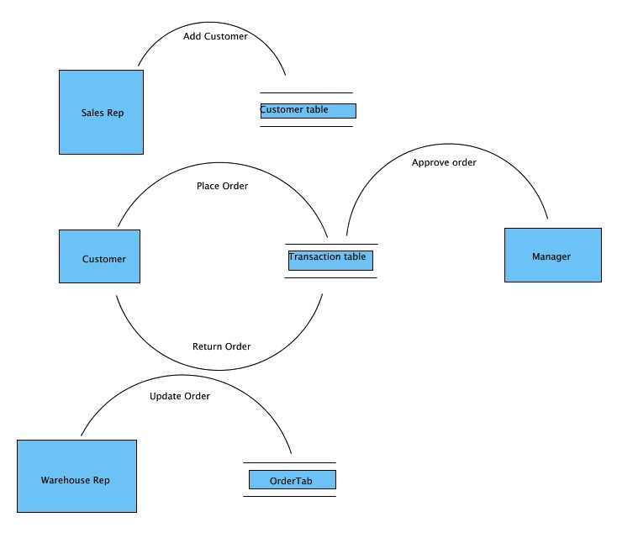
Figure 1 Data Flow Diagram
- A process is usually started physically when the sales representative meets with a potential customer.
- After agreement is made concerning the overall deal, the Sales representative will login to his account on the portal and adds the new customer and sets the prices and promotions they previously agreed upon.
- Once the customer is added, his username and password are sent to his procurement department by the sales representative.
- The customer can then login in to his account and place an order ( or return an existing order in other cases)
- The order is added to the transaction table, and the system notifies the manager that there is a pending order.
- The manager logs in and view the order’s details and can either approve (or decline) the order depending on both the customer’s current balance and products availability.
- After an order is approved, a pick slip is sent to the warehouse department to be processed.
The Warehouse representative can login to the portal, view the orders and edit the status of each order enabling shipment tracking.

4.4 Use-Case Diagram
A case diagram is one of the behavioral diagrams defined by the Unified Modeling Language (UML) for the purpose of describing the functional behavior of the system from user point of view. A use case diagram shows a graphical overview of the system functions in terms of actors and their goals represented as use cases. It shows interactions between users and the system.
Actors:
- Data Analyst
- System Admin
- End User
For example, the following diagram shows the use case diagram of some project of four main users: customer, sales representative, manager, and the warehouse representative. A case diagram that combines all users is presented in this section.
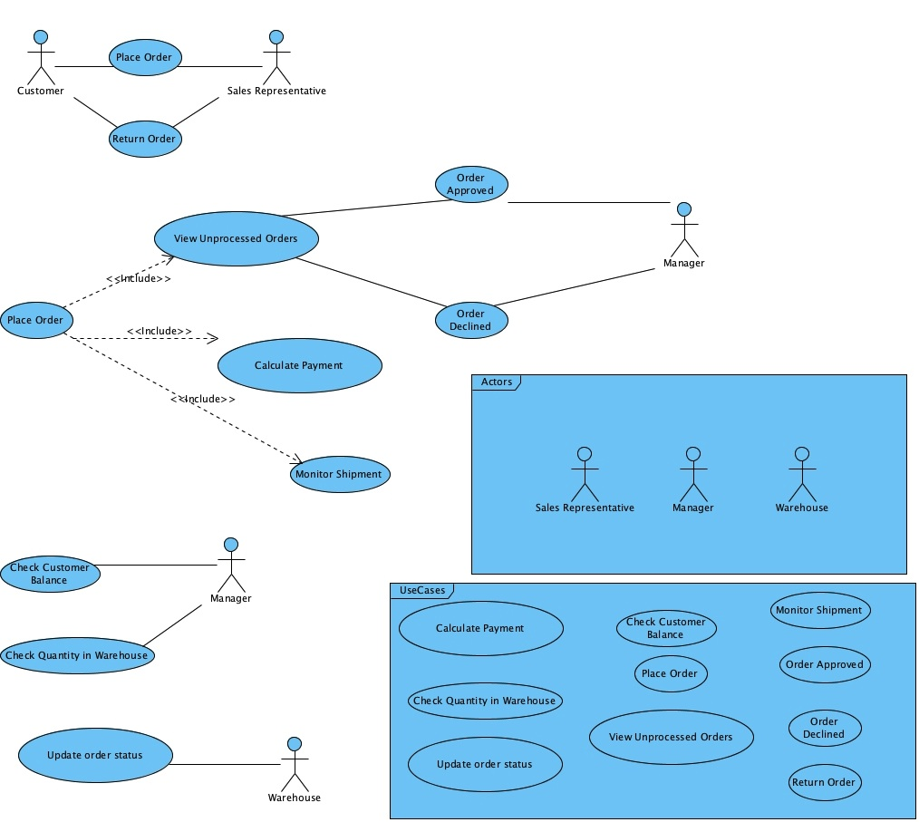
Figure 2 Use Case Diagram with Key

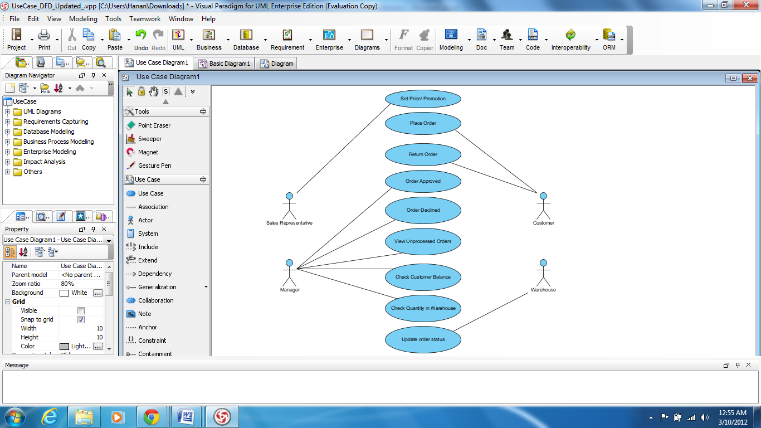
Figure 3 Use Case Diagram
This system will include 9 different use cases shown in the Use Case Diagram above. The are:
Use case 1: Add Customer; Set Price/Promotion:
Actor: Sales Representative | System
1- Selects “Add Customer” option from main menu.  3- Enters customers information including the price and promotion for selected products.  4- Clicks “Add Customer” button. | 2- Displays screen with input fields for data to be filled by user.  5- Displays the new customer added with prices and promotion.

Use case 2: Place Order
Actor: Customer | System
1- Selects “Place Order” option from main menu.  3- Enters order’s details.  4- Clicks “Finish and Submit” button. | 2- Displays screen with input fields for data to be filled by user.  5- Displays the order number.

Use case 3: Return Order
Actor: Customer | System
1- Selects “Return Order” option from main menu.  3- Enters order’s number, products, and reason for return  4- Clicks “Return” button. | 2- Displays screen with input fields for data to be filled by user.  5- Displays the confirmation after submitting the return order form.

Use case 4: Approve Order
Actor: Manager | System
1- Selects “Pending orders” option from main menu.  3- Selects order to be approved.  5- Selects customer history to check balance  7- Selects product’s availability.  9- Selects Approve order. | 2- Displays screen with pending orders  4-Opens order’s details.  6- Opens history, with customer’s balance page..  8- Open product’s availability page.  10- Displays the order’s stating and send notifications to order involved users.

Use case 5: Decline Order
Actor: Manager | System
1- Selects “Pending orders” option from main menu.  3- Selects order to be approved.  5- Selects customer history to check balance  7- Selects product’s availability.  9- Selects Decline order. | 2- Displays screen with pending orders  4-Opens order’s details.  6- Opens history, with customer’s balance page..  8- Open product’s availability page.  10- Displays the order’s stating and send notifications to order involved users.

Use case 6: Update Order Status
Actor: Warehouse Representative | System
1- Selects “Orders” option from main menu.  3- Selects order to be updated.  5- Enters the current status of the order. | 2- Displays screen with all orders  4-Opens order’s details.  6- Displays the updated order’s details.

4.5 Class Diagram
Present object-oriented class structure (if applicable).
Example Classes:
- Dataset
- Preprocessor
- ModelTrainer
- Evaluator

4.6 ER Diagram/ Data Model
Describe database entities, relationships, and constraints.
Example Entities:
- Customer
- Transaction
- Prediction
For example, the following figure shows the detailed ER diagram and the data definitions of some project.
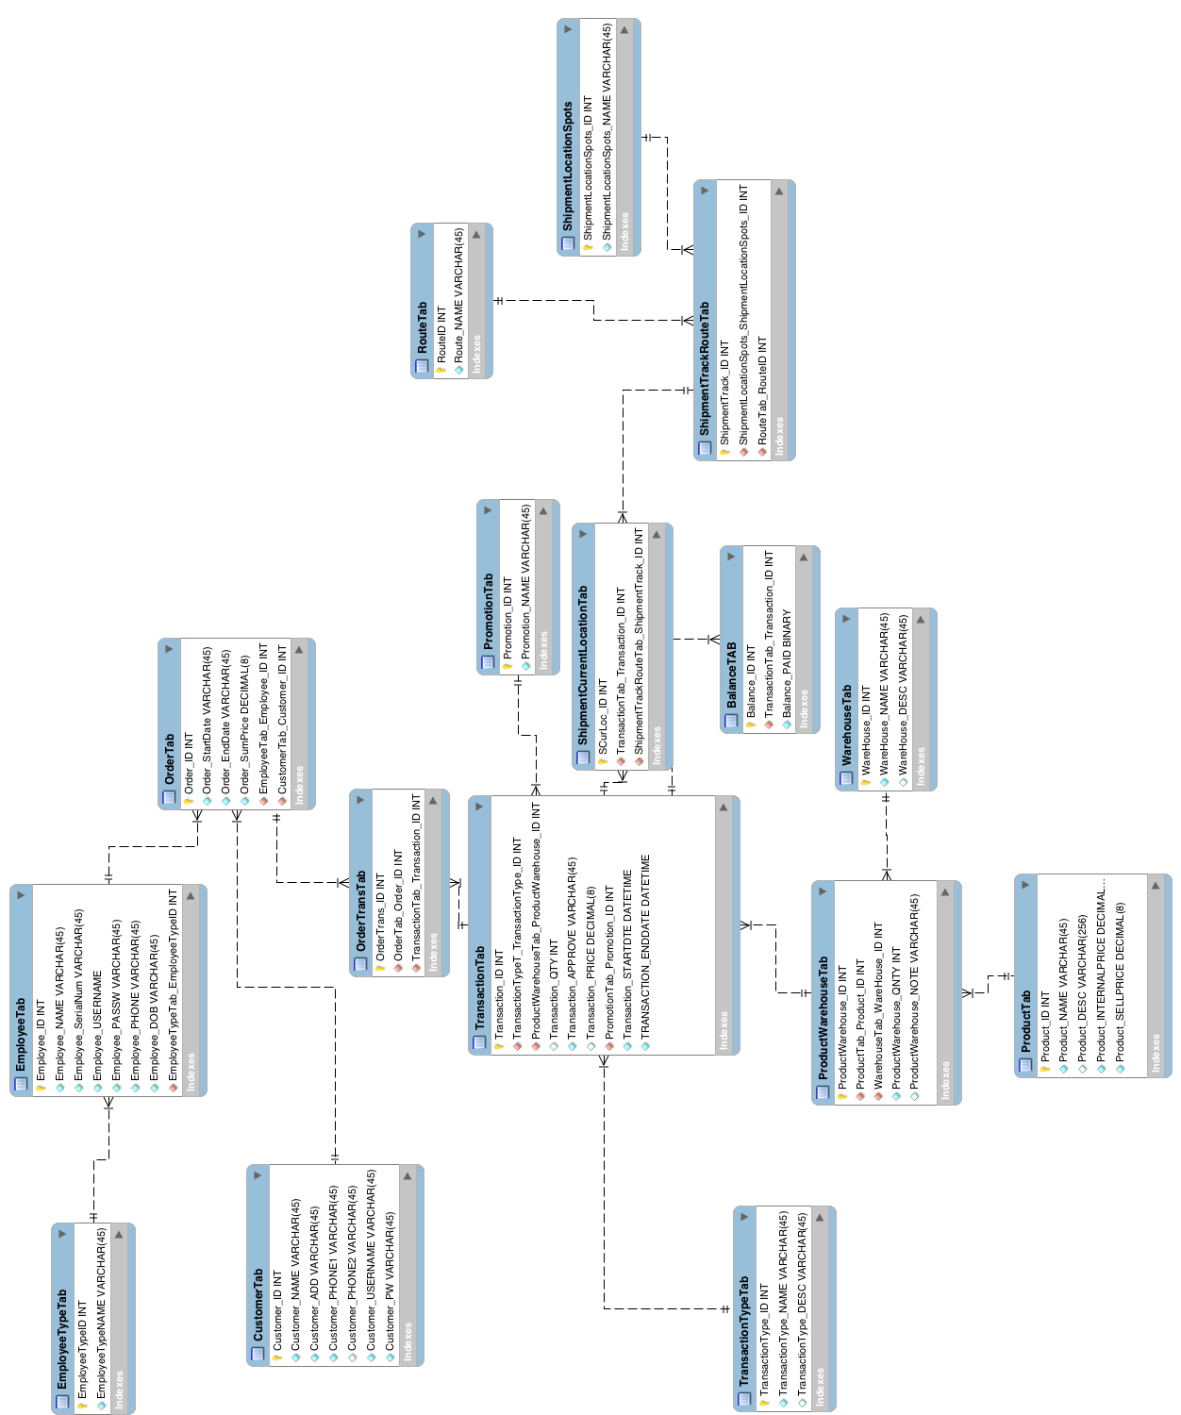
Figure 4 Entity Relationship Diagram

4.7 User Interface Design
This section presents a story board for the user interface design. For example, if the project is a website, the story board provides a detailed description of the layout and components of each page. The User interface design of other projects would be the windows that appear when using the system, etc. We should mention here that System design components here are built to describe some website project. Students should take this an example only, and use it as a guide to write the system design that express their projects and handles their projects’ specifications.

4.7.1 Site Map
An Example of Site Map, when the project is a website, is shown next.

Figure 5 Site Map

4.7.2 Story board
As the user enters the URL for the portal, he is directed to the home page. The home page is divided into a link bar that includes links to the following pages:
- About Us
- Contact Us
- Feedback
This link bar will appear in all pages of the portal. Then comes the header section of the page. The body is divided into two parts: An introduction to the portal and a welcoming message, and an image. The homepage will include a link to the login page.
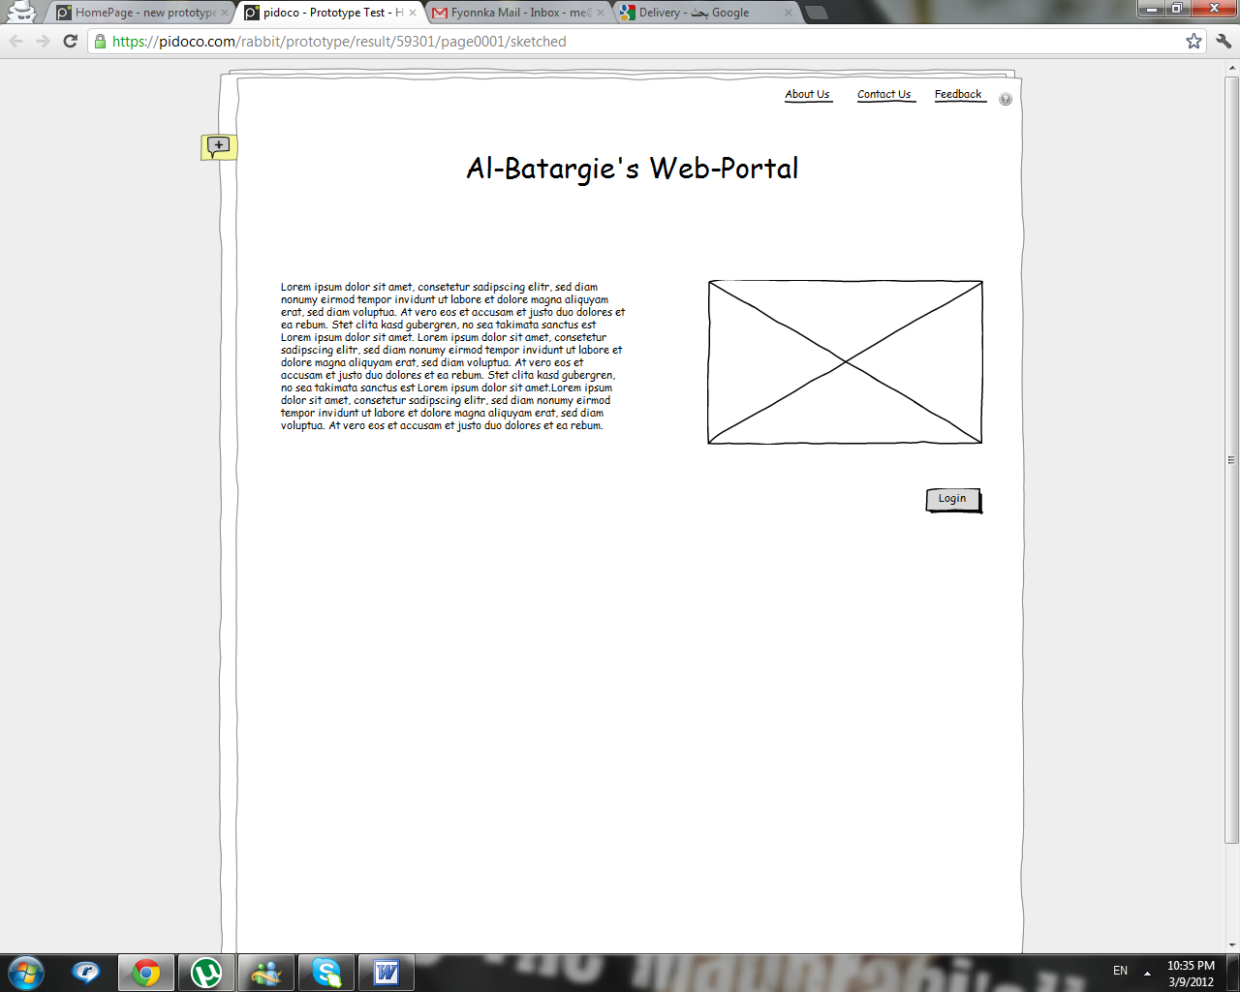
Figure 6 Homepage
The login in page will include a login plug-in, in which the user will enter his username and password. The user can click the remember me option or be directed to another form if he forgot his password.
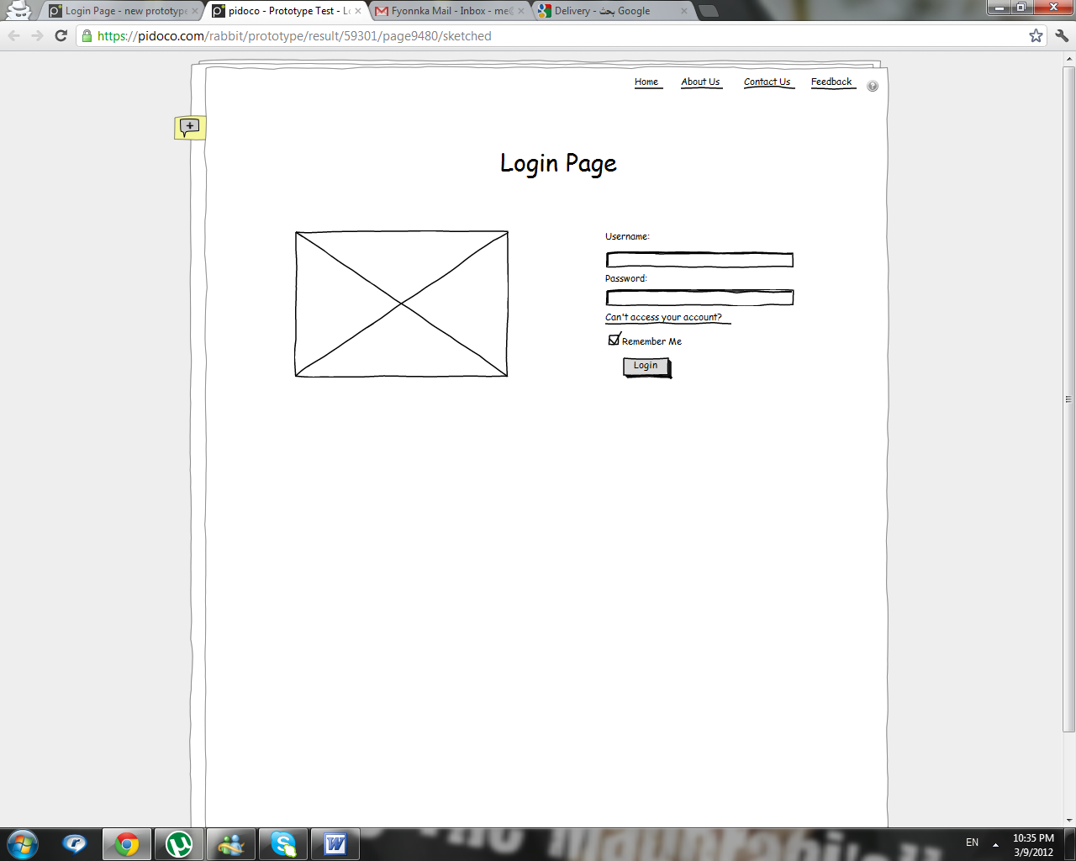
Figure 7 Login Page
After the user logs in, he will be directed to a confirmation page that will request that he checks his email to enter an automatically generated code that was sent by the system.
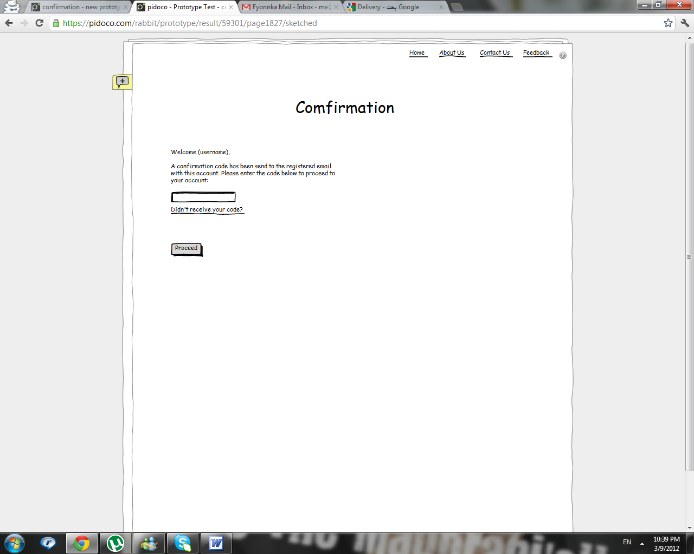
Figure 8 Confirmation Page
This system supports 4 types of users:
- Customers
- Sales Representatives
- Branch Managers
- Warehouse Representatives
If the user was a branch manager, he would be directed to the following dashboard in which he would have the following options to choose from:
  - View Pending Orders
  - View All Orders
  - View Inventory
  - View List of Customers
  - View List of Employees
  - Generate Reports
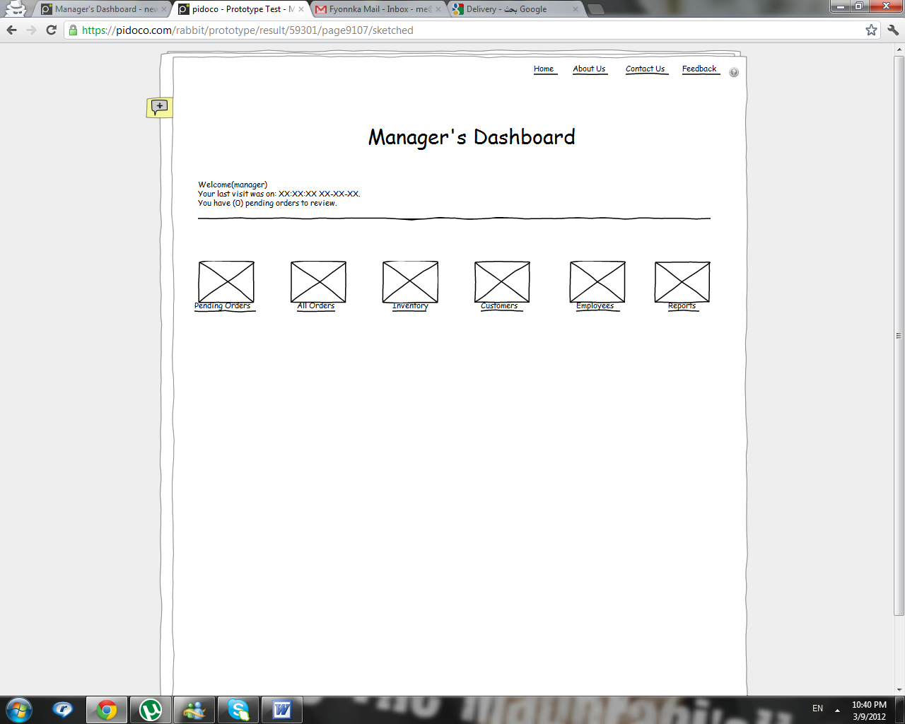
Figure 9 Manager's Dashboard
The manager can view all the pending orders he still needs to approve or reject. He can do so by clicking on the details link next to each order, view the orders details and customers’ history and the approval or reject. Whatever action the manager decides to take with the order, both the customer and sales representative will be notified.
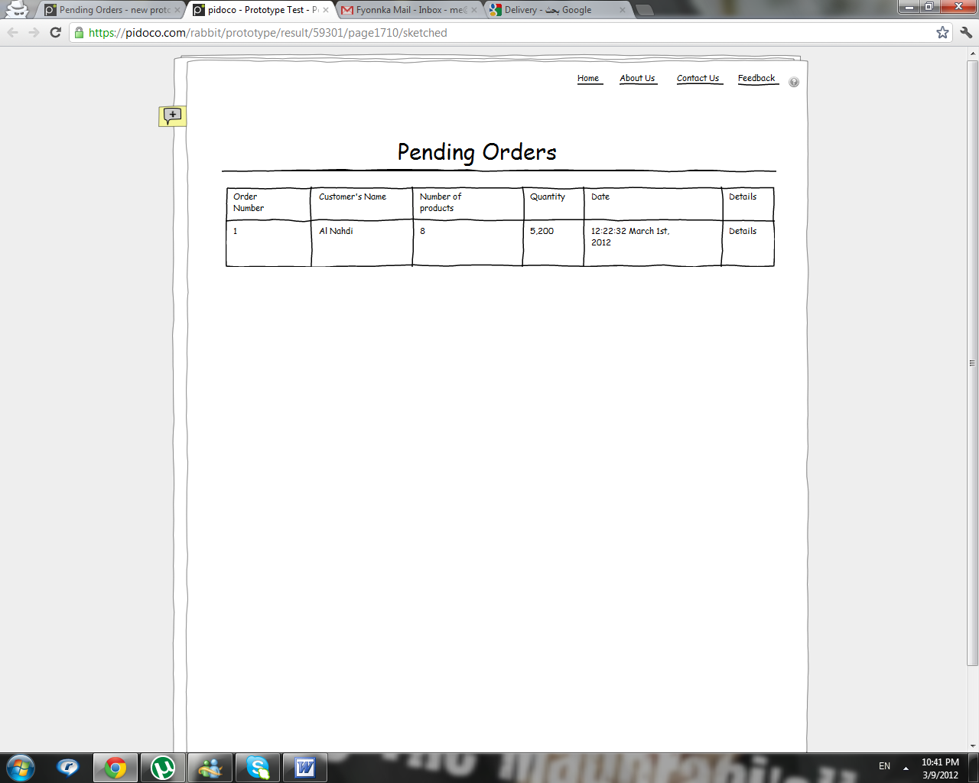
Figure 10 Pending Order Page
The manager can also view all the orders in his branch.
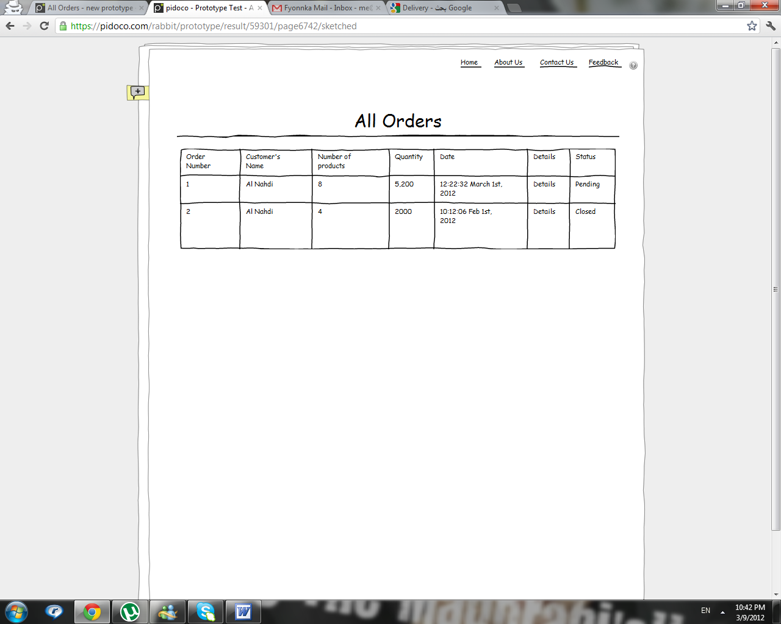
Figure 11 All Orders Page
The manager can check and edit the available inventory level. This page will also help the manager in making the decision regarding approving or rejecting an order according to the availability of the product ordered.
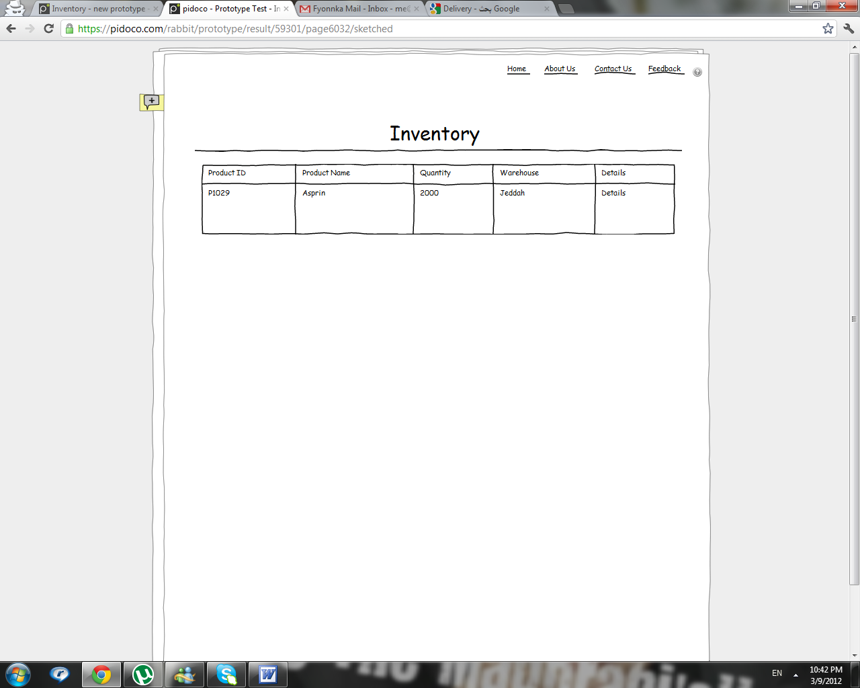
Figure 12 Inventory Page
The manager can also check the customers and the history of a certain customer. This page will help the manager in making the decision regarding approving or rejecting an order according to the balance of the customer.
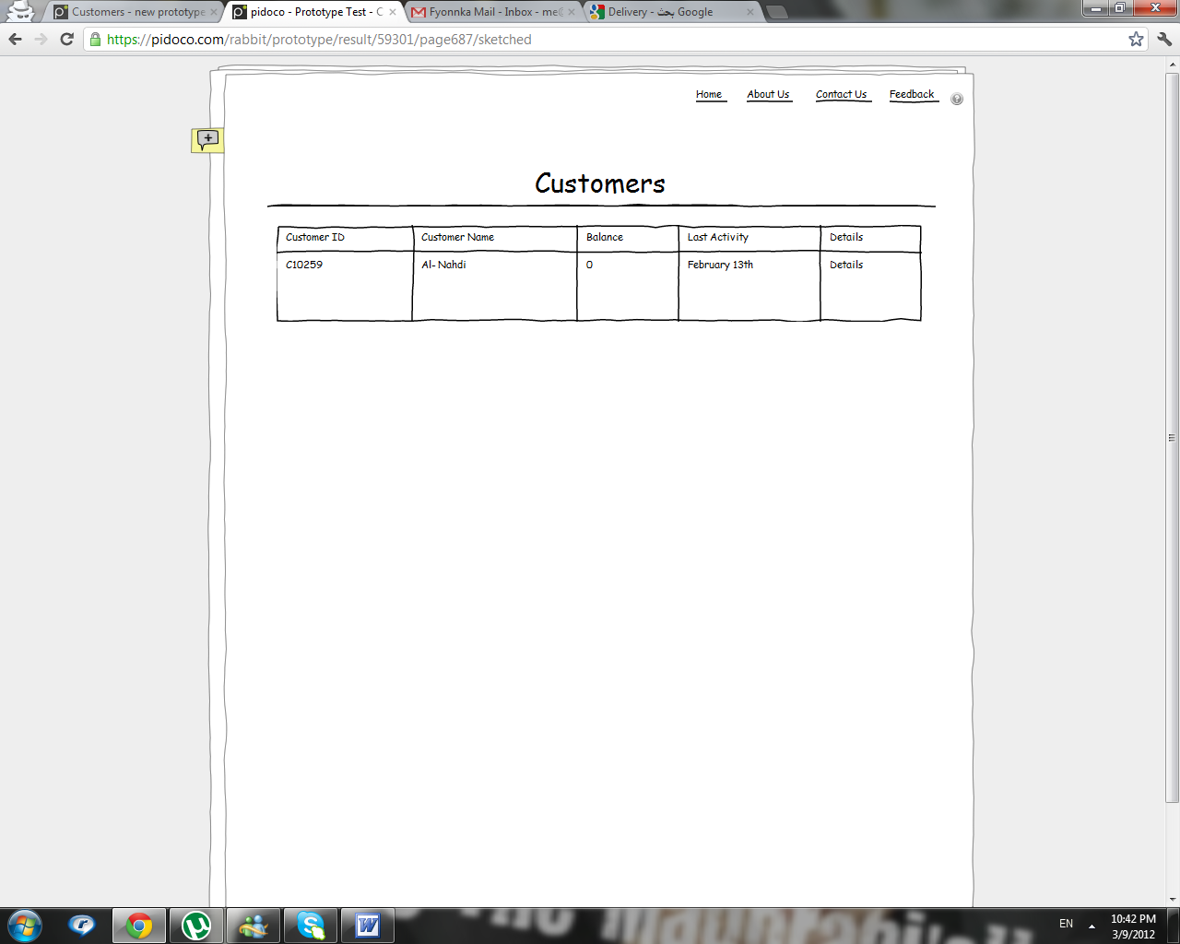
Figure 13 Customers Page
The manager can view the list of employees (Sales and Warehouse representatives) registered to the system and update them.
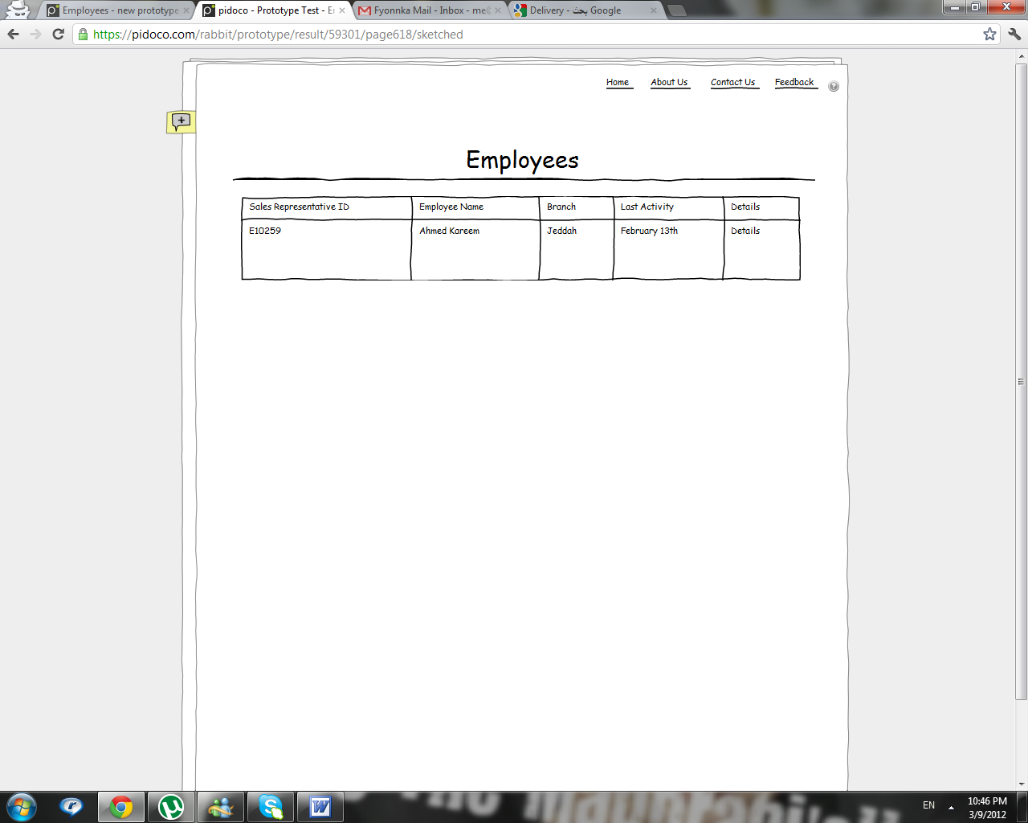
Figure 14 Employees Page
One of the main functions that the system needs to support for a manager is to generate reports. The manager can choose between 4 types of reports and enter the time period to generate the report for. The types are:
- Pending Orders
- In Progress Orders
- Complete Orders
- Cancelled Orders

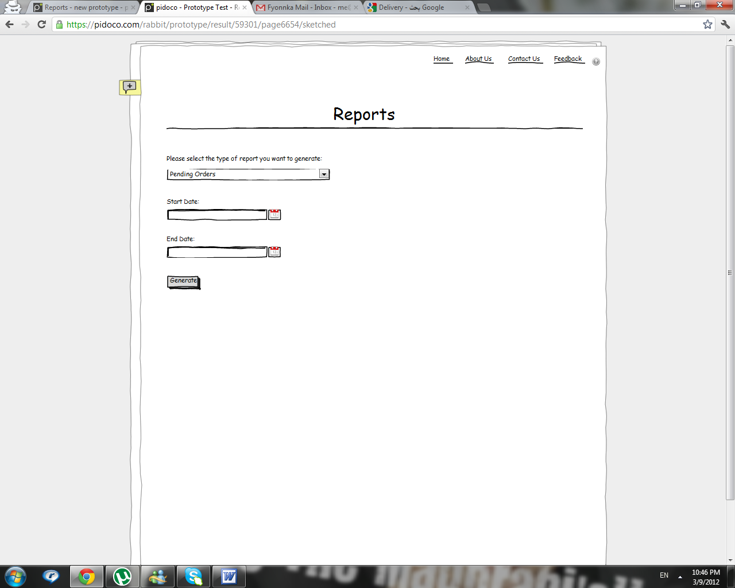
Figure 15 Reports Page
If the user logging into the system is a customer, he will be directed to this page that views some of the organization's details as well as links to 3 other pages:
- Previous Orders
- New Order
- Promotions

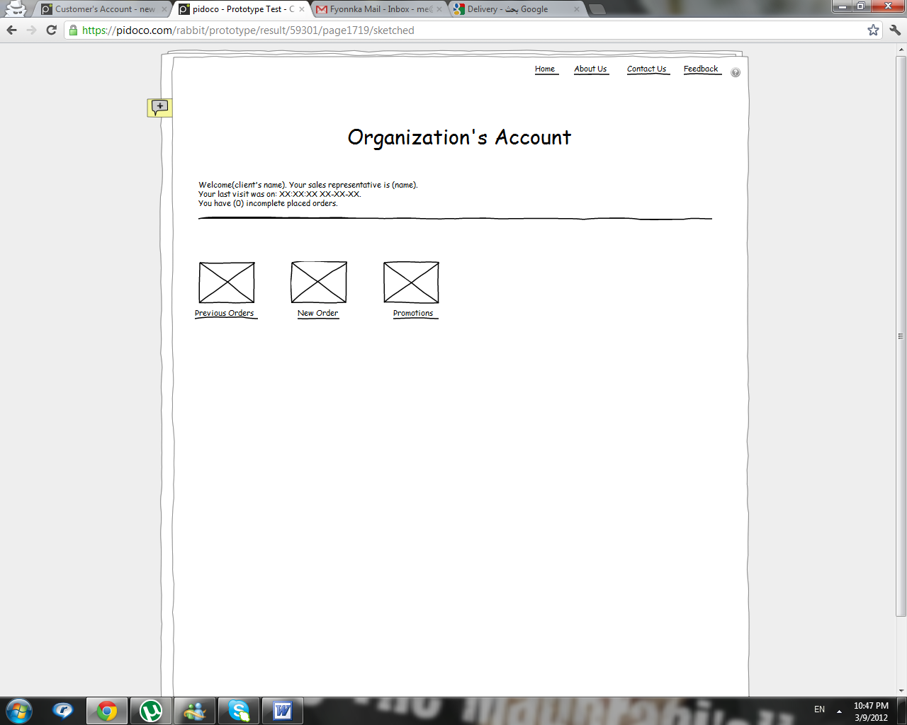
Figure 16 Organizations Page

The previous orders page views all the previous orders placed by the customer and their details.
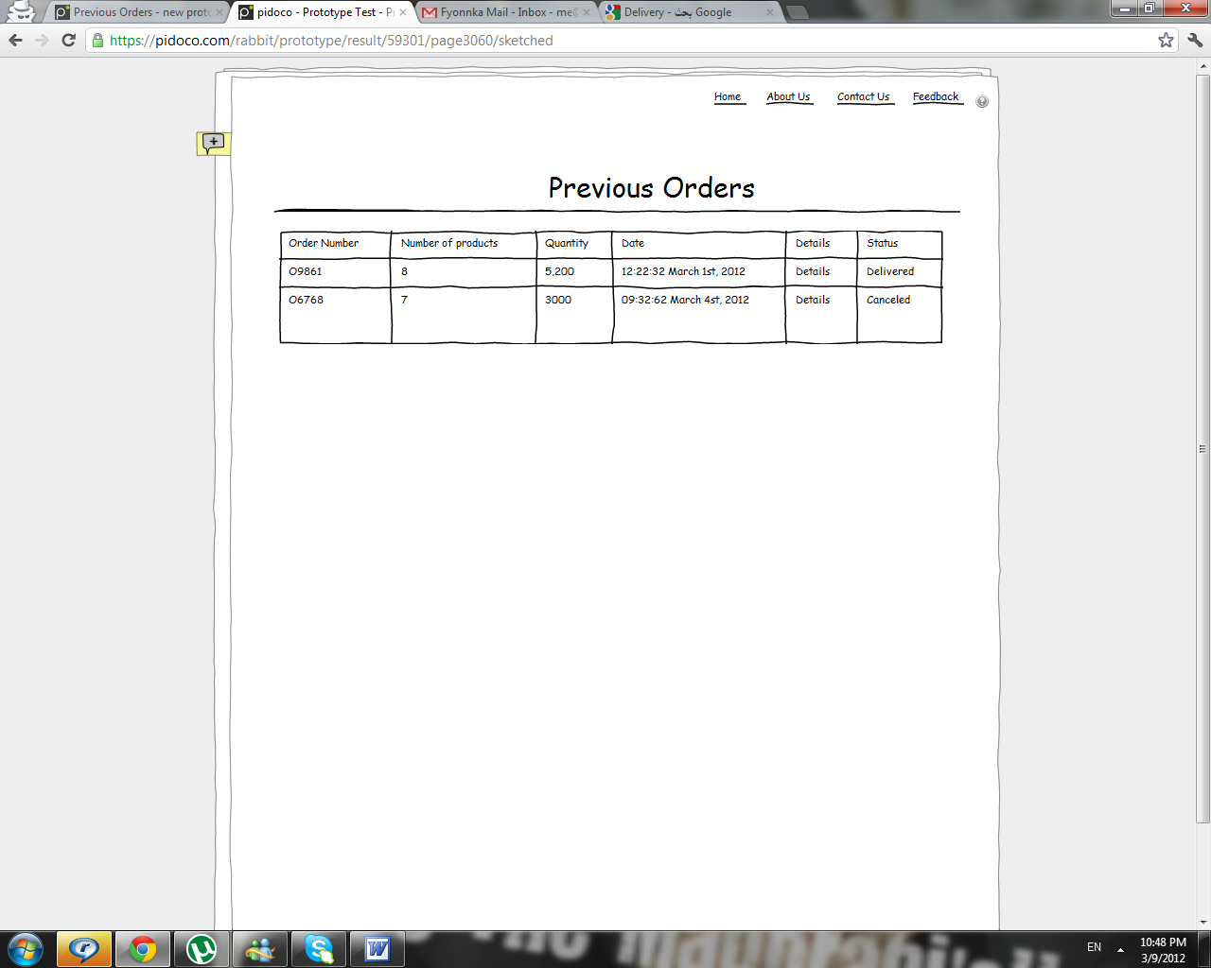
Figure 17 Previous Orders Page
When the customer clicks on the "New Order" link, he will first be directed to the following page. Since each organization (customer) is given only one account to log into the system, a list of some of the employees in that organization that can place an order is provided. The employee needs to pick his name from the list before continuing to the order form.
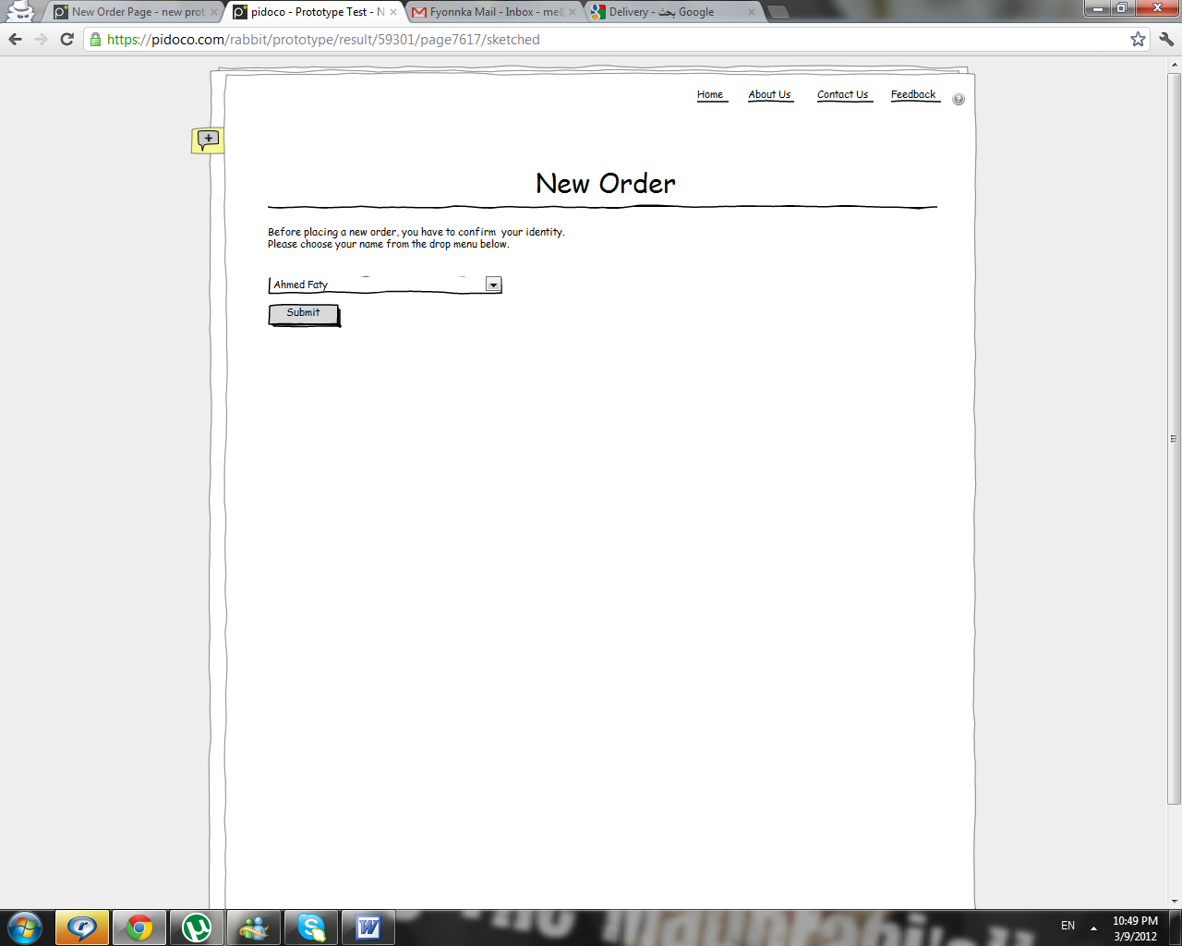
Once the employee chooses his name and submits, he will be directed to the placing order form. The employee needs to fill in the form once for every product he wishes to order. He could click on the "?" button to view the catalog if he forgot the products name or category as well.
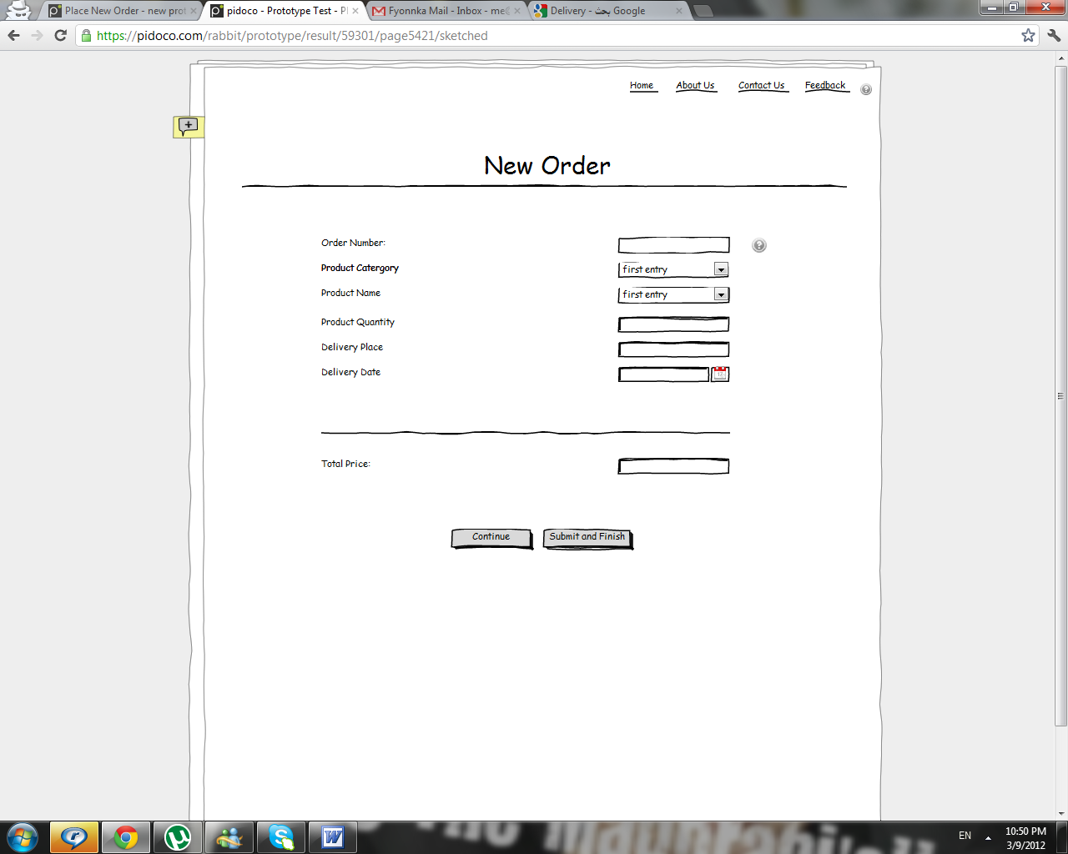
Once an order is completed and submitted, an order number will be given to it and sent to the client and sales representative by email.
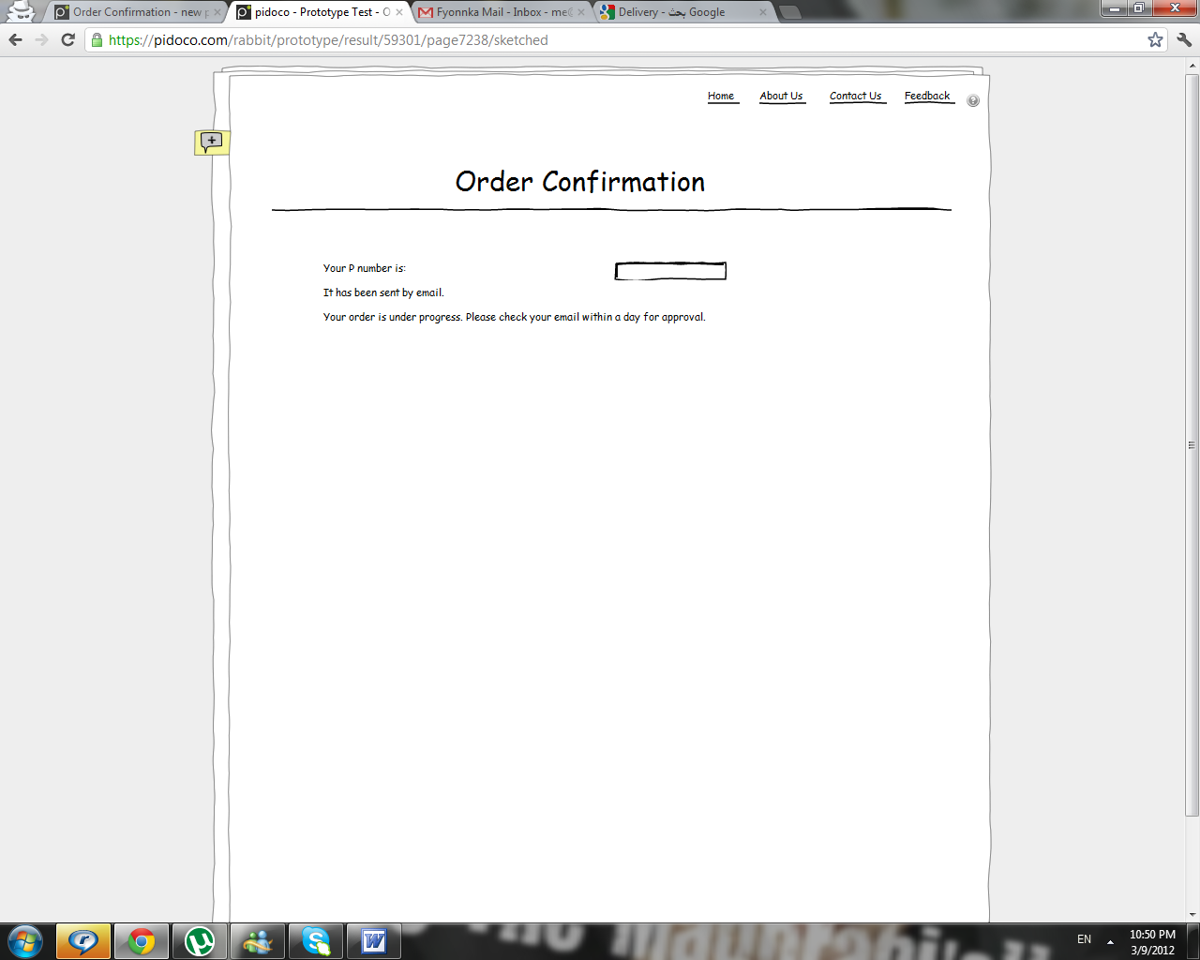

If the user logged in is a Sales Representative, he will be directed to his list of customers in which he can either add new customers he got, or edit the details of the existing ones.
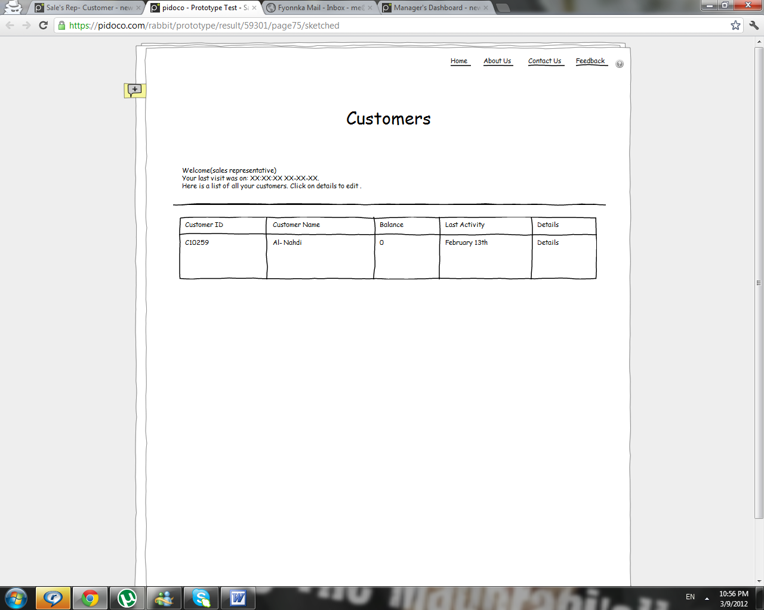
Figure 18 Customers List page
If the user logging in is a Warehouse Representative, he will be directed to the list of orders in which he edits the status to help enable shipment tracking.
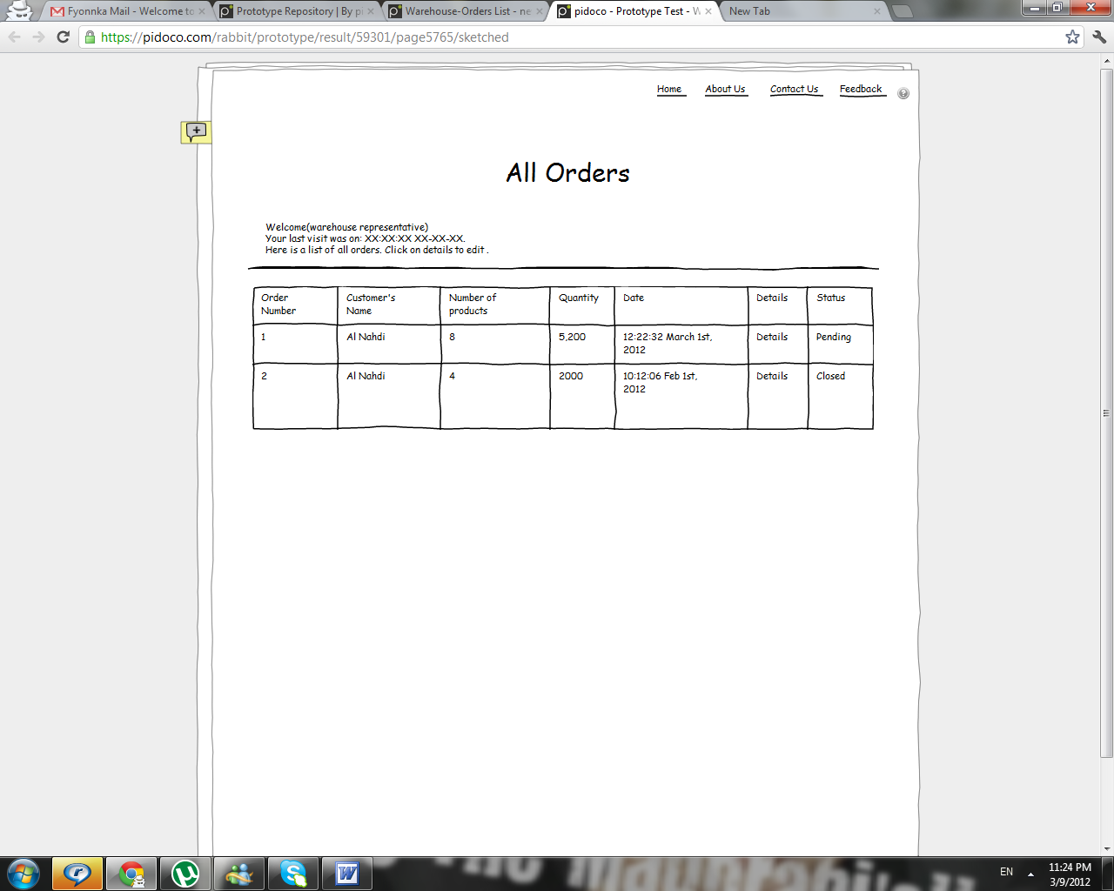
Figure 19 Orders Page

4.8 Tools and Technologies
List the main programming languages, libraries, frameworks, and platforms to be used in developing the project with a brief description.
Example 1:
- Python (Pandas, NumPy): a brief description here.
- Scikit-learn: a brief description here.
- Matplotlib / Seaborn: a brief description here.
- Flask: a brief description here.
- GitHub: a brief description here.
Example 2:
Microsoft SQL Server:
It is a Relational Database Management System (RDMS) that uses the Structured Query Language SQL to access and manipulate stored data developed by Microsoft. It is a software product whose primary function is to store and retrieve data as requested by other software applications. Its scope includes data query and data update, schema creation and modification and data access control. In SQL server, the RDMS is integrated within the visual studio IDE to simplify data access from windows applications. (About Microsoft SQL, 2012)
Microsoft visual studio:
Microsoft Visual Studio is an integrated development environment (IDE) from Microsoft. It is used to develop console and graphical user interface applications along with Windows Forms applications, web sites, web applications, and web services in both native code together with managed code for all platforms supported by Microsoft Windows, Windows Mobile, Windows CE,.NET Framework, .NET Compact Framework and Microsoft Silverlight. (What is Visual Studio, 2012)
Adobe Photoshop:
Adobe Photoshop is a computer application developed by Adobe Systems Incorporated. It is developed to be used for manipulating images and pictures. It’s considered the most well-known and used among graphical applications. Photoshop has various proprieties and features that facilitate the manipulation of images included in the application. (About Photoshop, 2012)
Microsoft Visio:
Microsoft Visio is a commercial diagramming program for Microsoft Windows that uses vector graphics to create diagrams. It can be used to create all types of diagrams, from simple flowcharts to complex ERDs. (Microsoft Office Visio, 2012).

Chapter 5: Project Management & Professional Practice
Describe planning, teamwork, and management aspects.

5.1 Team Roles and Responsibilities
Define roles of each team member.
Example:
- Member A: Data preprocessing & EDA
- Member B: Modeling & evaluation
- Member C: Deployment & documentation

5.2 Project Timeline
Provide a Gantt chart and milestone plan.
Example:
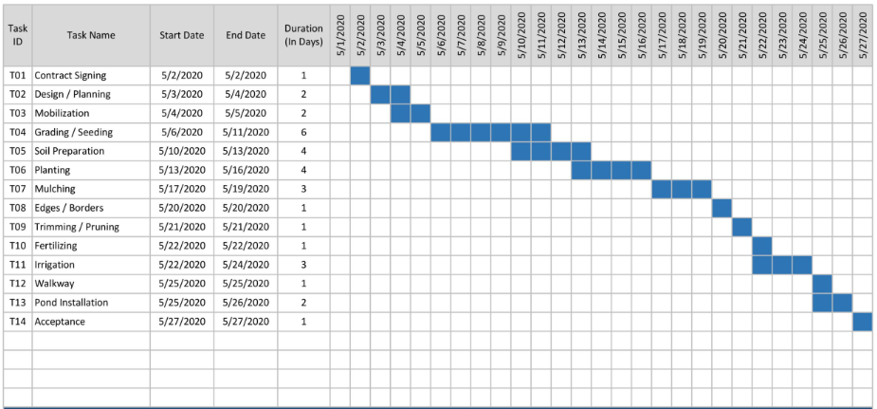
Figure 20: Phase I Gantt Chart

Figure 21: Phase II Gantt Chart

5.3 Risk Management
Identify risks and mitigation strategies.
Example:
- Risk: Poor data quality
- Mitigation: Data augmentation

5.4 Communication Plan
Explain communication and documentation practices.
It defines:
- Weekly meetings
- GitHub updates
- Supervisor reviews

PHASE II – IMPLEMENTATION, TESTING & DEPLOYMENT

Chapter 6: Data Preparation & Exploratory Data Analysis
This chapter documents the execution of the EDA plan and demonstrates applied data preprocessing skills.

6.1 Data Cleaning
Students must explain and justify data cleaning steps, including handling missing values, outlier treatment, encoding categorical variables, and normalization.
It explains:
- Missing value handling
- Outlier removal
- Encoding
Example:
“Missing income values were imputed using median values.”

6.2 Exploratory Data Analysis Results
Students should present statistical summaries and visualizations with clear interpretation and academic presentation standards.
It shows:
- Tables
- Charts
- Heatmaps

6.3 Insights from EDA
Students must discuss key insights and explain how these findings influenced engineering, model selection, or experimental design.
Example:
“EDA revealed strong correlation between tenure and churn, leading to feature prioritization.”

Chapter 7: Implementation
This chapter demonstrates technical competence in model development, software engineering practices, and reproducible experimentation using version control systems such as GitHub.

7.1 Model Implementation

7.1.1 Feature Engineering
Explain feature extraction and transformation.
Explanation:
Explain feature transformations.
Example:
Creating rolling average speed features over 15-minute intervals.

7.2 Model Training
Describe algorithms, training process, and tuning.

7.2 Tool/Software Implementation (GitHub Required)
Describe software implementation. Add GitHub repository link.
Students must:
- Use a GitHub repository
- Provide:
  - Code: Must include two folders: Software implementation and Unit test implementation folders.
  - Dataset (or access instructions)
  - README
  - Environment setup
Example README sections:
- Project overview
- Dataset description
- Installation steps
- How to run the code

Chapter 8: Testing & Evaluation
Evaluate the implemented models and system.

8.1 Evaluation Metrics
Define metrics used for performance evaluation.
Examples:
- Accuracy
- Precision
- Recall
- F1-Score
- ROC-AUC

8.2 Experimental Results
Present and analyze experimental outcomes.
It includes:
- Tables
- Graphs
- Model comparison

8.3 Systems Testing
Descript system testing including unit & integration testing plans, and methods.
Add examples of unit test, and integration testing. The unit test code must be added to the project GitHub repository.
Unit Testing Example:
def test_data_cleaning():
assert cleaned_data.isnull().sum().sum() == 0
Integration Testing Example:
- Data pipeline → model → API → UI

Chapter 9: Deployment
Describe deployment and operational aspects.

9.1 Deployment Architecture
Explain deployment environment and pipeline. Add a figure explaining the system deployment.
Example:
- Flask API + Docker + Cloud VM
Include a deployment diagram.

9.2 Maintenance and Scalability
Discuss future maintenance and scalability considerations.
Discusses:
- Retraining models
- Handling more data
- System upgrades

Chapter 10: Results, Discussion & Conclusion
This chapter synthesizes results, evaluates achievement of objectives, compares findings with related literature, and reflects on academic and professional learning outcomes.

10.1 Discussion (If applicable)
Summarize results, discuss implications, interpret model results and compare with literature.
Example:
“The Gradient Boosting model outperformed others, consistent with findings by Smith et al. (2023).”

10.2 Conclusion and Future Work
Conclude the project and suggest future extensions.
Example Future Work:
- Use deep learning
- Add real-time data
- Improve explainability

References
List all cited sources using an appropriate academic citation style. Uses consistent citation style (APA / IEEE).

Appendices
Include additional materials such as code snippets, extended tables, and diagrams.
Includes:
- User manual: provides clear, step-by-step instructions that enable end users to operate the developed system without requiring technical or programming knowledge.
- Extra plots
- Survey forms
- Additional tables

