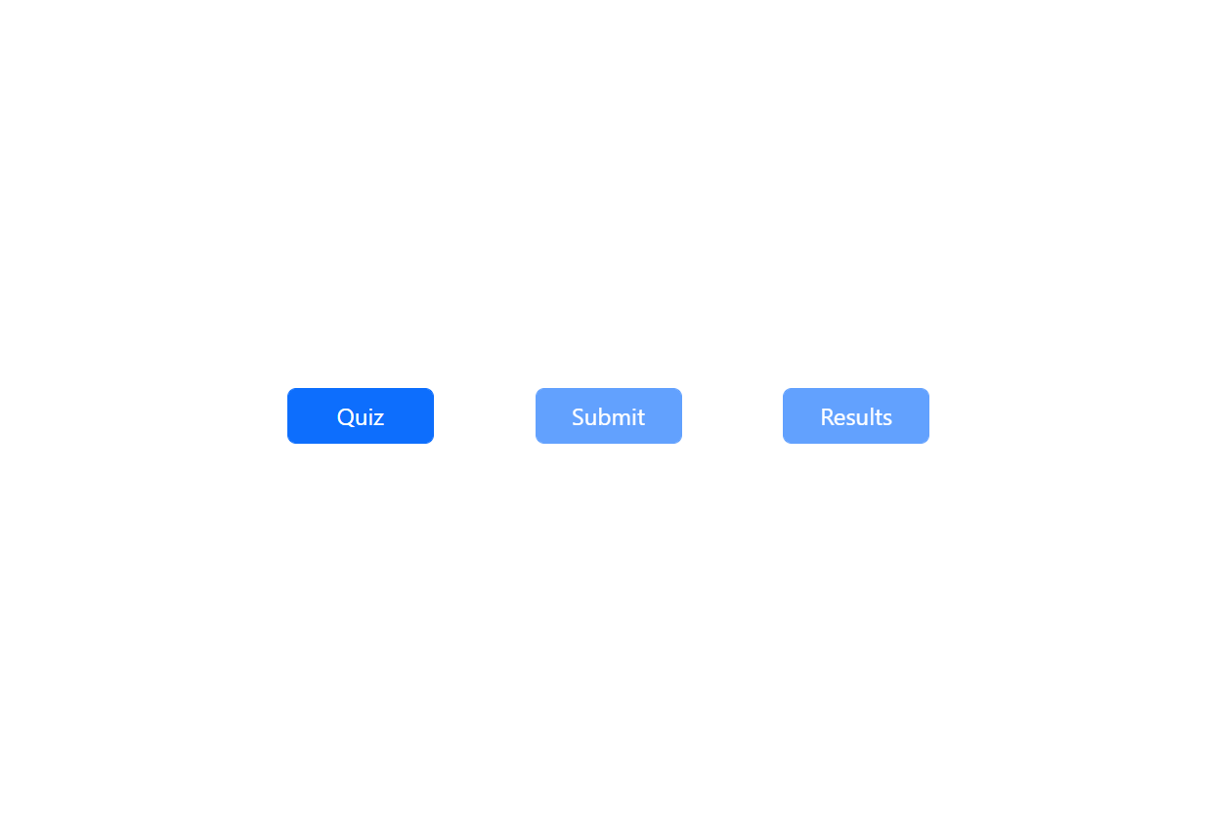

Figure : Homepage. Submit and Results button are disabled because the user must do the quiz first

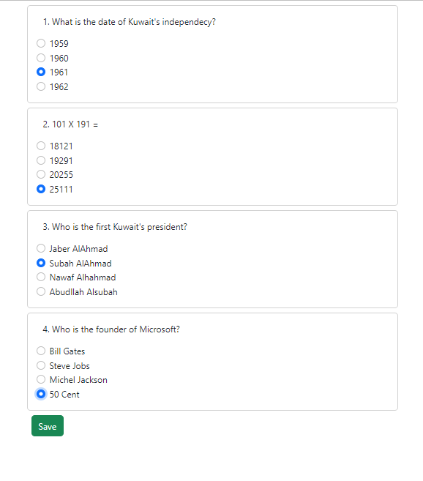

Figure : Quiz Page

Figure : Submit (Review) Page

Figure : Results Page