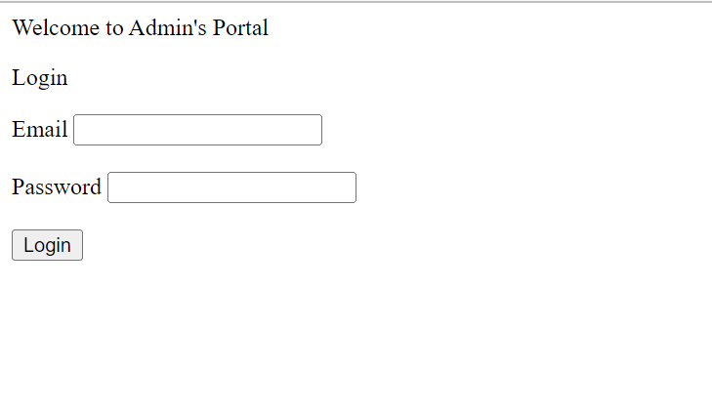

Figure : Login Page

Figure : email and password validation is checked in the backend

Figure : Homepage

Figure : Manage Subject Page

Figure : Manage Teachers Page

Figure : Manage Classes Page

Figure : Manage Students Page

Figure : Assign Teacher to class Page

Figure : Assign Subject to Class Page

Figure : Class Report Page

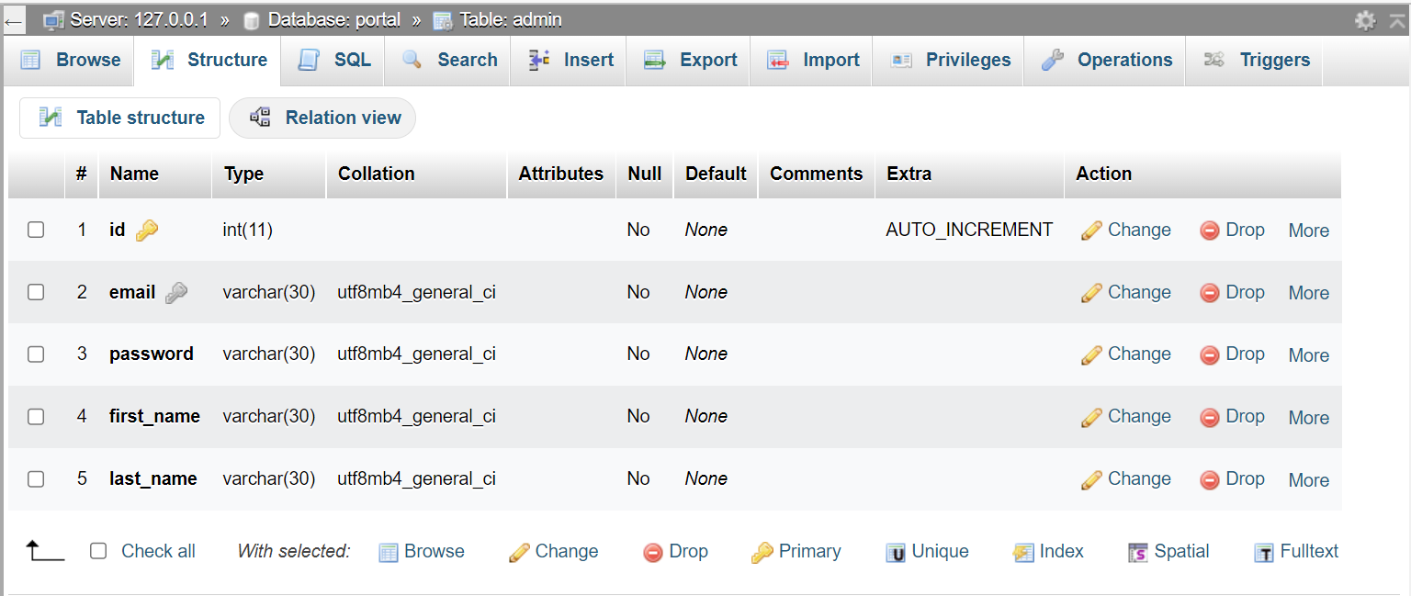

Figure : Admin table. id is the primary key, and the email is unique.

Figure : Class Table. id is the primary key, and both number and year columns composite unique key

Figure : ClassSujbect Table. id is the primary key. Instructor_id, subject_id, and class_id are foreign keys

Figure : Teacher table

Figure : Student's Table. class_id is a foreign key for the table class

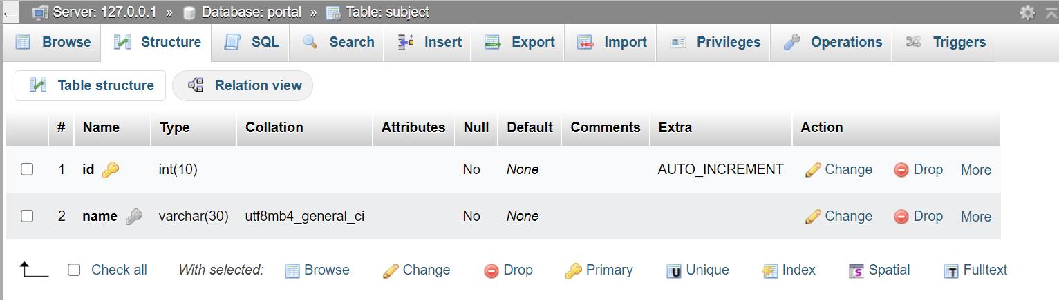

Figure : Subject Table