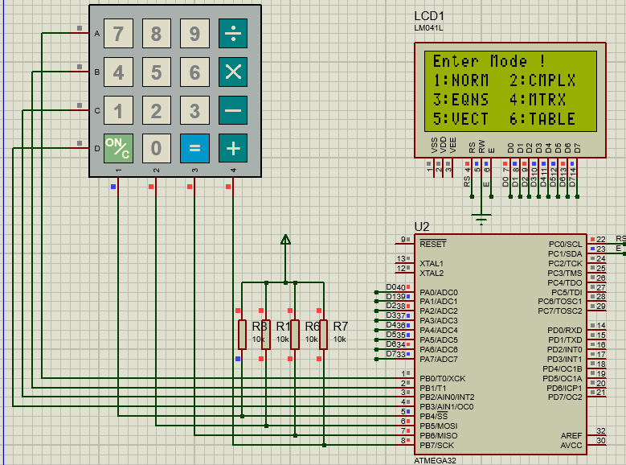**Advanced Calculator**

**Description:**

An advanced calculator similar to Casio-FX calculators implemented on ATmega32 microcontroller.

The system has 6 Modes:

1. **Normal:** Executes basic arithmetic operations like add, subtracting, multiplying and dividing.
2. **Complex:** Does basic arithmetic operations on complex numbers like adding and multiplying.
3. **Equations:** The mode can solve three different types of equations Two Equations in Two Unknowns, Three Equations in Three Unknowns, and Quadratic Equation.
4. **Matrix:** The mode can execute operations like adding, multiplying, transposing, and inversing on matrices.
5. **Vector:** Executes dot and cross multiplying on vectors.
6. **Table:** Generates a table of values from a given polynomial equation and a range of inputs.

**Programming Language(s):**

This project is written in C programming language.

**Hardware Implementation:**

This project is implemented on ATmega32 MC with a frequency of 1Mhz connected to the following components:

* 4x4 Keypad
* LM041L LCD

**Drivers:**

* GPIO
* LCD
* Keypad