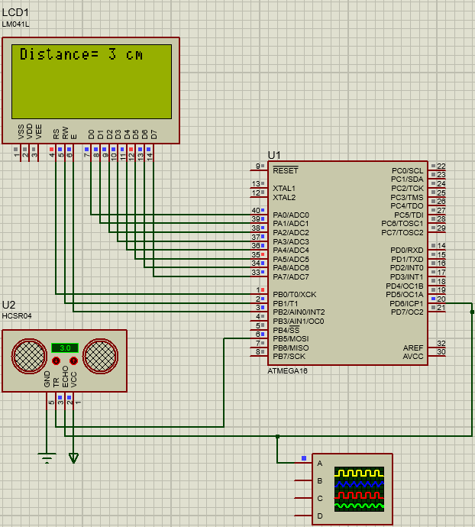**Distance Measuring System**

**Description:**

A distance measuring system using **Ultrasonic** sensor on ATmega16 microcontroller.

The system uses **HCSR04 Ultrasonic** distance to measure the distance of an opposing object.

The **PWM** signal sent from the signal is captured by the **ICU** driver implemented on the MC.

The distance is displayed on **LM041L LCD**.

**Programming Language(s):**

This project is written in C programming language.

**Hardware Implementation:**

This project is implemented on ATmega16 MC with a frequency of 8Mhz connected to the following components:

* HCSR04 Ultrasonic Sensor
* LM041L LCD

**Drivers:**

* ICU
* GPIO
* Ultrasonic Sensor
* LCD