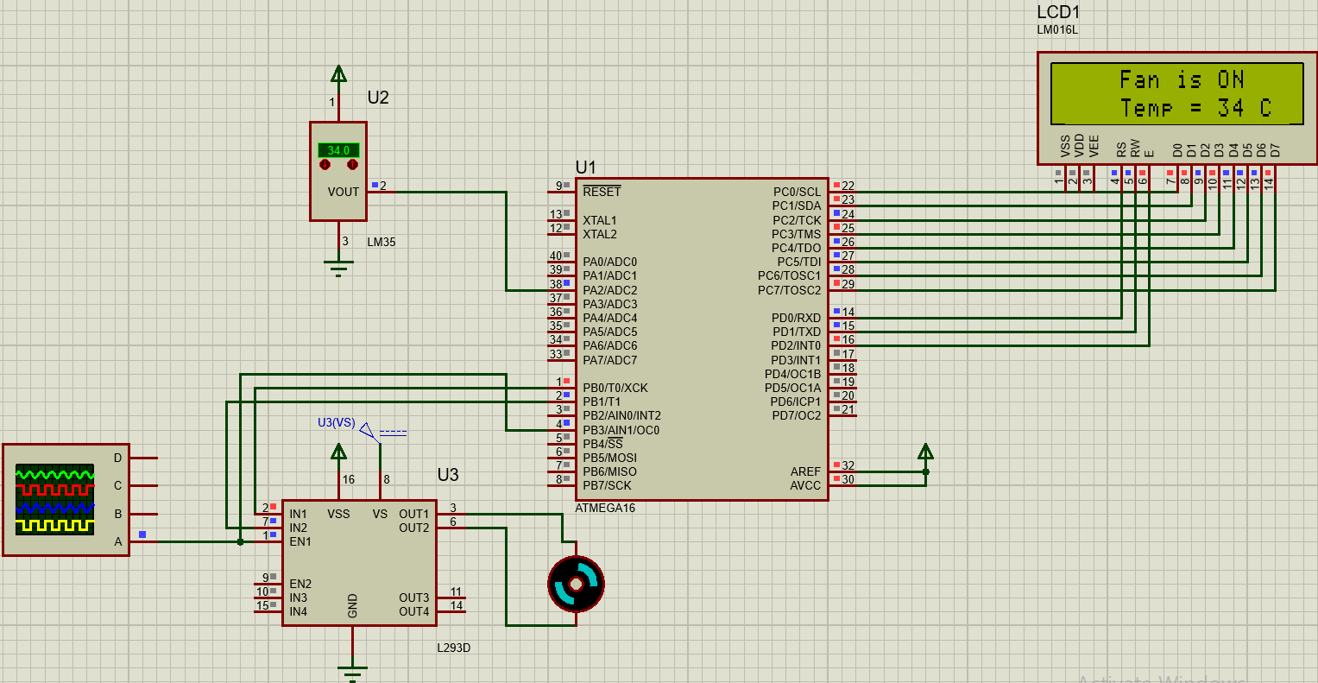**Fan Controller System**

**Description:**

A fan controller system to control fan speed and state based on measured room temperature on **ATmega16** microcontroller.

The system uses **LM35** temperature sensor to measure room temperature using **ADC** driver.

The speed of the DC motor is set based on the measured room temperature using **PWM**.

The state of the motor and temperature read is displayed on **LM016L LCD**

**Programming Language(s):**

This project is written in C programming language.

**Hardware Implementation:**

This project is implemented on ATmega16 MC with a frequency of 1Mhz connected to the following components:

* LM35 Temperature Sensor
* DC Motor
* L293D Motor Driver
* LM016L LCD

**Drivers:**

* ADC
* GPIO
* PWM
* DC Motor
* LCD
* LM35 Sensor