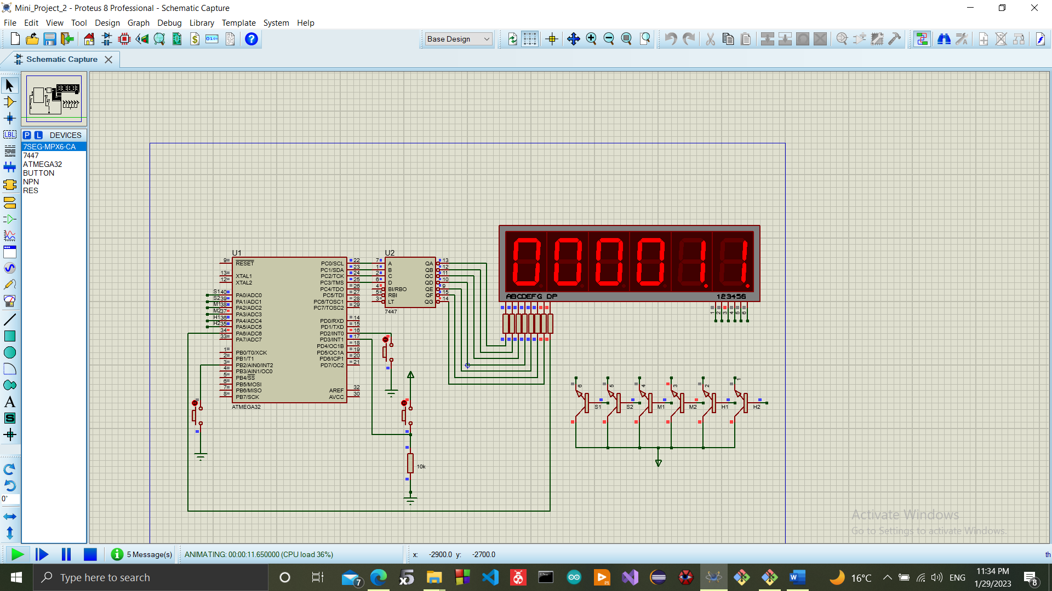**Stop Watch**

**Description:**

A stop-watch system that counts time in seconds with pause, resume and reset buttons using ATmega32 microcontroller.

The application uses **Timer1** on ATmega32 MC with **CTC** mode to count time.

The six 7-segments display time in (hh:mm:ss) format using the **Multiplexed Technique** to keep all the 7-segments visually active at the same time.

External Interrupt **INT0** is connected to a push button with a pull-up resistor and set up to be triggered with a falling edge to enable an **ISR** that will reset timer**.**

External Interrupt **INT1** is connected to a push button with a pull-down resistor and set up to be triggered with a rising edge to enable an **ISR** that will pause timer**.**

External Interrupt **INT2** is connected to a push button with a pull-up resistor and set up to be triggered with a falling edge to enable an **ISR** that will resume timer**.**

**Programming Language(s):**

This project is written in C programming language.

**Hardware Implementation:**

This project is implemented on ATmega32 MC with a frequency of 1Mhz connected to the following components:

* 6 Common Anode 7-segments
* 7447 Decoder
* 6 NPN BJT
* 3 Push Buttons

**Drivers:**

* Timer
* GPIO
* External Interrupts