UNIVERSITY OF WINDSOR
Faculty of Engineering

Stress Analysis – MECH-3211
Fall 2023

Laboratory #1
Experimental Determination of Principal Stresses

Objectives:
To determine the principal stresses at various points in a cantilevered tube that is subject to:
- a bending and torsional load;
- a bending and torsional load and internal pressure;

Equipment:
- Loading frame
- Steel and aluminum tubes with loading arm and load hanger
- Air pressure line
- 20-lb and 40-lb weights
- Datascan Analog Measurement Processor
- Dalite Datascan Configurator

Specimens:
The two specimens that are used in this laboratory experiment are very similar to each other, but one is made of steel and the other of aluminum. Each specimen consists of a 920 mm (36.22in.) long tube that is rigidly fixed at one end and has a side arm protruding at 90° to its axis at the other end. At the end of the 457.2 mm (18.0in.) long side arm is a hanger with a pan that can be loaded with dead weights. A strain gauge rosette is located on the top surface of the tubular specimen and another one on the bottom surface, both being at a distance of 228.6 mm (9.0 in.) from the fixed end of the steel specimen and at 152.4 mm (6.0in.) from the fixed end of the aluminum specimen. The tube wall thickness is 3.30 mm (0.13in.) for the steel specimen and 3.05 mm (0.12in.) for the aluminum specimen. The outer diameter of the tube is 76.2 mm (3.0in.) for both specimens.

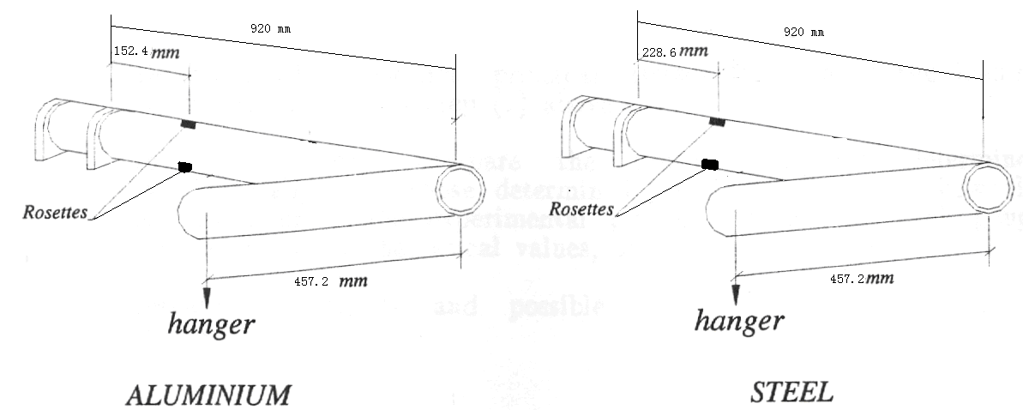
Preliminary set-up procedure:

- Check the specimen dimensions and strain gauge location.

45°
45°

45°
1
3
2

45°

L

4
6
5

L
top view
bottom view

- Check lead wires and identify each gauge with number of circuit in the Datascan Analog Measurement Processor.
- Hang the loading pan on the side arm of the tube at a distance of 457.2 mm (18 in.) from the tube axis.

Testing procedure:
- Check and record the initial values for each of the six strain gauges in the unloaded configuration.
- Loading A: Apply loads in six equal increments of 20 lbs (total 120 lbs) for the aluminum specimen and increments of 40 lbs (total 240 lbs) for the steel specimen. Record the readings of strain for each gauge and at each load. Unload the specimen.
- Loading B: Supply and maintain a constant air pressure in the specimens (100 psi in the aluminum specimen, and 200 psi in the steel specimen), as indicated by the pressure gauge. Apply loads in six equal increments of 20 lbs (total 120 lbs) for the aluminum specimen and increments of 40 lbs (total 240 lbs) for the steel specimen. Record the readings of strain for each gauge and at each load. Unload the specimen.

Loading A: Torsion and bending

- Aluminum specimen
 | Strain gauge readings (10⁻⁶)
Load (lb) | 1 | 2 | 3 | 4 | 5 | 6
0 | 0.0 | 0.0 | 0.0 | 0.0 | 0.0 | 0.0
20
40
60
80
100
120

- Steel specimen
 | Strain gauge readings (10⁻⁶)
Load (lb) | 1 | 2 | 3 | 4 | 5 | 6
0
40
80
120
160
200
240

Loading B: Torsion and bending with constant pressure

(a) Aluminum specimen (100 psi internal pressure)
 | Strain gauge readings (10⁻⁶)
Load (lb) | 1 | 2 | 3 | 4 | 5 | 6
0
20
40
60
80
100
120

- Steel specimen (200 psi internal pressure)
 | Strain gauge readings (10⁻⁶)
Load (lb) | 1 | 2 | 3 | 4 | 5 | 6
0
40
80
120
160
200
240

Preparation of the Laboratory Report:

- Objectives
- Procedure
Sketch the tubular structure with dimensions and gauge location.
- Results

- The raw experimental data tables on pages 3 and 4 should be reproduced in the Lab report
- For loading B only, plot the strain versus load for each of the three gauges in the top and bottom strain rosettes for both the steel and aluminum specimens. Draw a best fit straight line to represent the output at each gauge. This will lead to four different graphs.
- Draw a free body diagram of a loaded specimen and provide sample calculations of the theoretical principal stresses for the top strain rosette on the aluminum specimen when it is loaded with the maximum load (120 lb) and the constant internal pressure of 100 psi. These calculations should be written out by hand on blank sheets of paper and included in the Lab report.
- Determine the experimental and theoretical principal stresses at both top and bottom strain rosette locations for both specimens, but only for the following three loading cases:
Case 1: Maximum torsion and bending loads (i.e. when the applied load is maximum)
Case 2: Internal pressure only,
Case 3: Maximum torsion and bending loads and internal pressure.
This can be done using MS-Excel.

- Present the results in the tables provided on the next page (you can copy the empty tables from the next page into your Lab report). Compare the principal stresses determined experimentally with those determined theoretically. Also show the percent error of the experimental principal stresses at each gauge location from the theoretical values, using the latter as base.
Percent error = × 100

- Discussion
Discuss the results and possible sources of errors.

- Conclusions
Note: the Lab report must be prepared in the most professional manner possible; all graphs and text (other than the required hand calculations) should be prepared on a PC using commercial software such as Microsoft Office (Word, Excel), and the cover page provided.
Principal stresses
- Aluminum specimen: top rosette
 | Theoretical stresses (psi) |  | Experimental strains (in/in) |  | Experimental stresses (psi) |  | Percent error (%)
 | σ_{max} | σ_{min} | ε_{max} | ε_{min} | σ_{max} | σ_{min} | σ_{max} | σ_{min}
Case 1
Case 2
Case 3

- Aluminum specimen: bottom rosette
 | Theoretical stresses (psi) |  | Experimental strains (in/in) |  | Experimental stresses (psi) |  | Percent error (%)
 | σ_{max} | σ_{min} | ε_{max} | ε_{min} | σ_{max} | σ_{min} | σ_{max} | σ_{min}
Case 1
Case 2
Case 3

- Steel specimen: top rosette
 | Theoretical stresses (psi) |  | Experimental strains (in/in) |  | Experimental stresses (psi) |  | Percent error (%)
 | σ_{max} | σ_{min} | ε_{max} | ε_{min} | σ_{max} | σ_{min} | σ_{max} | σ_{min}
Case 1
Case 2
Case 3

- Steel specimen: bottom rosette
 | Theoretical stresses (psi) |  | Experimental strains (in/in) |  | Experimental stresses (psi) |  | Percent error (%)
 | σ_{max} | σ_{min} | ε_{max} | ε_{min} | σ_{max} | σ_{min} | σ_{max} | σ_{min}
Case 1
Case 2
Case 3

Appendix:
- Calculate the experimental principal stresses as follows:

Using the recorded strain gauge readings, determine ε_{x}, ε_{y} and γ_{xy}. This is accomplished by substituting the strains and corresponding angles into the following equation and then solving the three equations simultaneously (θ is the angle of the gauge measured from the longitudinal axis of the tube – counterclockwise is positive).

or

Calculate the principal strains using the following equation:

Calculate the principal stresses using the following equation:

This entire calculation can be verified with the MS-Excel spreadsheet provided.
Use E = 10 × 10⁶ psi and ν = 0.33 for aluminum, and E = 30 × 10⁶ psi and ν = 0.27 for steel.

- Calculate the theoretical principal stresses as follows:

- Normal stress along the x-axis due to bending (σ_{m})

where
σ_{m} = theoretical normal stress at distance ‘y’ from the neutral axis;
y = distance from neutral axis;
M = bending moment;
I = moment of inertia of the cross-section about the neutral axis of bending
for the cross-section of a thin-walled hollow tube.
- Normal stresses (σ₁, σ₂ ) due to internal pressure p

,

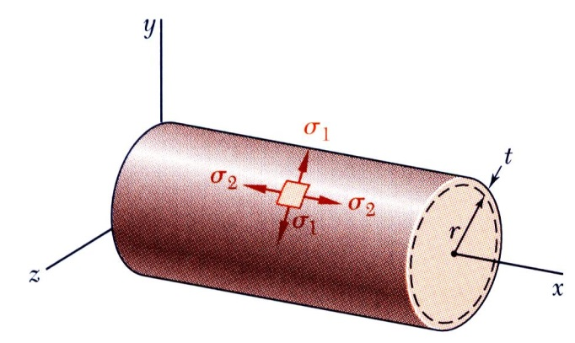

where
σ₁ = hoop stress acting perpendicular to the x-axis and tangentially to the tube wall;
σ₂ = longitudinal stress acting along the x-axis;
r = inner radius of the tube;
t = thickness of the tube wall.

- Shearing stress due to torsion (τ)

where
τ = theoretical shearing stress;
T = torque;
R = tube outside radius
J = polar moment of inertia. for the cross-section of a thin-walled tubular specimen.
R_{o} = outside radius of the tube;
R_{i} = inside radius of the tube.

