Day 1: Schematic Design & Footprint Creation
1. Power Delivery & Safety Architecture The BU04 requires a stable 3.3V supply capable of providing at least 500mA during active UWB ranging.
- To ensure a safe power rail, bring the 5V from your external buck converter into a right-hand side rozita, route it through an on/off switch, then a fuse, and into a 5V connector.
- From that 5V line, use a linear regulator (like the AMS1117-3.3) or a small step-down IC to drop the voltage to the required 3.3V.
- Place 10µF ceramic capacitors on both the 5V input and 3.3V output of the regulator, placed as physically close to the BU04’s VDD1 and 3V3 pins as possible to handle transient current spikes.
2. Data & Peripheral Interfaces The BU04 already has an integrated STM32F103, which will handle the heavy UWB processing and send clean localization data back to your main STM32H755.
- Break out the SPI, UART, and I2C pins to standard 2.54mm pitch headers.
- If you want a debugging interface on the breakout board itself, add a CH340C USB-to-UART bridge connected to the BU04's UART1_RX and UART1_TX.
- Safety: If you add a USB Type-C port for this debugging, you must include ESD protection arrays (such as the ESD5451N) on the D+ and D- lines to protect the module from static discharge when plugging/unplugging in a warehouse environment.
3. Control & Reset Mechanics
- Route the ST_NRST and BOOT0 pins to tactile push buttons pulling to GND and 3V3 respectively.
- Add a 100kΩ pull-down resistor to the IRQ pin (Pin 17) to prevent false interrupts during the module's sleep states.
Day 2: PCB Layout & Routing
1. Component Placement & RF Keep-Out
- Create the SMD-34 (35.5mm × 33.5mm) footprint for the BU04.
- Place the BU04 module flush against the edge of the PCB. Even though you plan to use an external IPEX antenna, you must leave the area immediately underneath and around the onboard ceramic antenna completely devoid of copper pours, traces, and components.
2. Ground Plane Optimization & Stackup
- While a 2-layer board can work for a simple breakout, using a 4-layer stackup (Signal, GND, 3V3, Signal) will yield much better ground plane optimization. This ensures the lowest possible impedance return paths for the 500mA current spikes and shields the SPI lines from noise.
- If you stick to a 2-layer design to expedite manufacturing, ensure the bottom layer is a solid, unbroken ground plane. Liberally use stitching vias around the perimeter of the BU04 module and near the power regulator.
3. Routing
- Route your SPI traces back to your headers. While these won't be running at ultra-high frequencies, keep them short, parallel, and unbroken over the ground plane.
- Route the power traces with a width of at least 20-25 mils to comfortably handle the 500mA requirement without heating.
Run your final DRC checks, generate the Gerbers, and send them to your fab. By replicating just the power regulation, basic UART/SPI breakout, and adding standard ESD protection, you will have 4 functional, Palletto-ready UWB nodes before the official kits even restock.

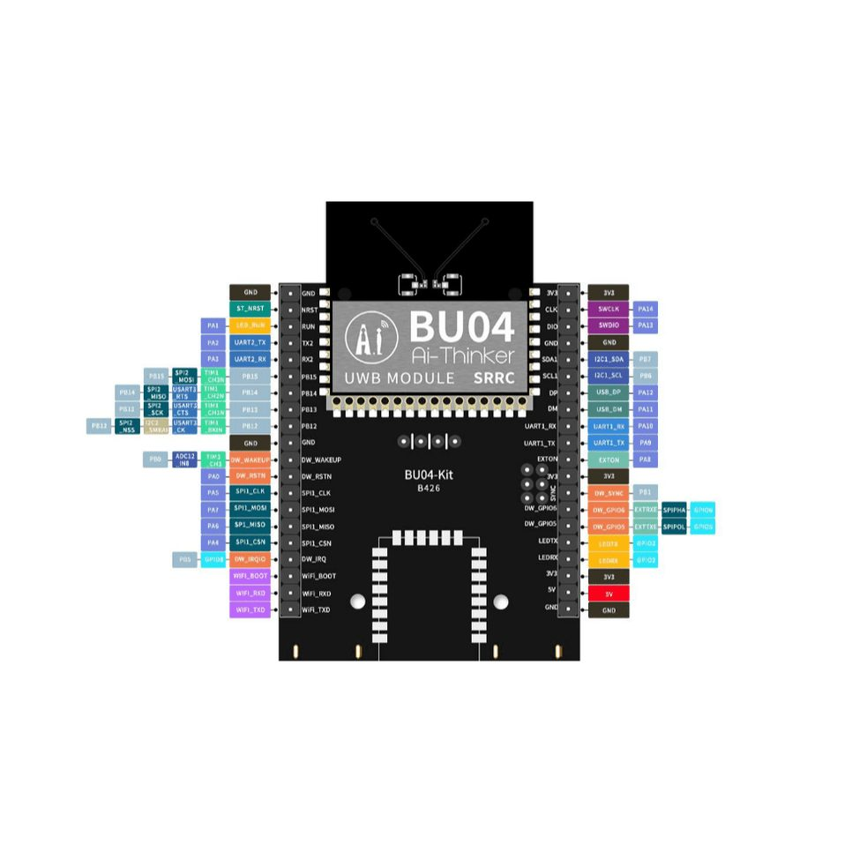

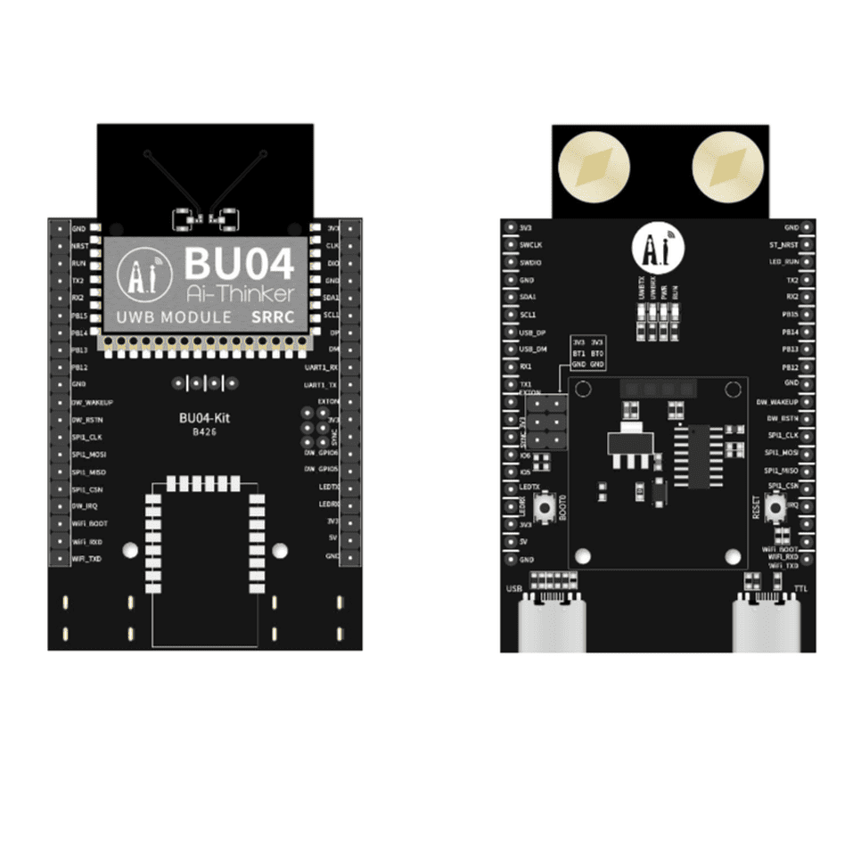

2x3 pin header block is the Boot Mode Selection Header for the STM32F103 microcontroller integrated inside the BU04 module.
The silkscreen box pointing to it gives you the map of the pins:
- Middle Row: BT1 (BOOT1) and BT0 (BOOT0) – These are the actual mode selection pins on the STM32.
- Top Row: 3V3 – Provides a logic HIGH.
- Bottom Row: GND – Provides a logic LOW.
By placing plastic jumper caps vertically across these pins, you dictate how the STM32 boots up when power is applied or when the reset button is pressed.
Here is how the combinations work and why they are necessary:
1. Normal Execution Mode (Run Mode)
- Configuration: Jumper connects BT0 to GND. (BT1 can be connected to GND or left alone).
- What it does: The STM32 boots from its Main Flash Memory. This is the standard operating mode where it runs your UWB localization firmware and communicates with your main controller.
2. System Memory Mode (Serial Flashing Mode)
- Configuration: Jumper connects BT0 to 3V3, and a second jumper connects BT1 to GND.
- What it does: This forces the STM32 to boot from its internal ROM, activating the factory bootloader. You must use this mode if you want to upload new firmware to the BU04 using a USB-to-UART adapter (like the CH340C) via the UART1_TX and UART1_RX pins, rather than using an ST-Link programmer.
3. SRAM Mode (Debugging)
- Configuration: Jumper connects BT0 to 3V3, and BT1 to 3V3.
- What it does: The chip boots from embedded SRAM. This is rarely used except for very specific debugging scenarios.
How to handle this on your custom PCB
Since you are designing a streamlined breakout board for Palletto, you do not need to replicate this bulky 6-pin header. You can simplify your design to save space:
- Hardwire BOOT1: You almost never need BOOT1 to be HIGH. You can permanently route the BOOT1 equivalent pin to GND through a 10kΩ pull-down resistor.
- Use a Button for BOOT0: Instead of a jumper, route BOOT0 through a 10kΩ pull-down resistor to GND (so it naturally stays in Normal Mode). Then, connect a tactile push button between BOOT0 and 3V3.
