**AI Fitness Coach at Home**

**1 Introduction**

In this study, we investigate the potential for an artificial intelligence (AI) fitness coach, which has computer vision technology at its core, to help people train for fitness in a manner akin to a human coach.

An AI fitness coach, an artificial intelligence coaching system with computer vision technology as the core, can help users with fitness training as a human coach. In this work, we investigate whether artificial intelligence can replace the coaching industry and how computer vision technology can empower it.

Figure 1 delineates a problem tree, encapsulating sub-issues and core problems within the contemporary fitness landscape, with the central concern being the incorrect execution of exercises by numerous individuals.

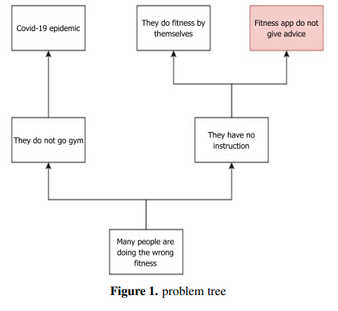

**2 Method**

Fig. 2 shows a diagram of the proposed system, AI Fitness Coach. It consists of the pose recognition unit, fitness movement analysis unit, and feedback unit. The user captures their pose by a camera. The pose recognition unit processes the captured image and outputs the recognition result to the fitness movement analysis unit. After the results are processed by the fitness movement analysis unit, the advice is output from the device through video or voice.

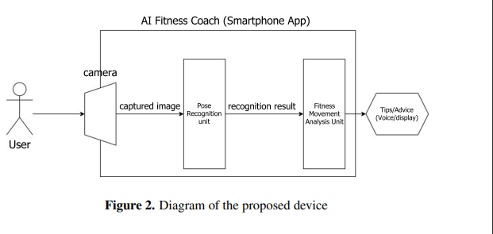

**3.1 System Design: Pose recognition Unit**

The pose recognition unit is designed to recognize 12 body segments shown in Fig 4. Each body segment has a tag from “a” to “l”, and a name.

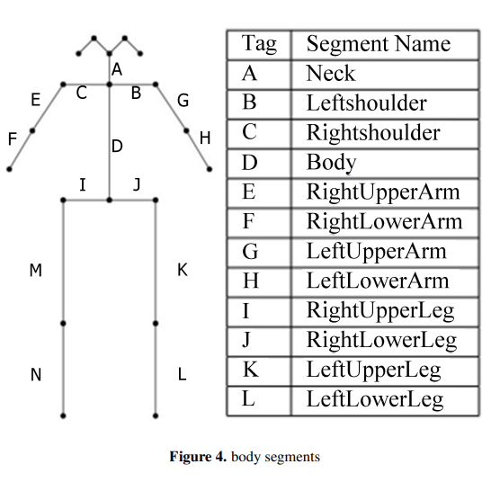

body segments We use OpenPose to extract the body segments. Openpose will detect the human body and output a JSON file, in which 25 key points are included, and the correct body segment is obtained by concatenating two adjacent key points through the developed database.

**3.2 System Design:** **Development of the function library**

The posture library is a function library written in Python. The library accept to the JSON file from OpenPose and a tuple (s1,s2,min,max). The library evaluates the tuple and returns the result. OpenPose output the 2D location of human body point in a large array.

**3.3 System Design: Pose analysis Unit**

OpenPose output the 2D parts location of the human body into a large array. To pick up the location of the desired body part, specifying the correct index is necessary. For example, for the location of the right shoulder, index value 6 for xcoordinate and value 7 for y-coordinate must be specified. Finally, we calculate the angle between two body segments using the eq. 1

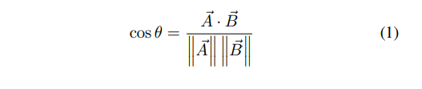

**3.4System Design: Feedback Unit**

After the Pose analysis Unit has processed the information and attained the corresponding values, the system will detect the output according to the angle of the preset body segment values and compare them, and finally judge whether the action is correct or not, and give the corresponding feedback, in the case of correct action, the system will output ”correct”.

**3.5 System Configuration**

Fig 5 shows the configuration of the prototype. The prototype uses a well-known open-source package OpenPose. OpenPose can recognize body segments from a photo image.

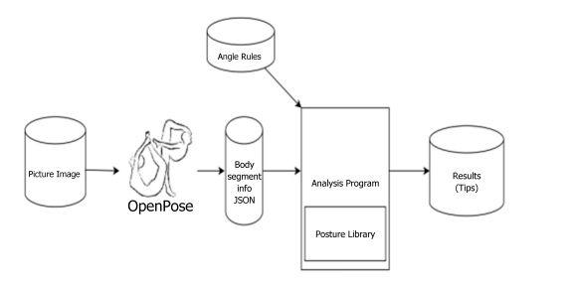

The user inputs the image file into OpenPose, and OpenPose processes it and outputs the result through a JSON file. Based on the JSON file, the result is given through the Analysis Program finally outputs tips. OpenPose. It not only can output JSON files but also can output various results, such as processed image files, CSV files, etc.

**3 Results**

Fig 7 shows the main page where the list of fitness poses is displayed. The user can select the desired pose by clicking a button. After selecting a pose, the user can enter the target time duration of the pose as shown in Fig 8. In this case, the user wants to keep this pose for 30 seconds. Then the user can start the function by clicking the “start” button. The user has to place the device so that its camera can capture the user’s pose. The device gives the user a preparation time before starting processing as shown in Fig 9.

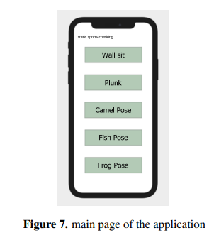 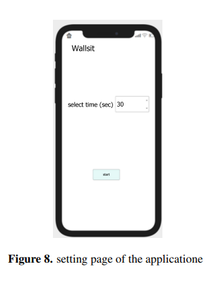 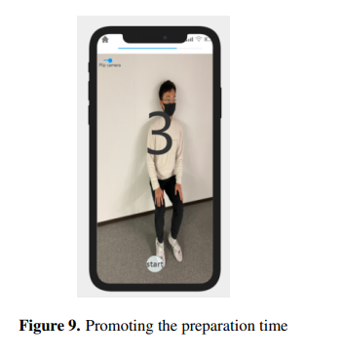

The device judges the correctness of the user’s pose once every second and count down from 30 seconds to zero while it judges the pose as correct, or gives proper tips if it judges the pose as incorrect for three continuous seconds. The device can also display and record the recognized result as shown in Fig 10. The user can play back and check their pose after fitness.

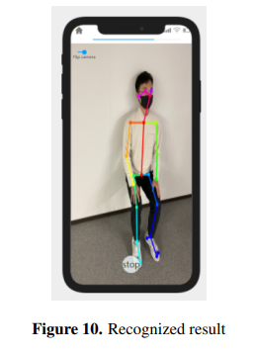

Fig 11 is the success result graph given by the system. When successful, the system gives the success feedback. Fig 12 is the graph of the failure results given by the system. When the action fails, the system gives the appropriate advice and has the option to return or retry.

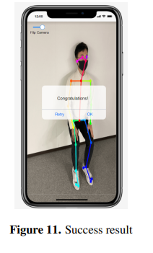 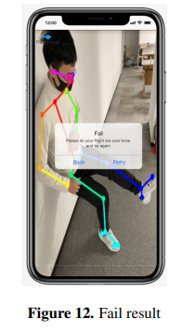

**4 Reference**

[**https://www.researchgate.net/profile/George-Taylor-28/publication/375186868_AI_Fitness_Coach_at_Home_Using_Image_Recognition/links/654361c3f7d021785f2edfe7/AI-Fitness-Coach-at-Home-Using-Image-Recognition.pdf**](https://www.researchgate.net/profile/George-Taylor-28/publication/375186868_AI_Fitness_Coach_at_Home_Using_Image_Recognition/links/654361c3f7d021785f2edfe7/AI-Fitness-Coach-at-Home-Using-Image-Recognition.pdf)