**About this project**

**Task:** Tiidelab pre-fellowship personal portfolio creation project.

**Task details:** Create a good, simple and responsive portfolio for yourself which should contain a

* **Homepage/ Landing page**
* **Skills page**
* **About page**
* **Contact page**

**Homepage**

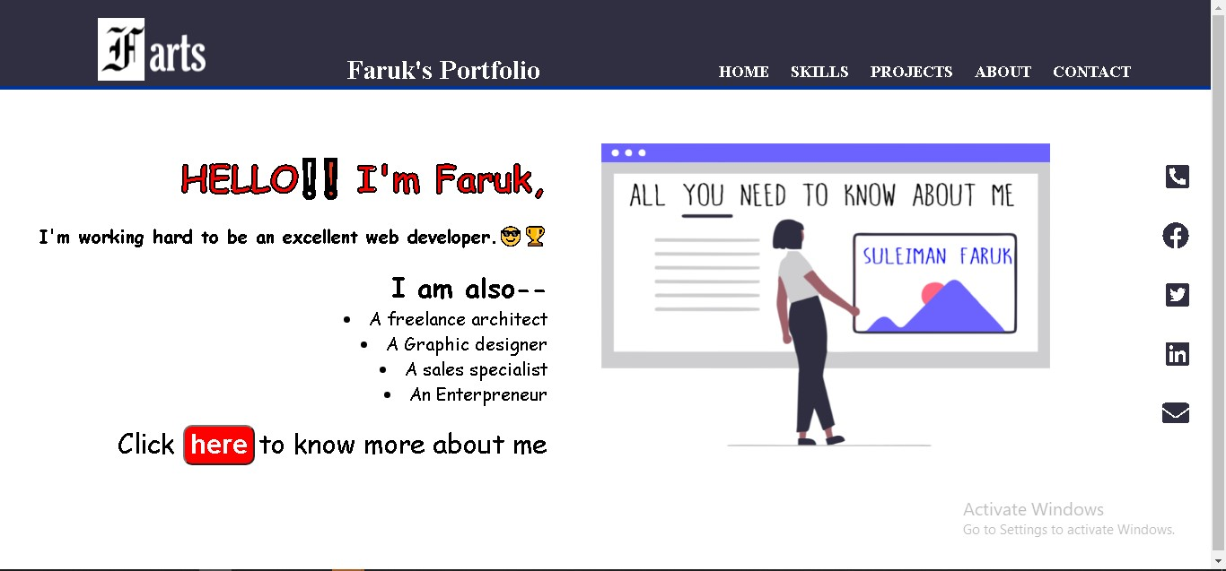

**Skills page**

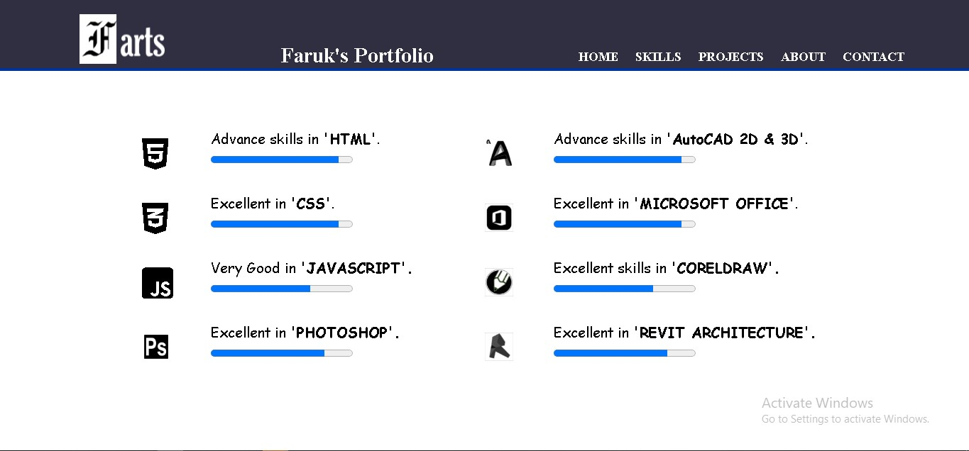

**About page**

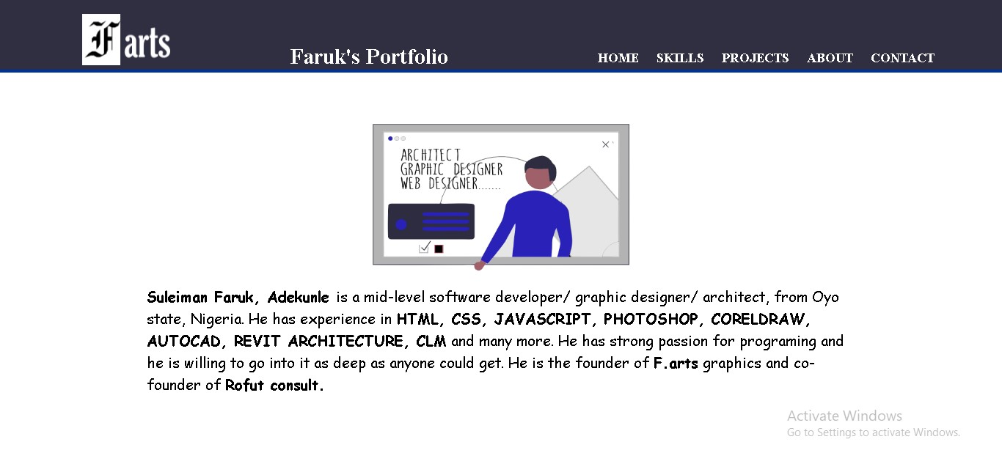

**Contact page**

