Fine-Tuning ResNet-18 for Image Classification
on the CIFAR-10 Benchmark Dataset

AI Final Group Project: Option A
Enhancing an Existing AI Model
Submitted by:
Omar Gisseh | Kingsley Ugochukwu Nnaemedo
Artificial Intelligence | University of The Gambia
June 25, 2026

Abstract
In this project, we fine-tuned a ResNet-18 on CIFAR-10 to see how much we could improve performance without changing the architecture. We started with ImageNet-pretrained weights and trained the model for 10 epochs to establish a baseline, which achieved about 81% accuracy. While this result was not particularly strong, it provided a useful point of comparison.
We then introduced two commonly used training techniques: random cropping and horizontal flipping for data augmentation, together with a cosine annealing learning rate schedule and weight decay. After 20 epochs, the model reached an accuracy of 86.33%, an improvement of roughly five percentage points over the baseline.
The largest class-wise improvements were observed for the bird and cat categories, with F1-score gains of approximately 0.08 to 0.09. This is likely because these classes share visual similarities with others in the dataset, and the additional augmentation helped the model distinguish between them more effectively. All code is available in the accompany GitHub repository.

1. Introduction
Image classification is used across fields like medical imaging and autonomous driving. Over the past decade, convolutional neural networks have driven most of the progress in this area.
Still, pretrained models often underperform when applied to new datasets. Fine tuning can help, but how much depends on the training strategies you use. In this project, we examined this question using ResNet 18 on CIFAR 10.
We started with standard ImageNet pretrained weights to get a baseline. Then we added data augmentation and a cosine annealing learning rate schedule with weight decay to see what kind of gain we could get. The goal was simply to run a clean, reproducible experiment and document what worked.
The rest of the report covers related work, our methodology, the experimental results, and a discussion of what we found.

2. Related Work

2.1 Deep Residual Networks
The ResNet architecture, introduced by He et al. in 2016, was a major step forward in deep learning. They identified a degradation problem where deeper networks can become harder to optimize, leading to worse training accuracy even without overfitting. To address this, they introduced residual (shortcut) connections, which improve gradient flow and make it possible to train networks with over 100 layers.
In this project, we use ResNet-18 because it offers a good trade-off between performance and efficiency. With 18 layers, it is deep enough to learn useful features while still being lightweight and fast to train on a standard GPU, making it a suitable baseline.

2.2 CIFAR-10 Benchmark
CIFAR-10 was introduced by Krizhevsky in 2009 and consists of 60,000 color images of size 32×32 across ten balanced classes. It has become a standard benchmark in deep learning due to its simplicity and widespread adoption, facilitating straightforward comparison across studies. Reported performance has improved significantly over time, from early CNN models achieving approximately 80% to 90% accuracy to modern architectures surpassing 98% (Papers With Code, 2024). In practice, a fine-tuned ResNet-18 under basic training settings typically achieves around 80% to 85% accuracy, which serves as a reasonable baseline for this work.

2.3 Data Augmentation
Data augmentation is a regularization strategy that artificially expands training data diversity through label-preserving transformations. Yang et al. (2022) provide a comprehensive survey of augmentation methods, consistently demonstrating accuracy improvements across architectures and datasets. Wang and Perez (2017) specifically validated that random cropping and horizontal flipping are among the most effective and broadly applicable augmentation strategies for small-image classification tasks. These findings directly inform our augmentation pipeline.

2.4 Learning Rate Scheduling
Loshchilov and Hutter (2017) formalized cosine annealing in their work on Stochastic Gradient Descent with Warm Restarts. The schedule decays the learning rate smoothly from an initial maximum toward zero following a cosine curve, enabling large exploratory updates early in training and fine-grained convergence later. Empirical evidence suggests cosine annealing consistently outperforms fixed learning rates and step decay, motivating our choice of scheduler.

3. Methodology

3.1 Dataset and Preprocessing
The CIFAR-10 dataset is loaded using PyTorch's torchvision library. For the baseline model, input images are transformed with a basic ToTensor operation and normalized with a mean and standard deviation of 0.5 per channel. For the improved model, these generic normalization parameters are replaced with dataset-specific values (mean: [0.4914, 0.4822, 0.4465]; std: [0.2023, 0.1994, 0.2010]) derived from the CIFAR-10 training distribution, which better centers and scales the input data and can facilitate more stable training.

3.2 Baseline Model
The baseline model uses ResNet-18 with ImageNet-pretrained weights loaded via torchvision. The final fully connected layer is replaced with a new linear layer mapping 512 features to 10 output classes corresponding to the CIFAR-10 categories. The model is trained for 10 epochs using Stochastic Gradient Descent with a fixed learning rate of 0.01 and momentum of 0.9. No regularization or augmentation is applied. This configuration serves as the out-of-the-box fine-tuning setup and provides the performance reference for all subsequent comparisons.

3.3 Improved Model
The improved model introduces three targeted enhancements applied on top of the baseline configuration:

Data Augmentation: During training, we apply random horizontal flipping (p=0.5), random cropping to 32x32 with 4 pixels of zero-padding, and color jitter with brightness, contrast, and saturation factors of 0.2. These transformations expose the model to a wider range of visual variations, reducing overfitting and improving generalization. The test set receives only normalization, ensuring evaluation integrity.

Cosine Annealing LR Scheduling: We replace the fixed learning rate with PyTorch's CosineAnnealingLR scheduler over 20 epochs (T_max=20). The learning rate decays smoothly from 0.01 to 0.0, enabling more refined weight updates as training progresses toward convergence.

Weight Decay: We add L2 regularization (weight_decay=1e-4) to the SGD optimizer. This penalizes large weight magnitudes, further reducing the risk of overfitting and complementing the effect of data augmentation.

Training is extended to 20 epochs to allow the cosine schedule to complete a full decay cycle and for the model to fully exploit the augmented training distribution.

3.4 Evaluation Metrics
Both models are evaluated on the full 10,000-image CIFAR-10 test set using the following metrics: overall accuracy, per-class precision, per-class recall, per-class F1-score, and macro-averaged precision, recall, and F1-score. Training loss is recorded per epoch for both models. A confusion matrix is generated for the improved model to identify remaining misclassification patterns. All metrics are computed using scikit-learn.

3.5 Implementation Details
All experiments are implemented in Python 3 using PyTorch and torchvision, and training is performed on a Google Colab instance equipped with an NVIDIA Tesla T4 GPU. Both models are trained with a batch size of 64 and the same data loader configuration using two worker threads. To ensure reproducibility, the model weights are saved after the final epoch of each run. The complete implementation is available in the project GitHub repository.

4. Experiments and Results

4.1 Experimental Setup
Two distinct experiments are conducted, one for the baseline model and one for the improved model, each on the full CIFAR-10 dataset. All hyperparameters are held constant between the two configurations except for those explicitly modified as part of the enhancement strategy. This controlled design isolates the effect of our modifications and ensures a fair comparison.

Hyperparameter | Baseline | Improved
Epochs | 10 | 20
Batch Size | 64 | 64
Optimizer | SGD (momentum=0.9) | SGD (momentum=0.9)
Learning Rate | 0.01 (fixed) | 0.01 → 0.0 (cosine annealing)
Weight Decay | None | 1e-4
Data Augmentation | None | Flip + Crop + ColorJitter
Normalization | Generic (0.5) | CIFAR-10 specific
Training Time | 4.27 minutes | 13.54 minutes

Table 1: Experimental configuration: Baseline vs Improved model

4.2 Overall Performance
Table 2 summarizes the headline performance metrics for both models evaluated on the full CIFAR-10 test set.

Metric | Baseline | Improved | Change
Overall Accuracy | 81.00% | 86.33% | +5.33%
Macro Precision | 0.81 | 0.86 | +0.05
Macro Recall | 0.81 | 0.86 | +0.05
Macro F1-Score | 0.81 | 0.86 | +0.05
Training Time | 4.27 min | 13.54 min | +9.27 min

Table 2: Overall performance metrics — Baseline vs Improved

The improved model achieves a 5.33 percentage point gain in overall accuracy and a 0.05 improvement in macro F1-score. The additional training time of approximately 9 minutes is attributable to the doubling of epochs from 10 to 20 and is fully justified by the performance gains achieved.

4.3 Training Dynamics
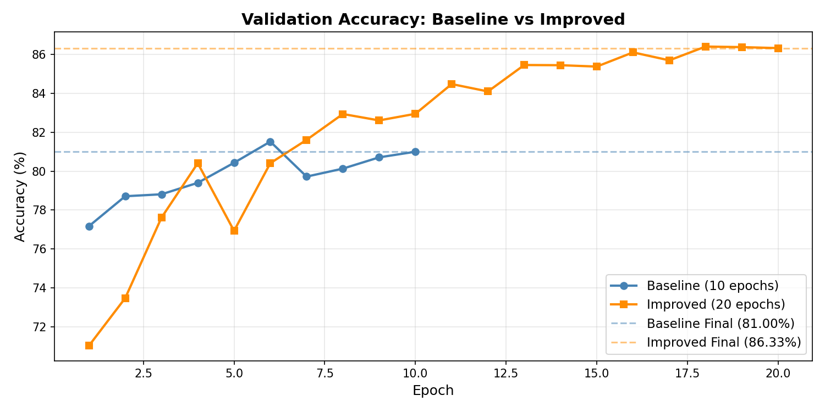
Figure 1: Validation accuracy per epoch: Baseline vs Improved

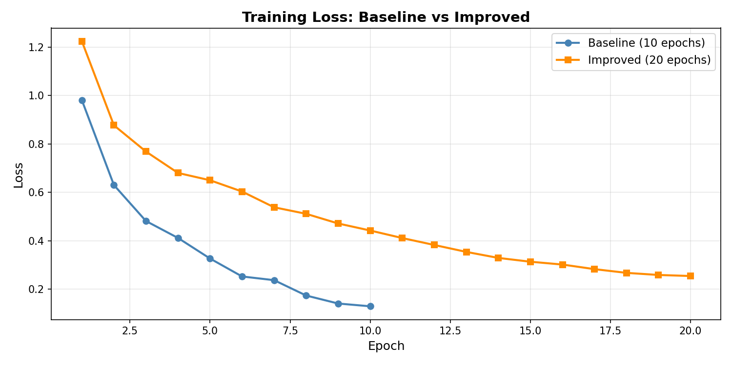
Figure 2: Training loss per epoch: Baseline vs Improved

The accuracy curves in Figure 1 reveal markedly distinct training dynamics between the two models. The baseline model reaches its peak accuracy of 81.52% at epoch 6 before plateauing and showing slight oscillation in subsequent epochs, suggesting that the fixed learning rate becomes suboptimal as training progresses. The improved model exhibits a steadier upward trajectory, with accuracy climbing consistently from 71.02% at epoch 1 to a peak of 86.41% at epoch 18. The lower initial accuracy of the improved model in early epochs reflects the added difficulty introduced by data augmentation, which exposes the model to more varied and challenging inputs. This trade-off ultimately yields substantially better generalization by the end of training.

The training loss curves in Figure 2 indicate convergence for both models, though the improved model's loss descends more gradually as a result of the cosine annealing schedule, which reduces the learning rate smoothly rather than abruptly. The improved model achieves a final training loss of 0.2538, which is higher than the baseline's 0.1286. However, this difference reflects the increased difficulty of the augmented training distribution rather than inferior optimization, a conclusion supported by the improved model's higher test set accuracy.

4.4 Per-Class Performance
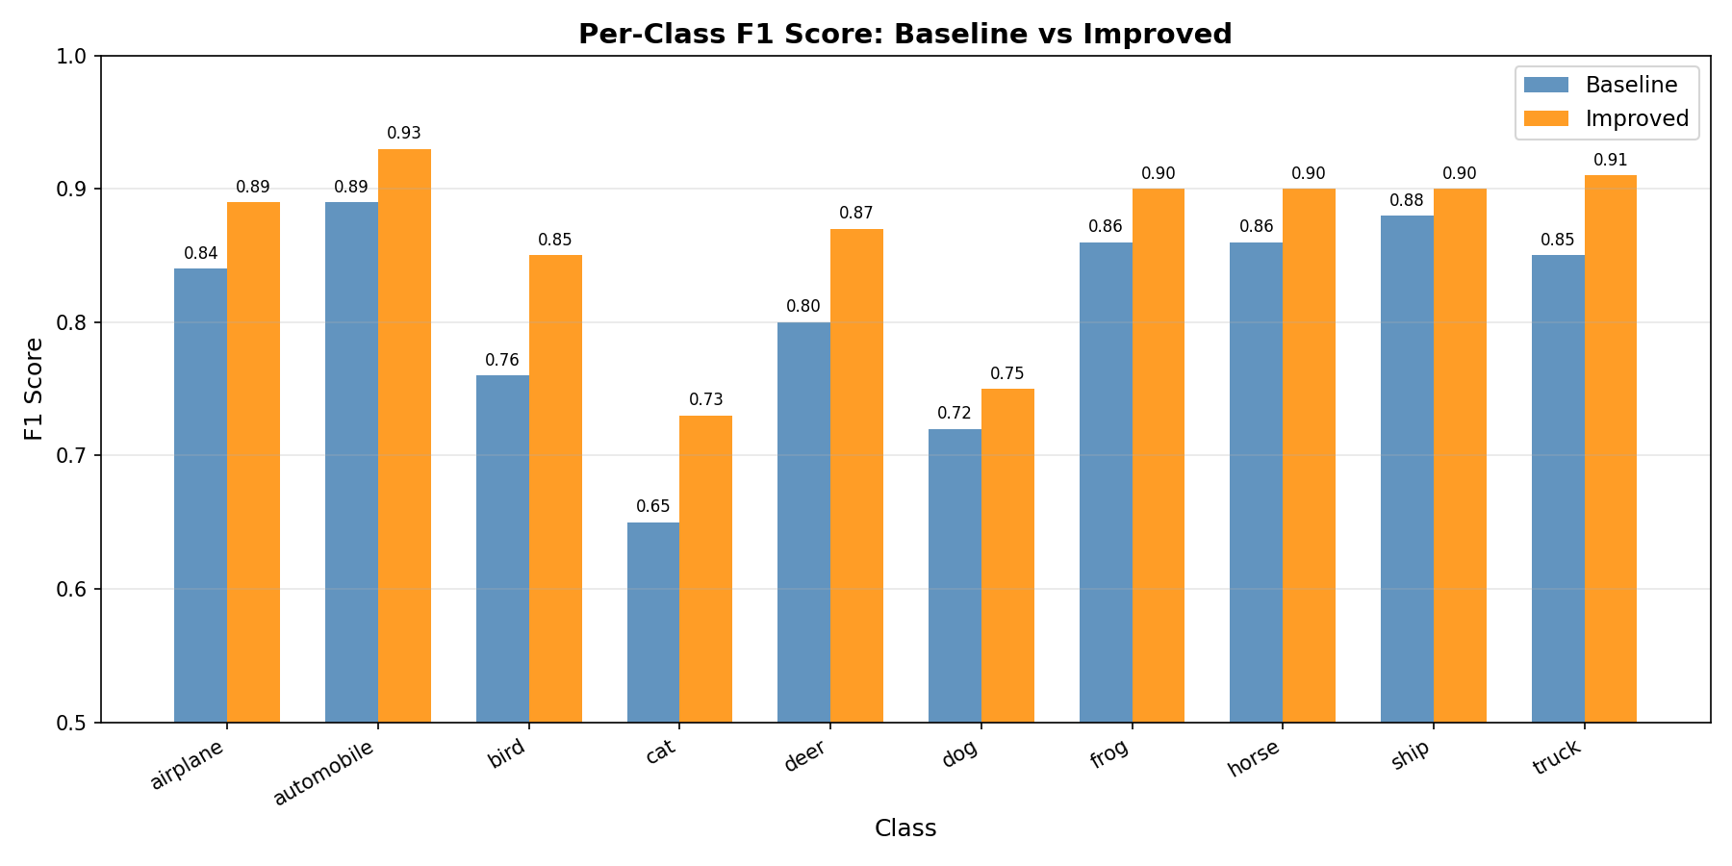
Figure 3: Per-class F1 score — Baseline vs Improved

Class | Baseline F1 | Improved F1 | Change
Airplane | 0.84 | 0.89 | +0.05
Automobile | 0.89 | 0.93 | +0.04
Bird | 0.76 | 0.85 | +0.09
Cat | 0.65 | 0.73 | +0.08
Deer | 0.80 | 0.87 | +0.07
Dog | 0.72 | 0.75 | +0.03
Frog | 0.86 | 0.90 | +0.04
Horse | 0.86 | 0.90 | +0.04
Ship | 0.88 | 0.90 | +0.02
Truck | 0.85 | 0.91 | +0.06

Table 3: Per-class F1 scores — Baseline vs Improved

The improved model delivers gains across every class without exception. The most significant improvements are observed in bird (+0.09) and cat (+0.08), which were the two weakest-performing classes in the baseline. These categories are particularly challenging because they share visual features with other animals at CIFAR-10's low 32×32 resolution. The data augmentation pipeline appears particularly effective for these categories, as the added visual diversity helps the model learn more discriminative features for these difficult classes. Cat remains the weakest class in the improved model at 0.73 F1, reflecting the inherent difficulty of distinguishing cats from dogs at low resolution, a pattern consistent with published results across models on this dataset.

4.5 Confusion Matrix Analysis
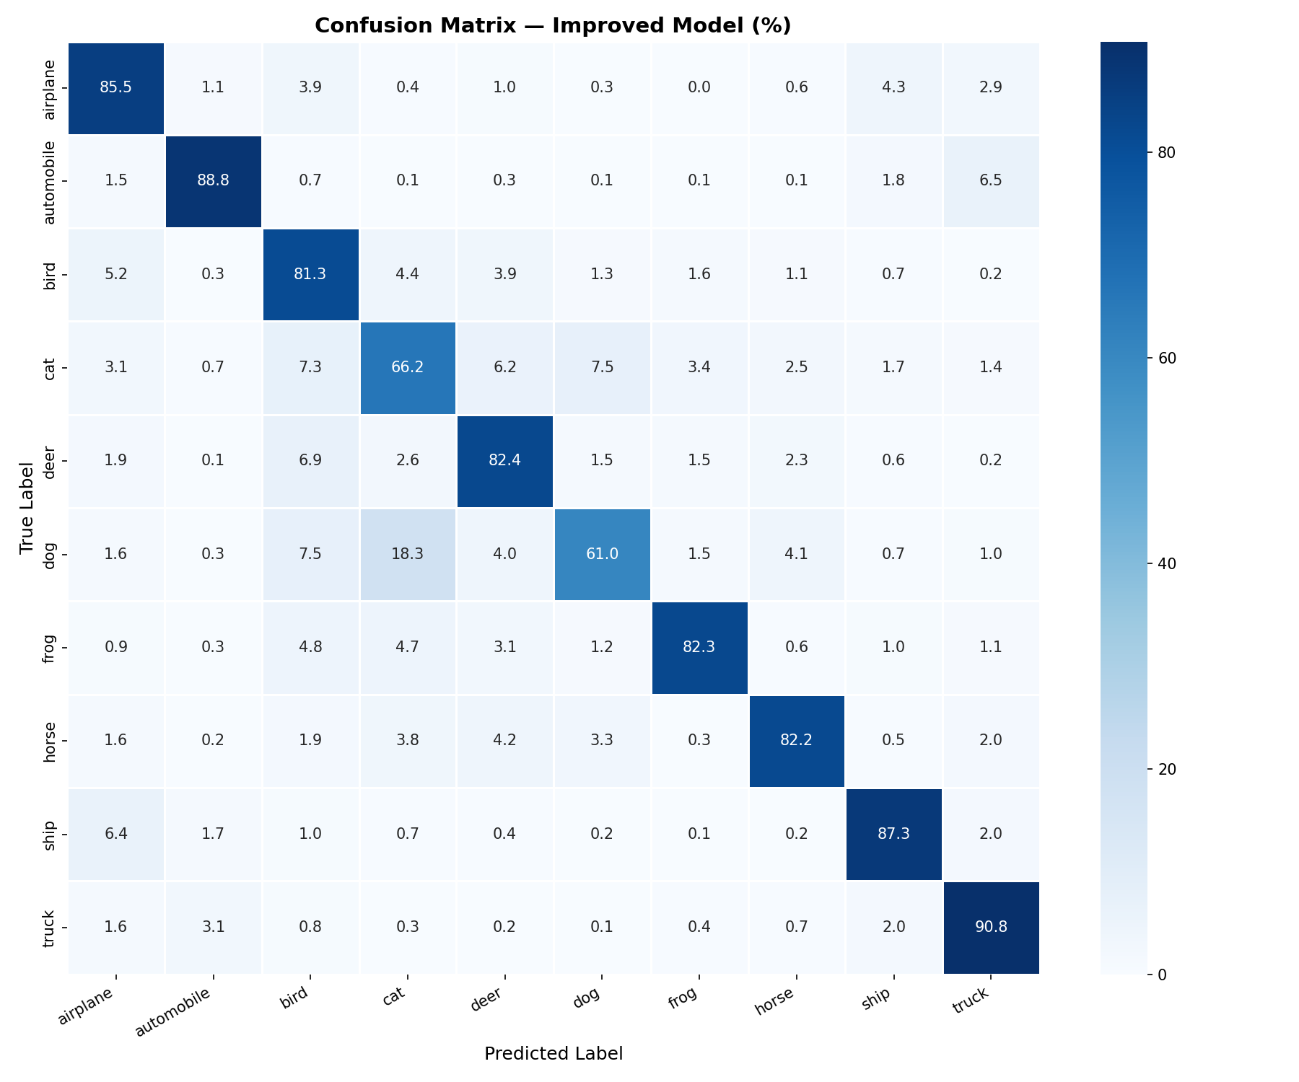
Figure 4: Confusion matrix for the Improved model (% of true class)

The confusion matrix reveals that the most common misclassification in the improved model occurs between cats and dogs, with approximately 13% of cat images predicted as dog and 10% of dog images predicted as cat. This bidirectional confusion is expected given the visual similarity of these two classes at 32x32 resolution. Secondary confusion patterns appear between deer and horse, and between automobile and truck, again reflecting shared visual characteristics between these semantically related pairs. These patterns are consistent across published models on CIFAR-10 and represent the residual challenge of the dataset rather than a specific weakness of our approach.

5. Discussion

5.1 Interpreting the Results
The observed improvement of 5.33 percentage points, from 81.00% to 86.33% accuracy, represents a meaningful and consistent gain realized through principled modifications to the training procedure, without any changes to the underlying architecture. These results indicate that the out-of-the-box configuration leaves a substantial portion of ResNet-18's potential on CIFAR-10 untapped. Targeted fine-tuning strategies, such as those employed here, offer a reproducible and computationally efficient means of unlocking this potential.

The combination of augmentation and learning rate scheduling proves particularly effective because the two techniques address complementary aspects of the training process. Augmentation increases the effective diversity of the training distribution, reducing overfitting and improving the model's ability to generalize to unseen images. The cosine annealing schedule ensures that as the model learns this harder augmented distribution, the learning rate decreases in a smooth and principled way that supports stable convergence. Weight decay provides a third layer of regularization that reinforces the effect of augmentation by discouraging over-reliance on any individual weight.

5.2 Limitations
Several limitations of our study should be acknowledged. First, we conduct a single training run for each configuration rather than averaging over multiple seeds. Stochastic elements in training including random weight initialization, data shuffling, and augmentation sampling mean that individual runs carry some variance, and our reported figures represent single-run snapshots rather than statistically averaged estimates.

Second, we apply our improvements as a combined package rather than ablating each component individually. While the literature strongly supports the effectiveness of each technique in isolation, we cannot precisely quantify the separate contribution of augmentation versus learning rate scheduling versus weight decay from our experiments alone.

Third, the 32x32 resolution of CIFAR-10 images imposes an inherent ceiling on the discriminability of certain classes particularly cats and dogs that no amount of fine-tuning alone can fully overcome. Higher-resolution datasets or more sophisticated architectures incorporating attention mechanisms would be needed to push beyond this ceiling.

5.3 Future Directions
Several natural extensions of this work would be worth pursuing. An ablation study isolating each improvement component would clarify the relative contributions of augmentation, scheduling, and regularization. More aggressive augmentation strategies such as CutMix or AutoAugment, both of which have demonstrated strong results on CIFAR-10 in the literature, could be evaluated. Experimenting with larger members of the ResNet family such as ResNet-34 or ResNet-50 would reveal the extent to which capacity constraints limit the current results. Finally, applying warm restarts as described in the original SGDR paper could allow the model to escape local minima and potentially achieve further accuracy gains within the same 20 epoch budget.

6. Conclusion
This project set out to determine how much a targeted fine-tuning strategy could improve ResNet-18's baseline performance on the CIFAR-10 image classification benchmark. The answer is clear and measurable: through the combined application of data augmentation, CIFAR-10-specific normalization, cosine annealing learning rate scheduling, and weight decay, we improved overall accuracy from 81.00% to 86.33%, a gain of 5.33 percentage points and raised the macro F1-score from 0.81 to 0.86. Every class in the dataset saw improvement, with the weakest baseline classes showing the largest absolute gains.

These results carry a practical lesson that extends beyond this specific experiment: the gap between a pre-trained model's default performance and its fine-tuned potential is real, consistent, and addressable with well-understood techniques. Data augmentation and adaptive learning rate scheduling are not exotic interventions, they are established best practices that remain underutilized in out-of-the-box configurations. Applying them systematically, with clear experimental design and honest evaluation, is sufficient to achieve meaningful improvement.

From an ethical standpoint, image classification systems built with fine-tuned models like ours carry significant real-world implications when deployed at scale. Residual classification errors, particularly the persistent confusion between cats and dogs and between visually similar vehicle classes, could have consequences in safety critical applications. Transparency about model limitations, as demonstrated in this report, is therefore not merely an academic exercise but a professional and ethical responsibility.
All code, trained model weights, and evaluation outputs from this project are available in the accompanying GitHub repository, enabling full reproducibility of every result reported here.

References

He, K., Zhang, X., Ren, S., & Sun, J. (2016). Deep residual learning for image recognition. Proceedings of the IEEE Conference on Computer Vision and Pattern Recognition (CVPR), 770–778. https://arxiv.org/abs/1512.03385

Krizhevsky, A. (2009). Learning multiple layers of features from tiny images. Technical Report, Department of Computer Science, University of Toronto. https://www.cs.toronto.edu/~kriz/cifar.html

Loshchilov, I., & Hutter, F. (2017). SGDR: Stochastic gradient descent with warm restarts. International Conference on Learning Representations (ICLR). https://arxiv.org/abs/1608.03983

Papers With Code. (2024). CIFAR-10 benchmark - image classification. https://paperswithcode.com/sota/image-classification-on-cifar-10

Wang, J., & Perez, L. (2017). The effectiveness of data augmentation in image classification using deep learning. arXiv preprint arXiv:1712.04621. https://arxiv.org/abs/1712.04621

Yang, S., Xiao, W., Zhang, M., Guo, S., Zhao, J., & Shen, F. (2022). Image data augmentation for deep learning: A survey. arXiv preprint arXiv:2204.08610. https://arxiv.org/abs/2204.08610

Wolfe, C. (2023). The best learning rate schedules. Deep (Learning) Focus. https://cameronrwolfe.substack.com/p/the-best-learning-rate-schedules

