**Literature Review**

Desktop robotic arms have gained attention due to their compact size, versatility, and accessibility. These devices are designed for tasks requiring precision, such as small-scale manufacturing, 3D printing, and educational purposes. Their user-friendly nature makes them valuable tools for students, researchers, and hobbyists, providing hands-on experience in robotics. As technology advances, desktop robotic arms are becoming more affordable and functional, bridging the gap between theory and practical application. This review explores the current developments, challenges, and potential future directions in the design and use of desktop robotic arms.

Madiha Farman et al. (2018) highlighted the increasing preference for robots over human labor in tasks requiring precision and accuracy, due to better performance and reduced risks. An articulated robotic arm consists of links connected by rotary joints, with the number of joints defining its Degrees of Freedom (DOF). Servomotors, controlled by microcontrollers, provide the necessary torque for joint movement. Proper design and simulation are essential to ensure the robotic arm performs tasks efficiently and accurately.

The study by Madiha Farman et al. (2018) outlined the design and kinematic analysis of a three DOF robotic arm. Forward kinematics describe the end effector's position and orientation, while inverse kinematics calculate the joint angles required for a specific position. The research also explored static torques, optimal link cross-sections, and workspace determination. Robotic arm analysis often faces challenges like multiple solutions and singularity points, which have been addressed in various studies using simulation tools like SolidWorks and MATLAB to validate theoretical models and improve motion accuracy.

In another study by Tanzila Younas et al. (2019), thy highlighted the increasing popularity of manipulator-based robotic arms and small mobile robots in educational settings worldwide. These platforms are effective tools for studying dynamics, kinematics, and control, which are essential components of modern robotics. Manipulator behavior plays a critical role in controlling robotic systems, and understanding this behavior requires kinematic analysis. Kinematics, which can be divided into forward and inverse kinematics, is key to determining the position of a robot’s end-effector based on joint parameters and vice versa. Numerous studies have modeled and simulated small robotic arms, such as the AL5B, a compact robot with four revolute joints that is commonly used for educational purposes.

Designing robotic arms using Computer-Aided Design (CAD) and integrating them with small to medium-sized DC servo motors is a widely adopted approach, as these components are easily accessible and controllable with open-source microcontrollers like Arduino. However, programming these systems can be tedious, leading researchers to use GUI-based software like LABVIEW to enhance user interaction. By developing forward and inverse kinematics algorithms in MATLAB and integrating them into LABVIEW, students can compare real-time calculated positions with actual measured positions, improving their understanding of error analysis and kinematics. This hands-on, interactive approach has proven to be effective in enhancing robotics education.

Zhou Dongxu et al. (2022) introduced a low-cost, desktop-sized, six-degree-of-freedom educational robotic arm named Mirobot, designed to provide a cost-effective solution for robotics education. Mechanically, Mirobot uses six small stepper motors with reducers for its joints, while its structural components are manufactured using 3D printing technology, allowing for iterative design improvements. The AVR MEGA2560 microcontroller is utilized in the electronic circuitry to control the system. To solve the inverse kinematics, the researchers combined the geometric method with the Euler angle transform method. The software includes look-ahead control technology to ensure smooth motion, and Mirobot can be operated via computer or mobile phone control software, with a remote-control option also developed to simplify its use.

The design and functionality of Mirobot emphasize affordability and ease of use, making it ideal for educational settings. Its combination of 3D-printed parts, accessible microcontroller, and straightforward control systems makes it an appealing option for teaching robotics concepts. By integrating both forward and inverse kinematics solutions, Mirobot provides hands-on experience with complex robotic motions while maintaining user-friendly operation through its software and remote-control features. This makes it an excellent tool for students and hobbyists alike.

Based on the reviewed studies above our project will be a desktop robotic arm that works in the sense of pick and place to aid in drilling process made by another robot.

***Milestone 2:***

a)

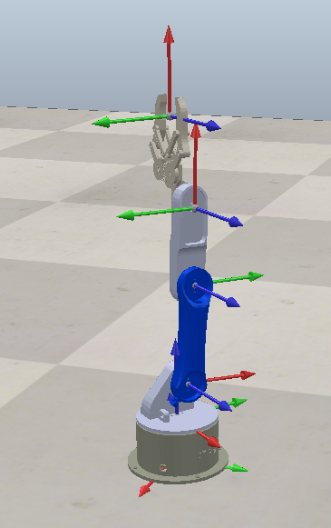

b)

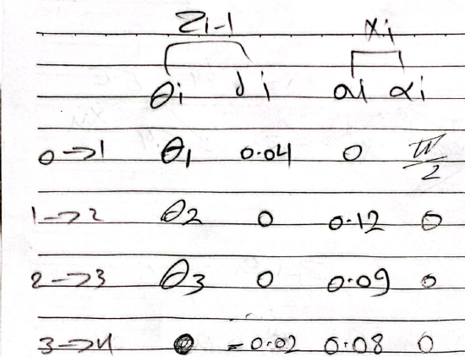

c)

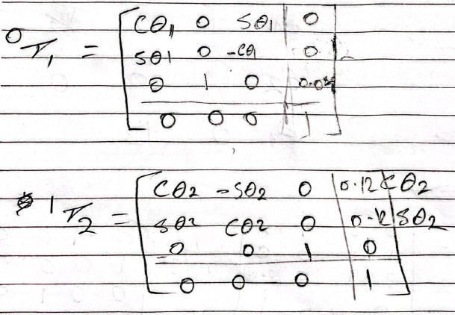

T04

d) ***Coppeliasim Simulations***: -

The coordinates after the pictures show the position of the end effector with respect to Z1 in each position

Q1=0; Q2=0; Q3=0; Q4=45

2-(potentially) PICKUP POSITION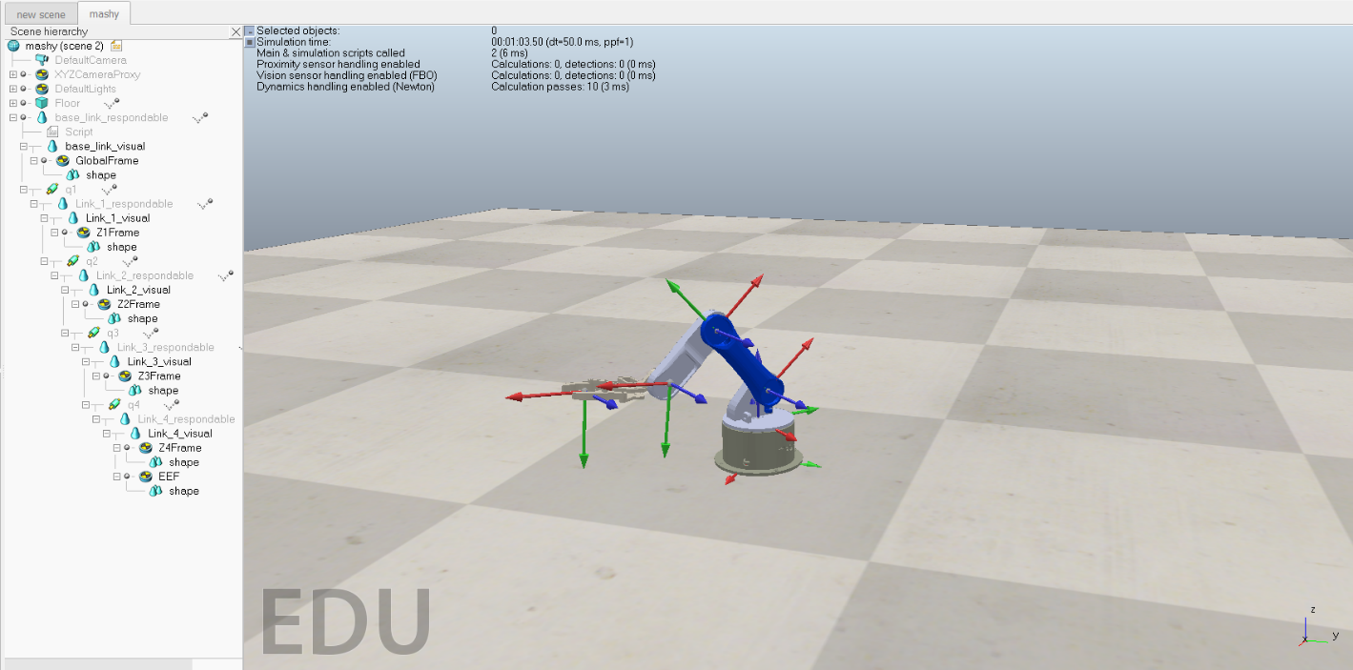

Q1=0; Q2=45; Q3=-90; Q4=90

***SIMSCAPE: -***

1- INITIAL POSITION

2-(potentially) PICKUP POSITION

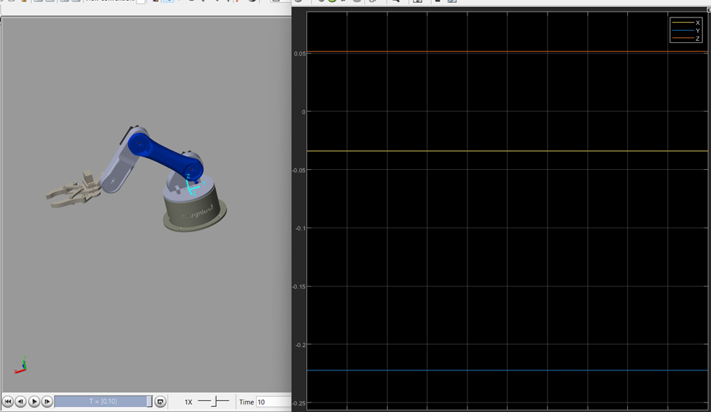

***Milestone 3:***

1. **Inverse Position:**

The Newton-Raphson method for inverse kinematics is an iterative approach used to find the joint angles of a robotic arm that position the end effector at a desired location. It starts with an initial guess for the joint angles and calculates the error between the current and desired positions. Using the Jacobian matrix, which describes how changes in joint angles affect the end effector's position, the method updates the joint angles to reduce the error. This process is repeated until the error is sufficiently small, indicating that the end effector has reached the target position.

The method uses numerical values instead of symbolic matrices. While symbolic expressions are initially defined, the Jacobian is computed symbolically but evaluated numerically during each iteration. This approach allows the method to update joint angles using numerical approximations, making it suitable for real-time calculations.

1. **Forward and Inverse Velocity Kinematics:**
   * 1. **Forward Kinematics:**

Forward Velocity Kinematics calculates the end-effector's velocity from the joint velocities. It uses the Jacobian matrix, which maps the joint velocities to the end-effector's linear and angular velocities. By multiplying the Jacobian matrix by the joint velocity vector, the resulting product gives the end-effector's velocity in space. This method is used to determine how the movement of the joints affects the movement of the end-effector.

Symbolic Matrix from Matlab:

* + 1. **Inverse Kinematics:**

Inverse velocity kinematics is used to calculate the joint velocities needed to achieve a specific velocity for the robot's end-effector. It works by relating the end-effector velocity to the joint velocities using the Jacobian matrix. By inverting the Jacobian, the method provides the necessary joint velocities to achieve the desired end-effector motion. This approach is essential in real-time motion control, ensuring that the robot can adjust its joints to move the end-effector at the required speed and direction. If the Jacobian is singular (non-invertible), alternative methods like the pseudo-inverse are used to find a solution.

Symbolic Matrix from MatLab:

The inverse velocity matrix, derived from the Jacobian, maps end-effector velocities to joint velocities. It's essential for controlling robot motion but can be complex to compute symbolically, especially for robots with many degrees of freedom. To simplify, numerical methods like the Moore-Penrose pseudo-inverse are often used instead of directly inverting the Jacobian, especially when it's non-square or near-singular, ensuring efficient and stable calculations in real-time control systems. The file to display it symbolically can be seen in the GitHub repo.

1. **Hardware Implementation:**

