Get the inventory for the network , and filter on the Amp you want to apply the power offset

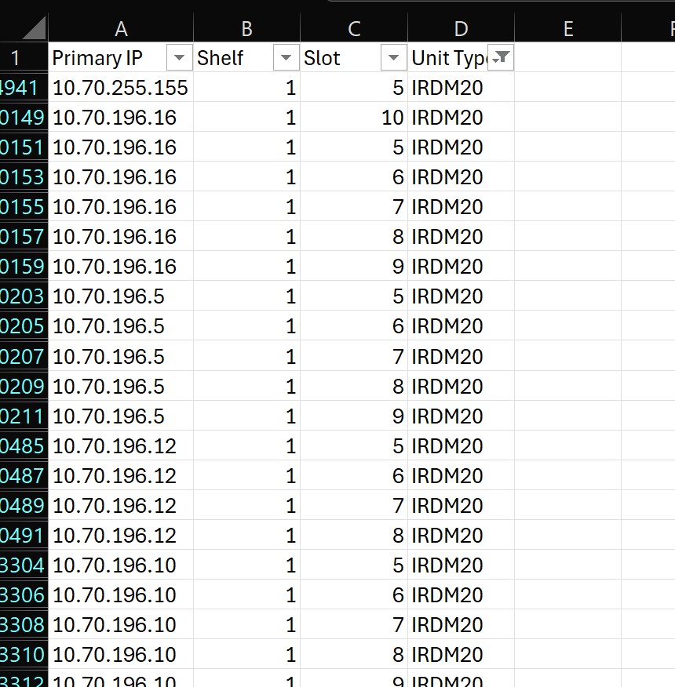

Copy the coloum contains IP , shelf & slot only to notepad ++

Replace all space with comma



