Security Principles
These are the principles representing best practices that should be used to build programs and systems in order to develop secure, reliable, and robust software against attacks. These principles aim to maintain CIA security. RentEase has implemented several of these important principles, including:
- The "Secrets Are Not Kept" Principle: This principle states that secrets (such as usernames and passwords) should not be stored or written within the code, as this would make the code visible and allow an attacker to exploit these secrets. This principle also states that secrets should not be stored even in binary code, as an attacker can retrieve the original code.

- RentEase applies this principle by storing secrets (such as usernames and passwords) in files and retrieving them from those files. Applying this principle helps reduce the exploitation of secrets and their associated risks, and protects sensitive data This is achieved by not storing sensitive information within the system code, such as passwords. The "Secrets Are Not Kept" principle prevents sensitive data and information from being stored within the system code; instead, it is stored in files, and passwords are not saved as is but converted into hashes

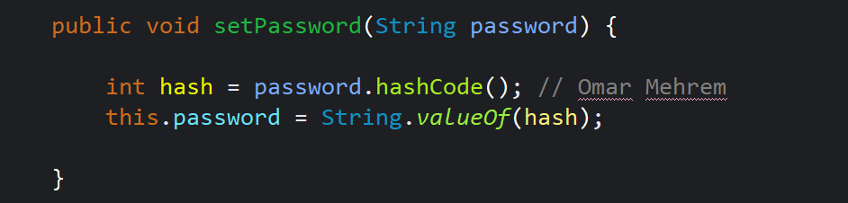
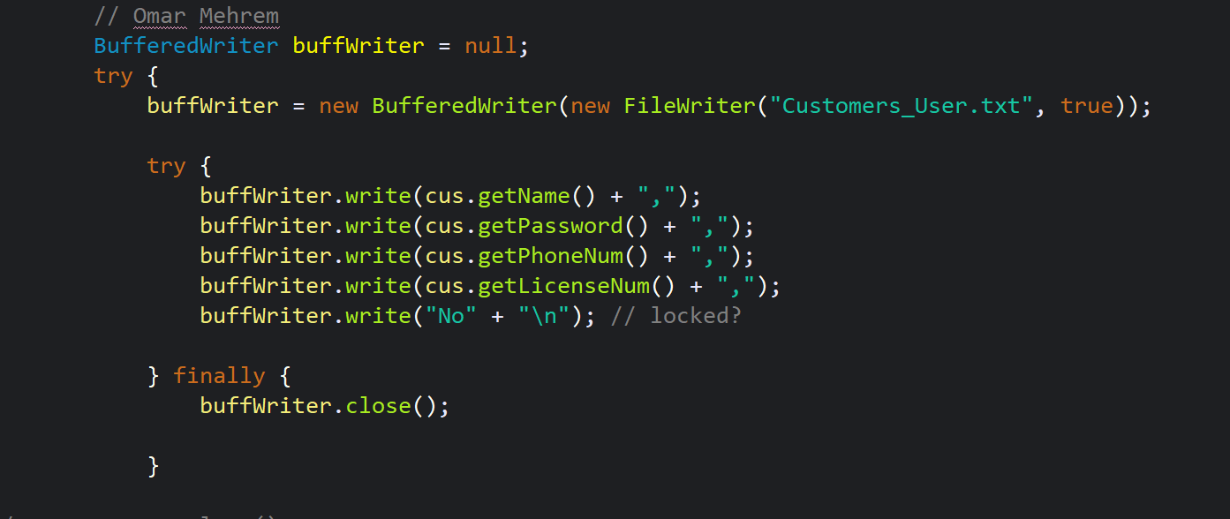

- The "Fail Securely" Principle: This principle refers to how the system should handle errors and exceptions securely. Errors and security vulnerabilities should not be disclosed to prevent their exploitation in the event of a system failure. This principle is one of the most important principles in building programs and systems.

- I apply this principle in RentEase by handling exceptions and errors by displaying a generic error message. Applying this principle helps reduce the opportunities for exploitation, mitigate risks, and more this is achieved by the system behaving securely in the event of an error or failure and not disclosing sensitive information such as detailed failure and error messages. Attacks and exploits target system errors, so the system should display a general message to the user and not reveal the technical details of the failure or error. Potential errors and their potential points of failure should be anticipated and protected, making it more difficult for an attacker to exploit system vulnerabilities
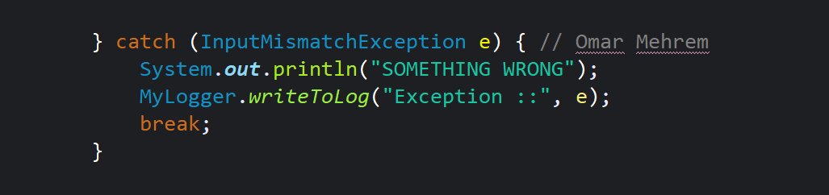

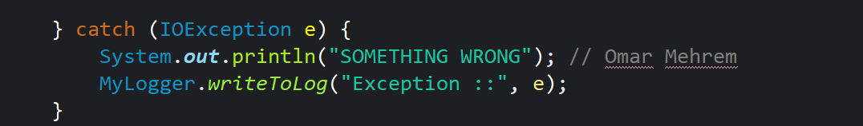

Quality Principles
These are the principles that aim to achieve high quality in programs and systems, ensuring ease of understanding, maintenance, and scalability. These principles are of paramount importance because producing low-quality programs makes them more prone to errors and vulnerabilities. The RentEase system implements many of these important principles, including:
- The "Understandability" principle
This principle states that code should be easy to understand and read by anyone who reads it. This is achieved by writing clear and understandable programming logic, avoiding complexity as much as possible, and using expressive variable and function names that reflect their true function. This facilitates problem detection and fixing. The more understandable the code, the fewer errors it will have. This principle also contributes to improving system quality in the long run.
- I applied this principle to RentEase by using expressive variable and function names that reflect their true function, clear and understandable programming logic, and minimizing complexity. This principle helps improve code quality, identify defects efficiently, and reduce testing and maintenance time, among other things.
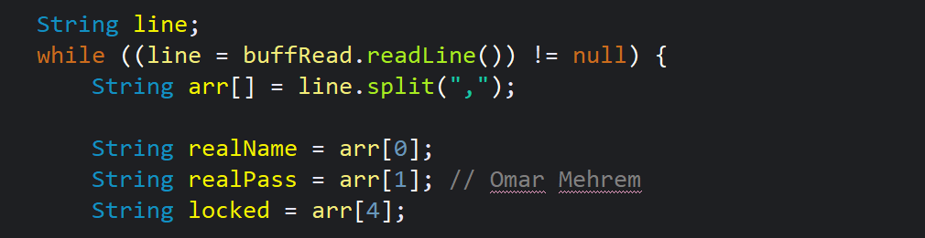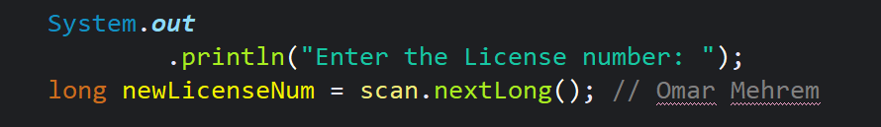

- The "Readability" Principle
This principle states that code should be easy to read and follow. Code should be written in a readable style and structure because it is often maintained and developed by other developers. This principle helps improve maintainability, saves time and effort, facilitates error tracking, promotes collaboration among developers, and more.
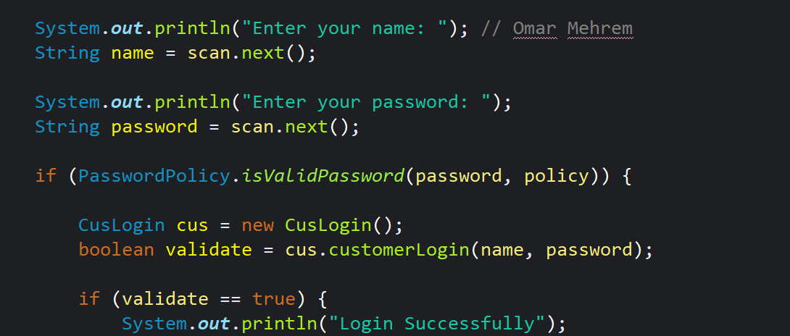

Use case diagram
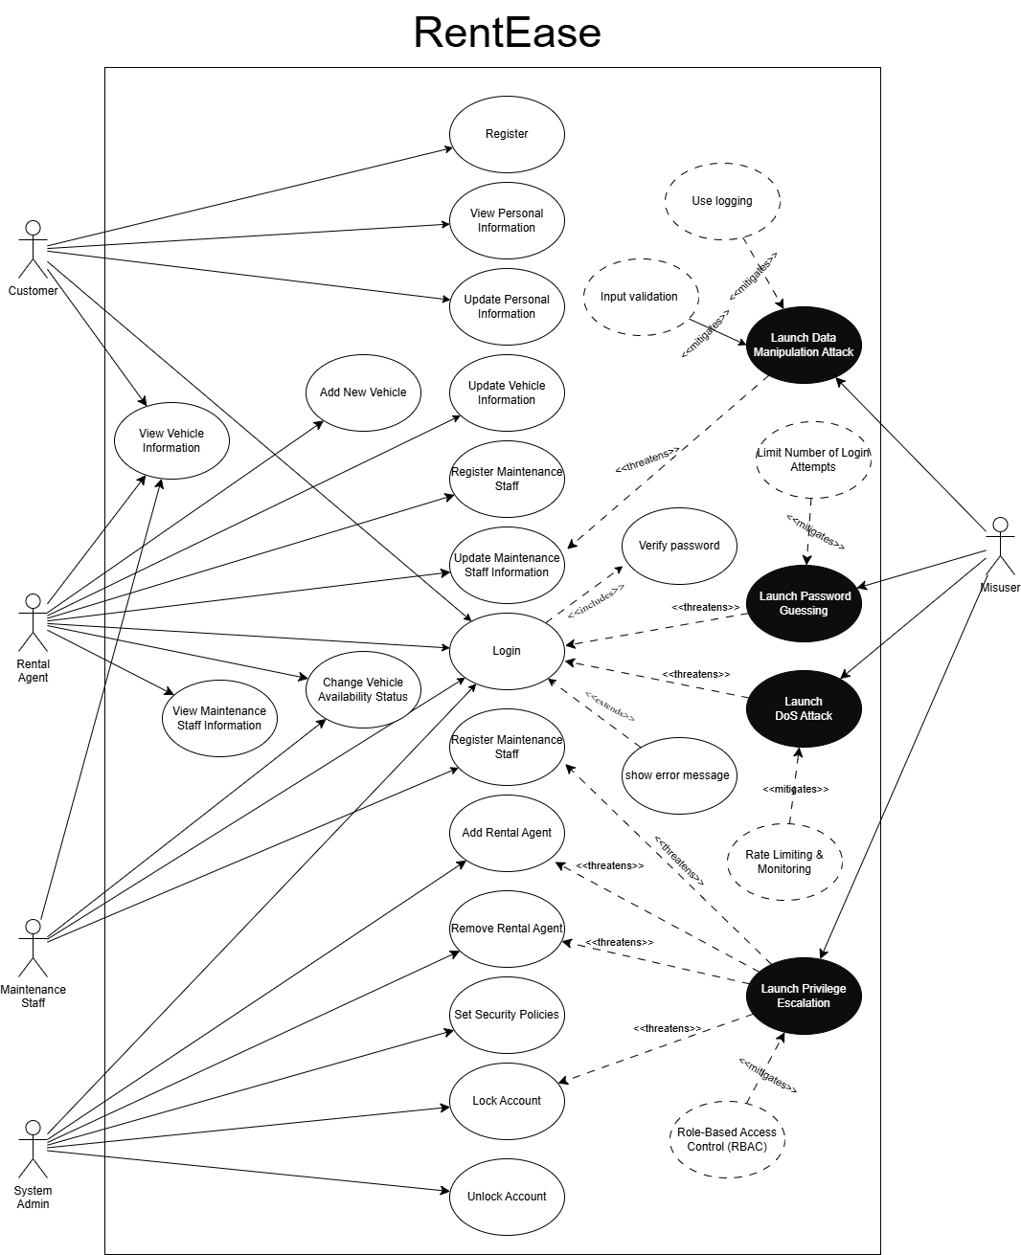

Use case name | Add new vehicle | Use case number | 1
Primary actors | Rental Agent | Secondary Actors | None
Description | Adding a new vehicle to the system by a Rental Agent
Pre-condition | Rental agent is logged in to the system
Post-condition | The new vehicle is stored in the system and available for Customer
Main flow | - The Rental Agent select “Add Vehicle”  - The Rental Agent enters vehicle details (model, Licnes plate Number, price, status)  - System validates the data  - 4. System add the vehicle information
Alternative flow | None

Use case name | View vehicle | Use case number | 2
Primary actors | Customer | Secondary Actors | None
Description | Customer views the vehicle list
Pre-condition | Customer is logged in to the system
Post-condition | Vehicle displayed to the customer
Main flow | - Customer select “View all Vehicles”  - System retrieves Vehicles  - 3. System displays Vehicles details (model, price, status).
Alternative flow | The system shows a message “no available vehicles”

Use case name | Update vehicle maintenance status | Use case number | 3
Primary actors | Maintenance Staff | Secondary Actors | None
Description | Maintenance staff updates the vehicle status
Pre-condition | Maintenance staff is logged in and there are vehicles that need maintenance.
Post-condition | Vehicle status is updated in the system
Main flow | - Maintenance Staff views vehicles under maintenance.  - Maintenance Staff selects a vehicle.  - Maintenance Staff updates status to “Available” or “Maintenance”  - System saves the update.
Alternative flow | If update fails, system displays an error message

Use case name | Add rental agents user | Use case number | 4
Primary actors | System Admin | Secondary Actors | None
Description | A brief description of the use case
Pre-condition | Admin is logged in
Post-condition | Rental agent is added
Main flow | - The System Admin select “Add Vehicle”  - The System Admin enters rental agents details (name, phone Number, password)  - System validates the data  - System add the rental agents
Alternative flow | None

Data flow diagram
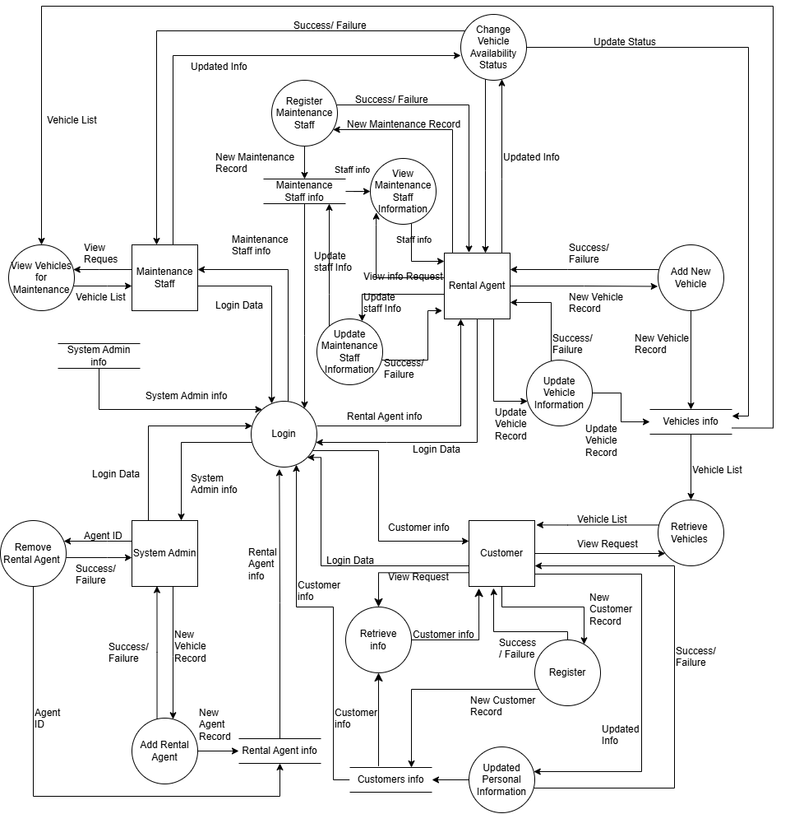

Quality Testing
Quality testing is the process of evaluating and testing application quality standards. It aims to ensure the application functions at a high level and meets user expectations and requirements. The test includes verifying that system functions operate correctly and comply with requirements. It also checks the application's ease of use and reliability, ensuring the final application is of high quality. This testing achieves several benefits, including:
- Overall quality improvement
- Enhancing user satisfaction
- Improving application performance
I used the following tests:
- Unit Testing: This is a type of functional testing used to test applications. This test focuses on examining each application unit separately to ensure it functions as required. I conducted this test on the application using the JUnit tool to test application quality, detect and fix errors, and ensure that each application unit operates efficiently and correctly. Testing each application unit separately to ensure it functions correctly has several benefits:
  - Improved overall code quality
  - Isolation of problems
  - Early detection of programming errors
  - Comprehensive application testing coverage

- Integration Testing: is a type of testing used to assess application quality and functionality. In this test, program modules are integrated and tested to ensure their proper interaction and integration, guaranteeing that the application components function correctly and smoothly. It offers several benefits:
  - Ensuring component integration
  - Detecting errors resulting from module interaction
  - Improving quality
  - Reducing crashes and the risk of application failure

- User Acceptance Testing is a type of functional testing where the system is tested by users to ensure it meets their requirements and needs, and that all functional requirements operate as intended in a real-world usage environment. This type of testing helps uncover problems that might not appear during technical testing and has several benefits, including:
  - Identifying gaps between requirements and implementation
  - Ensuring the system meets user requirements
ID | What to test | Description (input) | Expected | Actual | Status
01 | customerLogin | omar1,12341234Oo | True | True | Pass
02 | customerLogin | omar1,12341234OO | False | False | Pass
03 | customerLogin | omar1,12341234O | False | False | Pass
04 | customerLogin | omar1,empty | False | False | Pass
05 | customerLogin | Omar1,12341234Oo | False | False | Pass
06 | customerLogin | mm,12341234Oo | False | False | Pass
07 | customerLogin | Empty,12341234Oo | False | False | Pass
08 | customerLogin | Empty, Empty | False | False | Pass
09 | rentalAgentLogin | omar2,12341234Rr | True | True | Pass
10 | rentalAgentLogin | omar2,12341234RR | False | False | Pass
11 | rentalAgentLogin | omar2,12341234R | False | False | Pass
12 | rentalAgentLogin | omar2, Empty | False | False | Pass
13 | rentalAgentLogin | Omar2,12341234Rr | False | False | Pass
14 | rentalAgentLogin | mm,12341234Rr | False | False | Pass
15 | rentalAgentLogin | Empty,12341234Rr | False | False | Pass
16 | rentalAgentLogin | Empty, Empty | False | False | Pass
17 | maintenanceLogin | omar3,12341234Mm | True | True | Pass
18 | maintenanceLogin | omar3,12341234MM | False | False | Pass
19 | maintenanceLogin | omar3,12341234M | False | False | Pass
20 | maintenanceLogin | omar3, Empty | False | False | Pass
21 | maintenanceLogin | Omar3,12341234Mm | False | False | Pass
22 | maintenanceLogin | mm,12341234Mm | False | False | Pass
23 | maintenanceLogin | Empty,12341234Mm | False | False | Pass
24 | maintenanceLogin | Empty, Empty | False | False | Pass
25 | adminLogin | omar4,12341234Aa | True | True | Pass
26 | adminLogin | omar4,12341234AA | False | False | Pass
27 | adminLogin | omar4,12341234A | False | False | Pass
28 | adminLogin | omar4, Empty | False | False | Pass
29 | adminLogin | Omar4,12341234Aa | False | False | Pass
30 | adminLogin | mm,12341234Aa | False | False | Pass
31 | adminLogin | Empty,12341234Aa | False | False | Pass
32 | adminLogin | Empty, Empty | False | False | Pass

JUnit testing implementation:
customerLogin Function:
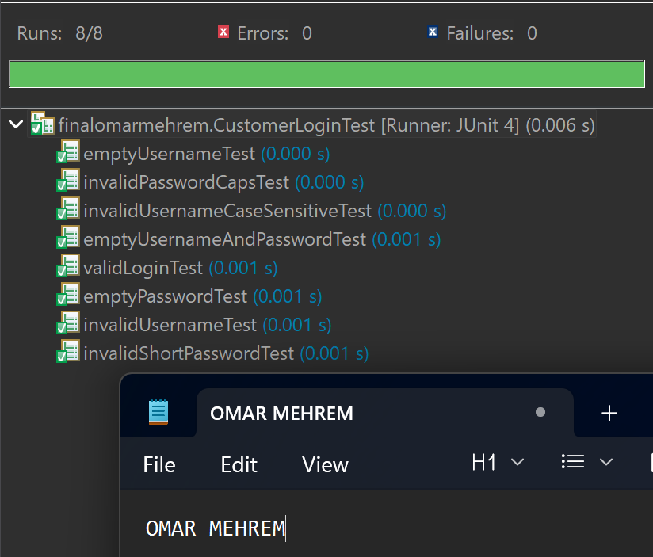

rentalAgentLogin Function:
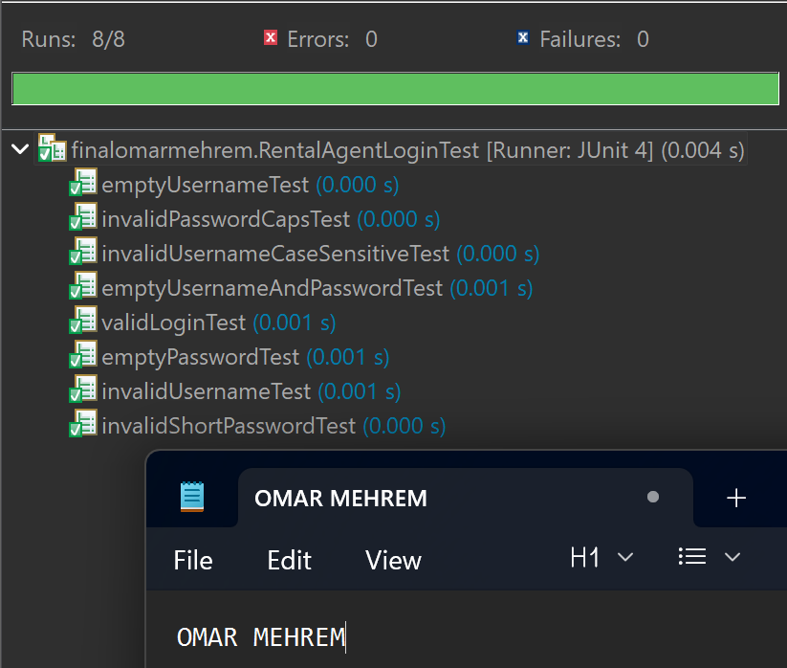
maintenanceLogin Function:
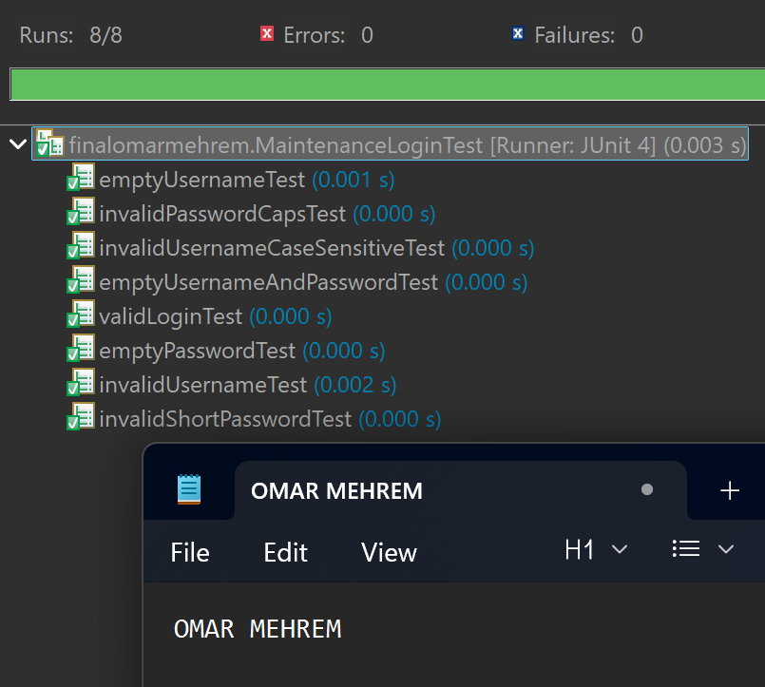
adminLogin Function:
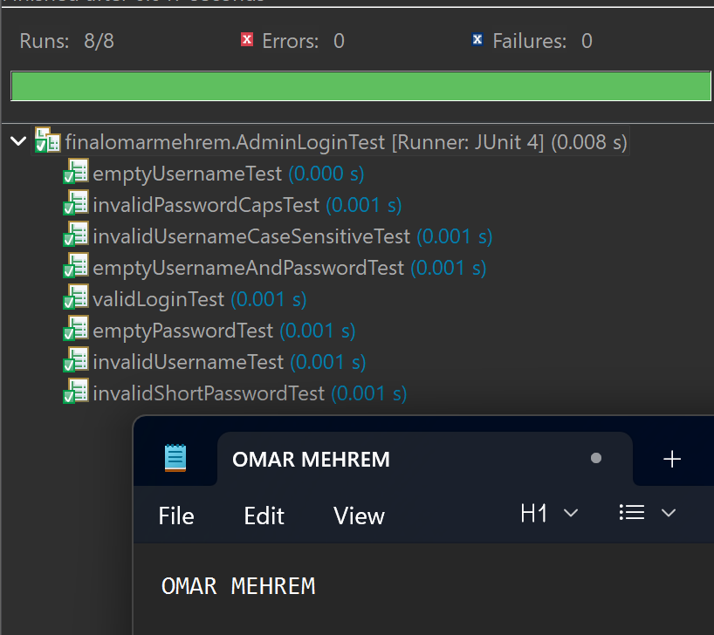
Test all funtions:
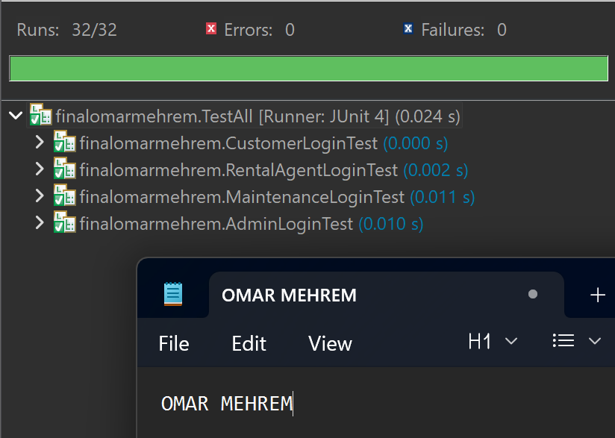
The result of integration testing to login for Customer and register customer:
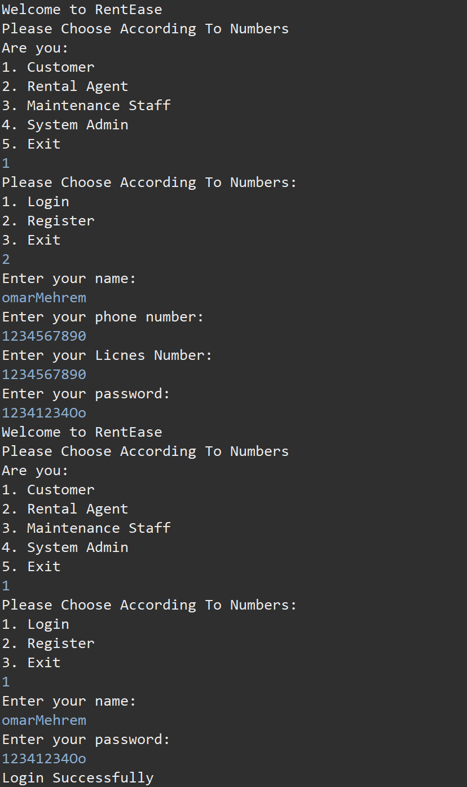

Security Testing
Security Testing is a process aimed at identifying system weaknesses and ensuring the system is protected against potential attacks and threats. It aims to guarantee the system's ability to handle various types of cyber threats. This type of testing focuses on uncovering security vulnerabilities that could be exploited. These tests offer several benefits:
- Reducing security risks
- Building a more secure system
- Identifying and addressing weaknesses
- Ensuring compliance with regulations

- Dynamic Testing: This is a type of security test that evaluates the system by running and monitoring it in real time, interacting with it using both valid and unexpected inputs. This test identifies security vulnerabilities that cannot be observed through code analysis alone, such as unexpected inputs. There are several benefits to dynamic testing, including:

  - Detecting runtime errors
  - Simulating real-world attacks that the system might face
  - Improving security levels

- Fuzzing Testing: This is a type of dynamic security test that evaluates the system by introducing random and invalid data to observe its behavior and how it handles it. This test aims to... This test helps detect unexpected system behavior that reveals serious errors such as system crashes. It also uncovers security vulnerabilities that might not appear during regular testing and has several benefits, including:

  - Discovering security vulnerabilities
  - Improving security levels
  - Comprehensive testing

- Static Testing: This is a type of security testing where the source code (instructions) is examined or analyzed without running the system. This type focuses on identifying and detecting security vulnerabilities in the code structure without running the system, such as programming errors that lead to security vulnerabilities. This test helps detect problems early and has several benefits, including:

  - Identifying security vulnerabilities
  - Early detection of errors
  - Low cost

- Static Code Analysis: This is a method that aims to discover errors and security vulnerabilities in the code by examining and analyzing the code without running the application using specialized tools. One such tool is PMD, which I used, and it has several benefits, including:

  - Identifying security vulnerabilities
  - Early detection of errors
  - Reducing risks
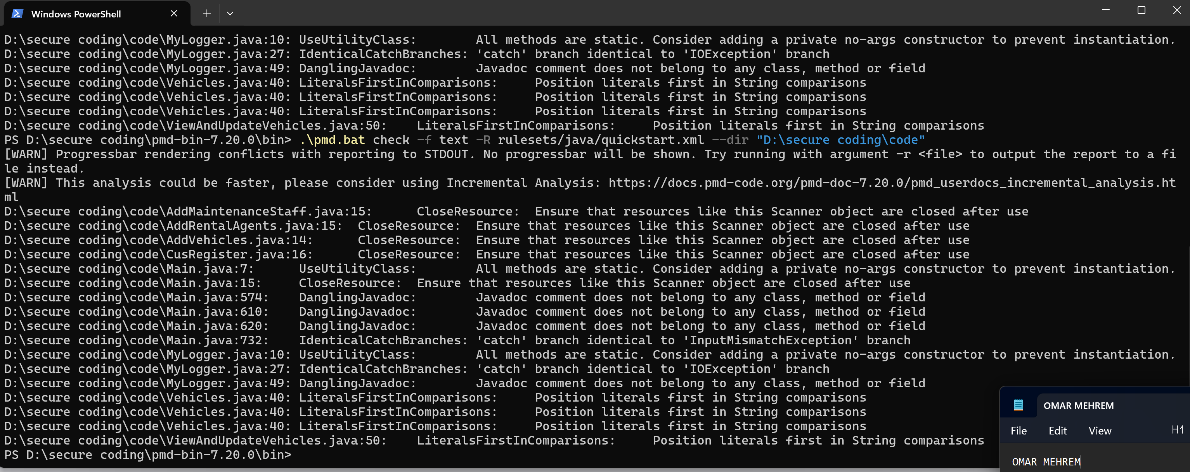

customerLogin Funtion: “Fuzzing Testing”
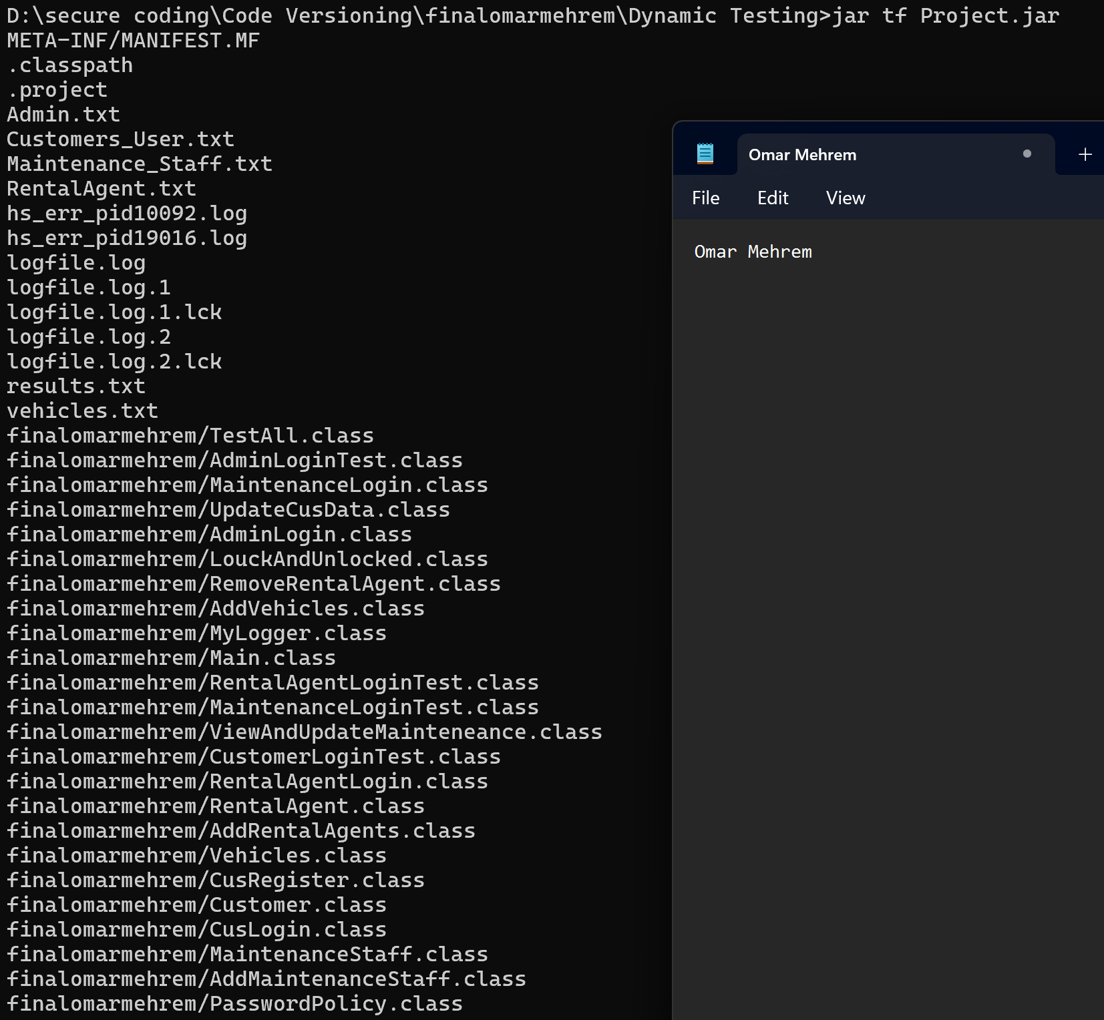
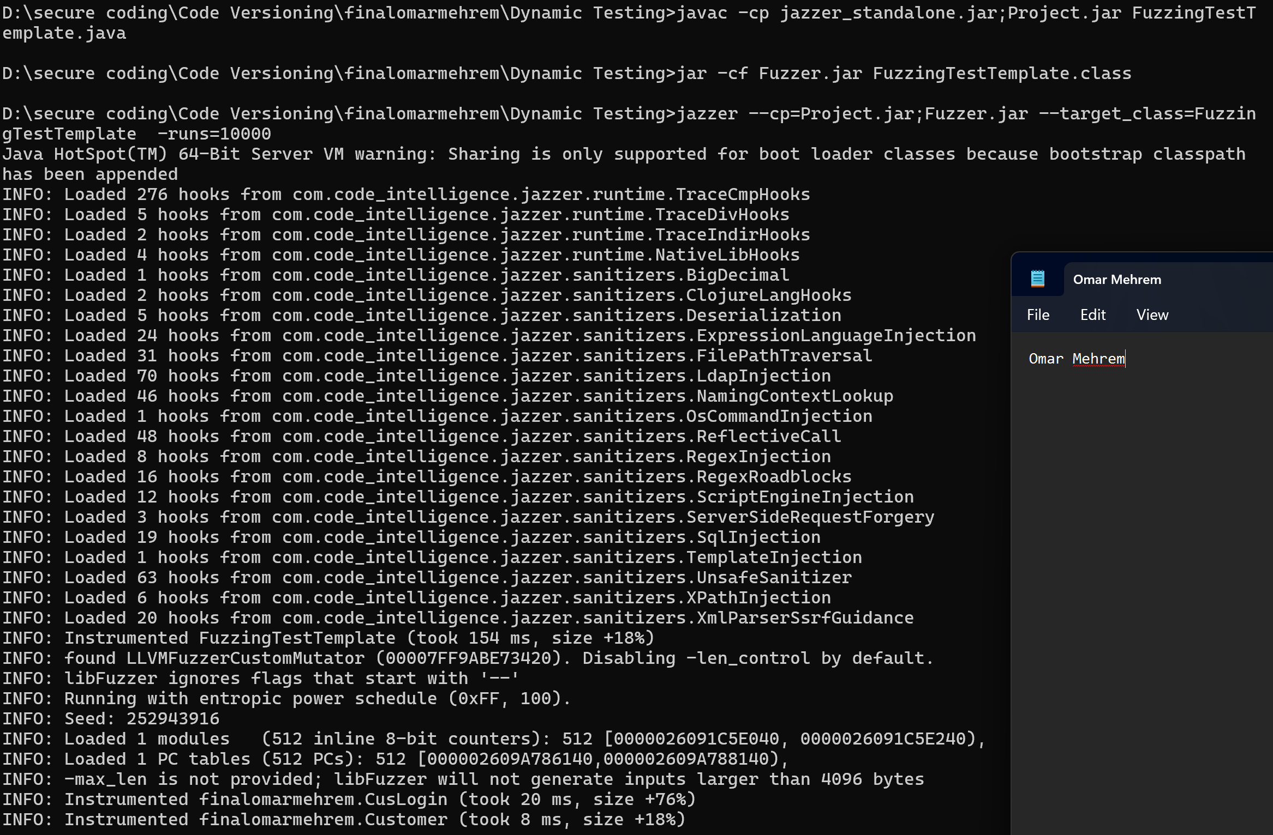
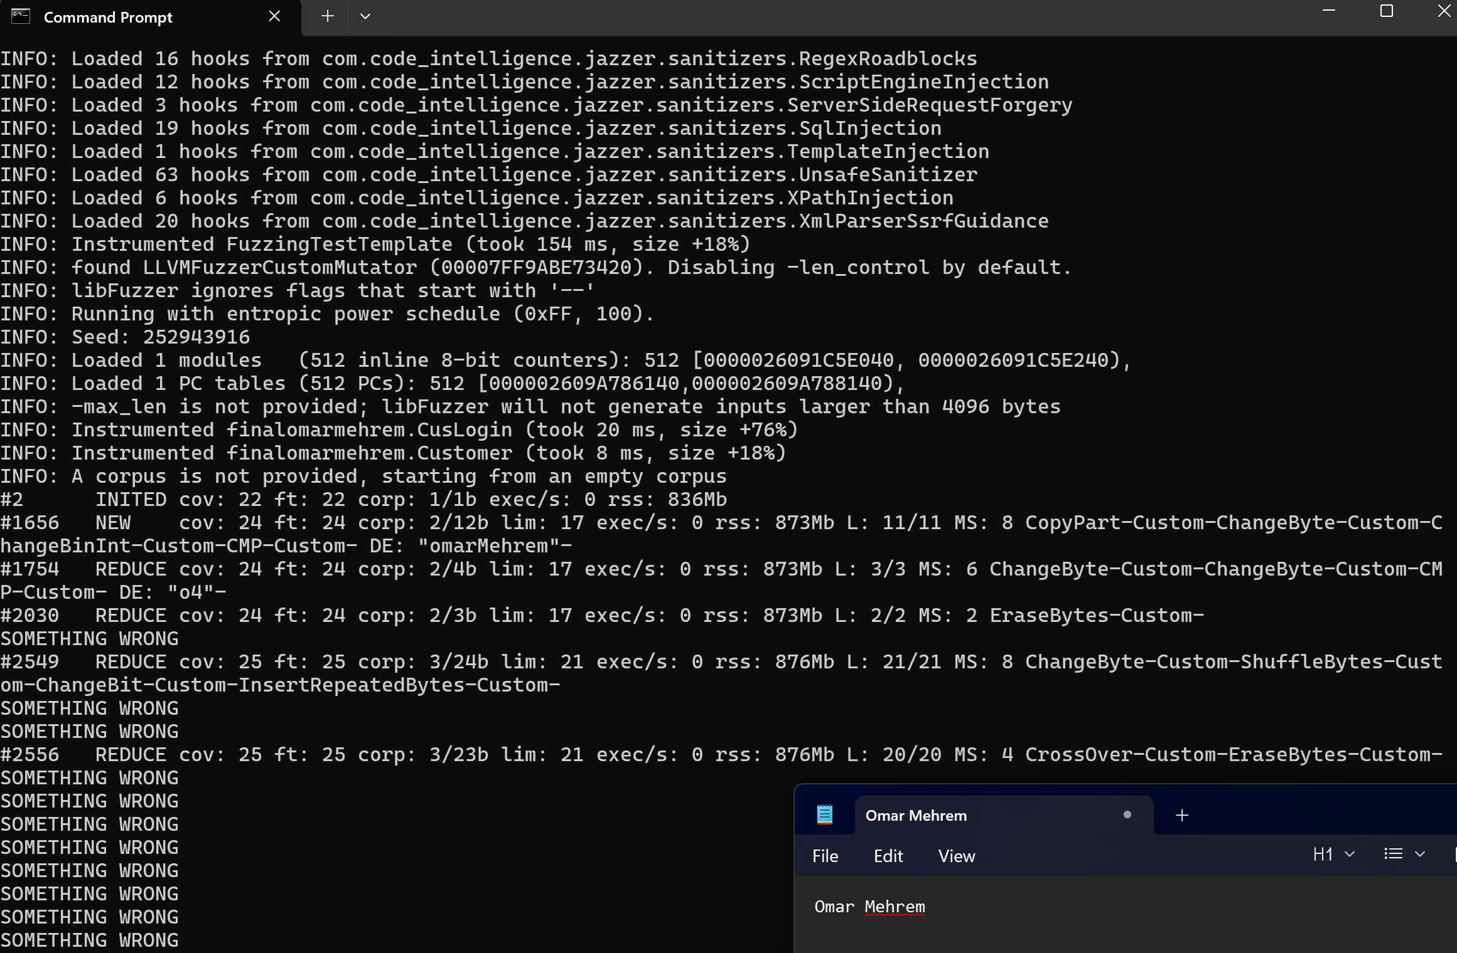

Code Versioning
github link: Omar-Mehrem/Final-SecureCoding
