**Name : عمرعبدالمنصف سالم حسن نجم**

**B.N: 554**

**Date :**

**Topic:** **Artificial intellengce**

**Github link :**

**Github page :**

**Application brief**

The subject of artificial intelligence was chosen due to its extreme importance and its current and future role in our lives and its significant influence on it.

Artificial Intelligencecanbe defined as a branch of computer science that aims to imbue software with the ability to analyze its environment using either predetermined rules and search algorithms, or pattern recognizing machine learning models, and then make decisions based on those analyses.

In this way, AI attempts to mimic biological intelligence to allow the software application or system to act with varying degrees of autonomy, thereby reducing manual human intervention for a wide range of functions.

Its importance lies in that it has been deployed to enhance our lives as well. Experiments with AI to compose original compositions from books to music, develop recipes based on what’s currently in the cupboard and even to create works of art are extending the influence of AI on our lives. The AI-powered recommendation engines of Netflix and Spotify help streamline our decision-making process when we are looking for the next show to watch or song to listen to.

It's clear that if we took AI away, our world would look vastly different in every way. As the current investments and research result in expanded and perfected uses of AI, we can expect the technology to become even more entangled into our daily existence, workplaces and society.

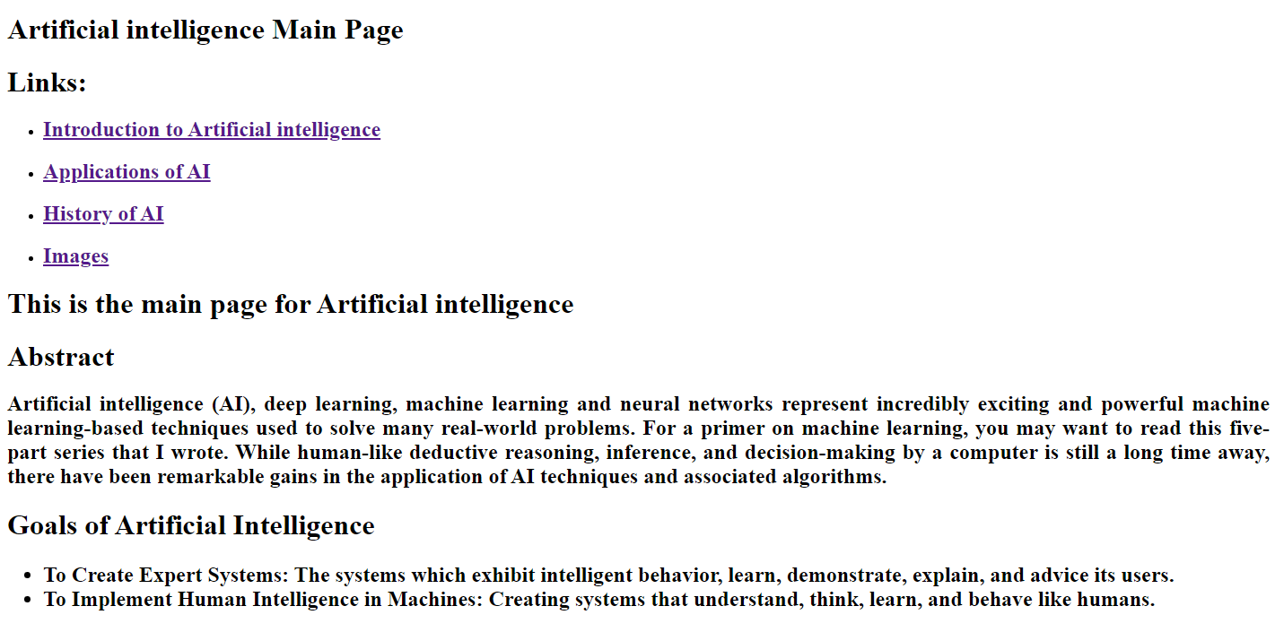**Screeshots :**

