PROJECT REPORT
Secure Local School Network using GNS3
Design, implementation, internal services, and access-control verification

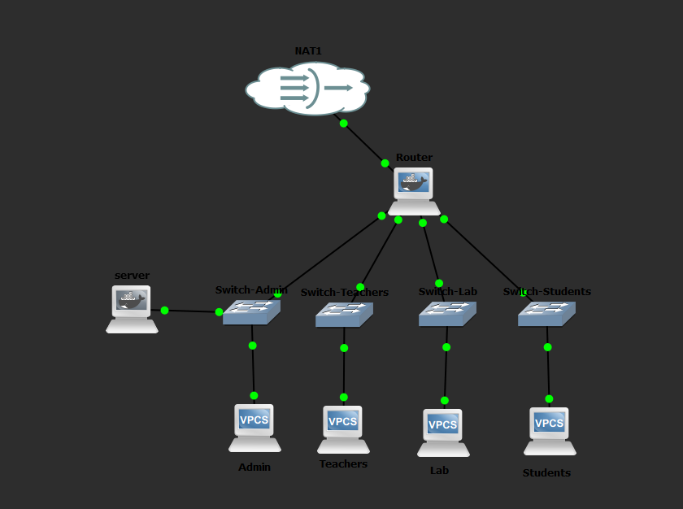
Figure 1. Implemented school network topology in GNS3.
Students Names: Omar Salous – Ferial Kalboneh
Instructor: Jehad Hamamreh
Submission Date: April. 17th, 2026

1. Project Overview
This project builds a secure local area network for a school using GNS3. The design separates the school into four departments - Administration, Teachers, Lab, and Students - and connects them through a central router. A server placed in the Administration network provides internal services, while NAT connectivity allows controlled Internet access through the cloud interface.
The main objective is not only to achieve connectivity, but also to enforce a clear access policy. Students are allowed to communicate with approved networks and router gateways, but are blocked from reaching the Administration network. This mirrors a realistic school environment where administrative resources require stronger protection.

2. Network Objectives
- Create a structured school LAN with separate networks for Admin, Teachers, Lab, and Students.
- Use a router to perform inter-network routing and forward approved traffic.
- Deploy internal services on the server: Web Server, DHCP, and shared files via Samba.
- Provide Internet exit through NAT while keeping the internal addressing scheme private.
- Apply a firewall rule that blocks Students from accessing the Administration network.
- Verify the design through successful ping tests and service checks.

3. Topology and Components
The implemented topology contains the following core components:
- 1 central router connected to four department switches and one NAT cloud interface.
- 4 access switches: Switch-Admin, Switch-Teachers, Switch-Lab, and Switch-Students.
- 1 internal server connected to the Administration network.
- 4 end devices represented by VPCS nodes: Admin, Teachers, Lab, and Students.

Figure 2. Logical relationship between the router, departmental switches, server, and end devices.

4. IP Addressing Plan
Network / Node | Interface | IP Address | Default Gateway
Router - Admin | eth0 | 192.168.10.1/24 | -
Router - Teachers | eth1 | 192.168.20.1/24 | -
Router - Lab | eth2 | 192.168.30.1/24 | -
Router - Students | eth3 | 192.168.40.1/24 | -
Router - NAT | eth4 | DHCP from NAT | -
Server | eth0 | 192.168.10.100/24 | 192.168.10.1
Admin PC | VPCS | 192.168.10.10/24 | 192.168.10.1
Teachers PC | VPCS | 192.168.20.10/24 | 192.168.20.1
Lab PC | VPCS | 192.168.30.10/24 | 192.168.30.1
Students PC | VPCS | 192.168.40.10/24 | 192.168.40.1

5. Router Configuration Summary
The router performs three essential tasks: IP addressing of all departmental networks, IP forwarding between those networks, and packet filtering/NAT using iptables.
- Assigned static gateway addresses to eth0, eth1, eth2, and eth3.
- Enabled IPv4 forwarding so traffic can pass between the subnets.
- Applied a firewall rule to drop traffic originating from Students (192.168.40.0/24) toward Administration (192.168.10.0/24).
- Enabled NAT masquerading on eth4 so private subnets can exit through the NAT cloud.

6. Server Configuration Summary
The server was configured with a static address in the Administration subnet and a default route toward the router. Three services were prepared on the server:
- Apache web service hosting an internal landing page for the school network.
- dnsmasq service to provide DHCP leases inside the Administration network.
- Samba file sharing through a shared folder named schoolshare.

7. Security Policy
The key security requirement was to protect administrative resources from student access. This was implemented with an iptables FORWARD rule on the router. The policy blocks traffic leaving eth3 (Students network) toward eth0 (Administration network), while other approved forwarding rules remain available.
Core firewall rule: iptables -A FORWARD -i eth3 -o eth0 -s 192.168.40.0/24 -d 192.168.10.0/24 -j DROP

8. Testing and Verification
Testing focused on both connectivity and policy enforcement. Successful checks and expected blocked traffic are summarized below.
Test Source | Verification Item | Result
Admin PC | Ping to internal server 192.168.10.100 | Successful
Admin PC | Ping to Teachers 192.168.20.10 | Successful
Admin PC | Ping to Lab 192.168.30.10 | Successful
Students PC | Ping to own gateway 192.168.40.1 | Successful
Teachers PC | Ping to own gateway 192.168.20.1 | Successful
Lab PC | Ping to own gateway 192.168.30.1 | Successful
Students PC | Ping to Admin 192.168.10.10 | Blocked as intended
Server | Local web page retrieval via 127.0.0.1 | Successful
Server | Shared folder and README file check | Successful

9. Key Commands Used
The implementation relied on Linux networking commands and service management. Representative commands included:
- ip addr add ... / ip link set ... up
- echo 1 > /proc/sys/net/ipv4/ip_forward
- iptables FORWARD rules and MASQUERADE for NAT
- udhcpc -i eth4 to obtain the NAT-side address
- httpd -k start for Apache
- dnsmasq for DHCP service
- smbd -D and nmbd -D for file sharing

10. Conclusion
The project achieved the required goals for a secure school LAN. The topology supports separation of departments, centralized routing, internal services, and a clear security rule that protects Administration resources from Students traffic. The final design is suitable as a practical demonstration of subnetting, routing, firewall configuration, and service deployment in GNS3.

Appendix A - Commands Reference
The full command history used during implementation can be attached separately in the presentation appendix or lab notes. This report focuses on the final design and verification outcomes.

