Title: Lost & Found Tracking System
Group Members: Omar Samad & Seerat Ahmad
Milestone | Version | Date | Remarks
1 | 1.0 | 26 April,2026

ERD:
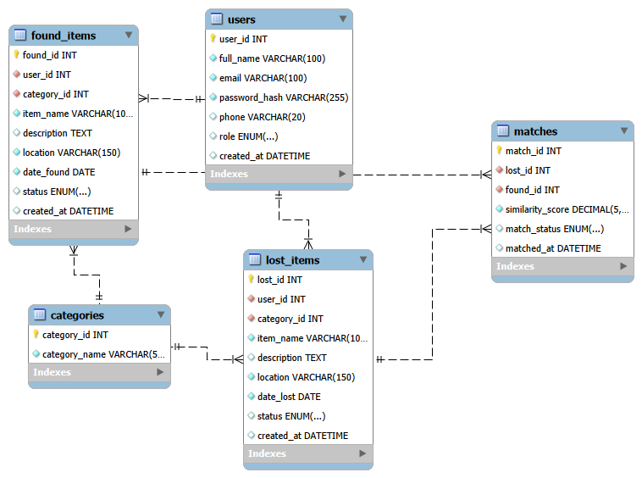

Schema Discription:
This database consists of 5 tables which work together handling everything.
Table 1: Users
This is the central table. Everyone who interacts with system whether a regular user or the admin is stored in this table. Admin is separated from users by role which is admin role and user role.
Column Datatype Key Description
user_id INT PK unique ID
full_name varchar(100) - full name of user
email varchar(100) - email for login
password varchar(255) - password is stored encrypted
phone varchar(15) - contact number
role enum(‘user’,’admin’) - to know who logins
created_at datetime - time when the account was created

Table 2: Categories
this table stores item categories.
Column Datatype Key Description
category_id INT PK unique id
category_name varchar(50) - category name wallet

Table 3: Lost_Items
When a user reports a lost item, a record is stored here.
Column Datatype Key Description
lost_id INT PK unique id
user_id int FK → users who reported this item
category_id INT FK → categories item category
item_name varchar(100) - name of lost item
description TEXT - item details
location varchar(150) - where it was lost
date_lost DATE - date when lost
status enum('pending','verified','returned') - current status
created_at DATETIME - time of submission

Table 4: Found_Items
When a user reports found item, it is stored in this table.
Column Datatype Key Description
found_id INT PK unique id
user_id INT FK → users who reported found item
category_id int FK → categories item category
item_name VARCHAR(100) - name of found item
description text - item details
location VARCHAR(150) - where it was found
date_found DATE - date when found
status ENUM('pending','verified','returned') - current status
created_at datetime - time of submission

Table 5: Matches
this table links lost and found items and stores similarity score.
Column Datatype Key Description
match_id INT PK unique id
lost_id INT FK → lost_items lost item in match
found_id INT FK → found_items found item in match
similarity_score decimal(5,2) - match percentage
match_status enum('pending','confirmed','rejected') - admin decision
matched_at datatime - time match created

