Milestone 5: Data Population (DML)
Populated the data from all the csv files using LOAD DATA INFILE Method.
All the data is populated correctly.
Now we update and delete:
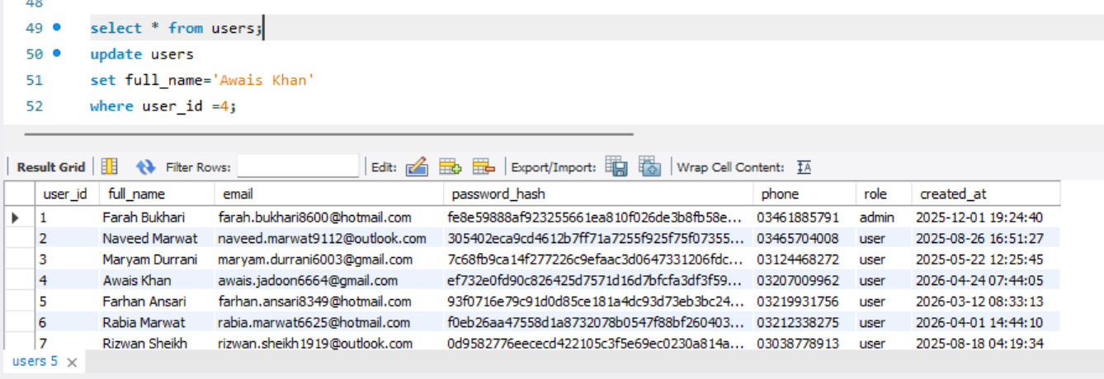

Validation Queries:

NULL check on key columns:
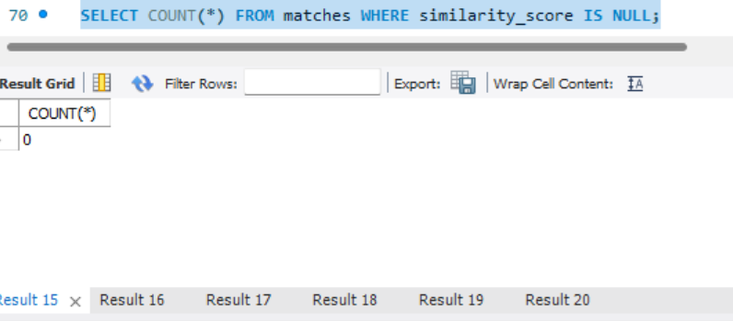

Checked all and found no null Record.

