

**Faculty of engineering - Shoubra Benha University**

# Research Article / Research Project / Literature Review

in fulfillment of the requirements of

|  |  |
| --- | --- |
| **Department** | Engineering Mathematics and Physics |
| **Division** | -------------- |
| **Academic Year** | 2019-2020 Preparatory |
| **Course name** | Computer |
| **Course code** | ECE001 |

**Title: -**

**Artificial Intelligence**

By:

|  |  |  |  |
| --- | --- | --- | --- |
|  | Name | Edu mail | B.N |
| 1 | Omar Yousri Zaki Ibrahim | Omar195634@feng.bu.edu.eg | 574 |

## Approved by:

|  |  |
| --- | --- |
| Examiners committee | Signature |
| Dr. Ahmed Bayoumi |  |
| Dr. Shady Elmashad |  |
| Dr. Abdelhamid Attaby |  |

**Report**

In this project, we chose the artificial intelligence as a topic to talk about, as it is considered now to be the leading field in all technology branches, it is believed that this branch will lead and rule the technology in the coming years because of the rapid development taking place, and the vast growth of its market, increasing the supply and demand process.

We tried to give a little bit of information to help in understanding the history of development of such an important technology, from IBM’s supercomputer that succeeded in beating one of the greatest chess champions of history Gary Kasparov in a legendary match that defined the value of such technology. And the great development in this field as years passed, until we reached the level of virtual assistants as the like of Siri in IOS and Alexa the Amazon assistant and the newly made Google Assistant. Self driving cars by Tesla and Uber not only offered to daily use but it is on its way of becoming the “mainstream” mean of transportation. All of this development and various applications, makes us wonder, it keeps on knocking and asking a question on larger scale, are humans capable of building a system even more intelligent than himself? And if he could, will this type of intelligence replace the human labor? These are all asked questions the coming years will ask, but for sure such high technology will help developing mankind and build civilizations.

**Source Code**

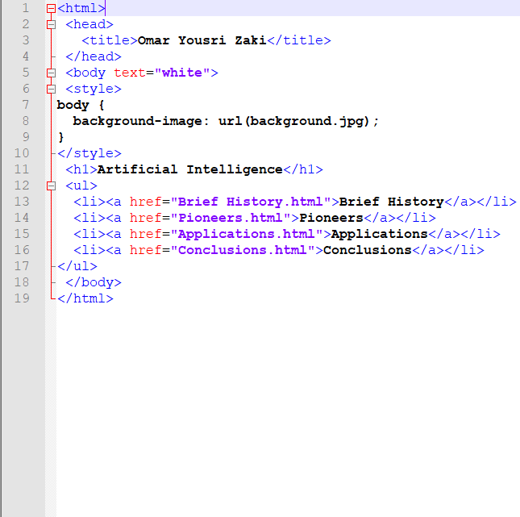

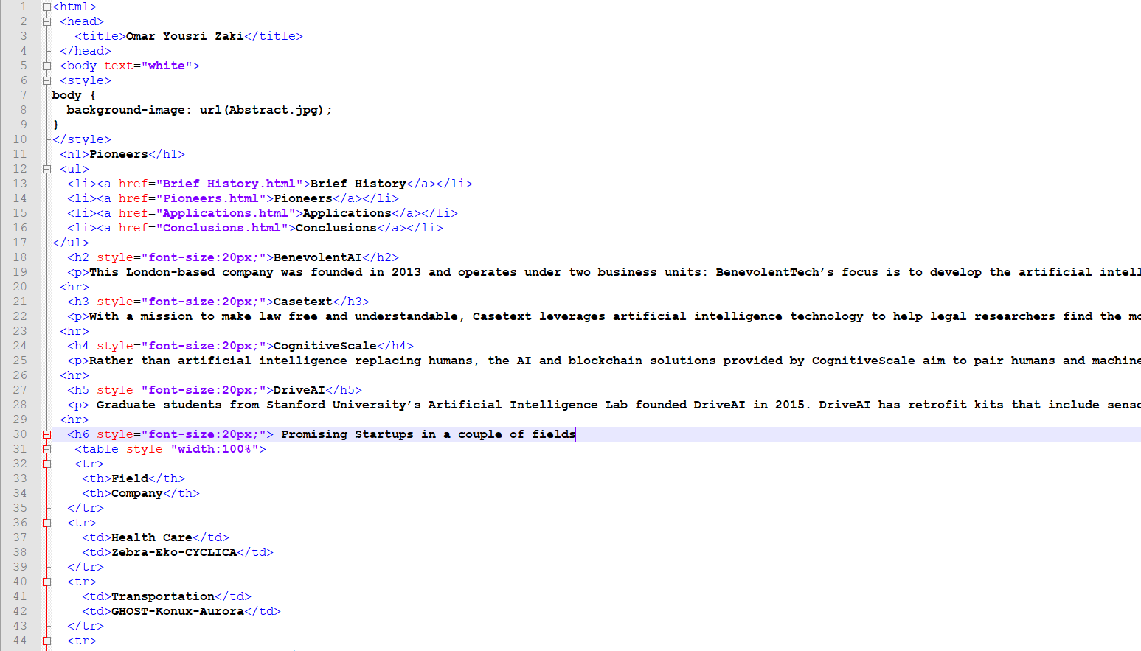

**Screenshots**

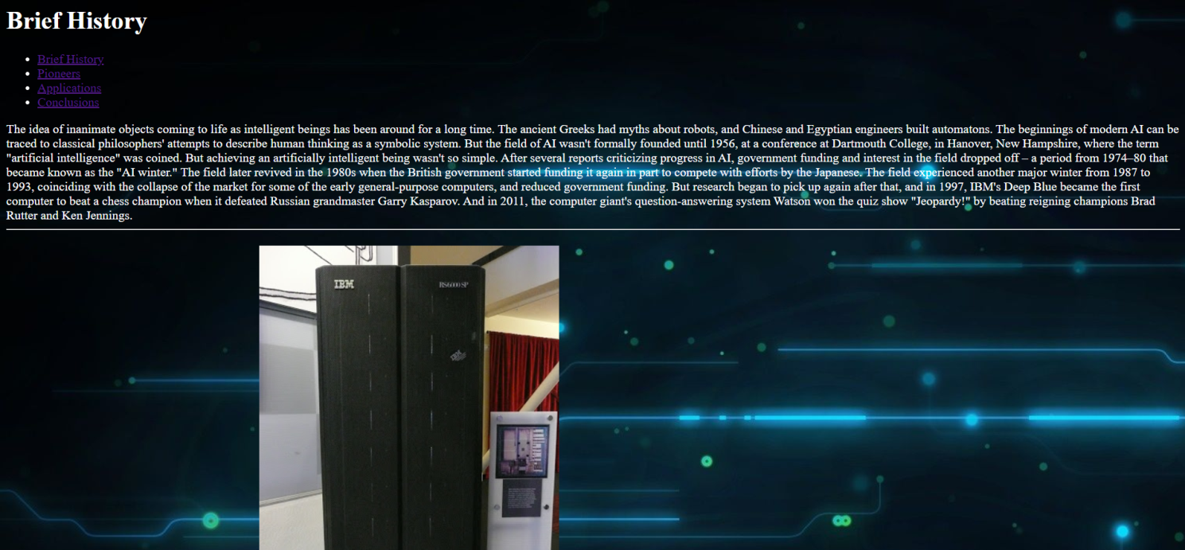

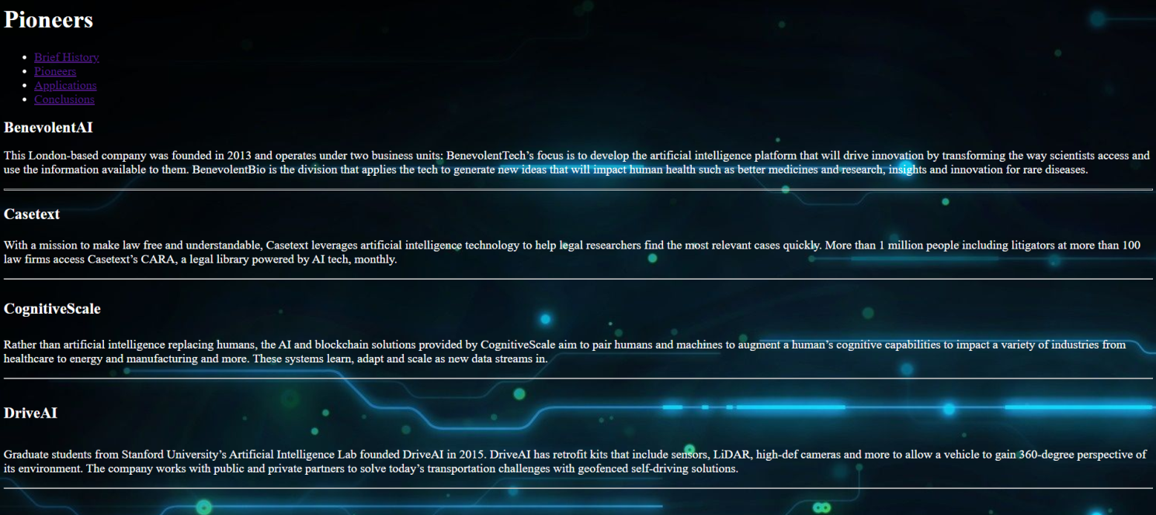

**References**

1. [**https://www.cbinsights.com/research/artificial-intelligence-top-startups/**](https://www.cbinsights.com/research/artificial-intelligence-top-startups/)
2. [**https://blog.zoominfo.com/statistics-about-artificial-intelligence/**](https://blog.zoominfo.com/statistics-about-artificial-intelligence/)
3. [**https://www.edureka.co/blog/artificial-intelligence-applications/**](https://www.edureka.co/blog/artificial-intelligence-applications/)
4. [**https://bernardmarr.com/default.asp?contentID=1531**](https://bernardmarr.com/default.asp?contentID=1531)
5. **Britannica Encyclopedia**

[**https://www.britannica.com/technology/artificial-intelligence**](https://www.britannica.com/technology/artificial-intelligence)