
Arab Academy for Science, Technology and Maritime Transport
College of Computing and Information Technology – Cairo
Course Name: Introduction to Software Engineering
Course Code:CSE2001
12th Week Project Documentation
Project Name: Nutrition Tracker
Nutrition Tracker is a digital platform that connects users with professional nutritionists. Users register, set up their profile, choose a subscription plan, and receive a personalized meal plan. The system handles payments, discount codes, and progress tracking, all in one place.

Presented By:
Name 1 :Seif Yasser  Reg # 1 : 241004681 | Name 2 :Omar Akram  Reg # 2 :241004666
Presented To:
Dr.Eman ElSayed Mahmoud
Eng.Anas Ahmad Ibraheem

Software Requirements Specification for Nutrition Tracker Page ii
Contents

1. Introduction ..............................................................................................................................
1.1 Problem Statement .......................................................................................................................
1.2 Purpose ........................................................................................................................................
1.3 Document Conventions ...............................................................................................................
1.4 Intended Audience and Reading Suggestions..............................................................................
1.5 Project Scope ...............................................................................................................................
1.6 Objectives ....................................................................................................................................
1.7 Goals ............................................................................................................................................
1.8 References ...................................................................................................................................

2. Overall Description ..................................................................................................................
2.1 Project Perspective ......................................................................................................................
2.2 Product Functions ........................................................................................................................
2.3 User Classes and Characteristics .................................................................................................
2.4 Operating Environment ...............................................................................................................
2.5 Design and Implementation Constraints ......................................................................................
2.6 User Documentation ....................................................................................................................
2.7 Assumptions and Dependencies ..................................................................................................

3. External Interface Requirements ...........................................................................................
3.1 User Interfaces .............................................................................................................................
3.2 Software Interfaces ......................................................................................................................
3.3 Communications Interfaces .........................................................................................................

4. Project Requirements ..............................................................................................................
4.1 Functional Requirements .............................................................................................................
4.2 Non – Functional Requirements ..................................................................................................

5. UML DESIGN ..........................................................................................................................
5.1 Usecase Diagram .........................................................................................................................
5.2 Activity Diagram .........................................................................................................................
5.3 Sequence Diagram .....................................................................................................................
5.4 Misuse Case Diagram ................................................................................................................
5.5 Class Diagram ..................................................................................................................

6. Implementation ......................................................................................................................
6.1 Implemented Functions .............................................................................................................
6.2 Project Implementation..............................................................................................................

Software Requirements Specification for Nutrition Tracker Page iii

Revision History
Name | Date | Reason For Changes | Version

1. Introduction

1.1 Problem Statement

Many people find it difficult to access professional nutrition guidance, while nutritionists have no proper digital tool to manage clients and meal plans. There is currently no single platform that brings both sides together and handles subscriptions, payments, and progress tracking all in one place.

1.2 Purpose
The purpose of this project is to build a digital platform that connects users with professional nutritionists, allowing users to set health goals, choose a subscription plan, and receive a personalized meal plan. The system also handles payments, discount codes, and progress tracking between users and nutritionists, while an admin manages the platform behind the scenes.

1.3 Document Conventions

The following conventions are used throughout this document:
- FR refers to Functional Requirements (e.g., FR1, FR2)
- NFR refers to Non-Functional Requirements (e.g., NFR1, NFR2)
- Requirements are written using the term “shall” to indicate mandatory features
- Headings and subheadings are numbered for clarity and easy navigation
- Important terms may be highlighted in bold for emphasis

1.4 Intended Audience and Reading Suggestions
This document is intended for:
Developers: to understand system functionality and implementation requirements
Nutritionists: to manage clients, create meal plans, and track user progress
Users: to register, subscribe, and receive personalized nutrition guidance
Admins: to manage and monitor the platform and its users
Testers: to validate system behavior against requirements

Academic Supervisors: to review and evaluate the project

1.5 Project Scope
SwiftAid is an offline-first mobile application that provides medically-vetted, step-by-step first aid guidance for 20+ emergency scenarios including CPR, choking, burns, seizures, and poisoning, supported by illustrated GIFs and visuals, with on-device storage of all content and user medical profiles (blood type, allergies), a localized panic button that auto-detects the user's country to connect them with local emergency services, hands-free voice command navigation, multi-language support, and content verified against the latest WHO and American Heart Association guidelines.

1.6 Objectives
• Users can register, log in, and fill in their health profile in under 5 minutes
• Users can select a plan, apply a discount if available, and complete payment in one flow
• Nutritionists receive new client notifications and can create a meal plan within the system
• Users can view their meal plan and send progress updates directly to their nutritionist
• Admins can manage all users, nutritionists, and subscriptions from a single dashboard

• The system confirms payment and notifies both the user and nutritionist automatically

1.7 Goals
• Build a reliable platform that connects users with qualified nutritionists
• Make the subscription and payment process smooth and secure
• Allow nutritionists to efficiently manage their clients and deliver meal plans
• Give users a clear view of their nutrition plan and a way to report progress

• Give admins full visibility and control over the platform

1.8 References
The following documents and resources were used as references for developing this Software Requirements Specification:
Pressman, R. S., & Maxim, B. (2020). Software Engineering: A Practitioner's Approach (9th ed.). McGraw-Hill.
Sommerville, I. (2016). Software Engineering (10th ed.). Pearson Education.
World Health Organization. (2023). Healthy diet and nutrition guidelines. Retrieved from https://www.who.int
OWASP Foundation. (2023). OWASP Top Ten Security Risks. Retrieved from https://owasp.org
Stripe. (2023). Payment gateway integration documentation. Retrieved from https://stripe.com/docs
Nielsen, J. (1994). Usability Engineering. Morgan Kaufmann.

2.Overall Description

2.1 Project Perspective

The Nutrition Tracker is a web-based platform that connects users with professional nutritionists in one organized system. It brings together nutrition guidance, subscription management, and payment processing in one place, making it easy for users to get personalized meal plans and for nutritionists to manage their clients. The system is accessible through major web browsers on both desktop and mobile devices.

2.2 Product Functions
• Users can register, log in, and set up their health profile
• Users can choose a subscription plan and apply a discount code
• Users can make a payment through a secure payment gateway
• Users can view their personalized meal plan and send progress updates
• Nutritionists can view client data, analyze it, and create or update meal plans
• Admins can manage users, nutritionists, subscriptions, and monitor system activity

2.3 User Classes and Characteristics
User: A regular person who registers, sets up their health profile, pays for a plan, and views their meal plan. No technical experience needed.
Nutritionist: A nutrition professional who views assigned clients' data and creates or updates their meal plans.
Admin: The platform manager who manages accounts, subscriptions, and discount codes, and monitors the system.
Payment Gateway: An external service that processes and confirms payments securely.

2.4 Operating Environment
Web Browsers: The platform runs on all major browsers including Chrome, Firefox, Safari, and Edge.
Devices: Accessible on both desktop and mobile screens.
Internet Connection: A stable internet connection is required to use the platform.
Payment Gateway: Integrated with a trusted third-party payment service to handle transactions securely.
Server: The system runs on a web server that supports at least 99% uptime to ensure availability at all times.

2.5 Design and Implementation Constraints
Security: User data and passwords must be encrypted and HTTPS must be enforced.
Payment: The system depends on a third-party payment gateway for processing transactions.
Compatibility: Must work on all major browsers and on both desktop and mobile.
Performance: Pages must load within 3 seconds with no delays during payment.
Data Integrity: No data or payments should be lost even if the system crashes.
Scalability: The system must handle a growing number of users without performance issue

2.6 User Documentation
User Guide: A simple guide explaining how to register, set up a health profile, choose a subscription plan, make a payment, and view a meal plan.
Nutritionist Guide: A guide explaining how to view assigned clients, analyze their data, and create or update meal plans.
Admin Guide: A guide explaining how to manage users, nutritionists, subscriptions, and discount codes.
FAQ: A list of common questions and answers to help users solve basic issues on their own.

2.7 Assumptions and Dependencies
Assumptions:
- Users have basic digital literacy and a stable internet connection. - Nutritionists are verified professionals before being added to the platform. - Users will provide accurate health information during registration.
Dependencies:
- The system relies on a third-party payment gateway to process payments. - Email notifications depend on an external email service. - The platform requires a reliable web server to maintain availability.

3. External Interface Requirements

3.1 User Interfaces
Registration & Login Page: Allows users to create an account or log in with their email and password.
Health Profile Page: Where users fill in their personal info, health goals, and training details.
Subscription Page: Displays available plans, allows users to apply a discount code and proceed to payment.
User Dashboard: Where users view their meal plan and send progress updates to their nutritionist.
Nutritionist Dashboard: Where nutritionists view assigned clients, analyze their data, and create or update meal plans.
Admin Panel: Where the admin manages users, nutritionists, subscriptions, and monitors system activity.

3.2 Software Interfaces
Payment Gateway: The system integrates with a third-party payment service to process and confirm user payments securely.
Email Service: An external email service is used to send notifications for account creation, payment confirmation, and progress updates.
Database: A database is used to store all user data, nutritionist info, meal plans, subscriptions, and payment records.
Web Server: The platform runs on a web server that handles all requests between users and the system.

3.3 Communications Interfaces
HTTPS: All data exchanged between the user and the system is encrypted using HTTPS to ensure secure communication.
Email Notifications: The system sends emails to notify users and nutritionists about key events such as payment confirmation and new client assignments.
Payment Gateway Communication: The system communicates with the payment gateway to send payment requests and receive confirmation responses.
Real-time Updates: The system notifies nutritionists when a new client is assigned and alerts users when their meal plan is ready.

4. Project Requirements

4.1 Functional Requirements

Functional ID | Name | Description
FR01 | User Registration & Login | Users can create an account, log in, and reset their password.
FR02 | Health Profile Setup | Users fill in their age, weight, height, health goals, and training schedule after registering.
FR03 | Subscription Plan Selection | Users can view and select a subscription plan and apply a discount code before paying.
FR04 | Payment | Users complete payment through a payment gateway. The system confirms payment and notifies both the user and nutritionist.
FR05 | View Meal Plan | Users can view their personalized meal plan from their dashboar
FR06 | Send Progress Updates | Users can submit progress reports directly to their nutritionist.
FR07 | Nutritionist View Clients | Nutritionists are notified when a new client is assigned and can view their full health profile..
FR08 | Create & Update Meal Plans | Nutritionists can create and update meal plans for each client.
FR09 | Admin Manage Accounts | The admin can add, edit, or remove user and nutritionist accounts.
FR10 | Admin Manage Subscriptions | The app shall verify all content against WHO and AHA guidelines.
FR11 | Automatic Notifications | The system sends notifications after key events like payment, client assignment, and progress updates.

4.2 Non – Functional Requirements
Performance: Pages must load within 3 seconds and payment must complete without delays.

Security: All data and passwords must be encrypted. Only authorized users can access their own data.

Usability: A new user should be able to register, fill in their profile, and complete payment in under 5 minutes.

Availability: The system must be available at least 99% of the time.

Scalability: The system must handle a growing number of users and nutritionists without slowing down.

Reliability: No payment should be lost or double-charged and no data should be lost if the system crashes.

Maintainability: The code must be clean and organized so developers can fix or update it easily.

Compatibility: The platform must work on all major browsers and display correctly on desktop and mobile.

5. UML DESIGN

5.1 Usecase Diagram

Shows the interactions between the system's actors (user, nutritionist, admin, and payment gateway) and the main functions of the platform such as registration, making payment, creating meal plans, and managing accounts.
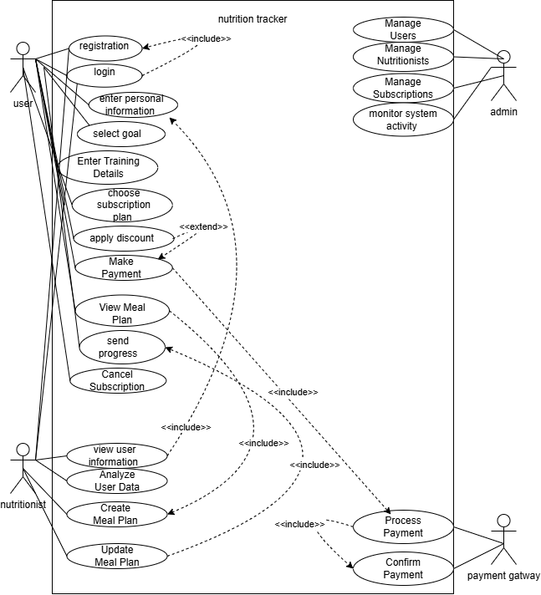

5.2 Activity Diagram

Shows the full workflow of the system from opening the app, registering, selecting a plan, making a payment, to finally receiving and responding to a meal plan.
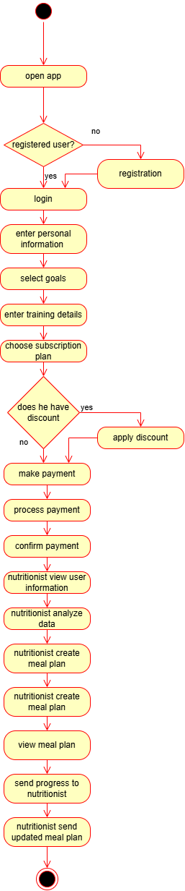

5.3 Sequence Diagram

Shows the step-by-step flow of interactions between the user, nutritionist, payment gateway, and system — from registration and payment all the way to receiving a meal plan

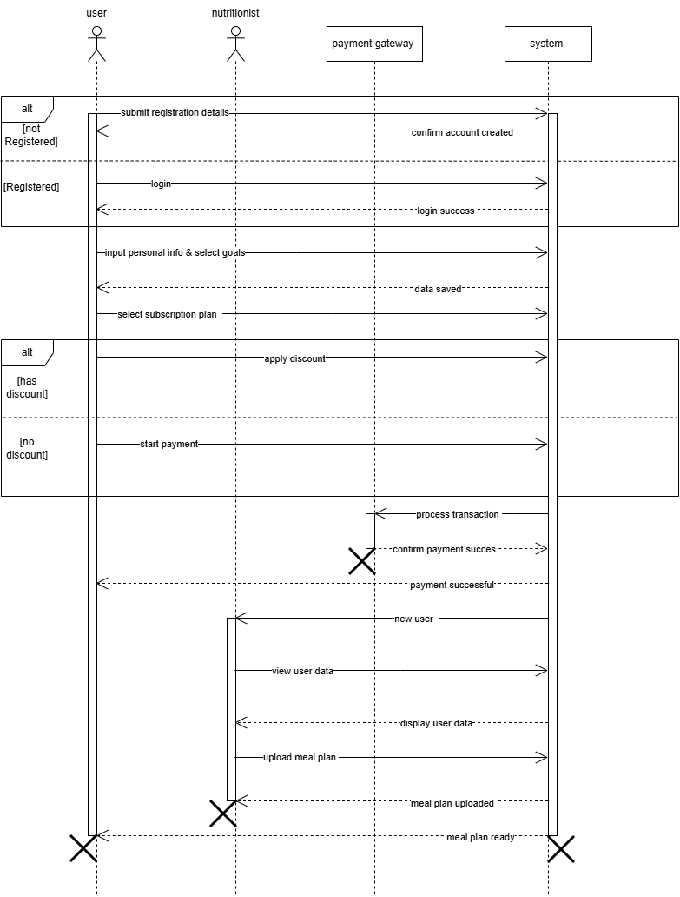

5.4 Misuse Case Diagram
Shows the possible security threats to the system such as brute-force login, SQL injection, fake discount codes, and man-in-the-middle attacks, along with the mitigations applied to prevent each threat.

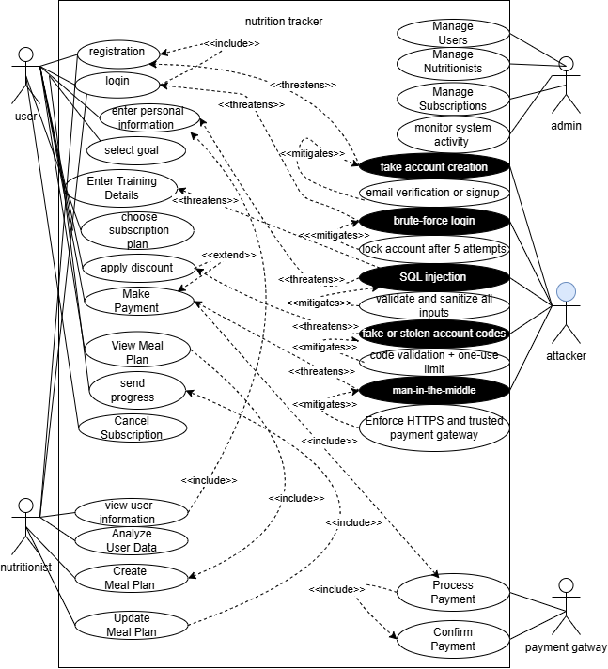

5.5 Class Diagram
SystemUser is the parent class for User, Admin, and Nutritionist. Users register, pay, and view meal plans. Admins manage the system. Nutritionists create meal plans. Subscription, MealPlan, and Payment support these operations.

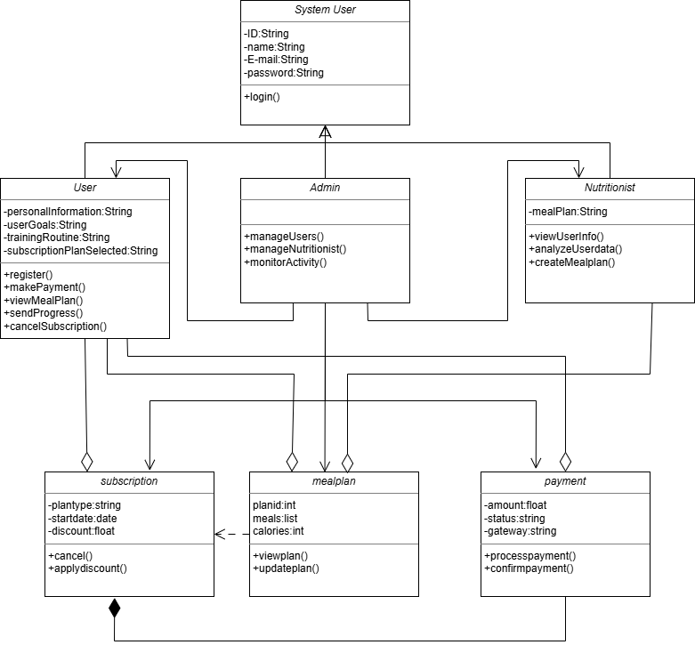

6. Implementation
6.1 Implemented Functions
1. Health Profile Setup (Body Metrics) Users fill in their current weight, height, age, target weight, activity level, medical conditions, and current diet in a 3-step form.
2. Goals & Training Setup Users select their health goals (e.g. Build Muscle, Improve Health), set training days per week, choose their training schedule, preferred meals per day, and add notes for their nutritionist.
3. Nutritionist Dashboard The nutritionist can view the assigned client's full profile (age, weight, height, goals, medical notes, client notes) and create a personalized meal plan with meal times, food items, calories, protein, and carbs for each day of the week.
4. Meal Plan Delivery Once the nutritionist submits the meal plan, the system confirms it was sent to the user's dashboard with a confirmation popup showing the client name, plan duration, meals per day, and delivery platform.

6.2 Project Implementation
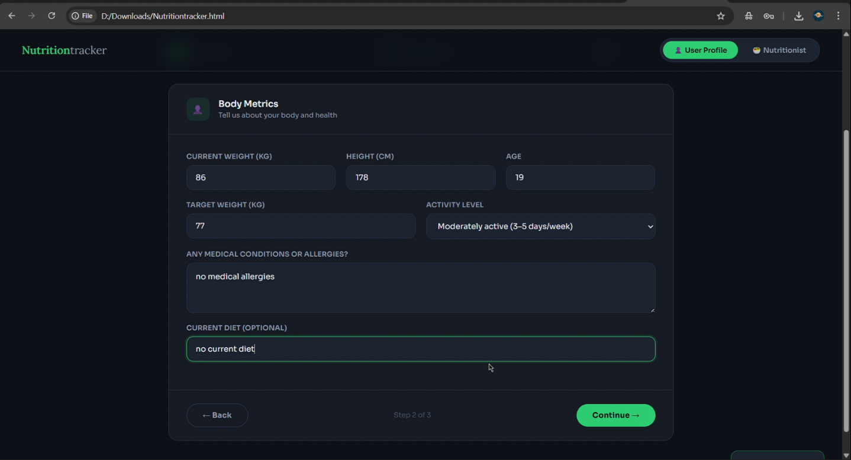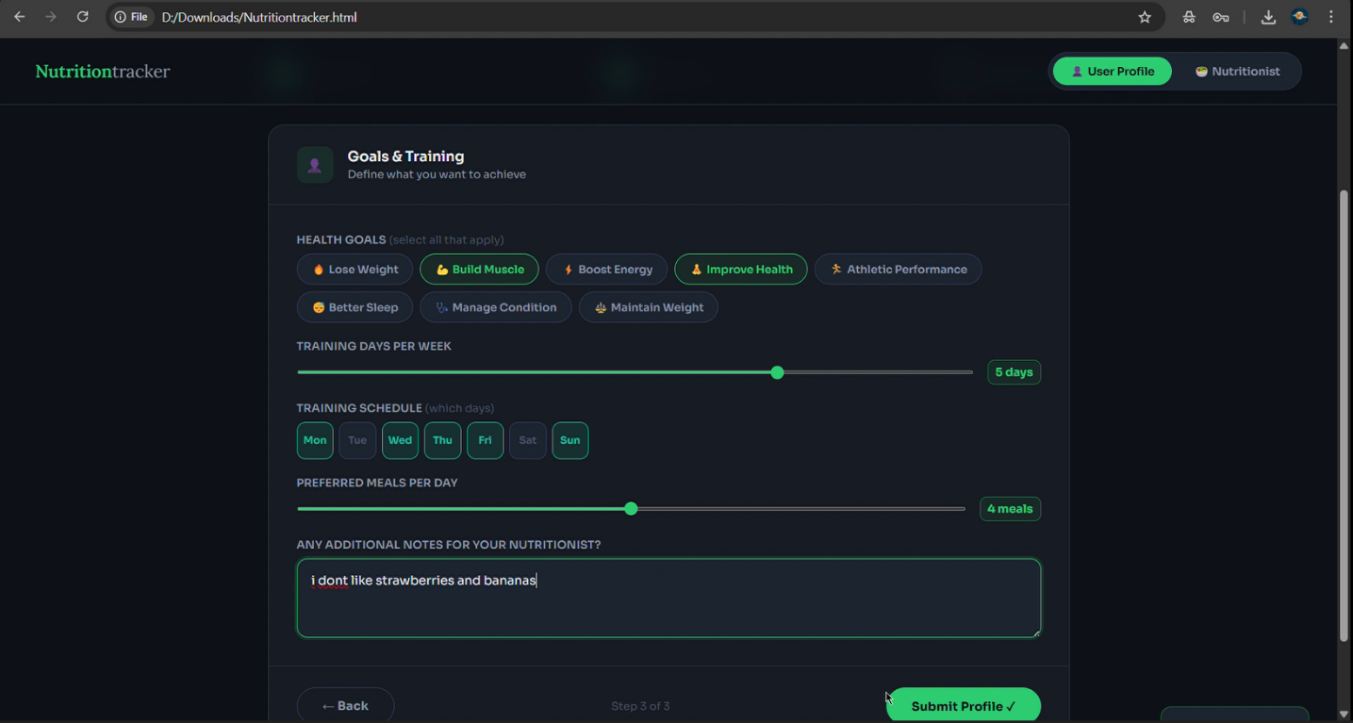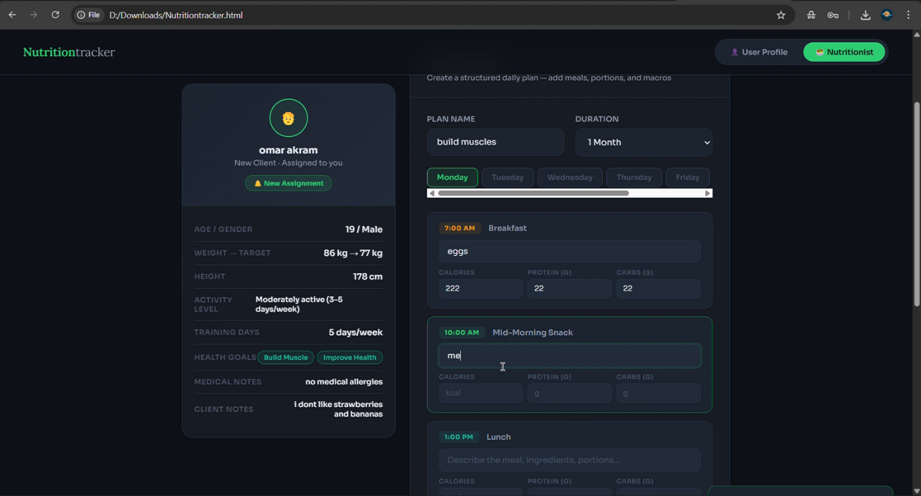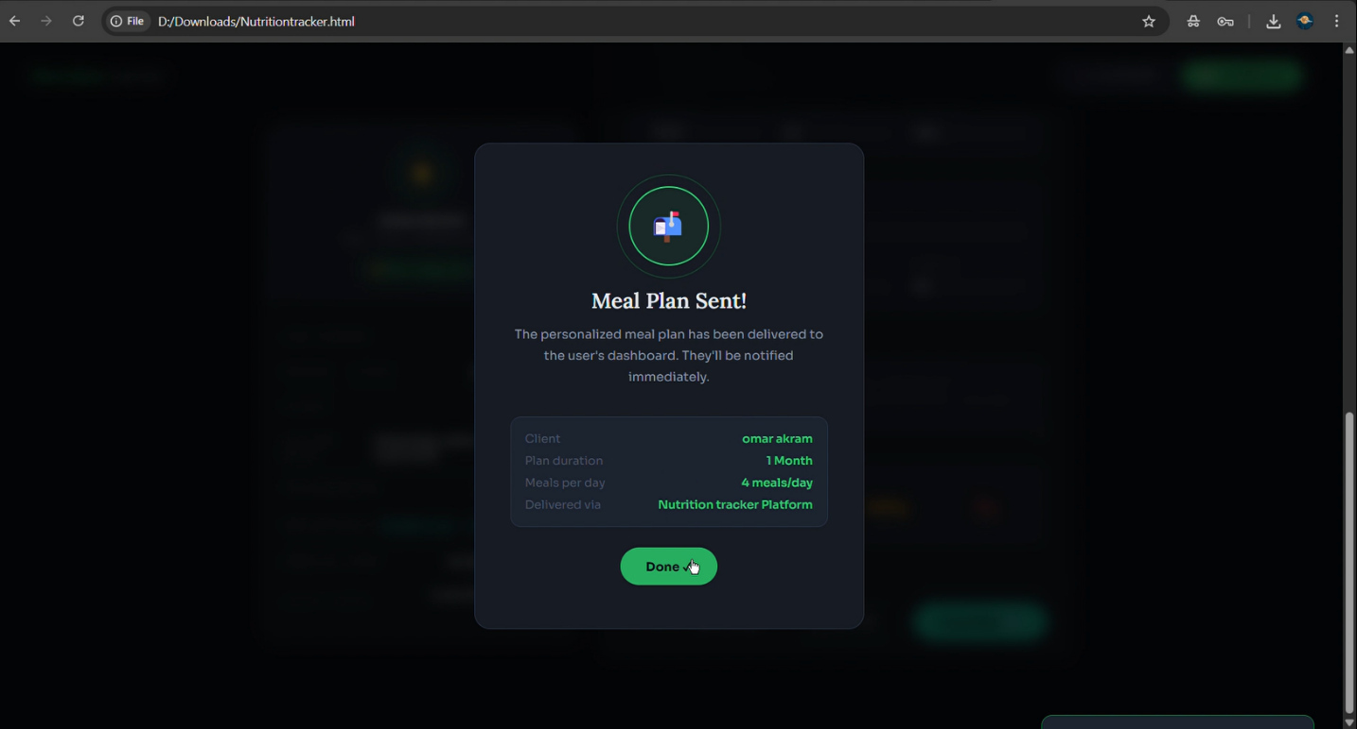

Appendix A: Glossary
User: Gets a meal plan from the platform.
Nutritionist: Creates meal plans for clients.
Admin: Manages the platform.
Meal Plan: A personalized eating schedule.
Subscription: A paid plan to access the service.
Discount Code: Reduces the payment price.
Payment Gateway: Processes payments.
Progress Update: A report sent to the nutritionist.
HTTPS: Keeps data secure and encrypted.
Brute-Force Attack: Trying many passwords to break in.
SQL Injection: Attacking the database through input fields.
Man-in-the-Middle: Intercepting data between user and system.

Appendix B: Analysis Models
- Use Case Diagram - Misuse Case Diagram
- Class Diagram - Sequence Diagram
- Activity Diagram

Appendix C: To Be Determined List
- The specific third-party payment gateway to be used.
- The email service provider for sending notifications.
- The exact subscription plan prices and durations.
- The criteria for verifying and approving nutritionists.

