CCY2001 – Introduction to Cybersecurity
Dr. Ehab Abousaif

WOKI TOKI
Secure Real-Time Chat Application
Project Documentation

Team Members
Student 1 Name: | Omar Akram Salah
Student 1 ID: | 241004666
Student 2 Name: | Seif Yasser
Student 2 ID: | 241004681

Table of Contents
1. Introduction
1.1 Project Idea and Objectives
1.2 Background and Context
2. Design Steps and System Diagrams
2.1 Design Steps
2.2 System Block Diagram
2.3 Message Flow Diagram
3. All Codes
3.1 Overview
3.2 index.html — The Front-End Interface
3.3 app.py — The Application Server
3.4 crypto.py — The Cryptographic Module
4. Conclusions and Future Work
4.1 Conclusions
4.2 Recommendations for Improvement
4.3 Future Work

1. Introduction

1.1 Project Idea and Objectives
Woki Toki is a real-time encrypted chat application built with Python Flask and WebSockets. The project demonstrates how modern cryptographic techniques can be embedded directly into a working web application, making security tangible rather than theoretical.
The main objectives of the project are:
- Build a fully functional real-time chat system for one-to-one and group conversations.
- Encrypt every message with AES-256-CBC before storing it on the server.
- Protect user passwords using PBKDF2-HMAC-SHA256 hashing with a unique random salt per user.
- Issue encrypted session tokens to authenticate all API and WebSocket requests.
- Demonstrate the CIA Triad (Confidentiality, Integrity, Availability) in a live system.

1.2 Background and Context
Messaging applications handle billions of messages every day. High-profile breaches have repeatedly shown that storing messages in plaintext — or relying solely on transport encryption — is insufficient. Regulations such as GDPR and Egypt’s Data Protection Law require organisations to protect personal communications at rest, not just in transit.
Woki Toki addresses this by applying encryption at the application layer: messages are encrypted before they reach the database, so even a complete server compromise does not expose readable content.

2. Design Steps and System Diagrams

2.1 Design Steps
The system was designed and built in the following order:
- Step 1 – Define requirements: secure messaging, user authentication, real-time delivery.
- Step 2 – Select cryptographic primitives: AES-256-CBC for encryption, PBKDF2-SHA256 for password hashing.
- Step 3 – Design crypto.py as a standalone module with no application dependencies.
- Step 4 – Design the REST API for registration, login, user listing, and history retrieval.
- Step 5 – Add the WebSocket layer for real-time message delivery and presence tracking.
- Step 6 – Integrate both modules in app.py and test end-to-end message flow.
- Step 7 – Conduct security review and document weaknesses with recommended mitigations.

2.2 System Block Diagram
The block diagram below shows the major components and how data flows between them.
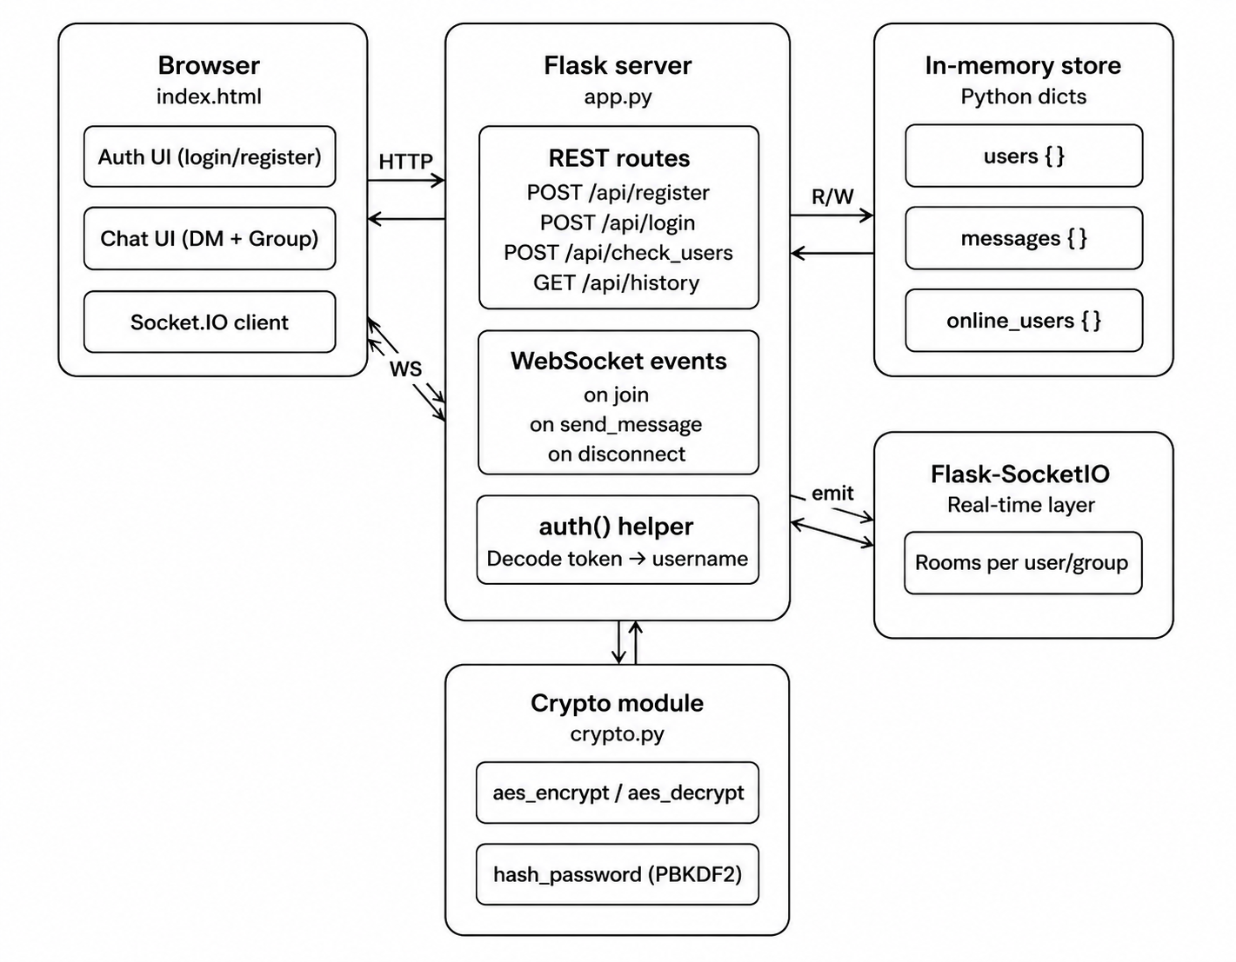
Figure 1: System Block Diagram

2.3 Message Flow Diagram
The flowchart below traces the complete path of a message from the moment a user sends it to the moment it is delivered to all recipients.
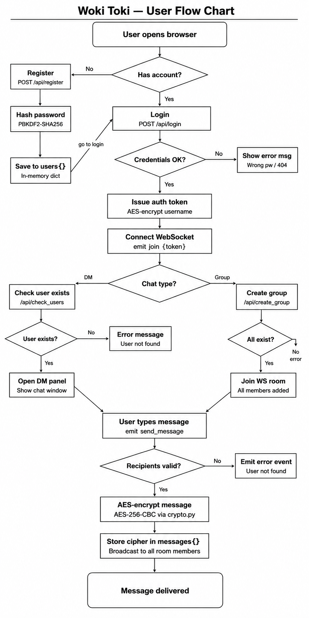
Figure 2: Message Flow Diagram

3. All Codes
This section presents the complete source code for both files that make up the Woki Toki backend, along with a brief explanation of what each file does and how its key parts work.

3.1 Overview
The project is made up of exactly two Python source files:
- app.py — the main application file. It starts the Flask server, defines all REST API routes, and handles WebSocket events. Every user-facing feature lives here.
- crypto.py — the security module. It provides three functions used by app.py: aes_encrypt, aes_decrypt, and hash_password. It has no knowledge of Flask or the web layer, making it independently testable and auditable.
Both files work together: app.py calls crypto.py whenever it needs to encrypt a message, decrypt a token, or verify a password. The rest of this section shows the full code for each file with a screenshot and a short explanation.

3.2 index.html — The Front-End Interface
What this file does
index.html is the only file the user sees. It is a single-page web application served directly by Flask. It handles everything the user interacts with: creating an account, logging in, seeing who is online, opening a conversation, and sending and receiving messages in real time. It communicates with the server in two ways — standard HTTP fetch calls for registration, login, and history, and a Socket.IO WebSocket connection for live message delivery and online presence updates.
Screenshot of index.html
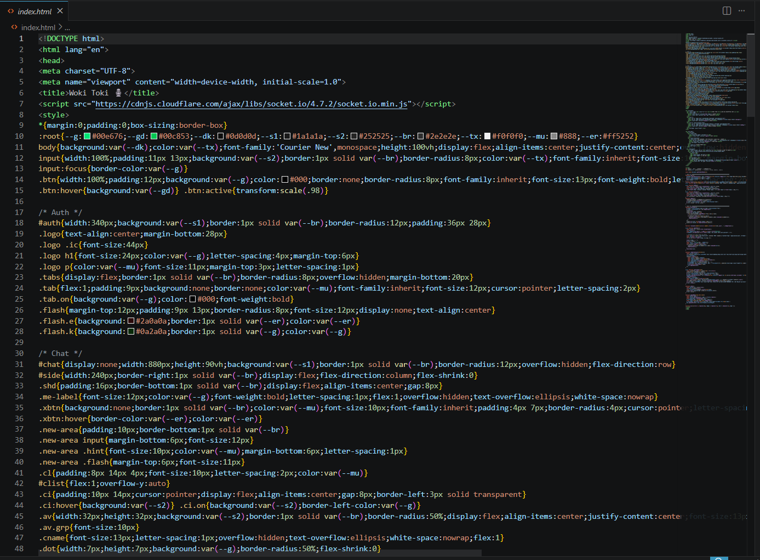
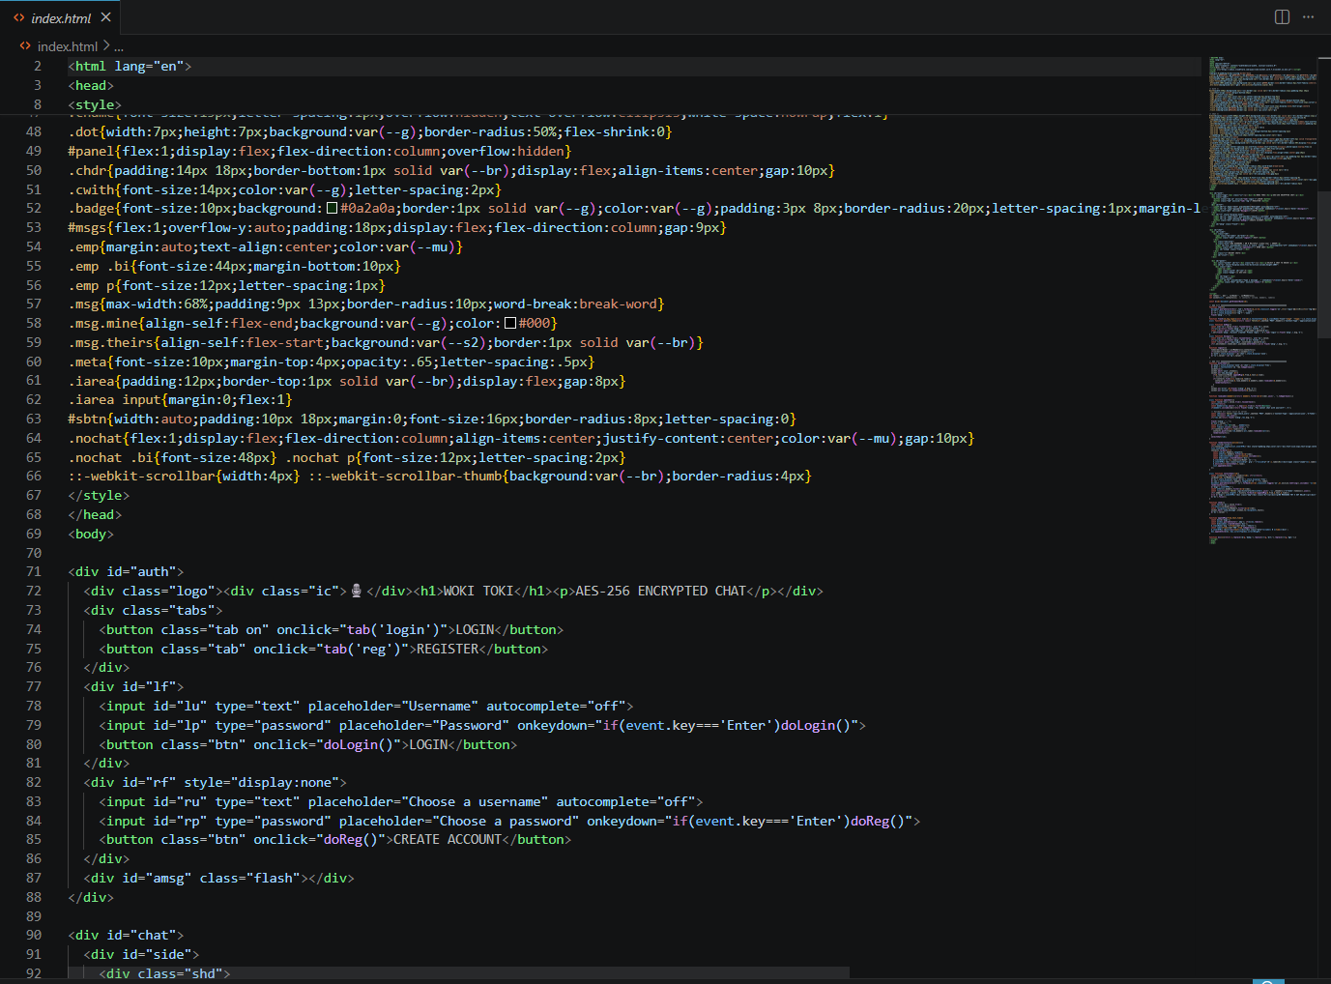
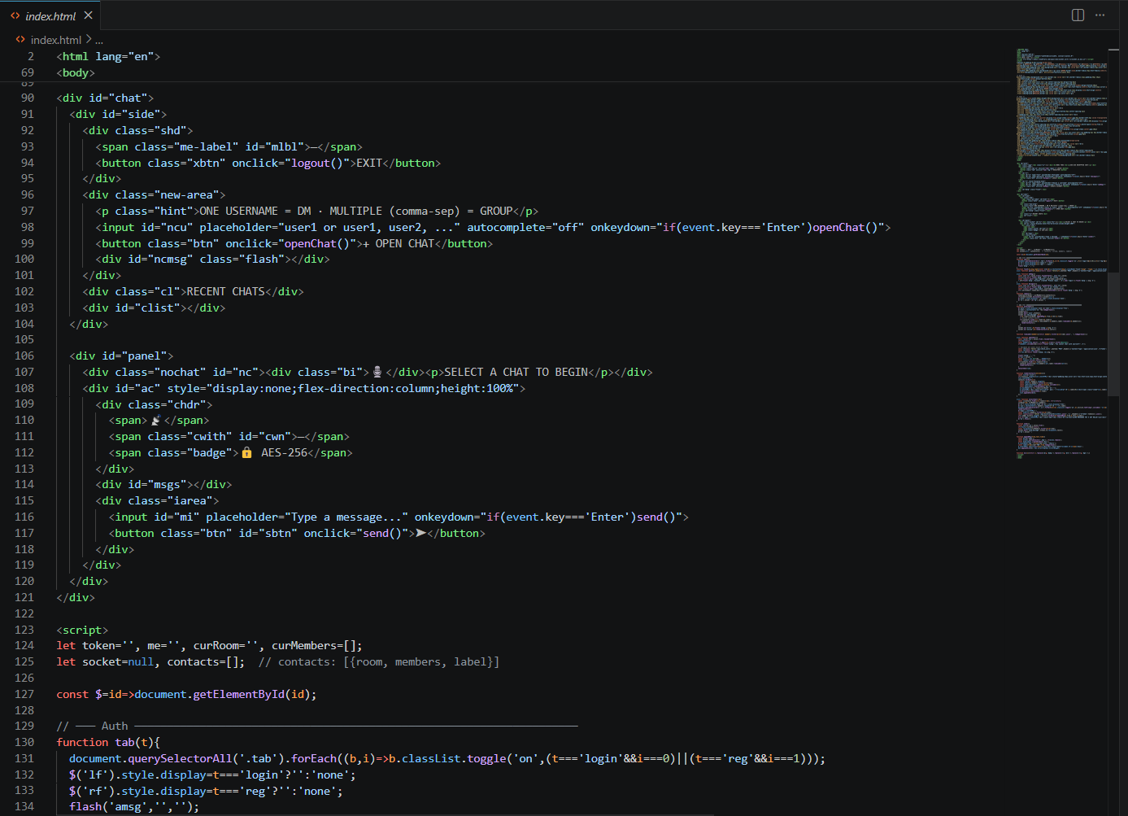
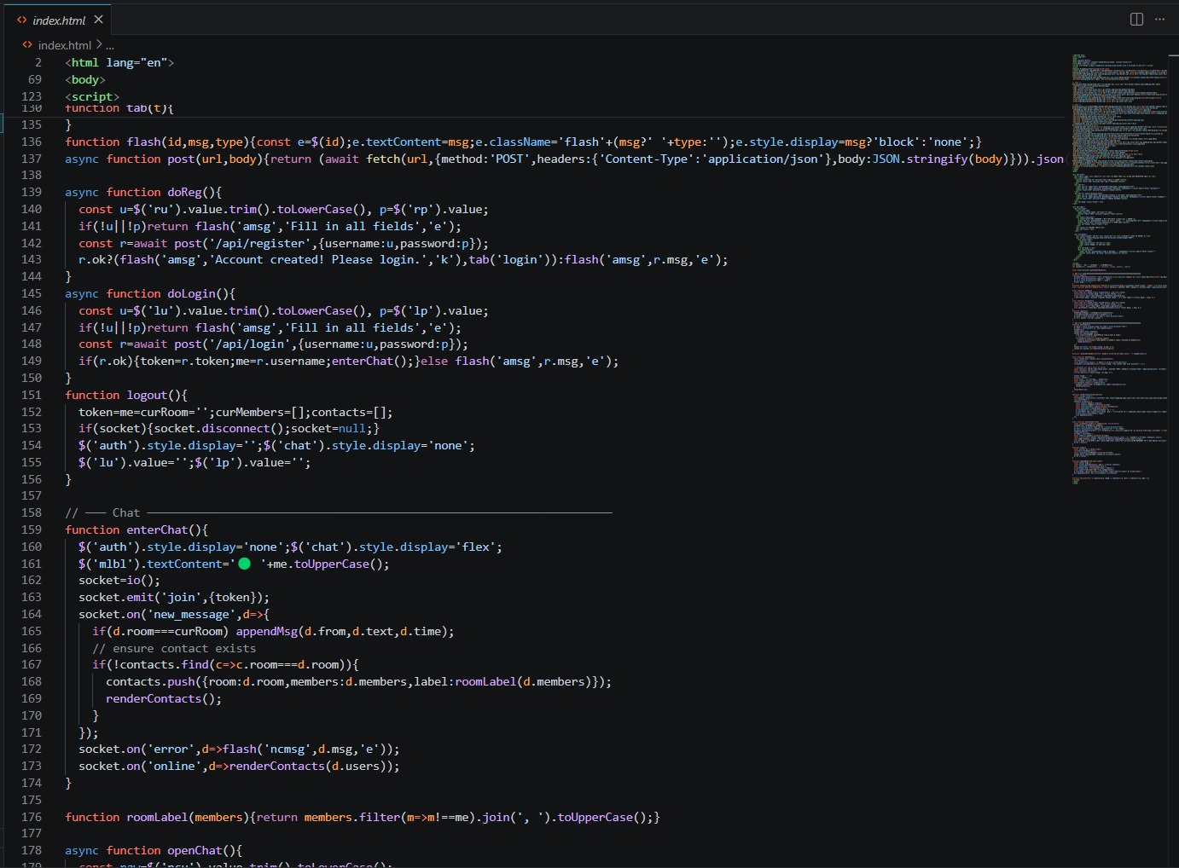

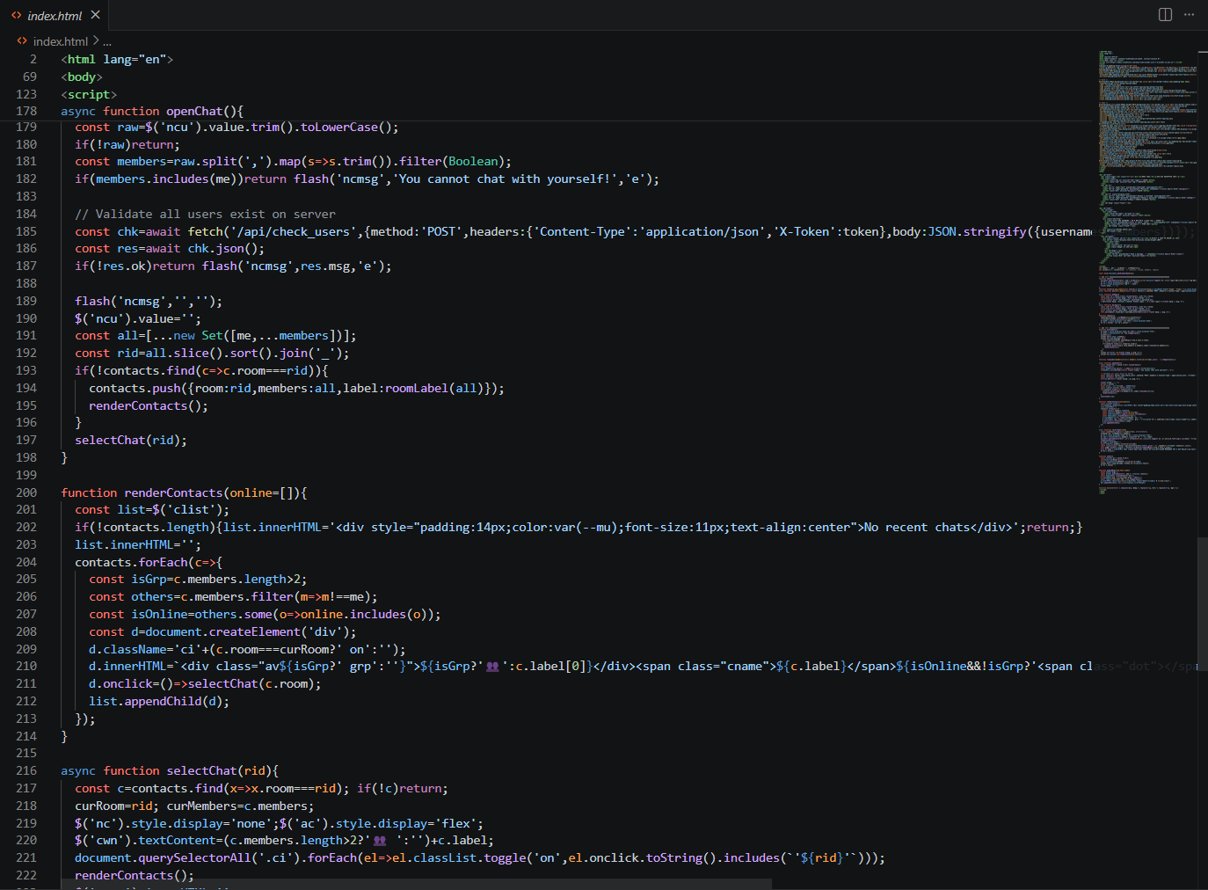
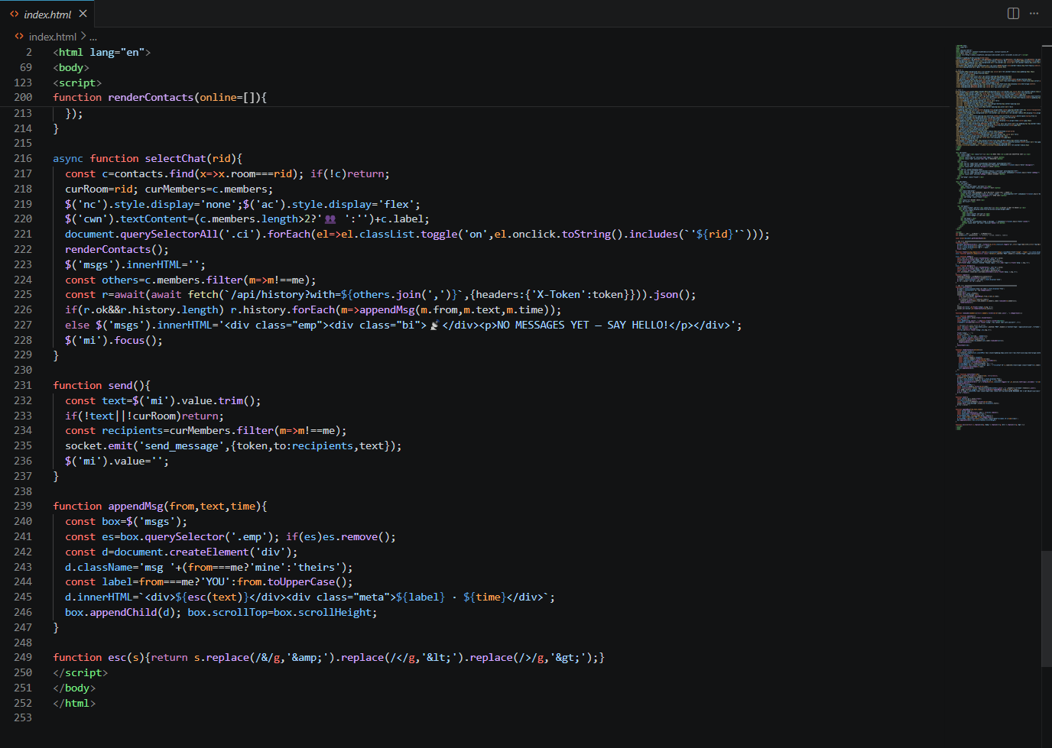
Figure 3: index.html — Front-End Interface Screenshots

3.3 app.py — The Application Server
What this file does
app.py is the heart of the application. It does four things: serves the front-end HTML page, handles user registration and login over HTTP, manages the encrypted message store, and runs the WebSocket server for real-time chat. Every request — whether a REST call or a WebSocket event — passes through this file.
Screenshot of app.py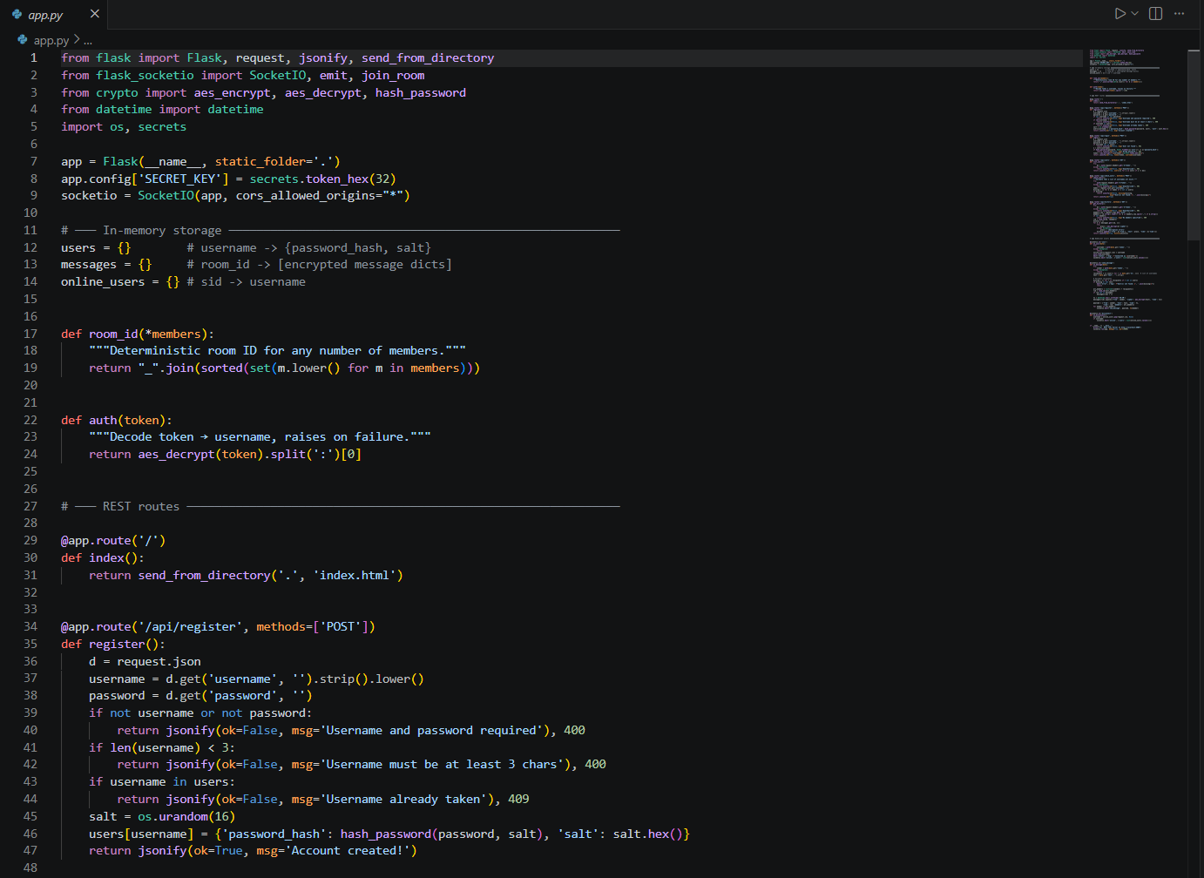
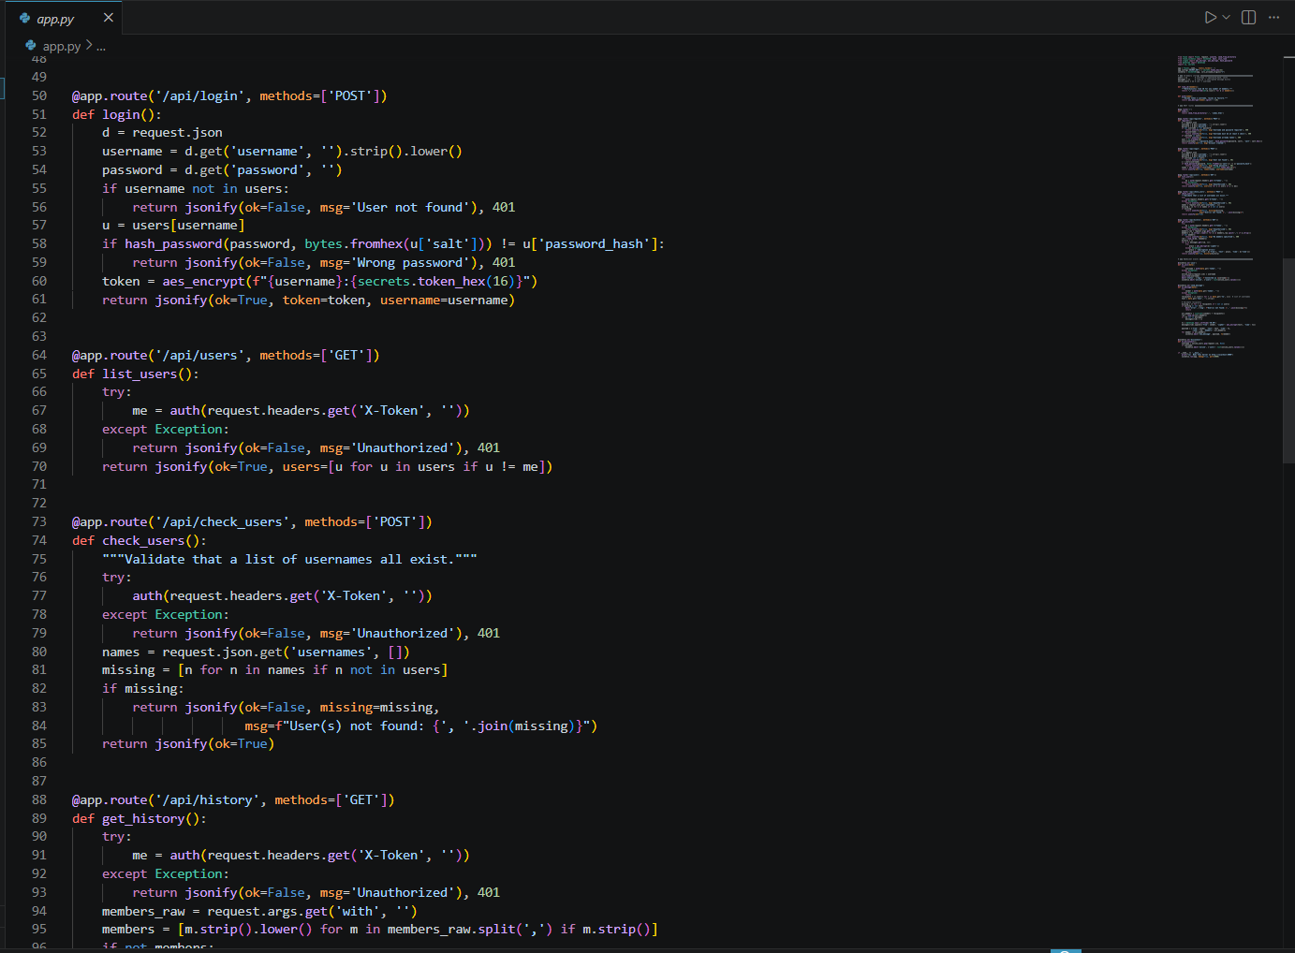
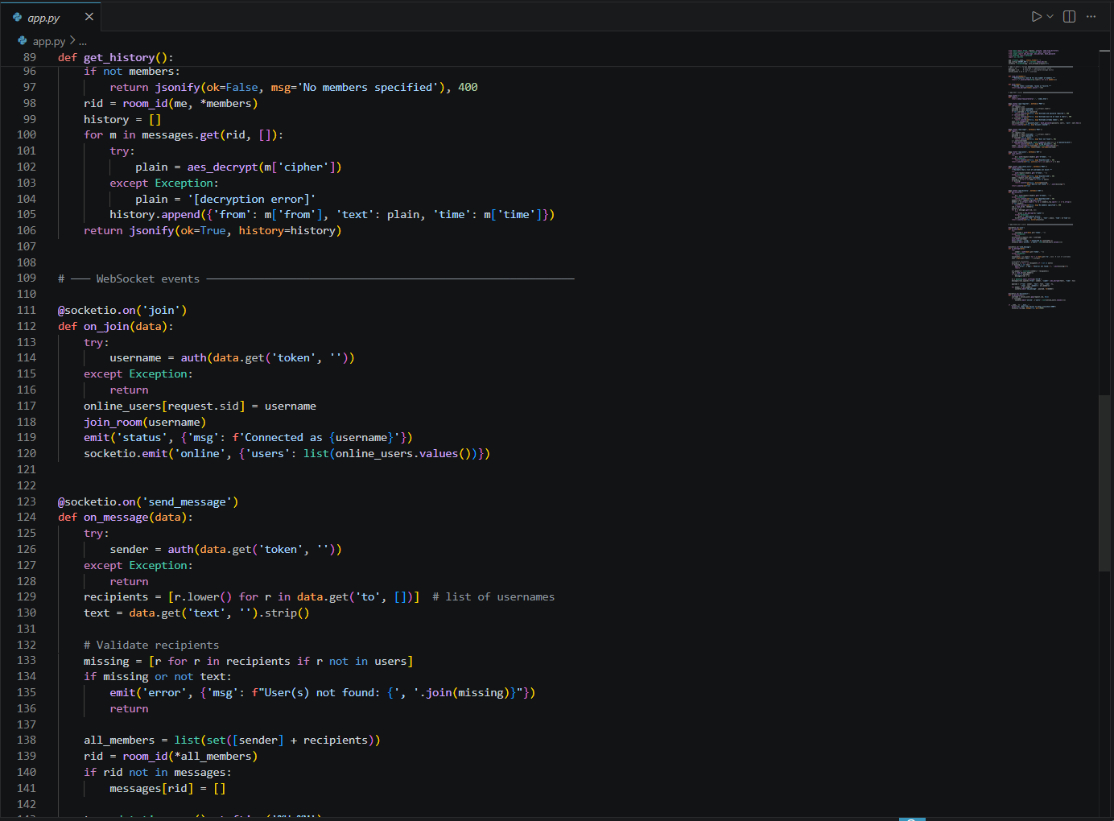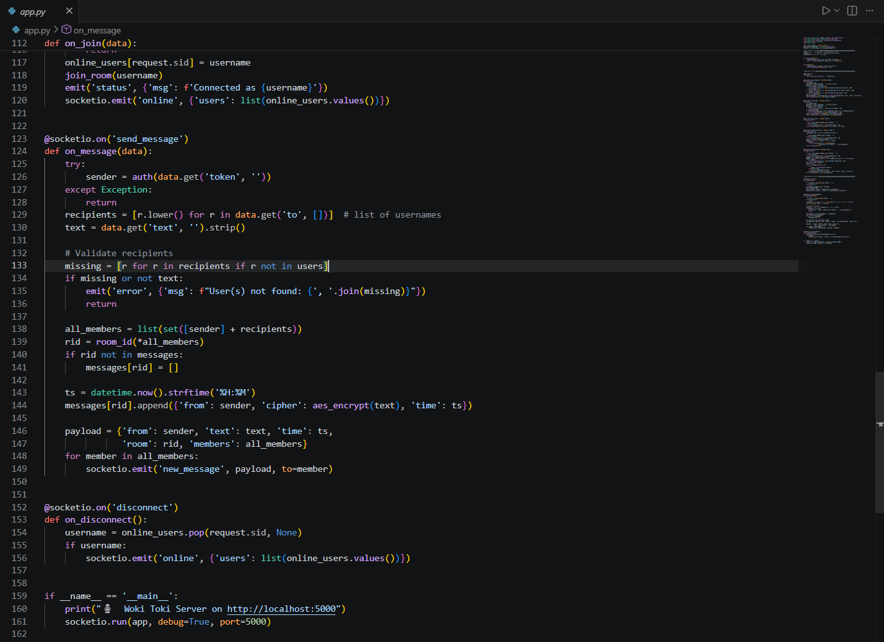
Figure 4: app.py — Application Server Screenshots
3.4 crypto.py — The Cryptographic Module
What this file does
crypto.py is a self-contained security library with no Flask dependency. It provides the three cryptographic operations the application needs: encrypting plaintext strings, decrypting ciphertext tokens back to plaintext, and turning a plaintext password into a secure stored hash. Keeping this code separate means the security logic can be read, tested, and audited independently of the web framework.
Screenshot of crypto.py

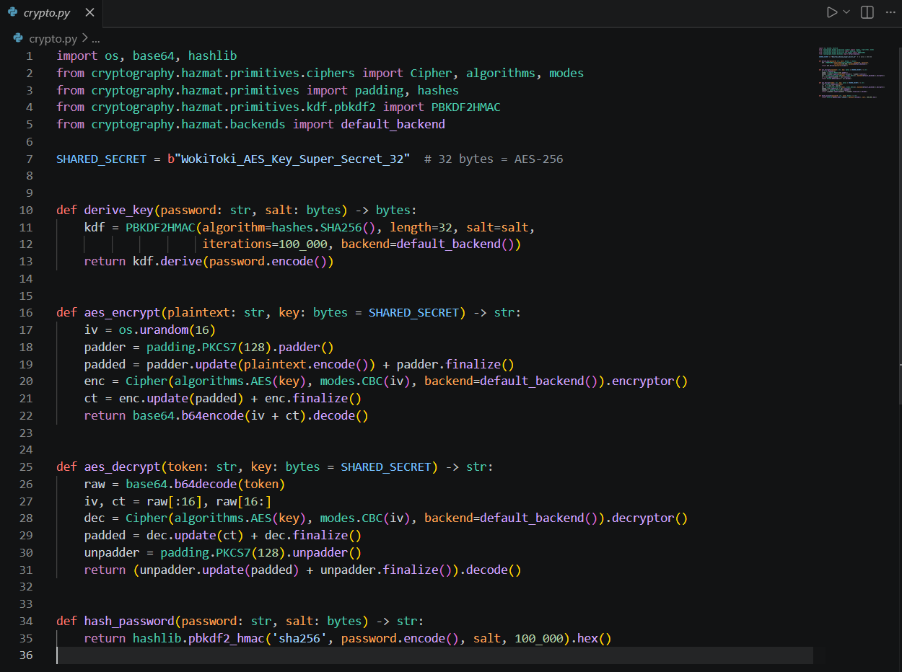
Figure 5: crypto.py — Cryptographic Module Screenshots
4. Conclusions and Future Work

4.1 Conclusions
Woki Toki successfully demonstrates that strong encryption is practical even in a lightweight web application. The project achieved all of its stated objectives:
- AES-256-CBC with a per-message random IV is correctly implemented, ensuring that no two ciphertexts are identical even for the same plaintext.
- PBKDF2-HMAC-SHA256 with 100,000 iterations and a unique salt per user protects all stored passwords against brute-force and rainbow-table attacks.
- AES-encrypted session tokens with a random nonce authenticate every REST and WebSocket request without a third-party library.
- The deterministic room_id() function enables correct history retrieval for both one-to-one and group conversations.
- Separating cryptographic logic into crypto.py produces a clean, independently auditable security module.
- The CIA Triad is satisfied: Confidentiality through AES encryption, Integrity through token validation, and Availability through real-time WebSocket delivery.
The main known weakness is the hardcoded shared AES key. In a production system this would be replaced by a per-session key derived through a key-exchange protocol such as ECDH, or stored securely in an environment variable or key management service.

4.2 Recommendations for Improvement
- Replace the hardcoded SHARED_SECRET with a key loaded from an environment variable or a dedicated key management service (AWS KMS, HashiCorp Vault).
- Add TLS (HTTPS and WSS) so all traffic is encrypted in transit as well as at rest.
- Implement end-to-end encryption using Diffie-Hellman or ECDH key exchange so the server never holds the decryption key.
- Replace the custom AES token with a signed JWT containing an expiration timestamp to limit the window of a stolen token.
- Migrate from in-memory dictionaries to a persistent database (SQLite or PostgreSQL) so data survives server restarts.
- Add rate limiting on the /api/login endpoint to prevent automated brute-force attacks.

4.3 Future Work
- Develop a polished front-end with React or Vue.js, including message notifications and a contact list.
- Add encrypted file and media sharing with per-file keys.
- Implement message deletion, editing, and read receipts.
- Add multi-factor authentication (TOTP or FIDO2 hardware keys).
- Package the application with Docker for one-command deployment.

