
Arab Academy for Science, Technology, and Maritime Transport
College of Computing and Information Technology – Heliopolis
CCY-2001 Introduction to Cybersecurity
Project Registration Form

Name of Team: | Byte Guardians
Project Title: | Woki Toki: End-to-End Encrypted Secure Chat Application

Team Information:
 | ID | Name | Mobile Number | Class #
1 | 241004666 | Omar akram | 01018648180 | Cs8
2 | 241004681 | Seif yasser | 01024665933 | Cs8
3 | Click or tap here to enter text. | Click or tap here to enter text. | Click or tap here to enter text. | Click or tap here to enter text.
4 | Click or tap here to enter text. | Click or tap here to enter text. | Click or tap here to enter text. | Click or tap here to enter text.
5 | Click or tap here to enter text. | Click or tap here to enter text. | Click or tap here to enter text. | Click or tap here to enter text.
6 | Click or tap here to enter text. | Click or tap here to enter text. | Click or tap here to enter text. | Click or tap here to enter text.

Project Details:
Project Idea:
Secure Chat Application End to end chat encryption between users
Project Summary:
Woki Toki is a secure chat application developed using Python that enables private communication between users using end-to-end encryption. The system verifies users through authentication before allowing access. After login, users exchange public keys to generate a shared secret key for secure messaging. All messages are encrypted before transmission and decrypted only by the intended receiver, ensuring confidentiality and protection from unauthorized access. The project demonstrates key cybersecurity concepts such as encryption, decryption, and secure key exchange.

Project Proposed GUI (if exist):
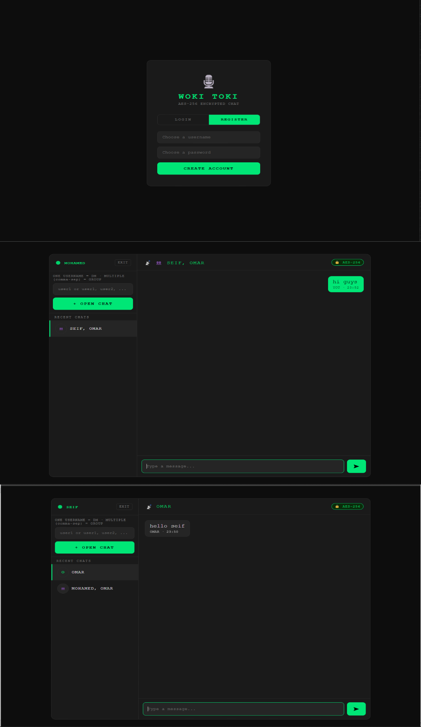
Project Benefits / Usage / Social Return :
1-Provides secure and private communication between users
2-Protects messages from unauthorized access and cyber threats
3-Demonstrates real-world use of cryptography and encryption techniques
4-Helps users understand how secure messaging systems work
5-Can be used as a model for safe communication applications
6-Improves knowledge of Python programming and cybersecurity concepts

