**Pressure control project**

Project by ENG. Omar Hassan

Learn-in-depth-diploma

Introduction:

The project aims to build a pressure control system in airplane cabin so if the pressure exceeded the predefined Threshold

(Ex.: 20 Bar) the system must warn the crew by a warning led or a Buzzer with time duration of 60 sec.

The feedback is simulated by 8 push and pull buttons to measure if the binary representation exceeded the Threshold or not.

Warning is actuated by Led.

The used Controller: stm32f10c6.

**Note (startup and linker script are derived on my own)**

System architecting:

Requirement diagram (SYSML)

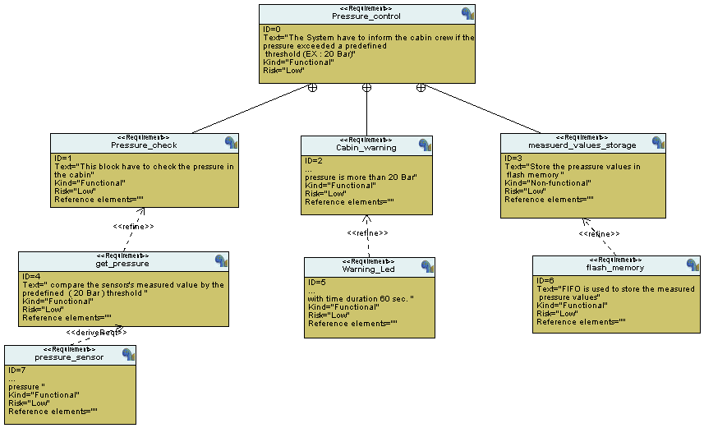

Here is the simple requirement diagram for our project.

System analysis:

First of all case use Diagram

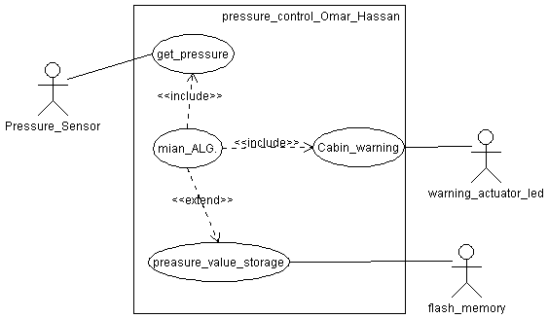

sequence diagram

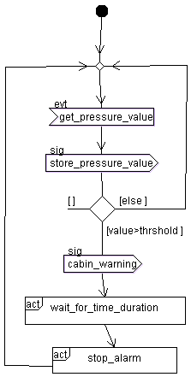

Activity diagram

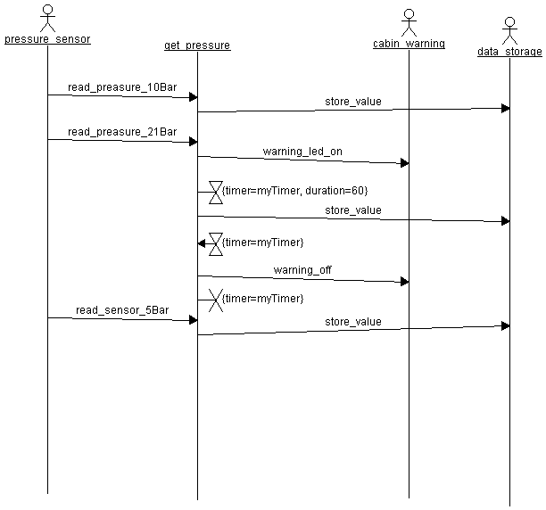

Now the system architecting is came to end.

The block diagram:

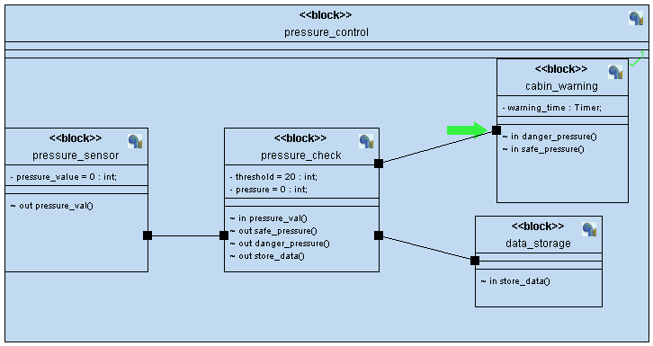

The state machine of the modules with source files:

Sensor:

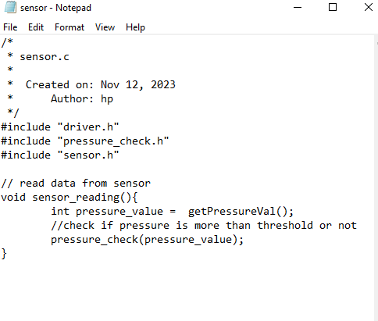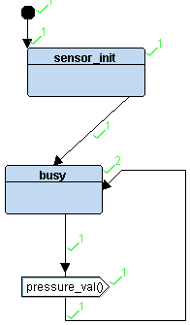

Pressure check:

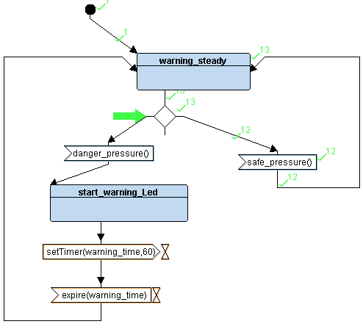

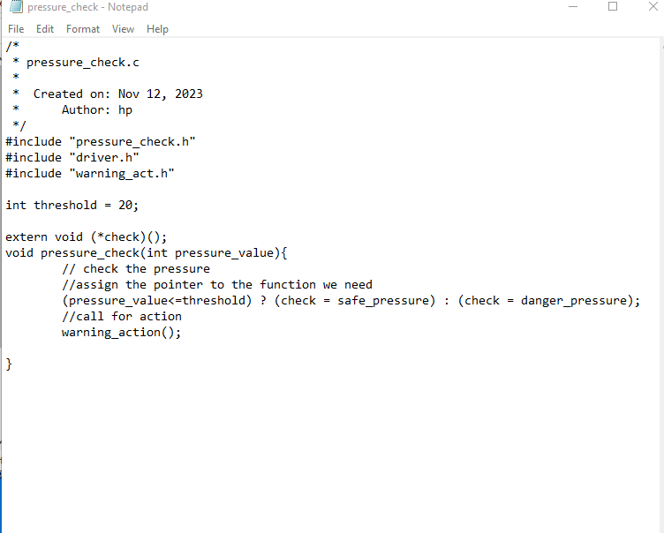

Cabin warning

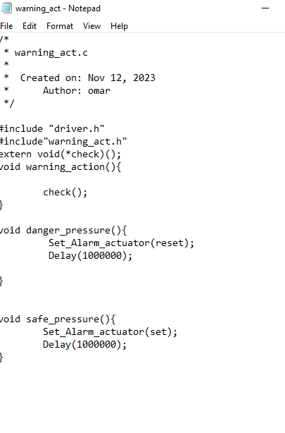

Startup script:

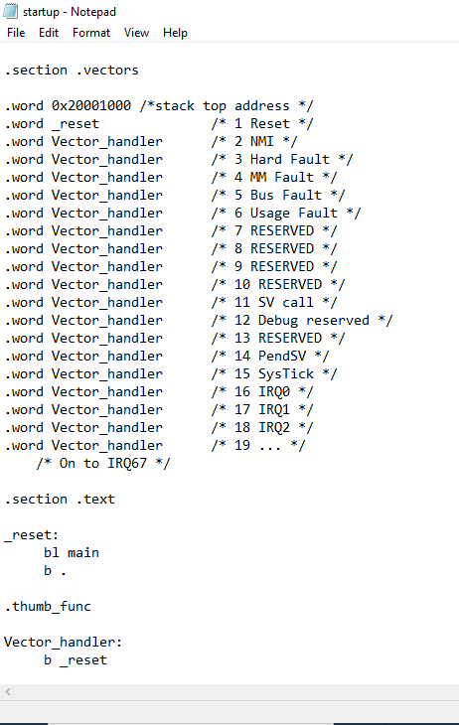

Linker script

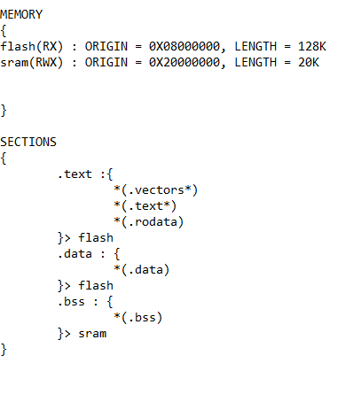

Make file

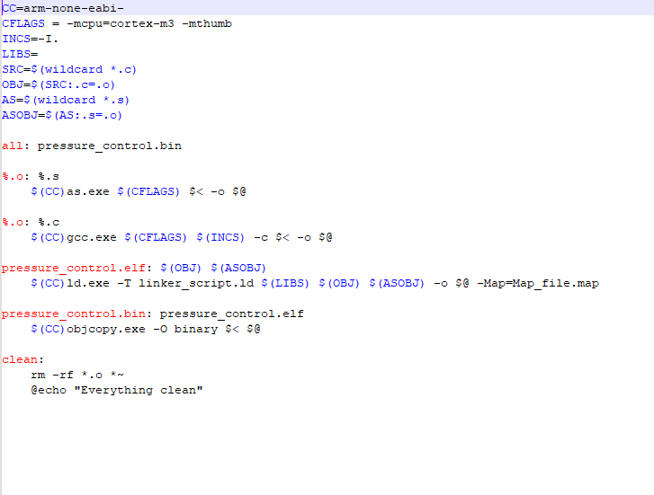

Proteus project:

