**Description:**

In this project I characterized whether a person is diabetic or not the given dataset has various features that tells if a patient is diabetic or not to do this, I implemented a perceptron model for binary classification using a simple training function with a specified accuracy target. It uses 10-fold cross-validation to evaluate the model's performance on different subsets of the dataset. The perceptron is trained iteratively, adjusting weights based on errors, until a specified number of iterations or until the model achieves perfect accuracy. Additionally, it includes a function to plot confusion matrices for each fold, providing insights into the model's performance.

**perceptron:**

Implements the perceptron training algorithm with a specified number of iterations (100) and learning rate (0.1).

**train_perceptron:**

Uses the perceptron function for training, iteratively updating weights until a target accuracy (0.75) or more is reached. It also evaluates the accuracy on a test set.

**plot_confusion_matrix:**

Generates and displays a confusion matrix heatmap for visualizing the model's performance on the test set.

**Code:**

import numpy as np

import pandas as pd

from sklearn.metrics import confusion_matrix

import matplotlib.pyplot as plt

import seaborn as sns

from sklearn.model_selection import train_test_split

from sklearn.metrics import accuracy_score

from sklearn.model_selection import KFold

def perceptron(X, Y, num_iterations=100, learning_rate=0.1):

    num_samples, num_features = X.shape

    weights = np.zeros(num_features)

    for iter in range(num_iterations):

        errors = []

        for idx, sample in enumerate(X):

            c = Y[idx]

            f = sample

            weighted_sum = np.dot(f, weights)

            output = 1 if weighted_sum >= 0 else 0

            errors.append(c - output)

            weights += learning_rate * errors[-1] * f

        if all(error == 0 for error in errors):

            break

    return weights

def train_perceptron(X_train, Y_train, X_test, Y_test, target_accuracy=0.75, num_iterations=100, learning_rate=0.1):

    X_train = np.column_stack([X_train, np.zeros(len(X_train))])

    X_test = np.column_stack([X_test, np.zeros(len(X_test))])

    weights = perceptron(X_train, Y_train, num_iterations, learning_rate)

    predictions = [1 if np.dot(sample, weights) >= 0 else 0 for sample in X_test]

    accuracy = accuracy_score(Y_test, predictions)

    # Repeat until the training accuracy is achieved

    while accuracy < target_accuracy:

        weights = perceptron(X_train, Y_train, num_iterations, learning_rate)

        predictions = [1 if np.dot(sample, weights) >= 0 else 0 for sample in X_test]

        accuracy = accuracy_score(Y_test, predictions)

    return weights, accuracy

def plot_confusion_matrix(y_true, y_pred):

    conf_matrix = confusion_matrix(y_true, y_pred)

    sns.heatmap(conf_matrix, annot=True, fmt='d', cmap='Blues', xticklabels=['0', '1'], yticklabels=['0', '1'])

    plt.xlabel('Predicted')

    plt.ylabel('Actual')

    plt.title('Confusion Matrix')

    plt.show(block=False)

df = pd.read_csv("/content/drive/MyDrive/ailabmiod/diabetes_binary_health_indicators_BRFSS2021.csv")

X = df.iloc[:, 1:].values

y = df.iloc[:,0].values

kf = KFold(n_splits=10, shuffle=True, random_state=32)

for train_index, test_index in kf.split(X):

    x_train, x_test = X[train_index], X[test_index]

    y_train, y_test = y[train_index], y[test_index]

    weights, accuracy = train_perceptron(x_train, y_train, x_test, y_test)

    print("Weights:", weights)

    print("Accuracy:", accuracy)

    # Use weights and bias to predict the classes for testing data

    x_test = np.column_stack([x_test, np.zeros(len(x_test))])

    test_predictions = [1 if np.dot(sample, weights) >= 0 else 0 for sample in x_test]

    # Plot confusion matrix for each fold

    plot_confusion_matrix(y_test, test_predictions)

**Output:**

**Fold 1:**

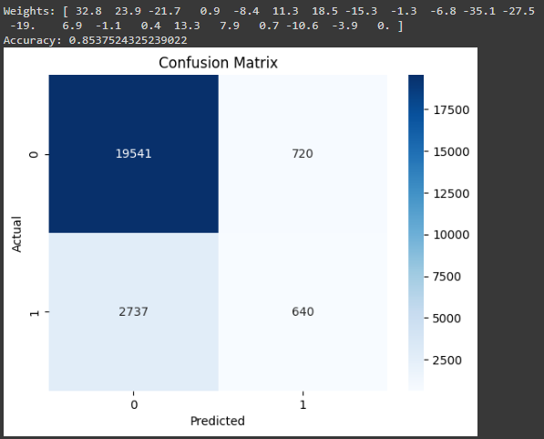

**Fold 2:**

**Fold 3:**

**Fold 4:**

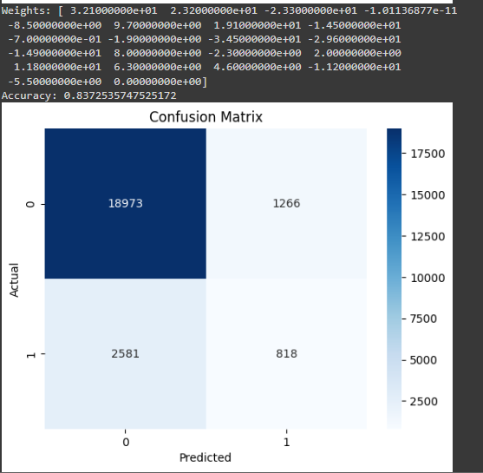

**Fold 5:**

**Fold 6:**

**Fold 7:**

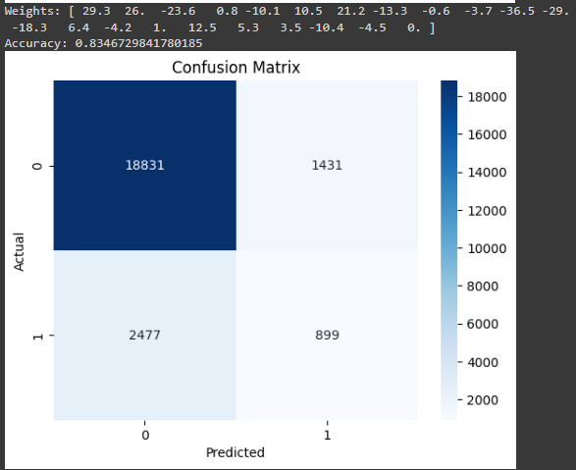

**Fold 8:**

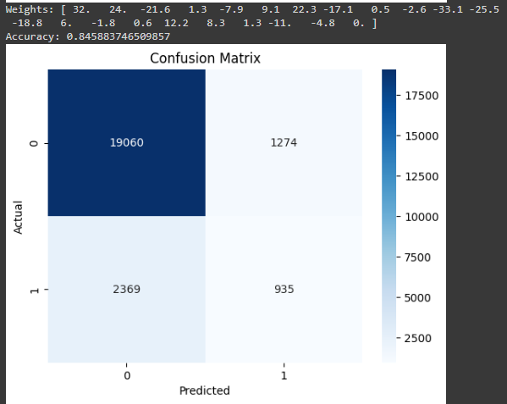

**Fold 9:**

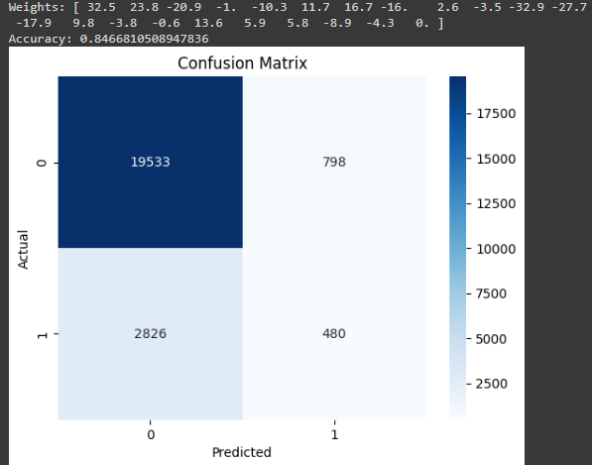

**Fold 10:**

