**Assistant-Bot**

By

Shimaa Samir

Nada Bassem

Omar Abdelfatah

Zynab Muhammed

Aya Attia

Supervised by

Dr. Ayman Elklany

TA. Ahmed Ramzy

Febraury2020

**Table of content:**

List of tables………………………………………………… ………..

List of figures …………………………………………………………

Acknowledge …………………………………….....................

Purpose and Audience ………………………………...............

Definitions and Acronyms.......................................................

**Chapter 1: Introduction**

1.1Background and Motivation…………………………….

1.2 Problem statement………………………………………

1.3 Software scope……………………………………………

1.4 Project objective…………………………………………….

1.5 Project development methodology……………………......

1.6 Suggestion solution…………………………………………

1.7 Limitation…………………………………………………….

1.8 The used tools in the project ……………………………..

1.9 Report organization………………………………………..

**Chapter 2: Requirement Analysis**

2.1 Stories …………………………………………………….

2.2 Requirements Apportioning………………………………

2.3Functional Requirements…………………………………..

2.4Non-functional Requirements………………………………

2.4.1 Accuracy ………………………………………….

2.4.2 Fast Response…………………………………….

2.4.3 Availability………………………………………….

2.4.4 Reliability ……………………………………………

2.4.5 Usability………………………………………………

2.5 Context diagram……………………………………………..

2.6 DFD fragment………………………………………………...

2.6.1 DFD fragment as a black box ……………………….

2.6.1 6 A detailed DFD fragment ………………………….

2.7 Data Flow Definition ………………………………………….

2.8 System Architecture …………………………………………

2.9 Process Description …………………………………………

**List of tables**

**Table Page**

Table (1-1) The used tools in the project

Table (2-1) Requirements Apportioning………………….

**List of Figures**

**Figures Page**

Figure (2-1) Context diagram ……………………………..

Figure (2-2) DFD fragment as a black box ………………..

Figure (2-2) A detailed DFD fragment …………………….

Figure (2-4) System Architecture…………………………

**Acknowledgment**

Firstly, we want to thank Dr.Ayman EL-Klany a lot for their support, guidance, and encouragement even when we changed in the idea of the project. We're very thankful for their flexibility, giving us time and helping us through each step. We're also grateful for TA.Ahmed Ramzy for giving us technical help to do every step right. We're so grateful

"The team"

**Document purpose and Audience**

**What is this document?**

This document is a software Requirement's Specification which describes the requirement to build Natural language units related with services system.

**Who is expected to read it?**

- Supervisor of the project.

- The team of designers and developers who will work in the project.

- Reviewers of the document /evaluators of the project.

- Student of FCI who need to read old graduation project.

**Definitions and Acronyms:**

* Chat bot

An interface, usually text based, specializing in the mimicry of natural language conversation. Also known as “artificial conversational entity”

* Natural language

The language that can be understood by English speaking high school graduates.

* NLP

Natural language processing.

* NLU

Natural language unit.

* Neo4j

Neo4j is an open-source, NoSQL, native graph database that provides an ACID-compliant transactional backend for your applications.

* Nltk

Natural Language ToolKit is a leading platform for building Python programs to work with human language data.

* Python

The programming language we use to implement the chat-bot.

* Graphql

GraphQL is a query language for your API, and a server-side runtime for executing queries by using a type system you define for your data.

* Cipher

A cipher is an algorithm for encrypting and decrypting data.

* Webhook

(also called a web callback or HTTP push API) is a way for an app to provide other applications with real-time information. A webhook delivers data to other applications as it happens, meaning you get data immediately.

* Pymessenger

Python messenger chatbot.

**Chapter 1: Introduction**

**1.1Background and Motivation**

The main tool that we're using in our project is the messenger chat Bot tool to understand user natural language about specific services like information about food, football, weather, etc… and reply with appropriate message which contain what he asked for.

A chat Bot allows scaling mobile messaging with user, facilitating the conversation with the user.

Chat Bot indicates a software system that aims at simulating and reproducing an intelligent conversation with the user.

A chat Bot provide easy and pleasant conversation, leading to more positive and involving user experience.

We are using chat Bot as it interact with user using natural language, conversation occurs through written message.

Natural Language Understanding (NLU) is a branch of artificial intelligence that uses computer software to understand input made in the form of sentences in text or speech format, NLU Understand human language and give computers the ability to communicate with humans in their own language. NLU is a subset of Natural Language Processing (NLP) while both understand human language. It has also been programmed to understand the meaning of speech in spite of human errors such as (wrong pronunciation or words spoken, etc.). The main drive behind NLU is to create chat bots that can interact effectively with the public without supervision.

we're also using messenger chat Bot as it is most popular nowadays so it will help us to reach a large number of user, and user already have background about how to use messenger, so they will not find it's hard to use our chat Bot.

Our motivation to solve that problem is that we don't want to waste the time of the user or money which spend or pay to looking for any service.

**1.2 Problem statement**

- To use different services like services that we provide in our chat Bot like asking for weather, food recipe, football news, currency conversion or movies, user need to deal with many different sources and that will be very costly in many sides.

**-** From here the problem arose. Why do we consider this a problem? , Because this problem is wasting time, effort, memory and money in case he use paid application.

- We will also face the problem that the chat bot understands the human language and thus will have difficulty in the communicating.

**1.3 Software scope**

- Our chat Bot can be used by any person who needs to deal with any service we provide.

We are trying to solve this problem using messenger chat Bot and making conversation with the user.

After receiving the message from the user our chat Bot try to understand user natural language to give him the answer he need.

We are building natural language unit to understand user natural language as much as possible.

After understanding the meaning behind user message, chat Bot giving him the service that he asked for, instead of giving you the list of websites that may contain the answer. For example, when it receives the question "What is the weather today?" it will give a response “The weather today is 30c.”

The goal also is to offer other developers the means in our assistant-bot like NLU to incorporate into their projects.

**1.4 Project objective**

-Save user memory and make it easy to reach any service of the services that we provide, since we collect those different services, so user can ask about football news about specific team, food recipe and quick answers about food, movies information like best movies and he also can make list of his favorite movies, or weather news and many other features in single place.

-We try to make our natural language unit to understand user natural language as much as possible, after that natural language unit should send the request that in the user message to the right feature in our data, then user could have the service that he asked for, for example if user send that he want to know about weather case today then our natural language unit should understand than and send this request to the weather feature and then our chat bot will give the user the right answer that he needs.

**1.5 Project development methodology**

-The methodology that we are used in this information is traditional methodology and waterfall, we have used waterfall methodology as the scope is known in advance and the requirements are stable and contract terms limit change.

**-The life cycle of the model:**

**I-conception:**

Understanding the idea and identify the problem.

**II-analysis:**

Making analysis and analysis model. Discover and understand the details of the problem and understand all details about chat Bot and how to build and focus specially to understand and discover how make and build natural language unit to understand the user natural language.

**III-design:**

Design the system components that solve the problem and start to build the chat Bot.

**IV-constriction:**

We start implementation and build the parts of the project.

**V-testing:**

Test and integrate the system components, and use different use case to ensure that the system is run well.

**1.6 Suggestion solution**

When we thought to solve this problem we decided to make a chat bot using the Facebook Messenger chat to provide users with many services.

Why did we use the chat bot especially though we could use other things like mobile application? Because most people use messenger chat daily and can easily deal with it. Also, using chat bot will not require the user to download a program and consume the memory, so we prefer to solve this problem with messenger chat Bot.

The main idea of our project is a conversation with the users which occurs through written messages between the messenger chat Bot and the user.

At first user sends message to the chat Bot then after receiving the message our chat Bot try to understand user natural language through natural language unit that we are building to give him the answer he need.

That natural language unit tries to understand user's message as much as possible which is composed of a set of sentences and each sentence is composed of a set of words; we separate each word from the other, categorizing (tagging) each one of them according to its figure of speech i.e. checking whether that word is a conjunction, noun, verb, adjective, etc.… That process is called Token Extraction.

Accordingly, we group these token in groups we call Chunks for better information extraction. The best way of chunking in our case is Noun Phrase Chunking. We then extract the Noun Phrase Chunk and identify the most fitting service or feature and run the script according to the noun that we have in hand.

After understanding the meaning behind user message, the natural language unit sends this request to the right feature that the user asked for.

**1.7 Limitation**

**1.7.1 Limited Question Scope:**

Creating a chatBot able to answer every single question about Assistant-bot is not possible to implement with current technology and within the duration of the project, so the system will be able to answer questions about limited topics.

**1.7.2 Language:**

The system will only support questions in Standard English.

**1.8 The used tools in the project**

|  |  |
| --- | --- |
| Tools | Use |
| Neo4j  Nltk  Graphql  Cipher | We used those tools to implement our natural language understanding unit (NLU). |
| Python | we use to implement the chat-bot |
| Nodejs | We use this tool to implement our function |

Table 1-1

**1.9 Report organization**

Chapter1: introduction about the problem that we thought about and how we thought in solving it and methodologies that we use.

Chapter2: introduce system analysis including the functional and non-functional requirements, class diagram, use case diagram and description, sequence diagrams, entity relationship diagram and system's test cases.

**Chapter 2: Requirement Analysis**

**2.1 Stories:**

2.1.1 If the user sent message like “I want trend films“ then our chat Bot will make analysis for his message and understand it through NLU unit, then it will reply to him with the trend films.

2.1.2 If the user sent message like “I want to know the daily weather“ then our chat Bot will make analysis for his message and understand he need weather service through NLU unit, then it will reply to him with the daily weather.

2.1.3 If the user sent message like “how much it will be if I want to convert 100 dollars to Egyptian pounds “ then our chat Bot will make analysis for his message and understand he need currency conversion service through NLU unit, then it will reply to him with the right amount.

**2.2 Requirements Apportioning**

Each feature will be assigned an importance value. The project will be complete if all the features of Priority 1 and at least 50% of features of Priority 2 are implemented. No Priority 3 requirements are necessary.

|  |  |
| --- | --- |
| Priority | Meaning |
| 1 | Essential, the project will not work without this feature. This feature will be implemented. |
| 2 | Important, the scope of the project will be significantly hindered without this feature. This feature will likely be implemented. |
| 3 | Desired, this feature complements the core functionality. This feature will be implemented, time allowing. |

(Table 2-1)

**2.3Functional Requirements:**

**2.4Non-functional Requirements:**

2.4.1 Accuracy:

2.4.1.1The overall accuracy of the assistant-bot response will be measured using a developer-made textual test set with our chat bot. (Priority1)

2.4.1.2The overall accuracy is calculated by dividing total number of correct answers by the number of questions asked. (Priority1)

2.4.1.3 The accuracy of the Generic Question Construction part will be close to 80%. (Priority 2)

2.4.1.4The accuracy of the Generic Answer Construction unit will be close to 65%. (Priority 2**)**

2.4.2 Fast Response

The average time for the server to respond, over the question testing set, will be less than or equal to 2 seconds. (Priority 2)

2.4.3 Availability

The system will be available 24 hours a day. (Priority1)

2.4.4 Reliability

System will handle wrong input from user by 60%. (priority2)

2.4.5 Usability

2.4.5.1 Our system will be easy to use by users because our simple chat bot and its simple language. (priority1)

2.4.5.2 If system didn't understand users message it will produce message to user telling them to rewrite the message again. (priority1)

**2.5 Context diagram:**

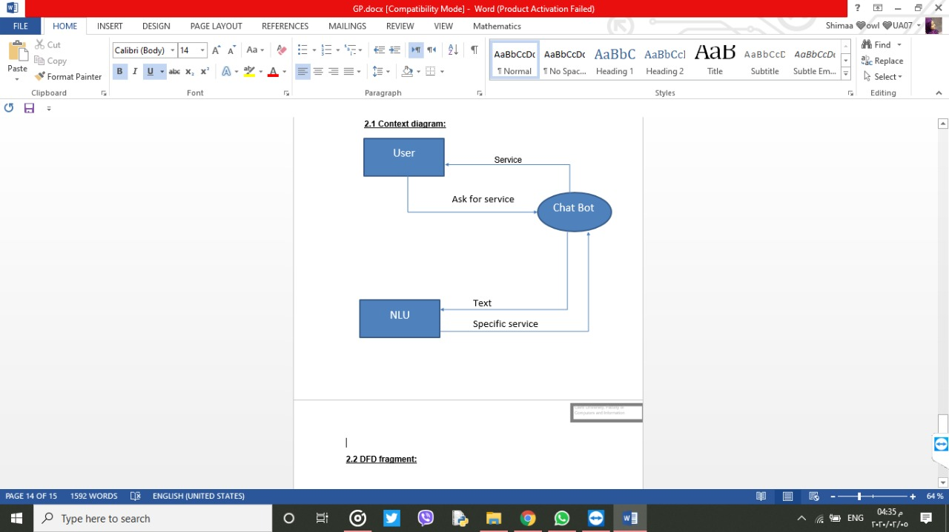

Figure 2-1

**2.6 DFD fragment:**

2.6.1 NLU As a black box

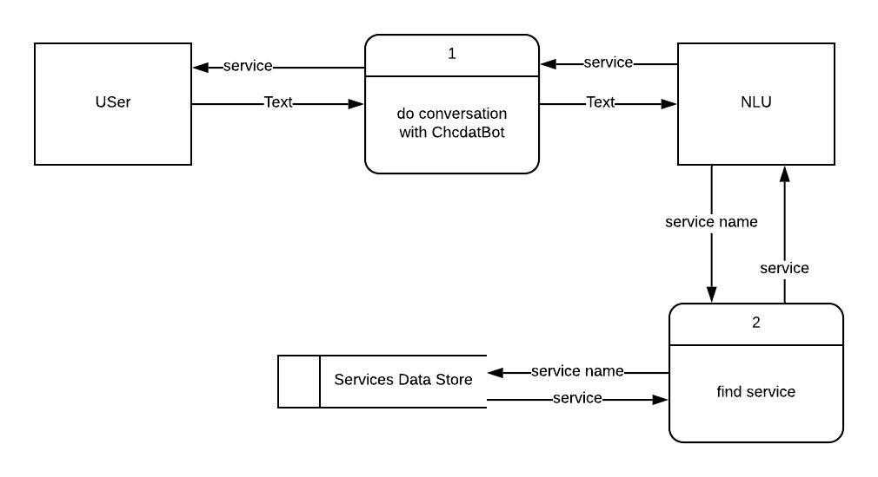

Figure 2-2

2.6.2 DFD fragment in detail:

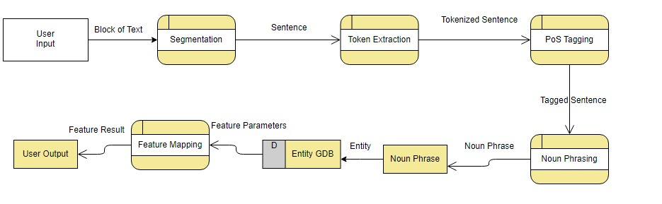Figure 2-3

**2.7 Data Flow Definition:**

It is the path of the data from source to data entry to a final report. The data being passed is being changed as It moves from a process to another. Here in our case, the data comes from the user then it goes through some operations such as token extraction and chunking, then the result is transferred to a graph database to be stored if it is new. The resulting entity is then mapped to a feature the takes a number of attributes. Finally, the result of the feature script then returns the reply to the user.

**2.8 System Architecture**

At First the user send a message to the chat-bot, then the chat-bot send the message as a text to the NLU that starts the process that contains of some steps, which is sentence segmentation then send the sentences to tokenization step, then send the tokenized sentences to be categorized(tagged),then check the words in the token extraction step, then do the chunking step which select the noun, and then get the noun to be compared and find the most fitting service or feature, and then send the result to the chat-bot which replay to the user with the required service.

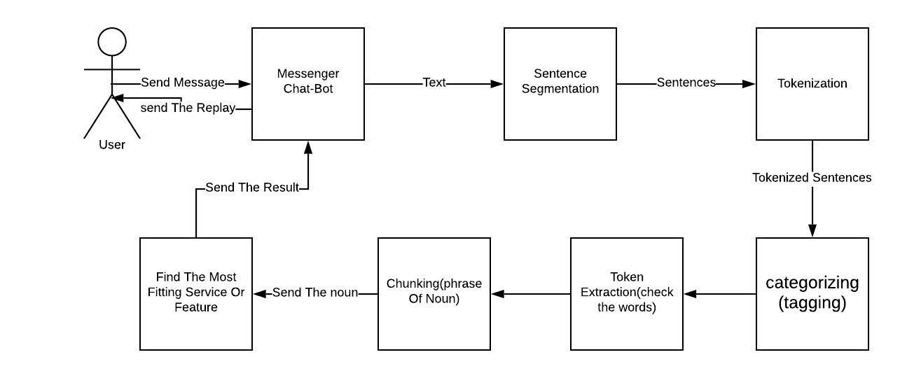

Figure 2-4

**2.9 Process Description**

Step 1: The user sends his first message

- Input: Text message from the user

-Output: A reply message from the chat bot to the user

-The user sends his first message, then chat Bot try to understand the user natural language through natural language unit that the most fitting service or feature Also, run the script according to the noun that we have in hand.

After understanding the meaning behind the user message, the natural language unit sends this request to the right and after that the chat bot will send a reply message to the user asking about his option.

Step 2: If the user chose weather

-Input: Text message "asking about the weather"

-Output: The weather

- The user sends asks about the weather, then chat Bot try to understand the user natural language through natural language unit that the most fitting service or feature Also, run the script according to the noun that we have in hand.

After understanding the meaning behind the user message, the natural language unit sends this request to the right and after that the chat bot will send to an application, the application reply to chat bot and chat bot will send a reply to user.

Step 3: If the user chose Move

-Input: Text message "name of move, asking the trend of moves"

-Output: The move

- The user sends name of move or asks about a trend, then chat Bot try to understand the user natural language through natural language unit that the most fitting service or feature Also, run the script according to the noun that we have in hand.

After understanding the meaning behind the user message, the natural language unit sends this request to the right and after that the chat bot will send to an application, the application reply to chat bot and chat bot will send a reply to user.

Step 4: If the user chose currency convertibility

-Input: Text message "the current currency and the new currency"

-Output: The new currency

- The user sends asks about the currency convertibility, then chat Bot try to understand the user natural language through natural language unit that the most fitting service or feature

Also, run the script according to the noun that we have in hand.

After understanding the meaning behind the user message, the natural language unit sends this request to the right and after that the chat bot will send to an application, the application reply to chat bot and chat bot will send a reply to user.

Step 5: If the user chose football

-Input: Text message "name of team, asking news of match or watching match"

-Output: The match, news of team or match

- The user sends asks about name of team, asking news of match or watching match, then chat Bot try to understand the user natural language through natural language unit that the most fitting service or feature Also, run the script according to the noun that we have in hand.

After understanding the meaning behind the user message, the natural language unit sends this request to the right and after that the chat bot will send to an application, the application reply to chat bot and chat bot will send a reply to user

Step 6: If the user chose food

-Input: Text message "name of food"

-Output: All information about this food

- The user sends asks about food then chat Bot try to understand the user natural language through natural language unit that the most fitting service or feature Also, run the script according to the noun that we have in hand.

After understanding the meaning behind the user message, the natural language unit sends this request to the right and after that the chat bot will send to an application, the application reply to chat bot and chat bot will send a reply to user.

Step 7: If the user chose flight

-Input: Text message "detention airline ticket"

-Output: All information about airline ticket companies

- The user sends asks about food then chat Bot try to understand the user natural language through natural language unit that the most fitting service or feature Also, run the script according to the noun that we have in hand.

After understanding the meaning behind the user message, the natural language unit sends this request to the right and after that the chat bot will send to an application, the application reply to chat bot and chat bot will send a reply to user.

**Chat bot creation steps:**

At first, we created a facebook app on <https://developers.facebook.com/> , then we created a facebook page, after that we installed virtual environment, flask, requests and pymessenger, then we created the webhook, then we tested to receive a message, after that we decoded the received message and pass it the page access token then we replay the user with the same message who send it.

Chapter 3:- Design system

