Omar Abdelmotaleb

Assignment 2

CS-559-B

I pledge my honor that I have abided by the Stevens Honor System.

Figure 1

For K = 30 eigenfaces, here are the visualized top 10 eigenfaces (color mapped to grey):

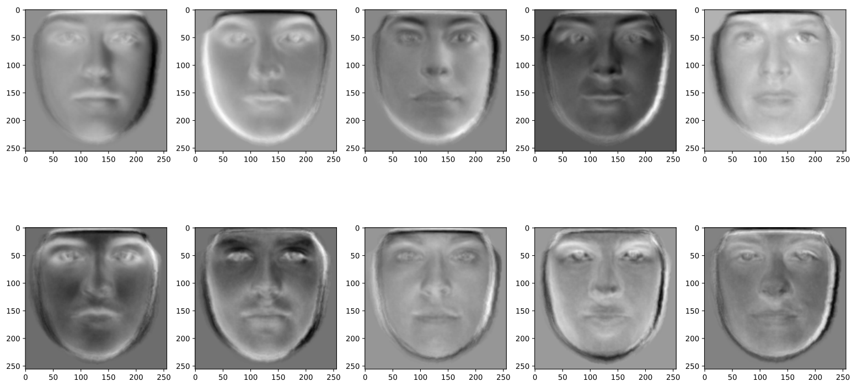

Figure 2

Based on the top 30 eigenfaces, here are the reconstructed faces (top row is original):

Figure 3

These are the error values based on the different number of eigenfaces used (K=10,30,50,100,150):

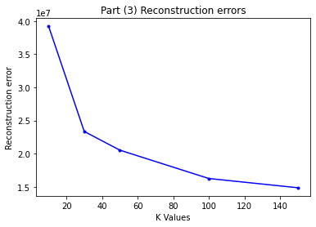

Actual values:

K = 10: 39215338.12742461  
K = 30: 23347157.383341566  
K = 50: 20523927.563391093  
K = 100: 16242962.883069996  
K = 150: 14848242.96413517